|  |  |  |  |  |
| --- | --- | --- | --- | --- |
| Test | Tool | Result | Passed |  |
| Attempted to log into the machine with the IPS 3 times successively. Should get banned by IPS | SSH/iptables | Remote host banned successfully | Yes | Fig 1, 2, 3 |
| Information about attempted connections displayed on webpage | Firefox | Shows details about ban, including expiry time. | Yes | Fig 2 |
| Users are unbanned after 1 day of being banned | iptables | User was unbanned when the ban expired | Yes | Fig 4 |
| User should not be banned for less than 3 attempted connections in 1 minute | iptables | Success | Yes | Fig 5, 6 |

Testing Doc

Figure 1:

|  |
| --- |
| Mar 1 14:52:50 datacomm sshd[4085]: pam_unix(sshd:auth): authentication failure; logname= uid=0 euid=0 tty=ssh ruser= rhost=192.168.0.21 user=root  Mar 1 14:52:50 datacomm sshd[4085]: pam_succeed_if(sshd:auth): requirement "uid >= 1000" not met by user "root"  Mar 1 14:52:52 datacomm sshd[4085]: Failed password for root from 192.168.0.21 port 55724 ssh2  Mar 1 14:52:53 datacomm sshd[4085]: pam_succeed_if(sshd:auth): requirement "uid >= 1000" not met by user "root"  Mar 1 14:52:55 datacomm sshd[4085]: Failed password for root from 192.168.0.21 port 55724 ssh2  Mar 1 14:52:56 datacomm sshd[4085]: pam_succeed_if(sshd:auth): requirement "uid >= 1000" not met by user "root"  Mar 1 14:52:58 datacomm sshd[4085]: Failed password for root from 192.168.0.21 port 55724 ssh2  Mar 1 14:52:59 datacomm sshd[4085]: Connection closed by 192.168.0.21 [preauth] |

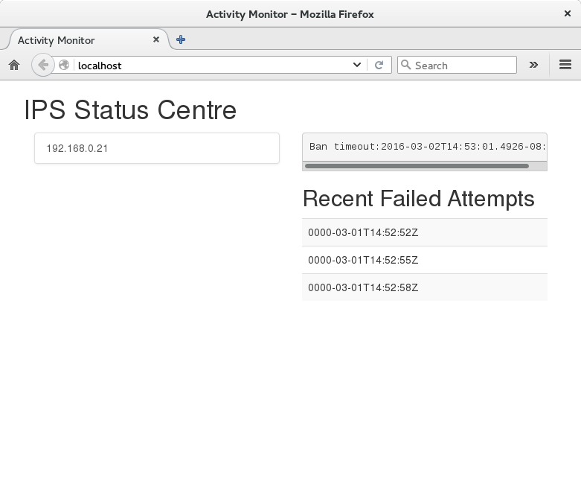Figure 2

Figure 3

|  |
| --- |
| Chain INPUT (policy ACCEPT)  target prot opt source destination  [root@datacomm COMP8006.IPS]# iptables -L  DROP all -- 192.168.0.21 anywhere  Chain FORWARD (policy ACCEPT)  target prot opt source destination  DROP all -- 192.168.0.21 anywhere  Chain OUTPUT (policy ACCEPT)  target prot opt source destination  DROP all -- 192.168.0.21 anywhere |

Figure 4

|  |
| --- |
| [root@datacomm COMP8006.IPS]# iptables -L  Chain INPUT (policy ACCEPT)  target prot opt source destination  Chain FORWARD (policy ACCEPT)  target prot opt source destination  Chain OUTPUT (policy ACCEPT)  target prot opt source destination |

Fig 5:

|  |
| --- |
| Mar 1 14:53:40 datacomm sshd[4085]: pam_unix(sshd:auth): authentication failure; logname= uid=0 euid=0 tty=ssh ruser= rhost=192.168.0.21 user=root  Mar 1 14:52:53 datacomm sshd[4085]: pam_succeed_if(sshd:auth): requirement "uid >= 1000" not met by user "root"  Mar 1 14:52:56 datacomm sshd[4085]: Failed password for root from 192.168.0.21 port 55724 ssh2  Mar 1 14:52:57 datacomm sshd[4085]: pam_succeed_if(sshd:auth): requirement "uid >= 1000" not met by user "root" |

Fig 6:

|  |
| --- |
| [root@datacomm COMP8006.IPS]# iptables -L  Chain INPUT (policy ACCEPT)  target prot opt source destination  Chain FORWARD (policy ACCEPT)  target prot opt source destination  Chain OUTPUT (policy ACCEPT)  target prot opt source destination |