**Project-1**

**Web Traffic and Search Engine Optimization**

**Name: Vijay Prakash Mudaliar**

**Student ID: 8962818**

**Email:** [**vmudaliar2818@conestogac.on.ca**](mailto:vmudaliar2818@conestogac.on.ca)

**Company Overview**

**Name and URL**: Buttercloth (<https://buttercloth.com/>)

**Products**: Buttercloth specializes in making very comfortable shirts. Their offerings consist of long-sleeve and short-sleeve shirts, polo tees, outerwear like jackets and hoodies, and accessories like socks.

**Target Audience**: The customers targeted by Buttercloth are mostly men who take comfort in their clothes seriously. The brand targets people who want to keep sharp without sacrificing comfort.

**Based on Screaming Frog Audit Data please answer the following questions.**

1. What internal or content issues does the website have? Provide a screen shot of the data supporting these statements.

Ans.

* **Issue 1:** Pagination URL Issues

**Description**: It refers to where pagination links do not use proper anchor tag, making it search engine crawlers to follow and index further pages.

**Solution**: Ensure each pagination link is in anchor tags, use of ‘rel’ to indicate page order and use canonical link to point main or first page.

* **Issue 2:** Meta Description

**Description:** Search engines may become confused by many meta descriptions on multiple pages.

**Solution:** Ensuring each page has a unique summary of its content, around 160 characters. It must include relevant keywords naturally to enhance search visibility.

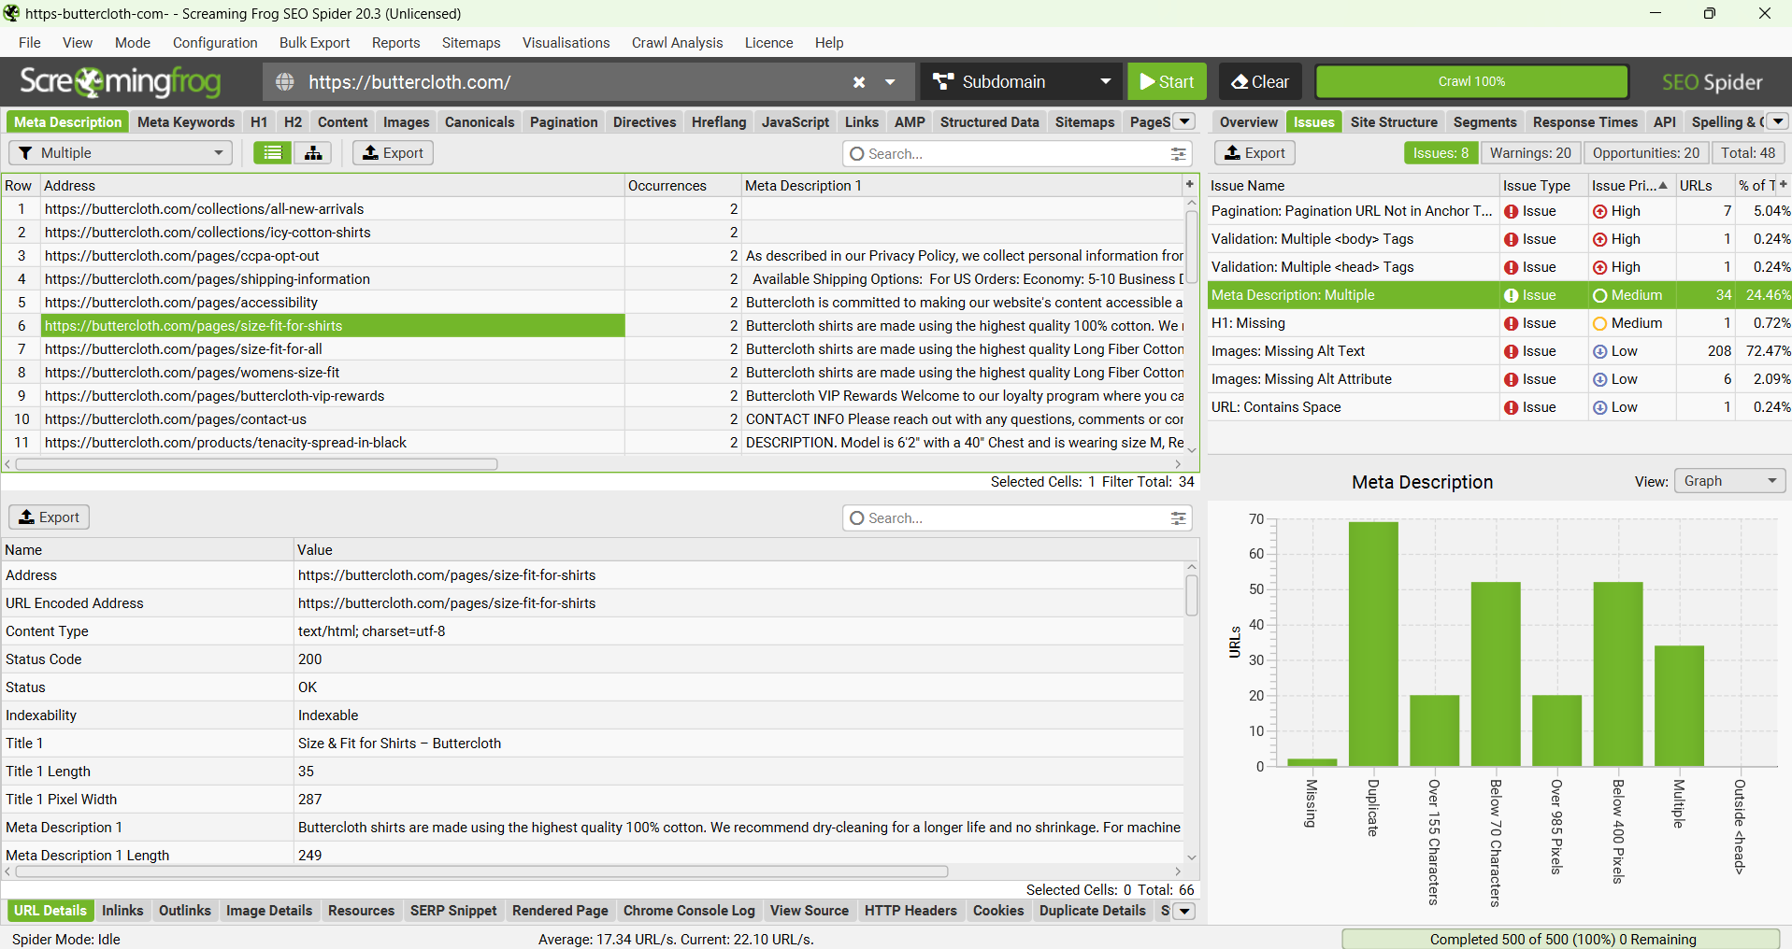

* **Issue 3**: Validation Issues

**Description:** Multiple <head> and <body> tags which can confuse search engines during indexing.

**Solution:** Carefully review the HTML pages and ensure that each page contains only one head and body. Make sure to validate in the W3C Markup Validation Service to identify and fix all the errors.

1. What internal or content issues does the website have? Provide a screen shot of the data supporting these statements.

Ans.

**Optimization and Issues**

1. **Multiple Head Tags**

* **Issue:** The issue can lead to improper linking of the CSS, JavaScript files or SEO Problems.
* **Fix:** Ensure that the head tag is present at the top of the HTML structure and contains the essential elements like meta, link and title. Meta can improve the better search ranking.

1. **Multiple Body Tags**

* **Issue:** This issue can lead to the browser not being able to correctly render the page content.
* **Fix:** Ensure that the body tag is present inside the structure

1. What indexing issues does this website have? If none explain why and include screen shots of the data to support your findings.

Ans.

**Indexing Issue:**

**Overview:**

A Client Error (4xx) which indicates that the resource (Buttercloth) is either inaccessible or it is not found. To be precise, 1 out of 500 URLs encountered the same issue, which make up to around 0.2% of total requests.

* Broken Links
* Invalid URL Syntax

Permissions Restrictions.

**Fix:**

* Find the problematic URL and examine the logs.
* Fix or remove the broken connections.
* If the problem is with access, make sure permissions are established appropriately.

**Based on a GT Metrix or Google Lighthouse scan of the site what speed issues does the site have and what should be fixed? Include screenshots of the scans and data supporting your findings.**

Key Metrics:

* Performance: 47
* Accessibility: 87
* Best Practices: 56
* SEO: 85

**Vital Assessments**:

* **Largest Contentful Paint (LCP)**

**Issue:** Slow loading of large images or video backgrounds.

**Fix:** Optimize photos by using contemporary formats and compressing them. Use lazy loading for resources that are not necessary.

* Interaction to Next Paint (INP)

**Issue:** Delayed responsiveness during interactions.

**Fix:** Minimize JavaScript execution time and optimize event handlers.

* Cumulative Layout Shift (CLS)

**Issue:** Unexpected layout changes brought on by advertising or pictures that load slowly.

**Fix:** Configure image size parameters and set aside room for advertisements or dynamic content.

* First Contentful Paint (FCP)

**Issue:** Slow initial rendering.

**Fix:** Use a content delivery network (CDN), minimize render-blocking resources, and improve server response times.

* Time to First Byte (TTFB)

**Issue:** Slow server response.

**Fix:** Consider a better hosting option, employ caching, and optimize server setup.

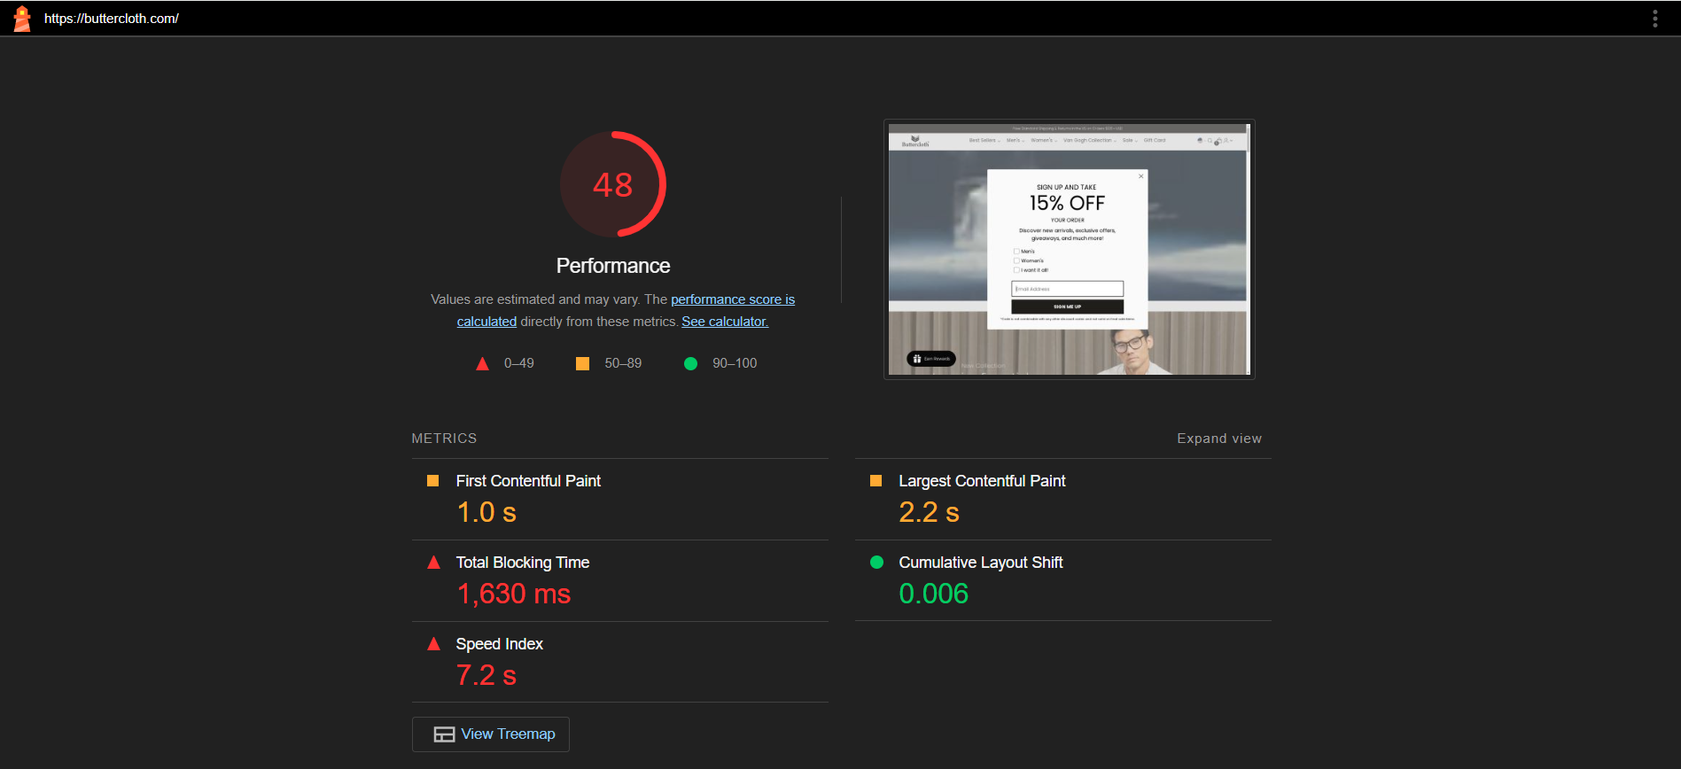

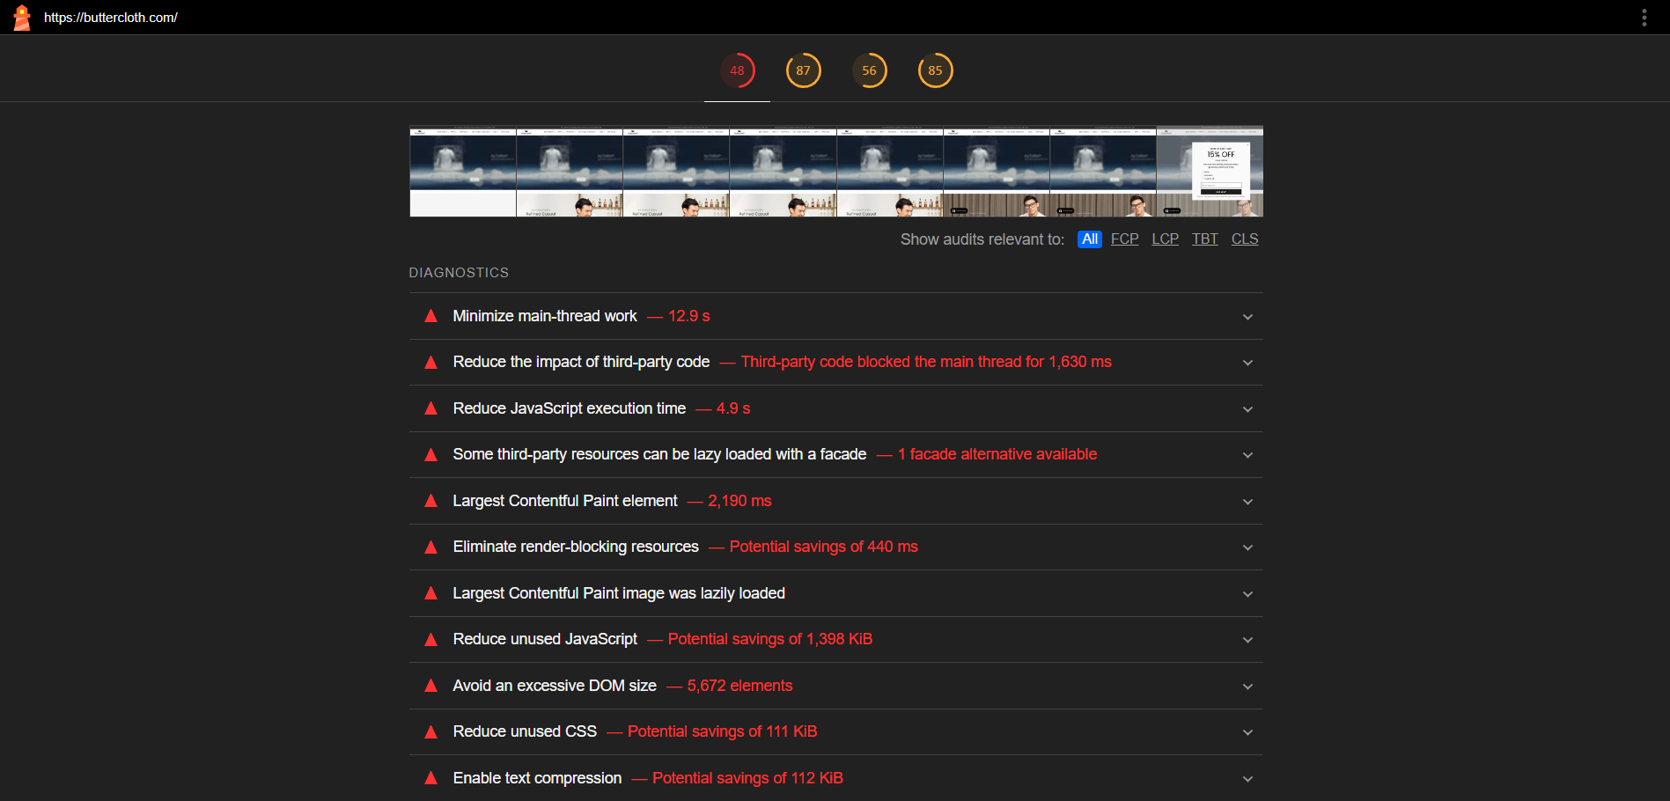

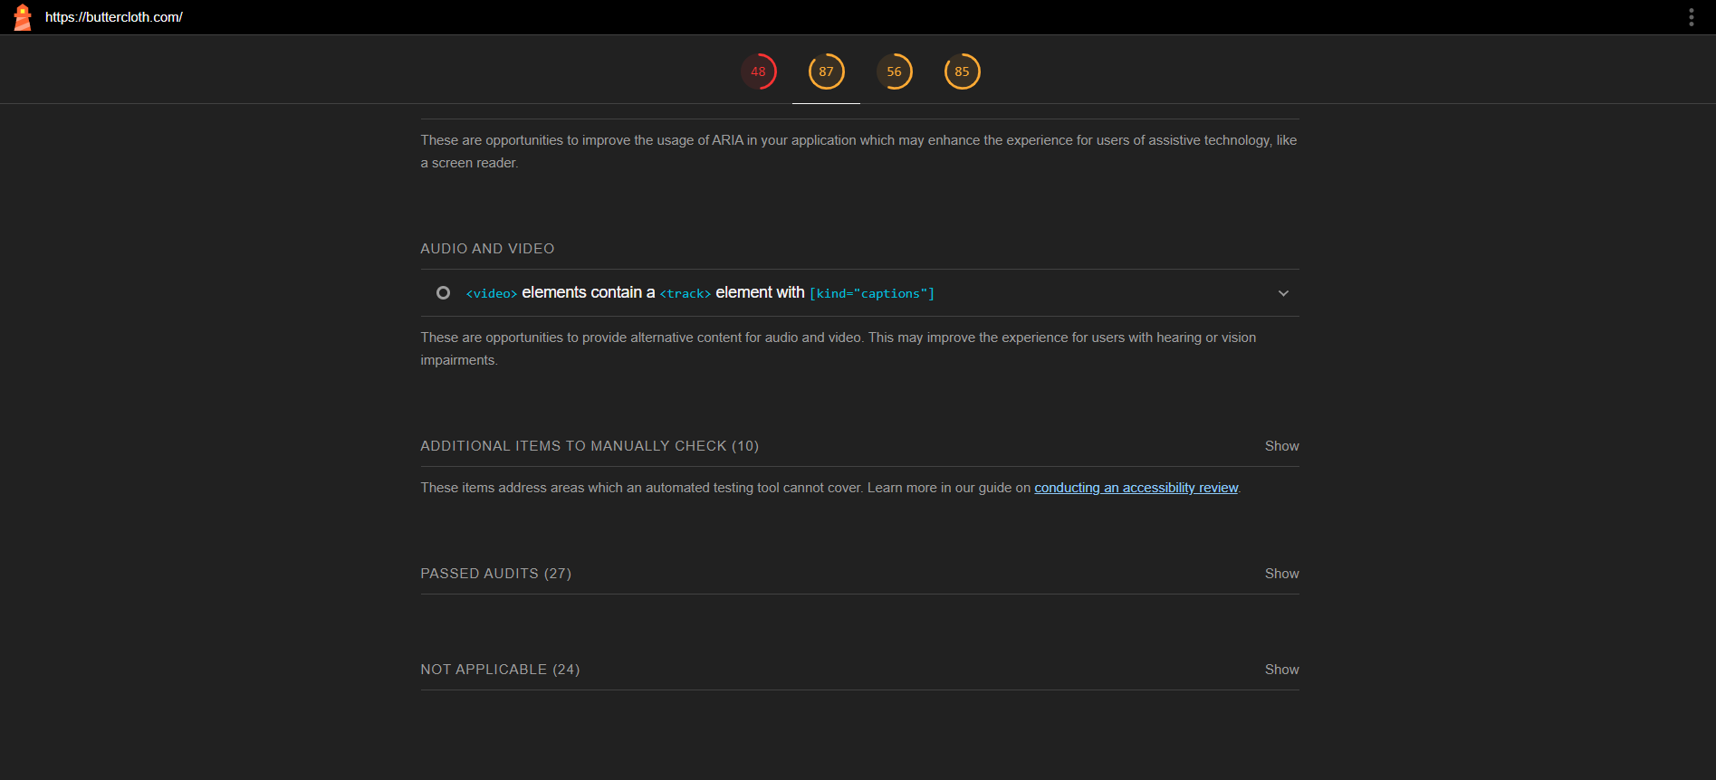

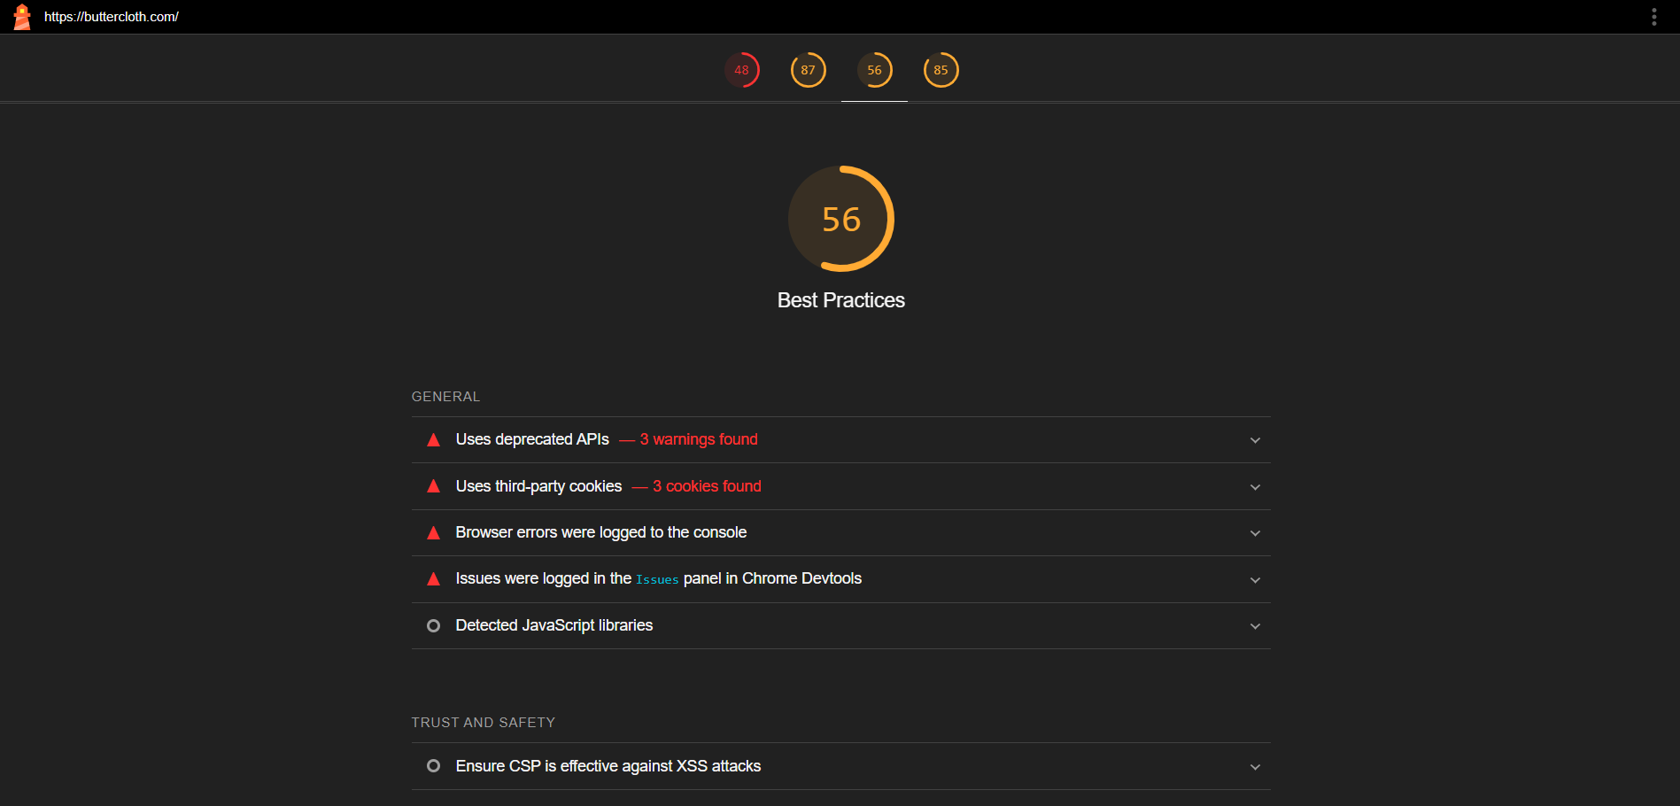

**Based on an SEMrush scan, what issues do you see with the types or number of inbound links this site has? Include screenshots of the scans and data supporting your findings.**

* **Low Authority Score:** Buttercloth has an Authority Score of 23, meaning they do have some backlinks, but these are from sources not trusted all that well by search engines. Generally, an Authority Score translates to increased appearance in search results.
* **Limited Number of Referring Domains:** While the referring domains are relatively few against such a small count of backlinks at just 109, this website does not have a strong link profile. A limited number of referring domains can directly influence the variety of linking sites into one site and hence limit its capability to rank effectively for competitive keywords.
* **Link Types**: It's good that about 96% of the links are follow links; however, the overall count is very low. A stronger mix of both follow and no follow links from diverse sources can strengthen the link profile.

**Competitor Analysis**

**Identify 3 competitors and list their URL’s below**

1. **Name:** Mizzen + Main

**URL:** <https://www.mizzenandmain.com/>

**Threat Factor:**

* Cutting-edge performance textiles that blend fashion and utility.
* aims to attract contemporary professionals looking for fashionable apparel.
* strong client loyalty because of the dedication to excellence.

1. **Name:** Bonobos

**URL:** <https://bonobos.com/>

**Threat Factor:**

* Fit and customization choices are prioritized.
* Personalized assistance and an omnichannel purchasing experience.
* strong web presence and successful digital advertising.

1. **Name:** Untuckit

**URL:** <https://www.untuckit.com/>

**Threat Factor:**

* Strong brand recognition in the market for casual clothing.
* Successful marketing techniques, such as collaborations with influencers.
* A wide variety of products to suit different customer tastes.

**Strategy**

Here is a thorough SEO strategy for Buttercloth based on the findings of the SEO audit. It tackles the issues found and suggests doable actions to enhance technical, on-page, and off-page aspects.

1. **Technical SEO Improvements**

* **Fix Pagination Issues**: To aid search engines in comprehending the relationship between pages, include rel="next" and rel="prev" tags in the pagination links. This will improve indexing and guarantee smooth content navigation for users.
* **Address Validation Issues**: Fix important issues with HTML validation, like multiple <head> and <body> tags. To find and fix these problems and enhance the site's general crawlability and user experience, employ tools like the W3C Validator.
* **Improve Site Speed**: Improve page load times by optimizing images and turning on browser caching. To get quicker loading time, use tools such as Google PageSpeed Insights to pinpoint the precise aspects influencing speed and put the suggestions into practice.
* **Implement Structured Data**: To improve search engine comprehension of product details, ratings, and prices, use schema markup. By increasing exposure in rich snippets, this can increase search result clicks.

1. **On-Page SEO Enhancements**

* **Optimize Meta Descriptions and Titles:** Examine and improve each meta description to make sure it is distinct, pertinent, and includes the desired keywords. To prevent truncation in search results, aim for a length of 150–160 characters.
* **Enhance Content Quality:** Update current information frequently to keep it instructive and pertinent. Find high-volume keywords associated with men's fashion using keyword research tools, then organically integrate them into the material.
* **Enhance internal linking structure:** Create a robust internal linking strategy to enhance site navigation for users and search engines alike. To boost their visibility, ensure that significant product pages are linked from various sections of the website.
* **Craft persuasive calls to action (CTAs:** To guide customers through the buying process and boost conversion rates. To determine what attracts visitors the most, try different wording and placement**.**

1. **Off-Page SEO Strategies**

* **Build High-Quality Backlinks:** Focus on acquiring high-quality backlinks from respected websites focusing on men's fashion, lifestyle, and apparel. Engaging in online forums, partnering with influencers, and guest posting are methods to achieve this.
* **Leverage social media:** Utilize social media platforms such as Instagram and Pinterest to engage with the desired audience and showcase products. To increase brand recognition and attract organic backlinks, create shareable content and host contests.
* **Content Marketing**: Create a blog with posts about men's fashion, styling advice, and product attributes. In addition to creating shareable material that may result in backlinks, this can help build authority and draw in organic traffic.
* **Monitor and Analyze Competitors:** Keep track of competitors and their strategies by analyzing their backlink profiles regularly to identify opportunities to improve your own link-building efforts. Tools like SEMrush can help you identify the sources of your competitors' backlinks.