**Solving the Helmholtz Equation Utilizing**

**Gauss-Seidel & Over-Relaxation in MATLAB**

**MECE 5397 – Scientific Computing**

**Dr. Andrea Prosperetti & Dr. Amit Amritkar**

**Project A - Helmholtz Equation**

Maria Violeta Paez, 1174656

Friday May 5th, 2017

# Abstract

This document is an official report that contains detailed information on the solution of the Helmholtz Equation, utilizing different numerical methods in the MATLAB for the project assigned in MECE 5397 Scientific Computing. The report contains the mathematical statement of the project, an explanation on the discretization version of the equation, the pseudocode, the specification on the computer used, and the results. The solution presented in the document, showcase the Gauss-Seidel method and compares it to the Successive Over-Relaxation method, utilizing graph and tables that illustrates the rate of conversation between the two methods. After analyzing the performance statistics and the grid convergence the Successive Over-Relaxation method is concluded to be the optimal method to solve the Helmholtz Equation.

# Mathematical Statement of Project

This reports will cover the different test conducted, utilizing numerical methods to solve the Helmholtz Equation. In the subject of mathematics, the Helmholtz equation is the partial differential equation that represents the time-independent wave equation. Below is Helmholtz Equation, where is the Laplacian, k is the wavenumber, and A is the amplitude.

The problem assigned asked to solve the Helmholtz equation on a rectangular surface with the following boundary conditions: 3 nonhomogeneous Dirichlet, 1 homogenous Neumann, and a function of F(x,y).

1. )2
2. 2
3. )-

|  |
| --- |
|  |
|  |
|  |

# Discretized Version of the Equations

Discretization is the transformation of continuous differential equation transforming them into discrete difference equation, which are fit for numerical computing. The partial derivatives given in the problem, are approximated by linear combinations of functions values at the grid point. Then, the second order center difference approximation is applied to both the x and y second derivatives at all points in the mesh.

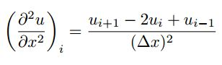

Now, the equation can be replaced into the original wave equation to approximate the x and y second derivatives of us at the mesh (i,j). Center difference approximation shown below:

After rearranging the equation above, one can find the discretized Helmholtz Equation, solved for ui,j to be solved in MATLAB:

)

# Numerical Method – Pseudo Code

## **Gauss-Seidel Method**

The Gauss-Seidel method is a mathematical procedure that generates a sequence of improving approximate solution for problems like the one presented in this report. The pseudocode for the method is shown below:

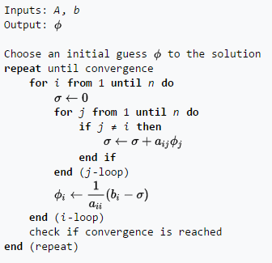

Figure 1 Gauss-Seidel Method Algorithm - Wikipedia

One must start with a guess for a solution to utilize this method. For the Helmholtz Equation project, assume all interior nodes are initially zero. Then, the linear system of equation, form in the zero matrix, can be solved using the error formula provided below:

This process continues until it the numerical method reaches convergence, which is found when the maximum error is less than the user-input tolerance, 1e-06.

The following discretized equation is the used in MATLAB:

## **Successive Over-Relaxation Method**

The Successive Over-Relaxation (SOR) method is another iterative method, similar to Gauss-Seidel method, however, it convergences faster. The pseudocode for the method is the following

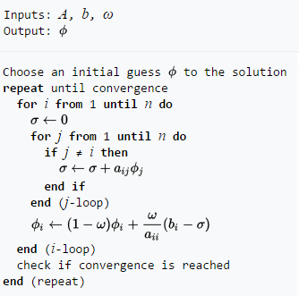

Figure 2 Successive Over-Relaxation Method Algorithm, Wikipedia

Like the Gauss-Seidel method the process starts with a guess, for the Helmholtz Equation project, assume all interior nodes are initially zero. Then, the linear system of equation can be solved using the initial guess. The process differs because the SOR method utilizes a coefficient B, which values bounded to 1<B<2. For the purpose of this project, B=1.5. Then, the error in the relation to previous value of the solution can be found utilizing equation below:

This process continues until it the numerical method reaches convergence, which is found when the maximum error is less than the user-input tolerance, 1e-06.

The following discretized equation is the used in MATLAB:

# Technical Specification of the Computer Used

The University of Houston provides computers for the engineering students at the Engineering Computing Center. The machine is an Intel ® Xeon ® CPU E5620 @ 2.40GHz with 1 core/CPU and a current CPU clock frequency of 2394 MHz (max CPU clock frequency of 2660 MHz). The machine has 64 memory channels, a DRAM total width of 32 bits, and a total DRAM per CPU of 16384 MB.

Processor: Intel® Core ™ i7-3770S CPU @ 3.10GHz

Installed memory RAM: 8.00 GB (7.88 GB Usable)

System type: 64- bit Operating System

# Results