High-Level Technical Design & Implementation Design

Marriage Registration Module — Kaveri 3.0
Field | Value
Document ID | HLD-K3-MRG-001
Version | 1.0 (Draft)
Status | Draft for Architecture / PO review
Module | Marriage Registration (Hindu Marriage + Special Marriage)
Source BRD | Finalized BRD/Marriage/RFP/BRD_Marriage_v1.9.docx (BRD-K3-MRG-HMA-001 v1.9)
Process sources | Process Diagrams/hindu marriage Online.png, hindu marriage Offline.png; Process Diagrams/Special Marriage/*
Architecture diagrams | HLD/ArchitectureDiagrams/C4_L1_System_Context.png, C4_L2_Containers.png, C4_L3_Components.png, C4_Deployment.png, C4_Channel_Workflow.png
Audience | Solution Architect, Tech Leads, Integration, Security, DevOps, Product Owner
Last updated | 2026-08-27

Document control
Version | Date | Author | Summary
1.0 | 2026-08-27 | Architecture | HLD derived from finalized BRD v1.9 — Hindu Marriage Online/Offline + Special Marriage Notice + Registration; NFRs §15, risks §16, fallbacks §17

Related documents
ID | Title
BRD-K3-MRG-HMA-001 v1.9 | Business Requirements Document — Marriage Registration
PROC-K3-MRG-HMA-TOBE-001 | Process flows (HMA Online/Offline; SMA Notice/Registration)
HLD-K3-MRG-001 | This document
[TBD] | Platform / Kaveri 3.0 foundational HLD (shared services)
PO Architecture Evaluation Guide | Programme-wide architecture evaluation criteria

1. Purpose and design goals

1.1 Purpose
Define the high-level technical architecture and implementation design for the Kaveri 3.0 Marriage Registration module covering:
- Hindu Marriage — registration of already-solemnized marriages under Section 8, HMA 1955 and Registration of Hindu Marriage (Karnataka) Rules, 1966 (Online + Offline).
- Special Marriage — Notice Generation — Intended Marriage (Chapter II) and Other Forms (Chapter III) under SMA 1954 / Special Marriage (Karnataka) Rules, 1961 (Online + Offline).
- Special Marriage — Marriage Registration — solemnization / Chapter III registration after notice validity (In Person only).

1.2 Design goals
Goal | How addressed
Correct legal path selection | Needs-Based Wizard (RS-MRG-001) — questions on solemnized vs intended and religion/custom; no raw Act picker
Statutory fidelity | Controlled templates for HMA Form I / IA / II / II-A and SMA Second–Fifth Schedules; Legal-locked wording
Dual channel where specified | Single application domain model with servicePath + channel; channel-specific workflow definitions
Payment hard gates | HMA: pay only after first SR approve; SMA: First Payment (notice) then Second Payment (registration)
Two-stage Offline HMA verification | Distinct Stage 1 / Stage 2; Stage 2 reject → DEO only
SMA statutory timeline | 30-day publication / objection clock; Intended ≥30 & ≤90 days; Other Forms ≥30 days
Role separation | Citizen / SR (Marriage Officer) / DEO–FDA–SDA / Admin; DEO cannot approve or DSC-sign
Resumable integrations | e-KYC / eSign / payment / SMS failures pause safely; no data loss (NFR-MRG-AVA-001, FB-MRG-*)
Audit & permanence | Immutable audit on critical transitions; registers / certificates retained permanently
Platform reuse | Shared Identity, Payment, Notification, Document, Master-Data, eSign/DSC adapters
Programme realism | Clear target service boundaries with Phase-1 deployable modular packages (see §5.4)

1.3 Out of scope (this HLD)
- Parsee / Sikh marriage Acts
- Divorce / nullity court workflows (NULL/VOID endorsement capability flagged in BRD only)
- Detailed UI wireframes (BRD §10)
- Legacy migration ETL design (flagged only)
- Exact infra SKUs / SDC BOM (capacity worksheet TBD)

2. Architecture principles
- Domain-aligned services — bounded contexts map to BRD capabilities (intake, notice, objection, verification, payment, register), not to UI screens.
- Workflow as a first-class concern — channel- and path-aware state machines own transitions; domain services own data and rules.
- API-first + events — synchronous APIs for user actions; domain events for notify, audit, MIS, DigiLocker, CRS/Kutumba fan-out.
- Shared platform services — Identity, Payment, Document Store, Notification, Master Data, Signing adapters are platform-owned where possible.
- Jurisdiction-scoped tenancy — SRO / DEO data access filtered by office.
- Security by design — TLS 1.3, AES-256 at rest, secrets vault, PII masking, malware scan, VAPT gates (NFR-MRG-VAPT-*).
- Idempotency — payment, eSign, DSC, appointment booking, notice publish, certificate issue must be safely retryable.
- Bilingual artefact pipeline — EN/KN templates versioned; PDF rendering with Kannada font QA gate.
- Fail-safe external dependencies — circuit breakers + resumable statuses; notifications never block certificate / notice issue (FB-MRG-004).

3. System context (C4 Level 1)
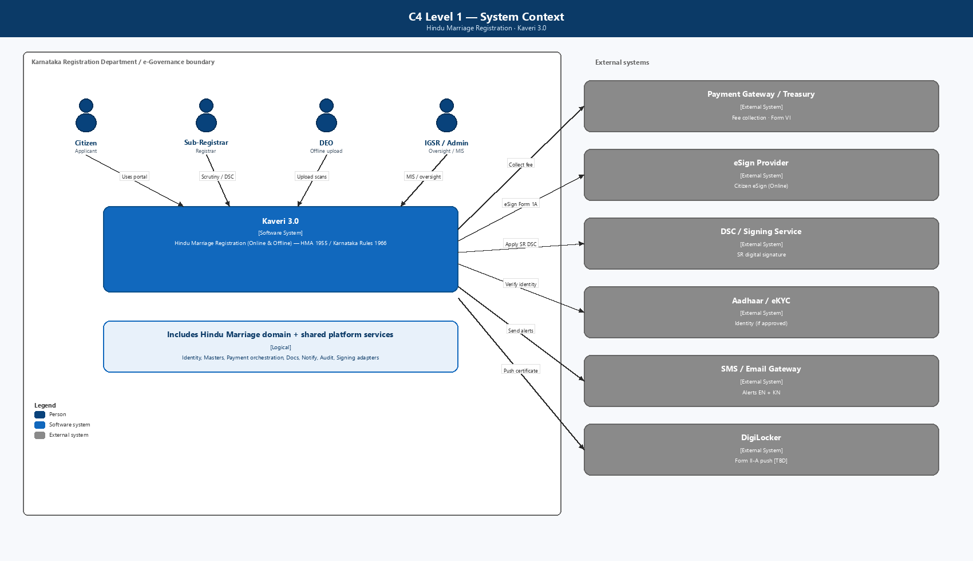
Figure: C4 Level 1 — System Context
Primary users
Persona | Channels / services | Primary surfaces
Citizen / parties | HMA Online/Offline; SMA Notice Online/Offline; SMA Registration | Needs wizard, application / notice wizard, tracker, payment, printout, certificate
Sub-Registrar / Marriage Officer | All | Verification queues, DEO allocation/reassignment, notice generation, objection enquiry, DSC
DEO / FDA / SDA | Offline HMA; Offline SMA Notice; SMA Registration | Signature checklist, photo capture, scan upload, declaration / certificate production
IGR / Admin | All | MIS, fee masters, office calendar, notice / registration reports

External systems (BRD §11): Payment Gateway / Treasury, eSign Provider, DSC / Signing Service, Aadhaar e-KYC / Face Authentication, SMS / Email Gateway, DigiLocker (TBD), Kutumba portal, Civil Registration System, Labor Department (as approved), inter-office notice transmission (SMA Sec. 6(3)).

4. Container diagram (C4 Level 2)
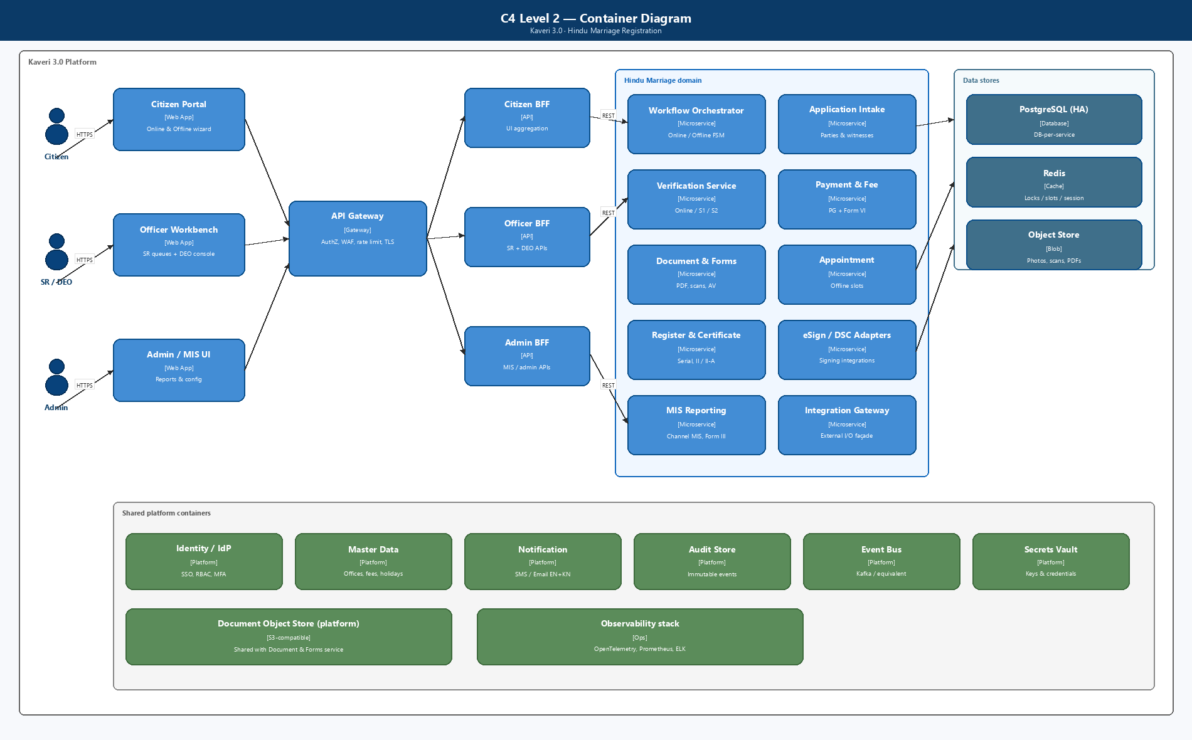
Figure: C4 Level 2 — Containers
Presentation
Layer | Responsibility
Citizen Portal | Needs-Based Wizard, HMA/SMA intake, eSign, pay, appointment, notice tracker, print, certificate download
SRO / Marriage Officer Workbench | Queues by service + stage, scrutiny, refusal orders, DEO allocate/reassign, notice generate, objection enquiry, DSC
DEO Console | Office-scoped tasks: signature check, photo, scan upload, declaration/certificate production
Admin / MIS | Fee masters, holidays, Form III / SMA books exports, channel-wise reports

BFFs keep UIs thin, compose screens by servicePath + channel, and avoid chatty cross-service calls from browsers.
Container summary
Tier | Containers
Edge | WAF / API Gateway (TLS 1.3)
Experience | Citizen Portal, Officer Workbench, Admin / MIS UI
Aggregation | Citizen BFF, Officer BFF, Admin BFF
Domain | Service Routing / Wizard, Intake, Workflow, Notice & Objection, Verification, Payment, Document/Forms, Appointment, Register/Certificate, eSign/DSC adapters, MIS, Integration Gateway
Platform | Identity, Master Data, Notification, Audit, Event Bus, Object Store, Vault
Data | PostgreSQL (HA), Redis, Object Store

4A. Component diagram (C4 Level 3)
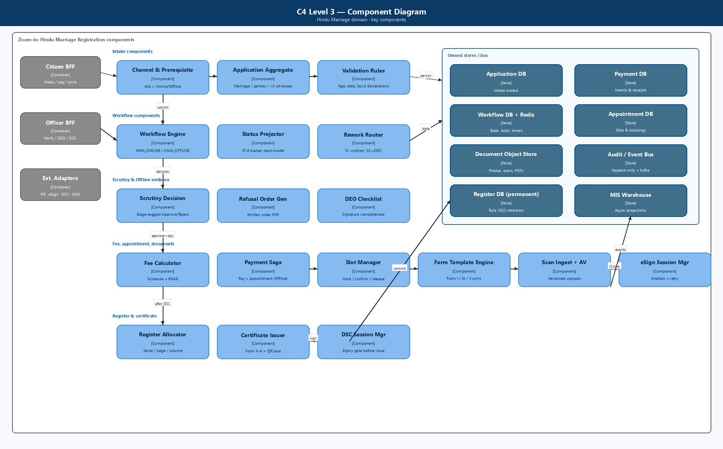
Figure: C4 Level 3 — Components
Zoom-in on Marriage domain components implementing BRD hard gates: needs routing, channel fork, HMA pay-after-approve, Offline Stage 1/2, SMA first/second payment, 30-day countdown, objection enquiry, DSC-gated certificate issue.

5. Microservices architecture

5.1 Service catalogue (target)
# | Service | Bounded context | Owns | Key BRD refs
1 | identity-access-service (platform) | AuthN/AuthZ | Users, roles, sessions, MFA, jurisdiction claims | NFR-MRG-SEC/PRIV/AUD
2 | master-data-service (platform) | Reference data | Districts, SRO offices, holidays, fee schedules (HMA + SMA), reason codes | FR-HMA-005/006; SMA fees
3 | service-routing-service | Needs-Based Wizard | Questionnaire answers, resolved servicePath, audit of routing | RS-MRG-001; FR-HMA-001; FR-SMA-001/004/005
4 | application-intake-service | Application / notice capture | Application header, channel, declarations, HMA/SMA party data, drafts | §7.1–7.3; FR-HMA-; FR-SMA-
5 | workflow-orchestrator | Process engine | Status models §7.1.2.4 / 7.2.2.4 / 7.3.2.3; transitions; SLA / countdown timers | BR-HMA-; BR-SMA-; FB-MRG-*
6 | document-form-service | Documents & statutory forms | Uploads, photos, Form I/IA/II/II-A, SMA schedules, scan versions, AV + password-PDF block | FR-HMA-015–019, 065; FB-MRG-003
7 | ekyc-adapter-service | Aadhaar / Face Auth | e-KYC sessions; fallback to manual + docs (RS-MRG-002) | FR-HMA-058; FR-SMA-009/010
8 | esign-adapter-service | Citizen eSign | eSign sessions, signed artefacts, retry without re-entry | FR-HMA-056–057; FB-MRG-002
9 | verification-service | SR / Marriage Officer scrutiny | Stage-tagged decisions, reason codes, written refusal PDF | FR-HMA-070–077; SMA notice/visit verify
10 | deo-task-service | Office operator tasks | Allocation, reassignment (FR-HMA-088), checklist, upload tasks | FR-HMA-063–069, 088; RS-MRG-003
11 | payment-fee-service | Fees & receipts | Fee calc, PG orchestration, poll-on-timeout, Form VI / SMA receipts, recon | FR-HMA-020–025; FR-SMA-049–053; FB-MRG-001
12 | appointment-service | Offline slots | Capacity, book/reschedule/cancel, no-show | HMA Offline; SMA Offline notice / registration visit
13 | notice-publication-service | SMA notice book & publish | Marriage Notice Book entry, portal / board publication, Sec. 6(3) transmit, 30-day clock | FR-SMA-014–021, 029–032
14 | objection-service | Public objection & enquiry | Objection intake, summons workflow, uphold / dismiss outcomes | FR-SMA-022–028
15 | register-certificate-service | Legal register & certificates | HMA serial/page/volume + Form II-A; SMA Fourth/Fifth Schedule; QR/seal; DigiLocker push | FR-HMA-078–082; FR-SMA-033–041
16 | dsc-signing-adapter | SR DSC | DSC session, expiry check, signed PDF | FR-HMA-078–079; SMA DSC
17 | notification-service (platform) | Alerts | SMS/email EN+KN; local queue + retry (FB-MRG-004) | FR-HMA-036–038; FR-SMA-054
18 | audit-compliance-service (platform) | Immutable audit | Append-only events for approvals, rejects, certificates, DEO allocations | NFR-MRG-AUD-001
19 | mis-reporting-service | Analytics | Channel MIS, aging, fee recon, Form III / SMA books exports | FR-HMA-039–045; FR-SMA-055–060
20 | integration-gateway (façade) | External I/O | Circuit breakers, idempotency keys, partner SLAs | §11; NFR-MRG-AVA-001

Sizing note: Services 3–16 and 19 are Marriage-module–owned (or module-owned adapters). Platform services (1, 2, 17, 18) are shared across Kaveri 3.0.

5.2 Service responsibilities (selected detail)

service-routing-service
- Implements Needs-Based Wizard: solemnized vs intended; Hindu customary vs special / other forms.
- Emits immutable ServicePathResolved with citizen answers (audit / dispute evidence).
- Hands off to intake with servicePath ∈ {HMA_REG, SMA_NOTICE_INTENDED, SMA_NOTICE_OTHER, SMA_REG}.

application-intake-service
- Create/update drafts for HMA registration and SMA notice.
- Persist channel selection before combined prerequisite + declaration (BR-HMA-008/009).
- HMA validations: ages, marriage date ≤ today, exactly 3 witnesses, jurisdiction basis.
- SMA Other Forms branch: capture date / place / form of already celebrated ceremony at notice intake.
- Online HMA: office selection + summary before Form I & IA submit.
- Publish ApplicationDetailsUpdated, ChannelSelected, DeclarationsAccepted.

workflow-orchestrator
- Source of truth for statuses in BRD §7.1.2.4, §7.2.2.4, §7.3.2.3.
- Process definitions (illustrative): HMA_ONLINE_v1, HMA_OFFLINE_v1, SMA_NOTICE_ONLINE_v1, SMA_NOTICE_OFFLINE_v1, SMA_REG_OFFLINE_v1.
- Enforces hard gates (payment, eSign, Stage 2 → DEO, SMA timeline, objection branch).
- Owns countdown timers for SMA 30-day / 90-day windows; emits expiry events.
- Emits ApplicationStatusChanged for every transition.

notice-publication-service
- After First Payment (and Offline DEO notice-board path): generate statutory notice, enter Marriage Notice Book.
- Online: portal publication; Offline: board paste confirmation after DEO upload.
- Trigger inter-office transmission to Marriage Officer of permanent residence district (Sec. 6(3)).
- Start / pause / complete 30-day objection period clock.

objection-service
- Public objection intake against published notice.
- SR enquiry with summons; decide within statutory window.
- Outcomes: uphold → Objected — closed + portal removal; dismiss → continue toward registration eligibility.

payment-fee-service
- HMA: enabled only when status = Approved for payment.
- SMA: First Payment (notice fee) and Second Payment (registration / solemnization fee) as distinct intents.
- On gateway timeout: poll until terminal status; lock UI against duplicate pay (NFR-MRG-PAY-001 / FB-MRG-001).
- Offline HMA: coordinates with appointment as one guided step.
- Blocks certificate / notice-completion paths until reconciled where required.

deo-task-service
- Explicit SR allocate / reassign / recall without Helpdesk (FR-HMA-088, RS-MRG-003).
- Checklist gates before upload; versioned scan metadata in document-form-service.
- Supports HMA Offline Stage 2 path and SMA Offline notice / registration office tasks.

register-certificate-service
- HMA: on successful DSC allocate serial/page/volume atomically; Form II endorsement + Form II-A.
- SMA: Fourth Schedule (Intended) or Fifth Schedule (Other Forms) after solemnization / Chapter III registration + DSC.
- Delivery: portal download; Offline counter + download as applicable.
- Optional DigiLocker / CRS / Kutumba fan-out via events after issue.

5.3 Data ownership (database per service)
Service | Primary store | Notes
service-routing | PostgreSQL | Wizard answers + resolved path
application-intake | PostgreSQL | Application / notice aggregate; party/witness children
workflow-orchestrator | PostgreSQL + Redis | Instance state, timers/locks
document-form | Object store + PostgreSQL metadata | Scans dominate Offline growth
notice-publication | PostgreSQL | Notice book, publication records, countdown
objection | PostgreSQL | Objections + enquiry decisions
verification | PostgreSQL | Decision history immutable
payment-fee | PostgreSQL | Intents, receipts, recon
appointment | PostgreSQL | Slots + bookings
deo-task | PostgreSQL | Allocation + task state
register-certificate | PostgreSQL | Permanent register / certificate
audit-compliance | Append-only / WORM | Separate from transactional DBs
mis-reporting | Read replica / warehouse | Async projections

No shared mutable DB across services. Cross-service reads via APIs or event-fed read models.

5.4 Phase-1 deployable packaging (programme realism)
Target catalogue above is the logical design. For an 11-month delivery window, Phase 1 may deploy as modular packages with explicit boundaries (same APIs / events), then split:
Deployable package | Contains (logical services) | Rationale
marriage-core | routing + intake + workflow + verification + deo-task | Shared state machine & queues
marriage-docs-sign | document-form + esign + dsc + ekyc adapters | Heavy I/O & partner SDKs
marriage-pay-appoint | payment-fee + appointment | Saga / poll logic localized
marriage-sma-notice | notice-publication + objection | SMA-specific statutory clock
marriage-register | register-certificate | Highest durability / DR bar
platform-\* | identity, master, notify, audit | Shared across modules

Independent deployability remains a target; do not block MVP on day-1 fine-grained runtime split.

6. Channel- and path-aware workflow design
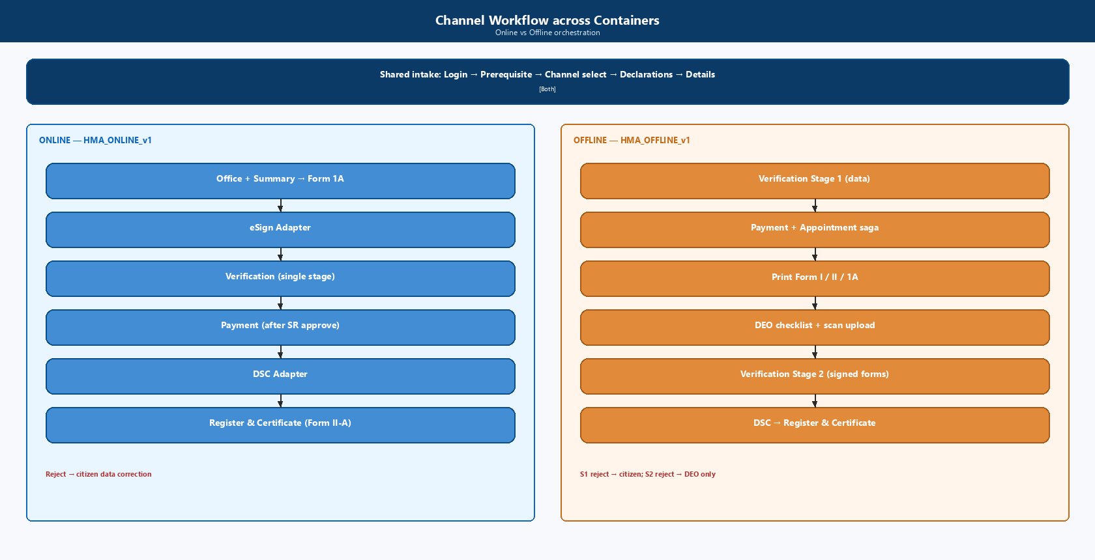
Figure: Channel Workflow across Containers

6.0 Needs-Based Wizard (all citizens)
START → Login → New Application → Marriage Registration
→ Needs-Based Wizard (solemnized? / intended? / religion-custom?)
→ servicePath resolved → Channel select (where applicable)
→ Combined Prerequisite + Declaration

6.1 Hindu Marriage — shared intake
→ Details captured (Online: e-KYC / Face Auth on Bride per FR-HMA-058)

6.2 Hindu Marriage Online (HMA_ONLINE_v1)
Details captured
→ Office selected & summary reviewed
→ Form I & Form IA submitted
→ eSign pending ──(complete)──► Pending SR verification
│ │
│ ├─ Reject ──► Rejected — data correction ──► Details captured
│ └─ Approve ─► Approved for payment
│ → Payment completed
│ → Pending SR digital signature
│ → Registered → Certificate issued → Closed
└─(retry; status stays eSign pending — FB-MRG-002)

6.3 Hindu Marriage Offline (HMA_OFFLINE_v1)
Details captured
→ Pending SR verification (Stage 1)
├─ Reject ──► Rejected — data correction ──► Details captured
└─ Approve ─► Approved for payment
→ Payment completed + Appointment scheduled
→ Forms printed
→ Allocated to DEO (SR; reassignable — FR-HMA-088)
→ Awaiting signed-form upload
→ Signed forms uploaded (DEO)
→ Pending SR verification — Stage 2
├─ Reject ──► Rejected — upload ──► DEO only
└─ Approve ─► Pending SR digital signature
→ Registered → Certificate issued → Closed

6.4 Special Marriage Notice Online (SMA_NOTICE_ONLINE_v1)
Details captured (+ Other Forms marriage details if applicable)
→ Notice application submitted (docs + photos)
→ Pending SR verification — notice
├─ Reject ──► Rejected — notice data
└─ Approve ─► Notice approved
→ First payment completed
→ Notice generated → Notice published (portal)
→ Citizen eSign on notice
→ Objection period running (30 days)
├─ Objection filed → Under objection enquiry → …
├─ Notice expired → Closed (fresh notice)
└─ Notice valid for registration → (hand-off to §6.6)

6.5 Special Marriage Notice Offline (SMA_NOTICE_OFFLINE_v1)
… (same through First payment)
→ Appointment scheduled
→ SR Generates Notice → Selects DEO
→ Photo / print / sign / scan / upload → Paste on notice board
→ Objection period running → … (same terminal outcomes as Online)

6.6 Special Marriage Registration (SMA_REG_OFFLINE_v1)
In Person only after Notice valid for registration:
Select notice → Timeline gate
(Intended: ≥30 & ≤90 days; Other Forms: ≥30 days)
→ If objection pending/open → enquiry branch
→ Second payment completed → Visit scheduled
→ Pending SR verification — visit
├─ Reject ──► Visit scheduled
└─ Approve ─► Solemnized / Chapter III conditions met
→ Allocated to DEO — certificate
→ Joint photo → witnesses → declaration → certificate artefact
→ Signed certificate uploaded
→ Pending SR digital signature → Certificate issued → Closed

6.7 Transition enforcement matrix (examples)
From | Event | Allowed if | Next
eSign pending | EsignCompleted | HMA Online; all required signatories done | Pending SR verification
Pending SR verification | SrApproved | HMA Online or Offline-S1 | Approved for payment
Pending SR verification — Stage 2 | SrRejected | HMA Offline | Rejected — upload (DEO)
Approved for payment | PaymentInit | Prior SR approve recorded | Intent created; status unchanged until success
Payment pending / timeout | PaymentPoll | FB-MRG-001 | Terminal success/fail; UI locked
Notice approved | FirstPaymentSucceeded | SMA notice | Notice generated
Objection period running | Day30Elapsed + no valid objection | Path rules | Notice valid for registration
Notice valid for registration | SecondPaymentSucceeded | Timeline gate OK | Visit scheduled
Pending SR digital signature | DscCompleted | Payment reconciled where required | Registered / Certificate issued

7. Implementation design

7.1 Suggested technology baseline (confirm with platform HLD)
Concern | Recommendation | Rationale
Runtime | Java 17+ / Spring Boot or .NET 8 (platform standard) | Gov ecosystem, talent, long support
API style | REST + OpenAPI 3; async via events | BFF-friendly
Event bus | Kafka / managed equivalent | Audit, notify, MIS, CRS fan-out
Primary DB | PostgreSQL HA | Strong consistency for register & payments
Cache / locks | Redis | Appointment contention, payment locks, countdown
Object storage | S3-compatible (SDC) | DEO scans, photos, signed PDFs
Workflow | Camunda / Temporal / custom FSM | Targeted rework + statutory timers
PDF | Template service with Kannada fonts | Statutory exactness
API Gateway | Kong / APIM / SDC standard | WAF, mTLS, TLS 1.3
Secrets | Vault / SDC secrets | NFR-MRG-SEC-001
Observability | OpenTelemetry + Prometheus + ELK | Ops / hypercare
CI/CD | GitOps, env promotion, STQC / VAPT-ready builds | NFR-MRG-VAPT-*

7.2 API surface (illustrative)
Citizen (via Citizen BFF)
Method | Path | Purpose
POST | /mrg/wizard/resolve | Needs-Based Wizard → servicePath
POST | /mrg/applications | Start application / notice
POST | /mrg/applications/{id}/channel | Online \ | Offline
POST | /mrg/applications/{id}/prerequisite | Combined ack
PUT | /mrg/applications/{id}/details | Parties / marriage / witnesses
POST | /mrg/applications/{id}/ekyc/start | e-KYC / Face Auth (or fallback)
POST | /mrg/applications/{id}/office | HMA Online office + summary
POST | /mrg/applications/{id}/forms/submit | Form I & IA / notice submit
POST | /mrg/applications/{id}/esign/start | Citizen eSign
POST | /mrg/applications/{id}/payments/{purpose} | HMA_REG \ | SMA_NOTICE \ | SMA_REG
POST | /mrg/applications/{id}/appointment | Offline slot
GET | /mrg/applications/{id}/printouts | Statutory PDFs
GET | /mrg/notices/{id} | Published notice / countdown
POST | /mrg/notices/{id}/objections | Public objection (authenticated policy TBD)
POST | /mrg/registrations/from-notice/{noticeId} | Start SMA registration
GET | /mrg/applications/{id}/certificate | Certificate download
GET | /mrg/applications/{id}/tracker | Path-specific progress

SR / DEO (via Officer BFF)
Method | Path | Purpose
GET | /mrg/queues?service=&stage= | HMA / SMA notice / visit queues
POST | /mrg/applications/{id}/verifications | Approve/Reject + reason
POST | /mrg/applications/{id}/deo/allocate | Allocate / reassign / recall
POST | /mrg/applications/{id}/deo/checklist | Signature completeness
POST | /mrg/applications/{id}/deo/uploads | Scan upload (versioned)
POST | /mrg/notices/{id}/generate | SR notice generation (Offline)
POST | /mrg/objections/{id}/enquiry | Enquiry decision
POST | /mrg/applications/{id}/dsc/sign | SR digital signature
POST | /mrg/applications/{id}/refusal-order | Written order artefact

All mutating APIs require: auth token, idempotency-key, office-scope check, and workflow permission for current status.

7.3 Domain events (minimum set)
Event | Producers | Consumers
ServicePathResolved | Routing | Intake, Workflow, Audit, MIS
ChannelSelected | Intake | Workflow, Audit, MIS
EsignCompleted / EsignFailed | eSign adapter | Workflow, Audit, Document
VerificationDecisionRecorded | Verification | Workflow, Notify, Audit, MIS
DeoAllocated / DeoReassigned | DEO task | Workflow, Notify, Audit
PaymentSucceeded / PaymentFailed | Payment | Workflow, Notify, Audit, MIS
AppointmentBooked | Appointment | Workflow, Notify, Audit
NoticePublished | Notice | Objection clock, Notify, Audit, MIS
ObjectionFiled / ObjectionResolved | Objection | Workflow, Notice, Notify, Audit
NoticeValidityChanged | Workflow / Notice | Citizen tracker, Audit
CertificateIssued | Register-Cert | Notify, DigiLocker/CRS, Audit, MIS
ApplicationStatusChanged | Workflow | Audit, Tracker read-model, MIS

7.4 Key sequence — HMA Online (happy path)
Citizen → Wizard → Intake (details + e-KYC)
Citizen → Office + Form I/IA → eSign → Workflow (Pending SR)
SR → Verification (Approve) → Workflow (Approved for payment)
Citizen → Payment → PG callback/poll → Workflow (Payment completed)
SR → DSC → Register-Cert (serial + Form II-A)
→ Workflow (Certificate issued) → Notification + Audit + MIS

7.5 Key sequence — HMA Offline (happy path)
Citizen → Intake → Workflow (Pending SR Stage 1)
SR → Approve → Citizen Payment + Appointment
Citizen → Print → SR Allocate DEO → Physical sign/visit
DEO → Checklist + upload → SR Stage 2 Approve → DSC → Certificate

7.6 Key sequence — SMA Notice → Registration
Citizen → Wizard (Intended / Other Forms) → Notice intake + docs
SR → Approve notice → First Payment → Notice generate/publish → 30-day clock
[optional Objection → Enquiry]
Citizen (when valid) → Second Payment → Visit → SR verify
DEO → Joint photo / witnesses / declaration / certificate artefact
SR → DSC → Certificate (Fourth or Fifth Schedule) issued

7.7 Payment resilience saga
- Create payment intent with idempotency key and purpose.
- Redirect / initiate PG; on timeout poll until terminal (FB-MRG-001).
- UI pay action disabled while status ∈ {Initiated, Pending, Polling}.
- On success: emit PaymentSucceeded; advance workflow.
- On failure: remain on payable status; allow single new intent after terminal fail.
- Offline HMA: soft-hold appointment; confirm on pay success; release on fail/timeout compensation.

7.8 Register / certificate allocation
- HMA per-office sequence: (officeId, registerVolume, page, serial) under row lock + transactional outbox.
- Never allocate before DSC success and required payment reconciliation.
- SMA certificate schedule selection driven by servicePath (Fourth vs Fifth Schedule).
- PDF generation async after commit; status flips when artefact ready.

7.9 Deployment view (C4)
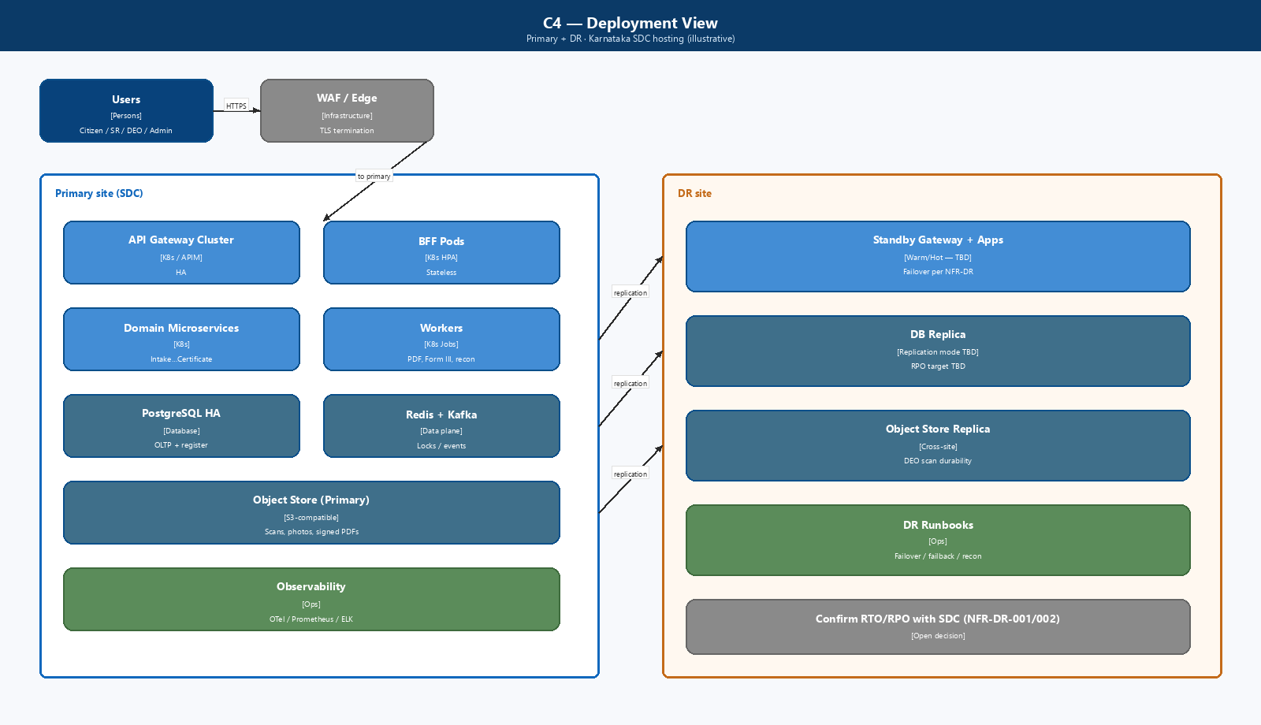
Figure: C4 — Deployment View
Environments: Dev → SIT → UAT → Pre-Prod → Prod (+ isolated DR). Non-prod uses anonymized data.

7.10 Implementation phases (suggested)
Phase | Scope | Exit criteria
P0 — Platform spine | Identity, Gateway, Masters, Audit, Notify, Doc store | Shared contracts published
P1 — Routing + HMA Online MVP | Wizard, HMA Online end-to-end (e-KYC, eSign, pay-after-approve, DSC, II-A) | HMA Online UAT
P2 — HMA Offline MVP | Stage 1/2, pay+appointment, printouts, DEO allocate/reassign, upload | HMA Offline UAT
P3 — SMA Notice | Online + Offline notice, First Payment, publication, 30-day clock, objections | Notice UAT + timeline tests
P4 — SMA Registration | Second Payment, visit, solemnization/Chapter III, Fourth/Fifth Schedule | Full SMA UAT
P5 — MIS, integrations, hardening | Channel MIS, Form III / books, DigiLocker/CRS/Kutumba, surge 3×, VAPT | Go-live gate

8. Security, privacy, and compliance design
Control | Design
AuthN | Citizen portal IdP; Officer SSO; MFA for SR/Admin (TBD)
AuthZ | RBAC: CITIZEN, SR, DEO, IGSR_ADMIN; jurisdiction claim on officer tokens
DEO separation | Checklist / photo / upload / declaration production only; deny approve/register/DSC
Encryption | TLS 1.3 in transit; AES-256 at rest (NFR-MRG-SEC-001)
PII | Mask Aadhaar / biometrics in logs and unauthorized views (NFR-MRG-PRIV-001)
Uploads | AV scan; reject password-protected PDFs / invalid types (FB-MRG-003)
eSign / DSC | Tamper-evident artefacts; retry without re-entry (FB-MRG-002)
Certificate | QR / digital seal verification endpoint (public, minimal PII)
Secrets | Vault; no secrets in images/git
VAPT | Pre-prod comprehensive VAPT; zero open Critical/High; annual + change-triggered (NFR-MRG-VAPT-001–004)
Compliance | GIGW, WCAG 2.x, MeitY/CERT-In, STQC path, UIDAI if eKYC used

9. NFR → architecture mapping
NFR (BRD §15) | Architecture response
NFR-MRG-PERF-001 | BFF aggregation, cached masters, async PDF; p95 UI ≤2s, external API ≤5s
NFR-MRG-PERF-002 | Stateless pods; HPA; load test 5k citizen + 2.5k officer sessions
NFR-MRG-SCALE-001 | Autoscaling runbook; surge test at 3× baseline (auspicious dates)
NFR-MRG-SEC-001 | TLS 1.3 + AES-256; gateway WAF
NFR-MRG-PRIV-001 | Field classification; masked logs; least-privilege DB views
NFR-MRG-AUD-001 | Every critical transition + DEO allocate → audit-compliance-service
NFR-MRG-AVA-001 | Circuit breakers; resumable statuses; bilingual error UX
NFR-MRG-PAY-001 | Payment poll + UI lock; idempotent intents
NFR-MRG-VAPT-* | Security gate in release checklist; retest Critical/High

10. Integration design
Integration | Pattern | Resilience
Payment gateway / Treasury | Sync initiate + async callback + poll on timeout | Idempotent; UI lock; circuit breaker
eSign provider | Redirect/SDK + callback | Retry; remain eSign pending
DSC / signing | Officer-initiated; tokenized session | Block issue if DSC expired
Aadhaar e-KYC / Face Auth | Adapter; fallback to manual + mandatory docs | UIDAI-compliant logging; RS-MRG-002
DigiLocker | Optional fetch / certificate push | Best-effort after issue
SMS / Email | Async via notification-service | Local queue + retry; never block critical path
Master data | Sync pull + cache TTL | Office/holiday invalidation
Notice publication (portal) | Internal module API | Idempotent publish
Objection intake | Public/authenticated API | Rate limit + audit
Inter-office notice transmit | Async outbound | Retry with DLQ
Kutumba / CRS / Labor | Event-driven outbound (as approved) | Best-effort; compensating reconcile

11. Logical data model (core)
ServiceRoutingDecision
id, answersJson, servicePath, decidedAt, citizenId

Application
id, servicePath, channel{ONLINE|OFFLINE|N/A}, status, officeId,
jurisdictionBasis, prerequisiteAckAt, noticeId?, createdBy, versions...

MarriageEvent
applicationId, marriageDate, place, ceremonyDescription # HMA; SMA Other Forms

Party (Bride | Bridegroom)
name, parents, dob/age, residence, address, maritalStatus, ekycRef?

Witness
name, relation, age, residence, address # HMA ×3 at intake; SMA ×3 at registration

MarriageNotice
id, applicationId, path{INTENDED|OTHER_FORMS}, noticeBookEntryNo,
publishedAt, channelPublication{PORTAL|BOARD}, countdownEndsAt, validFrom, validTo?

Objection
noticeId, objector, grounds, filedAt, enquiryStatus, decision, decidedAt

DocumentAsset
applicationId, type, version, storageUri, checksum, uploadedByRole

VerificationDecision
applicationId, stage, decision, reasonCode, actorId, at

Payment
applicationId, purpose{HMA_REG|SMA_NOTICE|SMA_REG}, amount, status, receiptNo, pgRef

Appointment
applicationId, officeId, slotStart, slotEnd, status

DeoAllocation
applicationId, deoUserId, allocatedBy, allocatedAt, active

RegisterEntry
applicationId, officeId, serialNo, pageNo, volumeNo, registeredAt # HMA

Certificate
applicationId, formType{II_A|FOURTH_SCHEDULE|FIFTH_SCHEDULE},
issuedAt, integrityToken, deliveryMode
Retention: RegisterEntry + Certificate + Notice Book + Memorandum artefacts = permanent; operational drafts/logs per policy.

12. Observability and operations
Signal | Examples
SLIs | Wizard→path success, submit p95, eSign success, pay success (no double-debit), Stage aging, notice countdown accuracy, cert issue latency
Alerts | PG poll lag, eSign/DSC errors, e-KYC outage fallback rate, upload AV/password rejects, queue backlog, notice expiry surge
Runbooks | Payment stuck, eSign abandon, DEO reassignment, objection enquiry SLA, DR failover, Form III / books rerun
Support | L1 portal; L2 workflow/payment/notice clock; L3 domain + infra; 90-day hypercare (BRD §18.4)

13. Risks, fallbacks, and open architecture decisions

13.1 BRD risks (mandatory mitigations)
ID | Mitigation in architecture
RS-MRG-001 | service-routing-service Needs-Based Wizard; no Act-code landing
RS-MRG-002 | Resumable workflow + e-KYC fallback to manual+docs; payment/eSign FB-MRG-*
RS-MRG-003 | deo-task-service allocate/reassign/recall APIs; audited

13.2 Fallbacks (FB-MRG)
ID | Design hook
FB-MRG-001 | Payment poller + UI lock in payment-fee-service
FB-MRG-002 | Persist eSign pending / Pending SR digital signature; retry signing only
FB-MRG-003 | Pre-persist validators in document-form-service (password PDF / MIME)
FB-MRG-004 | Notification outbox; workflow continues on SMS/email failure

13.3 Open decisions
ID | Topic | Impact | Owner
AD-01 | Workflow engine (Camunda / Temporal / custom) | Timers & SMA countdown | Arch
AD-02 | Platform language/runtime standard | Service templates | Platform Arch
AD-03 | Shared vs module-owned payment service | Reuse across Kaveri | Platform Arch
AD-04 | Phase-1 modular packages vs fine-grained deploy | Delivery risk | PO / Arch
AD-05 | Public objection authentication model | Abuse / spam controls | PO / Legal
AD-06 | DigiLocker / CRS / Kutumba / Labor go-live scope | Integration backlog | PO
AD-07 | Who must eSign on HMA Online (parties vs +witnesses) | eSign UX | Legal / DE
AD-08 | RPO/RTO for register DB + object store | DR topology | Arch / SDC

14. Traceability summary (BRD → services)
BRD capability | Primary services
Needs-Based Wizard / module entry | Routing, Intake, Audit
HMA data capture Form I/IA | Intake, Document-Form, eKYC
HMA Online eSign | eSign, Document-Form, Workflow
HMA Offline Stage 1 / 2 | Verification, DEO-Task, Workflow
HMA pay after approve | Payment-Fee, Workflow
Appointment | Appointment, Payment-Fee, Workflow
SMA Notice generate / publish / 30-day | Notice-Publication, Workflow, Payment
SMA Objection | Objection, Notice, Verification
SMA Registration / schedules | Intake, DEO-Task, Register-Certificate, DSC
MIS / Form III / books | MIS-Reporting
Notifications | Notification (queued)
NFRs §15 / Fallbacks §17 | Gateway, Payment, Audit, Observability, Security

15. Acceptance criteria for this HLD
Architecture review is complete when:
- Service boundaries (logical) and Phase-1 packaging are agreed.
- HMA Online/Offline and SMA Notice/Registration state machines are signed off against BRD process diagrams.
- Needs-Based Wizard routing matrix is approved by Domain Expert / PO.
- Integration adapter list and ownership (module vs platform) are confirmed.
- Security role matrix (Citizen / SR / DEO / Admin) is approved.
- NFR and fallback controls have owners and test evidence plans.
- P0–P5 delivery phasing is accepted by PO.

Appendix A — Glossary (architecture)
Term | Meaning
BFF | Backend-for-Frontend aggregation API for a UI surface
Hard gate | Workflow rule that blocks an action until precondition is true
servicePath | Resolved legal/service route from Needs-Based Wizard
Targeted rework | Return to a specific prior step (not generic resubmit)
Register cursor | Per-office counter for serial/page/volume allocation
Saga | Multi-service transaction with compensations (pay + appointment)
First / Second Payment | SMA notice fee vs registration/solemnization fee

Appendix B — Reference inputs
- BRD-K3-MRG-HMA-001 v1.9 — Business requirements (functional + NFR §15 + risks §16 + fallbacks §17 + training §18)
- Process diagrams — HMA Online/Offline; SMA Notice Online/Offline; SMA Registration Intended/Other Forms
- HMA 1955; Karnataka Rules 1966; SMA 1954; Special Marriage (Karnataka) Rules 1961
- Prior HLD draft for HMA-only (HLD_Implementation_Design_Hindu_Marriage_HMA_1955.md) — superseded for scope by this document

Appendix C — C4 diagram catalogue
Diagram | File | Section
System Context (L1) | ArchitectureDiagrams/C4_L1_System_Context.png | §3
Containers (L2) | ArchitectureDiagrams/C4_L2_Containers.png | §4
Components (L3) | ArchitectureDiagrams/C4_L3_Components.png | §4A
Channel Workflow | ArchitectureDiagrams/C4_Channel_Workflow.png | §6
Deployment | ArchitectureDiagrams/C4_Deployment.png | §7.9

Diagrams currently reflect the Hindu Marriage baseline container model; SMA notice/objection containers are specified in §§4–5 and should be refreshed in the next diagram iteration.

Appendix D — Process diagram catalogue (BRD)
Flow | Location
Hindu Marriage Online | Finalized BRD/Marriage/RFP/Process Diagrams/hindu marriage Online.png
Hindu Marriage Offline | Finalized BRD/Marriage/RFP/Process Diagrams/hindu marriage Offline.png
SMA Notice Online | .../Special Marriage/*NoticeOnline*.png
SMA Notice Offline | .../Special Marriage/*NoticeOffline*.png
SMA Registration Intended | .../Special Marriage/*Registration_IntendedMarriage*.png
SMA Registration Other Forms | .../Special Marriage/*Registration_Others*.png

End of HLD / Implementation Design v1.0 — derived from BRD_Marriage_v1.9; resolve AD- items through Architecture & Domain Expert workshops.*

