High-Level Technical Design & Implementation Design

Marriage Registration Module — Hindu Marriage (Kaveri 3.0)
Field | Value
Document ID | HLD-K3-MRG-HMA-001
Version | 0.2 (Draft)
Status | Draft for Architecture review
Module | Marriage Registration — Hindu Marriage Act, 1955
Source BRD | BRD_Template_Marriage_Hindu_Marriage_Act_1955.md / .docx (BRD-K3-MRG-HMA-001)
Process source | ProcessDiagrams/Hindu_Marriage_Online.png, ProcessDiagrams/Hindu_Marriage_Offline.png
Architecture diagrams | ArchitectureDiagrams/C4_L1_System_Context.png, C4_L2_Containers.png, C4_L3_Components.png, C4_Deployment.png, C4_Channel_Workflow.png
Related context | [NFR expansion session](bf5086ab-d69f-4747-b8f3-af1e96d35075) — Availability, Performance, Security, Privacy, Audit, DR, Ops, Capacity, Compliance
Audience | Solution Architect, Tech Leads, Integration, Security, DevOps, PO
Last updated | 2026-08-13

Document control
Version | Date | Author | Summary
0.1 | 2026-08-13 | Architecture | Initial HLD + microservices implementation design derived from BRD v0.3 To-Be
0.2 | 2026-08-13 | Architecture | Added C4 Level 1–3, Deployment, and Channel Workflow diagrams

Related documents
ID | Title
BRD-K3-MRG-HMA-001 | Business Requirements Document
PROC-K3-MRG-HMA-TOBE-001 | Online / Offline process diagrams
HLD-K3-MRG-HMA-001 | This document
[TBD] | Platform / Kaveri 3.0 foundational HLD (shared services)

1. Purpose and design goals

1.1 Purpose
Define the high-level technical architecture and microservices implementation design for registering already-solemnized Hindu marriages under Section 8, HMA 1955 and Registration of Hindu Marriage (Karnataka) Rules, 1966, as specified in the BRD.

1.2 Design goals
Goal | How addressed
Statutory fidelity | Form I / IA / II / II-A / III / VI generated from controlled templates; no wording change without Legal
Dual channel (Online / Offline) | Single application domain model with channel attribute; channel-specific workflow definitions
Payment after SR approval | Workflow hard-gate; Payment Service disabled until Approved for payment
Two-stage Offline verification | Distinct workflow stages + audit; Stage 2 reject → DEO, not citizen
Role separation | Citizen / SR / DEO / Admin RBAC; DEO cannot approve or DSC-sign
Audit & permanence | Immutable audit events; register entries retained per Rule 10(2)
Platform reuse | Shared Identity, Payment, Notification, Document, Master-Data, eSign/DSC adapters
Scale for e-Gov | Stateless services, async integrations, horizontal scale; align to ≥10k concurrent platform bar

1.3 Out of scope (this HLD)
- Special Marriage Act and other personal-law Acts
- Divorce / nullity court workflows
- Detailed UI wireframes (see BRD §11)
- Legacy migration ETL design (flagged only)
- Exact infra SKUs / SDC BOM (capacity worksheet TBD)

2. Architecture principles
- Domain-aligned microservices — bounded contexts map to BRD capabilities, not to UI screens.
- Workflow as a first-class service — channel-aware state machine owns transitions; domain services own data and rules.
- API-first + events — synchronous APIs for user actions; domain events for side effects (notify, audit, MIS, DigiLocker).
- Shared platform services — Identity, Payment, Document Store, Notification, Master Data, Signing adapters are platform-owned where possible.
- Jurisdiction-scoped tenancy — SRO / DEO data access filtered by office (FR-HMA-170, NFR-HMA-SEC-002).
- Security by design — TLS, secrets vault, PII masking, malware scan on uploads, UIDAI-compliant Aadhaar handling.
- Idempotency — payment, eSign, DSC, appointment booking, certificate issue must be safely retryable.
- Bilingual artefact pipeline — EN/KN templates versioned; PDF rendering with Kannada font QA gate.

3. System context (C4 Level 1)
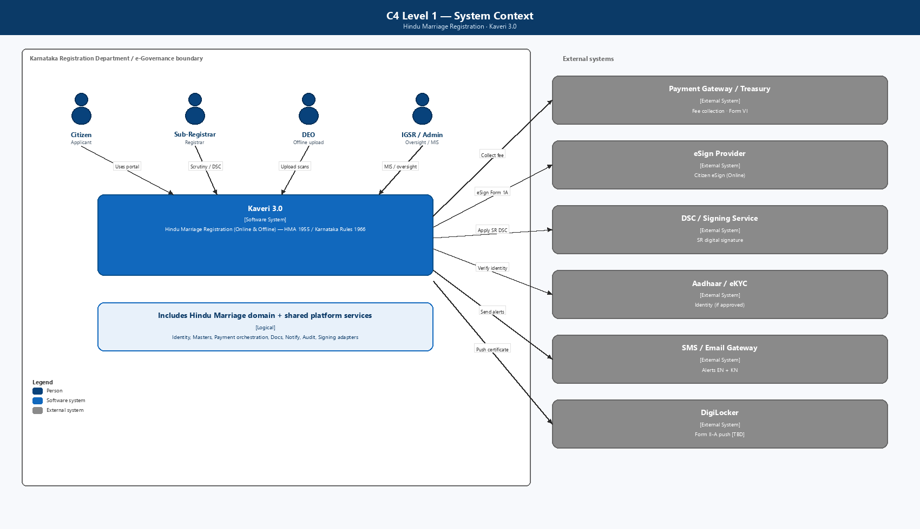
Figure: C4 Level 1 — System Context
Primary users
Persona | Channels | Primary surfaces
Citizen | Online + Offline | Portal application wizard, tracker, payment, printout, certificate download
Sub-Registrar (SR) | Both | Verification queues (Online / Offline S1 / Offline S2), DSC, refusal orders
Data Entry Operator | Offline only | Signature checklist + scan upload
IGSR / Admin | Both | MIS, config, Form III export

External systems: Payment Gateway / Treasury, eSign Provider, DSC / Signing Service, Aadhaar / eKYC (if approved), SMS / Email Gateway, DigiLocker (TBD).

4. Container diagram (C4 Level 2)
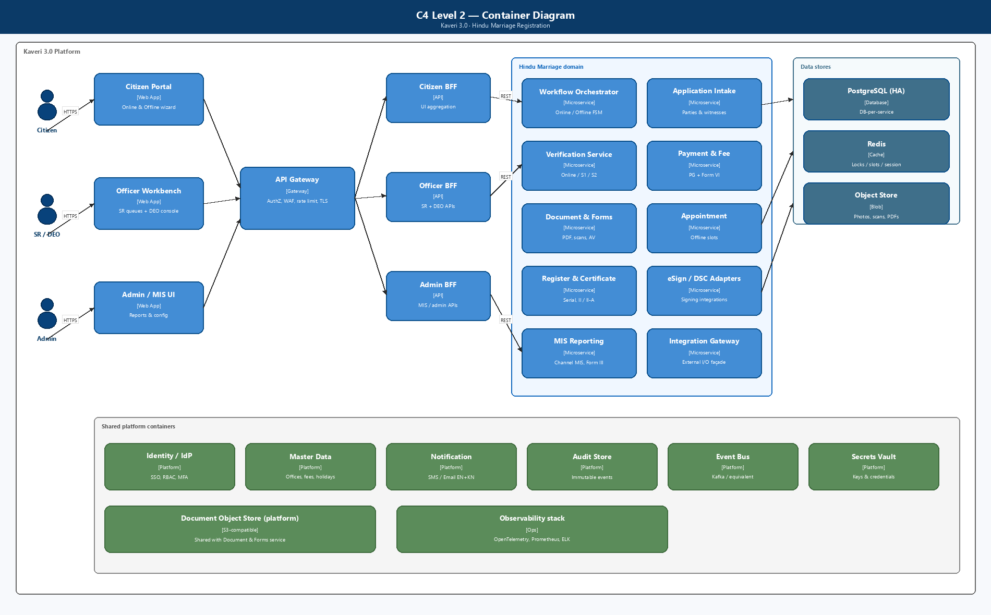
Figure: C4 Level 2 — Containers
Presentation
Layer | Responsibility
Citizen Portal | Prerequisite, channel select, data capture, eSign, pay, appointment, print, tracker
SRO Workbench | Queues by stage, scrutiny, written refusal, DSC, register/serial
DEO Console | Office-scoped lookup, signature checklist, upload/re-upload
Admin / MIS | Fee masters, office calendar, Form III, channel-wise reports

BFFs keep UIs thin, enforce channel-specific screen composition (FR-HMA-143), and avoid chatty cross-service calls from browsers.
Container summary
Tier | Containers
Edge | WAF / API Gateway
Experience | Citizen Portal, Officer Workbench, Admin / MIS UI
Aggregation | Citizen BFF, Officer BFF, Admin BFF
Domain | Workflow, Intake, Verification, Payment, Document/Forms, Appointment, Register/Certificate, eSign/DSC adapters, MIS, Integration Gateway
Platform | Identity, Master Data, Notification, Audit, Event Bus, Object Store, Vault
Data | PostgreSQL (HA), Redis, Object Store

4A. Component diagram (C4 Level 3)
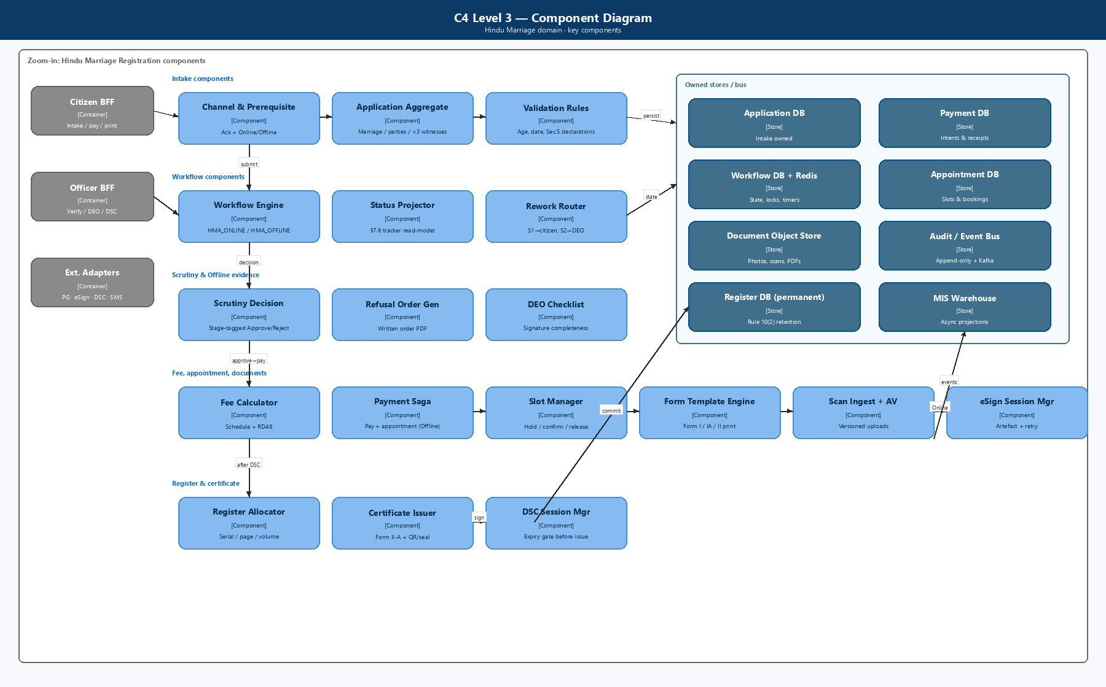
Figure: C4 Level 3 — Components
Zoom-in on the Hindu Marriage domain showing components that implement BRD hard gates: channel fork, targeted rework, pay-after-approve saga, DEO checklist, register allocation, and DSC-gated certificate issue.

5. Microservices architecture

5.1 Service catalogue
# | Service | Bounded context | Owns | Key BRD refs
1 | identity-access-service (platform) | AuthN/AuthZ | Users, roles, sessions, MFA, jurisdiction claims | NFR-SEC-001/002, SEC-011
2 | master-data-service (platform) | Reference data | Districts, SRO offices, holidays, fee schedule, reason codes | FR-010/011, FR-090
3 | application-intake-service | Application capture | Application header, channel, declarations, marriage/party/witness data, drafts | §7.2, FR-001–072, FR-140–145
4 | workflow-orchestrator | Process engine | Status model §7.6, transitions, targeted rework, SLA timers | FR-200, BR-010–019
5 | document-form-service | Documents & statutory forms | Uploads, joint photo, Form I/IA/II print PDFs, scan versions, AV scan hook | FR-080–082, FR-162–168
6 | esign-adapter-service | Citizen eSign | eSign sessions, signed artefacts, retry | FR-153–156, NFR-PERF-006
7 | verification-service | SR scrutiny | Stage-tagged decisions, reason codes, written refusal PDF | FR-180–188
8 | payment-fee-service | Fees & receipts | Fee calculation, PG orchestration, Form VI receipt, reconciliation | FR-090–096, BR-012
9 | appointment-service | Offline slots | Capacity, book/reschedule/cancel, no-show | FR-160–161, NFR-PERF-009
10 | register-certificate-service | Legal register | Serial/page/volume, Form II endorsement, Form II-A, QR/seal, DigiLocker push | FR-103–104, FR-190–194
11 | dsc-signing-adapter | SR DSC | DSC session, expiry check, signed PDF | FR-190–191, NFR-SEC-010
12 | notification-service (platform) | Alerts | SMS/email EN+KN templates | FR-120–121, FR-202
13 | audit-compliance-service (platform) | Immutable audit | Append-only events, export for AG/security | NFR-AUD-001–010
14 | mis-reporting-service | Analytics | Channel MIS, aging, fee recon, Form III batch | FR-130–136
15 | integration-gateway (optional façade) | External I/O | Circuit breakers, idempotency keys, partner SLAs | §12

Sizing note: Services 3–11 are Marriage-module–owned. Platform services (1, 2, 12, 13) are shared across Kaveri 3.0; Marriage consumes them via contracts.

5.2 Service responsibilities (detail)

application-intake-service
- Create/update draft applications.
- Persist prerequisite acknowledgement & channel selection (audited).
- Validate Section 5(iii) ages, marriage date ≤ today, exactly 3 witnesses.
- Jurisdiction basis capture (place of marriage or ordinary residence).
- Online: office selection + summary review gate before Form 1A submit.
- Publish ApplicationDetailsUpdated, ChannelSelected, DeclarationsAccepted.

workflow-orchestrator
- Source of truth for status (BRD §7.6).
- Separate process definitions: HMA_ONLINE_v1, HMA_OFFLINE_v1.
- Enforces hard gates: eSign complete → SR verify (Online); payment only after first SR approve; print only after payment+appointment; Stage 2 reject → DEO.
- Emits ApplicationStatusChanged for every transition (FR-HMA-203).

document-form-service
- Object storage for photos, proofs, DEO scans (versioned).
- Template engine for Form I, IA, II (pre-endorsement print — see OQ-006), II-A.
- Duplicate memorandum support (original + duplicate).
- Barcode/QR on offline printout for DEO retrieval.
- Malware scan before persist (NFR-SEC-012).

verification-service
- Work queues filtered by office + stage: Online | Offline-S1 | Offline-S2.
- Decision records: actor, timestamp, stage, decision, reason code + free text.
- Generates written refusal order PDF; notifies parties.
- Does not assign register serial (that is register-certificate-service after DSC).

payment-fee-service
- Fee from master schedule + notifications (RD48 etc.).
- Enabled only when workflow status = Approved for payment.
- Offline: coordinates with appointment-service as one guided step (FR-HMA-094).
- Idempotent PG callbacks; retry without reopening SR verification (FR-HMA-096).
- Blocks certificate path until reconciled (FR-HMA-095).

appointment-service
- Slot calendar per SRO office (holiday-aware via master-data).
- Optimistic locking / unique booking to prevent double-book (NFR-PERF-009).
- Reschedule/cancel/no-show events (rules TBD OQ-007).

register-certificate-service
- On successful DSC: allocate serial/page/volume atomically per office register book.
- Generate Form II endorsement + Form II-A with integrity QR/seal.
- Delivery mode: portal download (Online); counter + download (Offline).
- Monthly Form III duplicate bundle job for Registrar-General.

5.3 Data ownership (database per service)
Service | Primary store | Notes
application-intake | PostgreSQL | Application aggregate; party/witness child tables
workflow-orchestrator | PostgreSQL + optional Redis | Instance state, timers; Redis for locks/SLA
document-form | Object store (S3-compatible) + PostgreSQL metadata | Scans dominate Offline storage growth (NFR-OP-11)
verification | PostgreSQL | Decision history immutable
payment-fee | PostgreSQL | Payment intents, receipts, recon
appointment | PostgreSQL | Slots + bookings
register-certificate | PostgreSQL | Permanent register; strict backup/DR
audit-compliance | Append-only store (WORM / immutable table) | Separate from transactional DBs
mis-reporting | Read replica / warehouse | Async projection from events

No shared mutable DB across services. Cross-service reads via APIs or read models fed by events.

6. Channel-aware workflow design
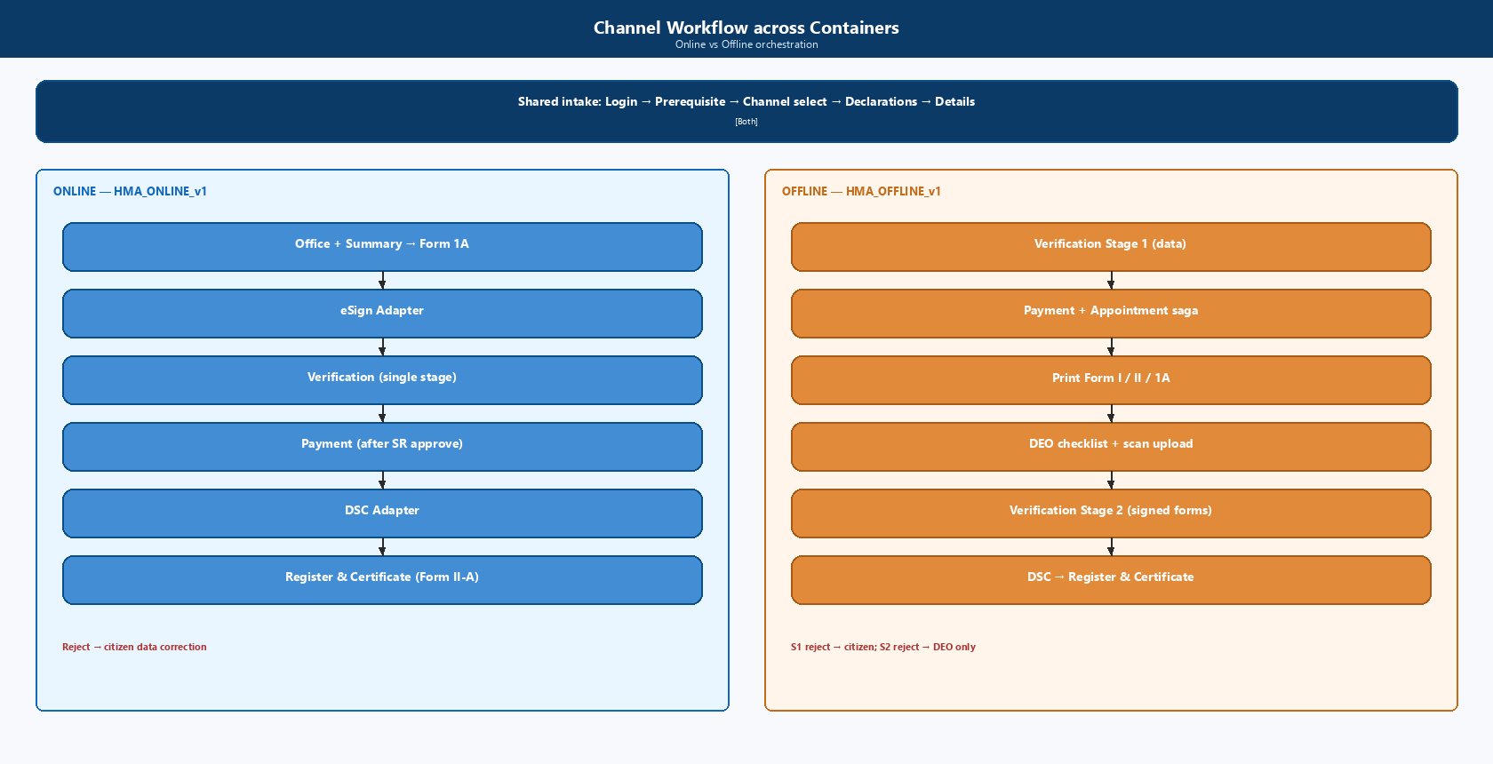
Figure: Channel Workflow across Containers

6.1 Shared intake (both channels)
START → Login → New Application → Marriage Registration
→ Prerequisite acknowledged → ChannelSelected(Online|Offline)
→ Declarations accepted → Details captured

6.2 Online process definition (HMA_ONLINE_v1)
Details captured
→ Office selected & summary reviewed
→ Form 1A submitted
→ eSign pending ──(complete)──► Pending SR verification
│ │
│ ├─ Reject ──► Rejected — data correction ──► Details captured
│ └─ Approve ─► Approved for payment
│ → Payment completed
│ → Pending SR digital signature
│ → Registered → Certificate issued → Closed
└─(retry on failure; status stays eSign pending)

6.3 Offline process definition (HMA_OFFLINE_v1)
Details captured
→ Pending SR verification (Stage 1)
├─ Reject ──► Rejected — data correction ──► Details captured
└─ Approve ─► Approved for payment
→ Payment completed + Appointment scheduled (atomic guided step)
→ Forms printed
→ Awaiting signed-form upload
→ Signed forms uploaded (DEO)
→ Pending SR verification — Stage 2
├─ Reject ──► Rejected — upload ──► Signed forms uploaded (DEO only)
└─ Approve ─► Pending SR digital signature
→ Registered → Certificate issued → Closed

6.4 Transition enforcement matrix (examples)
From | Event | Allowed if | Next
eSign pending | EsignCompleted | All required signatories done | Pending SR verification
Pending SR verification | SrApproved | Online or Offline-S1 | Approved for payment
Pending SR verification — Stage 2 | SrRejected | Offline | Rejected — upload
Approved for payment | PaymentInit | Prior SR approve recorded | (intent created; status unchanged until success)
Payment completed | PrintRequested | Offline + appointment exists | Forms printed
Awaiting signed-form upload | DeoUploadCompleted | DEO same office + checklist OK | Signed forms uploaded → Stage 2
Pending SR digital signature | DscCompleted | Payment reconciled | Registered → Certificate issued

7. Implementation design

7.1 Suggested technology baseline (confirm with platform HLD)
Concern | Recommendation | Rationale
Runtime | Java 17+ / Spring Boot or .NET 8 (platform standard) | Gov ecosystem, talent, long support
API style | REST + OpenAPI 3; async via events | BFF-friendly
Event bus | Kafka / managed equivalent | Audit projections, notify, MIS
Primary DB | PostgreSQL HA | Strong consistency for register & payments
Cache / locks | Redis | Appointment contention, session, rate limits
Object storage | S3-compatible (SDC) | DEO scans, photos, signed PDFs
Workflow | Camunda / Temporal / custom FSM service | Targeted rework + timers
PDF | Template service with Kannada fonts | Statutory exactness
API Gateway | Kong / APIM / SDC standard | WAF, mTLS to internals
Secrets | Vault / SDC secrets | NFR-SEC-004
Observability | OpenTelemetry + Prometheus + ELK | NFR-OPS-002
CI/CD | GitOps, env promotion, STQC-ready builds | Compliance

7.2 API surface (illustrative)
Citizen (via Citizen BFF)
Method | Path | Purpose
POST | /hma/applications | Start application
POST | /hma/applications/{id}/prerequisite | Acknowledge
POST | /hma/applications/{id}/channel | Online \ | Offline
PUT | /hma/applications/{id}/details | Marriage / parties / witnesses
POST | /hma/applications/{id}/office | Online office + summary confirm
POST | /hma/applications/{id}/form-1a/submit | Submit Form 1A
POST | /hma/applications/{id}/esign/start | Start eSign
POST | /hma/applications/{id}/payment/initiate | Post-approval pay
POST | /hma/applications/{id}/appointment | Offline slot (with pay step)
GET | /hma/applications/{id}/printouts | Form I/II/1A PDF
GET | /hma/applications/{id}/certificate | Form II-A download
GET | /hma/applications/{id}/tracker | Channel-specific progress

SR / DEO (via Officer BFF)
Method | Path | Purpose
GET | /hma/queues?stage= | Online / Offline-S1 / Offline-S2
POST | /hma/applications/{id}/verifications | Approve/Reject + reason
POST | /hma/applications/{id}/deo/checklist | Signature completeness
POST | /hma/applications/{id}/deo/uploads | Scan upload (versioned)
POST | /hma/applications/{id}/dsc/sign | SR digital signature
POST | /hma/applications/{id}/refusal-order | Written order artefact

All mutating APIs require: auth token, idempotency-key, office-scope check, and workflow permission for current status.

7.3 Domain events (minimum set)
Event | Producers | Consumers
PrerequisiteAcknowledged | Intake | Audit, Workflow
ChannelSelected | Intake | Workflow, Audit, MIS
ApplicationSubmittedForScrutiny | Workflow | Verification, Notify
EsignCompleted / EsignFailed | eSign adapter | Workflow, Audit, Document
VerificationDecisionRecorded | Verification | Workflow, Notify, Audit, MIS
PaymentSucceeded / PaymentFailed | Payment | Workflow, Notify, Audit, MIS
AppointmentBooked | Appointment | Workflow, Notify, Audit
SignedFormsUploaded | Document | Workflow, Verification, Audit
CertificateIssued | Register-Cert | Notify, DigiLocker, Audit, MIS
ApplicationStatusChanged | Workflow | Audit, Tracker read-model, MIS

7.4 Key sequence — Online (happy path)
Citizen → BFF → Intake (details)
Citizen → BFF → Intake (office + summary) → Workflow
Citizen → BFF → Document (Form 1A) → eSign Adapter → Workflow (Pending SR)
SR → BFF → Verification (Approve) → Workflow (Approved for payment)
Citizen → BFF → Payment → PG callback → Workflow (Payment completed)
SR → BFF → DSC Adapter → Register-Cert (serial + Form II + II-A)
→ Workflow (Certificate issued) → Notification + Audit + MIS

7.5 Key sequence — Offline (happy path)
Citizen → Intake (details) → Workflow (Pending SR Stage 1)
SR → Verification S1 Approve → Workflow (Approved for payment)
Citizen → Payment + Appointment (saga/orchestrated step)
Citizen → Document printout (I, II, 1A)
[Physical sign + visit]
DEO → checklist + upload → Workflow (Stage 2)
SR → Verification S2 Approve → DSC → Register-Cert → Certificate
Rejection routing
Stage | Reject target service action
Online / Offline S1 | Workflow → unlock Intake editable sections; notify citizen
Offline S2 | Workflow → DEO upload task; citizen data locked

7.6 Payment + appointment saga (Offline)
Orchestrated by workflow-orchestrator (preferred) or choreography:
- Create payment intent (payment-fee-service).
- Reserve slot (appointment-service) — soft hold.
- On PG success: confirm booking + emit PaymentSucceeded + AppointmentBooked.
- On PG failure: release hold; remain Approved for payment (FR-HMA-096).
- Compensate on timeout: release slot; keep payment retryable.

7.7 Register serial allocation
- Per-office sequence: (officeId, registerVolume, page, serial).
- Allocate inside a transactional outbox with row-level lock on office register cursor.
- Never allocate before DSC success and payment reconciliation.
- Certificate PDF generation is async after serial commit; status flips to Certificate issued when artefact ready.

7.8 Deployment view (C4)
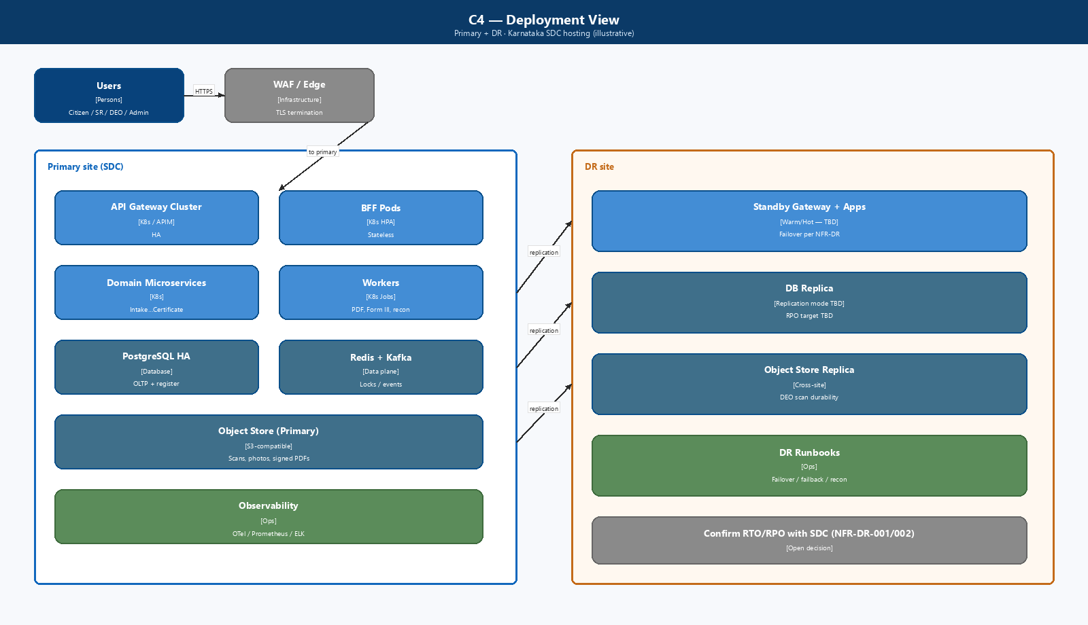
Figure: C4 — Deployment View
Environments: Dev → SIT → UAT → Pre-Prod → Prod (+ isolated DR). Non-prod uses anonymized data (NFR-PRIV-005).

7.9 Implementation phases (suggested)
Phase | Scope | Exit criteria
P0 — Platform spine | Identity, Gateway, Masters, Audit, Notify, Doc store | Shared contracts published
P1 — Common intake | Prerequisite, channel, declarations, details, validations | Both channels can save drafts
P2 — Online MVP | Office+summary, Form 1A, eSign, 1-stage SR, pay-after-approve, DSC, II-A | End-to-end Online UAT
P3 — Offline MVP | Stage 1, pay+appointment, printouts, DEO upload, Stage 2, DSC | End-to-end Offline UAT
P4 — MIS & compliance | Channel MIS, Form III, recon reports, DigiLocker (if approved) | IGSR reports signed off
P5 — Hardening | Perf/load (≥ module share of 10k), STQC/security, DR drill | Go-live gate

8. Security, privacy, and compliance design
Control | Design
AuthN | Citizen portal IdP / approved login; Officer SSO; MFA for SR/Admin (TBD)
AuthZ | RBAC: CITIZEN, SR, DEO, IGSR_ADMIN; jurisdiction claim on SR/DEO tokens
DEO separation | Permissions: checklist + upload only; deny approve/register/DSC (NFR-SEC-011)
Encryption | TLS 1.2+ in transit; at-rest for DB and object store
PII | Mask Aadhaar in UI/logs; field-level classification inventory
Uploads | AV scan; content-type/size limits; version history
eSign / DSC | Tamper-evident artefacts; signature metadata in audit
Certificate | QR / digital seal verification endpoint (public, minimal PII)
Secrets | Vault; no secrets in images/git
Compliance | GIGW, WCAG 2.x, MeitY/CERT-In, STQC path, UIDAI if eKYC used

9. NFR → architecture mapping
NFR area (BRD §13) | Architecture response
Availability | HA gateway + stateless pods; DB HA; status page hooks
Performance | BFFs, caching masters, async PDF, eSign timeout/retry, appointment locks
Scalability | HPA on intake/payment/document; object store for scans; Kafka consumers scale
Security | Gateway WAF, RBAC, vault, AV, UIDAI patterns
Privacy | PII inventory, masking, permanent register vs purgeable ops data
Audit | Every §7.6 transition + eSign/DSC/DEO/payment → audit-compliance-service
DR | Register DB continuous replication; object store cross-site; RPO/RTO TBD with SDC
Operations | OTel metrics/traces; runbooks for pay/eSign/DSC/restore
Capacity | Size for DEO scan growth + certificate PDFs; quarterly review
Compliance | Template legal lock; Kannada PDF QA; GIGW/WCAG gates in CI

10. Integration design
Integration | Pattern | Resilience
Payment gateway / Treasury | Sync initiate + async callback; recon job | Idempotent callback; circuit breaker
eSign provider | Redirect/SDK + callback | Retry; remain eSign pending
DSC / signing | Officer-initiated; tokenized session | Block issue if DSC expired
Aadhaar eKYC | Adapter; no raw Aadhaar stored beyond policy | UIDAI compliant logging
DigiLocker | Optional push of II-A | Best-effort after issue
SMS/Email | Async via notification-service | Template versioning EN/KN
Master data | Sync pull + cache TTL | Office/holiday changes invalidate cache

11. Logical data model (core)
Application
id, channel{ONLINE|OFFLINE}, status, officeId, jurisdictionBasis,
prerequisiteAckAt, createdBy, versions...

MarriageEvent
applicationId, marriageDate, place, ceremonyDescription

Party (Bride | Bridegroom)
name, parents, dob/ageAtMarriage, residence, address, maritalStatus

Witness (exactly 3)
name, relation, age, residence, address

DocumentAsset
applicationId, type{JOINT_PHOTO|PROOF|SIGNED_FORM_SCAN|ESIGN_PDF|CERT},
version, storageUri, checksum, uploadedByRole

VerificationDecision
applicationId, stage{ONLINE|OFF_S1|OFF_S2}, decision, reasonCode, actorId, at

Payment
applicationId, amount, status, receiptNo (Form VI), pgRef

Appointment
applicationId, officeId, slotStart, slotEnd, status

RegisterEntry
applicationId, officeId, serialNo, pageNo, volumeNo, registeredAt

Certificate
applicationId, formType{II_A}, issuedAt, integrityToken, deliveryMode
Retention: RegisterEntry + Certificate + Memorandum artefacts = permanent (Rule 10(2)); operational drafts/logs per policy (NFR-PRIV-003).

12. Observability and operations
Signal | Examples
SLIs | Submit p95, eSign success rate, pay success, Stage aging, cert issue latency
Alerts | PG callback lag, eSign provider errors, DSC expiry, upload AV fails, queue backlog
Runbooks | Payment stuck, eSign abandon, double-book prevention, DR failover, Form III rerun
Support | L1 portal issues; L2 workflow/payment; L3 domain + infra

13. Risks and open architecture decisions
ID | Topic | Impact | Owner
OQ-002 | Who must eSign (parties vs parties+witnesses) | eSign adapter UX & APIs | Legal / DE
OQ-005 | Channel switch after selection | Intake + workflow complexity | PO
OQ-006 | Form II print before endorsement | Template & document-form design | Legal / DE
OQ-007 | Appointment / no-show / refund rules | Appointment + payment saga | PO / SRO
OQ-008 | Refund if Offline Stage 2 fails after pay | Payment reversal design | Treasury / PO
OQ-012 | Offline office selection timing | Intake screens & jurisdiction | DE
NFR-OP-01..03 | Availability %, RPO/RTO | Infra topology | Arch / SDC
NFR-OP-09 | eSign provider & fallback | Online channel SLA | Arch / PO
AD-01 | Workflow engine product (Camunda/Temporal/custom) | Implementation velocity | Arch
AD-02 | Platform language/runtime standard | Service templates | Platform Arch
AD-03 | Shared vs module-owned payment service | Reuse across Kaveri modules | Platform Arch

14. Traceability summary (BRD → services)
BRD capability | Primary services
Prerequisite + channel | Intake, Workflow, Audit
Data capture Form I/IA | Intake, Document-Form
Online eSign | eSign Adapter, Document-Form, Workflow
Offline Stage 1 / 2 | Verification, Workflow
Pay after approve | Payment-Fee, Workflow
Appointment | Appointment, Payment-Fee, Workflow
Print Form I/II/1A | Document-Form
DEO checklist/upload | Document-Form, Verification (queue), Audit
SR DSC + Form II-A | DSC Adapter, Register-Certificate
MIS / Form III | MIS-Reporting
Notifications | Notification
NFRs §13 | Cross-cutting: Gateway, Audit, DR, Observability

15. Acceptance criteria for this HLD
Architecture review is complete when:
- Service boundaries and data ownership are agreed.
- Online and Offline state machines are signed off against process diagrams.
- Integration adapter list and ownership (module vs platform) are confirmed.
- Security role matrix (Citizen/SR/DEO/Admin) is approved.
- NFR open points have owners and target dates.
- P0–P5 delivery phasing is accepted by PO.

Appendix A — Glossary (architecture)
Term | Meaning
BFF | Backend-for-Frontend aggregation API for a UI surface
Hard gate | Workflow rule that blocks an action until precondition is true
Targeted rework | Return to a specific prior step (not generic resubmit)
Register cursor | Per-office counter for serial/page/volume allocation
Saga | Multi-service transaction with compensations (pay + appointment)

Appendix B — Reference inputs
- BRD-K3-MRG-HMA-001 — Business requirements (functional + NFR §13)
- Process diagrams — Online & Offline
- HMA 1955; Karnataka Rules 1966; statutory forms
- Prior NFR working session: Availability, Performance, Scalability, Security, Privacy, Audit, DR, Operations, Capacity, Compliance

Appendix C — C4 diagram catalogue
Diagram | File | Section
System Context (L1) | ArchitectureDiagrams/C4_L1_System_Context.png | §3
Containers (L2) | ArchitectureDiagrams/C4_L2_Containers.png | §4
Components (L3) | ArchitectureDiagrams/C4_L3_Components.png | §4A
Channel Workflow | ArchitectureDiagrams/C4_Channel_Workflow.png | §6
Deployment | ArchitectureDiagrams/C4_Deployment.png | §7.8

End of HLD / Implementation Design v0.2 — replace AD-/OQ- items through Architecture & Domain Expert workshops.

