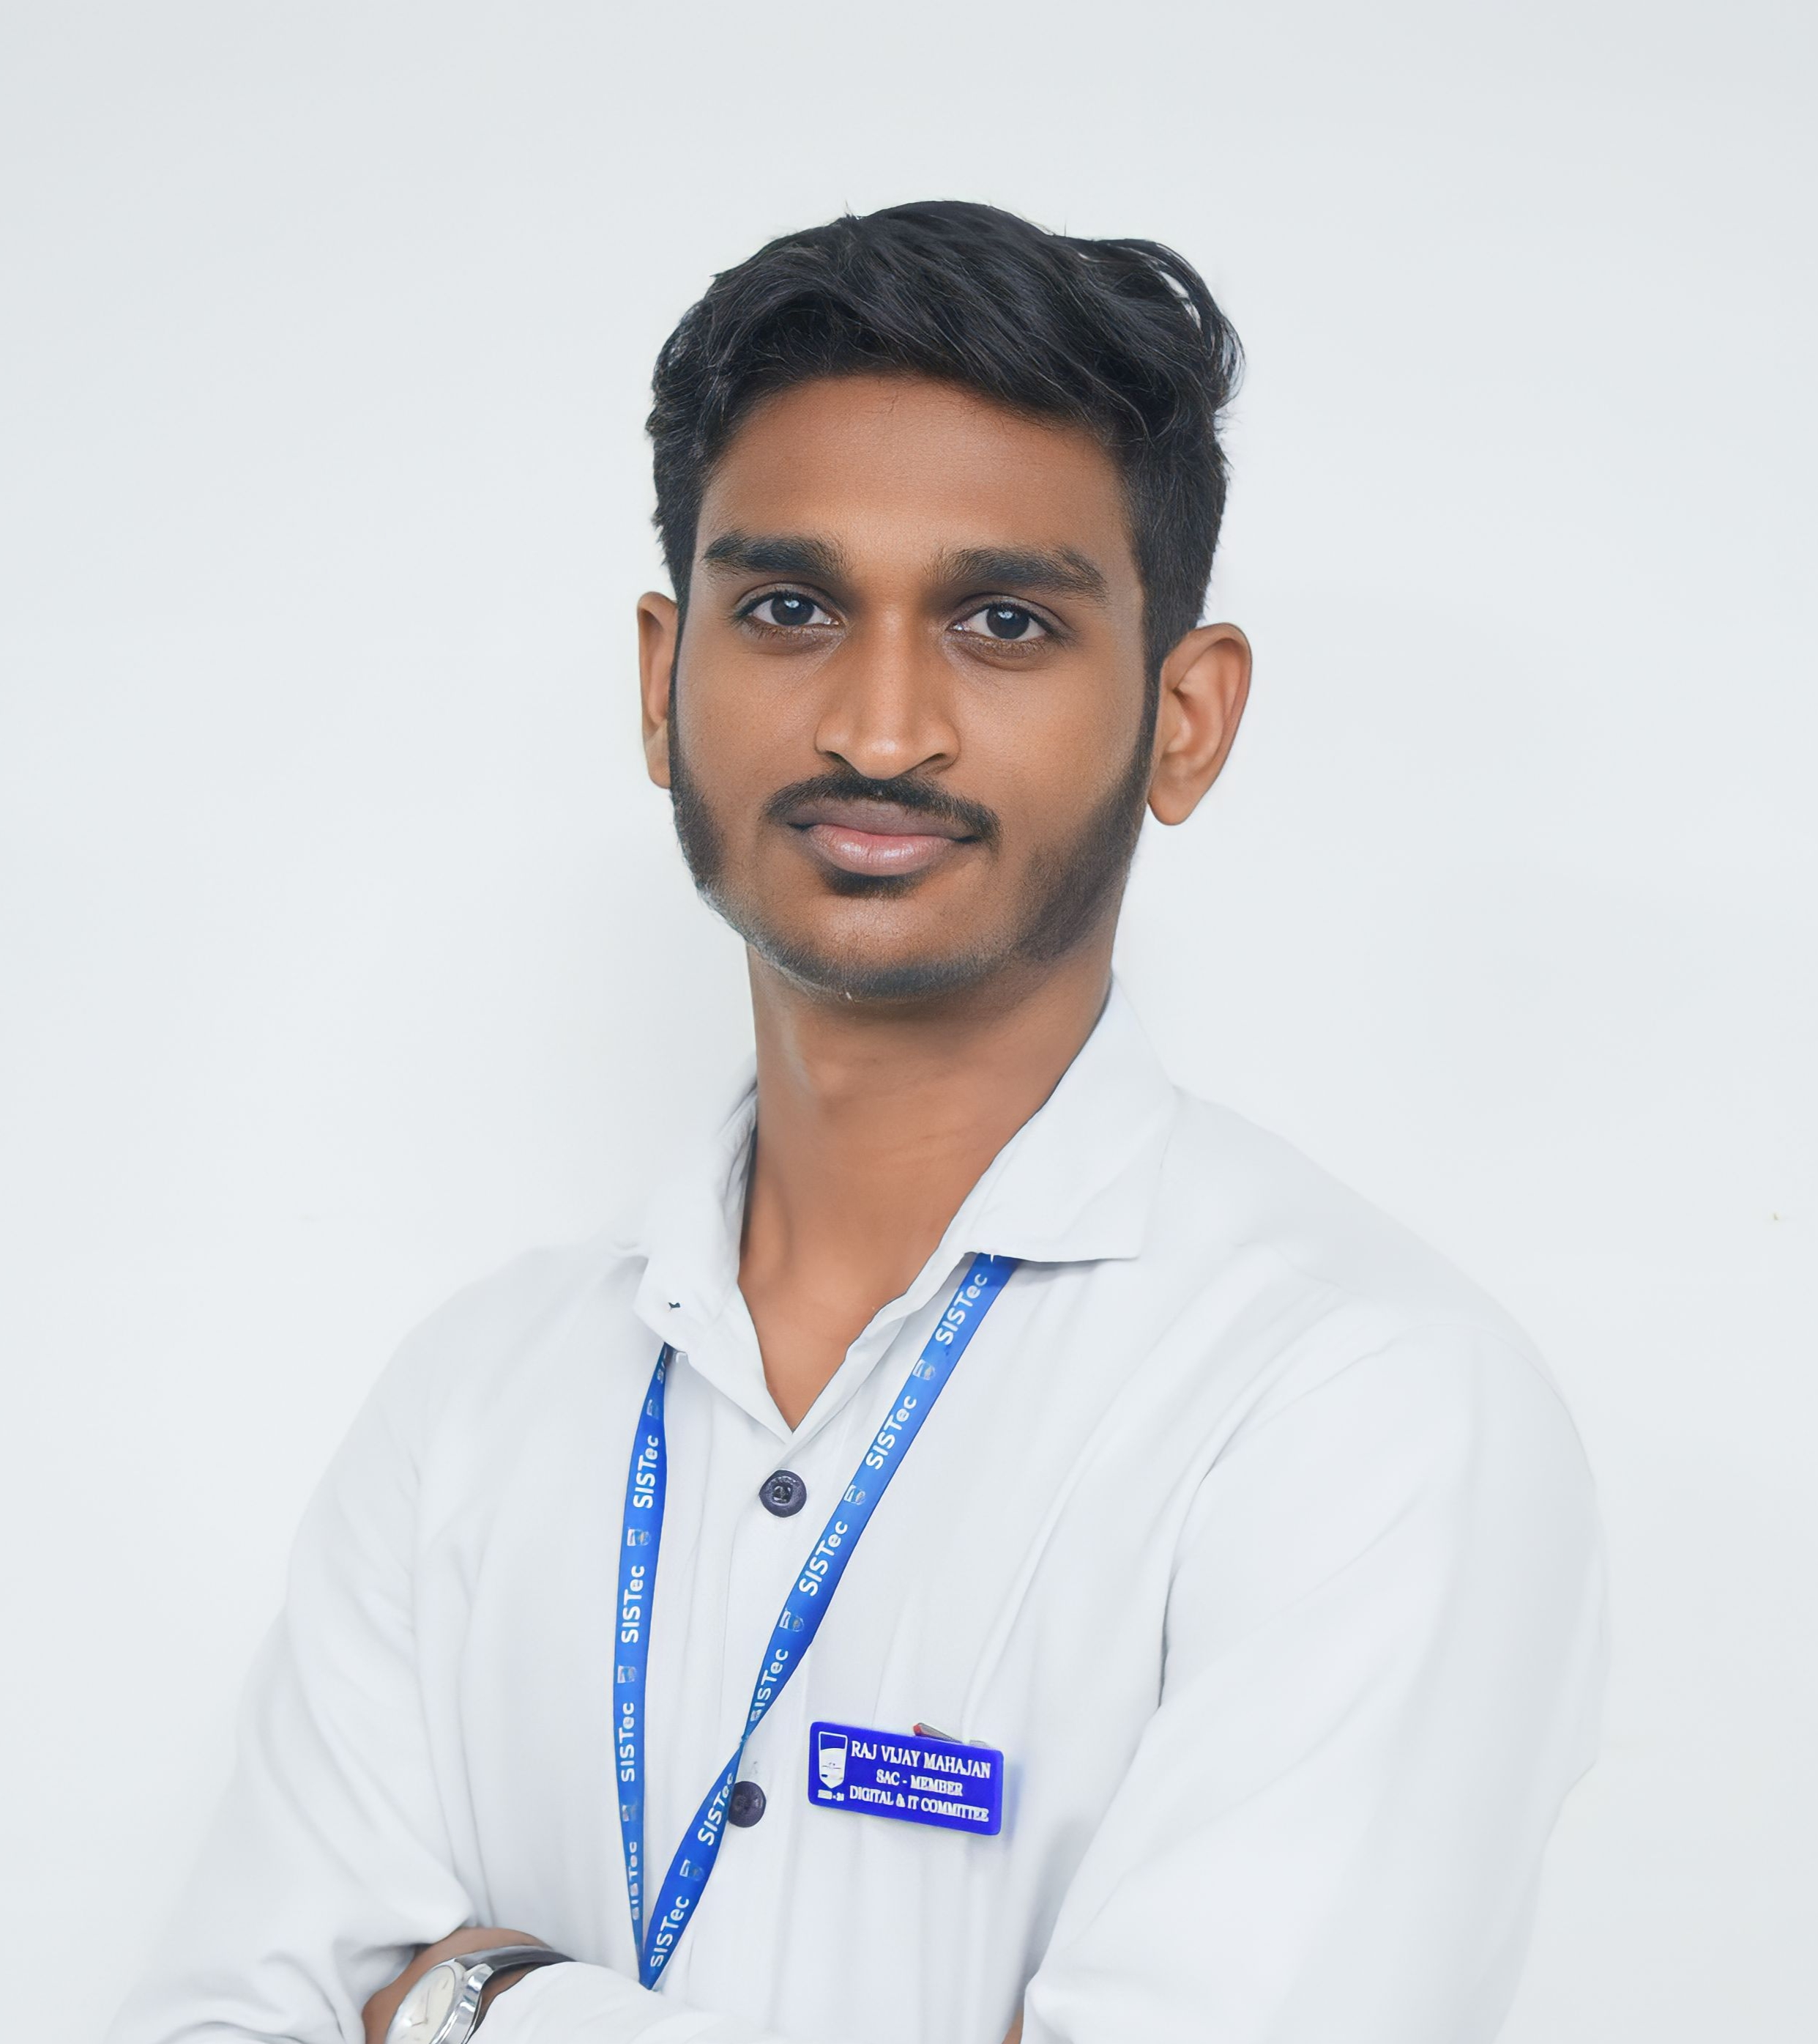
Raj Vijay Mahajan
📞 +91 7898844853 | 📍 Indore, India
mvraj7898@gmail.com| LinkedIn | GitHub

Introduction
Experienced Frontend React Developer and Graphics Designer, focused on UI/UX design and user-friendly interfaces. Currently implementing my MERN stack knowledge on my software product PRINT-ATM.

Technical Skills
• Languages | JavaScript, HTML, CSS
• Graphics Designing | Illustrator, Photoshop, Figma
• Libraries | React JS
• Tools | Git, Git Hub

Professional Experience
• Print-ATM | Founder Print-ATM 05 Apr, 2026 - Present
Key Skills: Wireframing, Figma, React, JavaScript, Prototyping, Express.js, MongoDB, AWS S3, Git, GitHub
Self-owned software product that automates the process of printing documents through features like document
upload, online payment, smart printing queue, automatic print instructions to printer. Saving efforts and
reducing manual work up to 80%.
• Solar-App Services | Freelance Frontend developer 22 Jan, 2026 - Present
Key Skills: Figma, JavaScript, CSS, Wireframing, User flows, ReactJS
Designed and developed 5+ user-friendly web applications and mobile interfaces
• Sagar Institute of Science and Technology | Graphic Designer Dec, 2022 - Jun, 2025
Key Skills: Adobe Photoshop Adobe illustrator Graphic designing
Created 30+ Graphic designs and 10+ videos edited throughout this journey.

Education
Bachelor of Technology – Computer Science and Engineering (2022–26)
Sagar Institute of Science and Technology, Bhopal CGPA: 7.28

Projects
• Digital Contract Farming Platform
• Built a platform connecting farmers with buyers via contracts, rental land options, and land selling features.
• Designed modules enabling farmers to view, bid, and manage contracts digitally, reducing manual processes by 80%.
• Selected for RGPV Incubation Funding for innovation impact.

• Smart Mart Self-Checkout System
• Built a MERN-based self-checkout platform using React Native and React, enabling barcode scanning, real-time billing, online payments, and QR-based verification.
• Developed secure REST APIs, MongoDB schemas, and role-based dashboards for inventory management and sales reporting.

• Country Details Website (Frontend Skills)
• Developed an animated React-based frontend using React Router DOM, Axios, and Framer Motion with dynamic data handling for 200+ countries.
• Added smooth transitions, interactive filters, and optimized component rendering to showcase advanced React UI skills.

Experience & Leadership
- Lead – Digital & IT Committee | Student Activity Council (2022 – 2025).
- Led IT and Digital support for 50+ college events, seminars, hackathons and guest lectures.
- Lead – Techno Freaks | Departmental Committee CSE (2023 – 2025).
- Organized the National Hackathon SAMADHAN 1.0, managing 400+ participants.

Achievements
- Selected Project, RGPV Incubation Funding of 5 Lakh.
- Winner, College-Level Innovation Competition – Contract Farming Project.
- Winner, Sagar Oral Olympics – Graphics Designing and Motion Graphics

Languages
- English
- Hindi
- Marathi
- Gurjar

