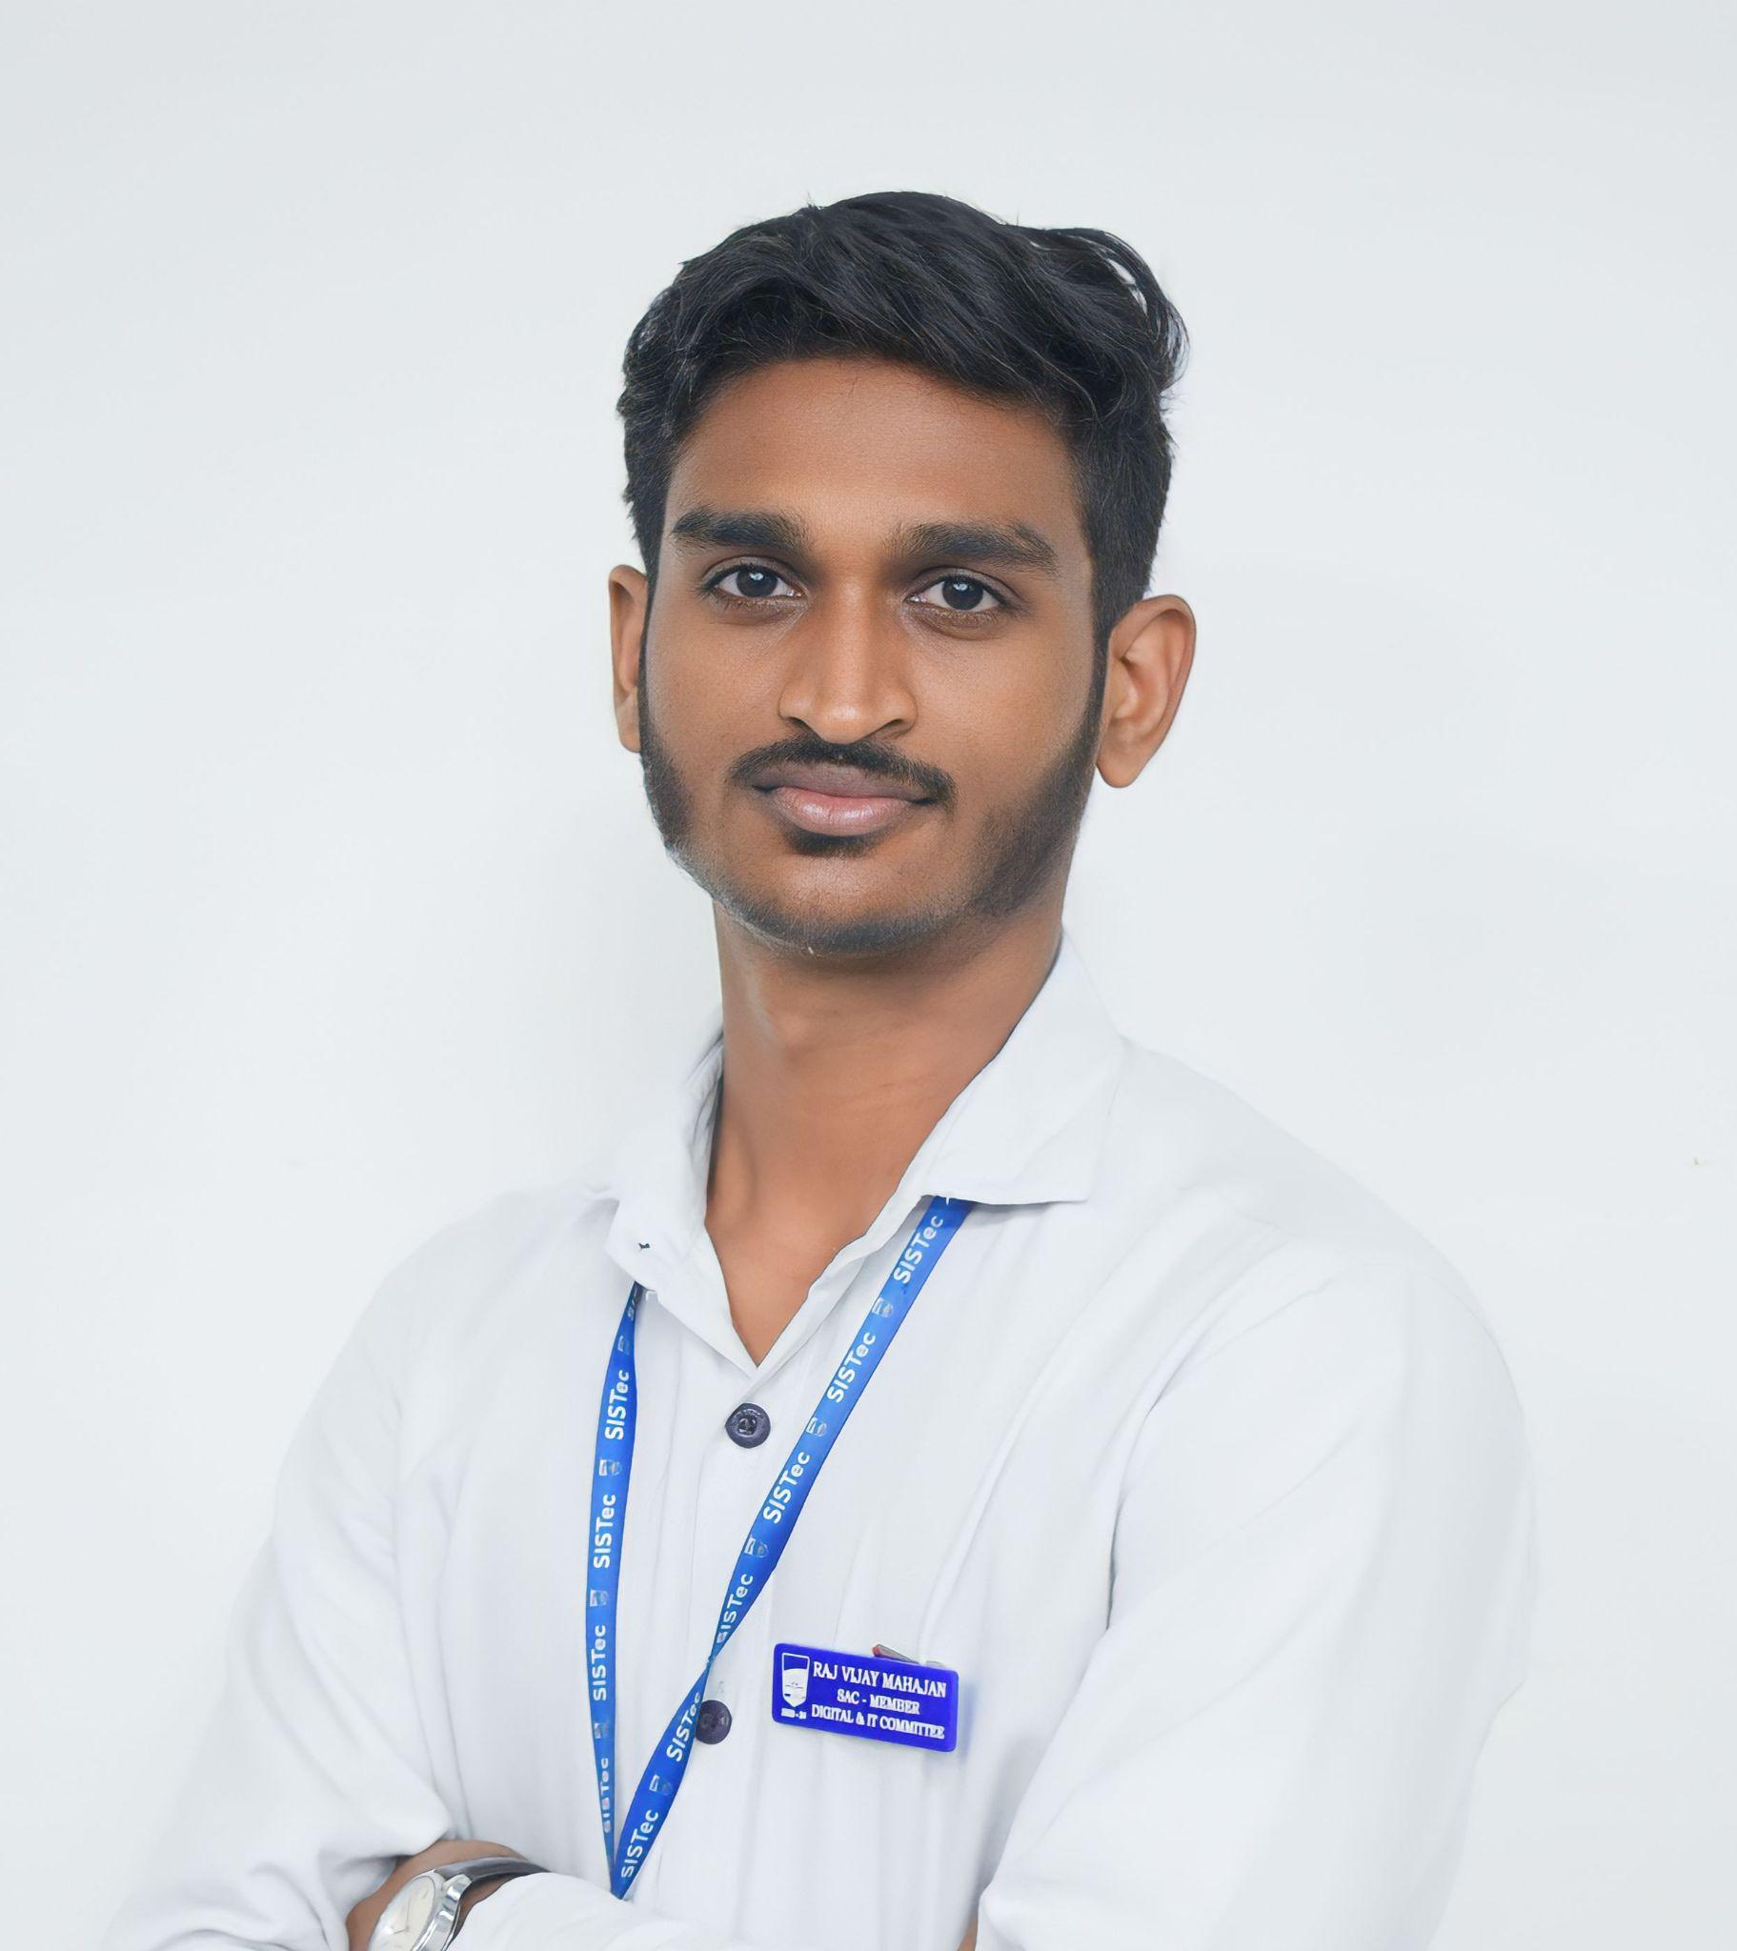
Raj Vijay Mahajan
+91 7898844853 | Pune, India
mvraj7898@gmail.com| LinkedIn | GitHub

Introduction
MERN Stack Developer with practical experience building full-stack applications such as Print-ATM and Contract Farming platforms(shortlisted for funding of 5 Lakh Rupees). Proficient in React-based UI development and backend API design using Node.js and Express.js. Strong problem-solving skills with a focus on scalable and user-friendly solutions. Currently working on my software product PRINT-ATM and Learning Fast API.

Education
Bachelor of Technology – Computer Science and Engineering (2022–26)
Sagar Institute of Science and Technology, Bhopal CGPA: 7.52

Technical Skills
- Languages JavaScript, Python
- Frontend React, HTML5, CSS3
- Backend Node JS, Express JS
- Database Mongo DB
- Tools Git, GitHub, Jira

Professional Experience
- Callybre | React Developer April, 2026 -Present
Key Skills: Figma, CSS, ReactJS, JavaScript, Jira
Designed and developed responsive web applications using React.

Projects
Printer Automation for Business | Link - https://print-atm-gamma.vercel.app
Key Skills: React, JavaScript, CSS, Express.js, MongoDB, AWS-S3, Git, GitHub, Figma, render
Description: A software that automates the process of printing documents through features like document upload, online payment, smart printing queue, automatic print instructions to printer. Saving efforts and reducing manual work up to 80%.
Digital Contract Farming -(RGPV Funding) | Link: github.com/mvraj07/Digital-Contract-Farming
Key Skills: ReactJS, UI/UX designing, Figma, JavaScript, CSS3, HTML5
Description: The platform functions as a digital marketplace where farmers can connect with
Contractors (Contract Farmers, Organizations, Buyers), negotiate contract terms, and manage agreements efficiently.

Achievements
- Selected Project, RGPV Incubation Funding of 5 Lakh Rupees.
- Winner, YUKTI Innovation - innovative solution for Farmers.
- Winner, Sagar Oral Olympics – Graphics Designing and Motion Graphics.

Experience & Leadership
- Led IT and Digital support for 50+ college events, seminars, hackathons and guest lectures.
- IT and Digital Lead – National level Hackathon SAMADHAN 1.0, managing 400+ participants.
- Appointed as Lead – Digital & IT Committee | Student Activity Council.

Languages
- English, Hindi, Marathi

