DIGITAL JEWELLERY ERP SYSTEM WITH WEIGHT-BASED BILLING & GST COMPLIANCE A
MAJOR PROJECT-II REPORT

Submitted in partial fulfillment of the requirements for the degree of

BACHELOR OF TECHNOLOGY

in

COMPUTER SCIENCE & ENGINEERING

By

GROUP NO.11

Adarsh Singh 0187CS221018

Om Soni 0187CS221143

Sankit Kumar Singh 0187CS221177 Tanisha Dale 0187CS221203

Under the guidance of Dr. Shweta Singh (Associate Professor)


Department of Computer Science & Engineering

Sagar Institute of Science & Technology (SISTec), Bhopal (M.P)

Approved by AICTE, New Delhi & Govt. of M.P.

Affiliated to Rajiv Gandhi Proudyogiki Vishwavidyalaya, Bhopal (M.P.)

June - 2026

Sagar Institute of Science & Technology (SISTec), Bhopal (M.P)

Department of Computer Science & Engineering


CERTIFICATE

We hereby certify that the work which is being presented in the B.Tech. Major Project- II
Report entitled DIGITAL JEWELLERY ERP SYSTEM WITH WEIGHT-BASED
BILLING & GST COMPLIANCE, in partial fulfillment of the requirements for the award of the degree of Bachelor of Technology, submitted to the Department of Computer Science & Engineering, Sagar Institute of Science & Technology (SISTec), Bhopal (M.P.) is an authentic record of our own work carried out during the period from Jan-2026 to Jun-2026 under the supervision of Dr. Shweta Singh.

The content presented in this project has not been submitted by me for the award of any other degree elsewhere.

Adarsh Singh | Om Soni | Sankit Singh | Tanisha Dale
0187CS221018 | 0187CS221143 | 0187CS221177 | 0187CS221203

This is to certify that the above statement made by the candidate is correct to the best of my knowledge.

Date:

Dr. Shweta Singh | Prof. Nargish Gupta | Dr. Manish Billore
Project Guide | HOD | Principal

ACKNOWLEGMENT

We take this occasion to thank God, almighty for blessing us with his grace and taking our endeavor to a successful culmination. We extend our sincere and heartfelt thanks to our esteemed Project Guide, Dr. Shweta Singh, for providing us with the right guidance and advice at crucial junctures and for showing us the right way.

We would like to express our sincere thanks to Dr. Manish Billore, Principal, SISTec, Gandhi Nagar, Bhopal for giving us an opportunity to undertake this project.

We would like to express our sincere thanks to Dr. Swati Saxena, Vice Principal, SISTec, Gandhi Nagar, Bhopal, for giving us an opportunity to undertake this project.

We also take this opportunity to express a deep sense of gratitude to Prof. Nargish Gupta (HOD) of the Department of Computer Science & Engineering for his kindhearted support. I would like to thank all those people who helped me directly or indirectly to complete.my project whenever I found myself in problems. All our faculties encouraged me and due to their kindness and helpful nature and help I got very much confidence in completing this project.

I am deeply inherited who devoted his precious time to giving me the information about the various aspects and giving support and guidance at every point of time. I am thankful to their kind and supportive nature. His inspiring nature has always made my work easy.

TABLE OF CONTENTS

TITLE PAGE NO.
Abstract i

List of Abbreviation |  | ii
List of Figures |  | iii
List of Tables |  | iv
Chapter 1 | Introduction | 1
 | 1.1 About Project | 1
 | 1.2 Project Objectives | 2
 | 1.3 Project Scope | 3
Chapter 2 | Software & Hardware Requirements | 4
 | 2.1 Software Requirement | 4
 | 2.2 Hardware Requirement | 4
Chapter 3 | Problem Description | 6
 | 3.1 Introduction | 6
 | 3.2 Analysis of Current Practices | 6
 | 3.3 Problem Identification | 6
 | 3.4 Proposed System | 7
 | 3.5 Features of Proposed System | 8
 | 3.6 Final Outcome | 8
Chapter 4 | Literature Survey | 10
Chapter 5 | Software Requirement Specification | 12
 | 5.1 Functional Requirement | 12
 | 5.2 Non-Functional Requirement | 13
Chapter 6 | Software Design | 14
 | 6.1 Use Case Diagram | 14
 | 6.2 Entity Relationship Diagram | 14

Chapter 7 | Web | Module | 15
 | 7.1 | User Authentication Module | 15
 | 7.2 | Inventory Management Module | 15
 | 7.3 | Billing Management Module | 16
 | 7.4 | Customer Management Module | 16
 | 7.5 | Reporting Module | 17
 | 7.6 | Admin Dashboard Module | 17
Chapter 8 Coding 18
  - Frontend Coding 18
  - Backend Coding 38
Chapter 9 Result & Output Screen 43
Chapter 10 Conclusion and Future work 49

References
Project Summary
  - Conclusion 49
  - Future Work 49

Appendix-1: Glossary of Terms

ABSTRACT
The Digital Jewellery ERP System with Weight-Based Billing and GST Compliance is a web-based solution designed to automate and streamline the operations of jewellery businesses. Traditional systems often rely on manual record-keeping and complex calculations based on weight and purity, which can lead to errors and inefficiencies. The application incorporates weight-based billing that calculates product cost using metal weight, purity, making charges, and applicable GST. It ensures accurate invoice generation and proper maintenance of tax records, supporting compliance with GST regulations. By digitizing core business processes, the system improves accuracy, reduces manual effort, and supports better decision-making. This project is aligned with the United Nations Sustainable Development Goals, including SDG 8: Decent Work and Economic Growth to improves business efficiency, SDG 9: Industry, Innovation and Infrastructure by using ERP technology, and SDG 12: Responsible Consumption and Production which ensures accurate billing and transparency.

LIST OF ABBREVIATIONS

ACRONYM | FULL FORM
SDLC | Software Development Life Cycle
GST | Goods and Services Tax
SQL | Structured Query Language
SRS | Software Requirements Specification
MVC | Model-View-Controller
KPI | Key Performance Indicator
OTP | One-Time Password
DBMS | Database Management System
UI | User Interface
UX | User Experience
PDF | Portable Document Format
API | Application Programming Interface
RBAC | Role-Based Access Control
HTTP | HyperText Transfer Protocol
HTTPS | HyperText Transfer Protocol Secure
3NF | Third Normal Form
OOPS | Object-Oriented Programming System
JSON | JavaScript Object Notation

 | LIST OF FIGURES
FIG. NO. | TITLE | PAGE NO.
6.1 | Use Case Diagram | 14
6.2 | Entity Relationship Diagram | 14
9.1 | Login Page | 43
9.2 | Billing Page | 43
9.3 | Customer Ledger | 44
9.4 | GST Summary | 44
9.5 | Sales Report | 45
9.6 | Stock Inward | 45
9.7 | Live Rates | 46
9.8 | Outstanding Payments Reports | 46
9.9 | Metal Rates | 47
9.10 | Customers | 47
9.11 | Invoices | 48
9.12 | Print Invoice | 48

 | LIST OF TABLES
TABLE NO. | TITLE | PAGE NO.
2.1 | Hardware Requirements | 5

CHAPTER 1 INTRODUCTION

The Digital Jewellery ERP System with Weight-Based Billing and GST Compliance is a web-based solution designed to modernize and streamline the operations of jewellery businesses. It provides a centralized and integrated platform for managing essential activities such as inventory control, customer information, billing, and taxation, thereby improving efficiency, accuracy, and overall business performance.
In traditional jewellery businesses, most operations are carried out manually using handwritten records or basic software tools that lack specialized features. Billing calculations based on metal weight, purity, and making charges are often complex and time-consuming, increasing the likelihood of errors. Inventory management also becomes challenging due to frequent stock updates and the absence of real-time tracking. Furthermore, maintaining proper GST-compliant records adds to the operational complexity and may result in inaccuracies in financial data.
To overcome these limitations, the proposed system introduces an automated ERP solution that simplifies and integrates core business processes. It incorporates weight-based billing that accurately calculates product cost using metal weight, purity, making charges, and applicable GST. The system also supports real-time inventory tracking, secure user authentication, and detailed report generation, enabling better control and monitoring of business activities.
By digitizing and automating these processes, the system reduces manual effort, minimizes human errors, and enhances data reliability. It allows business owners to access and manage information efficiently, leading to improved decision-making and operational transparency. Overall, the Digital Jewellery ERP System provides a reliable, efficient, and scalable platform for managing jewellery business operations in a structured and organized manner.

  - ABOUT PROJECT

The Digital Jewellery ERP System with Weight-Based Billing and GST Compliance is a web-based application developed to automate and manage the core operations of jewellery businesses in an efficient and organized manner. The system is designed to handle various business activities

such as inventory management, customer data handling, billing, and taxation within a single integrated platform.
Jewellery businesses deal with products whose pricing depends on multiple factors including metal weight, purity, making charges, and fluctuating market rates. Managing these calculations manually can be complex and error-prone. The proposed system simplifies this process by implementing automated weight-based billing, which ensures accurate and consistent pricing for all transactions.
In addition to billing, the system maintains detailed records of inventory and customer information, allowing business owners to track stock levels and manage customer interactions effectively. It also supports GST-compliant invoice generation and record maintenance, ensuring proper taxation and financial transparency. The application is designed with user-friendly interfaces and secure access controls, making it easy to use for both administrators and staff. It also provides reporting features that help in analyzing sales, inventory status, and overall business performance.
Overall, the Digital Jewellery ERP System aims to replace traditional manual methods with a modern, reliable, and efficient digital solution that improves accuracy, reduces workload, and enhances the management of jewellery business operations.

  - PROJECT OBJECTIVES

The primary objective of the Digital Jewellery ERP System with Weight-Based Billing and GST Compliance is to develop an efficient and reliable system that automates and simplifies jewellery business operations. The project aims to implement an accurate billing mechanism based on metal weight, purity, and making charges, while ensuring proper GST-compliant invoice generation.
Another important objective is to maintain organized and up-to-date inventory records with real-time tracking of stock. The system also focuses on efficient management of customer information through a centralized platform, enabling better record handling and quick access to data. By reducing dependency on manual processes, the project aims to minimize human errors and improve overall data accuracy.

Furthermore, the system is designed to provide secure user access with proper authentication and to generate detailed reports for sales, inventory, and financial analysis. Overall, the objective of the project is to enhance efficiency, transparency, and productivity in jewellery business operations through a user-friendly and scalable digital solution.

  - PROJECT SCOPE

The scope of the Digital Jewellery ERP System with Weight-Based Billing and GST Compliance is focused on automating and streamlining the core operations of jewellery businesses through a centralized web-based platform. The system is designed to manage inventory, customer data, billing processes, and financial transactions efficiently while ensuring accuracy in weight-based pricing and GST calculations.
The application covers essential functionalities such as jewellery product management based on weight and purity, real-time stock tracking, customer record maintenance, and automated invoice generation. It also supports GST-compliant billing, ensuring that all transactions follow proper taxation rules and generate accurate financial records.
Additionally, the system provides reporting features that help business owners analyse sales performance, monitor inventory levels, and track outstanding payments. The centralized database improves data accessibility and reduces manual errors, enhancing overall business efficiency.
However, the scope of the project is limited to small and medium-scale jewellery businesses and focuses on web-based implementation. Advanced features such as multi-branch integration, AI-based analytics, or mobile application support are not included in the current version but can be considered for future enhancements.

CHAPTER 2 SOFTWARE & HARDWARE REQUIREMENTS

The development and implementation of the Digital Jewellery ERP System with Weight-Based Billing and GST Compliance require an appropriate combination of software and hardware resources. These requirements ensure that the system functions efficiently, provides accurate results, and supports smooth operation for users. The system is designed as a web-based application.

  - SOFTWARE REQUIREMENT

The system is developed using modern web technologies to ensure flexibility, reliability, and ease of use. The frontend is designed using HTML, CSS, and JavaScript, which provide an interactive and user-friendly interface. Bootstrap (Version 5.3) is used to create a responsive layout that adapts to different devices and screen sizes.
The backend of the system is developed using PHP (Version 8.2), which is responsible for handling server-side logic, processing user requests, and managing application functionality. MySQL (Version 8.0) is used as the database management system to store and manage data related to products, inventory, customers, billing, and GST records.
For development and testing, XAMPP Server (Version 8.2.12) is used to create a local server environment. The code is written using Visual Studio Code, which provides efficient coding and debugging support. The system is executed and tested on modern web browsers such as Google Chrome (Version 120 or above) to ensure compatibility and performance.

  - HARDWARE REQUIREMENT

The hardware requirements for the system are designed to support development, deployment, and regular usage. For development purposes, a computer system with a minimum of Intel Core i3 processor or equivalent, 4 GB RAM, and 256 GB storage is sufficient for coding, testing, and running the application smoothly.
For deployment, a more powerful system is recommended, including a multi-core processor, at least 8 GB RAM, and sufficient storage capacity to handle multiple users and large volumes of

data. A stable internet connection is essential to ensure smooth communication between the client and server.
End users, such as shop owners and staff, can access the system using any device with a web browser, including desktops and laptops. This makes the system easily accessible without requiring any specialized hardware.

HARDWARE REQUIREMENTS TABLE

Table 2.1: Hardware Requirements

Category | Hardware Components | Minimum Specifications | Purpose
Development System | Processor | Intel Core i3 or equivalent | Smooth coding and testing environment
 | RAM | 4 GB or more | Basic multitasking
 | Storage | 256 GB HDD / SSD | Store code and project files
 | Operating System | Windows 10 / Linux | Compatibility with development tools
Server Requirements | Processor | Multi-core CPU | Efficient backend processing and request handling
 | RAM | 8 GB or more | Manage user sessions and database queries
 | Storage | 500 GB HDD/SSD | Store application data, logs, and backups
 | Internet Connection | 100 Mbps or higher | Reliable server-client and API access

CHAPTER 3 PROBLEM DESCRIPTION

  - INTRODUCTION

The jewellery business involves complex operations such as inventory management, weight-based pricing, billing, and tax compliance. Traditional methods used in jewellery shops often rely on manual record-keeping and calculations, which can lead to errors, inefficiencies, and lack of transparency. Managing different purity levels, metal rates, making charges, and GST calculations manually becomes difficult, especially as the business grows. This creates a need for a digital system that can automate these processes and improve accuracy. The Digital Jewellery ERP System is developed as a web-based solution to address these challenges by providing a centralized platform for efficient business management.

  - ANALYSIS OF CURRENT PRACTICES

Currently, many jewellery businesses depend on manual methods such as handwritten records, spreadsheets, or basic billing systems. Inventory is often tracked manually, making it difficult to maintain accurate stock records. Billing involves complex calculations based on weight, purity, and making charges, which increases the chances of human error. GST calculations are sometimes performed separately, leading to inconsistencies in invoices. Additionally, customer records and transaction histories are not always properly maintained, making it difficult to track outstanding payments or analyse sales. These traditional practices are time-consuming, less reliable, and not suitable for modern business requirements.

  - PROBLEM IDENTIFICATION

The primary problems this system seeks to solve are:

    - Lack of Centralized Data Management: Business data, including inventory details, customer records, and transaction history, is often stored in separate registers or files. This leads to duplication, inconsistency, and difficulty in retrieving accurate information when needed.

    - Manual and Error-Prone Billing Process: Jewellery billing involves multiple parameters like weight, purity, and making charges. Manual calculations increase the chances of errors and consume significant time, affecting customer service and business efficiency.
    - Inefficient Inventory Tracking: Jewellery items are diverse and frequently updated. Without a proper system, tracking stock levels, managing product categories, and updating inventory becomes difficult, leading to stock mismatches and poor resource management.
    - GST Calculation and Compliance Issues: Jewellery businesses must comply with GST regulations. Manual calculation of GST and maintenance of tax records can result in inaccuracies, improper invoice generation, and potential compliance issues.
    - Lack of Reporting and Data Analysis: Traditional systems do not provide proper reporting tools, making it difficult for business owners to analyse sales, inventory trends, and overall performance for decision-making.
    - Limited Transparency and Data Accessibility: Traditional systems lack real-time access to business data. This limits transparency and makes it difficult for business owners to monitor operations and make informed decisions.
By addressing these challenges, the Digital Jewellery ERP System aims to establish a centralized, efficient, and user-friendly digital platform that transforms traditional jewellery business operations.

  - PROPOSED SYSTEM

To overcome the limitations of the existing system, a Digital Jewellery ERP System is proposed. This system provides:
    - Automated weight-based billing system: The system automatically calculates jewellery prices based on weight, purity, making charges, and wastage, ensuring accuracy and consistency.
    - GST-compliant invoice generation: Invoices are generated in a standardized format with correct GST calculation, helping businesses comply with taxation rules.
    - Centralized inventory management: All stock data is stored in a single database, allowing real-time tracking and easy management of jewellery items.

    - Customer data and transaction tracking: The system maintains detailed customer records, including purchase history and outstanding balances, improving customer management.
    - Real-time updates and reporting: All transactions are updated instantly, and reports can be generated at any time for analysis and decision-making.
The proposed system reduces manual work, improves accuracy, and enhances overall efficiency.

  - FEATURES OF PROPOSED SYSTEM

    - Weight-based pricing with purity handling: The system calculates price based on metal weight and purity (such as 22K, 18K), ensuring accurate valuation of jewellery items.
    - Automatic GST calculation: GST is automatically applied during billing, reducing errors and ensuring compliance with tax regulations.
    - Inventory and stock management: The system maintains detailed stock records and updates inventory automatically after each transaction.
    - Customer management and ledger tracking: Customer details, payment history, and outstanding balances are stored and managed efficiently.
    - Multi-item billing with invoice generation: Users can generate invoices for multiple items in a single transaction, improving convenience and efficiency.
    - Report generation for sales and stock analysis: The system generates reports that help in analysing business performance and making informed decisions.
    - Secure user authentication system: Only authorized users can access the system, ensuring data security and preventing unauthorized operations.

  - FINAL OUTCOME

The final outcome of the Digital Jewellery ERP System with Weight-Based Billing and GST Compliance is a centralized web-based application that automates key jewellery business operations.

The system ensures accurate weight-based billing, GST-compliant invoice generation, and efficient inventory and customer management. It reduces manual errors, saves time, and provides real-time data for better decision-making. Overall, the system improves efficiency, reliability, and transparency in business processes.

CHAPTER 4 LITERATURE SURVEY

Sharma and Gupta (2021) presented “Enterprise Resource Planning Systems in Small and Medium Enterprises: Implementation and Benefits” in the International Journal of Information Management. Their research explains how ERP systems help integrate different business functions such as inventory, finance, and customer management into a single platform. The study highlights improvements in efficiency, data accuracy, and decision-making. However, it also notes that domain-specific customization is essential, especially for industries like jewellery where pricing depends on dynamic parameters such as weight, purity, and market rates [1].
Patel and Shah (2020), in their study “Web-Based Inventory Management System for Small Businesses,” focused on developing a web-based solution for tracking inventory in real time. Their work demonstrates that automated systems reduce manual effort, minimize stock discrepancies, and improve accessibility of business data. However, the proposed model does not include advanced functionalities such as GST-based billing or weight-dependent pricing, which are critical in jewellery ERP systems [2].
Singh and Kumar (2019) discussed “Design and Development of Automated Billing System Using Web Technologies” in IJERT. Their research shows that automated billing systems significantly improve speed, reduce human errors, and simplify invoice generation. The study emphasizes the importance of web-based solutions in business automation. However, it is limited to general billing systems and does not address complex calculations involving purity-based valuation and tax compliance required in jewellery businesses [3].
Pressman and Maxim (2015) provide fundamental concepts of software engineering, including system design methodologies, software lifecycle models, and requirement analysis techniques. Their work is widely used as a reference for structuring software projects and ensuring systematic development. These principles are applied in the design and implementation of the Jewellery ERP System to ensure scalability, reliability, and maintainability [4].
Silberschatz, Korth, and Sudarshan (2010), in Database System Concepts, explain relational database design, normalization techniques, and transaction processing. These concepts are essential for building a structured and efficient database for managing jewellery inventory,

customer data, and billing records. The principles ensure data consistency, integrity, and efficient query processing in the proposed system [5].
Laudon and Laudon (2020), in Management Information Systems: Managing the Digital Firm, highlight the role of information systems in transforming modern businesses through automation, data integration, and real-time analytics. Their concepts support the development of ERP systems that enhance operational efficiency and strategic decision-making, which aligns directly with the objectives of the Jewellery ERP System [6].
The official GST portal of India provides comprehensive guidelines on GST rules, tax slabs, invoice formats, and compliance procedures. It serves as a key reference for implementing accurate GST calculations in the billing module of the system, ensuring legal compliance and financial accuracy in jewellery transactions [7].
The MySQL official documentation provides detailed information about database architecture, query optimization, indexing, and data management techniques. These concepts are used in designing a robust backend database for efficient handling of large volumes of jewellery business data [8].
The PHP official documentation explains server-side scripting, session handling, and database integration techniques. It is used in developing dynamic functionalities such as billing generation, user authentication, and inventory updates in the system [9].
The Bootstrap documentation provides guidelines for creating responsive and mobile-friendly web interfaces. It helps in designing an intuitive and user-friendly frontend for the Jewellery ERP System, ensuring accessibility across desktops, tablets, and mobile devices with consistent performance [10].

CHAPTER 5 SOFTWARE REQUIREMENT SPECIFICATION

The Software Requirement Specification (SRS) defines the detailed functional and non-functional requirements for the development of the Digital Jewellery ERP System with Weight-Based Billing and GST Compliance. This document acts as a blueprint for designing, developing, and implementing the system, ensuring that all business processes are clearly defined and efficiently automated. The system aims to provide a centralized platform for managing jewellery inventory, customer details, billing operations, and GST-compliant invoicing in a structured and reliable manner.
The proposed system integrates all core business operations into a single digital environment, reducing manual effort and improving accuracy. It ensures smooth coordination between inventory management, billing processes, and financial record maintenance, thereby enhancing overall operational efficiency and transparency in jewellery businesses.

  - FUNCTIONAL REQUIREMENT

The functional requirements define the core features and operations of the system to achieve complete automation of jewellery business processes. The system allows users such as administrators and staff to securely register and log in to the application. After authentication, the admin can manage inventory by adding, updating, and deleting jewellery items based on category, weight, purity, and pricing details. The system enables real-time tracking of stock availability and product details.
The billing module automatically calculates product price based on metal weight, purity percentage, making charges, and applicable GST. It generates accurate and GST-compliant invoices for customers, reducing manual errors and saving time. The system also manages customer records, allowing storage of purchase history and transaction details. An administrative dashboard provides real-time insights into sales, stock levels, and revenue generation, supporting better decision-making.

Additionally, the system supports report generation for sales, inventory status, and GST summaries. These reports help business owners analyse performance and maintain proper financial records.

  - NON-FUNCTIONAL REQUIREMENT

The non-functional requirements ensure the system is efficient, secure, and reliable under all conditions. The system must be scalable to handle increasing data related to inventory, customers, and transactions as the business grows. It should provide high availability with minimal downtime to ensure uninterrupted business operations.
Security is a key requirement, ensuring protection of sensitive business data such as financial records, customer information, and billing details through proper authentication and secure data handling mechanisms. The system should be maintainable and flexible, allowing easy updates and enhancements in future such as new GST rules or pricing models. It should also be compatible across different devices and browsers to ensure accessibility for users.

CHAPTER 6 SOFTWARE DESIGN

  - USE CASE DIAGRAM
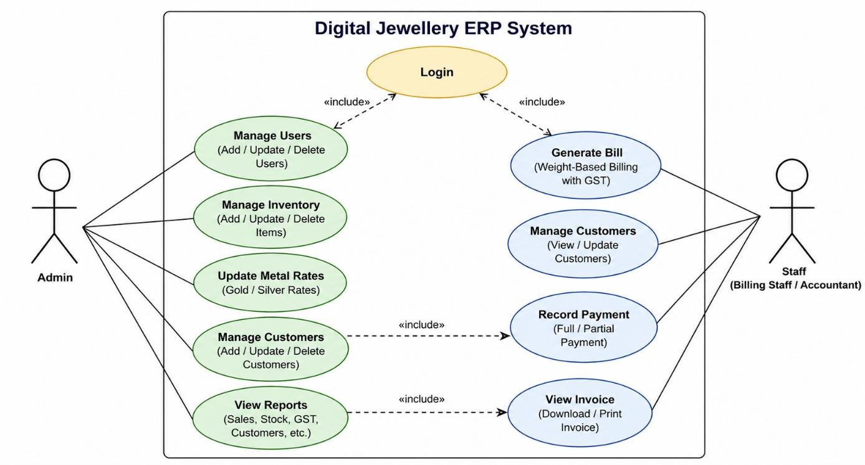

Figure 6.1: Use Case Diagram

  - ENTITY RELATIONSHIP DIAGRAM
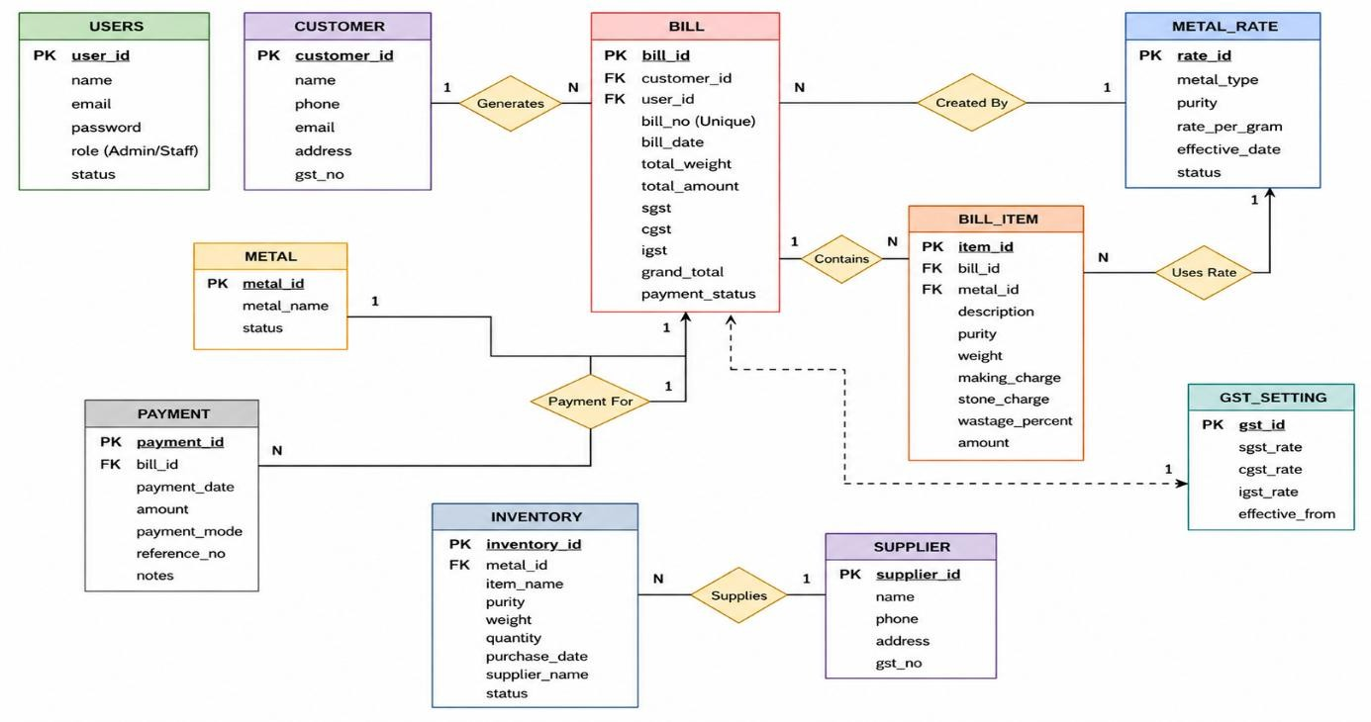

Figure 6.2: Entity Relationship Diagram

CHAPTER 7 WEB MODULE

The Digital Jewellery ERP System with Weight-Based Billing and GST Compliance is developed using a modular and layered architecture to ensure flexibility, scalability, and efficient management of business operations. Each module is designed to perform a specific set of tasks while interacting seamlessly with other modules, forming a fully integrated system. This modular approach reduces system complexity, simplifies maintenance, and allows easy future enhancements. The system provides a centralized platform for handling inventory, billing, customer management, financial transactions, and reporting in a structured and automated manner. The major modules of the system include User Authentication, Inventory Management, Billing Management, Customer Management, Reporting Module, and Admin Dashboard Module.

  - USER AUTHENTICATION MODULE

The User Authentication Module is responsible for securing the system and managing user access. It provides login functionality with encrypted password storage to ensure confidentiality of user credentials. The system supports role-based access control, allowing different permissions for administrators, billing staff, and accountants based on their responsibilities. This ensures that users can only access features relevant to their role, thereby maintaining data security and integrity.
The module also implements session management, including automatic session timeout and logout after a period of inactivity to prevent unauthorized access. In addition, it supports password management features such as password updates and secure credential handling. This module acts as the first line of defense, ensuring that all interactions within the system are authenticated and authorized.

  - INVENTORY MANAGEMENT MODULE

The Inventory Management Module manages all jewellery stock and ensures accurate tracking of products. It allows administrators to add new items, update existing records, and delete

obsolete entries. Each product is stored with detailed attributes such as category (ring, chain, bangle, etc.), metal type (gold, silver), purity (22K, 18K, etc.), weight, making charges, and price.
The system maintains real-time stock updates and automatically adjusts inventory levels after each sale or transaction. It supports stock classification based on metal type and purity, enabling better organization and tracking. The module also helps in identifying low stock levels and ensures timely restocking. By automating inventory processes, the system minimizes manual errors, improves accuracy, and enhances operational efficiency.

  - BILLING MANAGEMENT MODULE

The Billing Management Module is a core component of the system that handles invoice generation using weight-based pricing and GST compliance. It automatically calculates the cost of jewellery items based on parameters such as gross weight, net weight, purity, wastage, making charges (per gram or fixed), and applicable GST.
The module supports multi-item billing, allowing multiple products to be included in a single invoice. It generates detailed and GST-compliant invoices that clearly display all cost components, ensuring transparency for customers. The system also provides functionality to download or print invoices in PDF format for record-keeping and auditing purposes. By automating complex calculations, this module significantly reduces human errors, saves time, and ensures consistency in billing operations.

  - CUSTOMER MANAGEMENT MODULE

The Customer Management Module maintains comprehensive records of all customers. It allows users to add, edit, and manage customer details such as name, contact information, and transaction history. The system also supports credit-based transactions by allowing the configuration of credit limits and payment terms for each customer. The module maintains customer ledgers, tracking all purchases, payments, and outstanding balances. This helps in monitoring customer dues and managing financial interactions effectively. By organizing customer data in a structured manner, the system enhances customer relationship management and improves service quality.

  - REPORTING MODULE

The Reporting Module provides detailed insights into the system’s operations by generating various analytical reports. These include date-wise sales reports, customer-wise sales reports, inventory reports, GST summary reports, and outstanding payment reports.
The reports are generated dynamically based on stored data and can be used for performance analysis, financial tracking, and decision-making. The module presents data in a structured and easy-to-understand format, enabling users to quickly interpret information. This feature helps business owners identify trends, monitor growth, and optimize operations.

  - ADMIN DASHBOARD MODULE

The Admin Dashboard Module acts as the central control panel of the system, providing a comprehensive overview of all activities. It displays key performance indicators such as total sales, stock availability, recent transactions, and revenue trends in the form of summaries and visual charts. The dashboard allows administrators to manage all system components, including users, inventory, billing, and reports, from a single interface. It provides quick access to important data and supports real-time monitoring of business operations. The intuitive design of the dashboard ensures ease of use and helps administrators make faster and more informed decisions. Overall, this module enhances system control, improves visibility, and ensures efficient management of the entire application.

CHAPTER 8 CODING

FRONTEND CODING
<?php
/**
    - Login Page
*/
require_once DIR . '/includes/functions.php';
// Redirect if already logged in if (isLoggedIn()) {
header("Location: " . BASE_URL . "/dashboard.php"); exit();
}
$error = '';
if ($_SERVER['REQUEST_METHOD'] === 'POST') {
$username = sanitize($_POST['username'] ?? '');
$password = $_POST['password'] ?? '';
if (empty($username) || empty($password)) {
$error = 'Please enter both username and password.';
} else {
$db = getDBConnection();
$stmt = $db->prepare("SELECT id, username, password_hash, email, full_name, role, is_active FROM users WHERE username = ?");
$stmt->execute([$username]);
$user = $stmt->fetch();
if ($user && password_verify($password, $user['password_hash'])) { if (!$user['is_active']) {
$error = 'Your account has been deactivated. Please contact administrator.';
} else {
// Set session variables
$_SESSION['user_id'] = $user['id'];

$_SESSION['username'] = $user['username'];
$_SESSION['email'] = $user['email'];
$_SESSION['full_name'] = $user['full_name'];
$_SESSION['role'] = $user['role'];
$_SESSION['last_activity'] = time();
// Update last login
$stmt = $db->prepare("UPDATE users SET last_login = NOW() WHERE id = ?");
$stmt->execute([$user['id']]);
// Log activity
logActivity('login', 'User logged in successfully'); header("Location: " . BASE_URL . "/dashboard.php"); exit();
}
} else {
$error = 'Invalid username or password.';
logActivity('login_failed', "Failed login attempt for username: $username");
}
}
}
// Check for timeout message
if (isset($_GET['timeout']) && $_GET['timeout'] == 1) {
$error = 'Your session has expired. Please login again.';
}
?>
<!DOCTYPE html>
<html lang="en">
<head>
<meta charset="UTF-8">
<meta name="viewport" content="width=device-width, initial-scale=1.0">
<title>Login - <?php echo APP_NAME; ?></title>
<link href="https://cdn.jsdelivr.net/npm/bootstrap@5.3.0/dist/css/bootstrap.min.css" rel="stylesheet">
<link href="https://cdn.jsdelivr.net/npm/bootstrap-icons@1.10.0/font/bootstrap-icons.css" rel="stylesheet">

<link href="https://fonts.googleapis.com/css2?family=Playfair+Display:wght@400;600;700&family
=Poppins:wght@300;400;500;600&display=swap" rel="stylesheet">
<style>
* {
margin: 0;
padding: 0;
box-sizing: border-box;
}
body {
font-family: 'Poppins', sans-serif; min-height: 100vh;
display: flex;
background: linear-gradient(135deg, #1a1a2e 0%, #16213e 50%, #0f3460 100%); position: relative;
overflow-x: hidden;
}
/* Animated background particles */
.particles { position: fixed; top: 0;
left: 0;
width: 100%;
height: 100%; pointer-events: none; overflow: hidden;
z-index: 0;
}
.particle {
position: absolute; width: 4px; height: 4px;
background: rgba(255, 215, 0, 0.3);
border-radius: 50%;

animation: float 15s infinite;
}
@keyframes float { 0%,
100% {
transform: translateY(100vh) rotate(0deg); opacity: 0;
} 10% {
opacity: 1;
} 90% {
opacity: 1;
} 100% {
transform: translateY(-100vh) rotate(720deg); opacity: 0;
}
}
/* Left side - Branding */
.brand-section { flex: 1; display: flex;
flex-direction: column; justify-content: center; align-items: center; padding: 3rem; position: relative;
z-index: 1;
}
.brand-content { text-align: center; color: white;
max-width: 500px;

}
.logo-container { width: 120px; height: 120px;
background: linear-gradient(135deg, #FFD700 0%, #FFA500 100%);
border-radius: 50%; display: flex;
align-items: center; justify-content: center; margin: 0 auto 2rem;
box-shadow: 0 20px 40px rgba(255, 215, 0, 0.3), 0 0 60px rgba(255, 215, 0, 0.2); animation: pulse 2s ease-in-out infinite;
}
@keyframes pulse { 0%,
100% {
transform: scale(1);
} 50% {
transform: scale(1.05);
}
}
.logo-container i { font-size: 3.5rem; color: #1a1a2e;
}
.brand-title {
font-family: 'Playfair Display', serif; font-size: 2.5rem;
font-weight: 700; margin-bottom: 0.5rem;
background: linear-gradient(135deg, #FFD700 0%, #FFA500 50%, #FFD700 100%);
-webkit-background-clip: text;
-webkit-text-fill-color: transparent;

background-clip: text;
}
.brand-subtitle { font-size: 1.1rem;
color: rgba(255, 255, 255, 0.7); margin-bottom: 2rem;
}
.features { display: flex; gap: 2rem;
justify-content: center; flex-wrap: wrap;
}
.feature-item {
text-align: center; padding: 1rem;
}
.feature-item i { font-size: 1.5rem; color: #FFD700;
margin-bottom: 0.5rem; display: block;
}
.feature-item span { font-size: 0.85rem;
color: rgba(255, 255, 255, 0.8);
}
/* Right side - Login Form */
.login-section { width: 100%;
max-width: 480px; display: flex;
align-items: center; justify-content: center;

padding: 2rem; position: relative; z-index: 1;
}
.login-card {
background: rgba(255, 255, 255, 0.95); backdrop-filter: blur(20px);
border-radius: 24px; padding: 2.5rem; width: 100%;
box-shadow: 0 25px 50px -12px rgba(0, 0, 0, 0.5), 0 0 0 1px rgba(255, 255, 255, 0.1); animation: slideIn 0.6s ease-out;
}
@keyframes slideIn { from {
opacity: 0;
transform: translateX(30px);
}
to {
opacity: 1;
transform: translateX(0);
}
}
.login-header {
text-align: center; margin-bottom: 2rem;
}
.login-header h2 {
font-family: 'Playfair Display', serif; font-size: 1.75rem;
color: #1a1a2e;
margin-bottom: 0.5rem;
}

.login-header p { color: #6c757d; font-size: 0.9rem;
}
.form-floating { position: relative;
margin-bottom: 1.25rem;
}
.form-floating>.form-control { border: 2px solid #e9ecef; border-radius: 12px;
height: 56px; padding-left: 3rem; font-size: 0.95rem;
transition: all 0.3s ease;
}
.form-floating>.form-control:focus { border-color: #FFD700;
box-shadow: 0 0 0 4px rgba(255, 215, 0, 0.1);
}
.form-floating>label { padding-left: 3rem; color: #6c757d;
}
.input-icon { position: absolute; left: 1rem;
top: 50%;
transform: translateY(-50%); color: #adb5bd;
font-size: 1.1rem; z-index: 2;
transition: color 0.3s ease;
}

.form-floating>.form-control:focus~.input-icon { color: #FFD700;
}
.password-toggle { position: absolute; right: 1rem;
top: 50%;
transform: translateY(-50%); background: none;
border: none; color: #adb5bd; cursor: pointer; z-index: 2;
padding: 0.25rem; transition: color 0.3s ease;
}
.password-toggle:hover { color: #FFD700;
}
.btn-login {
background: linear-gradient(135deg, #FFD700 0%, #FFA500 100%); border: none;
border-radius: 12px; padding: 1rem;
font-weight: 600; font-size: 1rem; color: #1a1a2e; width: 100%; margin-top: 0.5rem;
transition: all 0.3s ease;
box-shadow: 0 4px 15px rgba(255, 215, 0, 0.4);
}

.btn-login:hover {
transform: translateY(-2px);
box-shadow: 0 8px 25px rgba(255, 215, 0, 0.5); color: #1a1a2e;
}
.btn-login:active { transform: translateY(0);
}
.alert {
border: none; border-radius: 12px;
padding: 1rem 1.25rem; margin-bottom: 1.5rem;
}
.alert-danger {
background: linear-gradient(135deg, #ff6b6b 0%, #ee5a5a 100%); color: white;
}
.divider { display: flex;
align-items: center; margin: 1.5rem 0; color: #adb5bd; font-size: 0.85rem;
}
.divider::before,
.divider::after { content: ''; flex: 1; height: 1px;
background: linear-gradient(90deg, transparent, #dee2e6, transparent);
}
.divider span { padding: 0 1rem; }

.default-login {
text-align: center; padding: 1rem;
background: linear-gradient(135deg, #f8f9fa 0%, #e9ecef 100%); border-radius: 12px;
border: 1px dashed #dee2e6;
}
.login-card { padding: 2rem;
}
}
@media (max-width: 576px) {
.brand-title {
font-size: 1.75rem;
}
.logo-container { width: 100px; height: 100px;
}
.logo-container i { font-size: 2.5rem;
}
.login-card { padding: 1.5rem;
border-radius: 20px;
}
}
</style>
</head>
<body>
<!-- Animated Particles -->
<div class="particles" id="particles"></div>
<!-- Brand Section -->
<div class="brand-section">

<div class="brand-content">
<div class="logo-container">
<i class="bi bi-gem"></i>
</div>
<h1 class="brand-title"><?php echo APP_NAME; ?></h1>
<p class="brand-subtitle">JewelSync ERP - Premium Jewellery Management</p>

<div class="features">
<div class="feature-item">
<i class="bi bi-receipt"></i>
<span>GST Invoicing</span>
</div>
<div class="feature-item">
<i class="bi bi-box-seam"></i>
<span>Inventory</span>
</div>
<div class="feature-item">
<i class="bi bi-graph-up"></i>
<span>Reports</span>
</div>
</div>
</div>
</div>
<!-- Login Section -->
<div class="login-section">
<div class="login-card">
<div class="login-header">
<h2>Welcome Back</h2>
<p>Sign in to access your dashboard</p>
</div>
<?php if ($error): ?>
<div class="alert alert-danger alert-dismissible fade show" role="alert">
<i class="bi bi-exclamation-circle-fill me-2"></i>
<?php echo $error; ?>

<button type="button" class="btn-close btn-close-white" data-bs-dismiss="alert"></button>
</div>
<?php endif; ?>
<form method="POST" action="" id="loginForm">
<div class="form-floating">
<i class="bi bi-person input-icon"></i>
<input type="text" class="form-control" id="username" name="username" placeholder="Username" required autofocus>
<label for="username">Username</label>
</div>
<div class="form-floating">
<i class="bi bi-lock input-icon"></i>
<input type="password" class="form-control" id="password" name="password" placeholder="Password" required>
<label for="password">Password</label>
<button type="button" class="password-toggle" onclick="togglePassword()">
<i class="bi bi-eye" id="toggleIcon"></i>
</button>
</div>
<button type="submit" class="btn btn-login">
<i class="bi bi-box-arrow-in-right me-2"></i> Sign In
</button>
</form>
</div>
</div>
<script src="https://cdn.jsdelivr.net/npm/bootstrap@5.3.0/dist/js/bootstrap.bundle.min.js"></script>
<script>
// Create floating particles function createParticles() {
const container = document.getElementById('particles'); const particleCount = 30;
for (let i = 0; i < particleCount; i++) {

const particle = document.createElement('div'); particle.className = 'particle'; particle.style.left = Math.random() * 100 + '%';
particle.style.animationDelay = Math.random() * 15 + 's'; particle.style.animationDuration = (10 + Math.random() * 10) + 's'; container.appendChild(particle);
}
}
createParticles();
// Toggle password visibility function togglePassword() {
const passwordInput = document.getElementById('password'); const toggleIcon = document.getElementById('toggleIcon');
if (passwordInput.type === 'password') { passwordInput.type = 'text'; toggleIcon.classList.remove('bi-eye'); toggleIcon.classList.add('bi-eye-slash');
} else {
passwordInput.type = 'password'; toggleIcon.classList.remove('bi-eye-slash'); toggleIcon.classList.add('bi-eye');
}
}
// Add subtle animation on input focus document.querySelectorAll('.form-control').forEach(input => {
input.addEventListener('focus', function() { this.parentElement.style.transform = 'scale(1.02)';
});
input.addEventListener('blur', function() { this.parentElement.style.transform = 'scale(1)';
});
});
</script>
</body>

</html>
<?php
/**
* Dashboard Page
*/
require_once DIR . '/includes/functions.php'; requireAuth();
$pageTitle = 'Dashboard';
$db = getDBConnection();
// Get dashboard statistics
$today = date(DB_DATE_FORMAT);
$currentMonth = date('Y-m');
// Today's sales (only today's new invoices, not old dues)
$stmt = $db->prepare("SELECT COALESCE(SUM(total_amount), 0) as total FROM invoices WHERE DATE(invoice_date) = ?");
$stmt->execute([$today]);
$todaySales = $stmt->fetch()['total'];
// Monthly sales
$stmt = $db->prepare("SELECT COALESCE(SUM(total_amount), 0) as total FROM invoices WHERE DATE_FORMAT(created_at, '%Y-%m') = ?");
$stmt->execute([$currentMonth]);
$monthlySales = $stmt->fetch()['total'];
// Total customers
$stmt = $db->query("SELECT COUNT(*) as total FROM customers WHERE is_active = 1");
$totalCustomers = $stmt->fetch()['total'];
// Outstanding amount
$stmt = $db->query("SELECT COALESCE(SUM(balance_amount), 0) as total FROM invoices WHERE payment_status != 'paid'");
$outstandingAmount = $stmt->fetch()['total'];
// Recent invoices
$stmt = $db->query("SELECT i.*, c.business_name FROM invoices i JOIN customers c ON i.customer_id = c.id
ORDER BY i.created_at DESC LIMIT 5");
$recentInvoices = $stmt->fetchAll();

// Today's metal rates
$stmt = $db->prepare("SELECT metal_type, purity, rate_per_gram FROM metal_rates WHERE rate_date = ? ORDER BY metal_type, purity");
$stmt->execute([$today]);
$todayRates = $stmt->fetchAll();
include DIR . '/includes/header.php';
?>
<div class="row">
<!-- Stats Cards -->
<div class="col-md-3 mb-4">
<div class="card stats-card primary">
<div class="card-body">
<div class="stats-icon"><i class="bi bi-cash-stack"></i></div>
<div class="stats-number"><?php echo formatCurrency($todaySales); ?></div>
<div class="stats-label">Today's Sales</div>
</div>
</div>
</div>
<div class="col-md-3 mb-4">
<div class="card stats-card success">
<div class="card-body">
<div class="stats-icon"><i class="bi bi-graph-up-arrow"></i></div>
<div class="stats-number"><?php echo formatCurrency($monthlySales); ?></div>
<div class="stats-label">Monthly Sales</div>
</div>
</div>
</div>
<div class="col-md-3 mb-4">
<div class="card stats-card info">
<div class="card-body">
<div class="stats-icon"><i class="bi bi-people"></i></div>
<div class="stats-number"><?php echo $totalCustomers; ?></div>
<div class="stats-label">Total Customers</div>
</div>

</div>
</div>
<div class="col-md-3 mb-4">
<div class="card stats-card warning">
<div class="card-body">
<div class="stats-icon"><i class="bi bi-exclamation-triangle"></i></div>
<div class="stats-number"><?php echo formatCurrency($outstandingAmount);
?></div>
<div class="stats-label">Outstanding</div>
</div>
</div>
</div>
</div>
<div class="row">
<!-- Metal Rates -->
<div class="col-md-4 mb-4">
<div class="card">
<div class="card-header">
<h5><i class="bi bi-currency-exchange"></i> Today's Metal Rates</h5>
</div>
<div class="card-body">
<?php if (empty($todayRates)): ?>
<div class="alert alert-warning">
<i class="bi bi-exclamation-circle"></i> No rates set for today.
<a href="<?php echo BASE_URL; ?>/settings/rates.php" class="alert-link">Set
rates now</a>
</div>
<?php else: ?>
<div class="row">
<?php foreach ($todayRates as $rate): ?>
<div class="col-6 mb-3">
<div class="rate-display">
<div class="rate-value"><?php echo
formatCurrency($rate['rate_per_gram']); ?></div>

<div class="rate-label"><?php echo ucfirst($rate['metal_type']) . ' ' .
$rate['purity']; ?></div>
</div>
</div>
<?php endforeach; ?>
</div>
<?php endif; ?>
<div class="text-center mt-3">
<a href="<?php echo BASE_URL; ?>/settings/rates.php" class="btn btn-sm btn-outline-primary">
<i class="bi bi-gear"></i> Manage Rates
</a>
</div>
</div>
</div>
</div>
<!-- Recent Invoices -->
<div class="col-md-8 mb-4">
<div class="card">
<div class="card-header d-flex justify-content-between align-items-center">
<h5 class="mb-0"><i class="bi bi-receipt"></i> Recent Invoices</h5>
<a href="<?php echo BASE_URL; ?>/billing/list.php" class="btn btn-sm btn-primary">View All</a>
</div>
<div class="card-body p-0">
<div class="table-responsive">
<table class="table table-hover mb-0">
<thead>
<tr>
<th>Invoice #</th>
<th>Customer</th>
<th>Date</th>
<th>Amount</th>
<th>Status</th>

<th>Action</th>
</tr>
</thead>
<tbody>
<?php if (empty($recentInvoices)): ?>
<tr>
<td colspan="6" class="text-center py-4 text-muted">No invoices yet</td>
</tr>
<?php else: ?>
<?php foreach ($recentInvoices as $invoice): ?>
<tr>
<td><strong><?php echo $invoice['invoice_no']; ?></strong></td>
<td><?php echo $invoice['business_name']; ?></td>
<td><?php echo formatDate($invoice['invoice_date']); ?></td>
<td><?php echo formatCurrency($invoice['total_amount']); ?></td>
<td>
<?php if ($invoice['payment_status'] === 'paid'): ?>
<span class="badge bg-success">Paid</span>
<?php elseif ($invoice['payment_status'] === 'partial'): ?>
<span class="badge bg-warning">Partial</span>
<?php else: ?>
<span class="badge bg-danger">Pending</span>
<?php endif; ?>
</td>
<td>
<a href="<?php echo BASE_URL; ?>/billing/view.php?id=<?php echo $invoice['id']; ?>" class="btn btn-sm btn-info">
<i class="bi bi-eye"></i>
</a>
</td>
</tr>
<?php endforeach; ?>
<?php endif; ?>
</tbody>

</table>
</div>
</div>
</div>
</div>
</div>
<!-- Quick Actions -->
<div class="row">
<div class="col-12">
<div class="card">
<div class="card-header">
<h5><i class="bi bi-lightning"></i> Quick Actions</h5>
</div>
<div class="card-body">
<div class="row">
<?php if (hasRole([ROLE_ADMIN, ROLE_BILLING])): ?>
<div class="col-md-3 mb-3">
<a href="<?php echo BASE_URL; ?>/billing/create.php" class="btn btn-primary w-100 py-3">
<i class="bi bi-receipt fs-3 d-block mb-2"></i> Create Invoice
</a>
</div>
<div class="col-md-3 mb-3">
<a href="<?php echo BASE_URL; ?>/customers/add.php" class="btn btn-success w-100 py-3">
<i class="bi bi-person-plus fs-3 d-block mb-2"></i> Add Customer
</a>
</div>
<?php endif; ?>

<?php if (hasRole([ROLE_ADMIN, ROLE_ACCOUNTANT])): ?>
<div class="col-md-3 mb-3">

w-100 py-3">
<a href="<?php echo BASE_URL; ?>/payments/entry.php" class="btn btn-info

<i class="bi bi-cash-coin fs-3 d-block mb-2"></i> Payment Entry
</a>
</div>
<div class="col-md-3 mb-3">
<a href="<?php echo BASE_URL; ?>/inventory/inward.php" class="btn btn-

warning w-100 py-3">
<i class="bi bi-box-arrow-in-down fs-3 d-block mb-2"></i> Stock Inward
</a>
</div>
<?php endif; ?>
</div>
</div>
</div>
</div>
</div>
<?php include DIR . '/includes/footer.php'; ?>

BACKEND CODING

<?php
/**
    - Generate 250-300 realistic invoices for jewellery billing system
*/
require_once DIR . '/../config/database.php';
$db = getDBConnection();
echo "Starting invoice generation...\n\n";
// Get all customers
$stmt = $db->query("SELECT id, customer_code, business_name, state FROM customers ORDER BY id");
$customers = $stmt->fetchAll();

if (empty($customers)) {
die("Error: No customers found in database. Please add customers first.\n");
}
echo "Found " . count($customers) . " customers\n";
// Get all products
$stmt = $db->query("SELECT id, product_code, name, metal_type, purity, category_id FROM products WHERE is_active = 1");
$products = $stmt->fetchAll();
echo "Found " . count($products) . " products\n\n";
// Default items if no products if (empty($products)) {
echo "No products found. Using default jewellery items...\n";
$defaultItems = [
['name' => 'Gold Ring 22K', 'metal_type' => 'gold', 'purity' => '22K'], ['name' => 'Gold Chain 22K', 'metal_type' => 'gold', 'purity' => '22K'], ['name' => 'Gold Bangle 22K', 'metal_type' => 'gold', 'purity' => '22K'], ['name' => 'Gold Necklace 22K', 'metal_type' => 'gold', 'purity' => '22K'], ['name' => 'Gold Earrings 22K', 'metal_type' => 'gold', 'purity' => '22K'], ['name' => 'Gold Pendant 22K', 'metal_type' => 'gold', 'purity' => '22K'], ['name' => 'Silver Anklet 925', 'metal_type' => 'silver', 'purity' => '925'], ['name' => 'Silver Chain 925', 'metal_type' => 'silver', 'purity' => '925'], ['name' => 'Silver Bracelet 925', 'metal_type' => 'silver', 'purity' => '925'],
];
}
// Get metal rates
$stmt = $db->query("SELECT metal_type, purity, rate_per_gram FROM metal_rates ORDER BY rate_date DESC LIMIT 10");
$rates = $stmt->fetchAll();
$metalRates = [];
foreach ($rates as $rate) {
$metalRates[$rate['metal_type']][$rate['purity']] = $rate['rate_per_gram'];
}
// Default rates
if (empty($metalRates['gold']['22K'])) {

$metalRates['gold']['22K'] = 5850.00;
$metalRates['gold']['24K'] = 6200.00;
$metalRates['gold']['18K'] = 4680.00;
$metalRates['silver']['925'] = 78.50;
$metalRates['silver']['999'] = 82.00;
}
echo "Metal Rates:\n";
foreach ($metalRates as $metal => $purities) { foreach ($purities as $purity => $rate) {
echo " " . ucfirst($metal) . " $purity: ₹$rate/gram\n";
}
}
echo "\n";
// Generate invoices
$targetInvoices = 250;
$invoicesCreated = 0;
echo "Generating $targetInvoices invoices...\n\n"; try {
$db->beginTransaction();
for ($i = 0; $i < $targetInvoices; $i++) {
$customer = $customers[array_rand($customers)];
$randomDays = rand(0, 180);
$invoiceDate = date('Y-m-d', strtotime("-$randomDays days"));
$dueDate = date('Y-m-d', strtotime("+30 days", strtotime($invoiceDate)));
$invoiceNo = 'INV' . str_pad(1000 + $i, 6, '0', STR_PAD_LEFT);
$companyState = 'Maharashtra';
$isIntraState = ($customer['state'] == $companyState);
$numItems = rand(1, 5);
$subtotal = 0;
$totalMetalAmount = 0;
$totalMakingAmount = 0;
$invoiceItems = [];
for ($j = 0; $j < $numItems; $j++) {
$metalType = array_rand($itemTemplates);

$purity = array_rand($itemTemplates[$metalType]);
$template =
$itemTemplates[$metalType][$purity][array_rand($itemTemplates[$metalType][$purity])];
$weight = round(rand($template['min_weight'] * 100, $template['max_weight'] * 100) / 100,

3);

}

$quantity = rand(1, 3);
$ratePerGram = $metalRates[$metalType][$purity];
$metalAmount = $weight * $ratePerGram;
$mcType = (rand(0, 1) == 0) ? 'per_gram' : 'fixed';
$mcRate = $template['mc_rate'];
$mcAmount = ($mcType === 'per_gram') ? ($weight * $mcRate) : ($quantity * $mcRate);

$itemTotal = $metalAmount + $mcAmount;
$totalMetalAmount += $metalAmount;
$totalMakingAmount += $mcAmount;
$subtotal += $itemTotal;

$metalGST = $totalMetalAmount * 0.03;
$makingGST = $totalMakingAmount * 0.05;
$totalGST = $metalGST + $makingGST; if ($isIntraState) {
$cgst = $totalGST / 2;
$sgst = $totalGST / 2;
$igst = 0;
} else {
$cgst = $sgst = 0;
$igst = $totalGST;
}
$totalAmount = $subtotal + $totalGST;
$paymentRand = rand(1, 100);
$paidAmount = ($paymentRand <= 70) ? $totalAmount : (($paymentRand <= 90) ? round($totalAmount * rand(50, 80) / 100, 2) : 0);
$balanceAmount = $totalAmount - $paidAmount;

$paymentStatus = ($paidAmount == 0) ? 'pending' : (($paidAmount == $totalAmount) ? 'paid'
: 'partial');
$stmt = $db->prepare("INSERT INTO invoices
(invoice_no, customer_id, invoice_date, due_date, subtotal, taxable_amount, cgst_amount, sgst_amount, igst_amount, total_amount, paid_amount, balance_amount,
payment_status, created_by)
VALUES (?, ?, ?, ?, ?, ?, ?, ?, ?, ?, ?, ?, ?, ?)");
$stmt->execute([
$invoiceNo, $customer['id'], $invoiceDate, $dueDate, $subtotal, $subtotal,
$cgst, $sgst, $igst, $totalAmount, $paidAmount, $balanceAmount, $paymentStatus, 1
]);
$invoicesCreated++;
if ($invoicesCreated % 50 == 0) {
echo "Created $invoicesCreated invoices...\n";
}
}
$db->commit();
echo "\n✓ Successfully created $invoicesCreated invoices!\n";
} catch (Exception $e) {
$db->rollBack();
echo "Error: " . $e->getMessage() . "\n";
}
?>

CHAPTER 9 RESULT & OUTPUT SCREEN

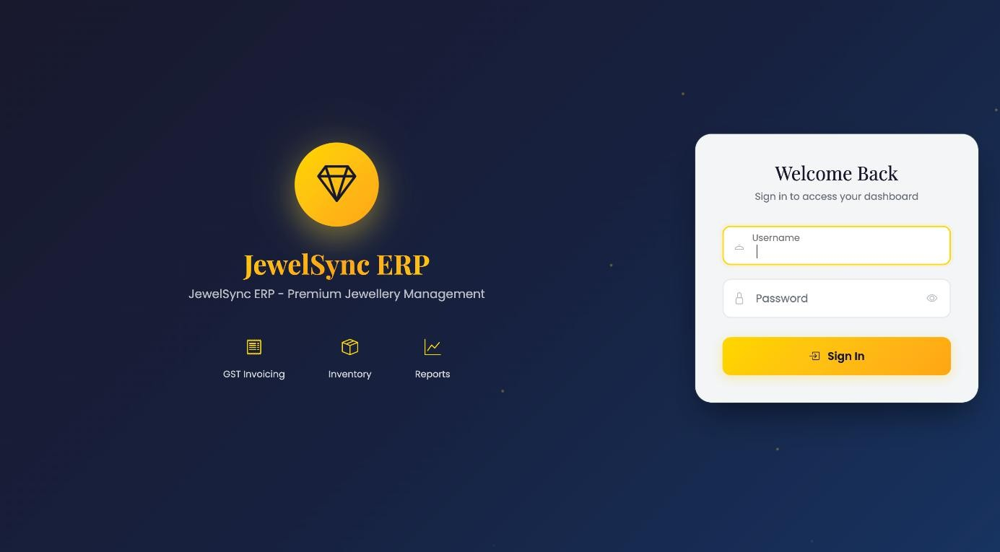

Figure 9.1: Login Page

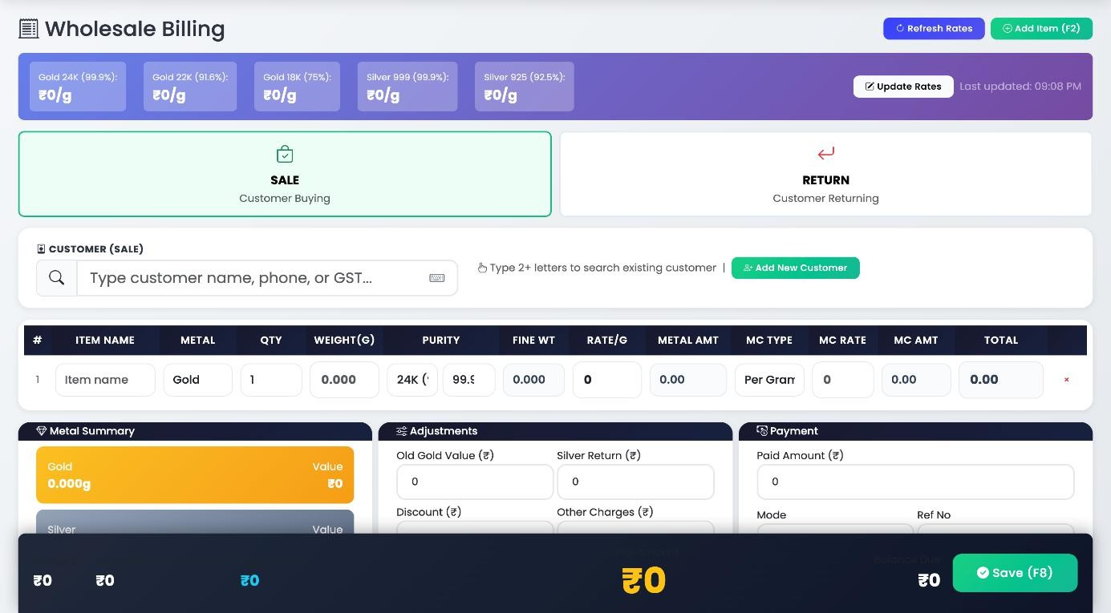

Figure 9.2: Billing Page

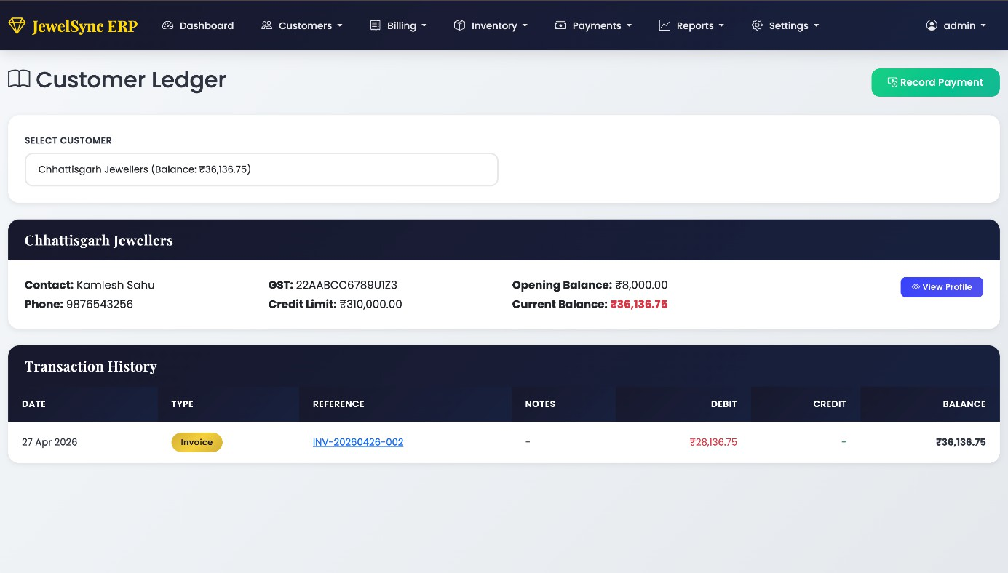

Figure 9.3: Customer Ledger

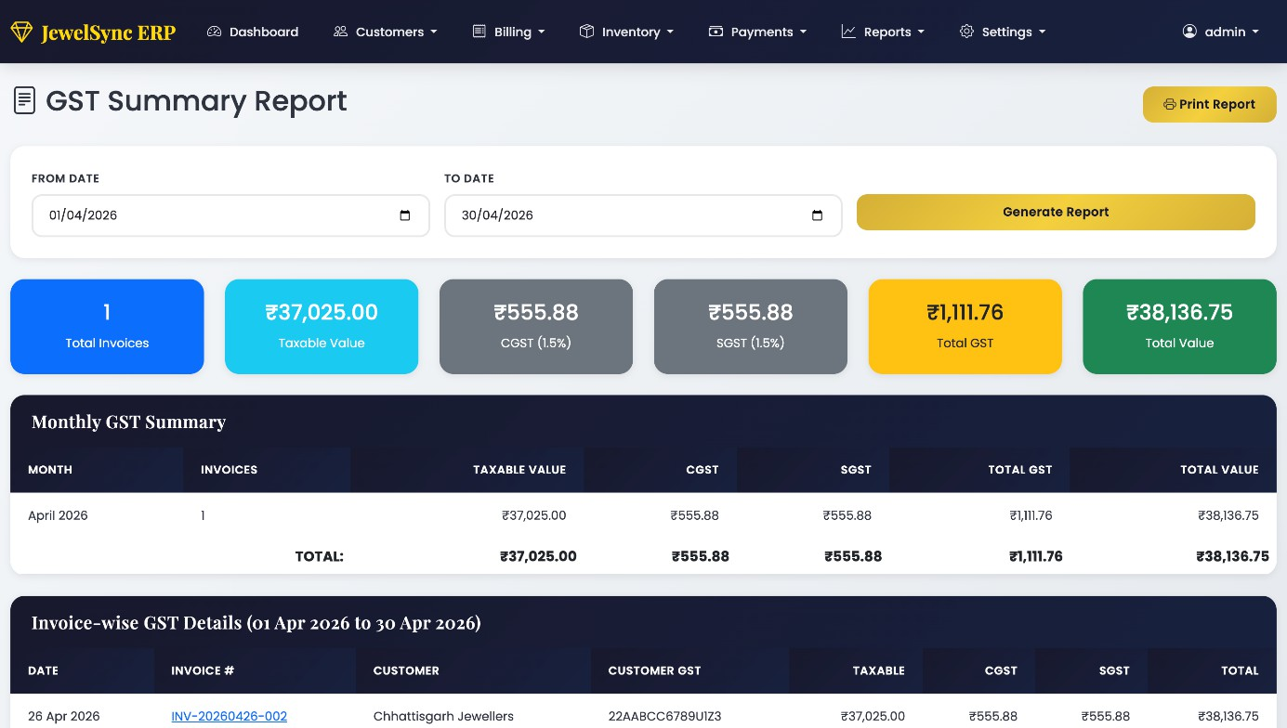

Figure 9.4: GST Summary

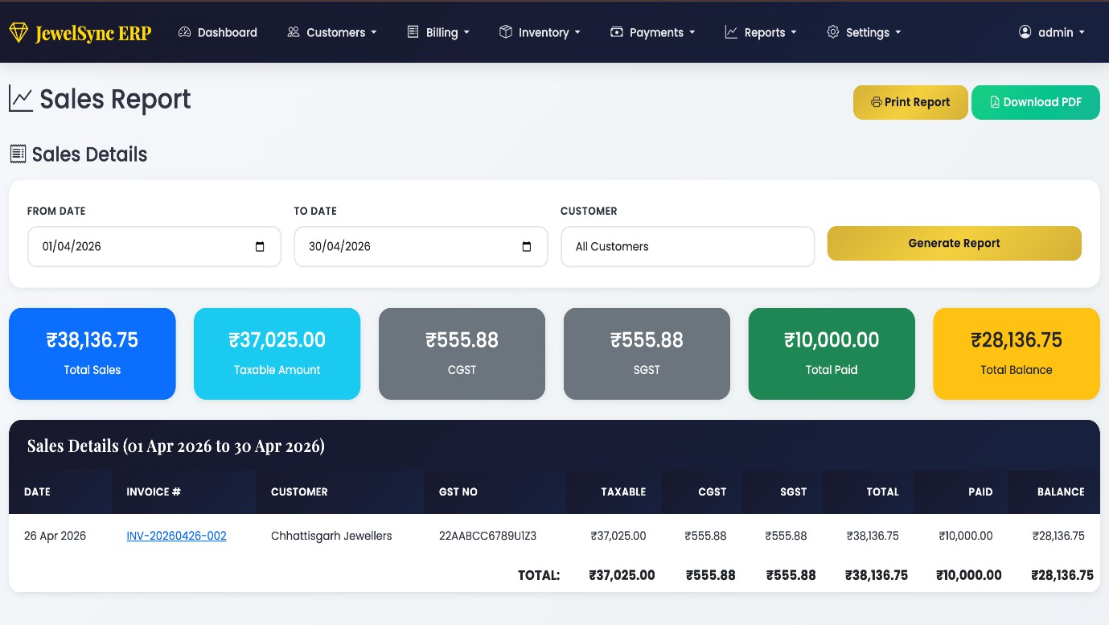

Figure 9.5: Sales Report

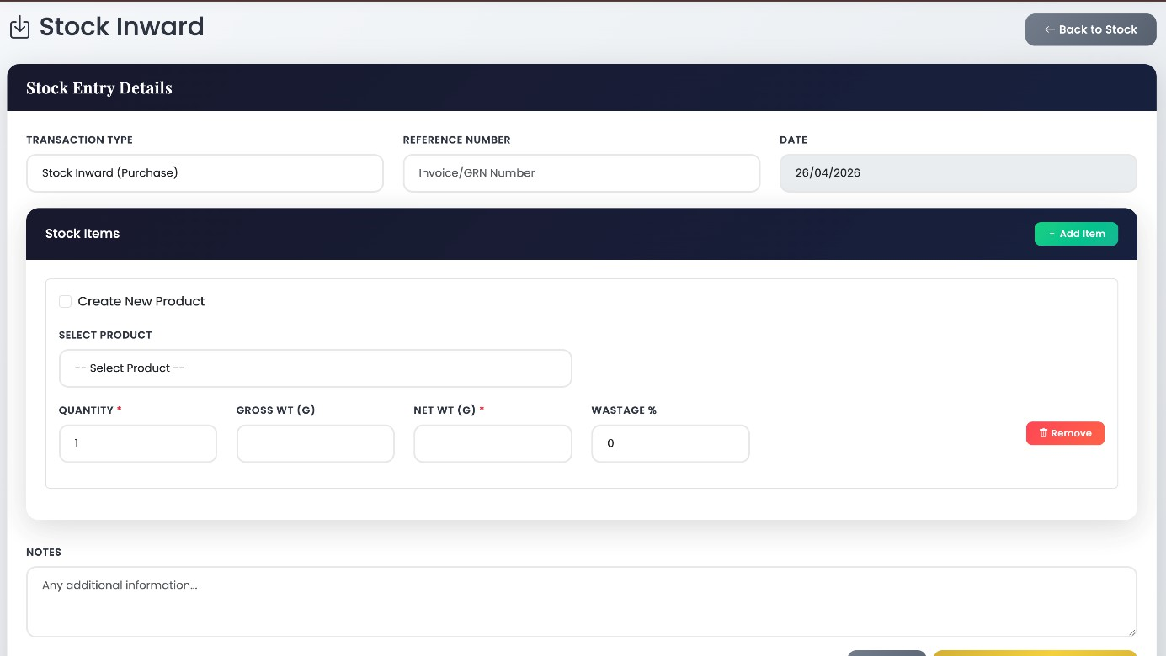

Figure 9.6: Stock Inward

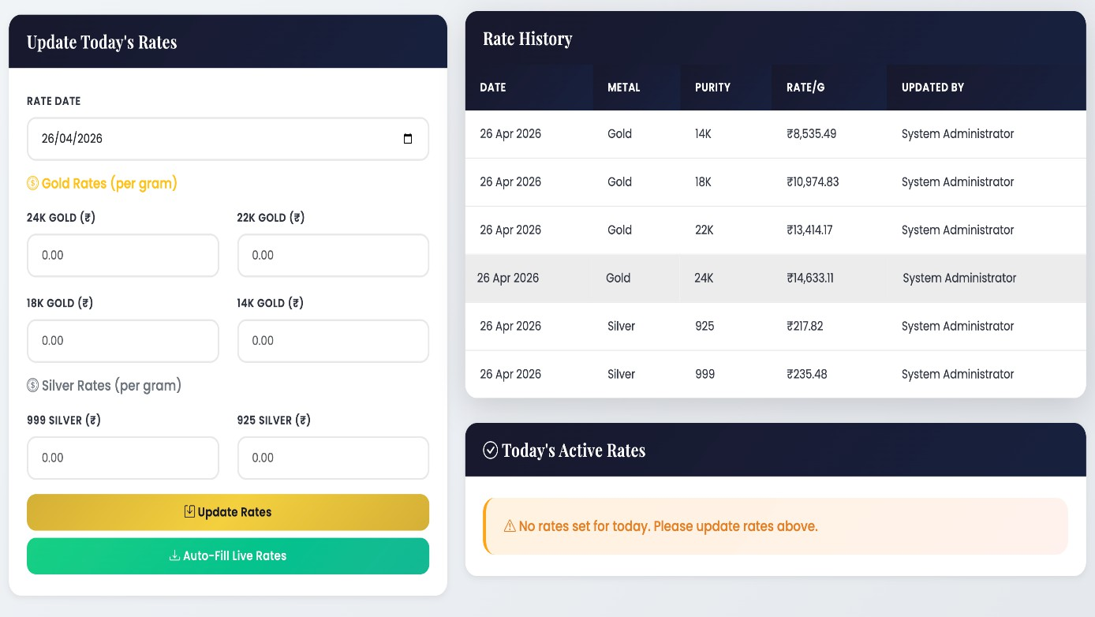

Figure 9.7: Live Rates

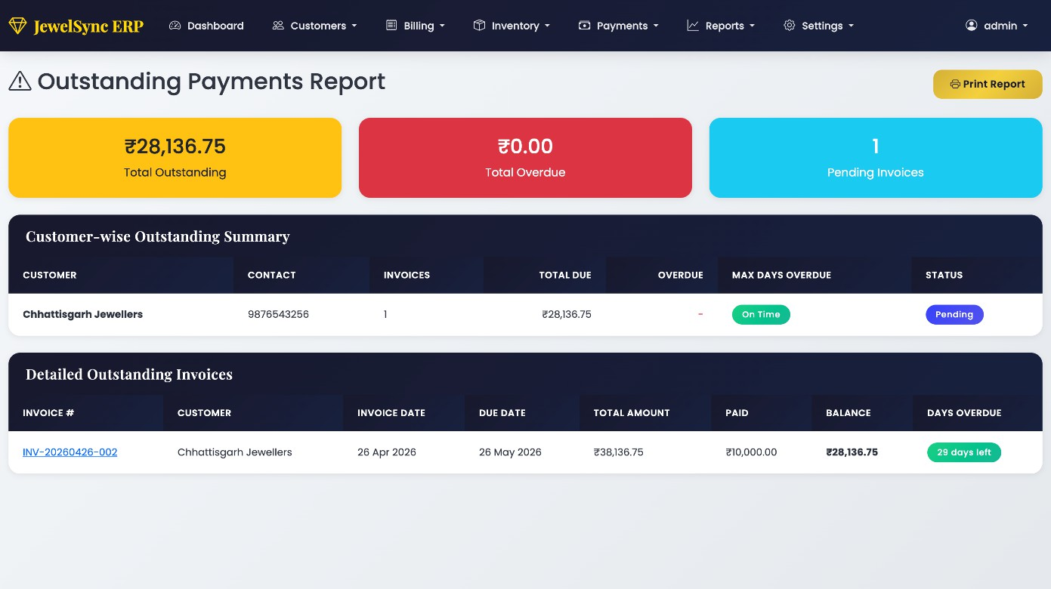

Figure 9.8: Outstanding Payments Reports

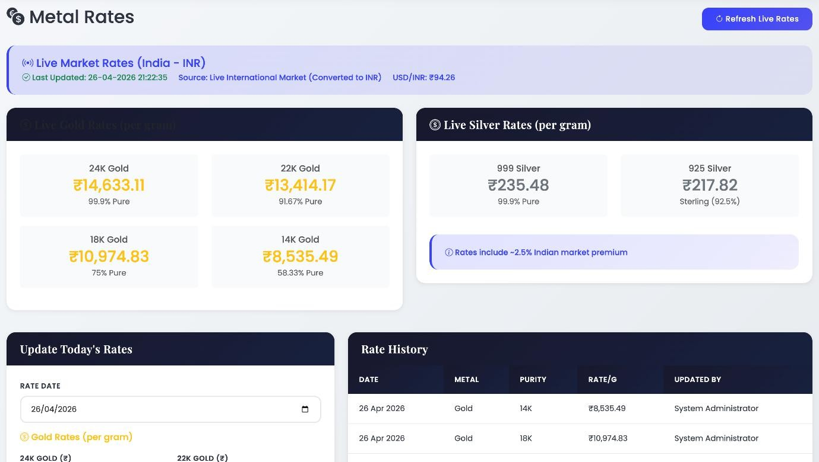

Figure 9.9: Metal Rates

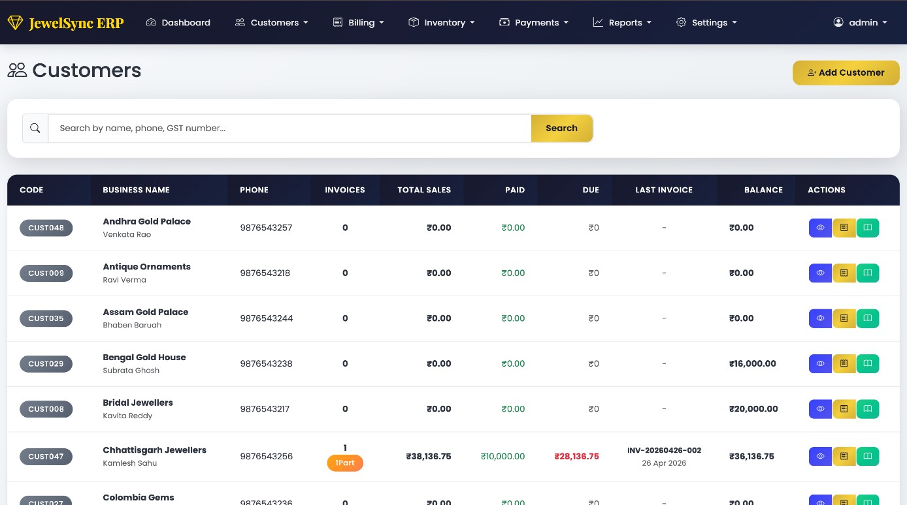

Figure 9.10: Customers

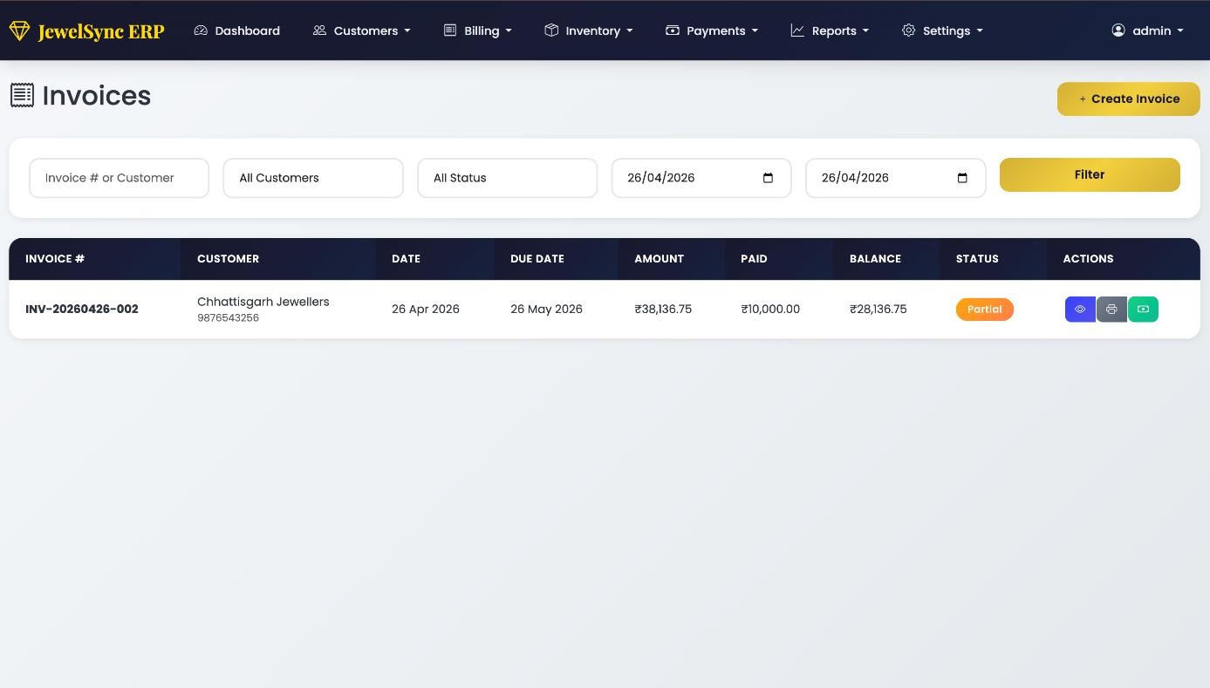

Figure 9.11: Invoices

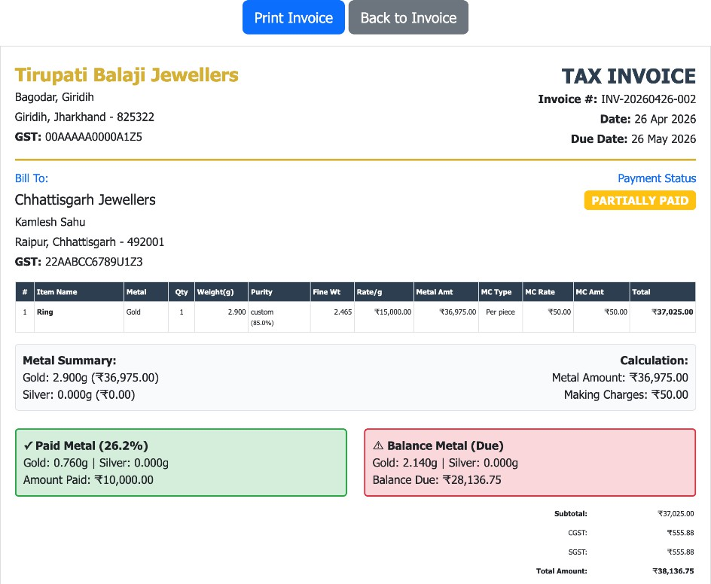

Figure 9.12: Print Invoice

CHAPTER 10 CONCLUSION AND FUTURE WORK

CONCLUSION

The Digital Jewellery ERP System with Weight-Based Billing and GST Compliance provides a comprehensive and automated solution for managing jewellery business operations efficiently. It bridges the gap between traditional manual practices and modern digital systems by offering a secure, centralized, and user-friendly platform that streamlines inventory management, billing, customer handling, and GST record maintenance.
By integrating key modules such as user authentication, inventory management, weight-based billing, GST-compliant invoice generation, and reporting features, the system ensures accurate calculations, improved data management, and faster business operations. The implementation of this system significantly reduces manual effort, minimizes errors, and enhances transparency in financial transactions.
Overall, the system contributes to the digital transformation of jewellery businesses by providing a reliable, scalable, and efficient platform. It improves operational productivity, supports better decision-making through organized data, and ensures compliance with taxation regulations, making it a valuable tool for modern jewellery business management.

  - FUTURE WORK

The Digital Jewellery ERP System has significant potential for future enhancements through the integration of advanced technologies. In the future, the system can incorporate Artificial Intelligence (AI) to analyze customer behavior, predict demand trends, and suggest optimized pricing strategies based on market conditions. Machine learning techniques can also be used to provide personalized recommendations and improve sales forecasting.
The integration of barcode or RFID technology can enable real-time inventory tracking and reduce manual effort in stock management. Additionally, a mobile application version of the system can be developed to provide easy access for business owners and staff, allowing them to manage operations anytime and anywhere.

Further improvements may include the implementation of cloud-based deployment for better scalability, data backup, and remote accessibility. Advanced data analytics dashboards can be introduced to provide insights into sales performance, inventory movement, and customer preferences. Integration with online payment gateways and e-commerce platforms can also expand business reach and improve customer experience.
Security enhancements such as biometric authentication and advanced encryption techniques can be implemented to protect sensitive business and customer data. Moreover, automated alert systems can be added to notify users about low stock levels, pending payments, and important transactions.
Through these advancements, the Digital Jewellery ERP System can evolve into a more intelligent, secure, and scalable platform, supporting long-term business growth and adapting to future technological developments.

REFERENCES

JOURNALS / RESEARCH PAPERS

- A. K. Sharma & R. Gupta (2021). “Enterprise Resource Planning Systems in Small and Medium Enterprises: Implementation and Benefits.” International Journal of Information Management, 58, 102–118.
- S. Patel & M. Shah (2020). “Web-Based Inventory Management System for Small Businesses.” International Journal of Computer Applications, 176(39), 15–20.
- P. Singh & V. Kumar (2019). “Design and Development of Automated Billing System Using Web Technologies.” International Journal of Engineering Research & Technology (IJERT), 8(6), 234–238.

BOOKS

- Pressman, R. S., & Maxim, B. R. (2015). Software Engineering: A Practitioner’s Approach.
McGraw-Hill, 8th Edition.
- Silberschatz, A., Korth, H. F., & Sudarshan, S. (2010). Database System Concepts. McGraw-Hill, 6th Edition.
- Laudon, K. C., & Laudon, J. P. (2020). Management Information Systems: Managing the Digital Firm. Pearson, 16th Edition.

WEBSITES

- https://www.gst.gov.in/ — Official GST portal of India, used for understanding GST rules, invoice formats, and tax compliance.
- https://dev.mysql.com/doc/ — Official MySQL documentation used for database design, queries, and data management.
- https://www.php.net/docs.php — Official PHP documentation used for backend development and server-side scripting.
- https://getbootstrap.com/docs/ — Official Bootstrap documentation used for designing responsive and user-friendly interfaces.

PROJECT SUMMARY

About Project

Title of the project | Digital Jewellery ERP System with Weight-Based Billing & GST Compliance
Semester | 8th Semester
Members | Adarsh Singh, Om Soni, Sankit Kumar Singh and Tanisha Dale
Team Leader | Adarsh Singh
Describe role of every member in the project | Adarsh Singh: Backend Development Om Soni: Frontend Development  Sankit Kumar Singh: Frontend Development / Project Management  Tanisha Dale: Backend Development / Database Manager
What is the motivation for selecting this project? | The motivation for selecting the Digital Jewellery ERP System with Weight-Based Billing and GST Compliance project comes from the need to improve efficiency in jewellery business operations. Many shops still rely on manual methods, which often lead to errors in billing, inventory management, and GST calculations. Since jewellery billing involves complex factors like weight, purity, and making charges, manual calculations become time-consuming and error-prone. This project aims to provide a digital solution that automates these processes, ensures accuracy, and simplifies business management. It also offers practical exposure to web development and database  management while solving a real-world problem.
Project Type  (Desktop Application, Web Application, Mobile App, Web) | Web Application
Tools &Technologies

Programming language used | PHP (Backend), JavaScript (Frontend)
Compiler used (with version) | XAMPP Server, Version: 8.2.12

IDE used (with version) | Visual Studio Code, Version: 1.88.0
Front End Technologies (with version, wherever Applicable) | HTML5, CSS3, JavaScript (ES6), Bootstrap, Version: 5.3
Back End Technologies (with version, wherever applicable) | PHP (Version 8.2) – for building the backend services
Database used (with version) | MySQL, Version: 8.0
Software Design & Coding

SDLC model followed  (Waterfall, Agile, Spiral etc.) | Agile SDLC Model
Why above SDLC model is followed? | Agile allows iterative development and frequent updates, which suits web applications development and evolving  requirements.
Justify that the SDLC model mentioned above is followed in the project. | The project was developed in phases with regular updates and testing. Continuous feedback and improvements were incorporated, making Agile suitable for handling changes and  fixing issues efficiently.
Software Design approach followed  (Functional or Object Oriented) | Object-Oriented Approach
Name the diagrams developed (According to the Design approach followed) | Use Case Diagram, ER Diagram
In case Object Oriented approach is followed, which of the OOPS principles are covered in design? | Encapsulation – Information hiding and restricting access to certain components.  Abstraction – Hiding complexity by providing a simple interface.  Inheritance – Using parent-child relationships to reuse code and extend functionality.  Polymorphism – Allowing methods to behave differently  based on the objects they act upon.
No. of Tiers  (example 3-tier) | 3-tier Architecture:  Presentation Layer (Frontend) – Handles user interactions.

Business Logic Layer (Backend/Server) – Handles data processing and logic.
Data Layer (Database) – Manages data storage and retrieval.
Total no. of front-end pages | 15
Total no. of tables in database | 12
Database in which Normal Form? | Third Normal Form(3NF)
Are the entries in database encrypted? | Yes
Front end validations applied (Yes / No) | Yes
Session management done (in case of web applications) | Yes
Commenting done in code (Yes / No) | Yes
Exception handling done | Yes
Naming convention followed (Yes / No) | Yes
What difficulties faced during deployment of project? | Database connection setup, handling GST calculations, and integrating frontend with backend were the main challenges during deployment.
Total no. of Use-cases | 10
Give titles of Use-cases | User Registration, User Login, Add Product, Update Product, Manage Inventory, Generate Bill, GST Calculation, Customer Management, Generate Reports
Project Requirements

MVC architecture followed (Yes / No) | Yes
If yes, write the name of MVC architecture followed (MVC-1, MVC-2) | MVC-2
Design Pattern used (Yes / No) | Yes
If yes, write the name of Design Pattern used | Singleton

Interface type (CLI / GUI) | Graphical User Inteface (Web Application Interface)
No. of Actors | 2
Name of Actors | Admin and Staff/User
Total no. of Functional Requirements | 12
List few important non-Functional Requirements | Performance, Security, Availability, Usability and Scalability
Testing

Which testing is performed?  (Manual or Automation) | Manual testing is performed
Is Beta testing done for this  project? | Yes (Tested on web browsers)

Write project narrative covering above mentioned points
The Digital Jewellery ERP System with Weight-Based Billing and GST Compliance is a web-based application designed to efficiently manage jewellery business operations, including inventory, customer records, and billing. It automates complex calculations based on metal weight, purity, making charges, and GST, ensuring accuracy and transparency in transactions. The system follows MVC architecture and Object-Oriented Design principles such as encapsulation and abstraction, making it scalable, maintainable, and structured. It is developed using technologies like HTML, CSS, JavaScript, PHP, and MySQL to provide a reliable and user-friendly interface. Using the Agile development approach, the system is built with continuous improvements and testing. Manual and beta testing ensure that the application performs effectively in real-world scenarios, with a focus on usability,
performance, and data security.

Adarsh Singh 0187CS221018
Om Soni 0187CS221143
Sankit Kumar Singh 0187CS221177 Tanisha Dale 0187CS221203

Guide Signature Dr. Shweta Singh

APPENDIX-1 GLOSSARY OF TERMS

(In alphabetical order)

A

AUTOMATED SYSTEM

A system that performs tasks automatically with minimal human intervention.

API Application Programming Interface, a set of tools and protocols for communication between frontend and backend systems.
D
DATABASE A structured collection of data stored electronically for easy access and management.
E
ERP A software system used to manage and integrate core business processes such as inventory, billing, and customer management.
F
FRONT-END The user-facing part of the system.
G
GST An indirect tax applied on the supply of goods and services in India.
GST COMPLIANCE Ensuring that all billing and transactions follow the rules and regulations defined under GST.

I

INVENTORY MANAGEMENT

The process of tracking, managing, and controlling stock levels of jewellery items.

INVOICE A document generated for a transaction that includes details of products, pricing, taxes, and total amount.
L
LEDGER A record that maintains all financial transactions related to a customer or business.
P
PURITY The proportion of pure metal in a jewellery item, usually expressed in karats (e.g., 22K, 18K).

PAYMENT The process of transferring funds for approved leases, tracked and recorded in the system.
R
REAL-TIME DATA Information that is updated instantly without delay after any transaction or operation.

REPORT

GENERATION

ROLE-BASED ACCESS
S

STOCK

MANAGEMENT
U

USSER

AUTHENTICATION
W
The process of creating summaries such as sales reports, stock reports, and payment reports for analysis.
A security mechanism that allows access to system features based on user roles such as admin or staff.

The process of monitoring and updating available quantities of jewellery items.

The process of verifying a user’s identity to grant secure access to the system.

WASTAGE The percentage of metal lost during the jewellery-making process, included in pricing calculations.

WEIGHT-BASED BILLING
A pricing method where the cost of jewellery is calculated based on its weight, purity, and making charges.

