Java Backend Interview Assignment:
1. Create a Java SpringBoot Application.
2. Project Structure is required for ease of maintainability and readability.
3. Explore api for Client (Example: to be test via Postman. Please provide the Postman Collection.)
4. Each api required to log REQUEST &amp; RESPONSE info into logs file.
5. Your project able connect to database, preferred with MSSQL database (Using Local Machine DB,
DB name: TESTDB).
- @transactional is required implement in the project. (For http Methos: INSERT, UPDATE, GET
method)
6. Explore 1 GET method api with Pagination (Each Page 10 records)
7. Explore an api which will nested calling another api from 3rd party.
Example: Postman/Client &gt; Your API Endpoint &gt; calling another api
You are able to upload the assignment to a public git folder and share the URL for us to review.

Project structure and prerequisites:
- Java 21
- Springboot 3.X.X
- Mysql or MSSQL

Recommended structure
Project Name : Maybank-GTDCards/
├─ src/main/java/com/maybank
│ ├─ MaybankGtdCardsApplication.java
│ ├─ config/
│ │ ├─ DatabaseConfig.java # Optional, mostly use application.properties
│ │ ├─ LoggingConfig.java # Logback configuration (inline or file)
│ │ └─ WebClientConfig.java # For 3rd-party API calls
│ ├─ interceptor/
│ │ └─ RequestResponseLoggingFilter.java # Logs request/response
│ ├─ controller/
│ │ └─ CustomerController.java
│ ├─ service/
│ │ └─ CustomerService.java
│ ├─ repository/
│ │ └─ CustomerRepository.java
│ ├─ model/
│ │ └─ Customer.java
│ ├─ dto/
│ │ ├─ ApiResponse.java
│ │ └─ CreateCustomerRequest.java
│ ├─ client/
│ │ └─ ExchangeRateClient.java # Example 3rd-party nested call
│ └─ exception/
│ ├─ GlobalExceptionHandler.java
│ └─ ResourceNotFoundException.java
├─ src/main/resources/
│ ├─ application.properties
│ └─ logback-spring.xml
├─ pom.xml

Prerequisites
- MSSQL Server running locally with database TESTDB and SQL authentication.
- Create login and user with appropriate privileges.
- Dev tools: Java 21, Maven, Postman.
Maven configuration
xml
<!-- pom.xml -->
<?xml version="1.0" encoding="UTF-8"?>
<project xmlns="http://maven.apache.org/POM/4.0.0"
xmlns:xsi="http://www.w3.org/2001/XMLSchema-instance"
xsi:schemaLocation="http://maven.apache.org/POM/4.0.0 https://maven.apache.org/xsd/maven-4.0.0.xsd">
<modelVersion>4.0.0</modelVersion>

<!-- ✅ Only ONE parent, aligned with Spring Boot 3.3.2 -->
<parent>
<groupId>org.springframework.boot</groupId>
<artifactId>spring-boot-starter-parent</artifactId>
<version>3.3.2</version>
<relativePath/> <!-- lookup parent from repository -->
</parent>

<groupId>com.maybank</groupId>
<artifactId>MayBankGtdCard-Mssql-Mysql-Demo</artifactId>
<version>0.0.1-SNAPSHOT</version>
<name>Maybank-GTDCards</name>
<description>Spring Boot Demo</description>

<properties>
<java.version>21</java.version>
</properties>

<dependencies>
<!-- Core Spring Boot starters -->
<dependency>
<groupId>org.springframework.boot</groupId>
<artifactId>spring-boot-starter-web</artifactId>
</dependency>
<dependency>
<groupId>org.springframework.boot</groupId>
<artifactId>spring-boot-starter-validation</artifactId>
</dependency>
<dependency>
<groupId>org.springframework.boot</groupId>
<artifactId>spring-boot-starter-data-jpa</artifactId>
</dependency>

<!-- Databases -->
<!-- <dependency>
<groupId>com.microsoft.sqlserver</groupId>
<artifactId>mssql-jdbc</artifactId>
<version>12.6.1.jre17</version>
</dependency>-->
<dependency>
<groupId>com.mysql</groupId>
<artifactId>mysql-connector-j</artifactId>
<version>8.0.33</version>
<scope>runtime</scope>
</dependency>

<!-- Reactive WebClient -->
<dependency>
<groupId>org.springframework.boot</groupId>
<artifactId>spring-boot-starter-webflux</artifactId>
</dependency>

<!-- Lombok -->
<dependency>
<groupId>org.projectlombok</groupId>
<artifactId>lombok</artifactId>
<optional>true</optional>
</dependency>

<!-- Devtools -->
<dependency>
<groupId>org.springframework.boot</groupId>
<artifactId>spring-boot-devtools</artifactId>
<scope>runtime</scope>
<optional>true</optional>
</dependency>

<!-- Testing -->
<dependency>
<groupId>org.springframework.boot</groupId>
<artifactId>spring-boot-starter-test</artifactId>
<scope>test</scope>
</dependency>
</dependencies>

<build>
<plugins>
<plugin>
<groupId>org.apache.maven.plugins</groupId>
<artifactId>maven-compiler-plugin</artifactId>
<configuration>
<annotationProcessorPaths>
<path>
<groupId>org.projectlombok</groupId>
<artifactId>lombok</artifactId>
</path>
</annotationProcessorPaths>
</configuration>
</plugin>
<plugin>
<groupId>org.springframework.boot</groupId>
<artifactId>spring-boot-maven-plugin</artifactId>
</plugin>
</plugins>
</build>
</project>
Configuration files
application.properties

# ==============================
# Server configuration
# ==============================
server.port=8080

# ==============================
# SQL Server Datasource (default)
# ==============================
#spring.datasource.url=jdbc:sqlserver://localhost:1433;databaseName=TESTDB;encrypt=false
#spring.datasource.username=sa
#spring.datasource.password=yourStrong(!)Password
#spring.datasource.driver-class-name=com.microsoft.sqlserver.jdbc.SQLServerDriver

# ==============================
# MySQL Datasource (alternative)
# ==============================
# comment these lines if you want to use MySQL instead of SQL Server
spring.datasource.url=jdbc:mysql://localhost:3306/testdb
spring.datasource.username=root
spring.datasource.password=root
spring.datasource.driver-class-name=com.mysql.cj.jdbc.Driver

# JPA / Hibernate
spring.jpa.hibernate.ddl-auto=update
spring.jpa.show-sql=true
spring.jpa.database-platform=org.hibernate.dialect.MySQL8Dialect
spring.jpa.properties.hibernate.format_sql=true

# ==============================
# Jackson configuration
# ==============================
#spring.jackson.serialization.write-dates-as-timestamps=false

# ==============================
# Logging configuration
# ==============================
logging.level.root=INFO
logging.level.org.springframework.web.filter.CommonsRequestLoggingFilter=INFO
logging.level.com.example.demo=DEBUG
logging.file.name=logs/app.log

Endpoints :-
Endpoint | Method | Purpose | Notes
/api/customers/{id} | GET | Fetch customer by ID | Transactional read-only
/api/customers | GET | Pagination list | Default size=10; use page param
/api/customers | POST | Create customer | Transactional; validates name/email
/api/customers/{id} | PUT | Update customer | Transactional; prevents duplicate emails
/api/customers/{id}/with-rate | GET | Nested 3rd-party call | Combines customer with USD-INR rate

Postman collection:-
Import this JSON in Postman. Adjust host/port if needed.
{
"info": {
"_postman_id": "a1d12fb4-2da7-4179-b00d-e6b1f0a52537",
"name": "SpringBoot MSSQL Demo",
"description": "Collection to test Customer APIs with logging, transactions, pagination, and nested API call.",
"schema": "https://schema.getpostman.com/json/collection/v2.1.0/collection.json",
"_exporter_id": "50502566",
"_collection_link": "https://mvr-rajendran-2914809.postman.co/workspace/Rajendran-M~91108527-1ddb-4839-99d1-1eb3a97866c6/collection/50502566-a1d12fb4-2da7-4179-b00d-e6b1f0a52537?action=share&source=collection_link&creator=50502566"
},
"item": [
{
"name": "Get Customer by ID",
"request": {
"method": "GET",
"header": [],
"url": {
"raw": "http://localhost:8080/api/customers/1",
"protocol": "http",
"host": [
"localhost"
],
"port": "8080",
"path": [
"api",
"customers",
"1"
]
}
},
"response": []
},
{
"name": "List Customers (Pagination)",
"request": {
"method": "GET",
"header": [],
"url": {
"raw": "http://localhost:8080/api/customers?page=0&size=10",
"protocol": "http",
"host": [
"localhost"
],
"port": "8080",
"path": [
"api",
"customers"
],
"query": [
{
"key": "page",
"value": "0"
},
{
"key": "size",
"value": "10"
}
]
}
},
"response": []
},
{
"name": "Create Customer",
"request": {
"method": "POST",
"header": [
{
"key": "Content-Type",
"value": "application/json"
}
],
"body": {
"mode": "raw",
"raw": "{\n \"name\": \"Rajendran\",\n \"email\": \"rajendran@example.com\"\n}"
},
"url": {
"raw": "http://localhost:8080/api/customers",
"protocol": "http",
"host": [
"localhost"
],
"port": "8080",
"path": [
"api",
"customers"
]
}
},
"response": []
},
{
"name": "Update Customer",
"request": {
"method": "PUT",
"header": [
{
"key": "Content-Type",
"value": "application/json"
}
],
"body": {
"mode": "raw",
"raw": "{\n \"name\": \"Rajendran M\",\n \"email\": \"rajendran.m@example.com\"\n}"
},
"url": {
"raw": "http://localhost:8080/api/customers/1",
"protocol": "http",
"host": [
"localhost"
],
"port": "8080",
"path": [
"api",
"customers",
"1"
]
}
},
"response": []
},
{
"name": "Get Customer with USD-INR rate",
"request": {
"method": "GET",
"header": [],
"url": {
"raw": "http://localhost:8080/api/customers/1/with-rate",
"protocol": "http",
"host": [
"localhost"
],
"port": "8080",
"path": [
"api",
"customers",
"1",
"with-rate"
]
}
},
"response": []
}
]
}
Database :
mysql> create database testdb;
Query OK, 1 row affected (0.02 sec)

mysql> show databases;
+--------------------+
| Database |
+--------------------+
| information_schema |
| mysql |
| performance_schema |
| sys |
| testdb |
+--------------------+
5 rows in set (0.02 sec)

mysql> use testdb;
Database changed

mysql> CREATE TABLE customers (
-> id BIGINT AUTO_INCREMENT PRIMARY KEY,
-> name VARCHAR(100) NOT NULL,
-> email VARCHAR(150) NOT NULL UNIQUE,
-> created_at TIMESTAMP NOT NULL DEFAULT CURRENT_TIMESTAMP
-> );
Query OK, 0 rows affected (0.14 sec)
mysql> SHOW COLUMNS FROM customers;
+------------+--------------+------+-----+-------------------+-------------------+
| Field | Type | Null | Key | Default | Extra |
+------------+--------------+------+-----+-------------------+-------------------+
| id | bigint | NO | PRI | NULL | auto_increment |
| name | varchar(100) | NO | | NULL | |
| email | varchar(150) | NO | UNI | NULL | |
| created_at | timestamp | NO | | CURRENT_TIMESTAMP | DEFAULT_GENERATED |
+------------+--------------+------+-----+-------------------+-------------------+
4 rows in set (0.00 sec)
mysql> select * from customers;
+----+-----------+---------------------+---------------------+
| id | name | email | created_at |
+----+-----------+---------------------+---------------------+
| 1 | Rajendran | rajendran@gmail.com | 2025-12-03 23:07:55 |
+----+-----------+---------------------+---------------------+
1 row in set (0.00 sec)

POST : http://localhost:8080/api/customers
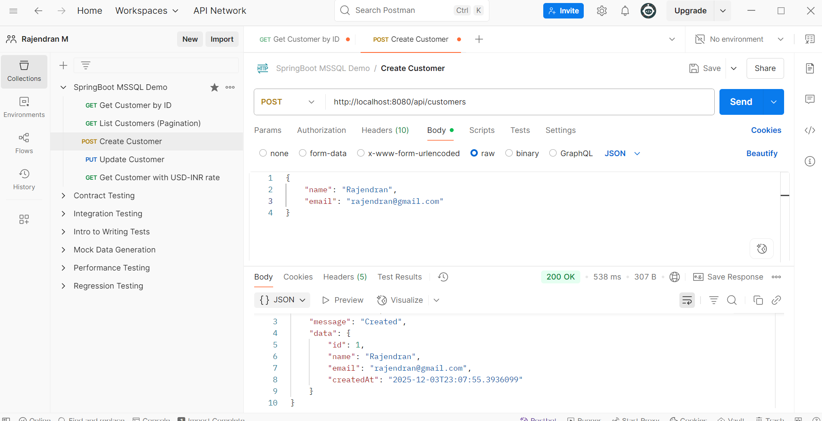
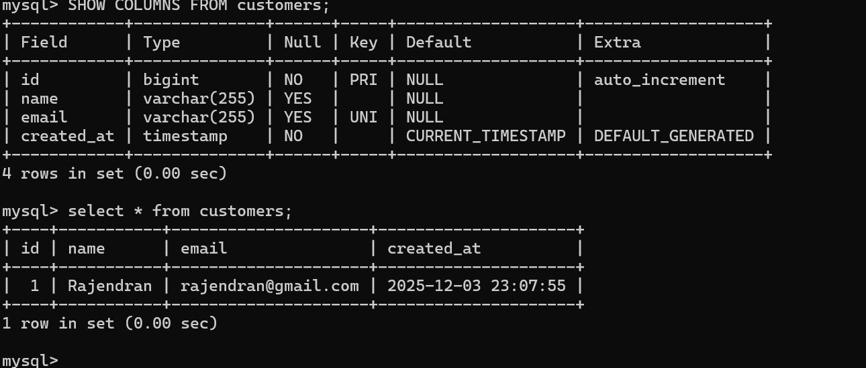

GET: http://localhost:8080/api/customers/1
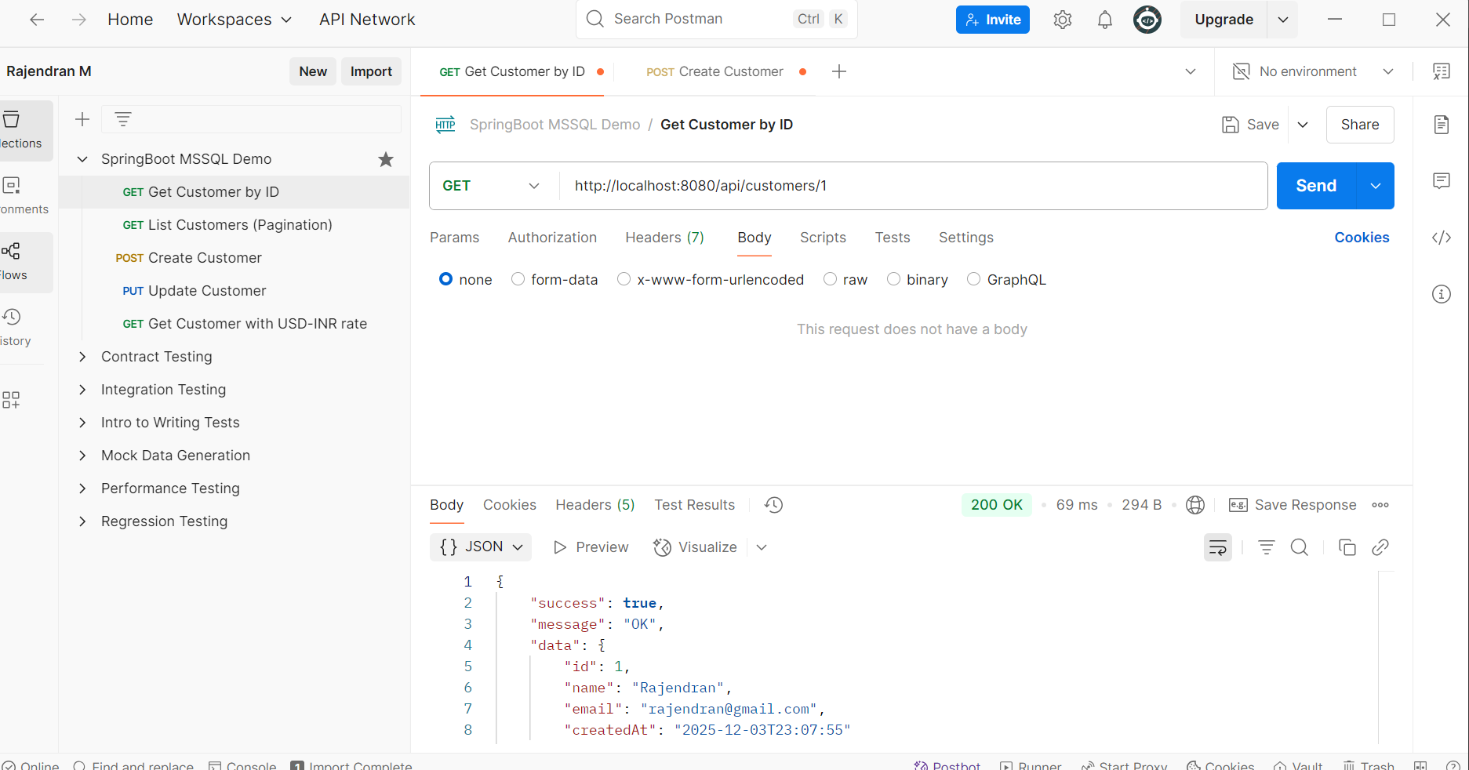

Pagination:
GET: http://localhost:8080/api/customers?page=0&size=10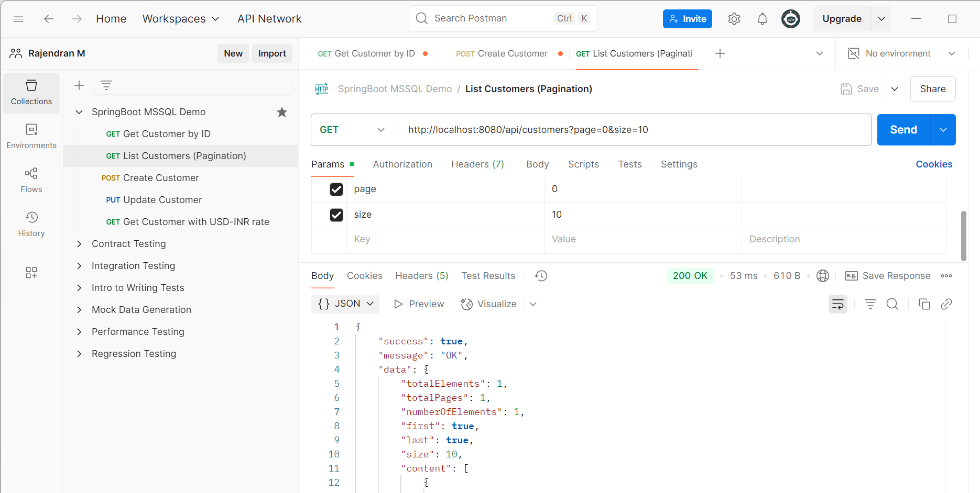
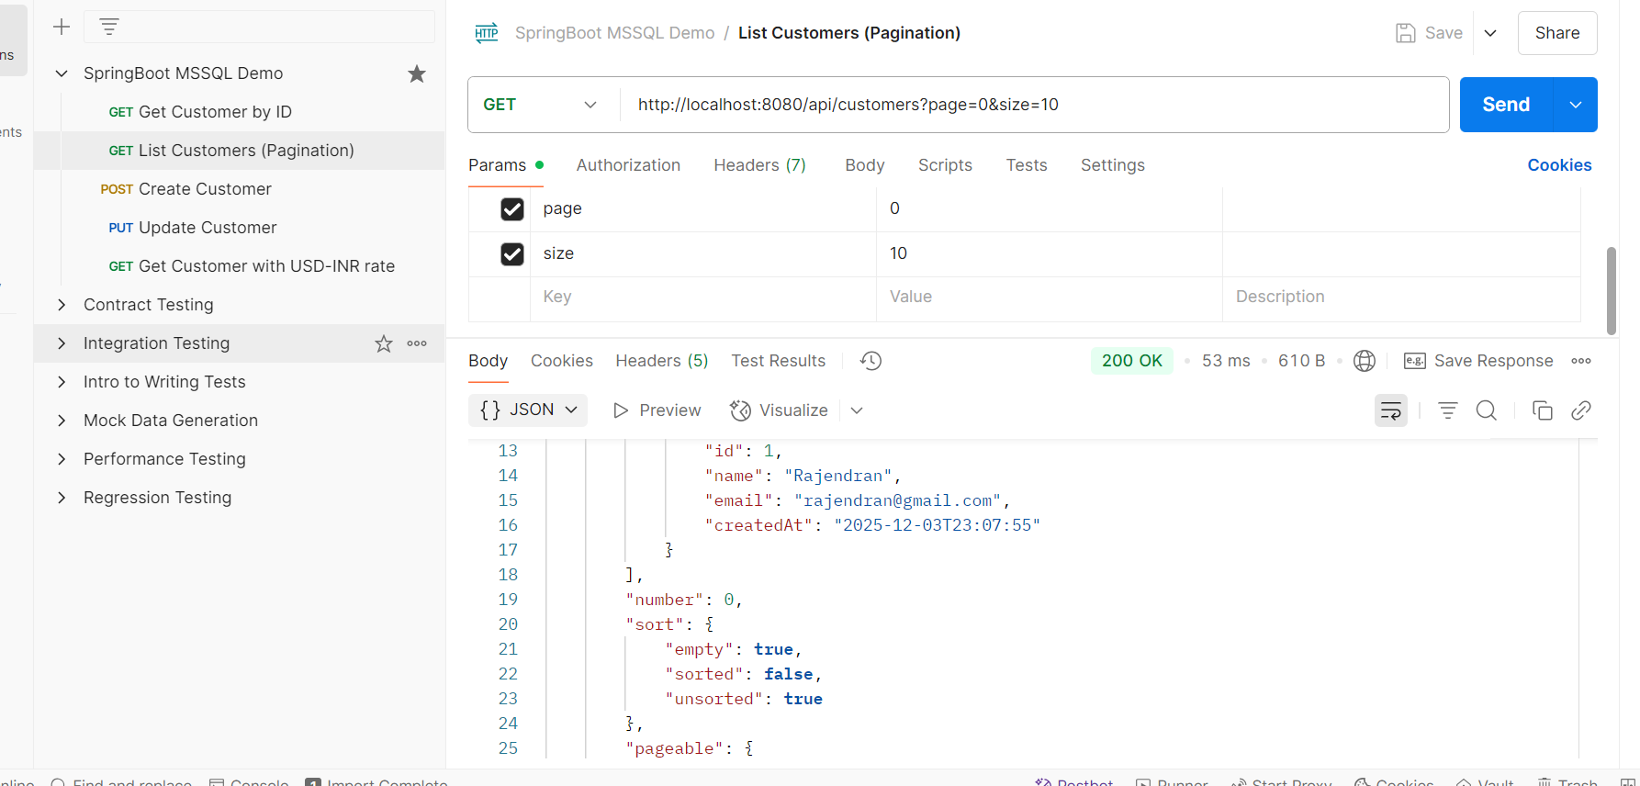
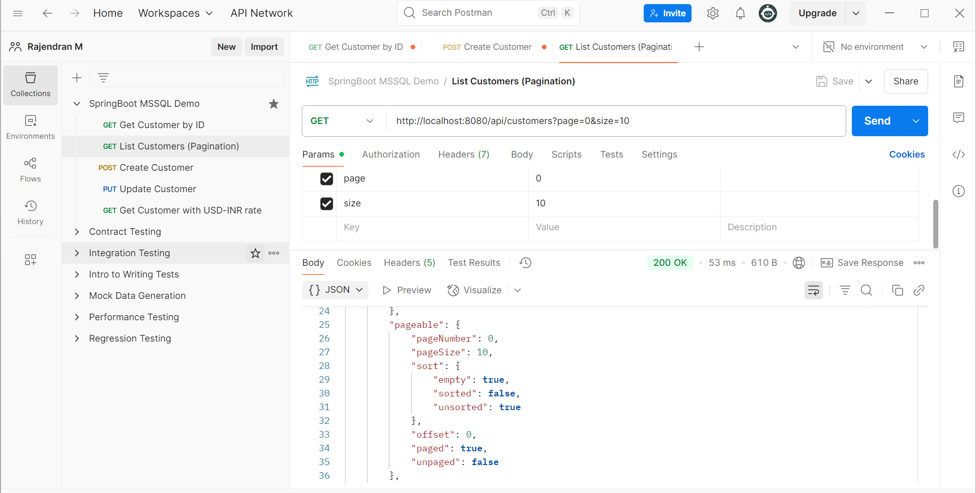
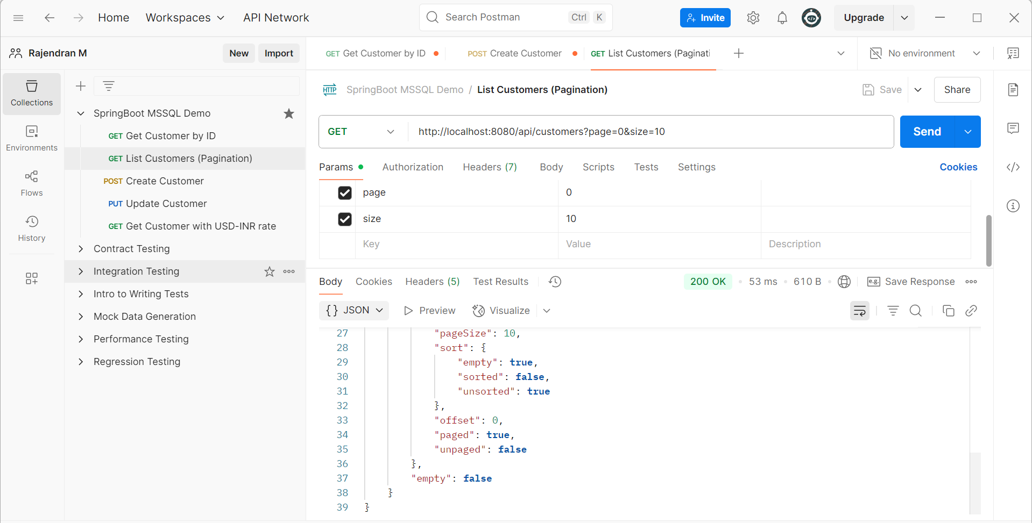
PUT: http://localhost:8080/api/customers/1
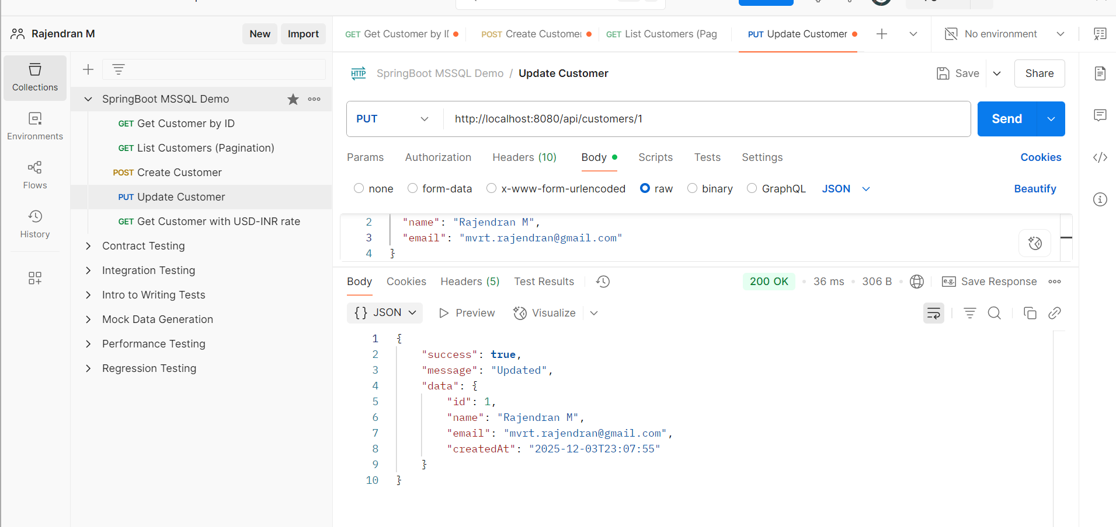

GET: http://localhost:8080/api/customers/1/with-rate

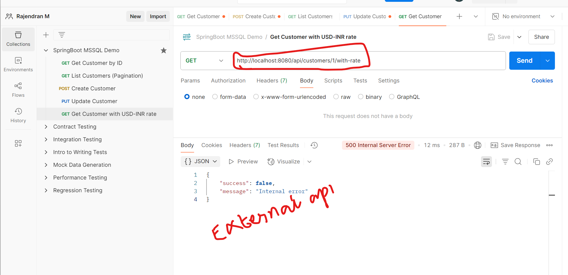

Thank you for giving me this opportunity. Welcome!

