wjISQL 1.20.4

Installation Test Plan

Change History
SNO | Version | Date | By | Description
1 | 01 | 2016-12-19 | Mvsagar | Created.
2 | 02 | 2018-10-17 | mvsagar | Removed Test Status from each test as the tests have been automated using Selenium.

Table of Contents
1 Introduction 1
1.1 Abbreviations 1
1.2 Prerequisites for all Tests 1
2 Installation Test Cases 2
2.1 Successful Test Cases 2
2.2 Unsuccessful Test Cases 3

Introduction

Abbreviations
None

Prerequisites for all Tests

1 | Ubuntu OS version 16.04 LTS on your test machine or Windows 7
2 | Apache Tomat version 7.0.63 is already installed on the machine.
3 | Java JRE 1.7.0_79 is already installed on the machine.
4 | Google Chrome browser 54.0.x.x or a later version is available.
5 | Mozilla FireFox browser 50.1.0 or a later version is available.
6 | Port number 8080 is available. Othewise configure Tomcat to use a different port number.
7 | Tomcat server is in shutdown state.

Installation Test Cases

Successful Test Cases

Test Case 1/1:: Test installation of wjISQL.
Test Prerequisites:
None.
Test Procedure:
1 | Copy wjisql.war to "webapps" folder of the apache tomcat.
2 | Delete "wjisql" folder, if any, from the webapps folder.
3 | Delete "work" folder from Tomcat home directory.
4 | Start apache tomcat web server.

Test Case 2/2:: Test installation of wjISQL using Chrome browser
Test Prerequisites:
1 | Successful test case 1.

Test Procedure:
1 | Enter "http://localhost:8080/wjisql" on web page address field of Chrome browser.

Test Expected o/p:
1 | Display of wjISQL main page as shown below:  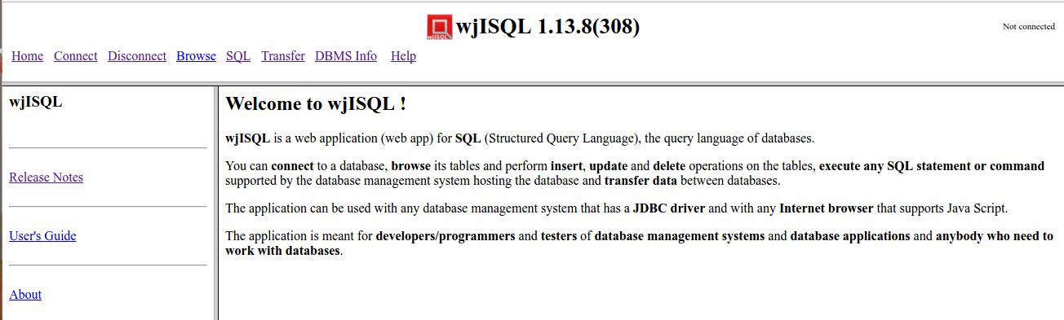

Test Case 3/3:: Test installation of wjISQL using Firefox browser
Test Prerequisites:
1 | Successful test case 1.

Test Procedure:
1 | Enter "http://localhost:8080/wjisql" on web page address field of Mozilla Firefox browser.

Test Expected o/p:
1 | Display of wjISQL main page as shown below:  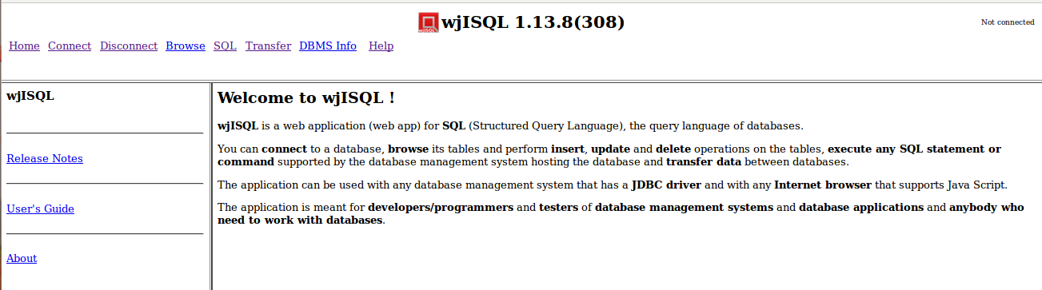

Unsuccessful Test Cases
None.

