wjISQL 1.20.4

Main Screen Test Plan

Change History
SNO | Version | Date | By | Description
1 | 1 | 2016-12-20 | mvsagar | Created.
2 | 2 | 2018-10-17 | mvsagar | Removed test status for each test as tests have been automated using Selenium.

Table of Contents
1 Introduction 1
1.1 Prerequisites for all Tests 1
2 Main Screen Component Presence Test Cases 1
2.1 Successful Test Cases 1
2.2 Unsuccessful Test Cases 3
3 Navigation Menu Items Test Cases 3
3.1 Successful Test Cases 3
3.2 Unsuccessful Test Cases 8
4 Left Bar Menu Items Test Cases 8
4.1 Successful Test Cases 8
4.2 Unsuccessful Test Cases 9

Introduction
This test plan has test cases for testing the main or the first screen of the wjISQL web app.

Prerequisites for all Tests

1 | Installation test is successful.
2 | Main screen is of wjISQL is currently shown in the browser. Otherwise, enter "http://localhost:8080/wjisql" in the browser address field.

Main Screen Component Presence Test Cases

Successful Test Cases

Test Case 1/1: Check for top line for wjISQL name and version details
Test Procedure
1 | Observe the very first or top line on the main screen

Test Expected o/p:
1 | Top line should contain logo, name and version and message as following:

Test Case 2/2:: Check for top line for database connection status message
Test Procedure
1 | Observe right side message on the very first or top line of the main screen

Test Expected o/p:
1 | Top line should contain message "Not connected"

Test Case 3/3:: Check for correctness of Navigation menu
Test Procedure
1 | Observe navigation menu items below the top line

Test Expected o/p:
1 | The navigation menu should be as following with 8 menu items:

Test Case 4/4:: Check for correctness of left side bar of the screen
Test Procedure
1 | Observe left side bar for details.

Test Expected o/p:
1 | The left bar should contain name wjISQL and 3 menu items as following:  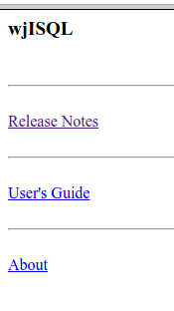

Test Case 5/5:: Check for correctness of right side of the screen
Test Procedure
1 | Observe right side of the screen for details.

Test Expected o/p:
1 | The right side of the screen should contain information about wjISQL as following:  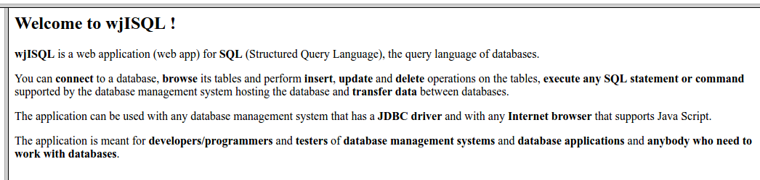

Unsuccessful Test Cases

None.

Navigation Menu Items Test Cases

Successful Test Cases

Test Case 1/6:: Test menu item Home.
Test Procedure
1 | Click button Home

Test Expected o/p:
1 | Entire screen is refreshed without any difference in its contents.

Test Case 2/7:: Test menu item Connect.
Test Procedure
1 | Click button Connect

Test Expected o/p:
1 | Right side part of the screen should contain Database login window as shown below:  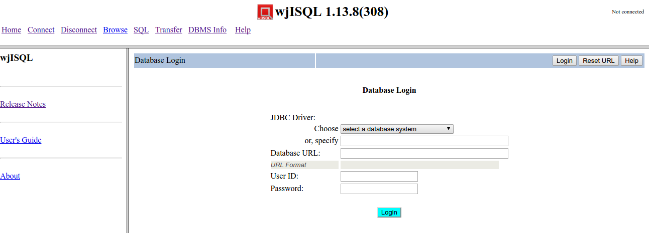

Test Case 3/8:: Test menu item Disconnect.
Test Procedure
1 | Click button Disconnect

Test Expected o/p:
1 | Right side part of the screen should contain message saying no database is active as shown below:  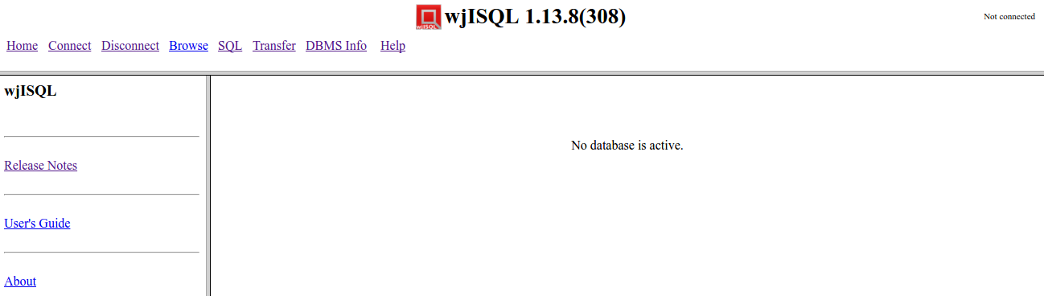

Test Case 4/9:: Test menu item Browse.
Test Procedure
1 | Click button Browse

Test Expected o/p:
1 | Right side part of the screen should contain message saying no active database connection exists as shown below:  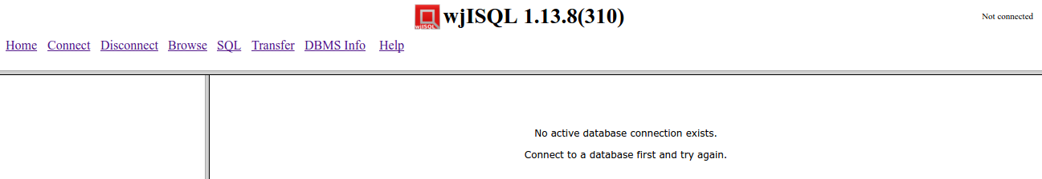

Test Case 5/10:: Test menu item SQL.
Test Procedure
1 | Click button SQL

Test Expected o/p:
1 | Right side part of the screen should contain an SQL Statement(s) window and a window with a message saying no active database connection exists as shown below:  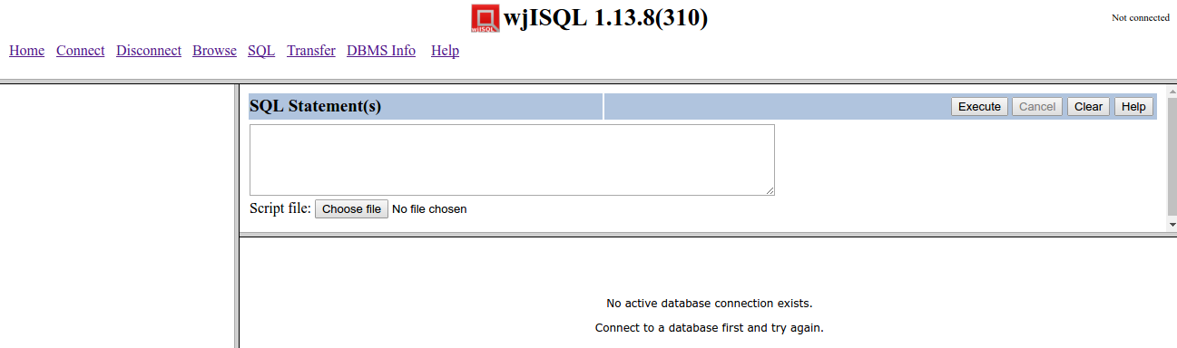

Test Case 6/11:: Test menu item Transfer.
Test Procedure
1 | Click button Transfer

Test Expected o/p:
1 | Main screen should get replaced with data transfer screen as shown below:  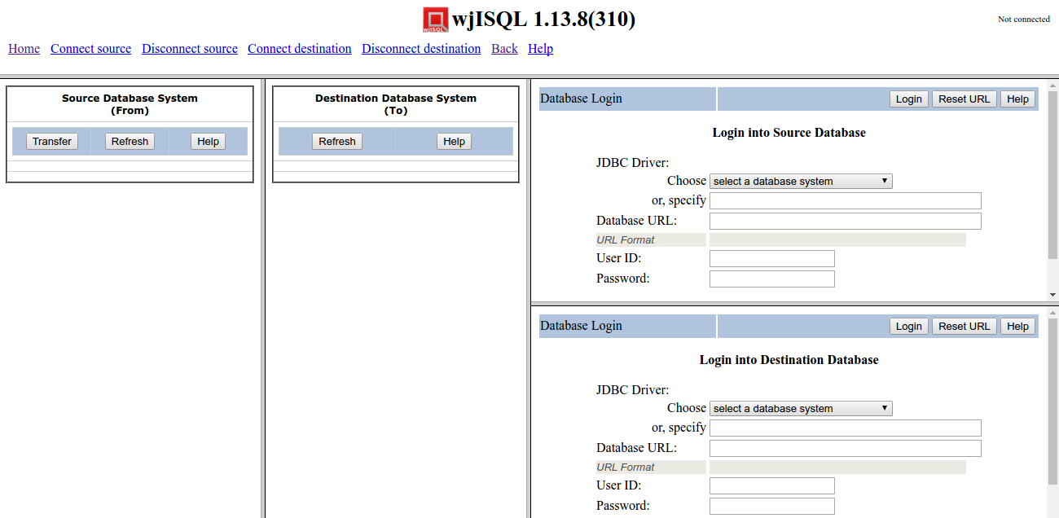

Post Test Activities:
1 | Click button Back to come back to the main screen.

Test Case 7/12:: Test menu item DBMS Info.
Test Procedure
1 | Click button DBMS Info

Test Expected o/p:
1 | An alert should be displayed as following:  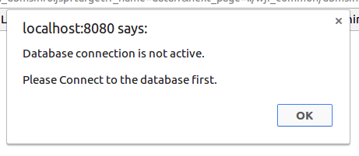  or  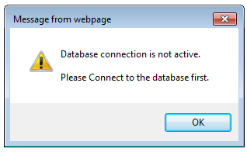

Post Test Activities:
1 | Click button OK on the alert message to come back to the main screen.
2 | Close the DBMS Info tab of the browser.

Test Case 8/13:: Test menu item Help.
Test Procedure
1 | Click button Help

Test Expected o/p:
1 | A window with help on the main screen of wjISQL as following:  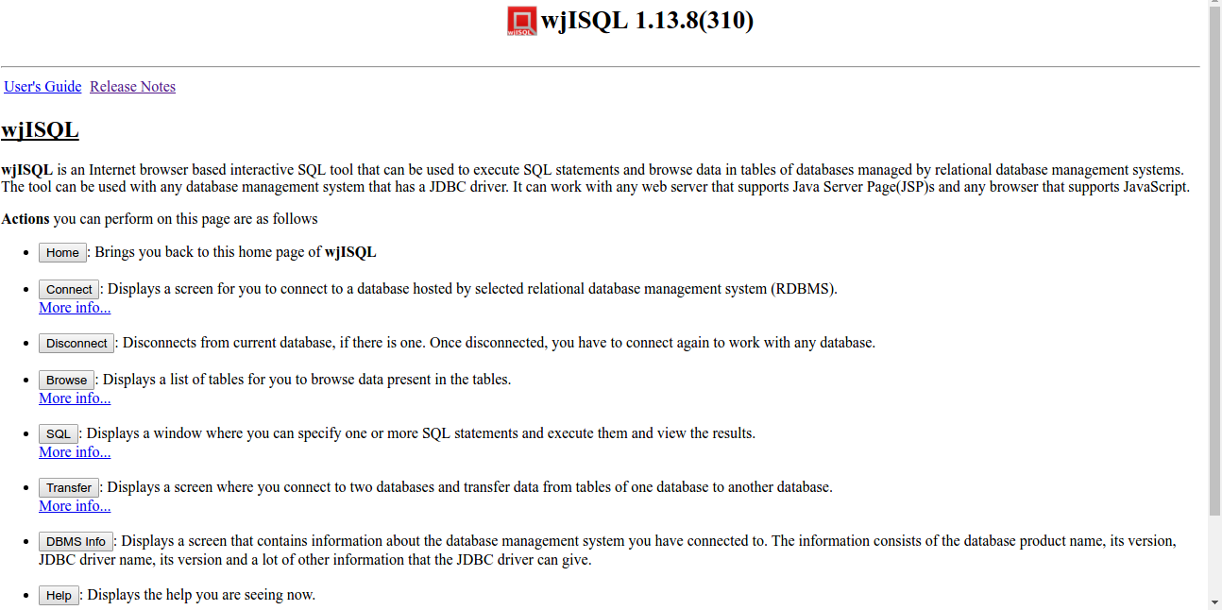

Post Test Activities:
1 | Close the "Main Menu" tab of the browser created for the help.

Unsuccessful Test Cases
None

Left Bar Menu Items Test Cases

Successful Test Cases

Test Case 1/14:: Test menu item Release Notes.
Test Procedure
1 | Click button "Release Notes".

Test Expected o/p:
1 | Release notes as shown below:  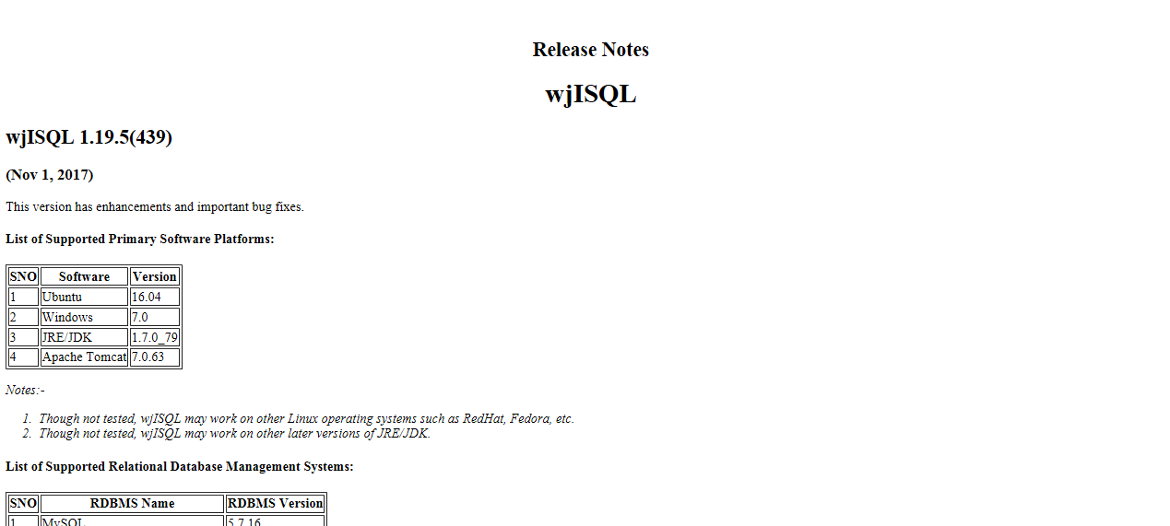

Post Test Activities:
1 | Close "Release Notes" tab of the browser.

Test Case 2/15:: Test menu item User's Guide.
Test Procedure
1 | Click button "User's Guide".

Test Expected o/p:
1 | Table of contents of User's Guide as shown below:  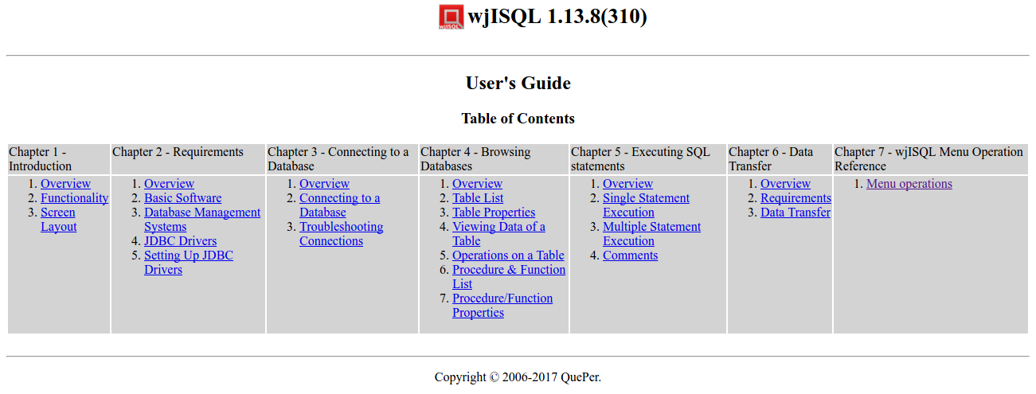

Post Test Activities:
1 | Close "User's Guide" tab of the browser.

Test Case 3/16:: Test menu item About.
Test Procedure
1 | Click button "About".

Test Expected o/p:
1 | Table of contents of User's Guide as shown below:  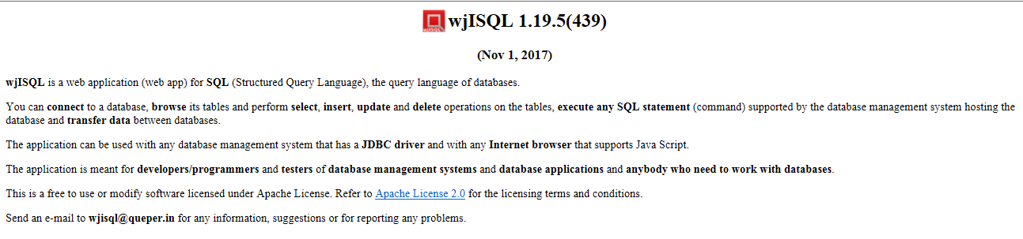

Post Test Activities:
1 | Close "About" tab of the browser.

Unsuccessful Test Cases
None

