wjISQL 1.20.4

Home Menu Item Test Plan

Change History
SNO | Version | Date | By | Description
1 | 1 | 2016-12-27 | Mvsagar | Created.
2 | 2 | 2018-10-17 | mvsagar | Removed Test Status for each test as tests have been automated using Selenium.

Table of Contents
1 Introduction 1
1.1 Prerequisites for all Tests 1
2 Home Menu Item Test Cases 1
2.1 Successful Test Cases 1
2.2 Unsuccessful Test Cases 6

Introduction
This test plan has test cases for testing the Home menu item of the top navigation menu.

Prerequisites for all Tests

1 | Installation test is successful.
2 | Main screen is of wjISQL is currently shown in the browser. Otherwise, enter "http://localhost:8080/wjisql" in the browser address field. Replace port number 8080 with appropriate port number if needed.

Home Menu Item Test Cases

Successful Test Cases

Test Case 1/1: Test menu item Home from Main/Home Screen
Test Pre-requisites:
1 | wjISQL is in the main or home screen as shown below:  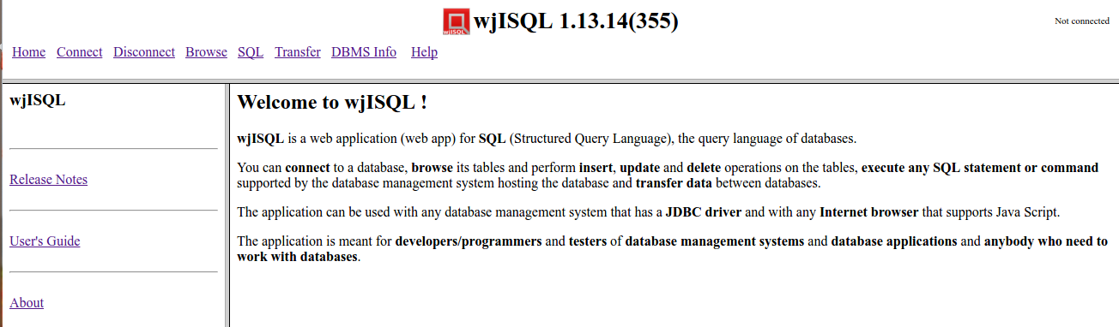

Test Procedure
1 | Click menu item Home.

Test Expected o/p:
1 | wjISQL shows the same home screen again as shown below:

Test Case 2/2: Test menu item Home from Login screen.
Test Pre-requisites:
1 | None

Test Procedure
1 | Click menu item Connect to display login screen on the right side.
2 | Click menu item Home.

Test Expected o/p:
1 | wjISQL shows the same home screen again as shown below:

Test Case 3/3: Test menu item Home after login into a database is done..
Test Pre-requisites:
1 | None

Test Procedure
1 | Click menu item Connect to display login screen on the right side.
2 | Login into MySQL database mysqldb with database URL jdbc:mariadb://localhost:3306/mariadb, user mariausr and password maria123.
3 | Click menu item Home.

Test Expected o/p:
1 | wjISQL shows the same home screen again as shown below:

Test Post Activities:
Click Disconnect.

Test Case 4/4: Test menu item Home from browsing screen.
Test Pre-requisites:
1 | Test Case 3.

Test Procedure
1 | Click menu item Browse to display table list.
2 | Click menu item Home.

Test Expected o/p:
1 | wjISQL shows the same home screen again as shown below:

Test Case 5/5: Test menu item Home from SQL statement execution screen.
Test Pre-requisites:
1 | Test Case 3.

Test Procedure
1 | Click menu item SQL to display screen that contains SQL Statement(s) window.
2 | Click menu item Home.

Test Expected o/p:
1 | wjISQL shows the same home screen again as shown below:

Test Case 6/6: Test menu item Home from data transfer screen.
Test Pre-requisites:
1 | Test Case 3.

Test Procedure
1 | Click menu item Transfer to displays data transfer screen.
2 | Click menu item Home.

Test Expected o/p:
1 | wjISQL shows the same home screen again as shown below:

Test Case 6/7: Test menu item Home from Disconnect screen.
Test Pre-requisites:
1 | Test Case 3.

Test Procedure
1 | Click menu item Disconnect to displays data transfer screen.
2 | Click menu item Home.

Test Expected o/p:
1 | Mysql database connected earlier is disconnected.
2 | wjISQL shows the same home screen again as shown below:

Unsuccessful Test Cases

None.

