wjISQL 1.20.4

Connect and Disconnect Menu Item Test Plan

Change History
Version | Date | By | Description
1 | 2016-12-23 | Mvsagar | Created.
2 | 2017-10-07 | Mvsagar | Added a section on MariaDB
3 | 2018-10-23 | Mvsagar | Modified to suit automated tests

Table of Contents
1 Introduction 1
1.1 Prerequisites for all Tests 2
2 Connect and Disconnect Menu Item Test Cases 2
2.1 MySQL Database Connection and Disconnection Test Cases 2
2.1.1 Prerequisites 2
2.1.2 Successful Test Cases 2
2.1.3 Unsuccessful Test Cases 4
2.2 MariaDB Database Connection and Disconnection Test Cases 8
2.2.1 Prerequisites 8
2.2.2 Successful Test Cases 8
2.2.3 Unsuccessful Test Cases 10
2.3 PostgreSQL Database Connection and Disconnection Test Cases 13
2.3.1 Pre-requisites 13
2.3.2 Successful Test Cases 14
2.3.3 Unsuccessful Test Cases 15
2.4 Oracle Database Connection and Disconnection Test Cases 18
2.4.1 Pre-requisites 18
2.4.2 Successful Test Cases 18
2.4.3 Unsuccessful Test Cases 20
2.5 MS SQL Database Connection and Disconnection Test Cases 23
2.5.1 Pre-requisites 23
2.5.2 Successful Test Cases 24
2.5.3 Unsuccessful Test Cases 25
2.6 SQLite Database Connection and Disconnection Test Cases 28
2.6.1 Pre-requisites 28
2.6.2 Successful Test Cases 28
2.6.3 Unsuccessful Test Cases 31

Introduction
This test plan has test cases for testing the Connect and Disconnect menu items of navigation menu.

Prerequisites for all Tests

1 | Installation test is successful.
2 | Main screen is of wjISQL is currently shown in the browser. Otherwise, enter "http://localhost:8080/wjisql" in the browser address field.
3 | MySQL database mysqldb is readily available for user mysqlusr and password mysql123. The user has DBA privileges.

Connect and Disconnect Menu Item Test Cases

MySQL Database Connection and Disconnection Test Cases

Prerequisites

1 | MySQL database mysqldb is readily available for user mysqlusr and password mysql123. The user has DBA privileges.

Successful Test Cases

Test Case 1/1: Test for successful connection to databse mysqldb.
Test Prerequisites
1 | None.

Test Procedure
1 | Click menu item "Connect".
2 | Choose MySQL JDBC Driver from field JDBC driver displayed in login window.
3 | Specify database mysqldb in the Database URL, enter user id mysqlusr and password mysql123.
4 | Click button Login.

Test Expected o/p:
1 | The login is successful with 3 windows – Tables , SQL Statement(s) and an empty - and MySQL version and user information at the top right corner as shown below:  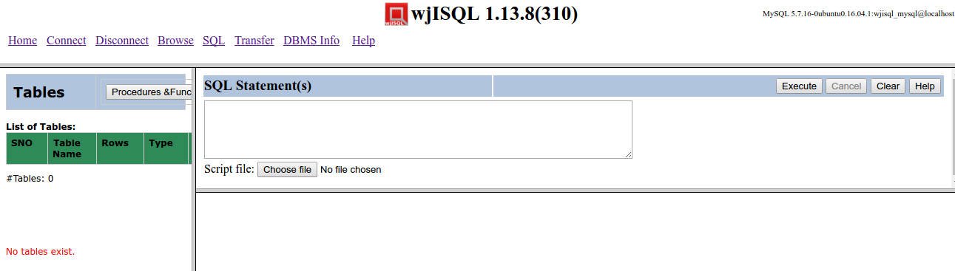

Test Status:
Platform | wjISQL Version | Date | Status | Remarks
Ubuntu 16.04 LTS  Chrome | 1.16.5(409) | 2017-10-07 | Success | Table list contains existing tables.
Windows 7

Test Case 2/2: Test successful disconnection from mysql db
Test Prerequisites
1 | Test case 1 is already executed.

Test Procedure
1 | Click button Disconnect..

Test Expected o/p:
1 | A successful disconnection message as shown below:  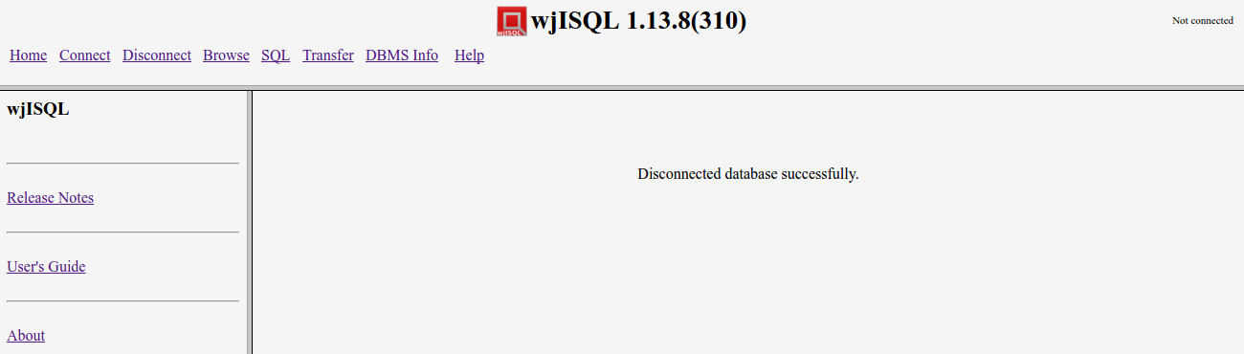

Test Status:
Platform | wjISQL | Date | Status | Remarks
Ubuntu 16.04 LTS  Chrome | 1.16.5(409) | 2017-10-07 | Success
Windows 7

Unsuccessful Test Cases

Test Case 1/3: Test unsuccessful connection to a mysql database with invalid prefix in the JDBC URL.
Test Prerequisites:
1 | None

Test Procedure
1 | Click menu item "Connect".
2 | Choose MySQL JDBC Driver from field JDBC driver displayed in login window.
3 | Specify invalid prefix xyz in the Database URL: xyz:mysql://localhost/mysqldb
4 | Enter user id mysqlusr and password mysql123.
5 | Click button Login.

Test Expected o/p:
1 | A connection failure error message popup window as shown below is displayed:  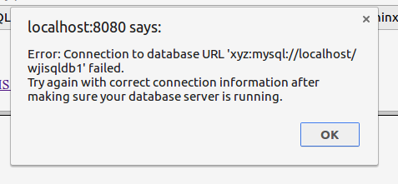

Test Postrequisites:
1 | Click button OK on the alert message window
2 | Make sure Database Login window is displayed.

Test Status:
Platform | wjISQL | Date | Status | Remarks
Ubuntu 16.04 LTS  Chrome | 1.16.5(409) | 2017-10-07 | Success
Windows 7

Test Case 2/4: Test unsuccessful connection to a mysql database with invalid host in the JDBC URL.
Test Prerequisites:
1 | None

Test Procedure
1 | Click menu item "Connect".
2 | Choose MySQL JDBC Driver from field JDBC driver displayed in login window.
3 | Specify invalid host name xyz in the Database URL: jdbc:mysql://xyz/mysqldb
4 | Enter user id mysqlusr and password mysql123.
5 | Click button Login.

Test Expected o/p:
1 | A connection failure error message popup window as shown below is displayed:  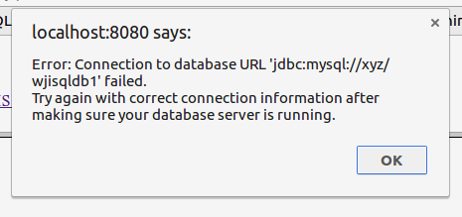

Test Postrequisites:
1 | Click button OK on the alert message window
2 | Make sure Database Login window is displayed.

Test Status:
Platform | wjISQL | Date | Status | Remarks
Ubuntu 16.04 LTS  Chrome | 1.16.5(409) | 2017-10-07 | Success
Windows 7

Test Case 3/5: Test unsuccessful connection to a mysql database with invalid database name in the JDBC URL.
Test Prerequisites:
1 | None

Test Procedure
1 | Click menu item "Connect".
2 | Choose MySQL JDBC Driver from field JDBC driver displayed in login window.
3 | Specify invalid database name xyzdb in the Database URL: jdbc:mysql://localhost/xyzdb
4 | Enter user id mysqlusr and password mysql123.
5 | Click button Login.

Test Exped o/p:
1 | A connection failure error message popup window as shown below is displayed:  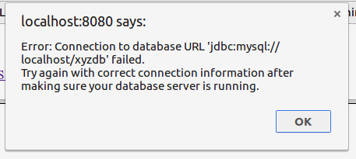

Test Postrequisites:
1 | Click button OK on the alert message window
2 | Make sure Database Login window is displayed.

Test Status:
Platform | wjISQL | Date | Status | Remarks
Ubuntu 16.04 LTS  Chrome | 1.16.5(409) | 2017-10-07 | Success
Windows 7

Test Case 4/6: Test unsuccessful connection to a mysql database with invalid user ID for login.
Test Prerequisites:
1 | None

Test Procedure
1 | Click menu item "Connect".
2 | Choose MySQL JDBC Driver from field JDBC driver displayed in login window.
3 | Specify Database URL: jdbc:mysql://localhost/mysqldb
4 | Enter invalid user id xyz and password mysql123.
5 | Click button Login.

Test Exped o/p:
1 | A connection failure error message popup window as shown below is displayed:  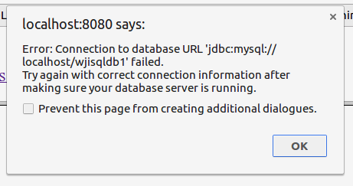

Test Postrequisites:
1 | Click button OK on the alert message window
2 | Make sure Database Login window is displayed.

Test Status:
Platform | wjISQL | Date | Status | Remarks
Ubuntu 16.04 LTS  Chrome | 1.16.5(409) | 2017-10-07 | Success
Windows 7

Test Case 5/7: Test unsuccessful connection to a mysql database with invalid password for login.
Test Prerequisites:
1 | None

Test Procedure
1 | Click menu item "Connect".
2 | Choose MySQL JDBC Driver from field JDBC driver displayed in login window.
3 | Specify Database URL: jdbc:mysql://localhost/mysqldb
4 | Enter user id mysqlusr and invalid password xyz.
5 | Click button Login.

Test Exped o/p:
1 | A connection failure error message popup window as shown below is displayed:  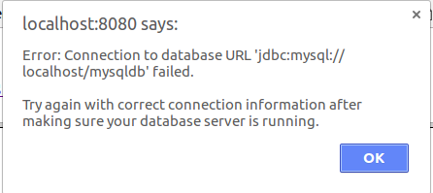

Test Postrequisites:
1 | Click button OK on the alert message window
2 | Make sure Database Login window is displayed.

Test Status:
Platform | wjISQL | Date | Status | Remarks
Ubuntu 16.04 LTS  Chrome | 1.16.5(409) | 2017-10-07 | Success
Windows 7

MariaDB Database Connection and Disconnection Test Cases

Prerequisites

1 | MariaDB database mariadb is readily available for user mariausr and password maria123. The user has DBA privileges.

Successful Test Cases

Test Case 1/8: Test for successful connection to databse mariadb.
Test Prerequisites
1 | None.

Test Procedure
1 | Click menu item "Connect".
2 | Choose MariaDB JDBC Driver from field JDBC driver displayed in login window.
3 | Specify database mariadb in the Database URL, enter user id mariausr and password maria123.
4 | Click button Login.

Test Expected o/p:
1 | The login is successful with 3 windows – Tables , SQL Statement(s) and an empty - and MariaDB version and user information at the top right corner as shown below:  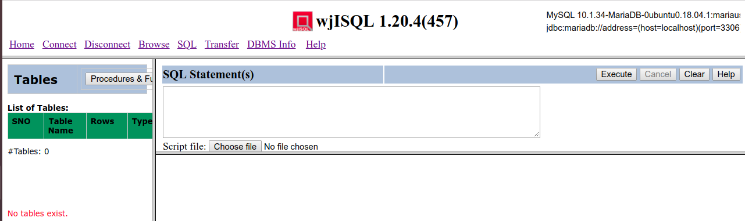

Test Case 2/9: Test successful disconnection from mysql db
Test Prerequisites
1 | Test case 1 is already executed.

Test Procedure
1 | Click button Disconnect..

Test Expected o/p:
1 | A successful disconnection message as shown below:  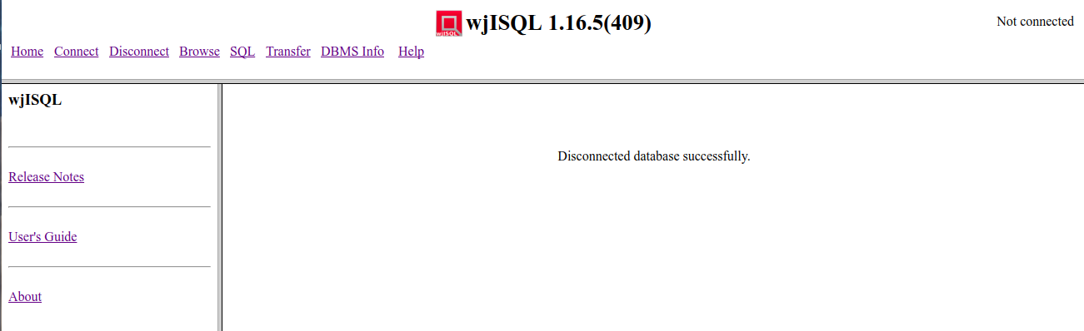

Test Status:
Platform | wjISQL | Date | Status | Remarks
Ubuntu 16.04 LTS  Chrome | 1.16.5(409) | 2017-10-07 | Success
Windows 7

Unsuccessful Test Cases

Test Case 1/10: Test unsuccessful connection to a mariadb database with invalid prefix in the JDBC URL.
Test Prerequisites:
1 | None

Test Procedure
1 | Click menu item "Connect".
2 | Choose MariaDB JDBC Driver from field JDBC driver displayed in login window.
3 | Specify invalid prefix xyz in the Database URL: xyz:mariadb://localhost/mariadb
4 | Enter user id mariausr and password maria123.
5 | Click button Login.

Test Expected o/p:
1 | A connection failure error message popup window as shown below is displayed:  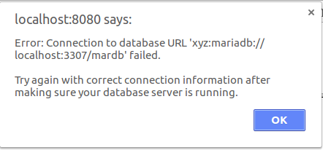

Test Postrequisites:
1 | Click button OK on the alert message window
2 | Make sure Database Login window is displayed.

Test Case 2/11: Test unsuccessful connection to a mariadb database with invalid host in the JDBC URL.
Test Prerequisites:
1 | None

Test Procedure
1 | Click menu item "Connect".
2 | Choose MariaDB JDBC Driver from field JDBC driver displayed in login window.
3 | Specify invalid host name xyz in the Database URL: jdbc:mariadb://xyz/mariadb
4 | Enter user id mariausr and password maria123.
5 | Click button Login.

Test Expected o/p:
1 | A connection failure error message popup window as shown below is displayed:  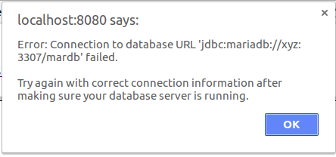

Test Postrequisites:
1 | Click button OK on the alert message window
2 | Make sure Database Login window is displayed.

Test Case 3/12: Test unsuccessful connection to a MariaDB database with invalid database name in the JDBC URL.
Test Prerequisites:
1 | None

Test Procedure
1 | Click menu item "Connect".
2 | Choose MariaDB JDBC Driver from field JDBC driver displayed in login window.
3 | Specify invalid database name xyzdb in the Database URL: jdbc:mariadb://localhost/xyzdb
4 | Enter user id mariausr and password maria123.
5 | Click button Login.

Test Exped o/p:
1 | A connection failure error message popup window as shown below is displayed:  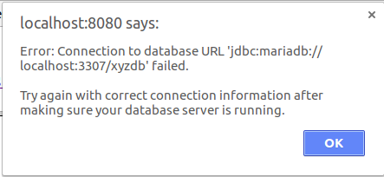

Test Postrequisites:
1 | Click button OK on the alert message window
2 | Make sure Database Login window is displayed.

Test Case 4/13: Test unsuccessful connection to a MariaDB database with invalid user ID for login.
Test Prerequisites:
1 | None

Test Procedure
1 | Click menu item "Connect".
2 | Choose MariaDB JDBC Driver from field JDBC driver displayed in login window.
3 | Specify Database URL: jdbc:mariadb://localhost/mariadb
4 | Enter invalid user id xyz and password maria123.
5 | Click button Login.

Test Exped o/p:
1 | A connection failure error message popup window as shown below is displayed:  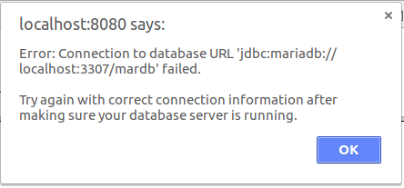

Test Postrequisites:
1 | Click button OK on the alert message window
2 | Make sure Database Login window is displayed.

Test Case 5/14: Test unsuccessful connection to a MariaDB database with invalid password for login.
Test Prerequisites:
1 | None

Test Procedure
1 | Click menu item "Connect".
2 | Choose MariaDB JDBC Driver from field JDBC driver displayed in login window.
3 | Specify Database URL: jdbc:mariadb://localhost/mariadb
4 | Enter user id mariausr and invalid password xyz.
5 | Click button Login.

Test Expected o/p:
1 | A connection failure error message popup window as shown below is displayed:

Test Postrequisites:
1 | Click button OK on the alert message window
2 | Make sure Database Login window is displayed.

PostgreSQL Database Connection and Disconnection Test Cases

Pre-requisites

1 | PostgreSQL database pgsqldb is readily available.
2 | The database owner is user pgsqlusr.
3 | The user password is 'pgsql123'.

Successful Test Cases

Test Case 1/15: Test for successful connection to databse pgsqldb.
Test Prerequisites
1 | Higher level pre-requisites

Test Procedure
1 | Click menu item "Connect".
2 | Choose PostgreSQL JDBC Driver from field JDBC driver displayed in login window.
3 | Specify database pgsqldb in the Database URL, enter user id pgsqlusr and password pgsql123.
4 | Click button Login.

Test Expected o/p:
1 | The login is successful with 3 windows – Tables , SQL Statement(s) and an empty - and PostgreSQL version and user information at the top right corner as shown below:  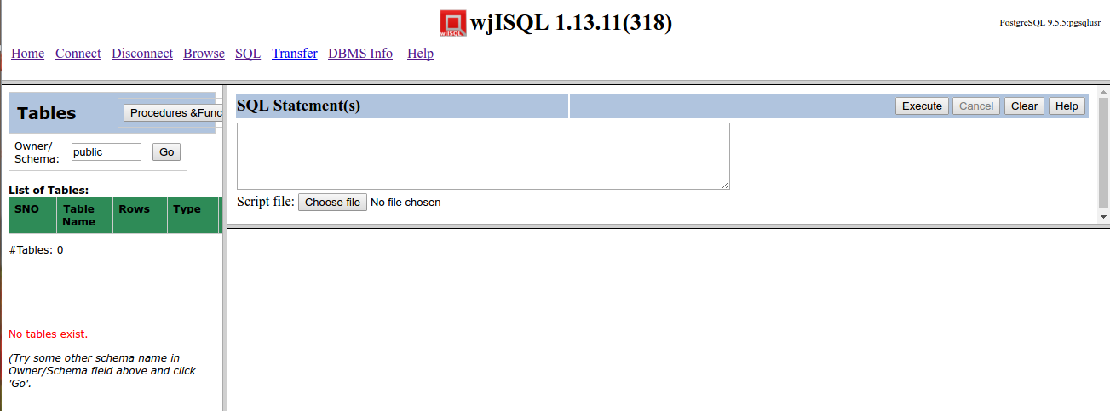

Test Case 2/16: Test successful disconnection from PostgreSQL db
Test Prerequisites
1 | Test case 1 is already executed.

Test Procedure
1 | Click button Disconnect..

Test Expected o/p:
1 | A successful disconnection message as shown below (version number may be different):

Unsuccessful Test Cases

Test Case 1/17: Test unsuccessful connection to a postgresql database with invalid prefix in the JDBC URL.
Test Prerequisites:
1 | None

Test Procedure
1 | Click menu item "Connect".
2 | Choose PostgreSQL JDBC Driver from field JDBC driver displayed in login window.
3 | Specify invalid prefix xyz in the Database URL: xyz:postgresql://localhost/pgsqldb
4 | Enter user id pgsqlusr and password pgsql123.
5 | Click button Login.

Test Expected o/p:
1 | A connection failure error message popup window.

Test Postrequisites:
1 | Click button OK on the alert message window
2 | Make sure Database Login window is displayed.

Test Case 2/18: Test unsuccessful connection to a mariadb database with invalid host in the JDBC URL.
Test Prerequisites:
1 | None

Test Procedure
1 | Click menu item "Connect".
2 | Choose PostgreSQL JDBC Driver from field JDBC driver displayed in login window.
3 | Specify invalid host name xyz in the Database URL: jdbc:postgresql://xyz/pgsqldb
4 | Enter user id pgsqlusr and password pgsql123.
5 | Click button Login.

Test Expected o/p:
1 | A connection failure error message popup window.

Test Postrequisites:
1 | Click button OK on the alert message window
2 | Make sure Database Login window is displayed.

Test Case 3/19: Test unsuccessful connection with invalid database name in the JDBC URL.
Test Prerequisites:
1 | None

Test Procedure
1 | Click menu item "Connect".
2 | Choose PostgreSQL JDBC Driver from field JDBC Driver displayed in login window.
3 | Specify invalid database name xyzdb in the Database URL: jdbc:postgresql://localhost:5432/xyzdb
4 | Enter user id pgsqlusr and password pgsql123.
5 | Click button Login.

Test Exped o/p:
1 | A connection failure error message popup window as shown below is displayed:  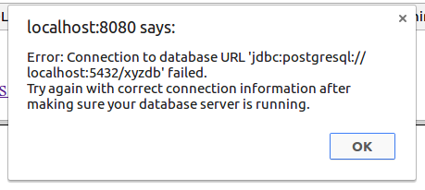

Test Postrequisites:
1 | Click button OK on the alert message window
2 | Make sure Database Login window is displayed.

Test Case 4/20: Test unsuccessful connection to database with invalid user ID for login.
Test Prerequisites:
1 | None

Test Procedure
1 | Click menu item "Connect".
2 | Choose PostgreSQL JDBC Driver from field JDBC driver displayed in login window.
3 | Specify Database URL: jdbc:postgresql://localhost:5432/pgsqldb
4 | Enter invalid user id xyz and password pgsql123.
5 | Click button Login.

Test Exped o/p:
1 | A connection failure error message popup window as shown below is displayed:  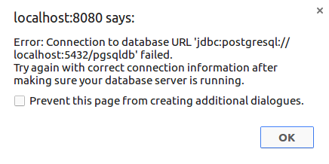

Test Postrequisites:
1 | Click button OK on the alert message window
2 | Make sure Database Login window is displayed.

Test Case 5/21: Test unsuccessful connection to a database with invalid password for login.
Test Prerequisites:
1 | None

Test Procedure
1 | Click menu item "Connect".
2 | Choose PostgreSQL JDBC Driver from field JDBC driver displayed in login window.
3 | Specify Database URL: jdbc:postgresql://localhost:5432/pgsqldb
4 | Enter invalid user id pgsqlusr and password xyz.
5 | Click button Login.

Test Exped o/p:
1 | A connection failure error message popup window as shown below is displayed:  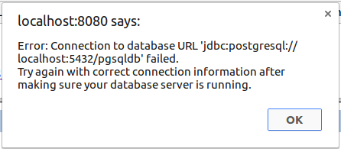

Test Postrequisites:
1 | Click button OK on the alert message window
2 | Make sure Database Login window is displayed.

Oracle Database Connection and Disconnection Test Cases

Pre-requisites

1 | Oracle database oradb with database character set AL32UTF8 is readily available.  Note:- Choose character set AL32UTF8 while creating database using Database Configuration Assistant of Oracle Database.
2 | The database owner is user orausr.
3 | The user password is 'ora123'.

After creating database oradb using Oracle Database Configuration Assisnt, login into the database using user SYSTEM and related password. Then Create use orausr with specified password and grant the user DBA privilege as following:

CREATE USER orausr identified by ora123;
GRANT DBA TO orausr;

Successful Test Cases

Test Case 1/22: Test for successful connection to databse oraldb.
Test Prerequisites
1 | Higher level pre-requisites

Test Procedure
1 | Click menu item "Connect".
2 | Choose Oracle JDBC Driver from field JDBC driver displayed in login window.
3 | Specify database oradb in the Database URL: jdbc:oracle:thin:@localhost:1521:oradb
4 | Enter user id orausr and password ora123.
5 | Click button Login.

Test Expected o/p:
1 | The login is successful with 3 windows – Tables , SQL Statement(s) and an empty window - and Oracle version and user information at the top right corner as shown below:  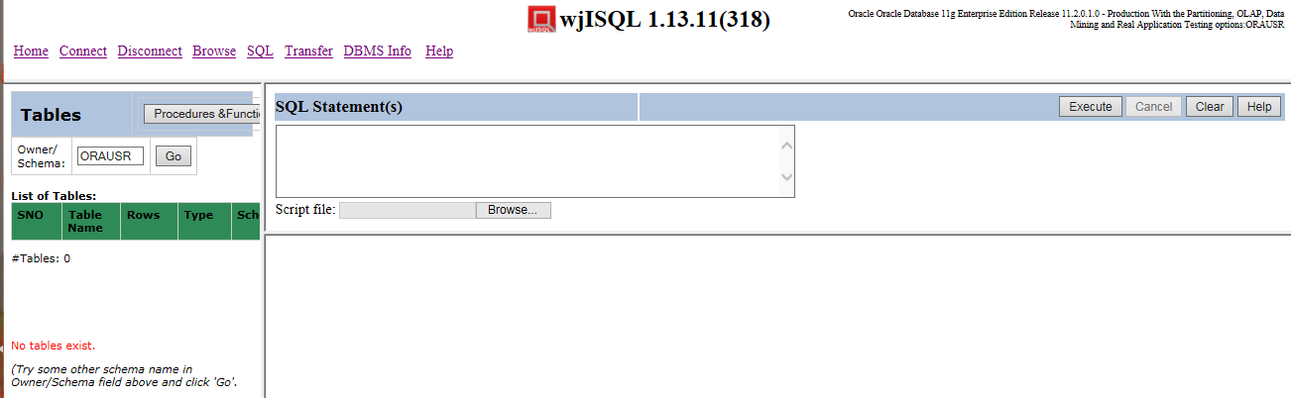

Test Status:
Platform | wjISQL Version | Date | Status | Remarks
Ubuntu 16.04 LTS
Chrome
Windows 7  Chrome | 1.19.5(439) | 2017-10-27 | Success

Test Case 2/23: Test successful disconnection from oradb
Test Prerequisites
1 | Test case 1 is already executed.

Test Procedure
1 | Click button Disconnect..

Test Expected o/p:
1 | A successful disconnection message as shown below (version number may be different):  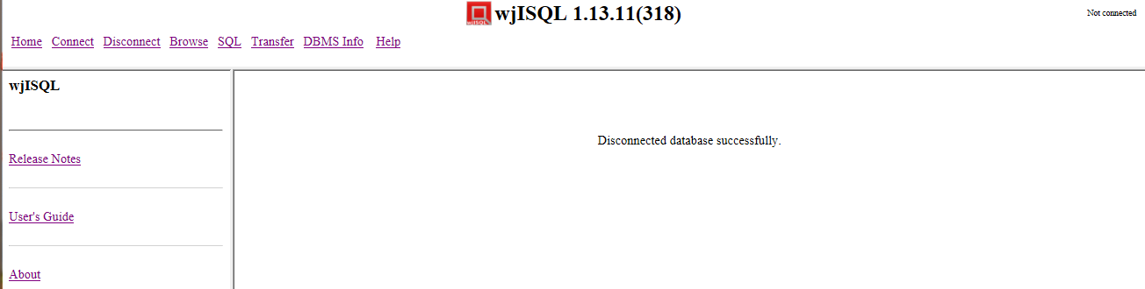

Test Status:
Platform | wjISQL | Date | Status | Remarks
Ubuntu 16.04 LTS
Chrome
Windows 7  Chrome | 1.19.5(439) | 2017-10-27 | Success

Unsuccessful Test Cases
Test Case 1/24: Test unsuccessful connection with invalid database name in the JDBC URL.
Test Prerequisites:
1 | None

Test Procedure
1 | Click menu item "Connect".
2 | Choose Oracle JDBC Driver from field JDBC driver displayed in login window.
3 | Specify invalid database name xyzdb in the Database URL: jdbc:oracle:thin:@localhost:1521:xyzdb
4 | Enter user id orausr and password ora123.
5 | Click button Login.

Test Exped o/p:
1 | A connection failure error message popup window as shown below is displayed:  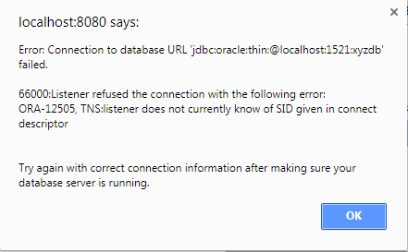

Test Postrequisites:
1 | Click button OK on the alert message window
2 | Make sure Database Login window is displayed.

Test Status:
Platform | wjISQL | Date | Status | Remarks
Ubuntu 16.04 LTS
Chrome
Windows 7  Chrome | 1.19.5(439) | 2017-10-27 | Success

Test Case 2/25: Test unsuccessful connection to database with invalid user ID for login.
Test Prerequisites:
1 | None

Test Procedure
1 | Click menu item "Connect".
2 | Choose Oracle JDBC Driver from field JDBC driver displayed in login window.
3 | Specify invalid database name xyzdb in the Database URL: jdbc:oracle:thin:@localhost:1521:oradb
4 | Enter user id xyzusr and password ora123.
5 | Click button Login.

Test Exped o/p:
1 | A connection failure error message popup window as shown below is displayed:  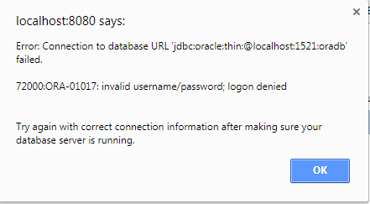

Test Postrequisites:
1 | Click button OK on the alert message window
2 | Make sure Database Login window is displayed.

Test Status:
Platform | wjISQL | Date | Status | Remarks
Ubuntu 16.04 LTS
Chrome
Windows 7  Chrome | 1.19.5(439) | 2017-10-27 | Success

Test Case 3/26: Test unsuccessful connection to a database with invalid password for login.
Test Prerequisites:
1 | None

Test Procedure
1 | Click menu item "Connect".
2 | Choose Oracle JDBC Driver from field JDBC driver displayed in login window.
3 | Specify invalid database name xyzdb in the Database URL: jdbc:oracle:thin:@localhost:1521:oradb
4 | Enter user id orausr and password xyz123.
5 | Click button Login.

Test Exped o/p:
1 | A connection failure error message popup window as shown below is displayed:

Test Postrequisites:
1 | Click button OK on the alert message window
2 | Make sure Database Login window is displayed.

Test Status:
Platform | wjISQL | Date | Status | Remarks
Ubuntu 16.04 LTS
Chrome
Windows 7  Chrome | 1.19.5(439) | 2017-10-27 | Success

MS SQL Database Connection and Disconnection Test Cases

Pre-requisites

1 | MS SQL server database mssqldb is readily available.
2 | The database owner is user mssqlusr.
3 | The user password is 'mssql123'.

Note:- To create database and users, login as user 'sa' and related password and create them from wjISQL itself.

For SQL server 2012 onward:

EXEC SP_CONFIGURE 'show advanced options',1
RECONFIGURE
EXEC SP_CONFIGURE 'contained database authentication',1
RECONFIGURE

CREATE DATABASE mssqldb CONTAINMENT=PARTIAL;
USE MSSQLDB;
CREATE USER mssqlusr WITH PASSWORD = 'mssql123';

Replace EXEC with CALL if needed. Not sure!.

// Give ownership of the database to the new user.
EXEC SP_ADDROLEMEMBER N'db_owner', N'mssqlusr';

Successful Test Cases

Test Case 1/27: Test for successful connection to databse pgsqldb.
Test Prerequisites
1 | Higher level pre-requisites

Test Procedure
1 | Click menu item "Connect".
2 | Choose Microsoft SQL Server JDBC Driver from field JDBC driver displayed in login window.
3 | Specify database mssqldb in the Database URL: jdbc:sqlserver://localhost:1433;databaseName=mssqldb;
4 | Enter user id mssqlusr and password mssql123.
5 | Click button Login.

Test Expected o/p:
1 | The login is successful with 3 windows – Tables , SQL Statement(s) and an empty window - and SQL Server version and user information at the top right corner as shown below:  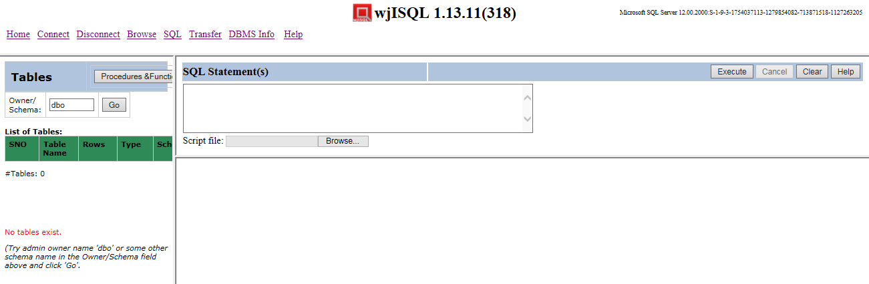

Test Status:
Platform | wjISQL Version | Date | Status | Remarks
Windows 7  IE11 | 1.19.5(439) | 2017-10-27 | Success

Test Case 2/28: Test successful disconnection from MS SQL db
Test Prerequisites
1 | Test case 1 is already executed.

Test Procedure
1 | Click button Disconnect..

Test Expected o/p:
1 | A successful disconnection message as shown below (version number may be different):  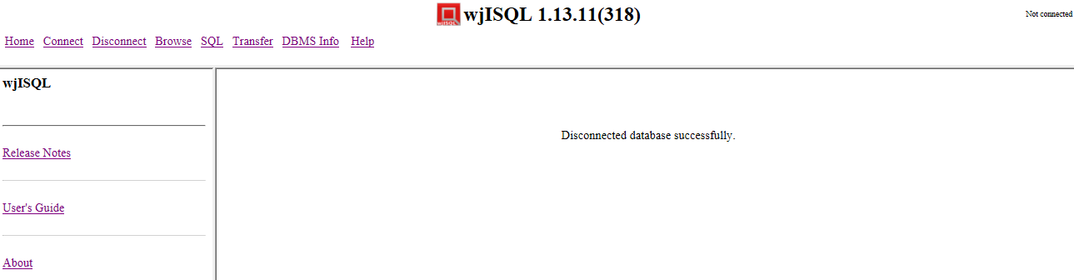

Test Status:
Platform | wjISQL | Date | Status | Remarks
Windows 7  IE 11 | 1.19.5(439) | 2017-10-27 | Success

Unsuccessful Test Cases
Test Case 1/29: Test unsuccessful connection with invalid database name in the JDBC URL.
Test Prerequisites:
1 | None

Test Procedure
1 | Click menu item "Connect".
2 | Choose Microsoft SQL JDBC Driver from field JDBC Driver displayed in login window.
3 | Specify invalid database name xyzdb in the Database URL: jdbc:sqlserver://localhost:1433;databaseName=xyzdb;
4 | Enter user id mssqlusr and password mssql123.
5 | Click button Login.

Test Exped o/p:
1 | A connection failure error message popup window as shown below is displayed:  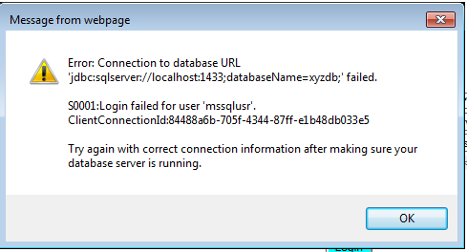

Test Postrequisites:
1 | Click button OK on the alert message window
2 | Make sure Database Login window is displayed.

Test Status:
Platform | wjISQL | Date | Status | Remarks
Windows 7  IE 11 | 1.19.5(439) | 2017-10-27 | Success

Test Case 2/30: Test unsuccessful connection to database with invalid user ID for login.
Test Prerequisites:
1 | None

Test Procedure
1 | Click menu item "Connect".
2 | Choose Microsoft SQL JDBC Driver from field JDBC Driver displayed in login window.
3 | Specify the Database URL: jdbc:sqlserver://localhost:1433;databaseName=mssqldb;
4 | Enter invalid user id xyz and password mssql123.
5 | Click button Login.

Test Exped o/p:
1 | A connection failure error message popup window as shown below is displayed:  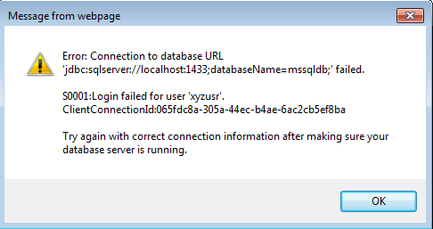

Test Postrequisites:
1 | Click button OK on the alert message window
2 | Make sure Database Login window is displayed.

Test Status:
Platform | wjISQL | Date | Status | Remarks
Windows 7  IE 11 | 1.19.5(439) | 2017-10-27 | Success

Test Case 3/31: Test unsuccessful connection to a database with invalid password for login.
Test Prerequisites:
1 | None

Test Procedure
1 | Click menu item "Connect".
2 | Choose Microsoft SQL JDBC Driver from field JDBC Driver displayed in login window.
3 | Specify the Database URL: jdbc:sqlserver://localhost:1433;databaseName=mssqldb;
4 | Enter user id mssqlusr and invalid password xyz123.
5 | Click button Login.

Test Expected o/p:
1 | A connection failure error message popup window as shown below is displayed:  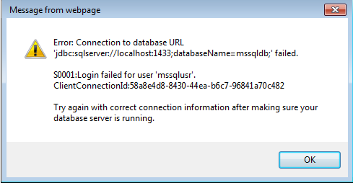

Test Postrequisites:
1 | Click button OK on the alert message window
2 | Make sure Database Login window is displayed.

Test Status:
Platform | wjISQL | Date | Status | Remarks
Windows 7  IE 11 | 1.19.5(439) | 2017-10-27 | Success

SQLite Database Connection and Disconnection Test Cases

Pre-requisites

1 | None.

Successful Test Cases

Test Case 1/32: Test for successful connection to databse sqlitedb.
Test Prerequisites
1 | None.

Test Procedure
1 | Click menu item "Connect".
2 | Choose SQLite JDBC Driver from field JDBC driver displayed in login window.
3 | Specify database sqlitedb in the Database URL: jdbc:sqlite:/tmp/sqlitedb
4 | Click button Login.

Test Expected o/p:
1 | The login is successful with 3 windows – Tables , SQL Statement(s) and an empty window - and SQLite version information at the top right corner as shown below:  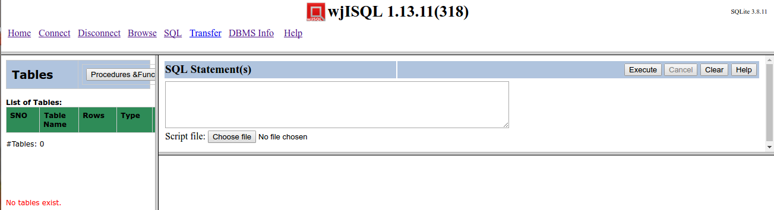

Test Case 2/33: Test successful disconnection from database
Test Prerequisites
1 | Test case 1 is already executed.

Test Procedure
1 | Click button Disconnect.

Test Expected o/p:
1 | A successful disconnection message as shown below (version number may be different):  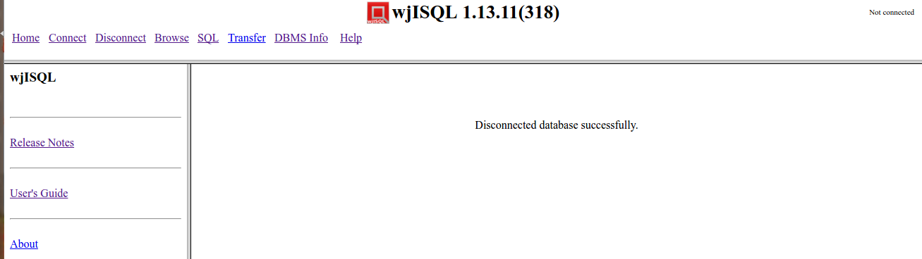

Test Case 3/34: Test for successful connection to databse sqlitedb using browsing folders for the database file.
Note:- This is not yet automated. Test it manually
Test Prerequisites:
1 | None.

Test Procedure
1 | Click menu item "Connect".
2 | Choose SQLite JDBC Driver from field JDBC driver displayed in login window.
3 | Specify directory path /tmp/ in the field folder on Linux OS and C:/sqlite on Windows.
4 | Click button Choose file and select database file sqllitedb from the specified folder.
5 | Click button Login.

Test Expected o/p:
1 | The login is successful with 3 windows – Tables , SQL Statement(s) and an empty - and SQLite version at the top right corner as shown below:

Test Post Actions

1 | Click button Disconnect to disconnect from the database.

Unsuccessful Test Cases

Test Case 1/35: Test unsuccessful connection with invalid prefix in JDBC URL.
Test Prerequisites:
1 | None

Test Procedure
1 | Click menu item "Connect".
2 | Choose SQLite JDBC Driver from field JDBC Driver displayed in login window.
3 | Specify invalid database directory xyzdb in the Database URL: xyz:sqlite:/tmp/sqlitedb
4 | Click button Login.

Test Exped o/p:
1 | A connection failure error message popup window.

Test Postrequisites:
1 | Click button OK on the alert message window
2 | Make sure Database Login window is displayed.

Test Case 2/36: Test unsuccessful connection with invalid database path in the JDBC URL.
Test Prerequisites:
1 | None

Test Procedure
1 | Click menu item "Connect".
2 | Choose SQLite JDBC Driver from field JDBC Driver displayed in login window.
3 | Specify invalid database directory xyzdb in the Database URL: jdbc:sqlite:/xyz/sqlitedb
4 | Click button Login.

Test Exped o/p:
1 | A connection failure error message popup window as shown below is displayed:  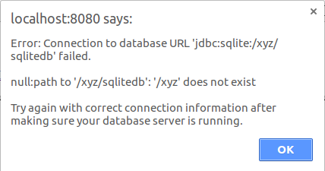

Test Postrequisites:
1 | Click button OK on the alert message window
2 | Make sure Database Login window is displayed.

Test Case 3/37: Test unsuccessful connection with invalid database file in a valid file path
Test Prerequisites:
1 | None

Test Procedure
1 | Click menu item "Connect".
2 | Choose SQLite JDBC Driver from field JDBC Driver displayed in login window.
3 | Specify valid database directory but a PNG file as database file in the Database URL: jdbc:sqlite:/tmp/baddb.png.  On windows use /tmp/Desert.jpg
4 | Click button Login.

Test Exped o/p:
1 | A connection failure error message popup window as shown below is displayed:  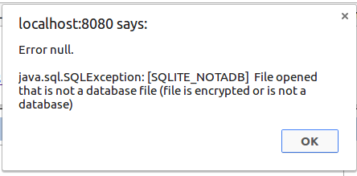

Test Postrequisites:
1 | Click button OK on the alert message window
2 | Make sure Database Login window is displayed.

