wjISQL 1.19.5

Browse Menu Item Test Plan

Change History
SNO | Version | Date | By | Description
1 | 1 | 2016-12-23 | Mvsagar | Created.

Table of Contents
1 Introduction 4
1.1 Prerequisites for all Tests 4
2 MySQL Database Browsing Test Cases 4
2.1 Prerequisites 4
2.2 Database Setup Test Cases 4
2.3 Browse Menu Item Test Cases 8
2.3.1 Successful Test Cases 8
2.3.2 Unsuccessful Test Cases 8
2.4 Table Properties Test Cases 9
2.4.1 Successful Test Cases 9
2.4.2 Unsuccessful Test Cases 10
2.5 Table Data Test Cases 10
2.5.1 Successful Test Cases 10
2.5.2 Unsuccessful Test Cases 13
2.6 Table Keys Test Cases 13
2.6.1 Successful Test Cases 13
2.7 Table Dropping Test Cases 14
2.7.1 Successful Test Cases 14
2.8 Table Properties Help Test Cases 15
2.8.1 Successful Test Cases 15
2.9 Procedure/Function Browsing Test Cases 16
2.9.1 Successful Test Cases 16
2.10 Procedure/Function Properties Test Cases 17
2.10.1 Successful Test Cases 17
2.11 Procedure/Function Dropping Test Cases 20
2.11.1 Successful Test Cases 20
2.12 Procedure/Function Properties Help Test Cases 21
2.12.1 Successful Test Cases 21
2.13 Procedure/Function Tables Button Test Cases 22
2.13.1 Successful Test Cases 22
3 MariaDB Database Browsing Test Cases 23
3.1 Prerequisites 23
3.2 Database Setup Test Cases 23
3.3 Browse Menu Item Test Cases 27
3.3.1 Successful Test Cases 27
3.3.2 Unsuccessful Test Cases 27
3.4 Table Properties Test Cases 27
3.4.1 Successful Test Cases 27
3.4.2 Unsuccessful Test Cases 29
3.5 Table Data Test Cases 29
3.5.1 Successful Test Cases 29
3.5.2 Unsuccessful Test Cases 32
3.6 Table Keys Test Cases 32
3.6.1 Successful Test Cases 32
3.7 Table Dropping Test Cases 33
3.7.1 Successful Test Cases 33
3.8 Table Properties Help Test Cases 34
3.8.1 Successful Test Cases 34
3.9 Procedure/Function Browsing Test Cases 35
3.9.1 Successful Test Cases 35
3.10 Procedure/Function Properties Test Cases 36
3.10.1 Successful Test Cases 36
3.11 Procedure/Function Dropping Test Cases 39
3.11.1 Successful Test Cases 39
3.12 Procedure/Function Properties Help Test Cases 40
3.12.1 Successful Test Cases 40
3.13 Procedure/Function Tables Button Test Cases 41
3.13.1 Successful Test Cases 41
4 PostgreSQL Database Browsing Test Cases 42
4.1 Prerequisites 42
4.2 Database Setup Test Cases 42
4.3 Browse Menu Item Test Cases 45
4.3.1 Successful Test Cases 45
4.3.2 Unsuccessful Test Cases 46
4.4 Table Properties Test Cases 46
4.4.1 Successful Test Cases 46
4.4.2 Unsuccessful Test Cases 47
4.5 Table Data Test Cases 47
4.5.1 Successful Test Cases 47
4.5.2 Unsuccessful Test Cases 50
4.6 Table Keys Test Cases 50
4.6.1 Successful Test Cases 50
4.7 Table Dropping Test Cases 51
4.7.1 Successful Test Cases 51
4.8 Table Properties Help Test Cases 52
4.9 Procedure/Function Browsing Test Cases 52
4.9.1 Successful Test Cases 52
4.10 Procedure/Function Properties Test Cases 53
4.10.1 Successful Test Cases 53
4.11 Procedure/Function Dropping Test Cases 54
4.11.1 Successful Test Cases 54
4.12 Procedure/Function Properties Help Test Cases 55
4.13 Procedure/Function Tables Button Test Cases 55
4.13.1 Successful Test Cases 55
5 Oracle Database Browsing Test Cases 56
5.1 Prerequisites 56
5.2 Database Setup Test Cases 56
5.3 Browse Menu Item Test Cases 60
5.3.1 Successful Test Cases 60
5.3.2 Unsuccessful Test Cases 61
5.4 Table Properties Test Cases 61
5.4.1 Successful Test Cases 61
5.4.2 Unsuccessful Test Cases 62
5.5 Table Data Test Cases 63
5.5.1 Successful Test Cases 63
5.5.2 Unsuccessful Test Cases 65
5.6 Table Keys Test Cases 65
5.6.1 Successful Test Cases 65
5.7 Table Dropping Test Cases 66
5.7.1 Successful Test Cases 66
5.8 Procedure/Function Browsing Test Cases 67
5.8.1 Successful Test Cases 67
5.9 Procedure/Function Properties Test Cases 68
5.9.1 Successful Test Cases 68
5.10 Procedure/Function Dropping Test Cases 70
5.10.1 Successful Test Cases 70
5.11 Procedure/Function Tables Button Test Cases 72
5.11.1 Successful Test Cases 72
6 MS SQL Database Browsing Test Cases 73
6.1 Prerequisites 73
6.2 Database Setup Test Cases 73
6.3 Browse Menu Item Test Cases 77
6.3.1 Successful Test Cases 77
6.3.2 Unsuccessful Test Cases 78
6.4 Table Properties Test Cases 78
6.4.1 Successful Test Cases 78
6.4.2 Unsuccessful Test Cases 79
6.5 Table Data Test Cases 79
6.5.1 Successful Test Cases 79
6.5.2 Unsuccessful Test Cases 82
6.6 Table Keys Test Cases 82
6.6.1 Successful Test Cases 82
6.7 Table Dropping Test Cases 83
6.7.1 Successful Test Cases 83
6.8 Procedure/Function Browsing Test Cases 84
6.8.1 Successful Test Cases 84
6.9 Procedure/Function Properties Test Cases 85
6.9.1 Successful Test Cases 85
6.10 Procedure/Function Dropping Test Cases 87
6.10.1 Successful Test Cases 87
6.11 Procedure/Function Tables Button Test Cases 89
6.11.1 Successful Test Cases 89
7 SQLite Database Browsing Test Cases 90
7.1 Prerequisites 90
7.2 Database Setup Test Cases 90
7.3 Browse Menu Item Test Cases 92
7.3.1 Successful Test Cases 92
7.3.2 Unsuccessful Test Cases 93
7.4 Table Properties Test Cases 93
7.4.1 Successful Test Cases 93
7.4.2 Unsuccessful Test Cases 95
7.5 Table Data Test Cases 95
7.5.1 Successful Test Cases 95
7.5.2 Unsuccessful Test Cases 98
7.6 Table Keys Test Cases 98
7.6.1 Successful Test Cases 98
7.7 Table Dropping Test Cases 99
7.7.1 Successful Test Cases 99
7.8 Procedure/Function Browsing Test Cases 100
7.8.1 Unsuccessful Test Cases 100
7.9 Procedure/Function Tables Button Test Cases 100
7.9.1 Successful Test Cases 100

Introduction
This test plan has test cases for testing the Connect and Disconnect menu items of navigation menu.

Prerequisites for all Tests

1 | Installation test is successful.
2 | Main screen is of wjISQL is currently shown in the browser. Otherwise, enter "http://localhost:8080/wjisql" in the browser address field.

MySQL Database Browsing Test Cases

Prerequisites

1 | MySQL database mysqldb is readily available for user mysqlusr and password mysql123. The user has DBA privileges.
2 | Set mysql configuration parameter before starting server:  log_bin_trust_function_creators = 1

Database Setup Test Cases

Test Case 1/1: Login into MySQL database mysqldb
Test Prerequisites
1 | None.

Test Procedure
1 | Click menu item "Connect".
2 | Choose MySQL JDBC Driver from field JDBC driver displayed in login window.
3 | Specify database mysqldb in the Database URL: jdbc:mysql://localhost/mysqldb
4 | Enter user id mysqlusr and password mysql123.
5 | Click button Login.

Test Expected o/p:
1 | The login is successful with 3 windows – Tables , SQL Statement(s) and an empty window- and MySQL version and user information at the top right corner as shown below:  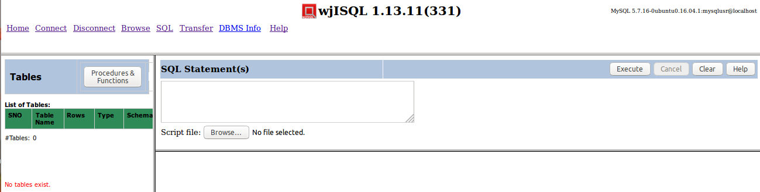

Test Status:
Platform | wjISQL Version | Date | Status | Remarks
Ubuntu 16.04 LTS  FireFox | 1.16.5(409) | 2017-10-08 | Success
Windows 7

Test Case 1/2: Create tables
Test Prerequisites
1 | Test case 1 was executed.

Test Procedure
1 | Click navigation button SQL.
2 | Execute the following script file to drop tables; gnore errors, if any. wji_tsrc/wji_scripts/wji_01_basic_mysql_tables/tst_01_001_tables_drop_uc.sql
3 | Execute the following script file to create tables: wji_tsrc/wji_scripts/wji_01_basic_mysql_tables/tst_01_002_tables_create_uc.sql
4 | Execute the following script file to load data: wji_tsrc/wji_scripts/wji_01_basic_mysql_tables/tst_01_003_tables_insert_uc.sql
5 | Click naviagtion button Browse.

Test Expected o/p:
1 | The login is successful with 3 windows – Tables , SQL Statement(s) and an empty - and MySQL version and user information at the top right corner as shown below:  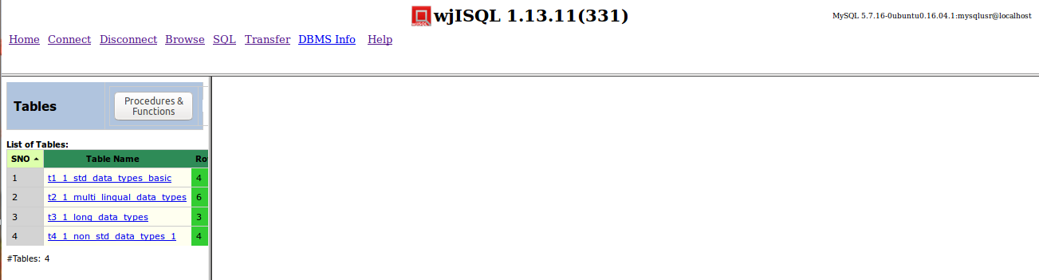

Test Status:
Platform | wjISQL Version | Date | Status | Remarks
Ubuntu 16.04 LTS  Chrome | 1.16.5(409) | 2017-10-08 | Success
Windows 7

Test Case 1/3: Create stored procedures
Test Prerequisites
1 | Test case 1 was executed.

Test Procedure
1 | Click navigation button SQL.
2 | Execute scripts files:  wji_tsrc/wji_scripts/wji_02_basic_mysql_procs/tst_02_00[1-6]*.sql  one by one to create stored procedures; ignore any errors while executing tst_02_001_*.sql.

Test Expected o/p:
1 | 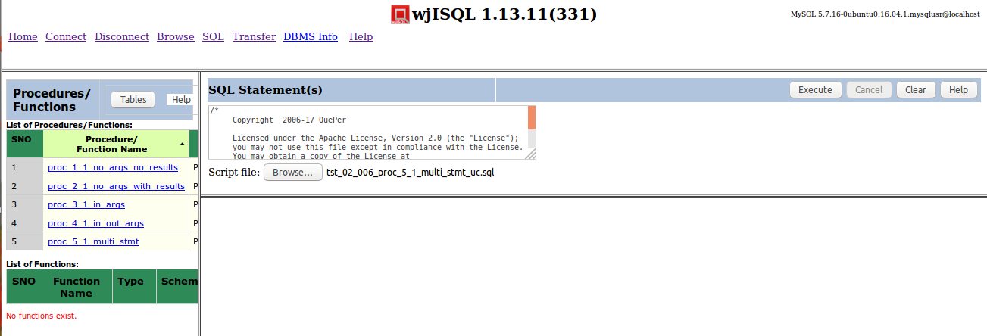

Test Status:
Platform | wjISQL Version | Date | Status | Remarks
Ubuntu 16.04 LTS  Chrome | 1.16.5(409) | 2017-10-09 | Success
Windows 7

Test Case 1/4: Create Stored Functions
Test Prerequisites
1 | Test case 1 was executed.

Test Procedure
1 | Click navigation button SQL.
2 | Execute scripts files:  wji_tsrc/wji_scripts/wji_03_basic_mysql_funcs/tst_03_*.sql  one by one to create stored functions; ignore errors if dropping of function fails.

Test Expected o/p:
1 | List of procedures and functions as following:  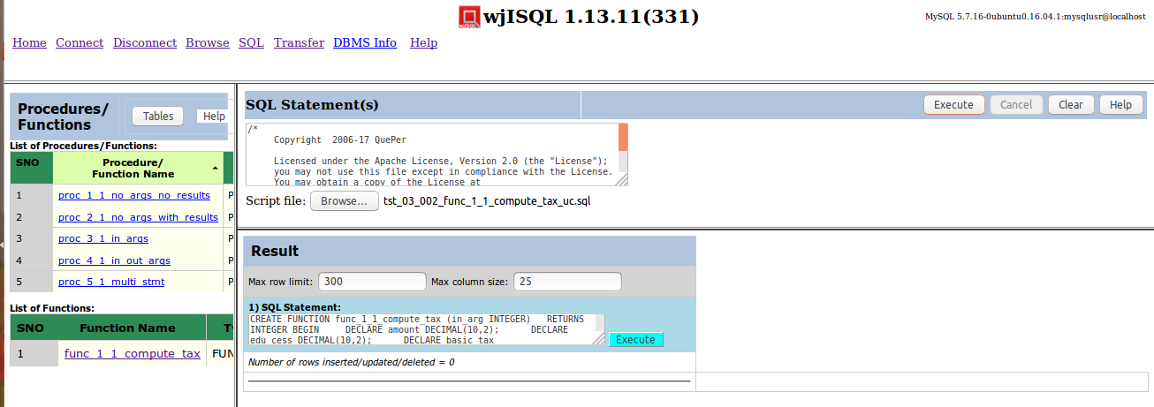

Test Status:
Platform | wjISQL Version | Date | Status | Remarks
Ubuntu 16.04 LTS  Chrome | 1.16.5(409) | 2017-10-09 | Success
Windows 7

Browse Menu Item Test Cases

Successful Test Cases

Test Case 1/5: Test that Browse menu item displays current tables
Test Prerequisites:
1 | Section 2.1, 2.2 and database connection is already done.

Test Procedure
1 | Click button Browse.

Test Expected o/p:
1 | List of tables in the database:  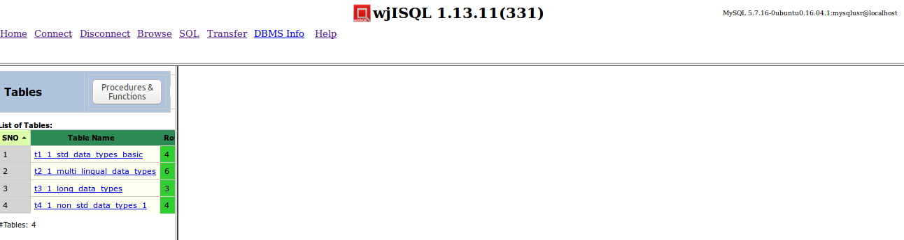

Test Status:
Platform | wjISQL | Date | Status | Remarks
Ubuntu 16.04 LTS  Chrome | 1.16.5(409) | 2017-10-09 | Success
Windows 7

Unsuccessful Test Cases
None.

Table Properties Test Cases

Successful Test Cases
Test Case 1/6: Test that clicking on a table causes display of column properties of the table on the right side.
Test Prerequisites:
1 | Section 2.3 Test cases

Test Procedure
1 | Click on the table: t1_1_std_data_types_basic

Test Expected o/p:
1 | The table columns as shown below:  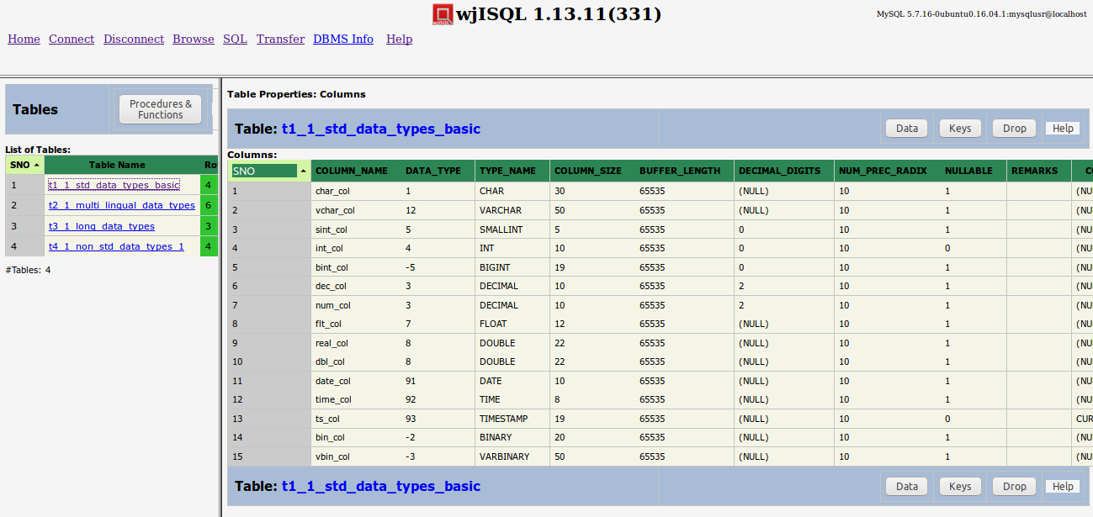

Test Status:
Platform | wjISQL | Date | Status | Remarks
Ubuntu 16.04 LTS  Chrome | 1.16.5(409) | 2017-10-09 | Success
Windows 7

Test Case 2/7: Test that clicking on another table causes display of column properties of the table replacing display of properties of previous table
Test Prerequisites:
1 | Test Case 1

Test Procedure
1 | Click on the table: t2_1_multi_lingual_data_types

Test Expected o/p:
1 | The table columns as shown below:  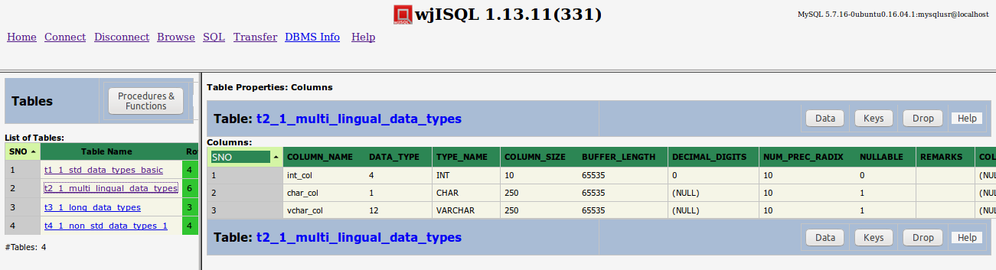

Test Status:
Platform | wjISQL | Date | Status | Remarks
Ubuntu 16.04 LTS  Chrome | 1.16.5(409) | 2017-10-09 | Success
Windows 7

Unsuccessful Test Cases
None.

Table Data Test Cases

Successful Test Cases
Test Case 1/8: Test that button Data displays data present in the table
Test Prerequisites:
1 | Section 2.3 Test cases

Test Procedure
1 | Click on the table: t1_1_std_data_types_basic
2 | Click button Data

Test Expected o/p:
1 | Data of the table as shown below:  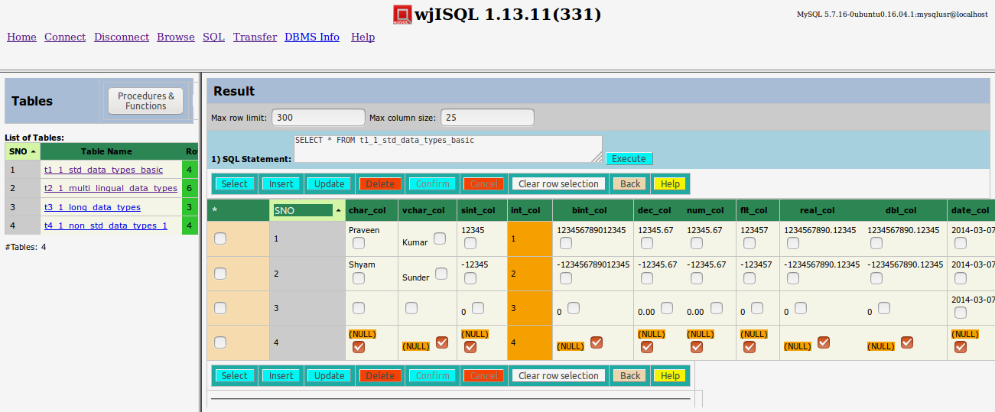

Post Test Actions:
1 | Click button Back to get back to table properties.

Test Status:
Platform | wjISQL | Date | Status | Remarks
Ubuntu 16.04 LTS  Chrome | 1.16.5(409) | 2017-10-09 | Success
Windows 7

Test Case 2/9: Test that button Data for another table to display multi-lingual data.
Test Prerequisites:
1 | Section 2.3 Test cases

Test Procedure
1 | Click on the table: t2_1_multi_lingual_data
2 | Click button Data

Test Expected o/p:
1 | Multi-lingual data of the table as shown below:  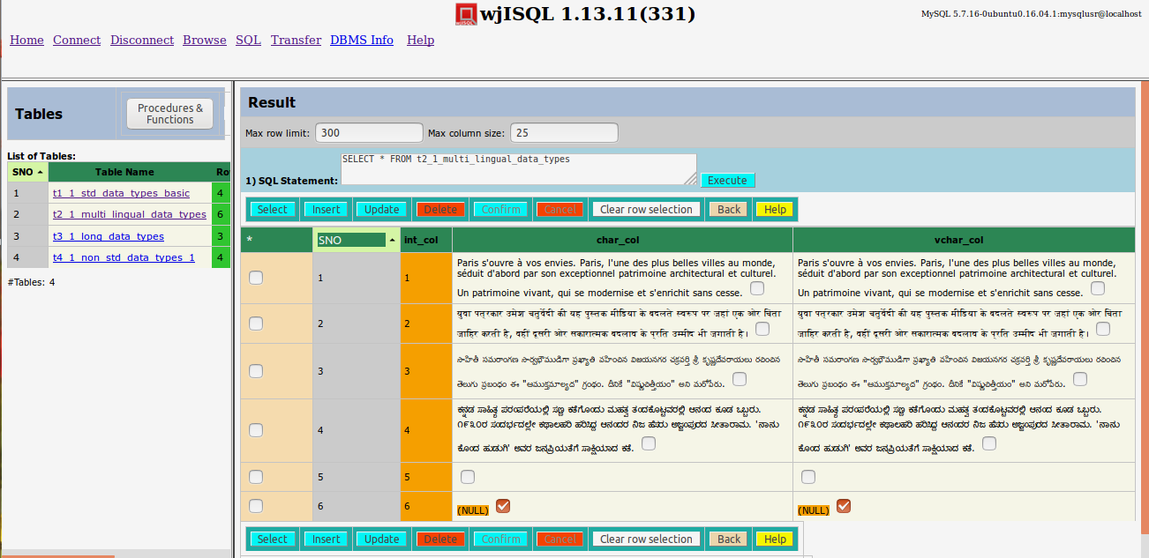

Post Test Actions:
1 | Click button Back to get back to table properties.

Test Status:
Platform | wjISQL | Date | Status | Remarks
Ubuntu 16.04 LTS  Chrome | 1.16.5(409) | 2017-10-09 | Success
Windows 7

Test Case 3/10: Test that button Data for a table having long data columns
Test Prerequisites:
1 | Section 2.3 Test cases

Test Procedure
1 | Click on the table: t3_1_long_data_types
2 | Click button Data

Test Expected o/p:
1 | Data of the table as shown below:  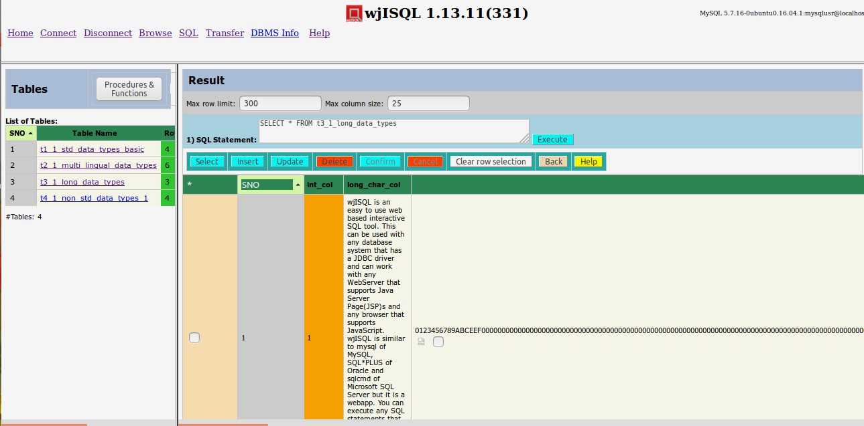

Post Test Actions:
1 | Click button Back to get back to table properties.

Test Status:
Platform | wjISQL | Date | Status | Remarks
Ubuntu 16.04 LTS  FireFox | 1.16.5(409) | 2017-10-09 | Success
Windows 7

Unsuccessful Test Cases
None.

Table Keys Test Cases

Successful Test Cases
Test Case 1/11: Test that button Keys displays keys of tables
Test Prerequisites:
1 | Section 2.3 Test cases

Test Procedure
1 | Click on the table: t1_1_std_data_types_basic
2 | Click button Keys

Test Expected o/p:
1 | Key of the table as shown below:  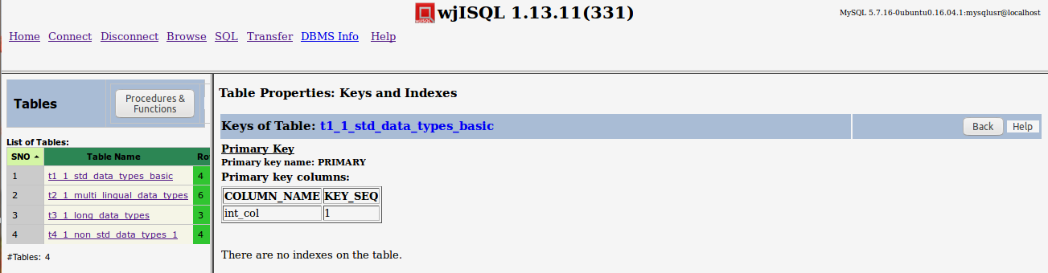

Post Test Actions:
1 | Click button Back to get back to table properties.

Test Status:
Platform | wjISQL | Date | Status | Remarks
Ubuntu 16.04 LTS  Chrome | 1.16.5(409) | 2017-10-09 | Success
Windows 7

Table Dropping Test Cases

Successful Test Cases
Test Case 1/12: Test that button Drop drops currently browsed table
Test Prerequisites:
1 | Section 2.3 Test cases

Test Procedure
1 | Click on the table: t4_1_non_std_data_types_1
2 | Click button Drop
3 | Confirm dropping

Test Expected o/p:
1 | Dropped table indicated by deletion of its name in the table list on the left side as shown below:  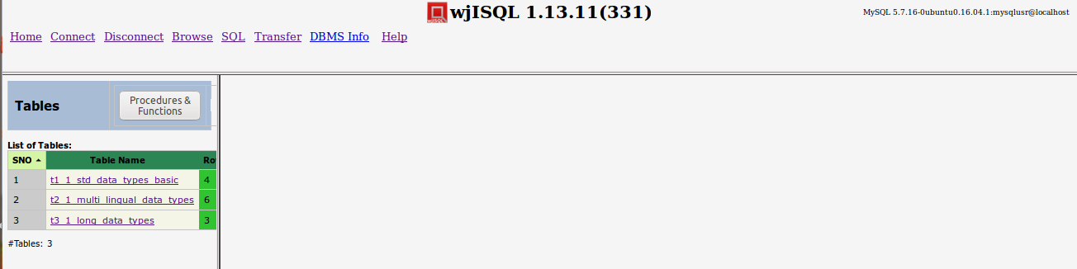

Post Test Actions:
1 | None

Test Status:
Platform | wjISQL | Date | Status | Remarks
Ubuntu 16.04 LTS  Chrome | 1.16.5(409) | 2017-10-09 | Success
Windows 7

Table Properties Help Test Cases

Successful Test Cases
Test Case 1/13: Test that button Help gives help on table properties
Test Prerequisites:
1 | Section 2.3 Test cases

Test Procedure
1 | Click on any table.
2 | Click button Help in right side bottom window.

Test Expected o/p:
1 | Separate browser tab with help as shown below:  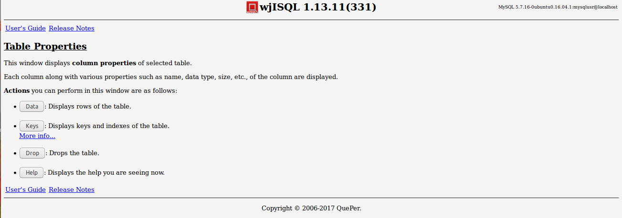

Post Test Actions:
1 | Close browser tab "Table Properties".

Test Status:
Platform | wjISQL | Date | Status | Remarks
Ubuntu 16.04 LTS  Chrome | 1.16.5(409) | 2017-10-09 | Success
Windows 7

Procedure/Function Browsing Test Cases

Successful Test Cases
Test Case 1/14: Test that button Procedures & Functions on the left section displays stored procedures and functions.
Test Prerequisites:
1 | Section 2.3 Test cases

Test Procedure
1 | Click button Procedures & Functions on the left section of page

Test Expected o/p:
1 | List of procedures and functions in the left section as shown below:  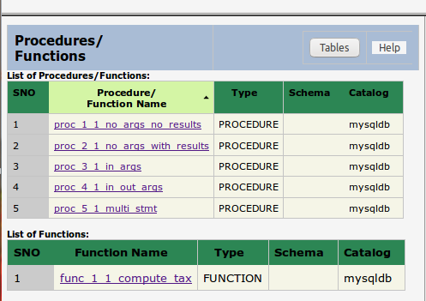

Post Test Actions:
1 | None.

Test Status:
Platform | wjISQL | Date | Status | Remarks
Ubuntu 16.04 LTS  Chrome | 1.16.5(409) | 2017-10-09 | Success
Windows 7

Procedure/Function Properties Test Cases

Successful Test Cases
Test Case 1/15: Test that properties of a procedure can be displayed.
Test Prerequisites:
1 | Section 2.3 Test cases

Test Procedure
1 | Click on the procedure proc_1_1_no_args_no_results

Test Expected o/p:
1 | The procedure properties as shown below:  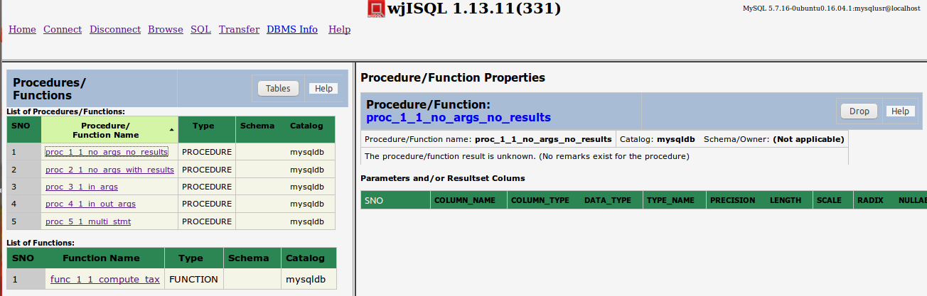

Post Test Actions:
1 | None.

Test Status:
Platform | wjISQL | Date | Status | Remarks
Ubuntu 16.04 LTS  Chrome | 1.16.5(409) | 2017-10-09 | Success
Windows 7

Test Case 2/16: Test properties of a procedure with parameters
Test Prerequisites:
1 | Section 2.3 Test cases

Test Procedure
1 | Click on the procedure proc_5_1_multi_stmt

Test Expected o/p:
1 | The procedure properties as shown below:  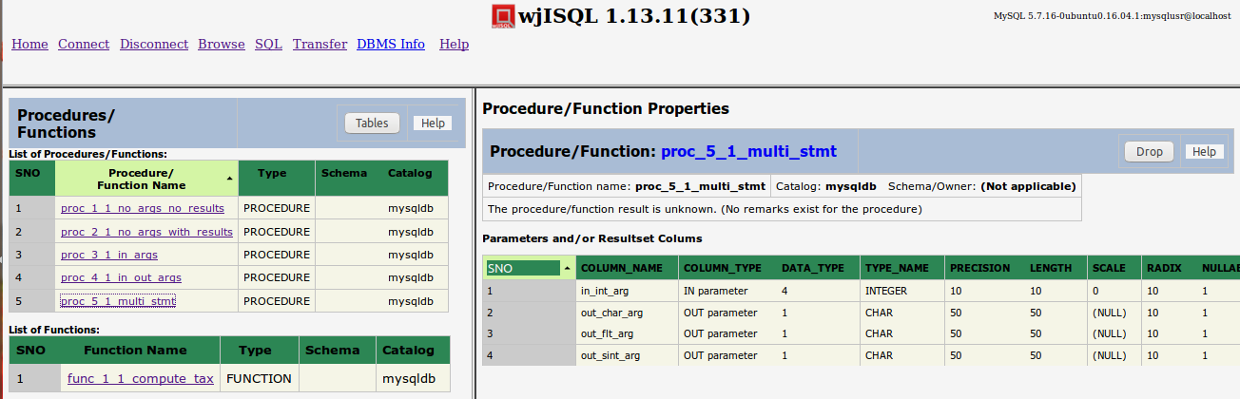

Post Test Actions:
1 | None.

Test Status:
Platform | wjISQL | Date | Status | Remarks
Ubuntu 16.04 LTS  Chrome | 1.16.5(409) | 2017-10-09 | Success
Windows 7

Test Case 2/17: Test properties of a function with parameters
Test Prerequisites:
1 | Section 2.3 Test cases

Test Procedure
1 | Click on the procedure func_1_1_compute_tax

Test Expected o/p:
1 | The procedure properties as shown below:  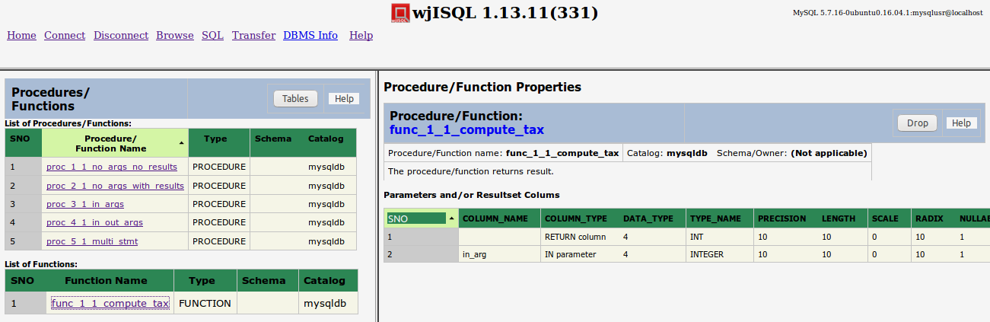

Post Test Actions:
1 | None.

Test Status:
Platform | wjISQL | Date | Status | Remarks
Ubuntu 16.04 LTS  Chrome | 1.16.5(409) | 2017-10-09 | Success
Windows 7

Procedure/Function Dropping Test Cases

Successful Test Cases
Test Case 1/18: Test that procedures can be dropped.
Test Prerequisites:
1 | Section 2.3 Test cases

Test Procedure
1 | Click on the procedure proc_5_1_multi_stmt.
2 | Click button Drop from right section of the screen.
3 | Confirm the dropping.

Test Expected o/p:
1 | The procedure is dropped with deletion of its name from left section of screen as shown below:  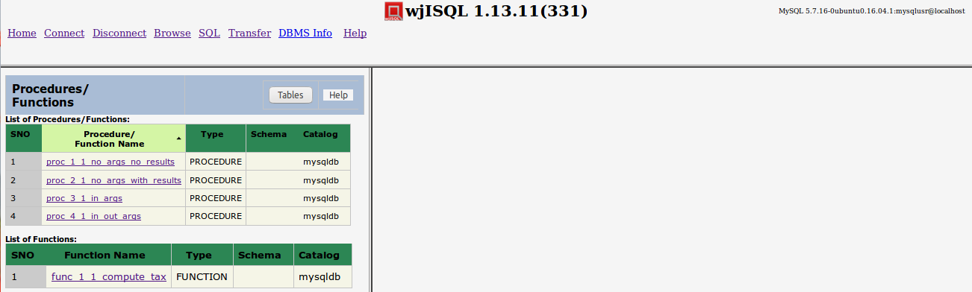

Post Test Actions:
1 | None.

Test Status:
Platform | wjISQL | Date | Status | Remarks
Ubuntu 16.04 LTS  Chrome | 1.16.5(409) | 2017-10-09 | Success
Windows 7

Test Case 2/19: Test that fuctions can be dropped.
Test Prerequisites:
1 | Section 2.3 Test cases

Test Procedure
1 | Click on the func_1_1_compute_tax.
2 | Click button Drop from right section of the screen.
3 | Confirm the dropping.

Test Expected o/p:
1 | The function is dropped with deletion of its name from left section of screen as shown below:  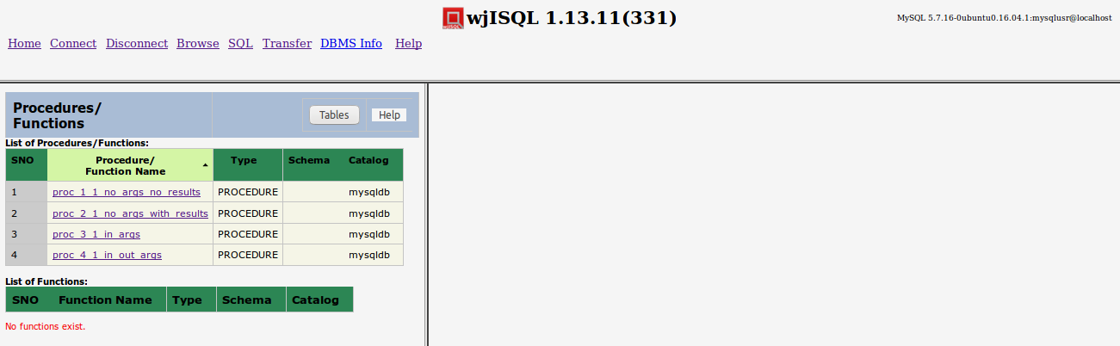

Post Test Actions:
1 | None.

Test Status:
Platform | wjISQL | Date | Status | Remarks
Ubuntu 16.04 LTS  Chrome | 1.16.5(409) | 2017-10-09 | Success
Windows 7

Procedure/Function Properties Help Test Cases

Successful Test Cases
Test Case 1/20: Test that button Help on Properties section works
Test Prerequisites:
1 | Section 2.3 Test cases

Test Procedure
1 | Click on the procedure proc_1_1_no_args_no_result
2 | Click button Help from right bottom section of the screen.

Test Expected o/p:
1 | Help is displayed in a new browser tab as shown below:  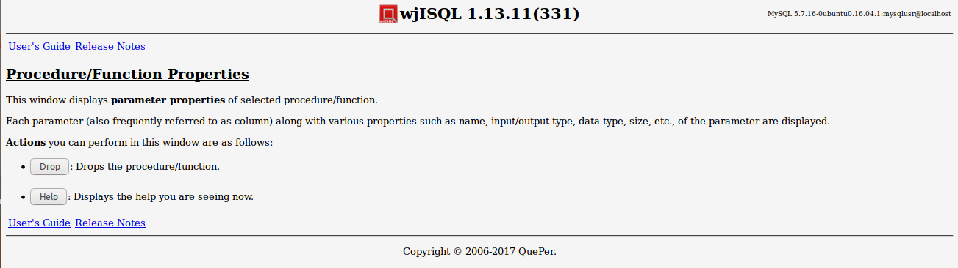

Post Test Actions:
1 | Close the brower tab Procedure/Function properties.

Test Status:
Platform | wjISQL | Date | Status | Remarks
Ubuntu 16.04 LTS  Chrome | 1.16.5(409) | 2017-10-09 | Success
Windows 7

Procedure/Function Tables Button Test Cases

Successful Test Cases
Test Case 1/21: Test that button Tables of left section displays list of tables
Test Prerequisites:
1 | Section 2.3 Test cases

Test Procedure
1 | Click button Tables

Test Expected o/p:
1 | List of tables as shown below:  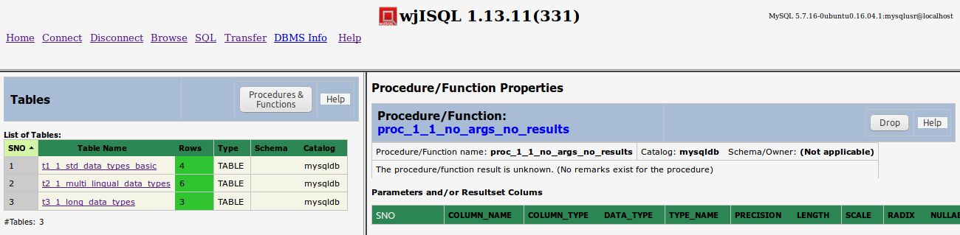

Post Test Actions:
1 | Disconnect from mysqldb

Test Status:
Platform | wjISQL | Date | Status | Remarks
Ubuntu 16.04 LTS  Chrome | 1.16.5(409) | 2017-10-09 | Success
Windows 7

MariaDB Database Browsing Test Cases

Prerequisites

1 | MariaDB database mariadb is readily available for user mariausr and password maria123. The user has DBA privileges.
2 | Set mysql configuration parameter before starting server:  log_bin_trust_function_creators = 1

Database Setup Test Cases

Test Case 1/22: Login into MariaDB database mariadb
Test Prerequisites
1 | None.

Test Procedure
1 | Click menu item "Connect".
2 | Choose MariaDB JDBC Driver from field JDBC driver displayed in login window.
3 | Specify database mariadb in the Database URL: jdbc:mariadb://localhost/mariadb
4 | Enter user id mariausr and password maria123.
5 | Click button Login.

Test Expected o/p:
1 | The login is successful with 3 windows – Tables , SQL Statement(s) and an empty window- and MariaDB version and user information at the top right corner as shown below:  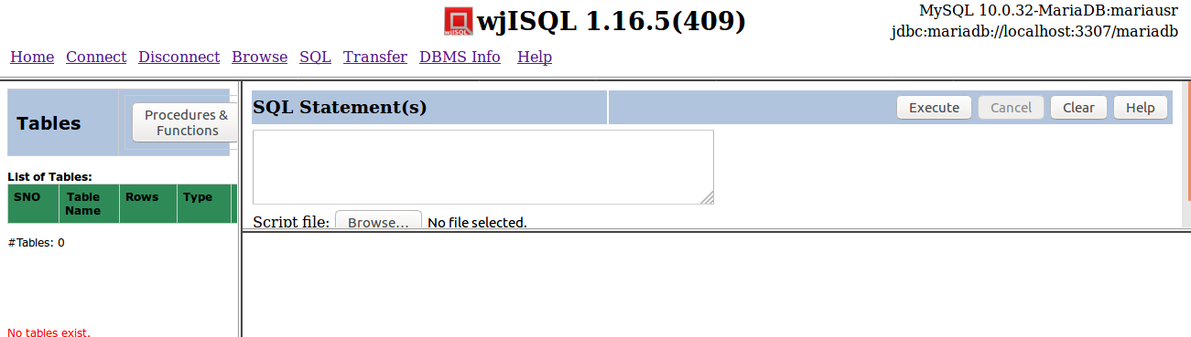

Test Status:
Platform | wjISQL Version | Date | Status | Remarks
Ubuntu 16.04 LTS  FireFox | 1.16.5(409) | 2017-10-09 | Success
Windows 7

Test Case 2/23: Create tables
Test Prerequisites
1 | Test case 1 was executed.

Test Procedure
1 | Click navigation button SQL.
2 | Execute the following script file to drop tables; ignore errors, if any. wji_tsrc/wji_scripts/wji_18_basic_mariadb_tables/tst_18_001_tables_drop_uc.sql
3 | Execute the following script file to create tables: wji_tsrc/wji_scripts/wji_18_basic_mariadb_tables/tst_18_002_tables_create_uc.sql
4 | Execute the following script file to load data: wji_tsrc/wji_scripts/wji_18_basic_mariadb_tables/tst_18_003_tables_insert_uc.sql
5 | Click naviagtion button Browse.

Test Expected o/p:
1 | The login is successful with 3 windows – Tables , SQL Statement(s) and an empty - and MariaDB version and user information at the top right corner as shown below:  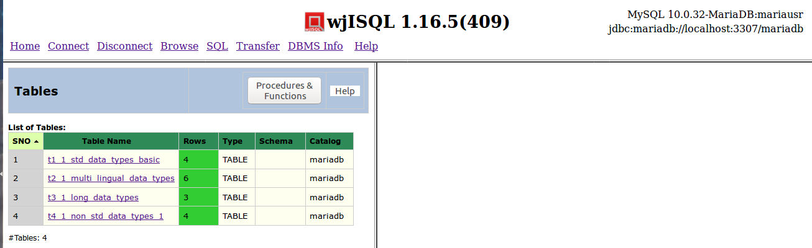

Test Status:
Platform | wjISQL Version | Date | Status | Remarks
Ubuntu 16.04 LTS  FireFox | 1.16.5(409) | 2017-10-09 | Success
Windows 7

Test Case 3/24: Create stored procedures
Test Prerequisites
1 | Test case 1 was executed.

Test Procedure
1 | Click navigation button SQL.
2 | Execute scripts files:  wji_tsrc/wji_scripts/wji_19_basic_mariadb_procs/tst_19_00[1-6]*.sql  one by one to create stored procedures; ignore any errors while executing tst_19_001_*.sql.

Test Expected o/p:
1

Test Status:
Platform | wjISQL Version | Date | Status | Remarks
Ubuntu 16.04 LTS  FireFox | 1.16.5(409) | 2017-10-09 | FAILED | Java.sql.SQLException: Out of range value for column 'REMARKS' : value is not in Short range
Windows 7

Test Case 4/25: Create Stored Functions
Test Prerequisites
1 | Test case 1 was executed.

Test Procedure
1 | Click navigation button SQL.
2 | Execute scripts files:  wji_tsrc/wji_scripts/wji_20_basic_mysql_funcs/tst_20_*.sql  one by one to create stored functions; ignore errors if dropping of function fails.

Test Expected o/p:
1 | List of procedures and functions as following:

Test Status:
Platform | wjISQL Version | Date | Status | Remarks
Ubuntu 16.04 LTS  Chrome | 1.16.5(410) | 2017-10-09 | FAILED | Java.sql.SQLException: Out of range value for column 'REMARKS' : value is not in Short range
Windows 7

Browse Menu Item Test Cases

Successful Test Cases

Test Case 1/26: Test that Browse menu item displays current tables
Test Prerequisites:
1 | Section 2.1, 2.2 and database connection is already done.

Test Procedure
1 | Click button Browse.

Test Expected o/p:
1 | List of tables in the database:

Test Status:
Platform | wjISQL | Date | Status | Remarks
Ubuntu 16.04 LTS  FireFox | 1.16.5(410) | 2017-10-09 | Success
Windows 7

Unsuccessful Test Cases
None.

Table Properties Test Cases

Successful Test Cases
Test Case 1/27: Test that clicking on a table causes display of column properties of the table on the right side.
Test Prerequisites:
1 | Section 2.3 Test cases

Test Procedure
1 | Click on the table: t1_1_std_data_types_basic

Test Expected o/p:
1 | The table columns as shown below:  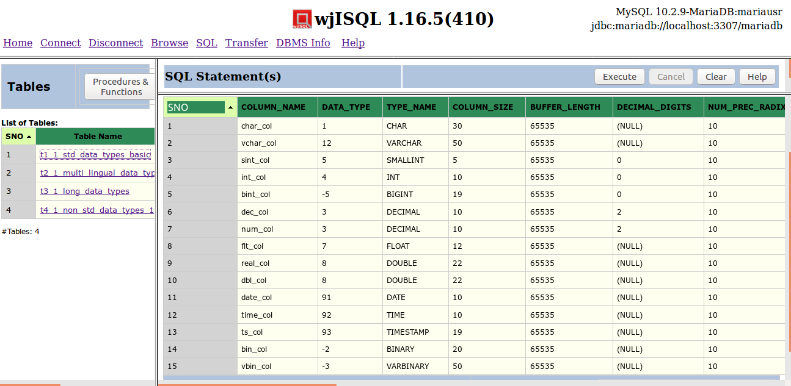

Test Status:
Platform | wjISQL | Date | Status | Remarks
Ubuntu 16.04 LTS  FireFox | 1.16.5(410) | 2017-10-09 | Success
Windows 7

Test Case 2/28: Test that clicking on another table causes display of column properties of the table replacing display of properties of previous table
Test Prerequisites:
1 | Test Case 1

Test Procedure
1 | Click on the table: t2_1_multi_lingual_data_types

Test Expected o/p:
1 | The table columns as shown below:  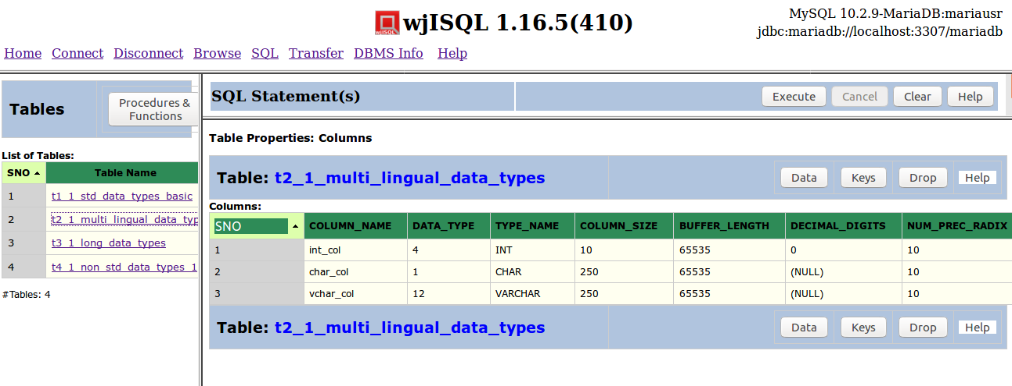

Test Status:
Platform | wjISQL | Date | Status | Remarks
Ubuntu 16.04 LTS  FireFox | 1.16.5(410) | 2017-10-09 | Success
Windows 7

Unsuccessful Test Cases
None.

Table Data Test Cases

Successful Test Cases
Test Case 1/29: Test that button Data displays data present in the table
Test Prerequisites:
1 | Section 2.3 Test cases

Test Procedure
1 | Click on the table: t1_1_std_data_types_basic
2 | Click button Data

Test Expected o/p:
1 | Data of the table as shown below:  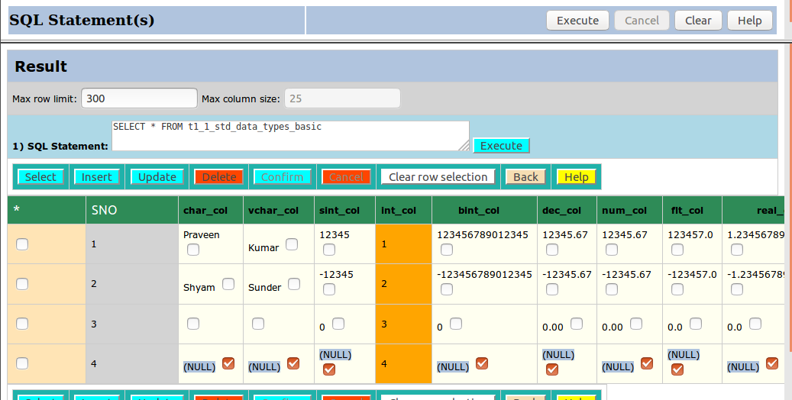

Post Test Actions:
1 | Click button Back to get back to table properties.

Test Status:
Platform | wjISQL | Date | Status | Remarks
Ubuntu 16.04 LTS  FireFox | 1.16.5(410) | 2017-10-09 | Success
Windows 7

Test Case 2/30: Test that button Data for another table to display multi-lingual data.
Test Prerequisites:
1 | Section 2.3 Test cases

Test Procedure
1 | Click on the table: t2_1_multi_lingual_data
2 | Click button Data

Test Expected o/p:
1 | Multi-lingual data of the table as shown below:  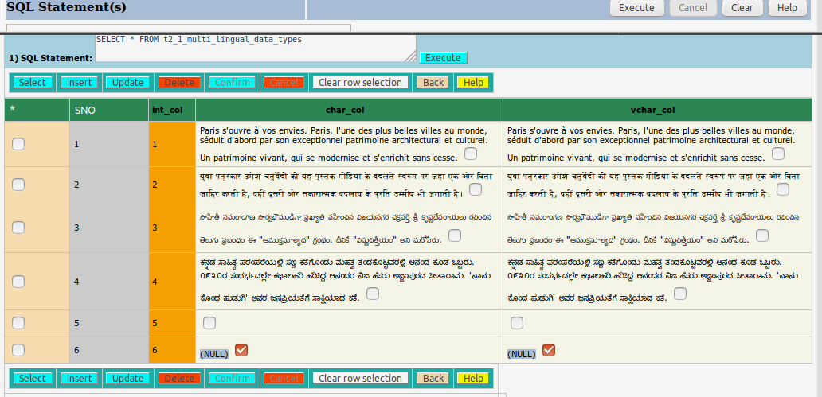

Post Test Actions:
1 | Click button Back to get back to table properties.

Test Status:
Platform | wjISQL | Date | Status | Remarks
Ubuntu 16.04 LTS  Chrome | 1.16.5(410) | 2017-10-09 | Success
Windows 7

Test Case 3/31: Test that button Data for a table having long data columns
Test Prerequisites:
1 | Section 2.3 Test cases

Test Procedure
1 | Click on the table: t3_1_long_data_types
2 | Click button Data

Test Expected o/p:
1 | Data of the table as shown below:  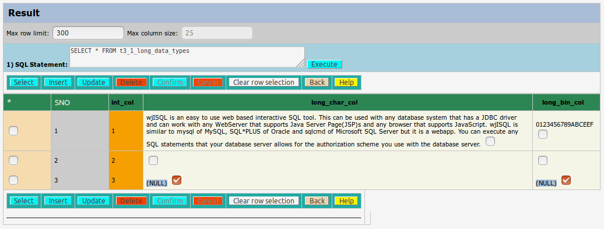

Post Test Actions:
1 | Click button Back to get back to table properties.

Test Status:
Platform | wjISQL | Date | Status | Remarks
Ubuntu 16.04 LTS  FireFox | 1.16.5(410) | 2017-10-09 | Success
Windows 7

Unsuccessful Test Cases
None.

Table Keys Test Cases

Successful Test Cases
Test Case 1/32: Test that button Keys displays keys of tables
Test Prerequisites:
1 | Section 2.3 Test cases

Test Procedure
1 | Click on the table: t1_1_std_data_types_basic
2 | Click button Keys

Test Expected o/p:
1 | Key of the table as shown below:  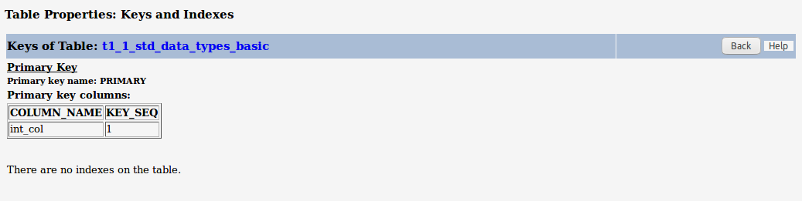

Post Test Actions:
1 | Click button Back to get back to table properties.

Test Status:
Platform | wjISQL | Date | Status | Remarks
Ubuntu 16.04 LTS  Chrome | 1.16.5(409) | 2017-10-09 | Success
Windows 7

Table Dropping Test Cases

Successful Test Cases
Test Case 1/33: Test that button Drop drops currently browsed table
Test Prerequisites:
1 | Section 2.3 Test cases

Test Procedure
1 | Click on the table: t4_1_non_std_data_types_1
2 | Click button Drop
3 | Confirm dropping

Test Expected o/p:
1 | Dropped table indicated by deletion of its name in the table list on the left side as shown below:  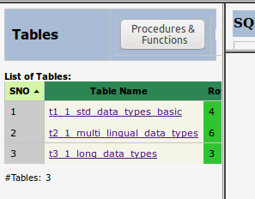

Post Test Actions:
1 | None

Test Status:
Platform | wjISQL | Date | Status | Remarks
Ubuntu 16.04 LTS  FireFox | 1.16.5(410) | 2017-10-09 | Success
Windows 7

Table Properties Help Test Cases

Successful Test Cases
Test Case 1/34: Test that button Help gives help on table properties
Test Prerequisites:
1 | Section 2.3 Test cases

Test Procedure
1 | Click on any table.
2 | Click button Help in right side bottom window.

Test Expected o/p:
1 | Separate browser tab with help as shown below:

Post Test Actions:
1 | Close browser tab "Table Properties".

Test Status:
Platform | wjISQL | Date | Status | Remarks
Ubuntu 16.04 LTS  FireFox | 1.16.5(410) | 2017-10-09 | Success
Windows 7

Procedure/Function Browsing Test Cases

Successful Test Cases
Test Case 1/35: Test that button Procedures & Functions on the left section displays stored procedures and functions.
Test Prerequisites:
1 | Section 2.3 Test cases

Test Procedure
1 | Click button Procedures & Functions on the left section of page

Test Expected o/p:
1 | List of procedures and functions in the left section as shown below:

Post Test Actions:
1 | None.

Test Status:
Platform | wjISQL | Date | Status | Remarks
Ubuntu 16.04 LTS  FireFox | 1.16.5(410) | 2017-10-09 | NOT TESTED | Because of issue of creating procedures
Windows 7

Procedure/Function Properties Test Cases

Successful Test Cases
Test Case 1/36: Test that properties of a procedure can be displayed.
Test Prerequisites:
1 | Section 2.3 Test cases

Test Procedure
1 | Click on the procedure proc_1_1_no_args_no_results

Test Expected o/p:
1 | The procedure properties as shown below:

Post Test Actions:
1 | None.

Test Status:
Platform | wjISQL | Date | Status | Remarks
Ubuntu 16.04 LTS  Chrome | 1.16.5(410) | 2017-10-09 | NOT TESTED | Because of issue of creating procedures
Windows 7

Test Case 2/37: Test properties of a procedure with parameters
Test Prerequisites:
1 | Section 2.3 Test cases

Test Procedure
1 | Click on the procedure proc_5_1_multi_stmt

Test Expected o/p:
1 | The procedure properties as shown below:

Post Test Actions:
1 | None.

Test Status:
Platform | wjISQL | Date | Status | Remarks
Ubuntu 16.04 LTS  Chrome | 1.16.5(410) | 2017-10-09 | NOT TESTED | Because of issue of creating procedures
Windows 7

Test Case 3/38: Test properties of a function with parameters
Test Prerequisites:
1 | Section 2.3 Test cases

Test Procedure
1 | Click on the procedure func_1_1_compute_tax

Test Expected o/p:
1 | The procedure properties as shown below:

Post Test Actions:
1 | None.

Test Status:
Platform | wjISQL | Date | Status | Remarks
Ubuntu 16.04 LTS  Chrome | 1.16.5(410) | 2017-10-09 | NOT TESTED | Because of issue of creating procedures
Windows 7

Procedure/Function Dropping Test Cases

Successful Test Cases
Test Case 1/39: Test that procedures can be dropped.
Test Prerequisites:
1 | Section 2.3 Test cases

Test Procedure
1 | Click on the procedure proc_5_1_multi_stmt.
2 | Click button Drop from right section of the screen.
3 | Confirm the dropping.

Test Expected o/p:
1 | The procedure is dropped with deletion of its name from left section of screen as shown below:

Post Test Actions:
1 | None.

Test Status:
Platform | wjISQL | Date | Status | Remarks
Ubuntu 16.04 LTS  FireFox | 1.16.5(410) | 2017-10-09 | NOT TESTED | Because of issue of creating procedures
Windows 7

Test Case 2/40: Test that fuctions can be dropped.
Test Prerequisites:
1 | Section 2.3 Test cases

Test Procedure
1 | Click on the func_1_1_compute_tax.
2 | Click button Drop from right section of the screen.
3 | Confirm the dropping.

Test Expected o/p:
1 | The function is dropped with deletion of its name from left section of screen as shown below:

Post Test Actions:
1 | None.

Test Status:
Platform | wjISQL | Date | Status | Remarks
Ubuntu 16.04 LTS  FireFox | 1.16.5(410) | 2017-10-09 | NOT TESTED | Because of issue of creating procedures
Windows 7

Procedure/Function Properties Help Test Cases

Successful Test Cases
Test Case 1/41: Test that button Help on Properties section works
Test Prerequisites:
1 | Section 2.3 Test cases

Test Procedure
1 | Click on the procedure proc_1_1_no_args_no_results
2 | Click button Help from right bottom section of the screen.

Test Expected o/p:
1 | Help is displayed in a new browser tab as shown below:

Post Test Actions:
1 | Close the brower tab Procedure/Function properties.

Test Status:
Platform | wjISQL | Date | Status | Remarks
Ubuntu 16.04 LTS  FireFox | 1.16.5(410) | 2017-10-09 | NOT TESTED | Because of issue of creating procedures
Windows 7

Procedure/Function Tables Button Test Cases

Successful Test Cases
Test Case 1/42: Test that button Tables of left section displays list of tables
Test Prerequisites:
1 | Section 2.3 Test cases

Test Procedure
1 | Click button Tables

Test Expected o/p:
1 | List of tables as shown below:

Post Test Actions:
1 | Disconnect from mysqldb

Test Status:
Platform | wjISQL | Date | Status | Remarks
Ubuntu 16.04 LTS  FireFox | 1.16.5(410) | 2017-10-09 | NOT TESTED | Because of issue of creating procedures
Windows 7

PostgreSQL Database Browsing Test Cases

Prerequisites

1 | PostgreSQL database pgsqldb is readily available for user pgsqlusr and password pgsql123. The user has DBA privileges.

Database Setup Test Cases

Test Case 1/43: Login into database pgsqldb
Test Prerequisites
1 | None.

Test Procedure
1 | Click menu item "Connect".
2 | Choose PostgreSQL JDBC Driver from field JDBC driver displayed in login window.
3 | Specify database pgsqldb in the Database URL: jdbc:postgresql://localhost:5432/pgsqldb
4 | Enter user id pgsqlusr and password pgsql123.
5 | Click button Login.

Test Expected o/p:
1 | The login is successful with 3 windows – Tables , SQL Statement(s) and an empty window- and PostgreSQL version and user name at the top right corner as shown below:  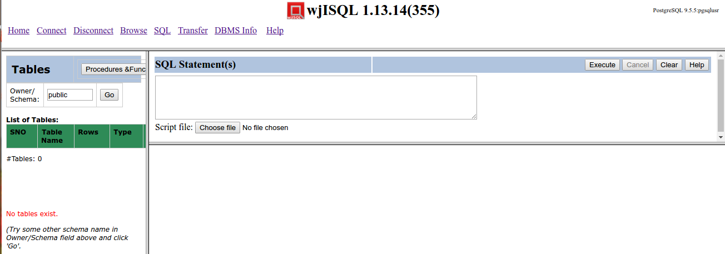

Test Status:
Platform | wjISQL Version | Date | Status | Remarks
Ubuntu 16.04 LTS  Chrome | 1.16.5(410) | 2017-10-09 | Success
Windows 7

Test Case 2/44: Create tables
Test Prerequisites
1 | Test case 1 was executed.

Test Procedure
1 | Click navigation button SQL.
2 | Execute the following script file to drop existing tables if any; ignore error messages: wji_tsrc/wji_scripts/wji_01_basic_pgsql_tables/tst_04_001_tables_drop_uc.sql
3 | Execute the following script file to create tables: wji_tsrc/wji_scripts/wji_01_basic_pgsql_tables/tst_04_002_tables_create_uc.sql
4 | Execute the following script file to insert data into the tables: wji_tsrc/wji_scripts/wji_01_basic_pgsql_tables/tst_04_003_tables_insert_uc.sql
5 | Click naviagtion button Browse.

Test Expected o/p:
1 | A list of 4 tables with number of rows inserted as shown below:  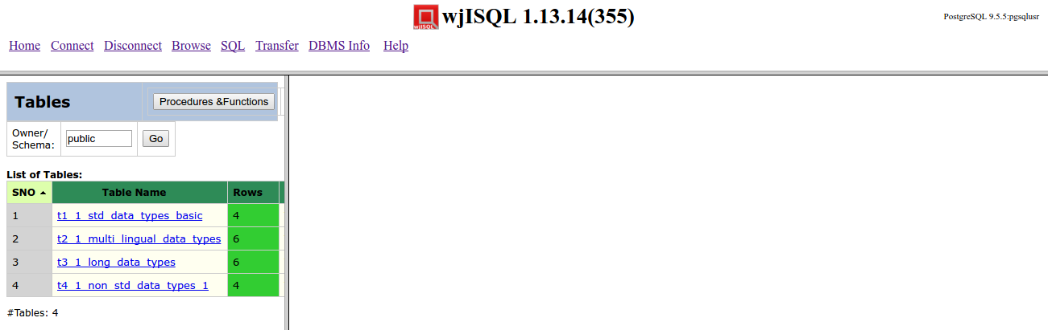

Test Status:
Platform | wjISQL Version | Date | Status | Remarks
Ubuntu 16.04 LTS  Chrome | 1.16.5(410) | 2016-12-27 | Success
Windows 7

Test Case 3/45: Create Stored Functions
Test Prerequisites
1 | Test case 1 was executed.

Test Procedure
1 | Click navigation button SQL.
2 | Execute scripts files:  wji_tsrc/wji_scripts/wji_06_basic_pgsql_funcs/tst_06_*.sql in the order of script files  one by one to create stored functions
3 | Click button Browse.
4 | Click button Procedures & Functions in the table list window.

Test Expected o/p:
1 | List of procedures and functions as following:  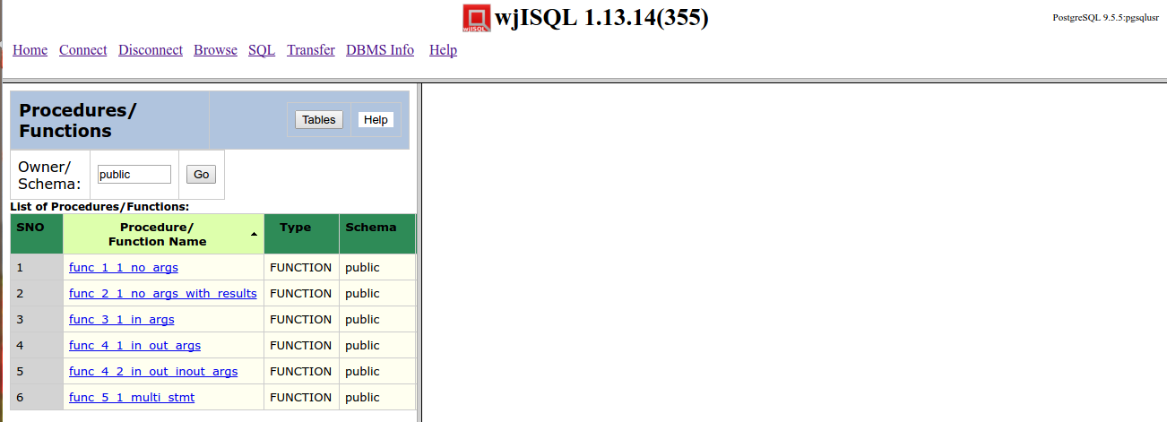

Test Status:
Platform | wjISQL Version | Date | Status | Remarks
Ubuntu 16.04 LTS  Chrome | 1.17.5(419) | 2017-10-10 | Success
Windows 7

Browse Menu Item Test Cases

Successful Test Cases

Test Case 1/46: Test that Browse menu item displays current tables
Test Prerequisites:
1 | Section 3.1, 3.2 and database connection is already done.

Test Procedure
1 | Click button Browse.

Test Expected o/p:
1 | List of tables in the database:  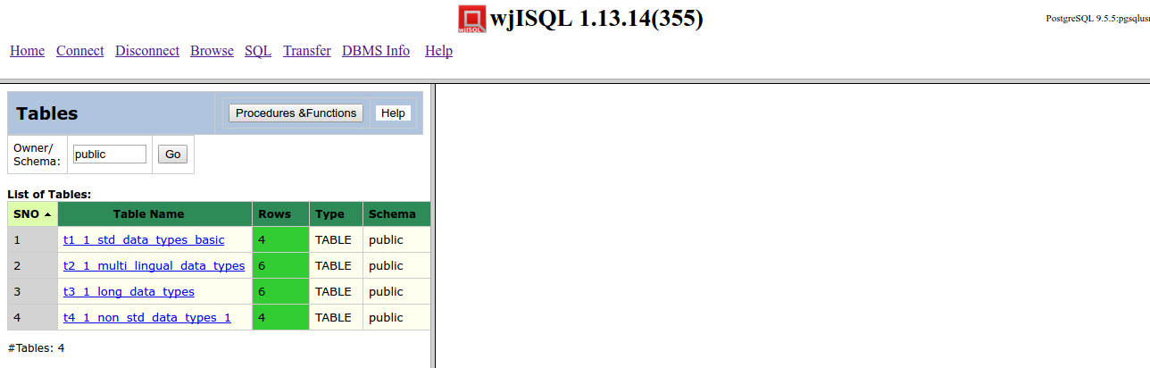

Test Status:
Platform | wjISQL | Date | Status | Remarks
Ubuntu 16.04 LTS  Chrome | 1.17.5(419) | 2017-10-10 | Success
Windows 7

Unsuccessful Test Cases
None.

Table Properties Test Cases

Successful Test Cases
Test Case 1/47: Test that clicking on a table causes display of column properties of the table on the right side.
Test Prerequisites:
1 | Section 3.2 Test cases

Test Procedure
1 | Click on the table: t1_1_std_data_types_basic

Test Expected o/p:
1 | The table columns as shown below:  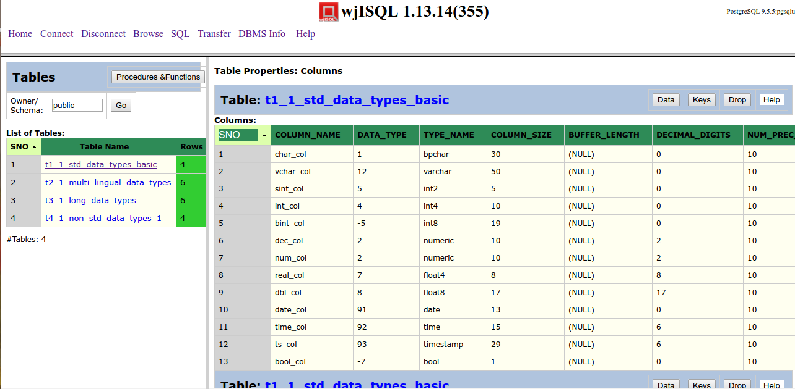

Test Status:
Platform | wjISQL | Date | Status | Remarks
Ubuntu 16.04 LTS  Chrome | 1.17.5(419) | 2017-10-10 | Success
Windows 7

Test Case 2/48: Test that clicking on another table causes display of column properties of the table replacing display of properties of previous table
Test Prerequisites:
1 | Test Case 1

Test Procedure
1 | Click on the table: t2_1_multi_lingual_data_types

Test Expected o/p:
1 | The table columns as shown below:  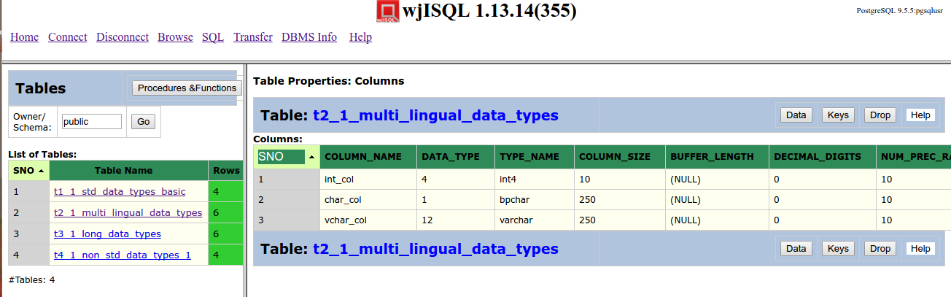

Test Status:
Platform | wjISQL | Date | Status | Remarks
Ubuntu 16.04 LTS  Chrome | 1.17.5(419) | 2017-10-10 | Success
Windows 7

Unsuccessful Test Cases
None.

Table Data Test Cases

Successful Test Cases
Test Case 1/49: Test that button Data displays data present in the table
Test Prerequisites:
1 | Section 3.3 Test cases

Test Procedure
1 | Click on the table: t1_1_std_data_types_basic
2 | Click button Data

Test Expected o/p:
1 | Data of the table as shown below:  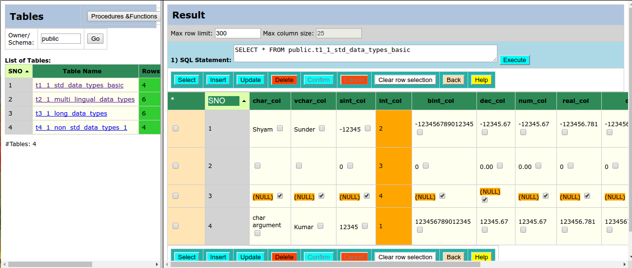

Post Test Actions:
1 | Click button Back to get back to table properties.

Test Status:
Platform | wjISQL | Date | Status | Remarks
Ubuntu 16.04 LTS  Chrome | 1.17.5(419) | 2017-10-10 | Success
Windows 7

Test Case 2/50: Test button Data for another table to display multi-lingual data.
Test Prerequisites:
1 | Section 3.3 Test cases

Test Procedure
1 | Click on the table: t2_1_multi_lingual_data
2 | Click button Data

Test Expected o/p:
1 | Multi-lingual data of the table as shown below:  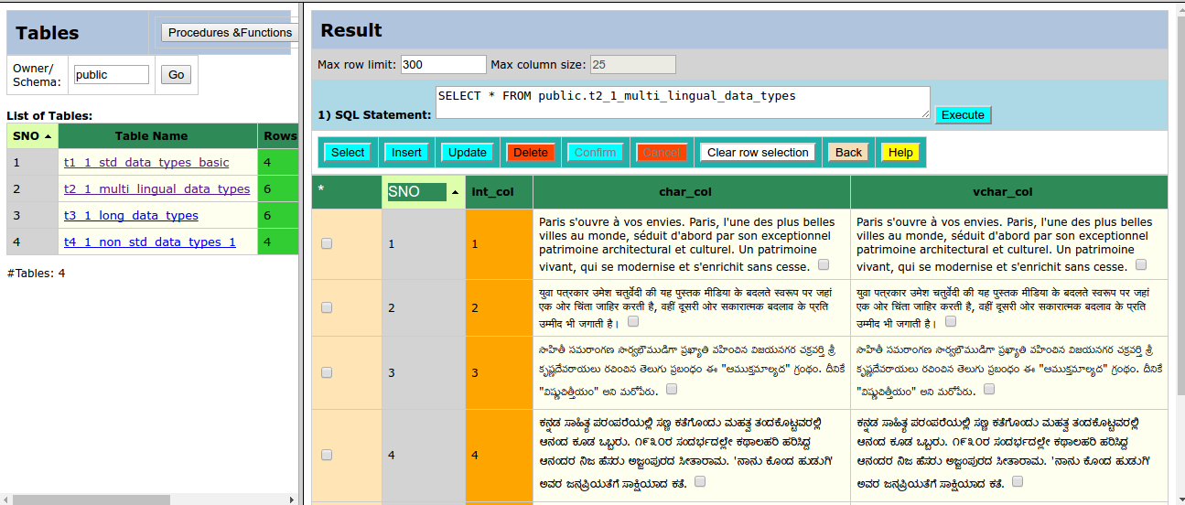

Post Test Actions:
1 | Click button Back to get back to table properties.

Test Status:
Platform | wjISQL | Date | Status | Remarks
Ubuntu 16.04 LTS  Chrome | 1.17.5(419) | 2017-10-10 | Success
Windows 7

Test Case 3/51: Test button Data for a table having long data columns
Test Prerequisites:
1 | Section 3.3 Test cases

Test Procedure
1 | Click on the table: t3_1_long_data_types
2 | Click button Data

Test Expected o/p:
1 | Data of the table as shown below:  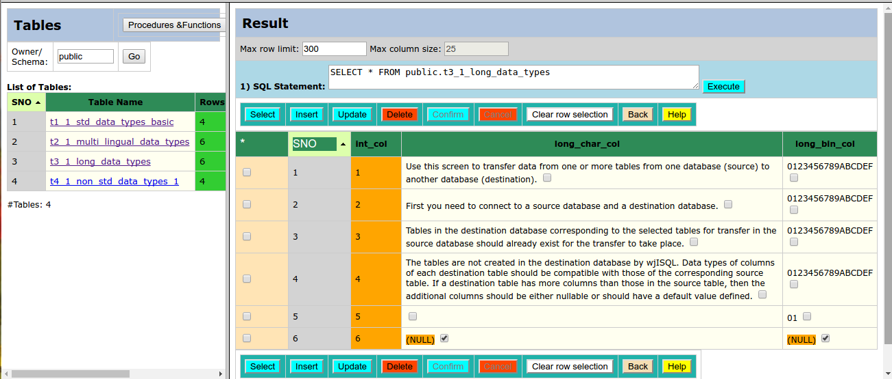

Post Test Actions:
1 | Click button Back to get back to table properties.

Test Status:
Platform | wjISQL | Date | Status | Remarks
Ubuntu 16.04 LTS  Chrome | 1.17.5(419) | 2017-10-10 | Success
Windows 7

Unsuccessful Test Cases
None.

Table Keys Test Cases

Successful Test Cases
Test Case 1/52: Test that button Keys displays keys of tables
Test Prerequisites:
1 | Section 3.3 Test cases

Test Procedure
1 | Click on the table: t1_1_std_data_types_basic
2 | Click button Keys

Test Expected o/p:
1 | Key of the table as shown below:  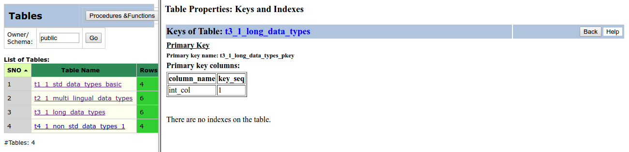

Post Test Actions:
1 | Click button Back to get back to table properties.

Test Status:
Platform | wjISQL | Date | Status | Remarks
Ubuntu 16.04 LTS  Chrome | 1.17.5(419) | 2017-10-10 | Success
Windows 7

Table Dropping Test Cases

Successful Test Cases
Test Case 1/53: Test that button Drop drops currently browsed table
Test Prerequisites:
1 | Section 2.3 Test cases

Test Procedure
1 | Click on the table: t4_1_non_std_data_types_1
2 | Click button Drop
3 | Confirm dropping

Test Expected o/p:
1 | Dropped table indicated by deletion of its name in the table list on the left side as shown below:  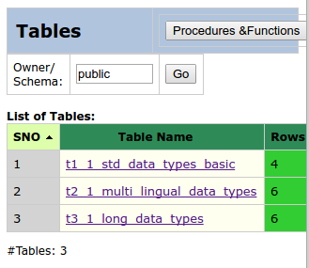

Post Test Actions:
1 | None

Test Status:
Platform | wjISQL | Date | Status | Remarks
Ubuntu 16.04 LTS  Chrome | 1.17.5(419) | 2017-10-10 | Success
Windows 7

Table Properties Help Test Cases
The help nothing to do with database and hence no testing requires as it is already done MySQL section.

Procedure/Function Browsing Test Cases

Successful Test Cases
Test Case 1/54: Test that button Procedures & Functions on the left section displays stored procedures and functions.
Test Prerequisites:
1 | Section 3.3 Test cases

Test Procedure
1 | Click button Procedures & Functions on the left section of page

Test Expected o/p:
1 | List of procedures and functions in the left section as shown below:  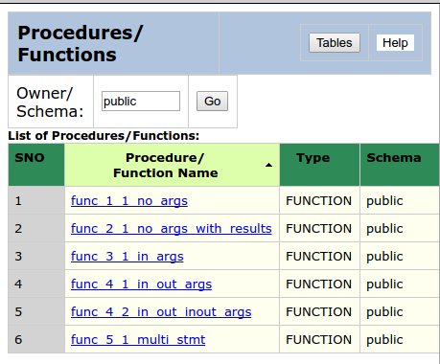

Post Test Actions:
1 | None.

Test Status:
Platform | wjISQL | Date | Status | Remarks
Ubuntu 16.04 LTS  FireFox | 1.17.5(419) | 2017-10-10 | Success
Windows 7

Procedure/Function Properties Test Cases

Successful Test Cases
Test Case 1/55: Test that properties of a function with parameters
Test Prerequisites:
1 | Section 2.3 Test cases

Test Procedure
1 | Click on the function func_4_2_in_out_inout_args

Test Expected o/p:
1 | The function properties as shown below:  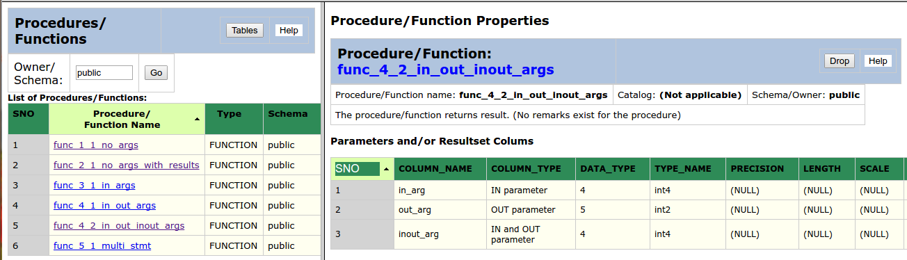

Post Test Actions:
1 | None.

Test Status:
Platform | wjISQL | Date | Status | Remarks
Ubuntu 16.04 LTS  Chrome | 1.17.5(419) | 2017-10-10 | Success
Windows 7

Procedure/Function Dropping Test Cases

Successful Test Cases
Test Case 2/56: Test that fuctions can be dropped.
Test Prerequisites:
1 | Section 3.3 Test cases

Test Procedure
1 | Click on the func_4_1_in_out_args
2 | Click button Drop from right section of the screen.
3 | Confirm the dropping.

Test Expected o/p:
1 | The function is dropped with deletion of its name from left section of screen.

Post Test Actions:
1 | None.

Test Status:
Platform | wjISQL | Date | Status | Remarks
Ubuntu 16.04 LTS  FireFox | 1.17.5(419) | 2017-10-10 | FAILED | Known issue.  Failed with error:  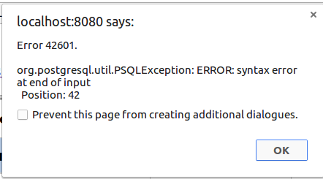
Windows 7

Procedure/Function Properties Help Test Cases

Note:- These are RDBMS independent tests and done as part of MySQL test cases.

Procedure/Function Tables Button Test Cases

Successful Test Cases
Test Case 1/57: Test that button Tables of left section displays list of tables
Test Prerequisites:
1 | Section 3.3 Test cases

Test Procedure
1 | Click button Tables

Test Expected o/p:
1 | List of tables as shown below:  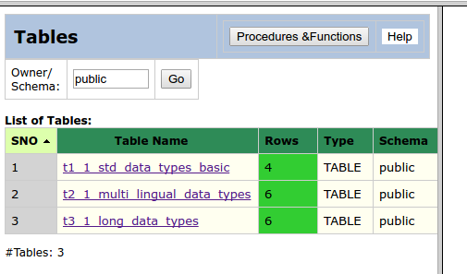

Post Test Actions:
1 | Close the brower tab Procedure/Function properties.

Test Status:
Platform | wjISQL | Date | Status | Remarks
Ubuntu 16.04 LTS  Chrome | 1.17.5(419) | 2017-10-10 | Success
Windows 7

Oracle Database Browsing Test Cases

Prerequisites

1 | Oracle database oradb with character set AL32UTF8 is readily available for user orausr and password ora123. The user has DBA privileges.

Database Setup Test Cases

Test Case 1/58: Login into database oradb
Test Prerequisites
1 | None.

Test Procedure
1 | Click menu item "Connect".
2 | Choose Oracle JDBC Driver from field JDBC driver displayed in login window.
3 | Specify database oradb in the Database URL: jdbc:oracle:thin:@localhost:1521:oradb
4 | Enter user id oraqlusr and password ora123.
5 | Click button Login.

Test Expected o/p:
1 | The login is successful with empty table list as shown below:  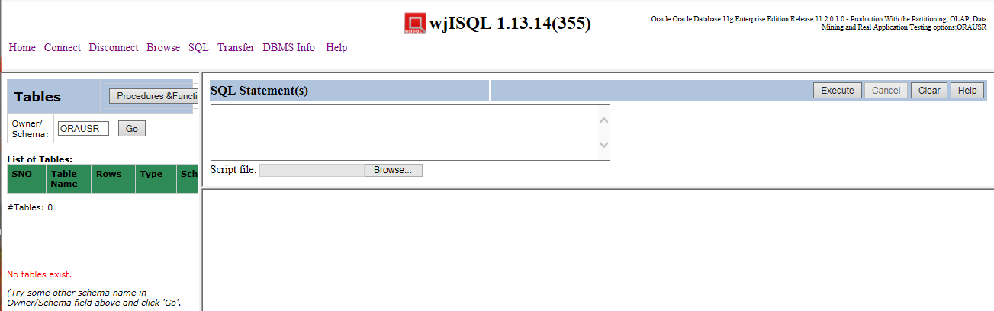

Test Status:
Platform | wjISQL Version | Date | Status | Remarks
Ubuntu 16.04 LTS
Windows 7  FireFox 56.0 | 1.19.5(439) | 2017-10-27 | Success

Test Case 2/59: Create tables
Test Prerequisites
1 | Test case 1 was executed.

Test Procedure
1 | Click navigation button SQL.
2 | Execute the following script file to drop tables if any; gnore errors wji_tsrc/wji_scripts/wji_07_basic_oracle_tables/tst_07_001_tables_drop_uc.sql
3 | Execute the following script file to create tables: wji_tsrc/wji_scripts/wji_07_basic_oracle_tables/tst_07_002_tables_create_uc.sql
4 | Execute the following script file to load data: wji_tsrc/wji_scripts/wji_07_basic_oracle_tables/tst_07_003_tables_insert_uc.sql

Test Expected o/p:
1 | The login is successful with table list as shown below:  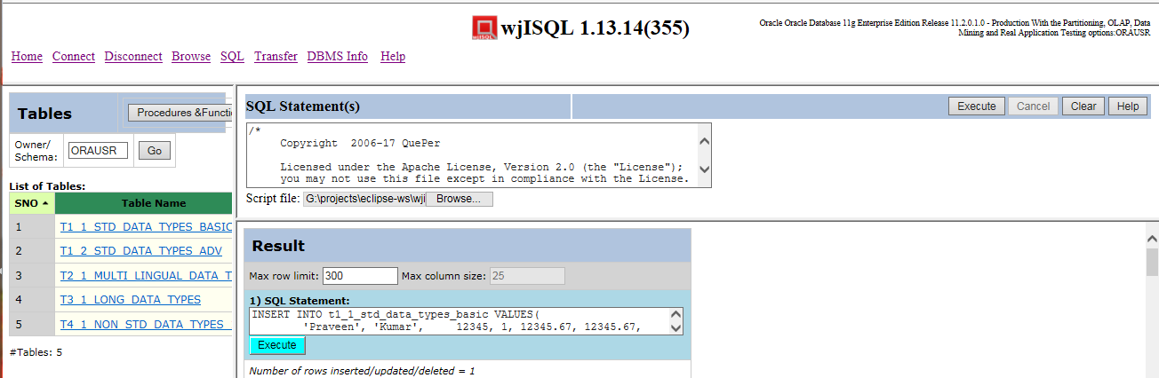

Test Status:
Platform | wjISQL Version | Date | Status | Remarks
Ubuntu 16.04 LTS
Windows 7  FireFox 56.0 | 1.19.5(439) | 2017-10-27 | Success

Test Case 3/60: Create stored procedures
Test Prerequisites
1 | Test case 1 was executed.

Test Procedure
1 | Click navigation button SQL.
2 | Execute the following script file; ignore proc not found error, if any:  wji_tsrc/wji_scripts/wji_08_basic_oracle_procs/tst_08_001_proc_drop.sql
3 | Execute the following scripts files to create stored procedures:  wji_tsrc/wji_scripts/wji_08_basic_oracle_procs/tst_08_00[2-8]_proc_create_*.sql

Test Expected o/p:
1 | Screen with list of created procedures as shown below:  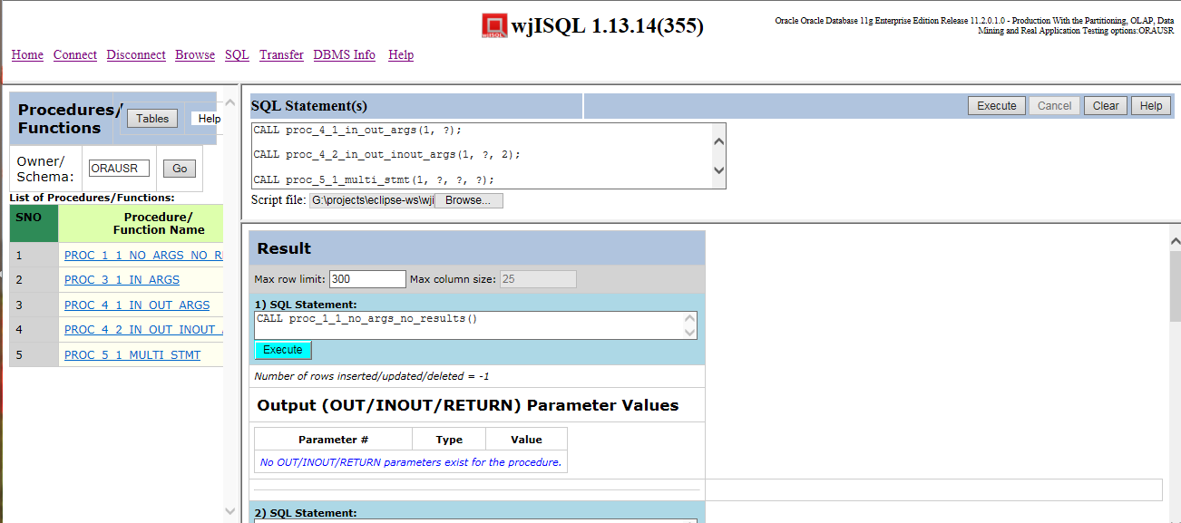

Test Status:
Platform | wjISQL Version | Date | Status | Remarks
Ubuntu 16.04 LTS
Windows 7  FireFox 56.0 | 1.19.5(439) | 2017-10-27 | Success

Test Case 4/61: Create Stored Functions
Test Prerequisites
1 | Test case 1 was executed.

Test Procedure
1 | Click navigation button SQL.
2 | Execute the following script file; ignore any function not found error if any:  wji_tsrc/wji_scripts/wji_09_basic_oracle_funcs/tst_09_001_func_drop.sql
3 | Execute the following scripts files in order of files:  wji_tsrc/wji_scripts/wji_09_basic_oracle_funcs/tst_09_00[2-3]_func_*.sql
4 | Click menu item Browse.
5 | Click button Procedures & Functions.

Test Expected o/p:
1 | List of procedures and functions as following:  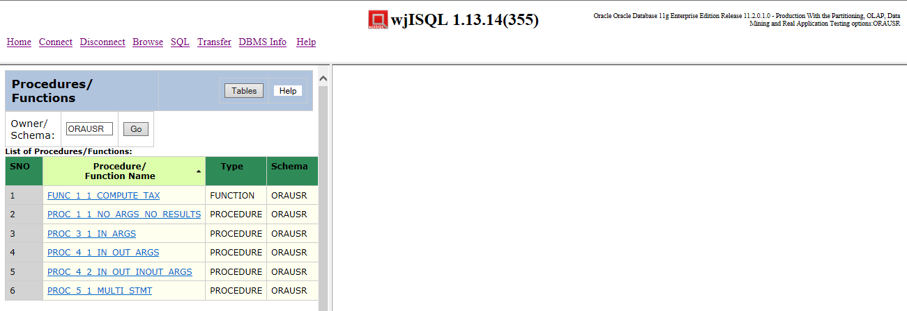

Test Status:
Platform | wjISQL Version | Date | Status | Remarks
Ubuntu 16.04 LTS
Chrome
Windows 7  FireFox 56.0 | 1.19.5(439) | 2017-10-27 | Success

Browse Menu Item Test Cases

Successful Test Cases
Test Case 1/62: Test that Browse menu item displays current tables
Test Prerequisites:
1 | Section 4.1, 4.2 and database connection is already done.

Test Procedure
1 | Click button Browse.

Test Expected o/p:
1 | List of tables in the database:  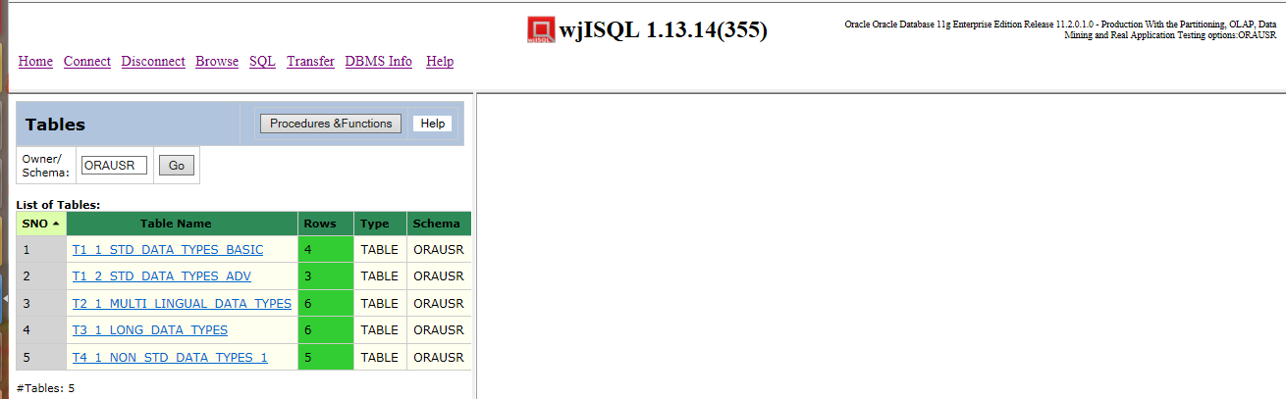

Test Status:
Platform | wjISQL | Date | Status | Remarks
Ubuntu 16.04 LTS
FireFox
Windows 7  FireFox 56.0 | 1.19.5(439) | 2017-10-27 | Success

Unsuccessful Test Cases
None.

Table Properties Test Cases

Successful Test Cases
Test Case 1/63: Test that clicking on a table causes display of column properties of the table on the right side.
Test Prerequisites:
1 | Section 4.3 Test cases

Test Procedure
1 | Click on the table: T1_1_STD_DATA_TYPES_BASIC

Test Expected o/p:
1 | The table columns as shown below:  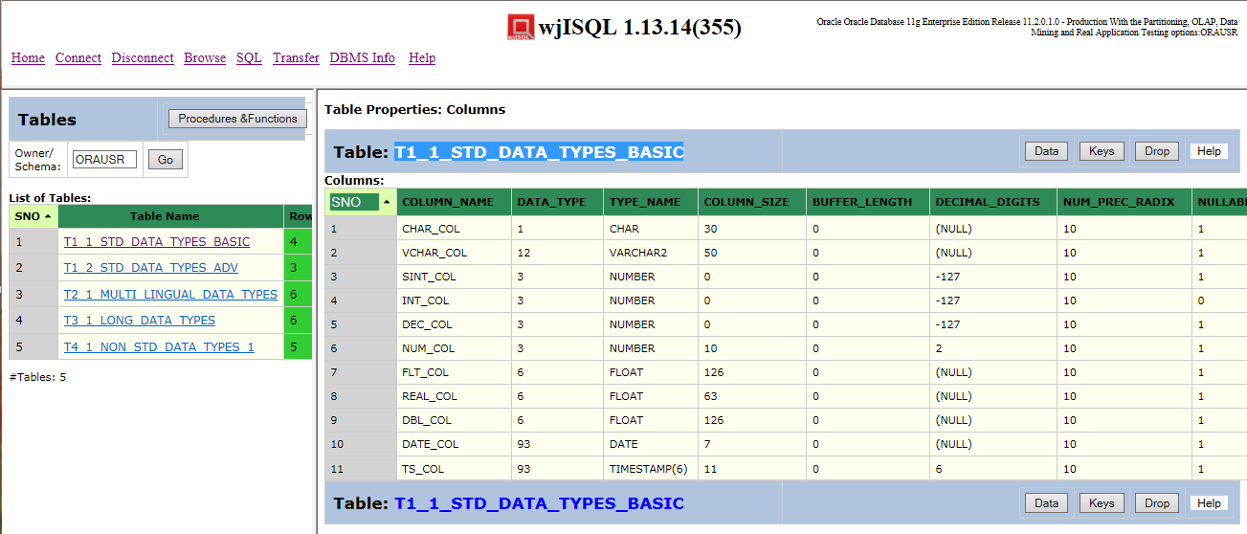

Test Status:
Platform | wjISQL | Date | Status | Remarks
Ubuntu 16.04 LTS
FireFox
Windows 7  FireFox 56.0 | 1.19.5(439) | 2017-10-27 | Success

Test Case 2/64: Test that clicking on another table causes display of column properties of the table replacing display of properties of previous table
Test Prerequisites:
1 | Test Case 1

Test Procedure
1 | Click on the table: T2_1_MULTI_LINGUAL_DATA_TYPES

Test Expected o/p:
1 | The table columns as shown below:  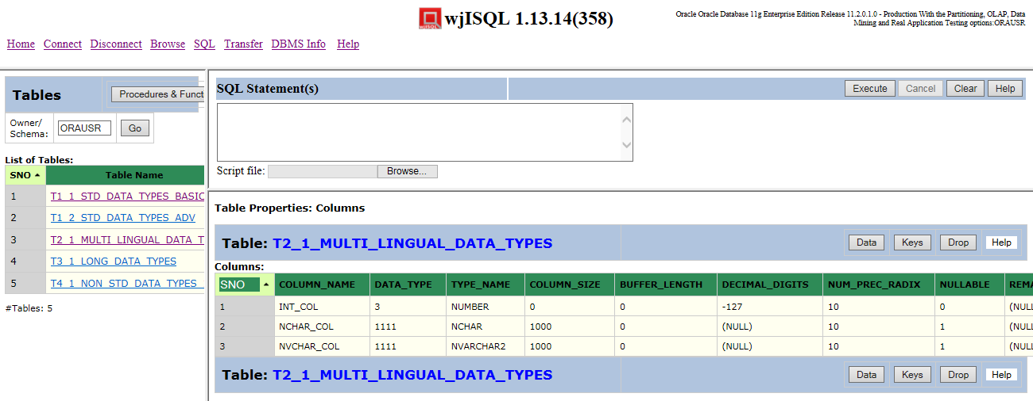

Test Status:
Platform | wjISQL | Date | Status | Remarks
Ubuntu 16.04 LTS
FireFox
Windows 7  FireFox 56.0 | 1.19.5(439) | 2017-10-27 | Success

Unsuccessful Test Cases
None.

Table Data Test Cases

Successful Test Cases
Test Case 1/65: Test that button Data displays data present in the table
Test Prerequisites:
1 | Section 4.3 Test cases

Test Procedure
1 | Click on the table: T1_1_STD_DATA_TYPES_BASIC
2 | Click button Data

Test Expected o/p:
1 | Data of the table as shown below:  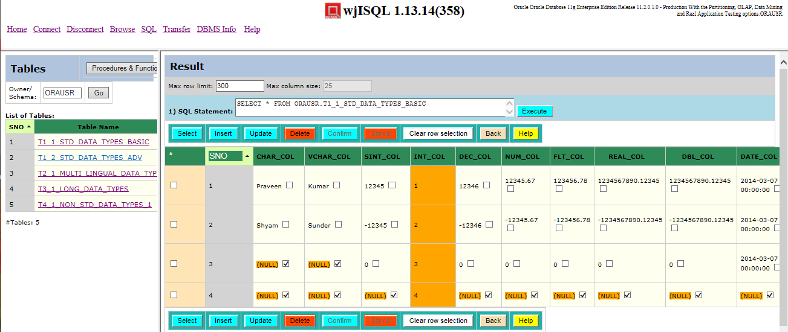

Post Test Actions:
1 | Click button Back to get back to table properties.

Test Status:
Platform | wjISQL | Date | Status | Remarks
Ubuntu 16.04 LTS
FireFox
Windows 7  FireFox 56.0 | 1.19.5(439) | 2017-10-27 | Success

Test Case 2/66: Test that button Data for another table to display multi-lingual data.
Test Prerequisites:
1 | Section 4.3 Test cases

Test Procedure
1 | Click on the table: T2_1_MULTI_LINGUAL_DATA_TYPES
2 | Click button Data

Test Expected o/p:
1 | Multi-lingual data of the table as shown below:  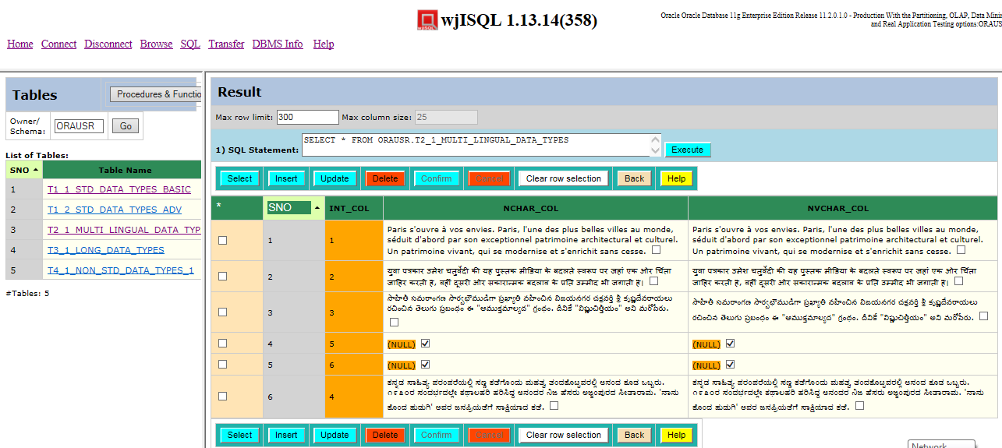

Post Test Actions:
1 | Click button Back to get back to table properties.

Test Status:
Platform | wjISQL | Date | Status | Remarks
Ubuntu 16.04 LTS
FireFox
Windows 7  FireFox 56.0 | 1.19.5(439) | 2017-10-27 | Success

Test Case 3/67: Test button Data for a table having long data columns
Test Prerequisites:
1 | Section 4.3 Test cases

Test Procedure
1 | Click on the table: T3_1_LONG_DATA_TYPES
2 | Click button Data

Test Expected o/p:
1 | Data of the table as shown below:  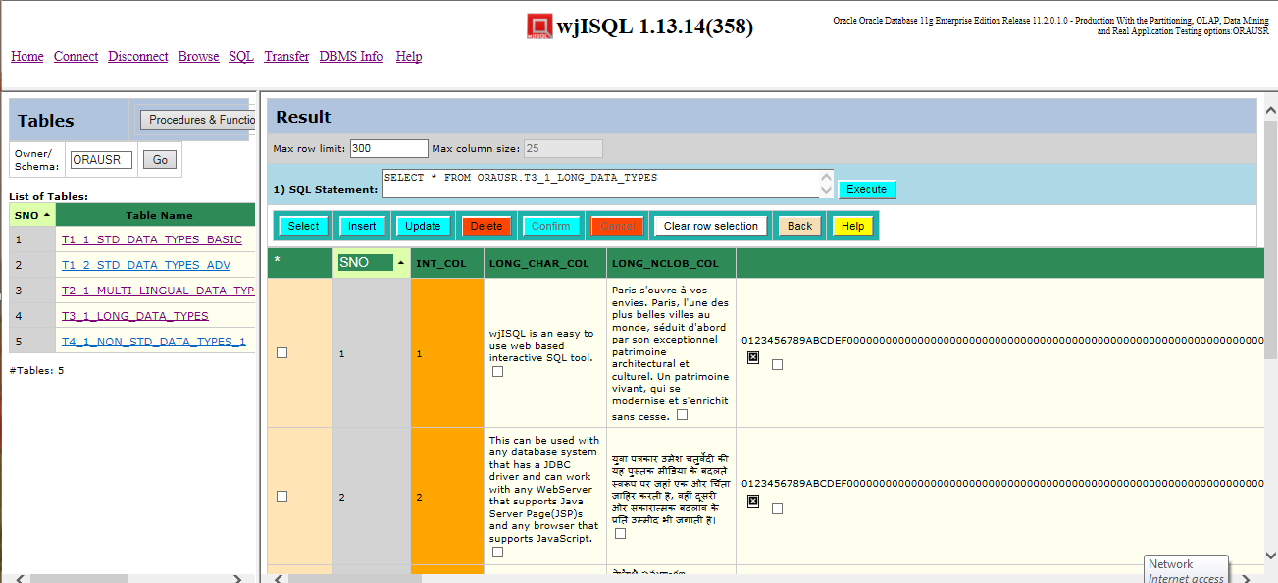

Post Test Actions:
1 | Click button Back to get back to table properties.

Test Status:
Platform | wjISQL | Date | Status | Remarks
Ubuntu 16.04 LTS
FireFox
Windows 7  FireFox 56.0 | 1.19.5(439) | 2017-10-27 | Success

Unsuccessful Test Cases
None.

Table Keys Test Cases

Successful Test Cases
Test Case 1/68: Test that button Keys displays keys of tables
Test Prerequisites:
1 | Section 4.3 Test cases

Test Procedure
1 | Click on the table: T1_1_STD_DATA_TYPES_BASIC
2 | Click button Keys

Test Expected o/p:
1 | Key of the table as shown below:  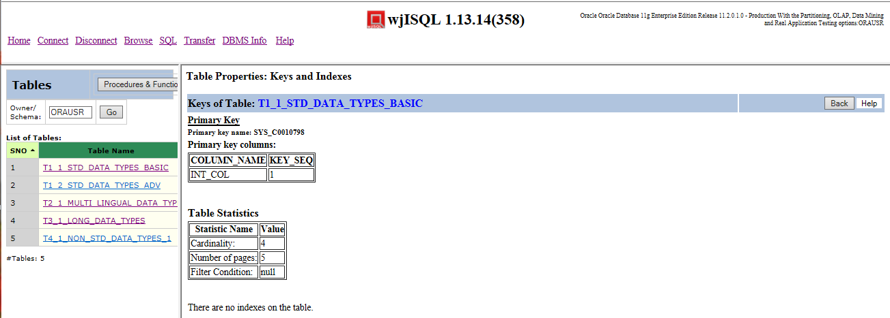

Post Test Actions:
1 | Click button Back to get back to table properties.

Test Status:
Platform | wjISQL | Date | Status | Remarks
Ubuntu 16.04 LTS
FireFox
Windows 7  FireFox 56.0 | 1.19.5(439) | 2017-10-27 | Success

Table Dropping Test Cases

Successful Test Cases
Test Case 1/69: Test that button Drop drops currently browsed table
Test Prerequisites:
1 | Section 2.3 Test cases

Test Procedure
1 | Click on the table: T4_1_NON_STD_DATA_TYPES_1
2 | Click button Drop
3 | Confirm dropping

Test Expected o/p:
1 | Dropped table indicated by deletion of its name in the table list on the left side as shown below:  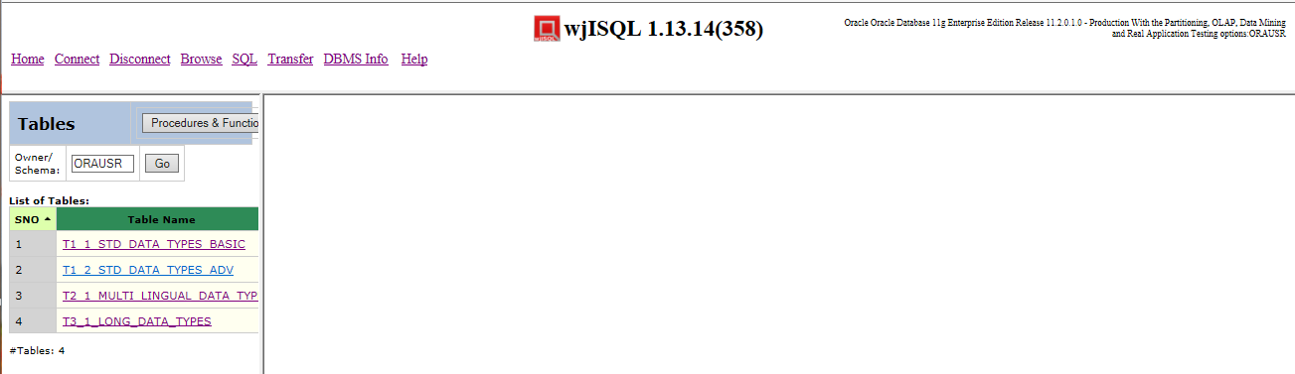

Post Test Actions:
1 | None

Test Status:
Platform | wjISQL | Date | Status | Remarks
Ubuntu 16.04 LTS
FireFox
Windows 7  FireFox 56.0 | 1.19.5(439) | 2017-10-27 | Success

Procedure/Function Browsing Test Cases

Successful Test Cases
Test Case 1/70: Test that button Procedures & Functions on the left section displays stored procedures and functions.
Test Prerequisites:
1 | Section 4.3 Test cases

Test Procedure
1 | Click button Browse
2 | Click button Procedures & Functions on the left section of page

Test Expected o/p:
1 | List of procedures and functions in the left section as shown below:  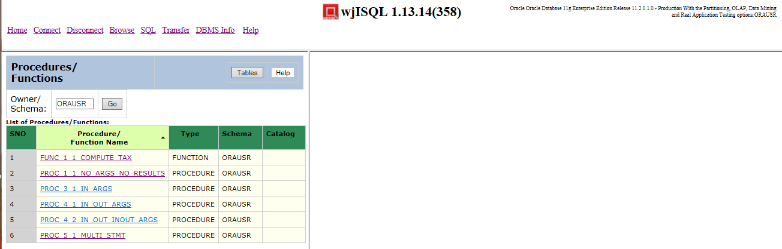

Post Test Actions:
1 | None.

Test Status:
Platform | wjISQL | Date | Status | Remarks
Ubuntu 16.04 LTS
FireFox
Windows 7  FireFox 56.0 | 1.19.5(439) | 2017-10-27 | Success

Procedure/Function Properties Test Cases

Successful Test Cases
Test Case 1/71: Test that properties of a procedure can be displayed.
Test Prerequisites:
1 | Section 4.3 Test cases

Test Procedure
1 | Click on the procedure PROC_1_1_NO_ARGS_NO_RESULTS

Test Expected o/p:
1 | The procedure properties as shown below:  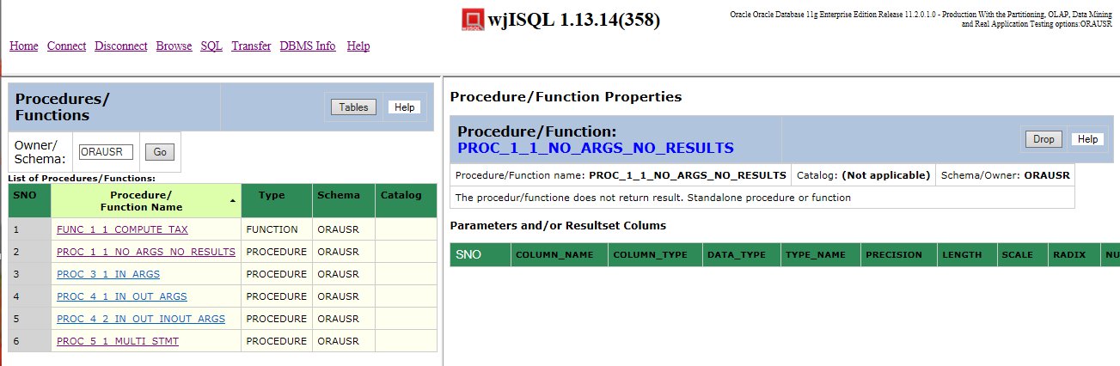

Post Test Actions:
1 | None.

Test Status:
Platform | wjISQL | Date | Status | Remarks
Ubuntu 16.04 LTS  FireFox |  |  | Success
Windows 7  FireFox 56.0 | 1.19.5(439) | 2017-10-27 | Success

Test Case 2/72: Test that properties of a procedure with parameters
Test Prerequisites:
1 | Section 4.3 Test cases

Test Procedure
1 | Click on the procedure PROC_5_1_MULTI_STMT

Test Expected o/p:
1 | The procedure properties as shown below:  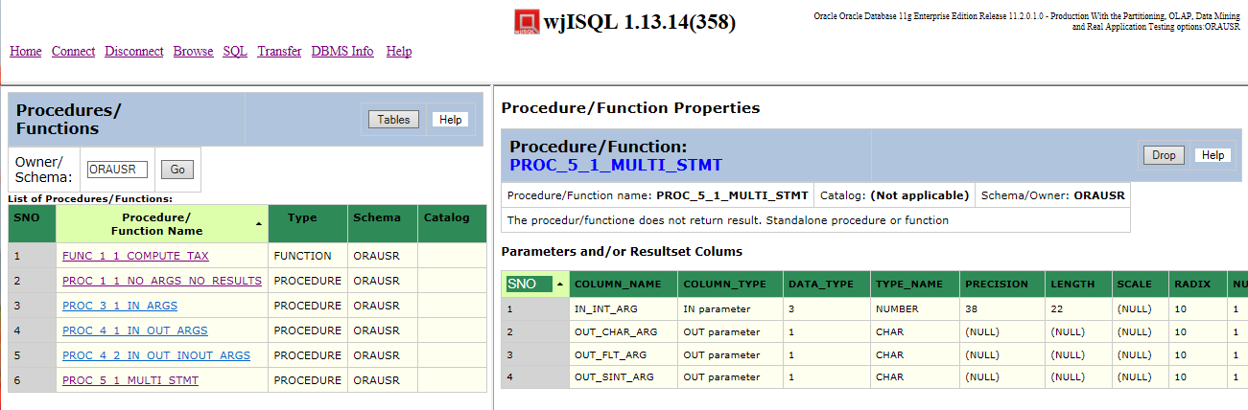

Post Test Actions:
1 | None.

Test Status:
Platform | wjISQL | Date | Status | Remarks
Ubuntu 16.04 LTS
FireFox
Windows 7  FireFox 56.0 | 1.19.5(439) | 2017-10-27 | Success

Test Case 2/73: Test that properties of a function with parameters
Test Prerequisites:
1 | Section 4.3 Test cases

Test Procedure
1 | Click on the function FUNC_1_1_COMPUTE_TAX

Test Expected o/p:
1 | The procedure properties as shown below:  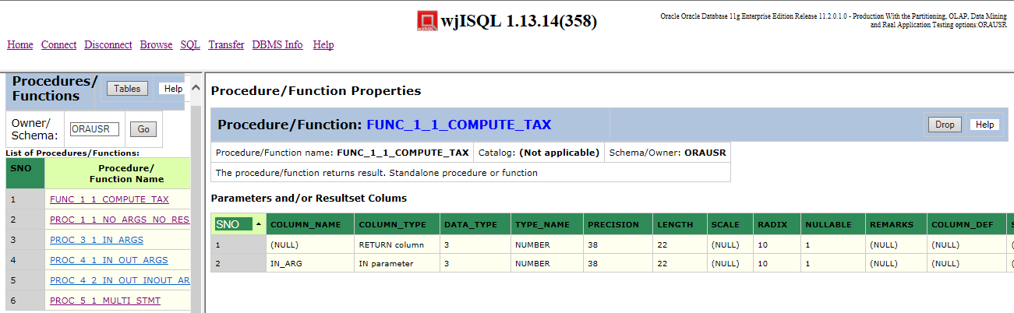

Post Test Actions:
1 | None.

Test Status:
Platform | wjISQL | Date | Status | Remarks
Ubuntu 16.04 LTS
FireFox
Windows 7  FireFox 56.0 | 1.19.5(439) | 2017-10-27 | Success

Procedure/Function Dropping Test Cases

Successful Test Cases
Test Case 1/74: Test that procedures can be dropped.
Test Prerequisites:
1 | Section 4.3 Test cases

Test Procedure
1 | Click on the procedure PROC_5_1_MULTI_STMT.
2 | Click button Drop from right section of the screen.
3 | Confirm the dropping.

Test Expected o/p:
1 | The procedure is dropped with deletion of its name from left section of screen as shown 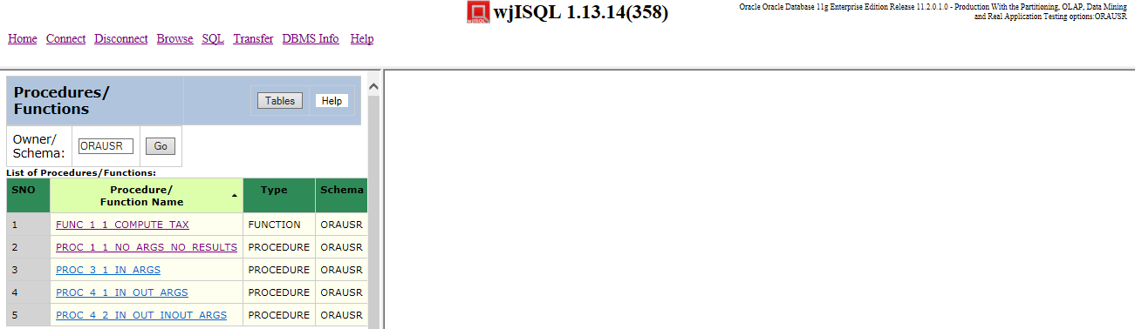below:

Post Test Actions:
1 | None.

Test Status:
Platform | wjISQL | Date | Status | Remarks
Ubuntu 16.04 LTS
FireFox
Windows 7  FireFox 56.0 | 1.19.5(439) | 2017-10-27 | Success

Test Case 2/75: Test that fuctions can be dropped.
Test Prerequisites:
1 | Section 4.3 Test cases

Test Procedure
1 | Click on the function FUNC_1_1_COMPUTE_TAX.
2 | Click button Drop from right section of the screen.
3 | Confirm the dropping.

Test Expected o/p:
1 | The function is dropped with deletion of its name from left section of screen as shown below:  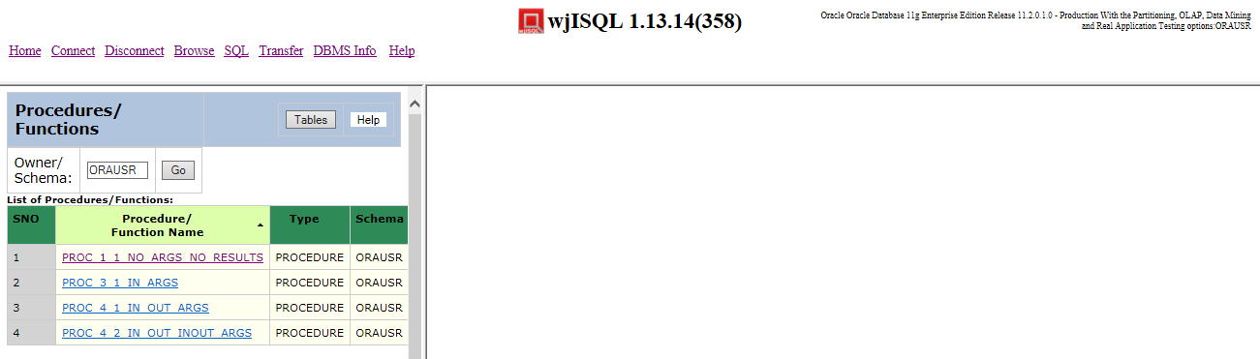

Post Test Actions:
1 | None.

Test Status:
Platform | wjISQL | Date | Status | Remarks
Ubuntu 16.04 LTS
FireFox
Windows 7  FireFox 56.0 | 1.19.5(439) | 2017-10-27 | Success

Procedure/Function Tables Button Test Cases

Successful Test Cases
Test Case 1/76: Test that button Tables of left section displays list of tables
Test Prerequisites:
1 | Section 4.3 Test cases

Test Procedure
1 | Click button Tables

Test Expected o/p:
1 | List of tables as shown below:  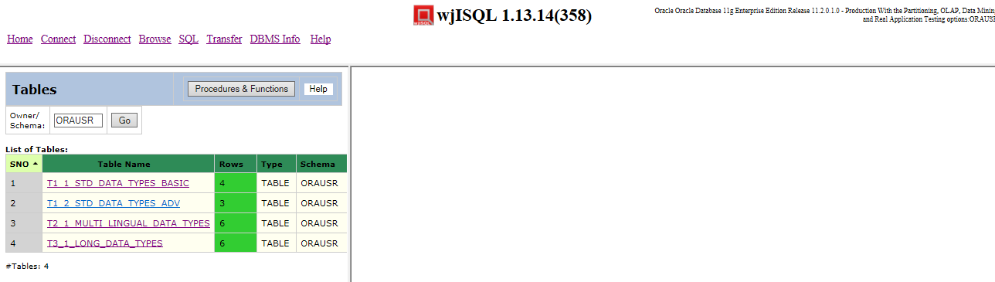

Post Test Actions:
1 | Close the brower tab Procedure/Function properties.

Test Status:
Platform | wjISQL | Date | Status | Remarks
Ubuntu 16.04 LTS
FireFox
Windows 7  FireFox 56.0 | 1.19.5(439) | 2017-10-27 | Success

MS SQL Database Browsing Test Cases

Prerequisites

1 | MS SQL Server database mssqldb is readily available for user mssqlusr and password mssql123.
2 | The user is owner of the database as mentioned in the connection/disconnection test plan.

Database Setup Test Cases

Test Case 1/77: Login into database oradb
Test Prerequisites
1 | None.

Test Procedure
1 | Click menu item "Connect".
2 | Choose Microsft SQL Server JDBC Driver from field JDBC driver displayed in login window.
3 | Specify database mssqldb in the Database URL: jdbc:sqlserver://localhost:1433;databaseName=mssqldb;
4 | Enter user id mssqlusr and password mssql123.
5 | Click button Login.

Test Expected o/p:
1 | The login is successful with empty table list as shown below:  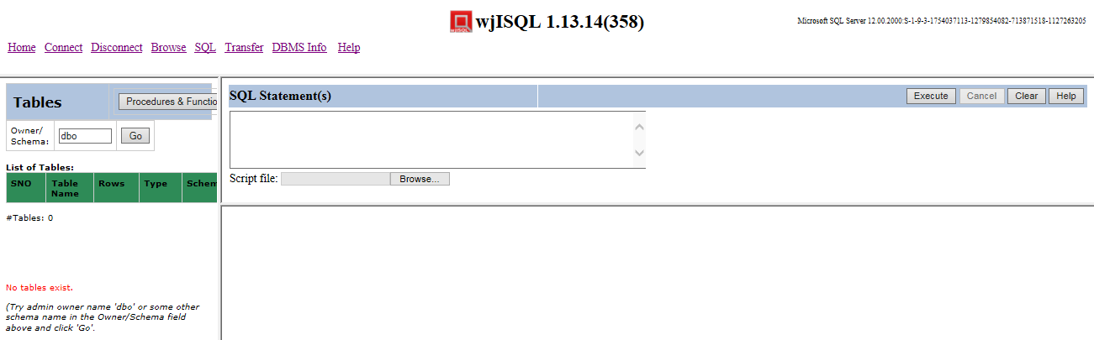

Test Status:
Platform | wjISQL Version | Date | Status | Remarks
Ubuntu 16.04 LTS
Windows 7  IE 11 | 1.19.5(439) | 2017-10-27 | Success

Test Case 2/78: Create tables
Test Prerequisites
1 | Test case 1 was executed.

Test Procedure
1 | Click navigation button SQL.
2 | Execute the following script file to drop tables if any; gnore errors wji_tsrc/wji_scripts/wji_10_basic_mssql_tables/tst_10_001_tables_drop_uc.sql
3 | Execute the following script file to create tables: wji_tsrc/wji_scripts/wji_10_basic_mssql_tables/tst_10_002_tables_create_uc.sql
4 | Execute the following script file to load data: wji_tsrc/wji_scripts/wji_10_basic_mssql_tables/tst_10_003_tables_insert_uc.sql
5 | Execute the following script file to load data: wji_tsrc/wji_scripts/wji_10_basic_mssql_tables/tst_10_004_tables_select_star_uc.sql

Test Expected o/p:
1 | The login is successful with table list as shown below:  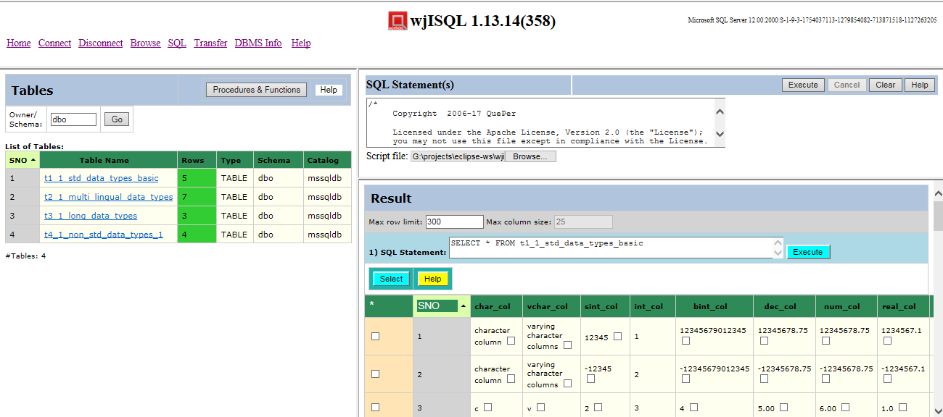

Test Status:
Platform | wjISQL Version | Date | Status | Remarks
Ubuntu 16.04 LTS
Windows 7  IE 11 | 1.19.5(439) | 2017-10-27 | Success

Test Case 3/79: Create stored procedures
Test Prerequisites
1 | Test case 1 was executed.

Test Procedure
1 | Click navigation button SQL.
2 | Execute the following script file; ignore proc not found error, if any:  wji_tsrc/wji_scripts/wji_11_basic_mssql_procs/tst_11_001_proc_drop.sql
3 | Execute the following scripts files to create stored procedures:  wji_tsrc/wji_scripts/wji_11_basic_mssql_procs/tst_11_00[2-6]_proc_create_*.sql
4 | Execute the following scripts files to create stored procedures:  wji_tsrc/wji_scripts/wji_11_basic_mssql_procs/tst_11_007_proc_exec.sql

Test Expected o/p:
1 | Screen with list of created procedures as shown below:  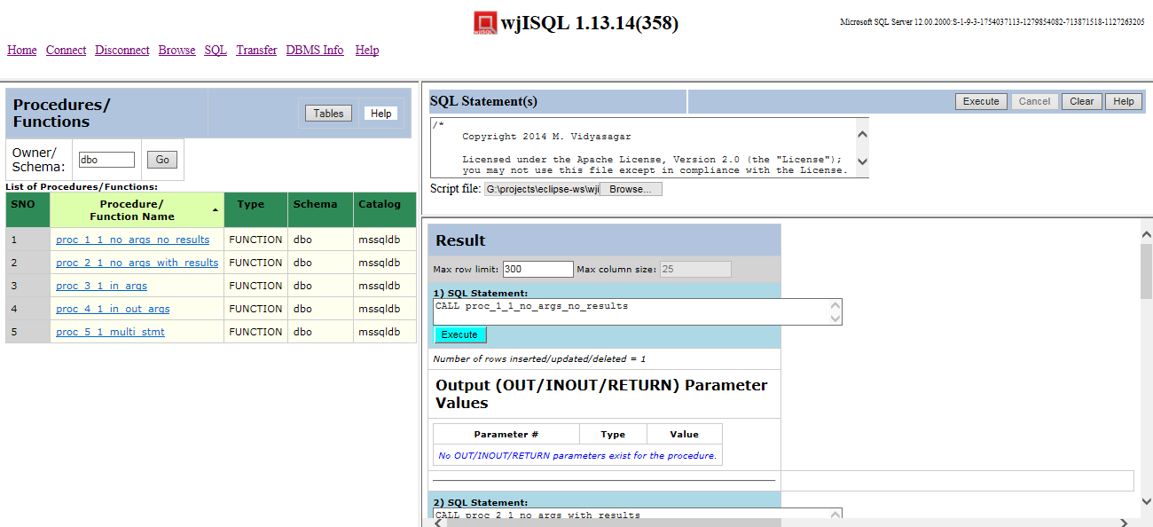

Test Status:
Platform | wjISQL Version | Date | Status | Remarks
Ubuntu 16.04 LTS
Windows 7  IE 11 | 1.19.5(439) | 2017-10-27 | Success

Test Case 4/80: Create Stored Functions
Test Prerequisites
1 | Test case 1 was executed.

Test Procedure
1 | Click navigation button SQL.
2 | Execute the following script file; ignore any function not found error if any:  wji_tsrc/wji_scripts/wji_09_basic_oracle_funcs/tst_09_001_func_drop.sql
3 | Execute the following scripts files in order of files:  wji_tsrc/wji_scripts/wji_09_basic_oracle_funcs/tst_09_00[2-3]_func_*.sql
4 | Click menu item Browse.
5 | Click button Procedures & Functions.

Test Expected o/p:
1 | List of procedures and functions as following:  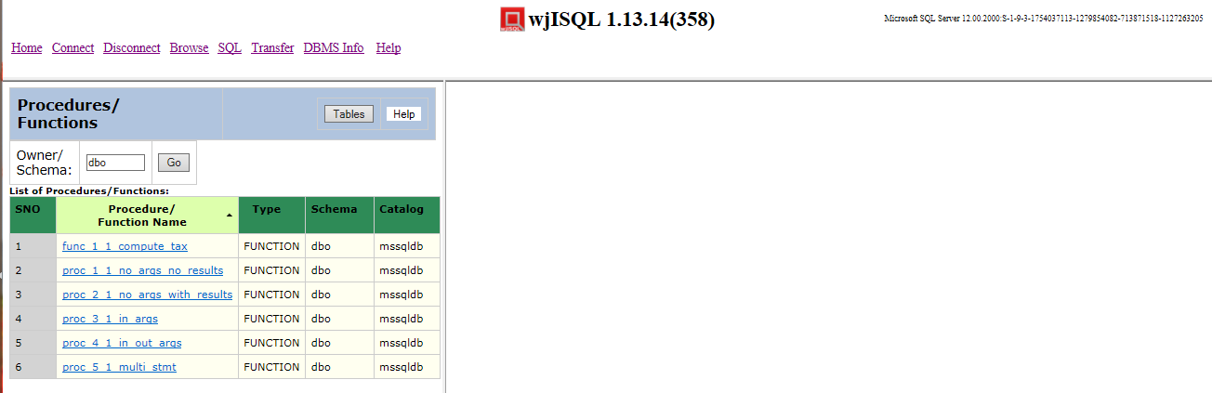

Test Status:
Platform | wjISQL Version | Date | Status | Remarks
Ubuntu 16.04 LTS
Chrome
Windows 7  IE 11 | 1.19.5(439) | 2017-10-27 | Success

Browse Menu Item Test Cases

Successful Test Cases
Test Case 1/81: Test that Browse menu item displays current tables
Test Prerequisites:
1 | Section 5.2 test cases were executed.

Test Procedure
1 | Click button Browse.

Test Expected o/p:
1 | List of tables in the database:  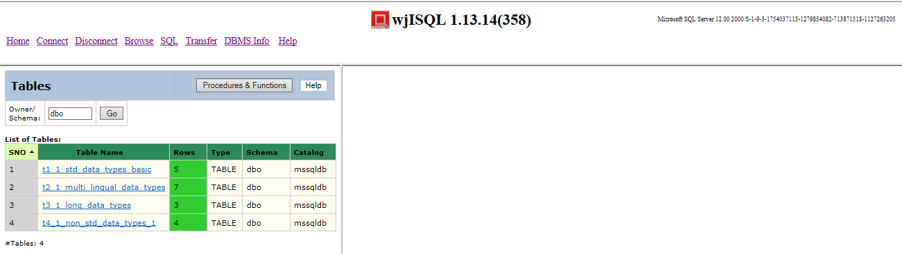

Test Status:
Platform | wjISQL | Date | Status | Remarks
Ubuntu 16.04 LTS
FireFox
Windows 7  IE 11 | 1.19.5(439) | 2017-10-27 | Success

Unsuccessful Test Cases
None.

Table Properties Test Cases

Successful Test Cases
Test Case 1/82: Test that clicking on a table causes display of column properties of the table on the right side.
Test Prerequisites:
1 | Section 4.3 Test cases

Test Procedure
1 | Click on the table: t1_1_std_data_types_basic

Test Expected o/p:
1 | The table columns as shown below:  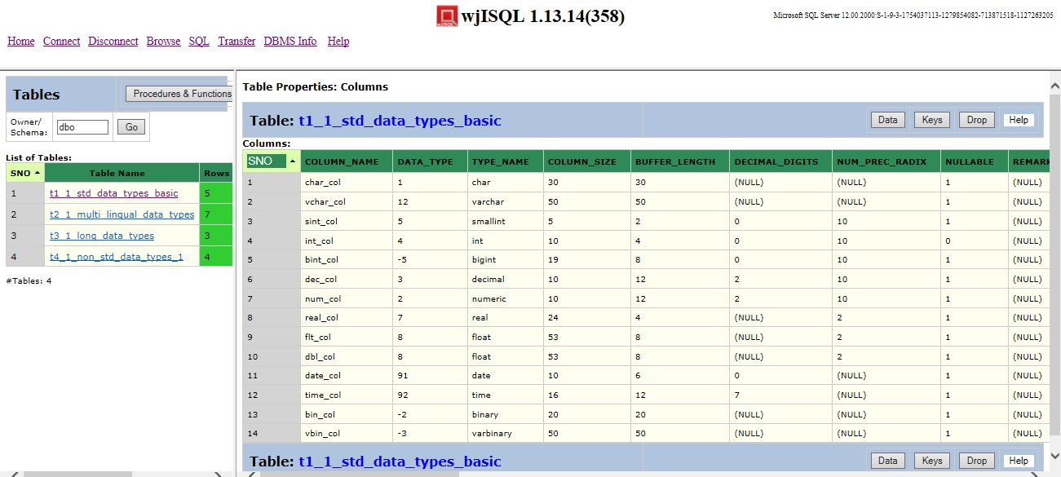

Test Status:
Platform | wjISQL | Date | Status | Remarks
Ubuntu 16.04 LTS
FireFox
Windows 7  IE 11 | 1.19.5(439) | 2017-10-27 | Success

Test Case 2/83: Test that clicking on another table causes display of column properties of the table replacing display of properties of previous table
Test Prerequisites:
1 | Test Case 1

Test Procedure
1 | Click on the table: t2_1_multi_lingual_data_types

Test Expected o/p:
1 | The table columns as shown below:  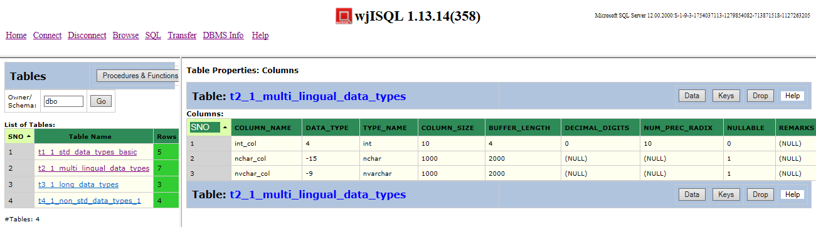

Test Status:
Platform | wjISQL | Date | Status | Remarks
Ubuntu 16.04 LTS
FireFox
Windows 7  IE 11 | 1.19.5(439) | 2017-10-27 | Success

Unsuccessful Test Cases
None.

Table Data Test Cases

Successful Test Cases
Test Case 1/84: Test that button Data displays data present in the table
Test Prerequisites:
1 | Section 5.3 Test cases were already executed.

Test Procedure
1 | Click on the table: t1_1_std_data_types_basic
2 | Click button Data

Test Expected o/p:
1 | Data of the table as shown below:  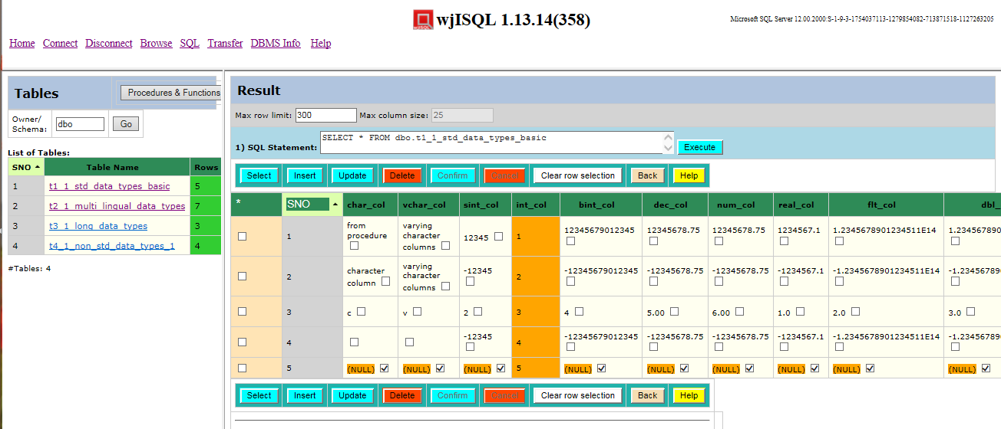

Post Test Actions:
1 | Click button Back to get back to table properties.

Test Status:
Platform | wjISQL | Date | Status | Remarks
Ubuntu 16.04 LTS
FireFox
Windows 7  IE 11 | 1.19.5(439) | 2017-10-27 | Success

Test Case 2/85: Test that button Data for another table to display multi-lingual data.
Test Prerequisites:
1 | Section 4.3 Test cases

Test Procedure
1 | Click on the table: t2_1_multi_lingual_data_types
2 | Click button Data

Test Expected o/p:
1 | Multi-lingual data of the table as shown below:  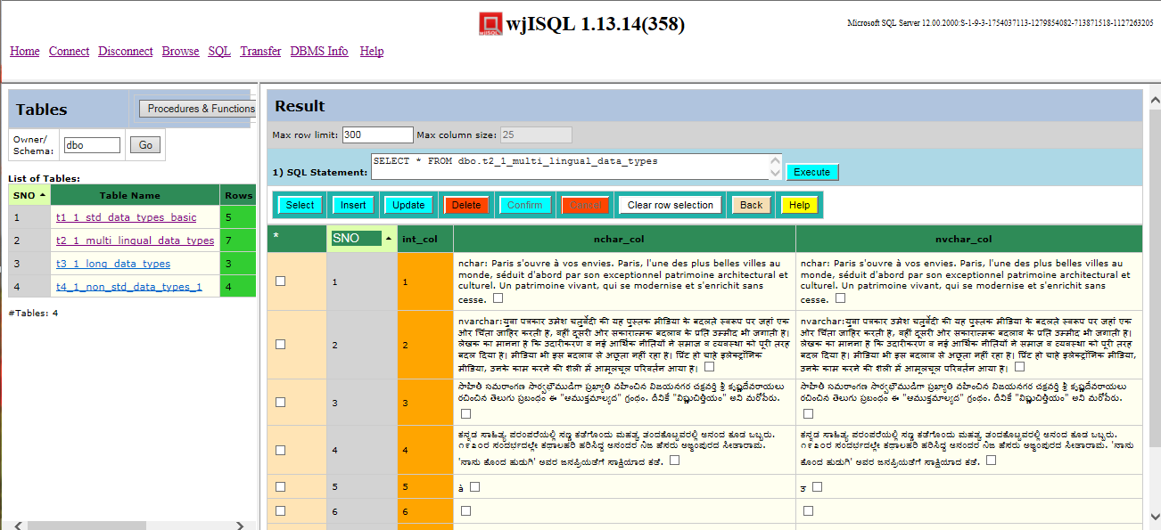

Post Test Actions:
1 | Click button Back to get back to table properties.

Test Status:
Platform | wjISQL | Date | Status | Remarks
Ubuntu 16.04 LTS
FireFox
Windows 7  IE 11.0 | 1.19.5(439) | 2017-10-27 | Success

Test Case 3/86: Test that button Data for a table having long data columns
Test Prerequisites:
1 | Section 5.3 Test cases

Test Procedure
1 | Click on the table: t3_1_long_data_types
2 | Click button Data

Test Expected o/p:
1 | Data of the table as shown below:  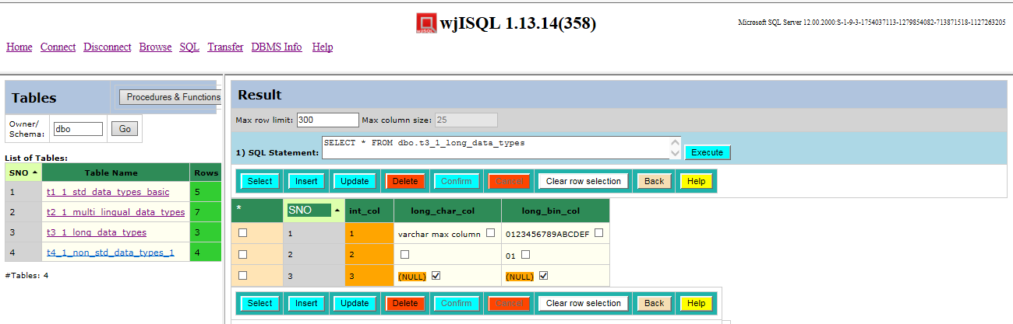

Post Test Actions:
1 | Click button Back to get back to table properties.

Test Status:
Platform | wjISQL | Date | Status | Remarks
Ubuntu 16.04 LTS
FireFox
Windows 7  IE 11.0 | 1.19.5(439) | 2017-10-27 | Success

Unsuccessful Test Cases
None.

Table Keys Test Cases

Successful Test Cases
Test Case 1/87: Test that button Keys displays keys of tables
Test Prerequisites:
1 | Section 5.3 Test cases were already executed.

Test Procedure
1 | Click on the table: t1_1_std_data_types_basic
2 | Click button Keys

Test Expected o/p:
1 | Key of the table as shown below:  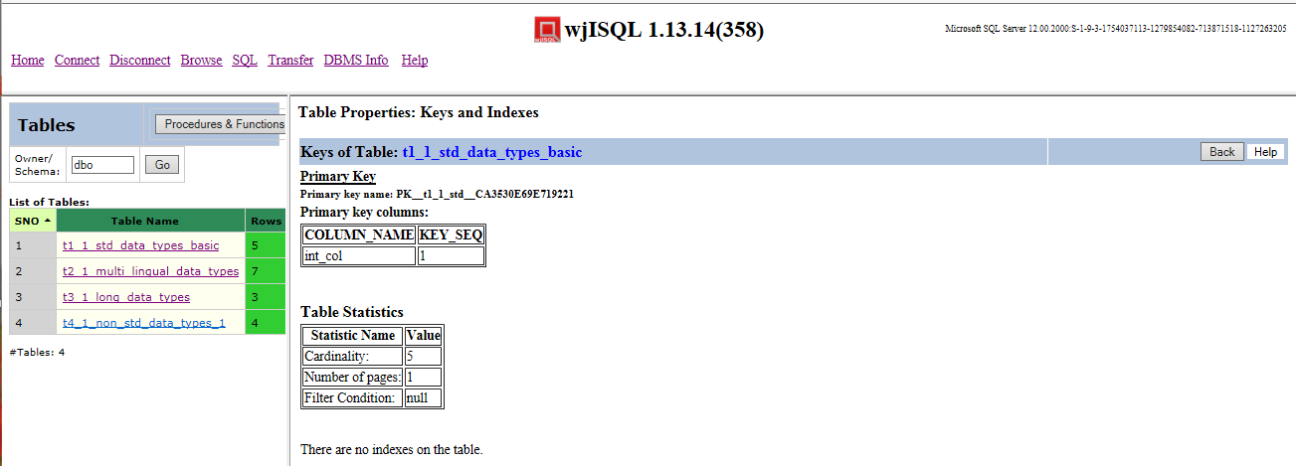

Post Test Actions:
1 | Click button Back to get back to table properties.

Test Status:
Platform | wjISQL | Date | Status | Remarks
Ubuntu 16.04 LTS
FireFox
Windows 7  IE 11.0 | 1.19.5(439) | 2017-10-27 | Success

Table Dropping Test Cases

Successful Test Cases
Test Case 1/88: Test that button Drop drops currently browsed table
Test Prerequisites:
1 | Section 4.3 Test cases were already executed.

Test Procedure
1 | Click on the table: t4_1_non_std_data_types_1
2 | Click button Drop
3 | Confirm dropping

Test Expected o/p:
1 | Dropped table indicated by deletion of its name in the table list on the left side as shown below:  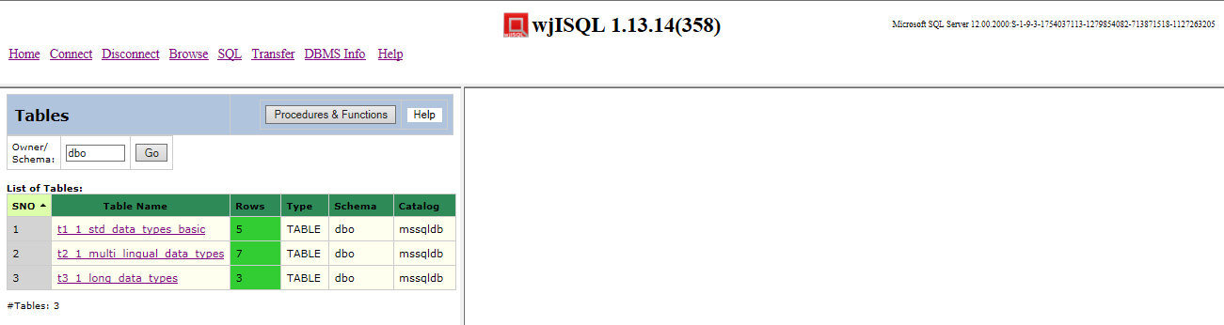

Post Test Actions:
1 | None

Test Status:
Platform | wjISQL | Date | Status | Remarks
Ubuntu 16.04 LTS
FireFox
Windows 7  IE 11.0 | 1.19.5(439) | 2017-10-27 | Success

Procedure/Function Browsing Test Cases

Successful Test Cases
Test Case 1/89: Test that button Procedures & Functions on the left section displays stored procedures and functions.
Test Prerequisites:
1 | Section 5.3 Test cases were already executed.

Test Procedure
1 | Click button Browse
2 | Click button Procedures & Functions on the left section of page

Test Expected o/p:
1 | List of procedures and functions in the left section as shown below:  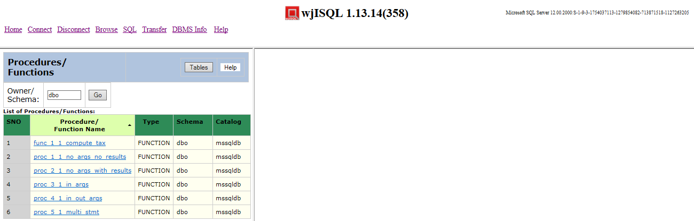

Post Test Actions:
1 | None.

Test Status:
Platform | wjISQL | Date | Status | Remarks
Ubuntu 16.04 LTS
FireFox
Windows 7  IE 11.0 | 1.19.5(439) | 2017-10-27 | Success

Procedure/Function Properties Test Cases

Successful Test Cases
Test Case 1/90: Test that properties of a procedure can be displayed.
Test Prerequisites:
1 | Executiom of section 5.3 Test cases

Test Procedure
1 | Click on the procedure proc_1_1_no_args_no_results

Test Expected o/p:
1 | The procedure properties as shown below:  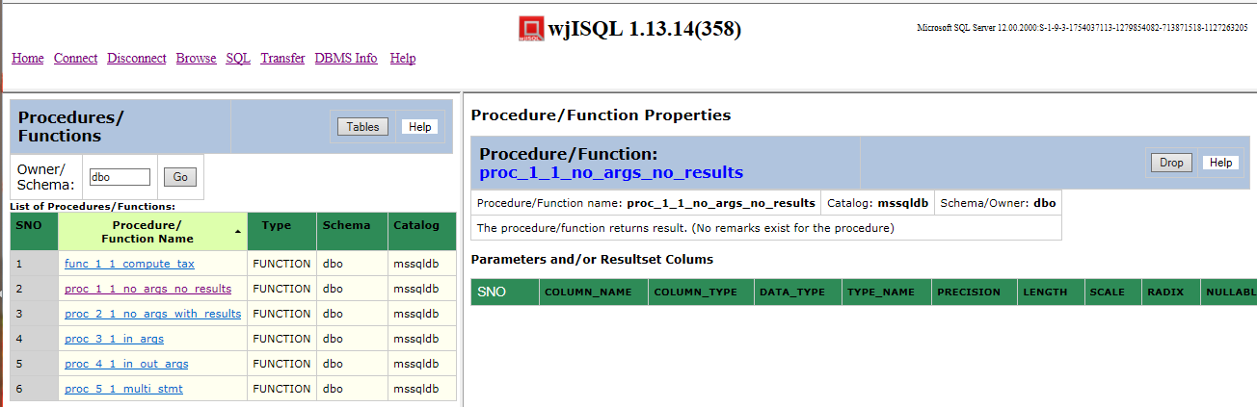

Post Test Actions:
1 | None.

Test Status:
Platform | wjISQL | Date | Status | Remarks
Ubuntu 16.04 LTS  FireFox |  |  | Success
Windows 7  IE 11.0 | 1.19.5(439) | 2017-10-27 | Success

Test Case 2/91: Test properties of a procedure with parameters
Test Prerequisites:
1 | Section 4.3 Test cases

Test Procedure
1 | Click on the procedure proc_5_1_multi_stmt

Test Expected o/p:
1 | The procedure properties as shown below:  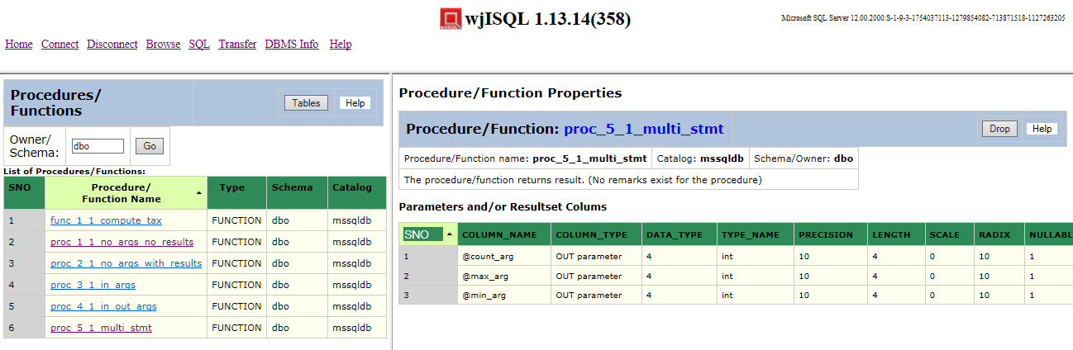

Post Test Actions:
1 | None.

Test Status:
Platform | wjISQL | Date | Status | Remarks
Ubuntu 16.04 LTS
FireFox
Windows 7  IE 11.0 | 1.19.5(439) | 2017-10-27 | Success

Test Case 2/92: Test that properties of a function with parameters
Test Prerequisites:
1 | Section 5.3 Test cases

Test Procedure
1 | Click on the function func_1_1_compute_tax

Test Expected o/p:
1 | The function properties as shown below:  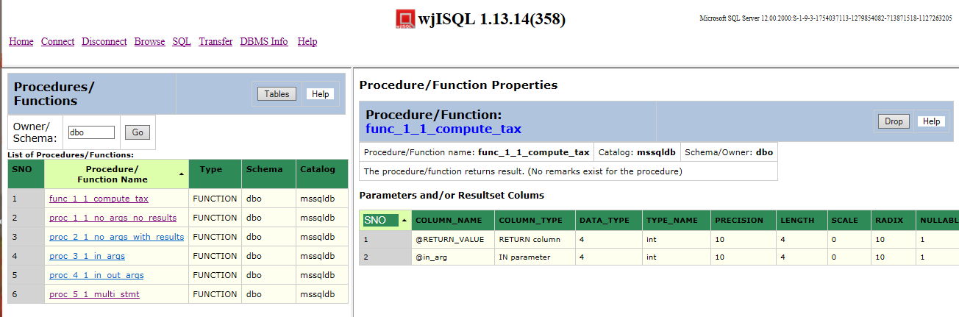

Post Test Actions:
1 | None.

Test Status:
Platform | wjISQL | Date | Status | Remarks
Ubuntu 16.04 LTS
FireFox
Windows 7  IE 11.0 | 1.19.5(439) | 2017-10-27 | Success

Procedure/Function Dropping Test Cases

Successful Test Cases
Test Case 1/93: Test that procedures can be dropped.
Test Prerequisites:
1 | Execution of section 5.3 Test cases

Test Procedure
1 | Click on the procedure proc_5_1_multi_stmt.
2 | Click button Drop from right section of the screen.
3 | Confirm the dropping.

Test Expected o/p:
1 | The procedure is dropped with deletion of its name from left section of screen.

Post Test Actions:
1 | None.

Test Status:
Platform | wjISQL | Date | Status | Remarks
Ubuntu 16.04 LTS
FireFox
Windows 7  IE 11.0 | 1.19.5(439) | 2017-10-27 | FAILED | This is a known issue. MS SQL treats all procs as functions and hence expects user to use DROP FUNCTION … TBF

Test Case 2/94: Test that fuctions can be dropped.
Test Prerequisites:
1 | Section 4.3 Test cases

Test Procedure
1 | Click on the function func_1_1_compute_tax.
2 | Click button Drop from right section of the screen.
3 | Confirm the dropping.

Test Expected o/p:
1 | The function is dropped with deletion of its name from left section of screen as shown below:  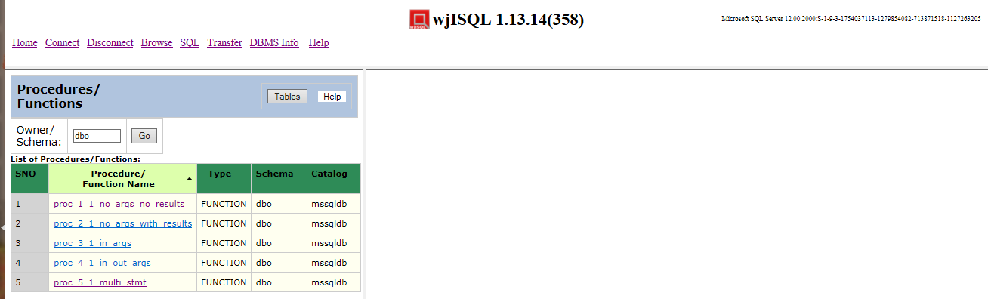

Post Test Actions:
1 | None.

Test Status:
Platform | wjISQL | Date | Status | Remarks
Ubuntu 16.04 LTS
FireFox
Windows 7  IE 11.0 | 1.19.5(439) | 2017-10-27 | Success

Procedure/Function Tables Button Test Cases

Successful Test Cases
Test Case 1/95: Test that button Tables of left section displays list of tables
Test Prerequisites:
1 | Section 5.3 Test cases

Test Procedure
1 | Click button Tables

Test Expected o/p:
1 | List of tables as shown below:  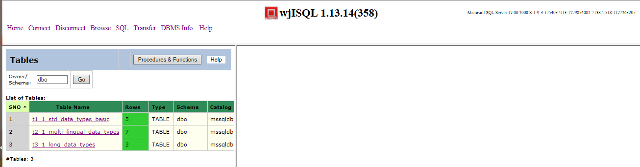

Post Test Actions:
1 | Close the brower tab Procedure/Function properties.

Test Status:
Platform | wjISQL | Date | Status | Remarks
Ubuntu 16.04 LTS
FireFox
Windows 7  IE 11.0 | 1.19.5(439) | 2017-10-27 | Success

SQLite Database Browsing Test Cases

Prerequisites

1 | None.

Database Setup Test Cases

Test Case 1/96: Login into SQLite database sqlitedb.
Test Prerequisites
1 | Assumes /tmp directory on Linux machines and  C:\TEMP directory on Windows

Test Procedure
1 | Click menu item "Connect".
2 | Choose SQLIte JDBC Driver from field JDBC driver displayed in login window.
3 | Specify database with path for sqlitedb in the Database URL as following:  On Linux: jdbc:sqlite:/tmp/sqlitedb  On Windows: jdbc:sqlite:C:/TEMP/sqlitedb
4 | Click button Login.

Test Expected o/p:
1 | Empty database as shown below:  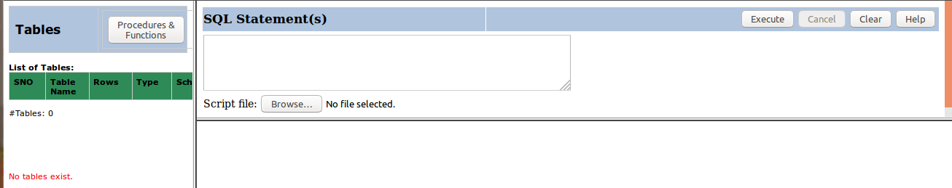

Test Status:
Platform | wjISQL Version | Date | Status | Remarks
Ubuntu 16.04 LTS  FireFox | 1.17.5(419) | 2017-10-10 | Success
Windows 7  FireFox 56.0 | 1.19.5(439) | 2017-10-27 | Success

Test Case 2/97: Create tables
Test Prerequisites
1 | Test case 1 was executed.

Test Procedure
1 | Click navigation button SQL.
2 | Execute the following script file to drop tables if any; ignore errors wji_tsrc/wji_scripts/wji_13_basic_sqlite_tables/tst_13_001_tables_drop_uc.sql
3 | Execute the following script file to create tables: wji_tsrc/wji_scripts/wji_13_basic_sqlite_tables/tst_13_002_tables_create_uc.sql
4 | Execute the following script file to load data: wji_tsrc/wji_scripts/wji_13_basic_sqlite_tables/tst_13_003_tables_insert_uc.sql
5 | Execute the following script file to retrieve data from the tables: wji_tsrc/wji_scripts/wji_13_basic_sqlite_tables/tst_13_004_tables_select_star_uc.sql

Test Expected o/p:
1 | Screen with 4 tables created as shown below:  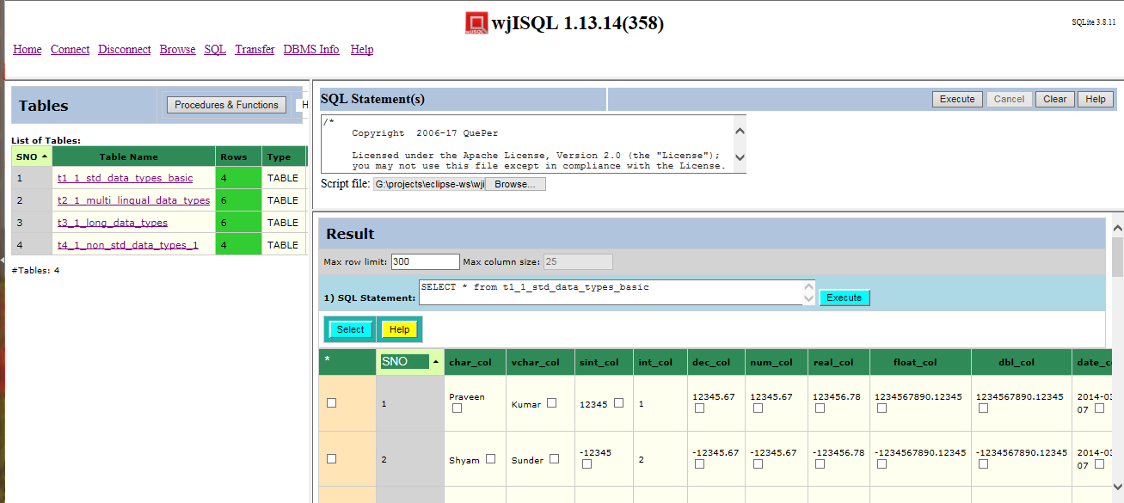

Test Status:
Platform | wjISQL Version | Date | Status | Remarks
Ubuntu 16.04 LTS  FireFox | 1.17.5(419) | 2017-10-10 | Success
Windows 7  FireFox 56.0 | 1.19.5(439) | 2017-10-27 | Success

Browse Menu Item Test Cases

Successful Test Cases

Test Case 1/98: Test that Browse menu item displays current tables
Test Prerequisites:
1 | Loaded database.

Test Procedure
1 | Click button Browse.

Test Expected o/p:
1 | List of tables in the database:  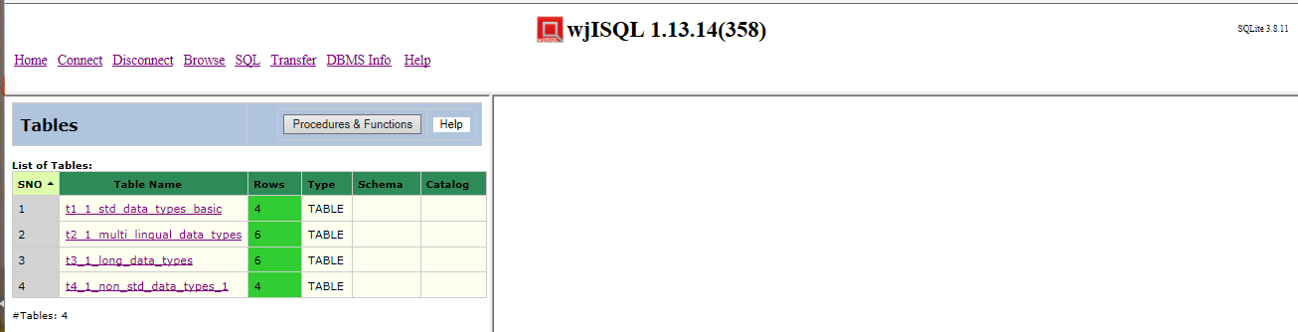

Test Status:
Platform | wjISQL | Date | Status | Remarks
Ubuntu 16.04 LTS  FireFox | 1.17.5(419) | 2017-10-10 | Success
Windows 7  FireFox 56.0 | 1.19.5(439) | 2017-10-27 | Success

Unsuccessful Test Cases
None.

Table Properties Test Cases

Successful Test Cases
Test Case 1/99: Test that clicking on a table causes display of column properties of the table on the right side.
Test Prerequisites:
1 | Section 6.3 Test cases

Test Procedure
1 | Click on the table: t1_1_std_data_types_basic

Test Expected o/p:
1 | The table columns as shown below:  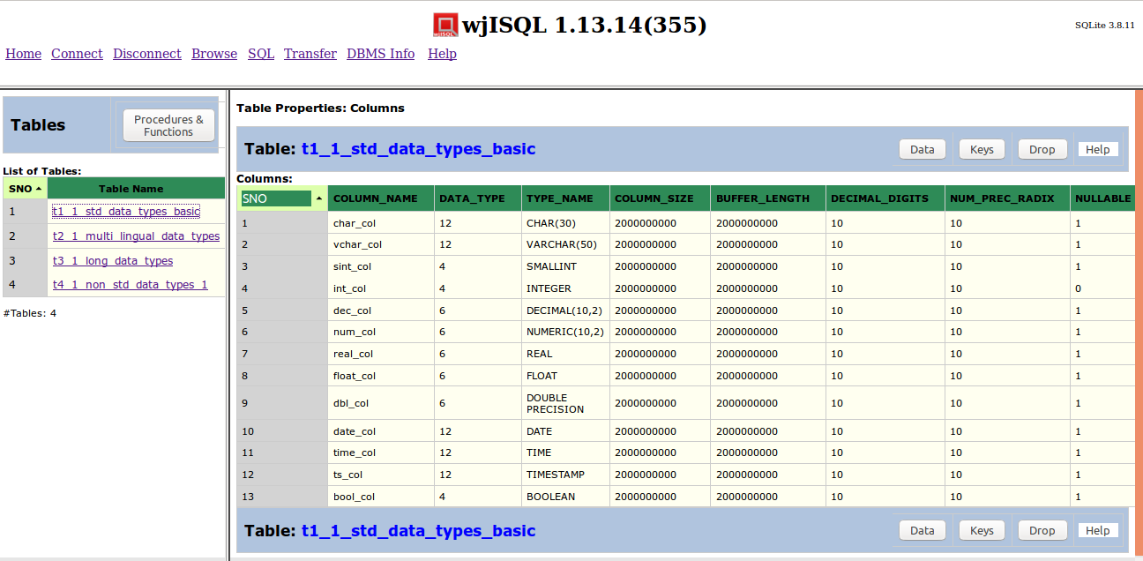

Test Status:
Platform | wjISQL | Date | Status | Remarks
Ubuntu 16.04 LTS  FireFox | 1.17.5(419) | 2017-10-10 | Success
Windows 7  FireFox 56.0 | 1.19.5(439) | 2017-10-27 | Success

Test Case 2/100: Test that clicking on another table causes display of column properties of the table replacing display of properties of previous table
Test Prerequisites:
1 | Test Case 1

Test Procedure
1 | Click on the table: t2_1_multi_lingual_data_types

Test Expected o/p:
1 | The table columns as shown below:  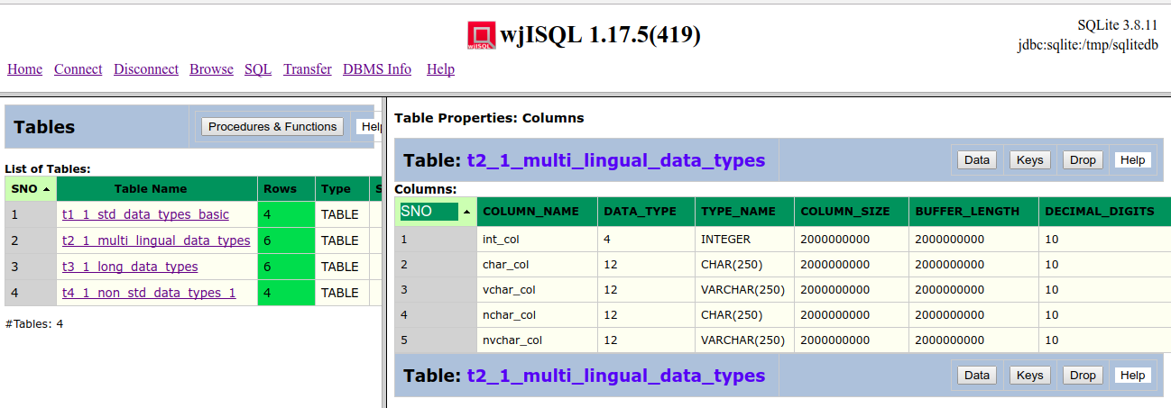

Test Status:
Platform | wjISQL | Date | Status | Remarks
Ubuntu 16.04 LTS  FireFox | 1.17.5(419) | 2017-10-10 | Success
Windows 7  FireFox 56.0 | 1.19.5(439) | 2017-10-27 | Success

Unsuccessful Test Cases
None.

Table Data Test Cases

Successful Test Cases
Test Case 1/101: Test that button Data displays data present in the table
Test Prerequisites:
1 | Section 7.3 Test cases

Test Procedure
1 | Click on the table: t1_1_std_data_types_basic
2 | Click button Data

Test Expected o/p:
1 | Data of the table as shown below:  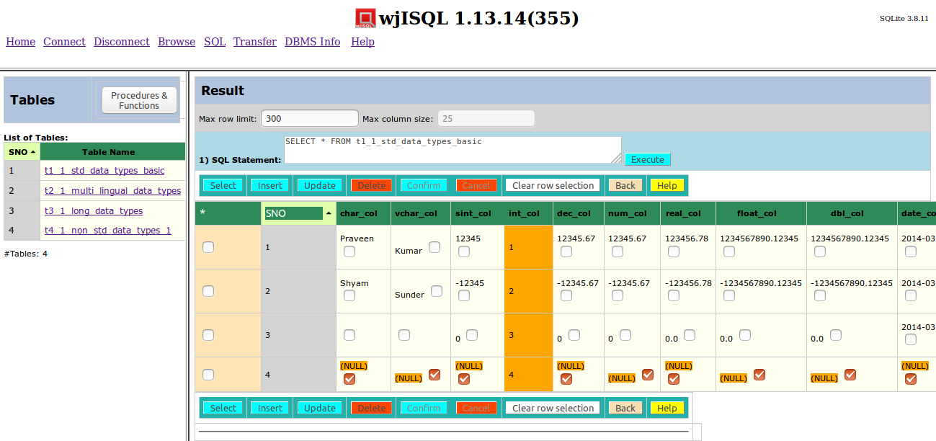

Post Test Actions:
1 | Click button Back to get back to table properties.

Test Status:
Platform | wjISQL | Date | Status | Remarks
Ubuntu 16.04 LTS  FireFox | 1.17.5(419) | 2017-10-10 | Success
Windows 7  FireFox 56.0 | 1.19.5(439) | 2017-10-27 | Success

Test Case 2/102: Test that button Data for another table to display multi-lingual data.
Test Prerequisites:
1 | Section 7.3 Test cases

Test Procedure
1 | Click on the table: t2_1_multi_lingual_data
2 | Click button Data

Test Expected o/p:
1 | Multi-lingual data of the table as shown below:  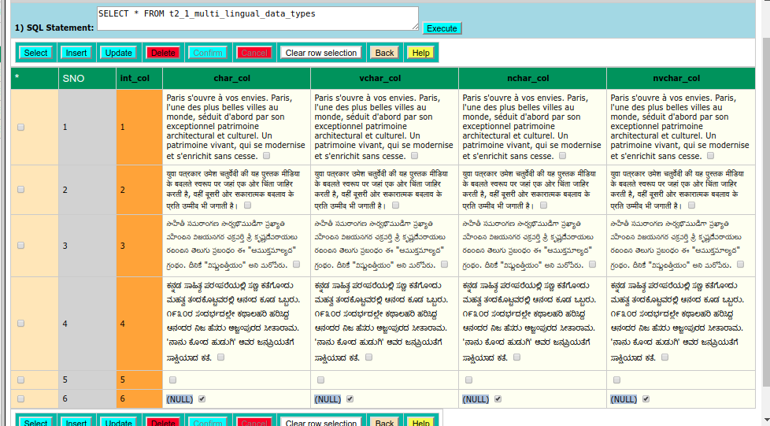

Post Test Actions:
1 | Click button Back to get back to table properties.

Test Status:
Platform | wjISQL | Date | Status | Remarks
Ubuntu 16.04 LTS  FireFox | 1.17.5(419) | 2017-10-10 | Success
Windows 7  FireFox 56.0 | 1.19.5(439) | 2017-10-27 | Success

Test Case 3/103: Test button Data for a table having long data columns
Test Prerequisites:
1 | Section 7.3 Test cases

Test Procedure
1 | Click on the table: t3_1_long_data_types
2 | Click button Data

Test Expected o/p:
1 | Data of the table as shown below:  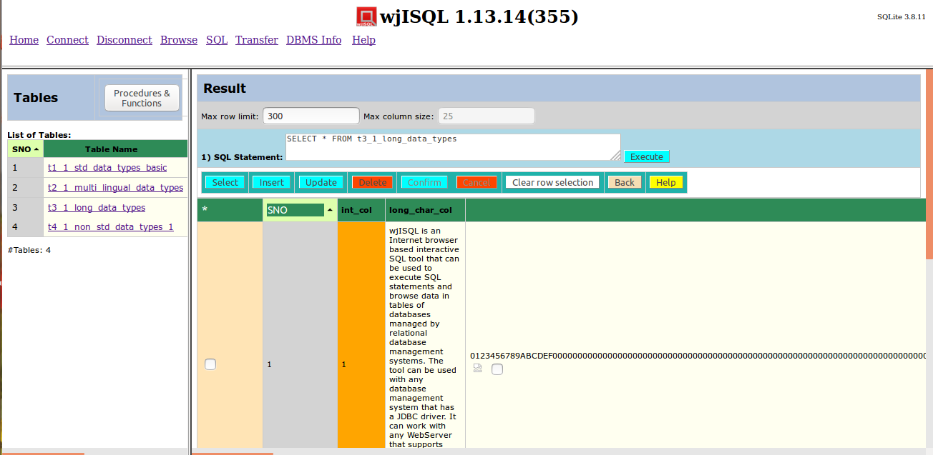

Post Test Actions:
1 | Click button Back to get back to table properties.

Test Status:
Platform | wjISQL | Date | Status | Remarks
Ubuntu 16.04 LTS  FireFox | 1.17.5(419) | 2017-10-10 | Success
Windows 7  FireFox 56.0 | 1.19.5(439) | 2017-10-27 | Success

Unsuccessful Test Cases
None.

Table Keys Test Cases

Successful Test Cases
Test Case 1/104: Test that button Keys displays keys of tables
Test Prerequisites:
1 | Section 7.3 Test cases

Test Procedure
1 | Click on the table: t1_1_std_data_types_basic
2 | Click button Keys

Test Expected o/p:
1 | Key of the table as shown below:  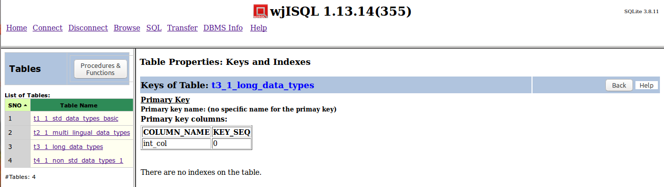

Post Test Actions:
1 | Click button Back to get back to table properties.

Test Status:
Platform | wjISQL | Date | Status | Remarks
Ubuntu 16.04 LTS  FireFox | 1.17.5(419) | 2017-10-10 | Success
Windows 7  FireFox 56.0 | 1.19.5(439) | 2017-10-27 | Success

Table Dropping Test Cases

Successful Test Cases
Test Case 1/105: Test that button Drop drops currently browsed table
Test Prerequisites:
1 | Section 7.3 Test cases

Test Procedure
1 | Click on the table: t4_1_non_std_data_types_1
2 | Click button Drop
3 | Confirm dropping

Test Expected o/p:
1 | Dropped table indicated by deletion of its name in the table list on the left side as shown below:  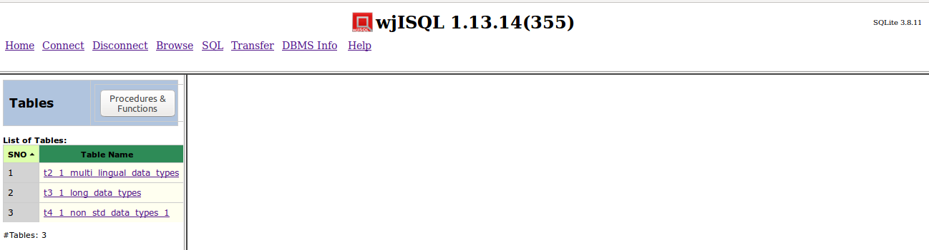

Post Test Actions:
1 | None

Test Status:
Platform | wjISQL | Date | Status | Remarks
Ubuntu 16.04 LTS  FireFox | 1.17.5(419) | 2017-10-10 | Success
Windows 7  FireFox 56.0 | 1.19.5(439) | 2017-10-27 | Success

Procedure/Function Browsing Test Cases

Unsuccessful Test Cases
Test Case 1/106: Test that button Procedures & Functions on the left section displays a message saying procedures are not supported by SQLite
Test Prerequisites:
1 | Section 7.3 Test cases

Test Procedure
1 | Click button Procedures & Functions on the left section of page

Test Expected o/p:
1 | An informational message as following:  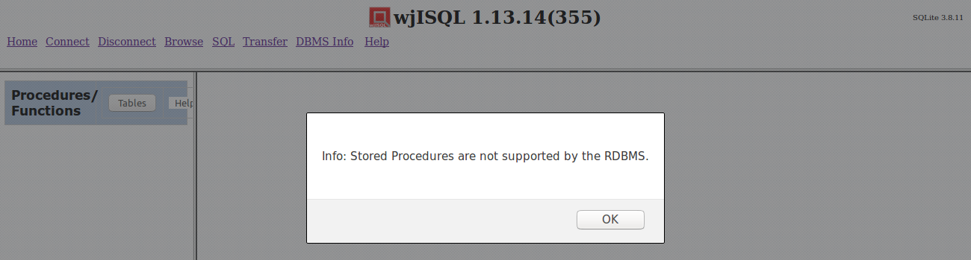

Post Test Actions:
1 | Click button OK on the message box

Test Status:
Platform | wjISQL | Date | Status | Remarks
Ubuntu 16.04 LTS  FireFox | 1.17.5(419) | 2017-10-10 | Success
Windows 7  FireFox 56.0 | 1.19.5(439) | 2017-10-27 | Success

Procedure/Function Tables Button Test Cases

Successful Test Cases
Test Case 1/107: Test that button Tables of left section displays list of tables
Test Prerequisites:
1 | Section 7.8 Test cases

Test Procedure
1 | Click button Tables

Test Expected o/p:
1 | List of tables as shown below:  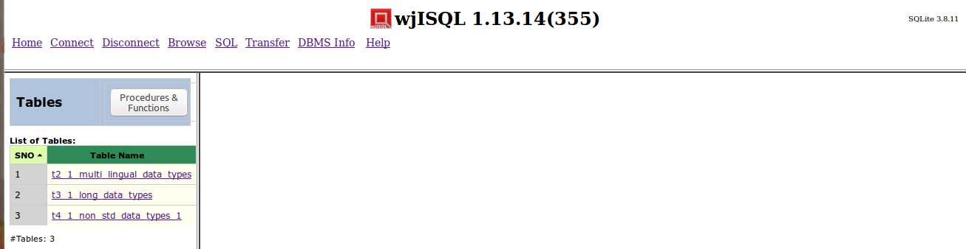

Post Test Actions:
1 | None

Test Status:
Platform | wjISQL | Date | Status | Remarks
Ubuntu 16.04 LTS  FireFox | 1.17.5(419) | 2017-10-10 | Success
Windows 7  FireFox 56.0 | 1.19.5(439) | 2017-10-27 | Success

