wjISQL 1.19.5

SQL Menu Item Test Plan

Change History
SNO | Version | Date | By | Description
1 | 1 | 2016-12-25 | Mvsagar | Created.

Table of Contents
1 Introduction 2
1.1 Prerequisites for all Tests 2
2 MySQL SQL Statement Execution using FireFox Test Cases 3
2.1 Prerequisites 3
2.2 SQL Menu Item Test Cases 3
2.2.1 Successful Test Cases 3
2.2.2 Unsuccessful Test Cases 4
2.3 SQL Statement(s) Window: SQL statement Execution Test Cases 4
2.3.1 Successful Test Cases 4
2.3.2 Unsuccessful Test Cases 8
2.4 SQL Statement(s) Window: SQL Script Execution Test Cases 8
2.4.1 Successful Test Cases 8
2.5 SQL Statement(s) Window: Selected Statements Execution Test Cases 9
2.5.1 Successful Test Cases 9
3 MariaDB SQL Statement Execution using FireFox Test Cases 11
3.1 Prerequisites 11
3.2 SQL Menu Item Test Cases 12
3.2.1 Successful Test Cases 12
3.2.2 Unsuccessful Test Cases 12
3.3 SQL Statement(s) Window: SQL statement Execution Test Cases 13
3.3.1 Successful Test Cases 13
3.3.2 Unsuccessful Test Cases 16
3.4 SQL Statement(s) Window: SQL Script Execution Test Cases 17
3.4.1 Successful Test Cases 17
3.5 SQL Statement(s) Window: Selected Statements Execution Test Cases 18
3.5.1 Successful Test Cases 18
4 PostgreSQL SQL Statement Execution using Chrome Test Cases 20
4.1 Prerequisites 20
4.2 SQL Menu Item Test Cases 21
4.2.1 Successful Test Cases 21
4.2.2 Unsuccessful Test Cases 21
4.3 SQL Statement(s) Window: SQL statement Execution Test Cases 21
4.3.1 Successful Test Cases 21
4.3.2 Unsuccessful Test Cases 24
4.4 SQL Statement(s) Window: SQL Script Execution Test Cases 24
4.4.1 Successful Test Cases 24
4.5 SQL Statement(s) Window: Selected Statements Execution Test Cases 25
4.5.1 Successful Test Cases 25
5 Oracle SQL Statement Execution using FireFox Test Cases 28
5.1 Prerequisites 28
5.2 SQL Menu Item Test Cases 28
5.2.1 Successful Test Cases 28
5.2.2 Unsuccessful Test Cases 29
5.3 SQL Statement(s) Window: SQL statement Execution Test Cases 29
5.3.1 Successful Test Cases 29
5.3.2 Unsuccessful Test Cases 32
5.4 SQL Statement(s) Window: SQL Script Execution Test Cases 32
5.4.1 Successful Test Cases 32
5.5 SQL Statement(s) Window: Selected Statements Execution Test Cases 33
5.5.1 Successful Test Cases 33
6 MS SQL SQL Statement Execution using IE Test Cases 36
6.1 Prerequisites 36
6.2 SQL Menu Item Test Cases 36
6.2.1 Successful Test Cases 36
6.2.2 Unsuccessful Test Cases 37
6.3 SQL Statement(s) Window: SQL statement Execution Test Cases 37
6.3.1 Successful Test Cases 37
6.3.2 Unsuccessful Test Cases 40
6.4 SQL Statement(s) Window: SQL Script Execution Test Cases 40
6.4.1 Successful Test Cases 40
6.5 SQL Statement(s) Window: Selected Statements Execution Test Cases 41
6.5.1 Successful Test Cases 41
7 SQLite SQL Statement Execution Chrome Test Cases 44
7.1 Prerequisites 44
7.2 SQL Menu Item Test Cases 44
7.2.1 Successful Test Cases 44
7.2.2 Unsuccessful Test Cases 45
7.3 SQL Statement(s) Window: SQL statement Execution Test Cases 45
7.3.1 Successful Test Cases 45
7.3.2 Unsuccessful Test Cases 47
7.4 SQL Statement(s) Window: SQL Script Execution Test Cases 47
7.4.1 Successful Test Cases 47
7.5 SQL Statement(s) Window: Selected Statements Execution Test Cases 48
7.5.1 Successful Test Cases 48

Introduction
This test plan has test cases for testing SQL statement execution functionality of wjISQL. The goal is to test working of features in various browsers than to test with various RDBMSs.

Prerequisites for all Tests

1 | Installation test is successful.
2 | Main screen is of wjISQL is currently shown in the browser. Otherwise, enter "http://localhost:8080/wjisql" in the browser address field.

MySQL SQL Statement Execution using FireFox Test Cases

Prerequisites

1 | MySQL database mysqldb is readily available for user mysqlusr and password mysql123. The user has DBA privileges.
2 | You have already logged into the database.
3 | Database setup was done as mentioned in browse test plan.

SQL Menu Item Test Cases

Successful Test Cases

Test Case 1/1: Test that SQL menu item displays current tables, a window "SQL Statement(s)" to execute statements and an empty window.
Test Prerequisites:
1 | None.

Test Procedure
1 | Click button SQL.

Test Expected o/p:
1 | A screen as shown below:  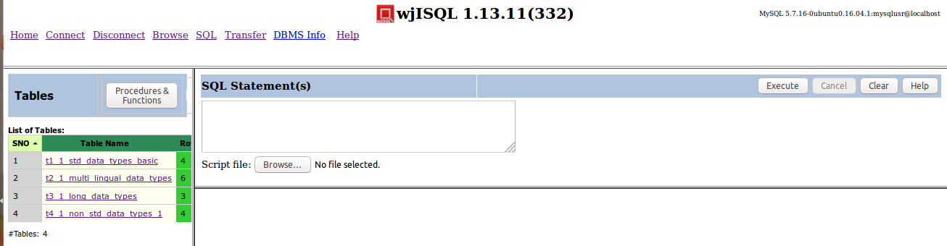

Test Status:
Platform | wjISQL | Date | Status | Remarks
Ubuntu 16.04 LTS  FireFox | 1.17.5(419) | 2017-10-10 | Success
Windows 7

Unsuccessful Test Cases
None.

SQL Statement(s) Window: SQL statement Execution Test Cases

Successful Test Cases
Test Case 1/2: Test execution of simple SELECT statment as following:
Test Prerequisites:
1 | None

Test Procedure
1 | Enter statement "SELECT * FROM t1_1_std_data_types_basic;" in window SQLStatement(s)
2 | Click button Execute.

Test Expected o/p:
1 | Screen with results as shown below:  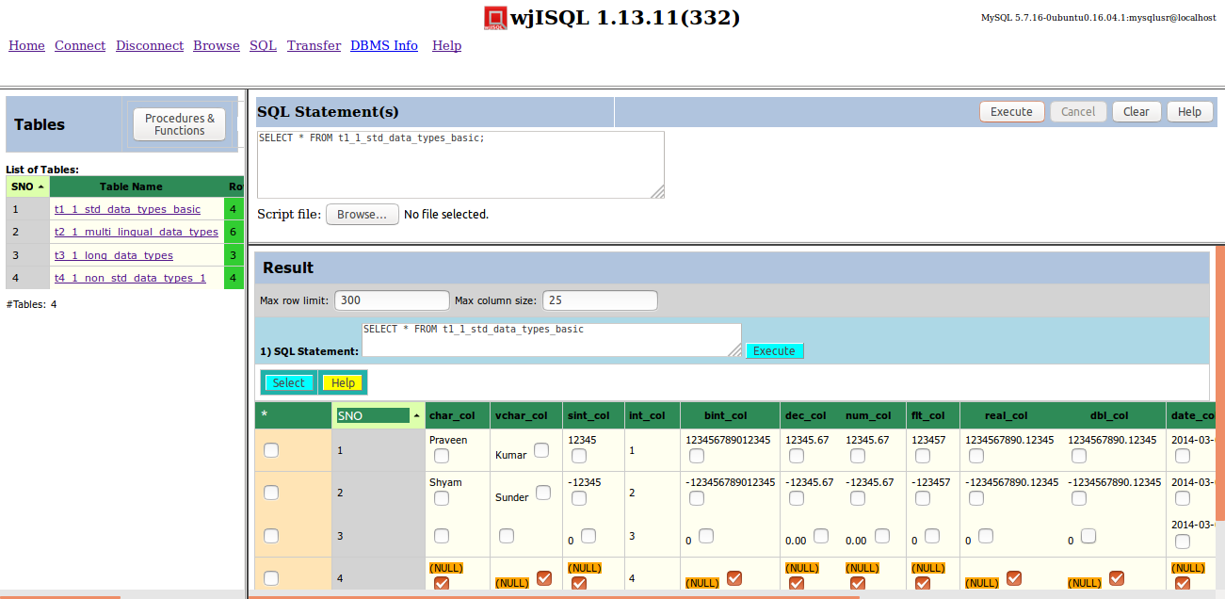

Test Status:
Platform | wjISQL | Date | Status | Remarks
Ubuntu 16.04 LTS  FireFox | 1.17.5(419) | 2017-10-10 | Success
Windows 7

Test Case 2/3: Test Execution of Stored Procedure
Test Prerequisites:
1 | Test Case 1

Test Procedure
1 | Click button Clear.
2 | Write the following statement in window SQL Statement(s):  CALL proc_4_1_in_out_args(1, ?);
3 | Click button Execute

Test Expected o/p:
1 | The table columns as shown below:  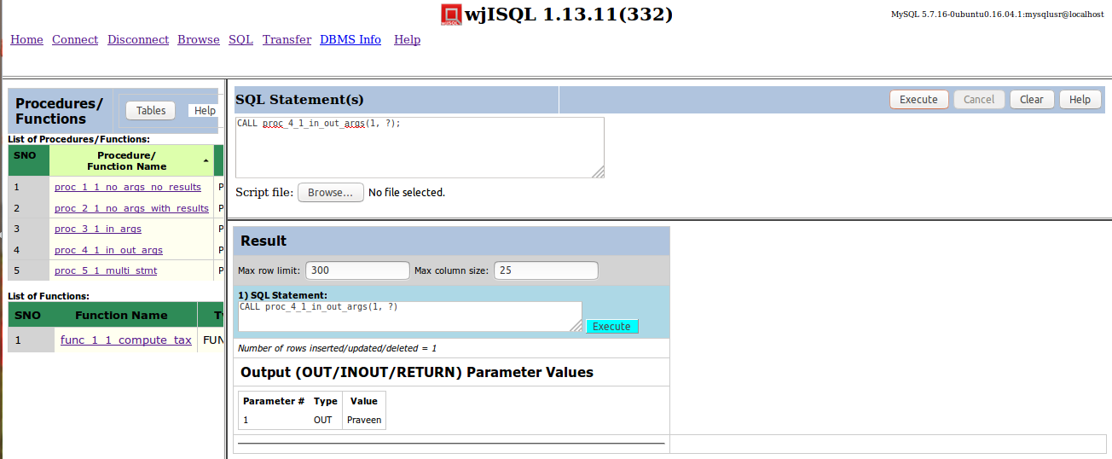

Test Status:
Platform | wjISQL | Date | Status | Remarks
Ubuntu 16.04 LTS  FireFox | 1.17.5(419) | 2017-10-10 | Success
Windows 7

Test Case 3/4: Test Execution of Stored Function
Test Prerequisites:
1 | Test Case 1

Test Procedure
1 | Click button Clear.
2 | Write the following statement in window SQL Statement(s):  SELECT func_1_1_compute_tax(1);
3 | Click button Execute

Test Expected o/p:
1 | The table columns as shown below:  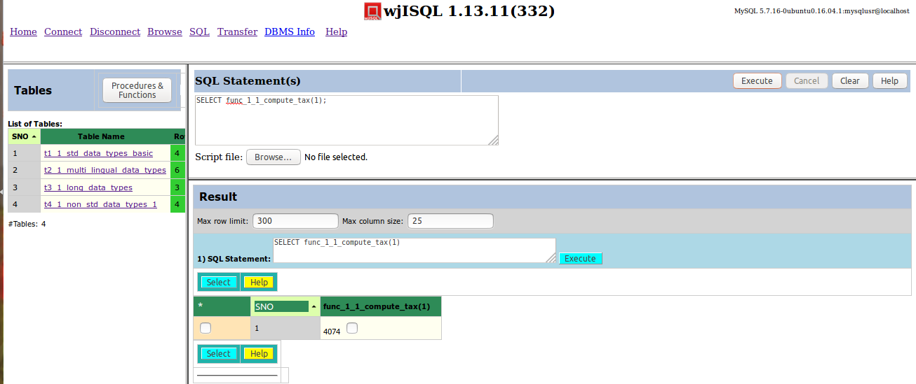

Test Status:
Platform | wjISQL | Date | Status | Remarks
Ubuntu 16.04 LTS  FireFox | 1.17.5(419) | 2017-10-10 | Success
Windows 7

Test Case 4/5: Test Execution of multiple statements at one time
Test Prerequisites:
1 | Test Case 1

Test Procedure
1 | Click button Clear.
2 | Write the following statements in the window SQL Statement(s) (or copy and paste from scripts source directory):  DROP TABLE emp;  DROP TABLE dept;  CREATE TABLE dept (dno INT NOT NULL PRIMARY KEY  , dname VARCHAR(20));  CREATE TABLE emp(eno INT NOT NULL PRIMARY KEY  , ename VARCHAR(20), dno INT REFERENCES dept(dno));  INSERT INTO dept(dno, dname) VALUES(1, 'Research');  INSERT INTO dept(dno, dname) VALUES(2, 'Development');  INSERT INTO dept(dno, dname) VALUES(3, 'Marketing');  INSERT INTO emp VALUES(1001, 'Brahma', 1);  INSERT INTO emp VALUES(1002, 'Vishnu', 1);  INSERT INTO emp VALUES(1003, 'Narayana', 2);  INSERT INTO emp VALUES(1004, 'Krishna', 2);  INSERT INTO emp VALUES(1005, 'Narada', 3);  INSERT INTO emp VALUES(1006, 'Hanuman', 3);  SELECT * FROM dept;  SELECT * from emp;
3 | Click button Execute.
4 | Click OK on alert message box for an error messages by DROP statements due to non-existent of tables for the first time.

Test Expected o/p:
1 | Tables dept and emp as shown below:  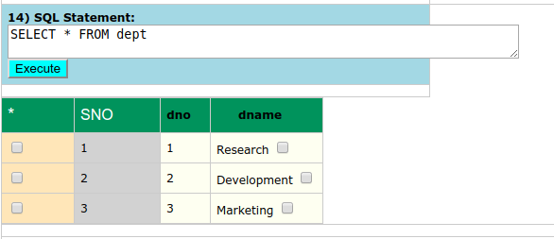  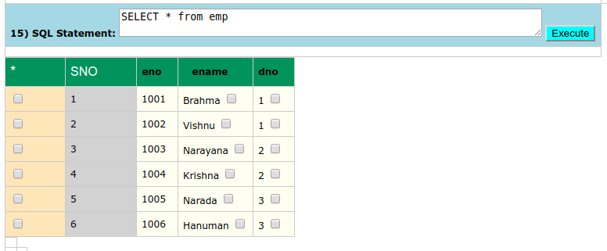

Test Status:
Platform | wjISQL | Date | Status | Remarks
Ubuntu 16.04 LTS  FireFox | 1.17.5(419) | 2017-10-10 | Success
Windows 7

Unsuccessful Test Cases
None.

SQL Statement(s) Window: SQL Script Execution Test Cases

Successful Test Cases
Test Case 1/6: Test execution of a script
Test Prerequisites:
1 | None.

Test Procedure
1 | Click navigation link SQL.
2 | Click button Browse below the SQL Statement(s) window and choose the following file:  wjisql/wji_tsrc/wji_scripts/wji_16_sql_scripts/tst_16_001_sql_script.sql
3 | Click button Execute.

Test Expected o/p:
1 | Loading of SQL statements from the file into SQL Statement(s) window and execution of all statements with results as shown below:  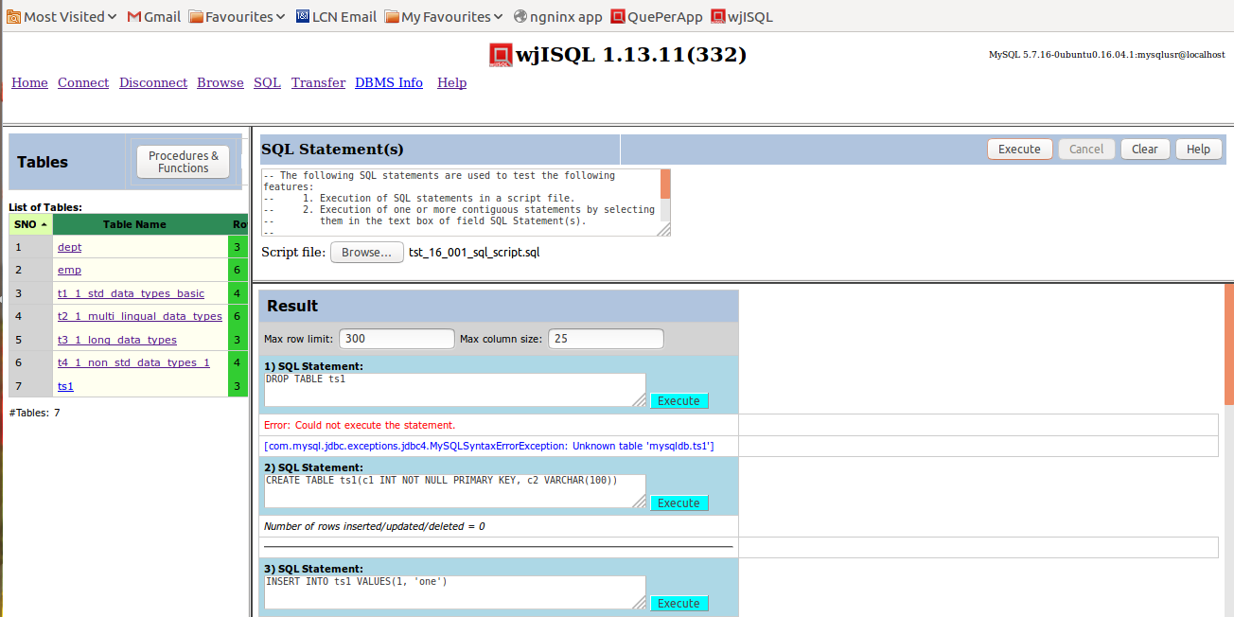

Test Status:
Platform | wjISQL | Date | Status | Remarks
Ubuntu 16.04 LTS  FireFox | 1.17.5(419) | 2017-10-10 | Success
Windows 7

SQL Statement(s) Window: Selected Statements Execution Test Cases

Successful Test Cases
Test Case 1/7: Test execution of an SQL statement selected in SQLStatement(s) window.
Test Prerequisites:
1 | None

Test Procedure
1 | Click navigation link SQL.
2 | Click button Browse/Choose File below the SQL Statement(s) window and choose the following file:  wjisql/wji_tsrc/wji_scripts/wji_16_sql_scripts/tst_16_001_sql_script.sql
3 | Select the first SQL statement: as shown below:  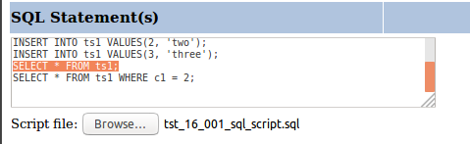
4 | Click button Execute.

Test Expected o/p:
1 | Execution of the selected statement with results as shown below:  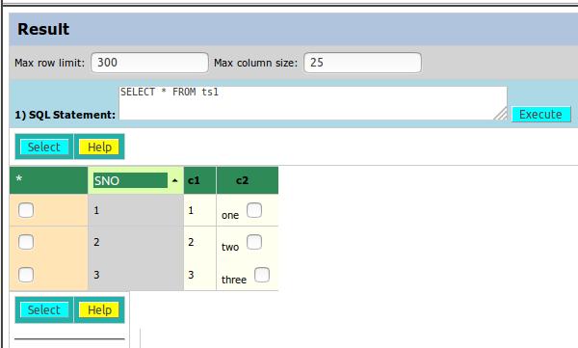

Test Status:
Platform | wjISQL | Date | Status | Remarks
Ubuntu 16.04 LTS  FireFox | 1.17.5(419) | 2017-10-10 | Success
Windows 7

Test Case 2/8: Test execution of consecutive multiple SQL statements selected in SQLStatement(s) window.
Test Prerequisites:
1 | Test Case 1

Test Procedure
1 | Add new SQL statement above first SELECT statement as following:  INSERT INTO ts1 VALUES(4, 'four');
2 | Select the last 3 SQL statements including the new one: as shown below:  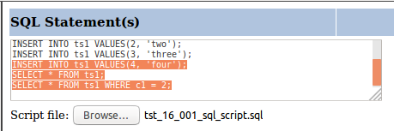
3 | Click button Execute.

Test Expected o/p:
1 | Result window that shows exwecution of the three statements:  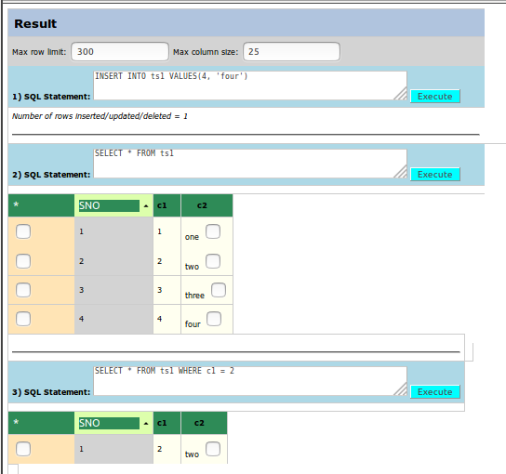

Test Status:
Platform | wjISQL | Date | Status | Remarks
Ubuntu 16.04 LTS  FireFox | 1.17.5(419) | 2017-10-10 | Success
Windows 7

MariaDB SQL Statement Execution using FireFox Test Cases

Prerequisites

1 | MySQL database mariadb is readily available for user mariausr and password maria123. The user has DBA privileges.
2 | You have already logged into the database.
3 | Database setup was done as mentioned in browser test plan.

SQL Menu Item Test Cases

Successful Test Cases

Test Case 1/9: Test that SQL menu item displays current tables, a window "SQL Statement(s)" to execute statements and an empty window.
Test Prerequisites:
1 | None.

Test Procedure
1 | Click button SQL.

Test Expected o/p:
1 | A screen as shown below:  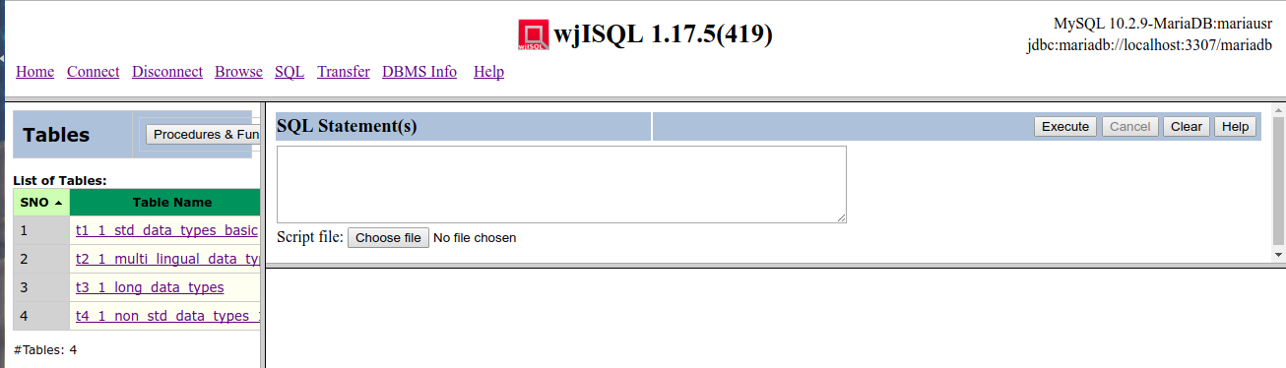

Test Status:
Platform | wjISQL | Date | Status | Remarks
Ubuntu 16.04 LTS  FireFox | 1.17.5(419) | 2017-10-11 | Success
Windows 7

Unsuccessful Test Cases
None.

SQL Statement(s) Window: SQL statement Execution Test Cases

Successful Test Cases
Test Case 1/10: Test execution of simple SELECT statment as following:
Test Prerequisites:
1 | None

Test Procedure
1 | Enter statement "SELECT * FROM t1_1_std_data_types_basic;" in window SQLStatement(s)
2 | Click button Execute.

Test Expected o/p:
1 | Screen with results as shown below:  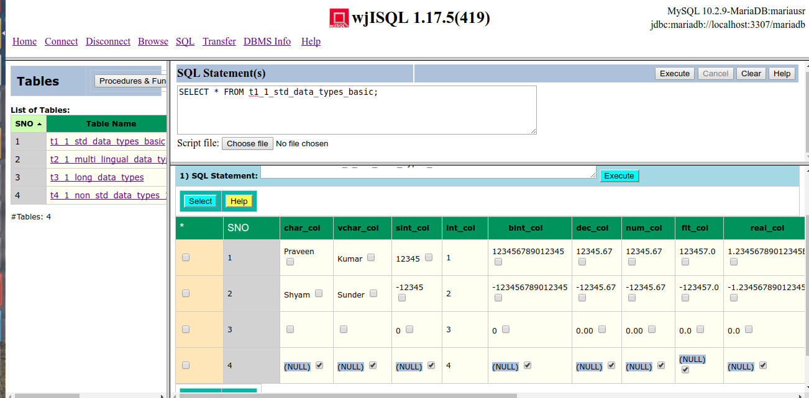

Test Status:
Platform | wjISQL | Date | Status | Remarks
Ubuntu 16.04 LTS  FireFox | 1.17.5(419) | 2017-10-11 | Success
Windows 7

Test Case 2/11: Test Execution of Stored Procedure
Test Prerequisites:
1 | Test Case 1

Test Procedure
1 | Click button Clear.
2 | Write the following statement in window SQL Statement(s):  CALL proc_4_1_in_out_args(1, ?);
3 | Click button Execute

Test Expected o/p:
1 | The table columns as shown below:

Test Status:
Platform | wjISQL | Date | Status | Remarks
Ubuntu 16.04 LTS  FireFox | 1.17.5(419) | 2017-10-11 | FAILED
Windows 7

Test Case 3/12: Test Execution of Stored Function
Test Prerequisites:
1 | Test Case 1

Test Procedure
1 | Click button Clear.
2 | Write the following statement in window SQL Statement(s):  SELECT func_1_1_compute_tax(1);
3 | Click button Execute

Test Expected o/p:
1 | The table columns as shown below:

Test Status:
Platform | wjISQL | Date | Status | Remarks
Ubuntu 16.04 LTS  FireFox | 1.17.5(419) | 2017-10-11 | FAILED
Windows 7

Test Case 4/13: Test Execution of multiple statements at one time
Test Prerequisites:
1 | Test Case 1

Test Procedure
1 | Click button Clear.
2 | Write the following statements in the window SQL Statement(s) (or copy and paste from scripts source directory):  DROP TABLE IF EXISTS emp;  DROP TABLE IF EXISTS dept;  CREATE TABLE dept (dno INT NOT NULL PRIMARY KEY  , dname VARCHAR(20));  CREATE TABLE emp(eno INT NOT NULL PRIMARY KEY  , ename VARCHAR(20), dno INT REFERENCES dept(dno));  INSERT INTO dept(dno, dname) VALUES(1, 'Research');  INSERT INTO dept(dno, dname) VALUES(2, 'Development');  INSERT INTO dept(dno, dname) VALUES(3, 'Marketing');  INSERT INTO emp VALUES(1001, 'Brahma', 1);  INSERT INTO emp VALUES(1002, 'Vishnu', 1);  INSERT INTO emp VALUES(1003, 'Narayana', 2);  INSERT INTO emp VALUES(1004, 'Krishna', 2);  INSERT INTO emp VALUES(1005, 'Narada', 3);  INSERT INTO emp VALUES(1006, 'Hanuman', 3);  SELECT * FROM dept;  SELECT * from emp;
3 | Click button Execute.
4 | Click OK on alert message box for an error messages by DROP statements due to non-existent of tables for the first time.

Test Expected o/p:
1 | Tables dept and emp as shown below:

Test Status:
Platform | wjISQL | Date | Status | Remarks
Ubuntu 16.04 LTS  FireFox | 1.17.5(419) | 2017-10-11 | Success
Windows 7

Unsuccessful Test Cases
None.

SQL Statement(s) Window: SQL Script Execution Test Cases

Successful Test Cases
Test Case 1/14: Test execution of a script
Test Prerequisites:
1 | None.

Test Procedure
1 | Click navigation link SQL.
2 | Click button Browse below the SQL Statement(s) window and choose the following file:  wjisql/wji_tsrc/wji_scripts/wji_16_sql_scripts/tst_16_001_sql_script.sql
3 | Click button Execute.

Test Expected o/p:
1 | Loading of SQL statements from the file into SQL Statement(s) window and execution of all statements with results as shown below:  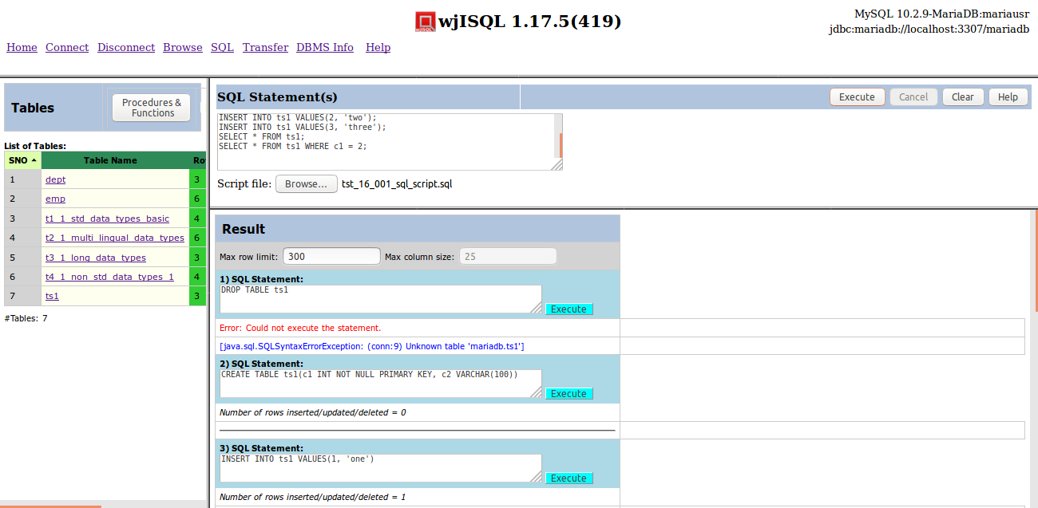

Test Status:
Platform | wjISQL | Date | Status | Remarks
Ubuntu 16.04 LTS  FireFox | 1.17.5(419) | 2017-10-11 | Success
Windows 7

SQL Statement(s) Window: Selected Statements Execution Test Cases

Successful Test Cases
Test Case 1/15: Test execution of an SQL statement selected in SQLStatement(s) window.
Test Prerequisites:
1 | None

Test Procedure
1 | Click navigation link SQL.
2 | Click button Browse/Choose File below the SQL Statement(s) window and choose the following file:  wjisql/wji_tsrc/wji_scripts/wji_16_sql_scripts/tst_16_001_sql_script.sql
3 | Select the first SQL statement: as shown below:
4 | Click button Execute.

Test Expected o/p:
1 | Execution of the selected statement with results as shown below:

Test Status:
Platform | wjISQL | Date | Status | Remarks
Ubuntu 16.04 LTS  FireFox | 1.17.5(419) | 2017-10-11 | Success
Windows 7

Test Case 2/16: Test execution of consecutive multiple SQL statements selected in SQLStatement(s) window.
Test Prerequisites:
1 | Test Case 1

Test Procedure
1 | Add new SQL statement above first SELECT statement as following:  INSERT INTO ts1 VALUES(4, 'four');
2 | Select the last 3 SQL statements including the new one: as shown below:
3 | Click button Execute.

Test Expected o/p:
1 | Result window that shows exwecution of the three statements:

Test Status:
Platform | wjISQL | Date | Status | Remarks
Ubuntu 16.04 LTS  FireFox | 1.17.5(419) | 2017-10-11 | Success
Windows 7

PostgreSQL SQL Statement Execution using Chrome Test Cases

Prerequisites

1 | PostgreSQL database pgsqldb is readily available for user pgsqlusr and password pgsql123. The user has DBA privileges.
2 | You have already logged into the database.
3 | Setup database as mentioned in wji.tpl.05.browse.docx

SQL Menu Item Test Cases

Successful Test Cases

Test Case 1/17: Test that SQL menu item displays current tables, a window "SQL Statement(s)" to execute statements and an empty window.
Test Prerequisites:
1 | None.

Test Procedure
1 | Click button SQL.

Test Expected o/p:
1 | A screen as shown below:  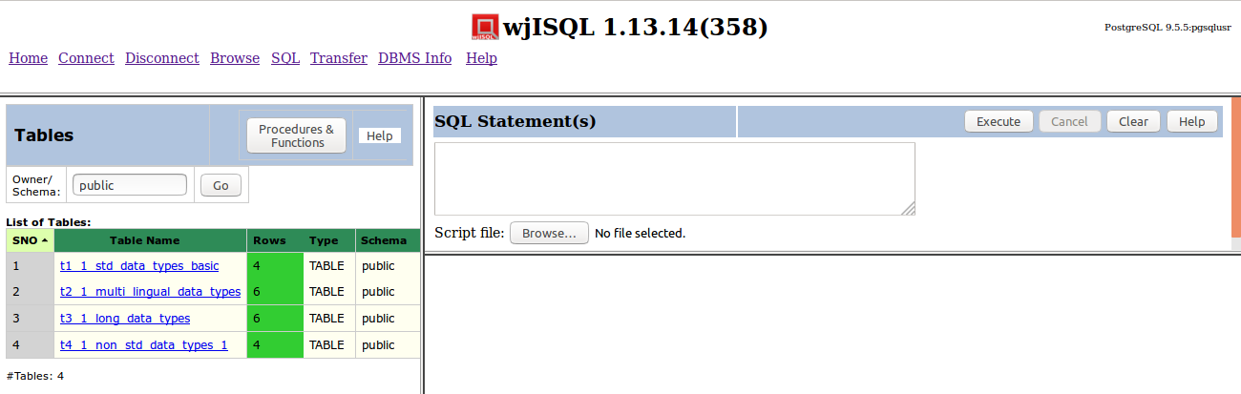

Test Status:
Platform | wjISQL | Date | Status | Remarks
Ubuntu 16.04 LTS  FireFox | 1.17.5(419) | 2017-10-11 | Success
Windows 7

Unsuccessful Test Cases
None.

SQL Statement(s) Window: SQL statement Execution Test Cases

Successful Test Cases
Test Case 1/18: Test execution of simple SELECT statment as following:
Test Prerequisites:
1 | None

Test Procedure
1 | Enter statement "SELECT * FROM t1_1_std_data_types_basic;" in window SQLStatement(s)
2 | Click button Execute.

Test Expected o/p:
1 | Screen with results as shown below:  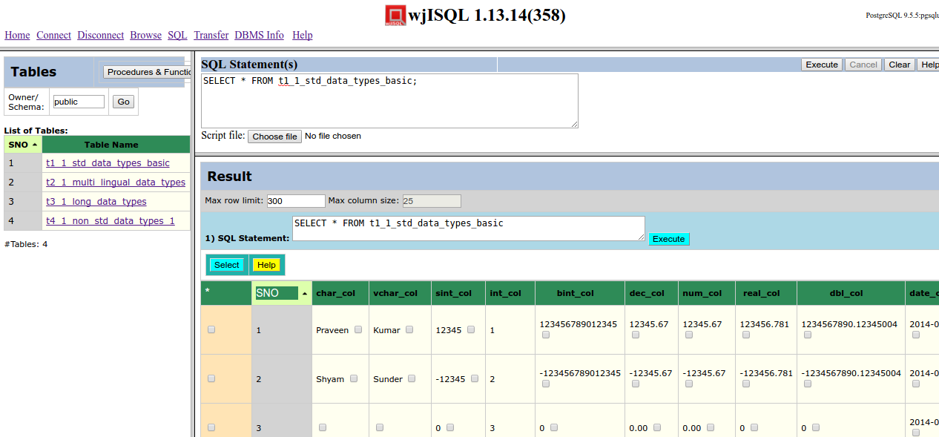

Test Status:
Platform | wjISQL | Date | Status | Remarks
Ubuntu 16.04 LTS  Chrome | 1.17.5(419) | 2017-10-11 | Success
Windows 7

Test Case 2/19: Test Execution of Stored Procedure
Not applicable to PosqtgreSQL.

Test Case 3/20: Test Execution of Stored Function
Test Prerequisites:
1 | Test Case 1

Test Procedure
1 | Click button Clear.
2 | Write the following statement in window SQL Statement(s):  SELECT * FROM func_4_2_in_out_inout_args(1,5);
3 | Click button Execute

Test Expected o/p:
1 | Result from the function execution as shown below:  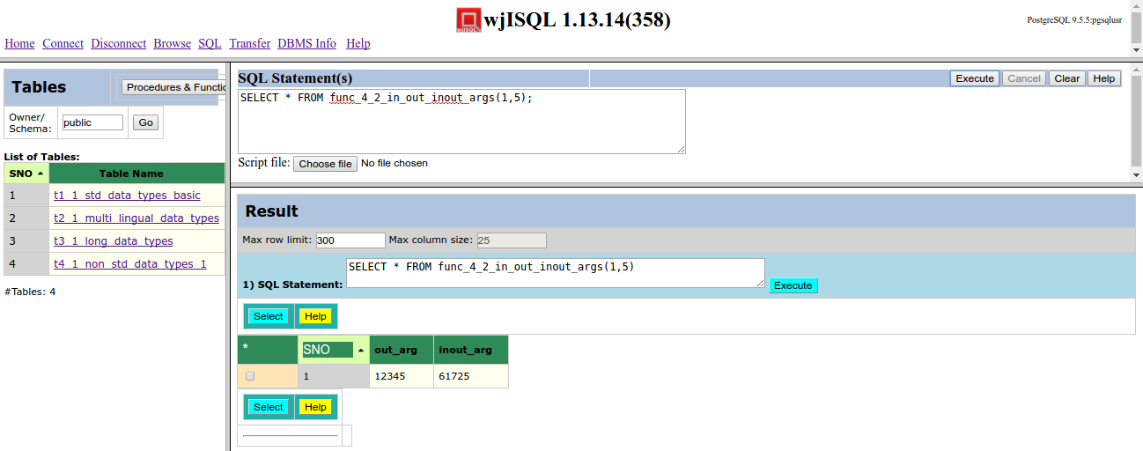

Test Status:
Platform | wjISQL | Date | Status | Remarks
Ubuntu 16.04 LTS  Chorme | 1.17.5(419) | 2017-10-11 | Success
Windows 7

Test Case 4/21: Test Execution of multiple statements at one time
Test Prerequisites:
1 | Test Case 1

Test Procedure
1 | Click button Clear.
2 | Write the following statements in the window SQL Statement(s) (or copy and paste from scripts source directory):  DROP TABLE emp;  DROP TABLE dept;  CREATE TABLE dept (dno INT NOT NULL PRIMARY KEY  , dname VARCHAR(20));  CREATE TABLE emp(eno INT NOT NULL PRIMARY KEY  , ename VARCHAR(20), dno INT REFERENCES dept(dno));  INSERT INTO dept(dno, dname) VALUES(1, 'Research');  INSERT INTO dept(dno, dname) VALUES(2, 'Development');  INSERT INTO dept(dno, dname) VALUES(3, 'Marketing');  INSERT INTO emp VALUES(1001, 'Brahma', 1);  INSERT INTO emp VALUES(1002, 'Vishnu', 1);  INSERT INTO emp VALUES(1003, 'Narayana', 2);  INSERT INTO emp VALUES(1004, 'Krishna', 2);  INSERT INTO emp VALUES(1005, 'Narada', 3);  INSERT INTO emp VALUES(1006, 'Hanuman', 3);  SELECT * FROM dept;  SELECT * from emp;  DROP TABLE emp;  DROP TABLE dept;
3 | Click button Execute.
4 | Click OK on alert message box for an error messages by DROP statements due to non-existent of tables for the first time.

Test Expected o/p:
1 | Created new tables in the table list and the Result window as shown below:  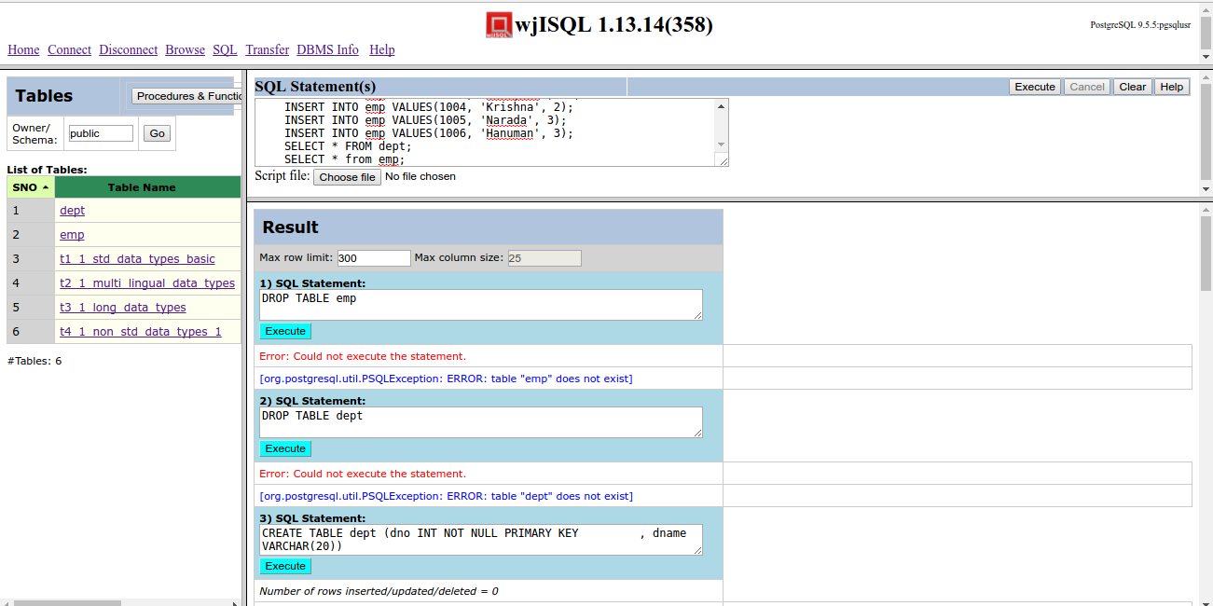

Test Status:
Platform | wjISQL | Date | Status | Remarks
Ubuntu 16.04 LTS  Chrome | 1.17.5(419) | 2017-10-11 | Success
Windows 7

Unsuccessful Test Cases
None.

SQL Statement(s) Window: SQL Script Execution Test Cases

Successful Test Cases
Test Case 1/22: Test execution of a script
Test Prerequisites:
1 | None.

Test Procedure
1 | Click navigation link SQL.
2 | Click button Browse below the SQL Statement(s) window and choose the following file:  wjisql/wji_tsrc/wji_scripts/wji_16_sql_scripts/tst_16_001_sql_script.sql
3 | Click button Execute.

Test Expected o/p:
1 | Loading of SQL statements from the file into SQL Statement(s) window and execution of all statements with results as shown below:  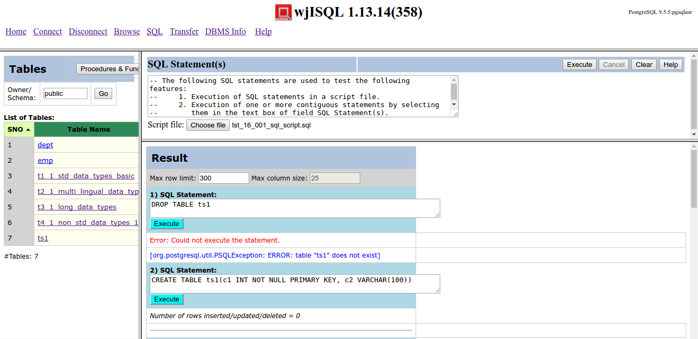

Test Status:
Platform | wjISQL | Date | Status | Remarks
Ubuntu 16.04 LTS  Chrome | 1.17.5(419) | 2017-10-11 | Success
Windows 7

SQL Statement(s) Window: Selected Statements Execution Test Cases

Successful Test Cases
Test Case 1/23: Test execution of an SQL statement selected in SQLStatement(s) window.
Test Prerequisites:
1 | None

Test Procedure
1 | Click navigation link SQL.
2 | Click button Browse below the SQL Statement(s) window and choose the following file:  wjisql/wji_tsrc/wji_scripts/wji_16_sql_scripts/tst_16_001_sql_script.sql
3 | Select the first SQL statement: as shown below:  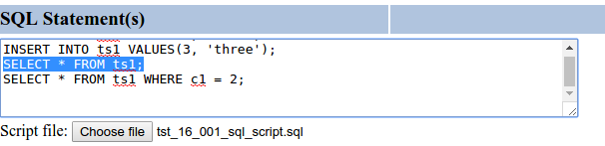
4 | Click button Execute.

Test Expected o/p:
1 | Loading of SQL statements from the file into SQL Statement(s) window and execution of all statements with results as shown below:

Test Status:
Platform | wjISQL | Date | Status | Remarks
Ubuntu 16.04 LTS  Chrome | 1.17.5(419) | 2017-10-11 | Success
Windows 7

Test Case 2/24: Test execution of consecutive multiple SQL statements selected in SQLStatement(s) window.
Test Prerequisites:
1 | Test Case 1

Test Procedure
1 | Add new SQL statement above first SELECT statement as following:  INSERT INTO ts1 VALUES(4, 'four');
2 | Select the last 3 SQL statements including the new one: as shown below:  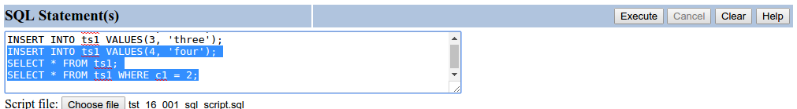
3 | Click button Execute.

Test Expected o/p:
1 | Result window that shows exwecution of the three select statements:  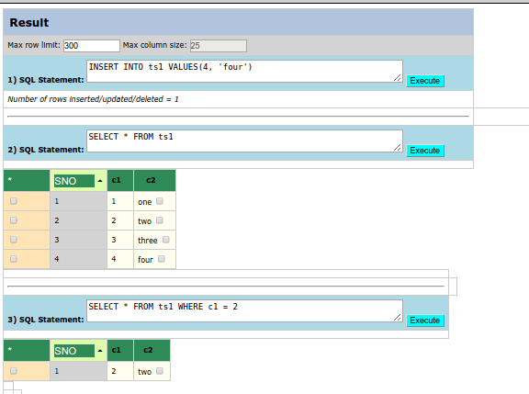

Test Status:
Platform | wjISQL | Date | Status | Remarks
Ubuntu 16.04 LTS  Chrome | 1.17.5(419) | 2017-10-11 | Success
Windows 7

Oracle SQL Statement Execution using FireFox Test Cases

Prerequisites

1 | Oracle database oradb is readily available for user orausr and password ora123. The user has DBA privileges.
2 | You have already logged into the database.
3 | Database setup was done as mentioned in wpl.tpl.05.browse.docx

SQL Menu Item Test Cases

Successful Test Cases

Test Case 1/25: Test that SQL menu item displays current tables, a window "SQL Statement(s)" to execute statements and an empty window.
Test Prerequisites:
1 | None.

Test Procedure
1 | Click button SQL.

Test Expected o/p:
1 | A screen as shown below:  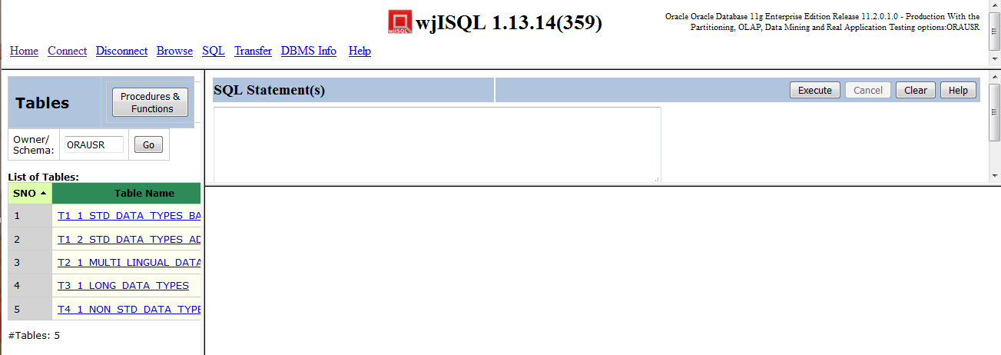

Test Status:
Platform | wjISQL | Date | Status | Remarks
Ubuntu 16.04 LTS
Windows 7  FireFox 56.0 | 1.19.5(439) | 2017-10-27 | Success

Unsuccessful Test Cases
None.

SQL Statement(s) Window: SQL statement Execution Test Cases

Successful Test Cases
Test Case 1/26: Test execution of simple SELECT statment as following:
Test Prerequisites:
1 | None

Test Procedure
1 | Enter statement "SELECT * FROM t1_1_std_data_types_basic;" in window SQLStatement(s)
2 | Click button Execute.

Test Expected o/p:
1 | Screen with results as shown below:  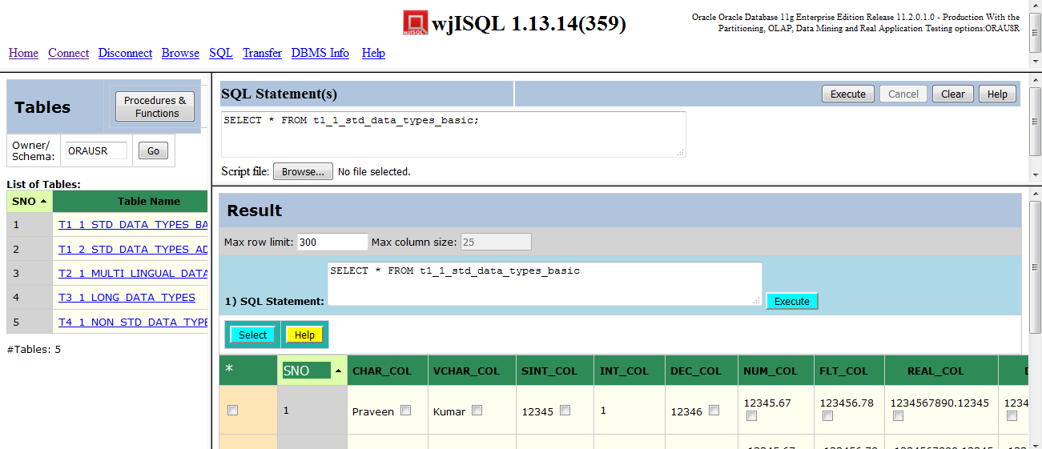

Test Status:
Platform | wjISQL | Date | Status | Remarks
Ubuntu 16.04 LTS
Windows 7  FireFox 56.0 | 1.19.5(439) | 2017-10-27 | Success

Test Case 2/27: Test Execution of Stored Procedure
Test Prerequisites:
1 | Test Case 1

Test Procedure
1 | Click button Clear.
2 | Write the following statement in window SQL Statement(s):  CALL proc_4_1_in_out_args(1, ?);
3 | Click button Execute

Test Expected o/p:
1 | Procedure execution results as shown below:  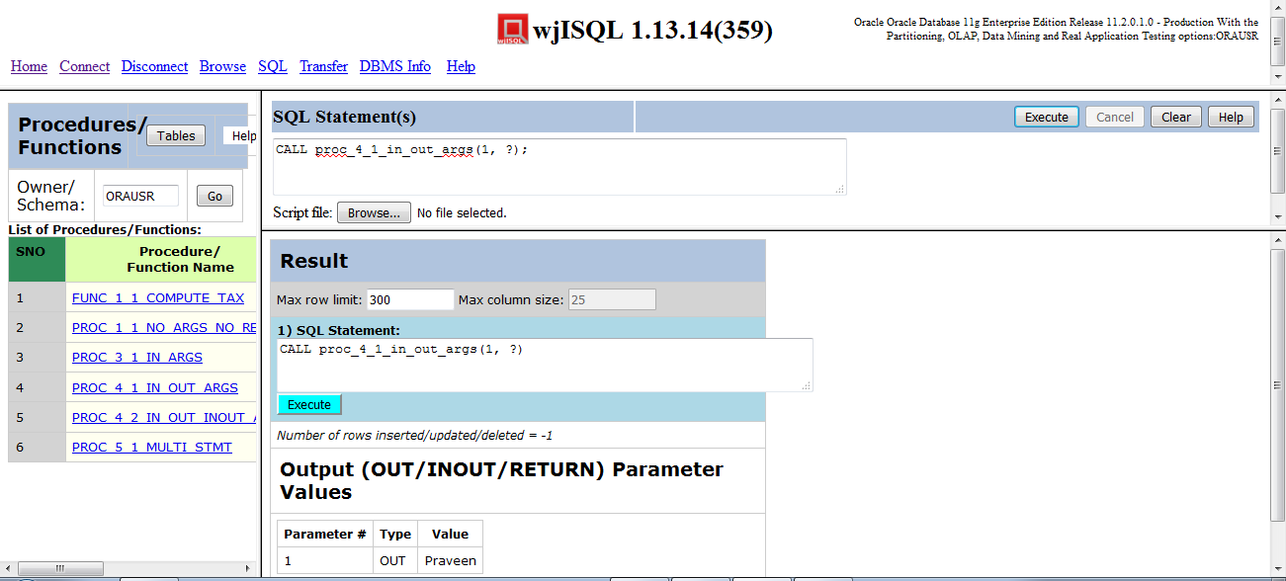

Test Status:
Platform | wjISQL | Date | Status | Remarks
Ubuntu 16.04 LTS
Windows 7  FireFox 56.0 | 1.19.5(439) | 2017-10-27 | Success

Test Case 3/28: Test Execution of Stored Function
Test Prerequisites:
1 | Test Case 1

Test Procedure
1 | Click button Clear.
2 | Write the following statement in window SQL Statement(s):  SELECT func_1_1_compute_tax(1) FROM DUAL;
3 | Click button Execute

Test Expected o/p:
1 | Function results as shown below:  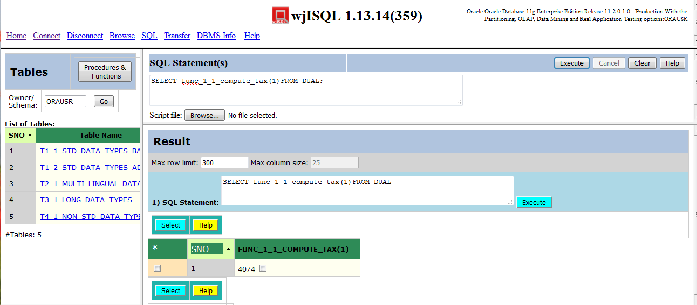

Test Status:
Platform | wjISQL | Date | Status | Remarks
Ubuntu 16.04 LTS
Windows 7  FireFox 56.0 | 1.19.5(439) | 2017-10-27 | Success

Test Case 4/29: Test Execution of multiple statements at one time
Test Prerequisites:
1 | Test Case 1

Test Procedure
1 | Click button Clear.
2 | Write the following statements in the window SQL Statement(s) (or copy and paste from scripts source directory):  DROP TABLE emp;  DROP TABLE dept;  CREATE TABLE dept (dno INT NOT NULL PRIMARY KEY  , dname VARCHAR(20));  CREATE TABLE emp(eno INT NOT NULL PRIMARY KEY  , ename VARCHAR(20), dno INT REFERENCES dept(dno));  INSERT INTO dept(dno, dname) VALUES(1, 'Research');  INSERT INTO dept(dno, dname) VALUES(2, 'Development');  INSERT INTO dept(dno, dname) VALUES(3, 'Marketing');  INSERT INTO emp VALUES(1001, 'Brahma', 1);  INSERT INTO emp VALUES(1002, 'Vishnu', 1);  INSERT INTO emp VALUES(1003, 'Narayana', 2);  INSERT INTO emp VALUES(1004, 'Krishna', 2);  INSERT INTO emp VALUES(1005, 'Narada', 3);  INSERT INTO emp VALUES(1006, 'Hanuman', 3);  SELECT * FROM dept;  SELECT * from emp;
3 | Click button Execute.
4 | Click OK on alert message box for an error messages by DROP statements due to non-existent of tables for the first time.

Test Expected o/p:
1 | Execution results, after scrolling down Result window, are as shown below:  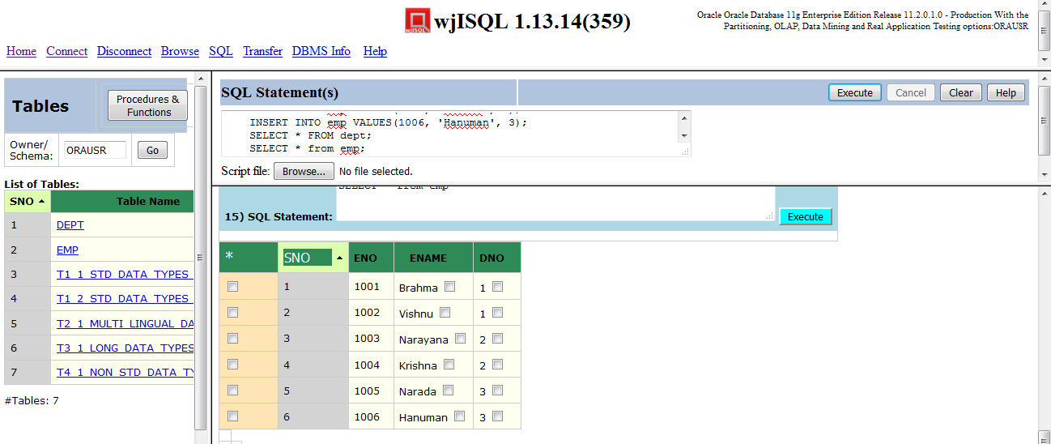

Test Status:
Platform | wjISQL | Date | Status | Remarks
Ubuntu 16.04 LTS
Windows 7  FireFox 56.0 | 1.19.5(439) | 2017-10-27 | Success

Unsuccessful Test Cases
None.

SQL Statement(s) Window: SQL Script Execution Test Cases

Successful Test Cases
Test Case 1/30: Test execution of a script
Test Prerequisites:
1 | None.

Test Procedure
1 | Click navigation link SQL.
2 | Click button Browse below the SQL Statement(s) window and choose the following file:  wjisql/wji_tsrc/wji_scripts/wji_16_sql_scripts/tst_16_001_sql_script.sql
3 | Click button Execute.

Test Expected o/p:
1 | Loading of SQL statements from the file into SQL Statement(s) window and execution of all statements with results, after scrolling down Result window, are as shown below:  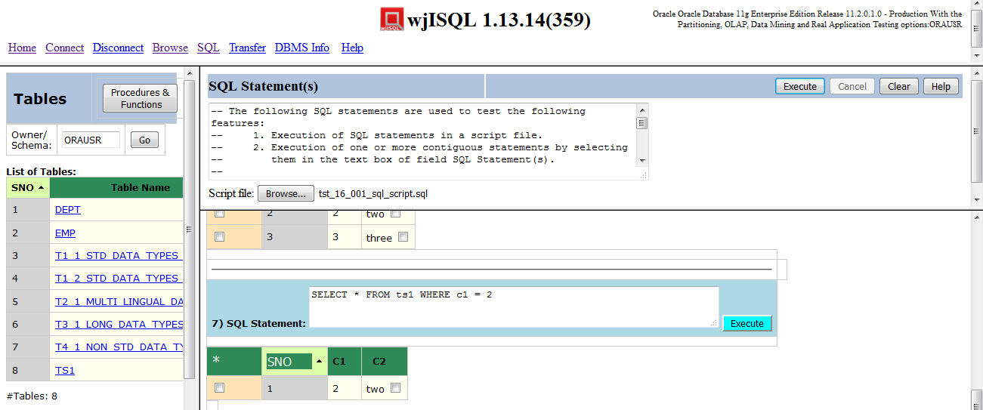

Test Status:
Platform | wjISQL | Date | Status | Remarks
Ubuntu 16.04 LTS
Windows 7  FireFox 56.0 | 1.19.5(439) | 2017-10-27 | Success

SQL Statement(s) Window: Selected Statements Execution Test Cases

Successful Test Cases
Test Case 1/31: Test execution of an SQL statement selected in SQLStatement(s) window.
Test Prerequisites:
1 | None

Test Procedure
1 | Click navigation link SQL.
2 | Click button Browse below the SQL Statement(s) window and choose the following file:  wjisql/wji_tsrc/wji_scripts/wji_16_sql_scripts/tst_16_001_sql_script.sql
3 | Select the first SQL statement: as shown below:  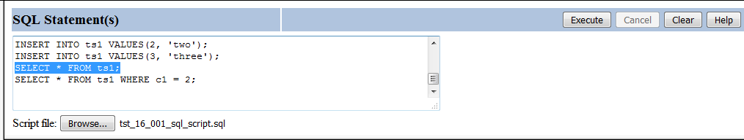
4 | Click button Execute.

Test Expected o/p:
1 | Loading of SQL statements from the file into SQL Statement(s) window and execution of all statements with results as shown below:

Test Status:
Platform | wjISQL | Date | Status | Remarks
Ubuntu 16.04 LTS
Windows 7  FireFox 56.0 | 1.19.5(439) | 2017-10-27 | Success

Test Case 2/32: Test execution of consecutive multiple SQL statements selected in SQLStatement(s) window.
Test Prerequisites:
1 | Test Case 1

Test Procedure
1 | Add new SQL statement above first SELECT statement as following:  INSERT INTO ts1 VALUES(4, 'four');
2 | Select the last 3 SQL statements including the new one: as shown below:  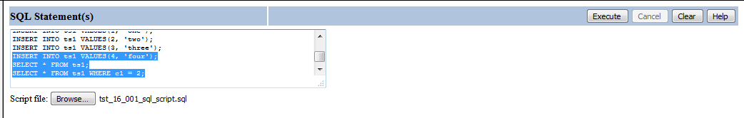
3 | Click button Execute.

Test Expected o/p:
1 | Result window that shows exwecution of the three select statements:

Test Status:
Platform | wjISQL | Date | Status | Remarks
Ubuntu 16.04 LTS
Windows 7  FireFox 56.0 | 1.19.5(439) | 2017-10-27 | Success

MS SQL SQL Statement Execution using IE Test Cases

Prerequisites

1 | MS SQL database msqldb is readily available for user mssqlusr and password mssql123. The user has DBA privileges.
2 | You have already logged into the database.
3 | Database setup was done as mentioned in wpl.tpl.05.browse.docx

SQL Menu Item Test Cases

Successful Test Cases

Test Case 1/33: Test that SQL menu item displays current tables, a window "SQL Statement(s)" to execute statements and an empty window.
Test Prerequisites:
1 | None.

Test Procedure
1 | Click button SQL.

Test Expected o/p:
1 | A screen as shown below:  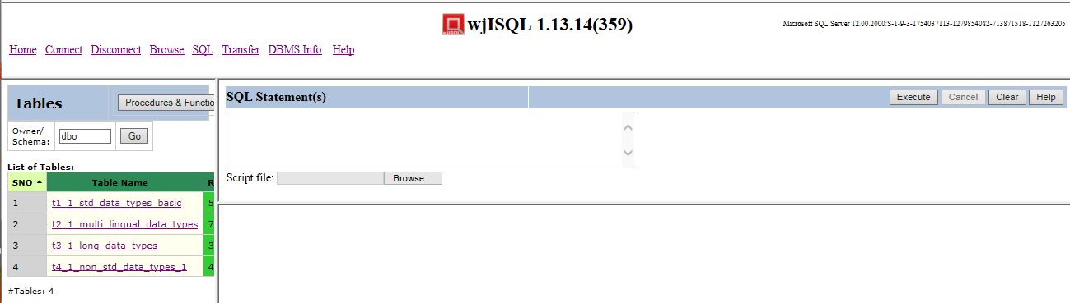

Test Status:
Platform | wjISQL | Date | Status | Remarks
Ubuntu 16.04 LTS
Windows 7  IE 11.0 | 1.19.5(439) | 2017-10-27 | Success

Unsuccessful Test Cases
None.

SQL Statement(s) Window: SQL statement Execution Test Cases

Successful Test Cases
Test Case 1/34: Test execution of simple SELECT statment as following:
Test Prerequisites:
1 | None

Test Procedure
1 | Enter statement "SELECT * FROM t1_1_std_data_types_basic;" in window SQLStatement(s)
2 | Click button Execute.

Test Expected o/p:
1 | Screen with results as shown below:  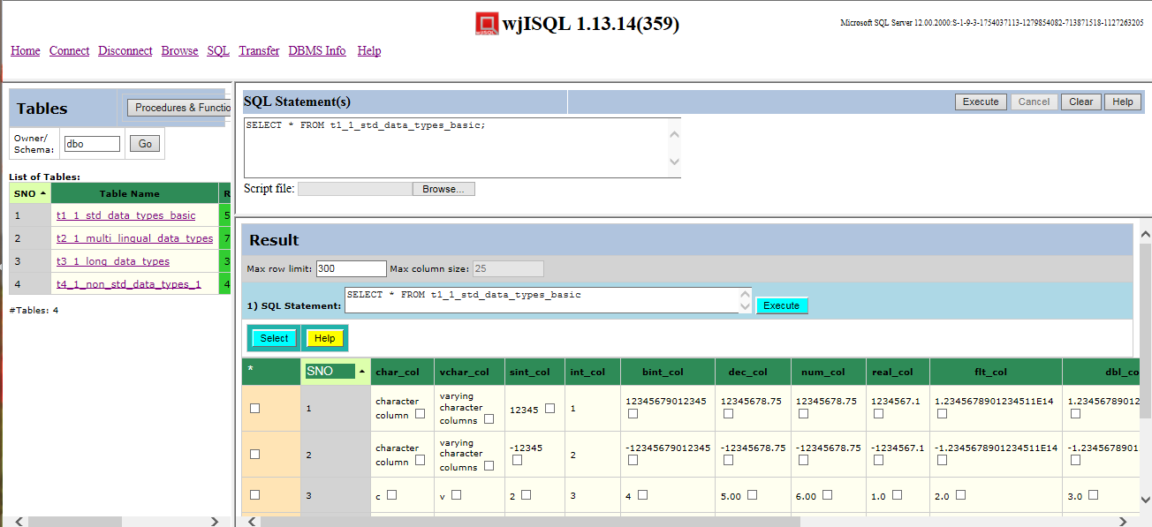

Test Status:
Platform | wjISQL | Date | Status | Remarks
Ubuntu 16.04 LTS
Windows 7  IE 11.0 | 1.19.5(439) | 2017-10-27 | Success

Test Case 2/35: Test Execution of Stored Procedure
Test Prerequisites:
1 | Test Case 1

Test Procedure
1 | Click button Clear.
2 | Write the following statement in window SQL Statement(s):  CALL proc_4_1_in_out_args(1, ?);
3 | Click button Execute

Test Expected o/p:
1 | Procedure execution results as shown below:  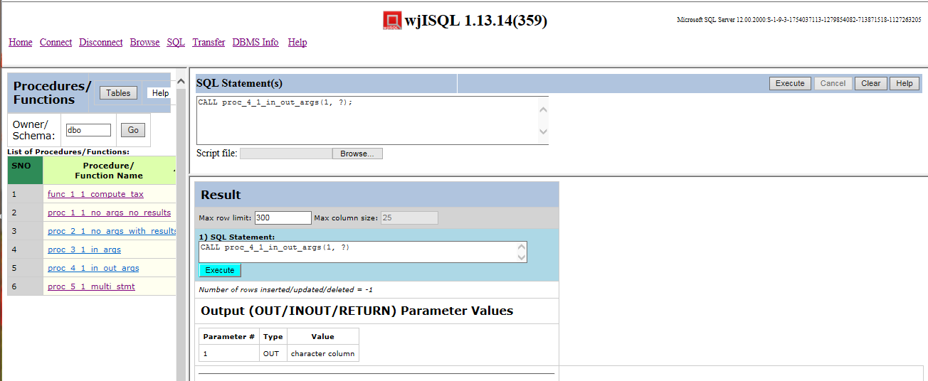

Test Status:
Platform | wjISQL | Date | Status | Remarks
Ubuntu 16.04 LTS
Windows 7  IE 11.0 | 1.19.5(439) | 2017-10-27 | Success

Test Case 3/36: Test Execution of Stored Function
Test Prerequisites:
1 | Test Case 1

Test Procedure
1 | Click button Clear.
2 | Write the following statement in window SQL Statement(s):  SELECT dbo.func_1_1_compute_tax(1);
3 | Click button Execute

Test Expected o/p:
1 | Function results as shown below:  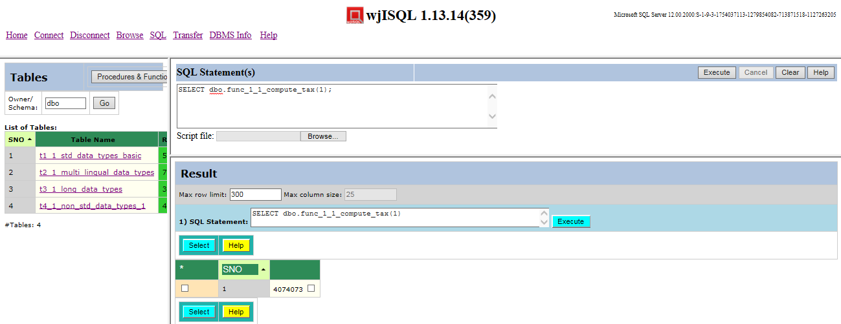

Test Status:
Platform | wjISQL | Date | Status | Remarks
Ubuntu 16.04 LTS
Windows 7  IE 11.0 | 1.19.5(439) | 2017-10-27 | Success

Test Case 4/37: Test Execution of multiple statements at one time
Test Prerequisites:
1 | Test Case 1

Test Procedure
1 | Click button Clear.
2 | Write the following statements in the window SQL Statement(s) (or copy and paste from scripts source directory):  DROP TABLE emp;  DROP TABLE dept;  CREATE TABLE dept (dno INT NOT NULL PRIMARY KEY  , dname VARCHAR(20));  CREATE TABLE emp(eno INT NOT NULL PRIMARY KEY  , ename VARCHAR(20), dno INT REFERENCES dept(dno));  INSERT INTO dept(dno, dname) VALUES(1, 'Research');  INSERT INTO dept(dno, dname) VALUES(2, 'Development');  INSERT INTO dept(dno, dname) VALUES(3, 'Marketing');  INSERT INTO emp VALUES(1001, 'Brahma', 1);  INSERT INTO emp VALUES(1002, 'Vishnu', 1);  INSERT INTO emp VALUES(1003, 'Narayana', 2);  INSERT INTO emp VALUES(1004, 'Krishna', 2);  INSERT INTO emp VALUES(1005, 'Narada', 3);  INSERT INTO emp VALUES(1006, 'Hanuman', 3);  SELECT * FROM dept;  SELECT * from emp;
3 | Click button Execute.
4 | Click OK on alert message box for an error messages by DROP statements due to non-existent of tables for the first time.

Test Expected o/p:
1 | Execution results, after scrolling down Result window, are as shown below:  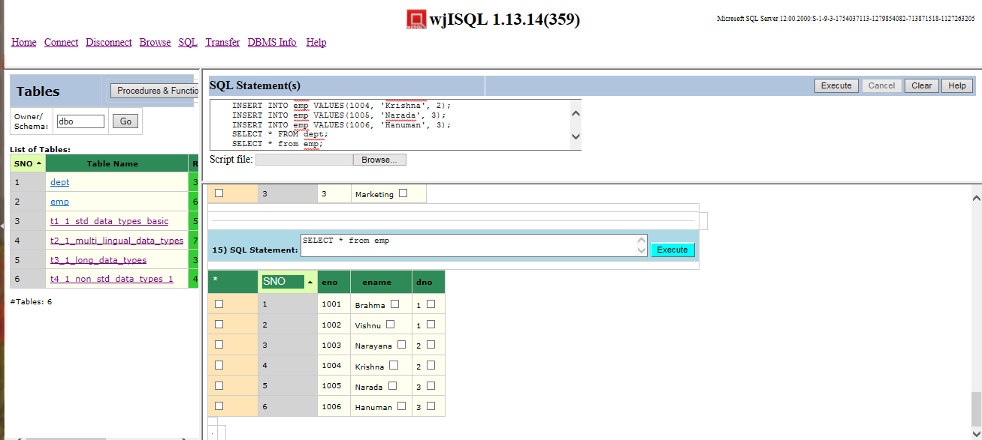

Test Status:
Platform | wjISQL | Date | Status | Remarks
Ubuntu 16.04 LTS
Windows 7  IE 11.0 | 1.19.5(439) | 2017-10-27 | Success

Unsuccessful Test Cases
None.

SQL Statement(s) Window: SQL Script Execution Test Cases

Successful Test Cases
Test Case 1/38: Test execution of a script
Test Prerequisites:
1 | None.

Test Procedure
1 | Click navigation link SQL.
2 | Click button Browse below the SQL Statement(s) window and choose the following file:  wjisql/wji_tsrc/wji_scripts/wji_16_sql_scripts/tst_16_001_sql_script.sql
3 | Click button Execute.

Test Expected o/p:
1 | Loading of SQL statements from the file into SQL Statement(s) window and execution of all statements with results, after scrolling down Result window, are as shown below:  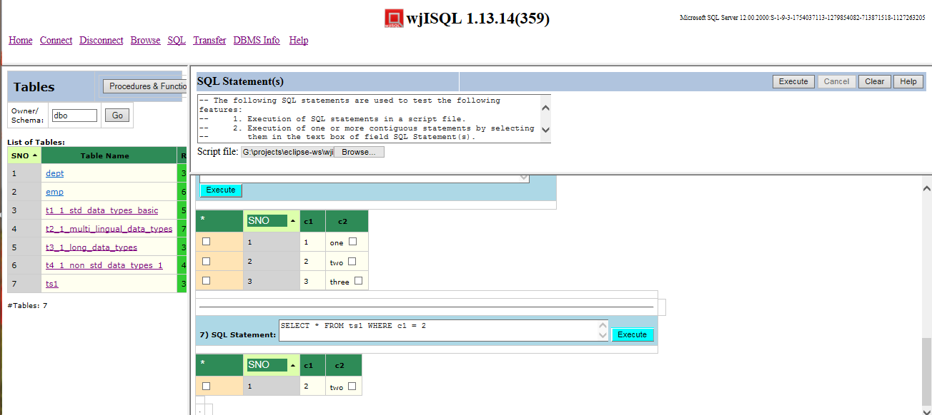

Test Status:
Platform | wjISQL | Date | Status | Remarks
Ubuntu 16.04 LTS
Windows 7  IE 11.0 | 1.19.5(439) | 2017-10-27 | Success

SQL Statement(s) Window: Selected Statements Execution Test Cases

Successful Test Cases
Test Case 1/39: Test execution of an SQL statement selected in SQLStatement(s) window.
Test Prerequisites:
1 | None

Test Procedure
1 | Click navigation link SQL.
2 | Click button Browse below the SQL Statement(s) window and choose the following file:  wjisql/wji_tsrc/wji_scripts/wji_16_sql_scripts/tst_16_001_sql_script.sql
3 | Select the first SQL statement: as shown below:  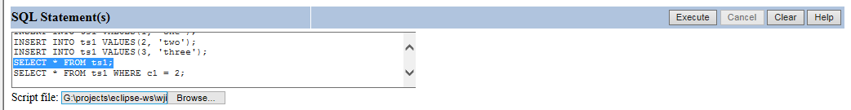  The file path may vary; ignore it.
4 | Click button Execute.

Test Expected o/p:
1 | Loading of SQL statements from the file into SQL Statement(s) window and execution of all statements with results as shown below:

Test Status:
Platform | wjISQL | Date | Status | Remarks
Ubuntu 16.04 LTS
Windows 7  IE 11.0 | 1.19.5(439) | 2017-10-27 | Success

Test Case 2/40: Test execution of consecutive multiple SQL statements selected in SQLStatement(s) window.
Test Prerequisites:
1 | Test Case 1

Test Procedure
1 | Add new SQL statement above first SELECT statement as following:  INSERT INTO ts1 VALUES(4, 'four');
2 | Select the last 3 SQL statements including the new one: as shown below:  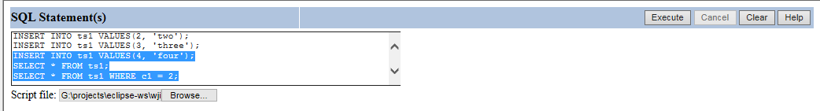  The file path may vary; ignore it.
3 | Click button Execute.

Test Expected o/p:
1 | Result window that shows exwecution of the three select statements:

Test Status:
Platform | wjISQL | Date | Status | Remarks
Ubuntu 16.04 LTS
Windows 7  IE 11.0 | 1.19.5(439) | 2017-10-27 | Success

SQLite SQL Statement Execution Chrome Test Cases

Prerequisites

1 | Linux: SQLite database /tmp/sqlitedb is readly available for use.  Windows: SQLite database C:/TEMP/sqlitedb is readily available for use.
2 | You have already logged into the database.
3 | Database setup was done as mentioned in wpl.tpl.05.browse.docx

SQL Menu Item Test Cases

Successful Test Cases

Test Case 1/41: Test that SQL menu item displays current tables, a window "SQL Statement(s)" to execute statements and an empty window.
Test Prerequisites:
1 | None.

Test Procedure
1 | Click button SQL.

Test Expected o/p:
1 | A screen as shown below:  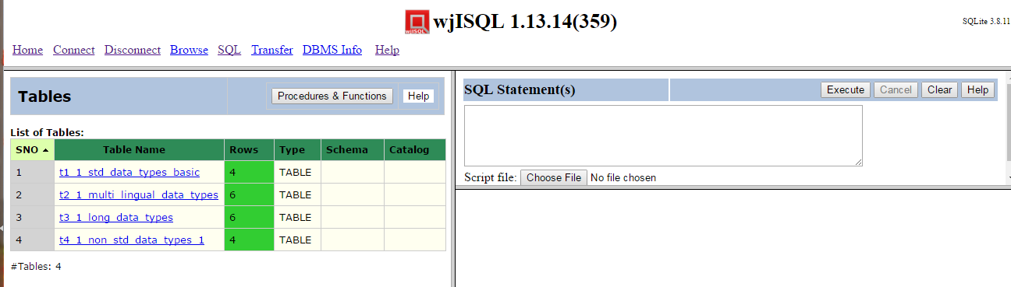

Test Status:
Platform | wjISQL | Date | Status | Remarks
Ubuntu 16.04 LTS | 1.17.5(419) | 2017-10-11 | Success
Windows 7  Chrome 61.0 | 1.19.5(439) | 2017-10-27 | Success

Unsuccessful Test Cases
None.

SQL Statement(s) Window: SQL statement Execution Test Cases

Successful Test Cases
Test Case 1/42: Test execution of simple SELECT statment as following:
Test Prerequisites:
1 | None

Test Procedure
1 | Enter statement "SELECT * FROM t1_1_std_data_types_basic;" in window SQLStatement(s)
2 | Click button Execute.

Test Expected o/p:
1 | Screen with results as shown below:  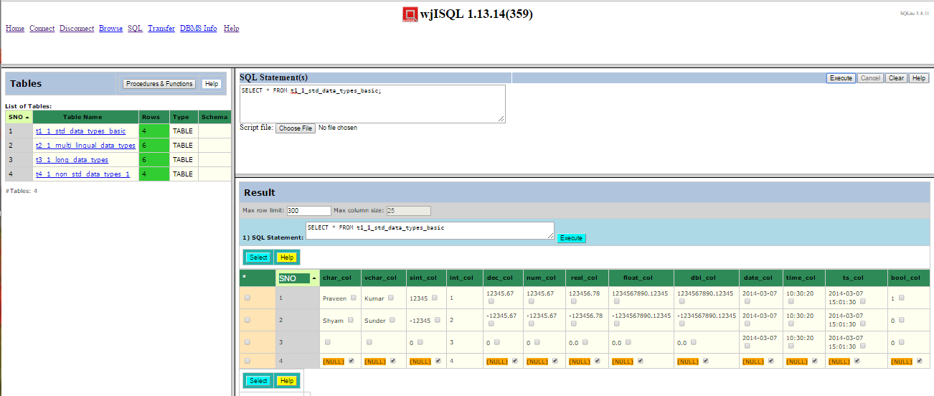

Test Status:
Platform | wjISQL | Date | Status | Remarks
Ubuntu 16.04 LTS | 1.17.5(419) | 2017-10-11 | Success
Windows 7  Chrome 61.0 | 1.19.5(439) | 2017-10-27 | Success

Test Case 2/43: Test Execution of Stored Procedure
SQLite does not support stored procedures.

Test Case 3/44: Test Execution of Stored Function
SQLite does not support stored functions.

Test Case 4/45: Test Execution of multiple statements at one time
Test Prerequisites:
1 | Test Case 1

Test Procedure
1 | Click button Clear.
2 | Write the following statements in the window SQL Statement(s) (or copy and paste from scripts source directory):  DROP TABLE emp;  DROP TABLE dept;  CREATE TABLE dept (dno INT NOT NULL PRIMARY KEY  , dname VARCHAR(20));  CREATE TABLE emp(eno INT NOT NULL PRIMARY KEY  , ename VARCHAR(20), dno INT REFERENCES dept(dno));  INSERT INTO dept(dno, dname) VALUES(1, 'Research');  INSERT INTO dept(dno, dname) VALUES(2, 'Development');  INSERT INTO dept(dno, dname) VALUES(3, 'Marketing');  INSERT INTO emp VALUES(1001, 'Brahma', 1);  INSERT INTO emp VALUES(1002, 'Vishnu', 1);  INSERT INTO emp VALUES(1003, 'Narayana', 2);  INSERT INTO emp VALUES(1004, 'Krishna', 2);  INSERT INTO emp VALUES(1005, 'Narada', 3);  INSERT INTO emp VALUES(1006, 'Hanuman', 3);  SELECT * FROM dept;  SELECT * from emp;  DROP TABLE emp;  DROP TABLE dept;
3 | Click button Execute.
4 | Click OK on alert message box for an error messages by DROP statements due to non-existent of tables for the first time.

Test Expected o/p:
1 | Execution results, after scrolling down Result window, are as shown below:

Test Status:
Platform | wjISQL | Date | Status | Remarks
Ubuntu 16.04 LTS | 1.17.5(419) | 2017-10-11
Windows 7  Chrome 61.0 | 1.19.5(439) | 2017-10-27 | Success

Unsuccessful Test Cases
None.

SQL Statement(s) Window: SQL Script Execution Test Cases

Successful Test Cases
Test Case 1/46: Test execution of a script
Test Prerequisites:
1 | None.

Test Procedure
1 | Click navigation link SQL.
2 | Click button Browse below the SQL Statement(s) window and choose the following file:  wjisql/wji_tsrc/wji_scripts/wji_16_sql_scripts/tst_16_001_sql_script.sql
3 | Click button Execute.

Test Expected o/p:
1 | Loading of SQL statements from the file into SQL Statement(s) window and execution of all statements with results, after scrolling down Result window, are as shown below:

Test Status:
Platform | wjISQL | Date | Status | Remarks
Ubuntu 16.04 LTS | 1.17.5(419) | 2017-10-11
Windows 7  Chrome 61.0 | 1.19.5(439) | 2017-10-27 | Success

SQL Statement(s) Window: Selected Statements Execution Test Cases

Successful Test Cases
Test Case 1/47: Test execution of an SQL statement selected in SQLStatement(s) window.
Test Prerequisites:
1 | None

Test Procedure
1 | Click navigation link SQL.
2 | Click button Browse below the SQL Statement(s) window and choose the following file:  wjisql/wji_tsrc/wji_scripts/wji_16_sql_scripts/tst_16_001_sql_script.sql
3 | Select the first SQL statement: as shown below:  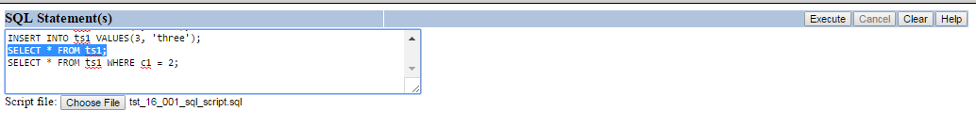
4 | Click button Execute.

Test Expected o/p:
1 | Loading of SQL statements from the file into SQL Statement(s) window and execution of all statements with results as shown below:

Test Status:
Platform | wjISQL | Date | Status | Remarks
Ubuntu 16.04 LTS | 1.17.5(419) | 2017-10-11 | Success
Windows 7  Chrome 61.0 | 1.19.5(439) | 2017-10-27 | Success

Test Case 2/48: Test execution of consecutive multiple SQL statements selected in SQLStatement(s) window.
Test Prerequisites:
1 | Test Case 1

Test Procedure
1 | Add new SQL statement above first SELECT statement as following:  INSERT INTO ts1 VALUES(4, 'four');
2 | Select the last 3 SQL statements including the new one: as shown below:  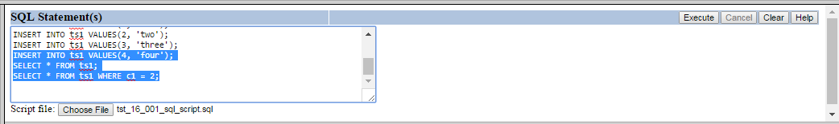
3 | Click button Execute.

Test Expected o/p:
1 | Result window that shows exwecution of the three select statements:

Test Status:
Platform | wjISQL | Date | Status | Remarks
Ubuntu 16.04 LTS | 1.17.5(419) | 2017-10-11 | Success
Windows 7  Chrome 61.0 | 1.19.5(439) | 2017-10-27 | Success

