wjISQL 1.19.5

Result Window Test Plan

Change History
SNO | Version | Date | By | Description
1 | 1 | 2016-12-25 | Mvsagar | Created.

Table of Contents
1 Introduction 1
1.1 Prerequisites for all Tests 1
2 MySQL Database Test Cases 1
2.1 Prerequisites 1
2.2 Result Window Test Cases 2
2.2.1 Successful Test Cases 2
3 PostgreSQL Database Connection and Disconnection Test Cases 6
4 Oracle Database Connection and Disconnection Test Cases 6
5 MS SQL Database Connection and Disconnection Test Cases 6
6 SQLite Database Connection and Disconnection Test Cases 6

Introduction
This test plan has test cases for testing functionality available in Result window displayed when an SQL statement is executed.

Prerequisites for all Tests

1 | Installation test is successful.
2 | Main screen is of wjISQL is currently shown in the browser. Otherwise, enter "http://localhost:8080/wjisql" in the browser address field.

MySQL Database Test Cases
Not essential. Add testcases later if required.

MariaDB Database Test Cases

Prerequisites

1 | MySQL database mysqldb is readily available for user mysqlusr and password mysql123. The user has DBA privileges.
2 | You have already logged into the database.
3 | Database setup was done as mentioned in wji.tpl.05.browse.docx
4 | SQL Statement(s) window is visibile.
5 | Tables emp and dept with data already exist. Otherwise, load script:  wjisql/wji_tsrc/wji_scripts/wji_16_sql_scripts/tst_16_002_sql_script_deptemp.sql

Result Window Test Cases

Successful Test Cases
Test Case 1/1: Test execution of simple SELECT statment as following:
Test Prerequisites:
1 | None

Test Procedure
1 | Enter statement "SELECT * FROM emp;" in window SQLStatement(s)
2 | Click button Execute.

Test Expected o/p:
1 | Result window as shown below:  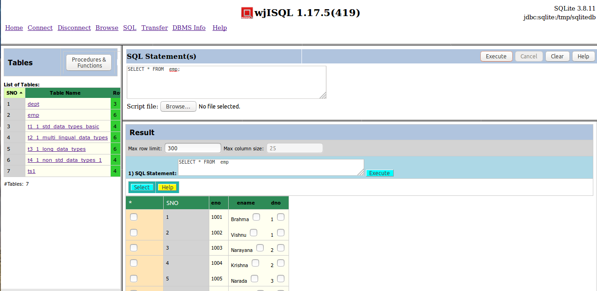

Test Status:
Platform | wjISQL | Date | Status | Remarks
Ubuntu 16.04 LTS  FireFox | 1.17.5(419) | 2017-10-11 | Success
Windows 7

Test Case 2/2: Test limiting of rows using limit specified in field Max row limit and executing it using button Execute.
Test Prerequisites:
1 | Test Case 1

Test Procedure
1 | Entet value 4 in the field Max row limit.
2 | Click button Execute of Result window.

Test Expected o/p:
1 | A warining as shown below:  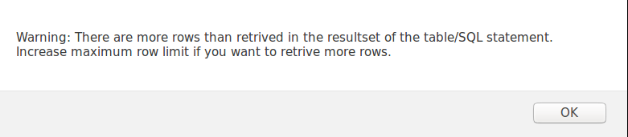  and 4 rows as shown below with a warning saying there are more rows to be retrieved:  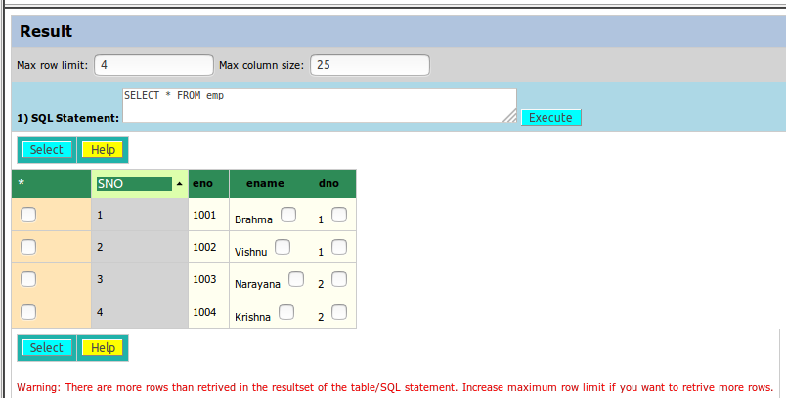

Test Status:
Platform | wjISQL | Date | Status | Remarks
Ubuntu 16.04 LTS  FireFox | 1.17.5(419) | 2017-10-11 | Success
Windows 7

Test Case 3/3: Test limiting of rows using limit specified in field Max row limit and executing it using button Select.
Test Prerequisites:
1 | Test Case 2

Test Procedure
1 | Enter value 2 in the field Max row limit.
2 | Click button Select of Result window.

Test Expected o/p:
1 | A warining as shown below:  and 2 rows as shown below with a warning saying there are more rows to be retrieved:  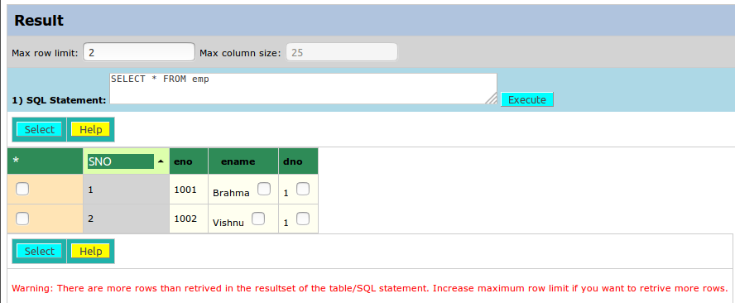

Test Status:
Platform | wjISQL | Date | Status | Remarks
Ubuntu 16.04 LTS  FireFox | 1.17.5(419) | 2017-10-11 | Success
Windows 7

Test Case 4/4: Test help available in the Result Window
Test Prerequisites:
1 | A SELECT stmt was already executed

Test Procedure
1 | Click button Help of Result window.

Test Expected o/p:
1 | New help tab as shown below:  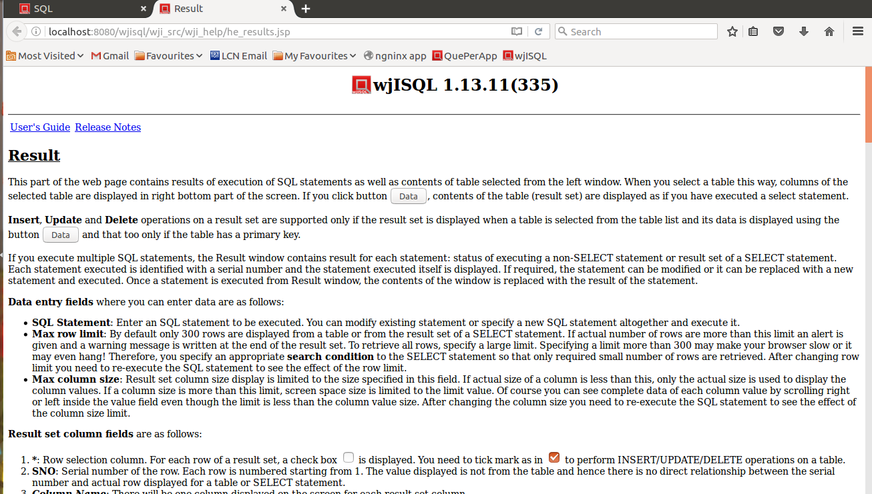

Post Test Procedure
1 | Close the new help tab "Result" of the browser.

Test Status:
Platform | wjISQL | Date | Status | Remarks
Ubuntu 16.04 LTS  FireFox | 1.17.5(419) | 2017-10-11 | Success
Windows 7

PostgreSQL Database Connection and Disconnection Test Cases

Not essential. Add testcases later if required.

Oracle Database Connection and Disconnection Test Cases

Not essential. Add testcases later if required.

MS SQL Database Connection and Disconnection Test Cases

Not essential. Add testcases later if required.

SQLite Database Connection and Disconnection Test Cases

Not essential. Add testcases later if required.

