wjISQL

Table Result Window Test Plan

Change History
SNO | Version | Date | By | Description
1 | 1 | 2016-12-25 | Mvsagar | Created.
2 | 2 | 2019-08-04 | Mvsagar | Moidified to suit auomated tests.

Table of Contents
1 Introduction 2
1.1 Prerequisites for all Tests 2
2 MySQL Database Test Cases 2
2.1 Prerequisites 2
2.2 Primary Key Identification Test Cases 3
2.2.1 Successful Test Cases 3
2.3 Data Insertion Test Cases 4
2.3.1 Successful Test Cases 4
2.3.2 Unsuccessful Test Cases 5
2.4 Data Updating Test Cases 6
2.4.1 Successful Test Cases 6
2.4.2 Unsuccessful Test Cases 7
2.5 Data Deletion Test Cases 8
2.5.1 Successful Test Cases 8
2.5.2 Unsuccessful Test Cases 9
2.6 Row Selection Clearing Test Cases 10
2.6.1 Successful Test Cases 10
2.7 Help Test Cases 11
2.7.1 Successful Test Cases 11
2.8 Button Select Test Cases 12
2.8.1 Successful Test Cases 12
3 MariaDB Database Test Cases 12
3.1 Prerequisites 12
3.2 Primary Key Identification Test Cases 13
3.2.1 Successful Test Cases 13
3.3 Data Insertion Test Cases 14
3.3.1 Successful Test Cases 14
3.3.2 Unsuccessful Test Cases 15
3.4 Data Updating Test Cases 16
3.4.1 Successful Test Cases 16
3.4.2 Unsuccessful Test Cases 17
3.5 Data Deletion Test Cases 18
3.5.1 Successful Test Cases 18
3.5.2 Unsuccessful Test Cases 19
3.6 Row Selection Clearing Test Cases 20
3.6.1 Successful Test Cases 20
3.7 Help Test Cases 21
3.7.1 Successful Test Cases 21
3.8 Button Select Test Cases 21
3.8.1 Successful Test Cases 21
3.9 Button Delete All Test Cases 22
3.9.1 Successful Test Cases 22
3.9.2 Unsuccessful Test Cases 23
3.10 Button Cancel Test Case 23
3.10.1 Successful Test Cases 23
3.11 Button Back Test Cases 26
3.11.1 Successful Test Cases 26
3.11.2 Unsuccessful Test Cases 26
4 PostgreSQL Database Test Cases 26
4.1 Prerequisites 26
5 Oracle Database Test Cases 27
5.1 Prerequisites 27
6 MSSQL Database Test Cases 27
6.1 Prerequisites 27
7 SQLite Database Test Cases 27
7.1 Prerequisites 27

Introduction
Tests of this test plan test functionality available in Result window displayed when button Data in table properties window is clicked. This result window allows user to insert data into the table, update existing data in the table and delete the data from the table.

Note:- PostgreSQL tests have a few more tests compared to other database test cases. These test cases test insertion and updating of NULL values in columns. Add these test cases for other databases in future.

Prerequisites for all Tests

1 | Installation test is successful.
2 | Main screen is of wjISQL is currently shown in the browser. Otherwise, enter "http://localhost:8080/wjisql" in the browser address field.

MySQL Database Test Cases

Prerequisites

1 | MySQL database mysqldb is readily available for user mysqlusr and password mysql123. The user has DBA privileges.
2 | You have already logged into the database.
3 | Database setup was done as mentioned in wpl.tpl.05.browse.docx
4 | SQL Statement(s) window is visibile.
5 | Tables emp and dept with data already exist. Otherwise, load script:  wjisql/wji_tsrc/wji_scripts/wji_16_sql_scripts/tst_16_002_sql_script_deptemp.sql

Primary Key Identification Test Cases

Successful Test Cases
Test Case 1/1: Test that primary key column is displayed in orange color.
Test Prerequisites:
1 | None

Test Procedure
1 | Click table emp in the left side button
2 | Click button Data in table properties window.

Test Expected o/p:
1 | Result window with primary key column eno and its data are shown in orange color:  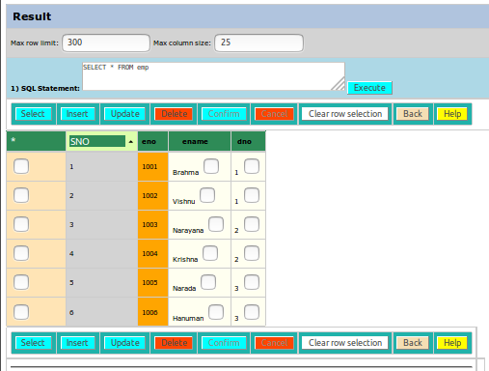

Test Status:
Platform | wjISQL | Date | Status | Remarks
Ubuntu 16.04 LTS  FireFox | 1.17.5(419) | 2017-10-11 | Success
Windows 7

Test Case 2/2: Test that all columns of a multi-column primary key are displayed in orange color.
Test Prerequisites:
1 | None.

Test Procedure
1 | Execute the following script:  wjisql/wji_tsrc/wji_scripts/wji_16_sql_scripts/tst_16_003_sql_script_keysindexes.sql
2 | Click on the newly created table questions.
3 | Click button Data in the table properies window.

Test Expected o/p:
1 | Result window with data of the table with all 5 primary key columns shown in orange color:  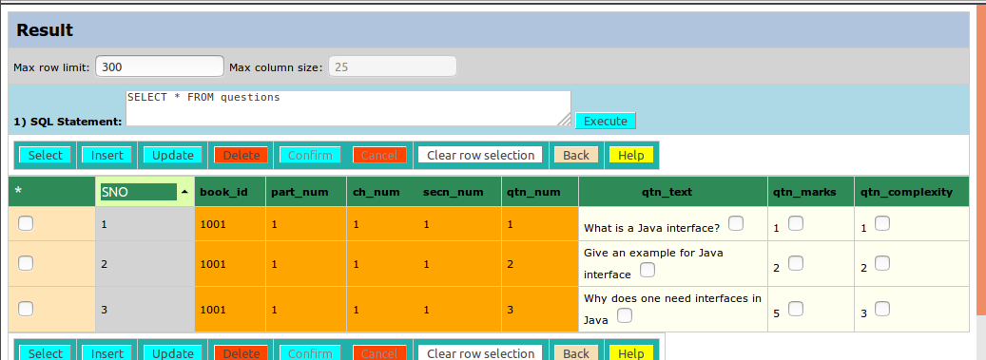

Test Status:
Platform | wjISQL | Date | Status | Remarks
Ubuntu 16.04 LTS  FireFox | 1.17.5(419) | 2017-10-11 | Success
Windows 7

Data Insertion Test Cases

Successful Test Cases
Test Case 1/3: Test insertion of a row into a table.
Test Prerequisites:
1 | Result window with data of the table questions is active.

Test Procedure
1 | Click button insert.
2 | Enter data in the displayed empty row of the table:  1001, 1, 1, 2, 1, Give an example of implementing an interface., 3, 3
3 | Click button confirm.

Test Expected o/p:
1 | Result window with newly inserted row displayed as 4th row:  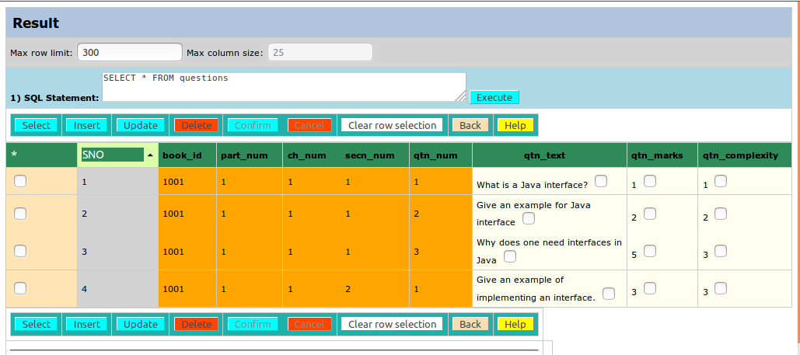

Test Status:
Platform | wjISQL | Date | Status | Remarks
Ubuntu 16.04 LTS  FireFox | 1.17.5(419) | 2017-10-11 | Success
Windows 7

Unsuccessful Test Cases
Test Case 1/4: Test insertion of a row with incompatible values into a table.
Test Prerequisites:
1 | Result window with data of the table questions is active.

Test Procedure
1 | Click button insert.
2 | Enter data in the displayed empty row of the table:  1001, xyz, 1, 2, 1, abc, 3, 3
3 | Click button confirm.

Test Expected o/p:
1 | Display of an error message window and control back to Result window with previous. rows intact:  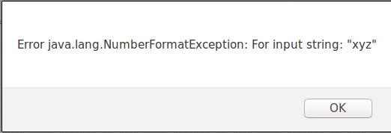

Test Status:
Platform | wjISQL | Date | Status | Remarks
Ubuntu 16.04 LTS  FireFox | 1.17.5(419) | 2017-10-11 | Success
Windows 7

Data Updating Test Cases

Successful Test Cases
Test Case 1/5: Test updating of a row into a table.
Test Prerequisites:
1 | Result window with data of the table questions is active.

Test Procedure
1 | Click check box of row 4.
2 | Click button update.
3 | Enter value 6 in cell of column qtn_marks and row 4.
4 | Click button confirm.

Test Expected o/p:
1 | Result window with qtn_marks updated with value 6 for row 4:  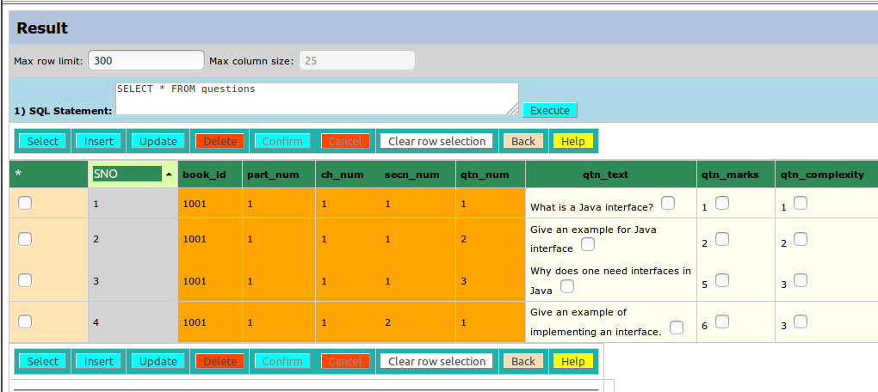

Test Status:
Platform | wjISQL | Date | Status | Remarks
Ubuntu 16.04 LTS  FireFox | 1.17.5(419) | 2017-10-11 | Success
Windows 7

Unsuccessful Test Cases
Test Case 1/6: Test updating of a row with character value for question complexity.
Test Prerequisites:
1 | Result window with data of the table questions is active.

Test Procedure
1 | Click check box of row 1.
2 | Click button update.
3 | Enter value A in cell of column qtn_complexity and row 1.
4 | Click button confirm.

Test Expected o/p:
1 | An error message window as shown below and control back to the table data after clicking button OK:  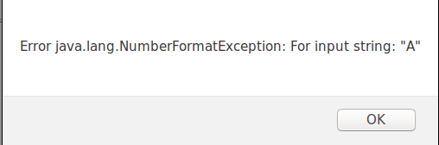

Test Status:
Platform | wjISQL | Date | Status | Remarks
Ubuntu 16.04 LTS  FireFox | 1.17.5(419) | 2017-10-11 | Success
Windows 7

Data Deletion Test Cases

Successful Test Cases
Test Case 1/7: Test deletion of a row from a table.
Test Prerequisites:
1 | Result window with data of the table questions is active.

Test Procedure
1 | Click check box of row 2.
2 | Click button delete.
3 | Click button confirm.
4 | Click OK button on an alert message window

Test Expected o/p:
1 | Result window with old row deleted:  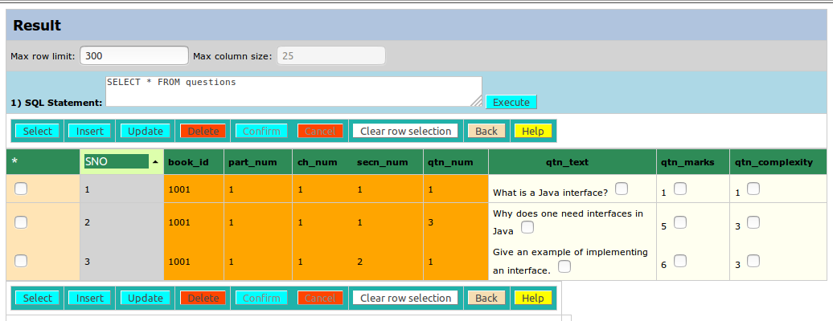

Test Status:
Platform | wjISQL | Date | Status | Remarks
Ubuntu 16.04 LTS  FireFox | 1.17.5(419) | 2017-10-11 | Success
Windows 7

Unsuccessful Test Cases
Test Case 1/8: Test deletion of rows without selecting any row
Test Prerequisites:
1 | Result window with data of the table questions is active.

Test Procedure
1 | Do not select any row.
2 | Click button delete.

Test Expected o/p:
1 | An error message window as shown below and control back to the table data after clicking button OK:  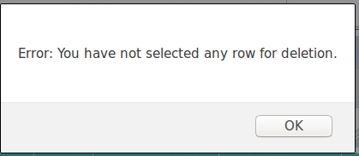

Test Status:
Platform | wjISQL | Date | Status | Remarks
Ubuntu 16.04 LTS  FireFox | 1.17.5(419) | 2017-10-11 | Success
Windows 7

Test Case 1/9: Test cancelation of deletion of a row
Test Prerequisites:
1 | Result window with data of the table questions is active.

Test Procedure
1 | Select 2nd row
2 | Click button delete.
3 | Click button Cancel.

Test Expected o/p:
1 | A warning message window as shown below and control back to the table with original 2nd row data after clicking button OK:  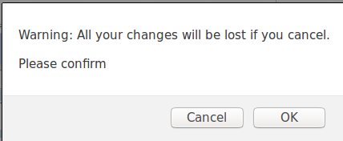

Test Status:
Platform | wjISQL | Date | Status | Remarks
Ubuntu 16.04 LTS  FireFox | 1.17.5(419) | 2017-10-11 | Success
Windows 7

Row Selection Clearing Test Cases

Successful Test Cases
Test Case 1/10: Test clearing of selected rows
Test Prerequisites:
1 | Result window with data of the table questions is active.

Test Procedure
1 | Click check box of row 1 and 2.
2 | Click button Clear row selection.

Test Expected o/p:
1 | Result window with data with row selection cleared.

Test Status:
Platform | wjISQL | Date | Status | Remarks
Ubuntu 16.04 LTS  FireFox | 1.17.5(419) | 2017-10-11 | Success
Windows 7

Help Test Cases

Successful Test Cases
Test Case 1/11: Test display of help for the table data
Test Prerequisites:
1 | Result window with data of the table questions is active.

Test Procedure
1 | Click button Help.

Test Expected o/p:
1 | A new browser tab containing help:  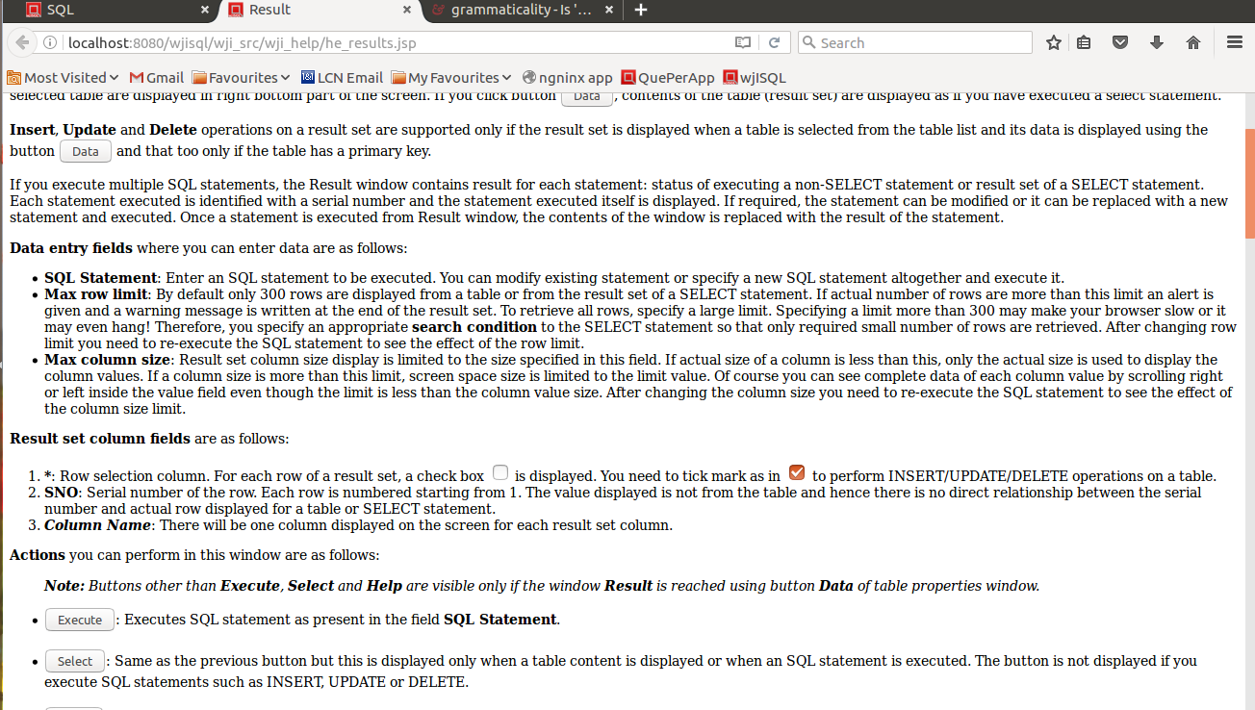

Test Status:
Platform | wjISQL | Date | Status | Remarks
Ubuntu 16.04 LTS  FireFox | 1.17.5(419) | 2017-10-11 | Success
Windows 7

Button Select Test Cases

Successful Test Cases
Test Case 1/12: Test that button Select executes SELECT statement on the table and key column color is lost
Test Prerequisites:
1 | Result window with data of the table questions is active.

Test Procedure
1 | Click button Select.

Test Expected o/p:
1 | Table data as before but without data insert/update/delete related buttons and without orange color on table key columns:  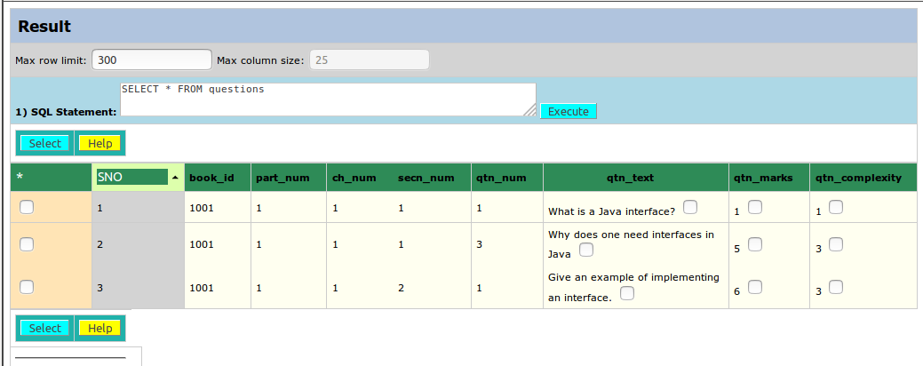

Test Status:
Platform | wjISQL | Date | Status | Remarks
Ubuntu 16.04 LTS  FireFox | 1.17.5(419) | 2017-10-11 | Success
Windows 7

MariaDB Database Test Cases

Prerequisites

1 | MariaDB database mariadb is readily available for user mariausr and password maria123. The user has DBA privileges.
2 | You have already logged into the database.
3 | Database setup was done as mentioned in wpl.tpl.05.browse.docx
4 | SQL Statement(s) window is visibile.
5 | Tables emp and dept with data already exist. Otherwise, load script:  wjisql/wji_tsrc/wji_scripts/wji_16_sql_scripts/tst_16_002_sql_script_deptemp.sql

Primary Key Identification Test Cases

Successful Test Cases
Test Case 1/13: Test that primary key column is displayed in orange color.
Test Prerequisites:
1 | None

Test Procedure
1 | Click table emp in the left side button
2 | Click button Data in table properties window.

Test Expected o/p:
1 | Result window with primary key column eno and its data are shown in orange color:

Test Status:
Platform | wjISQL | Date | Status | Remarks
Ubuntu 16.04 LTS  FireFox | 1.17.5(421) | 2017-10-11 | Success
Windows 7

Test Case 2/14: Test that all columns of a multi-column primary key are displayed in orange color.
Test Prerequisites:
1 | None.

Test Procedure
1 | Execute the following script:  wjisql/wji_tsrc/wji_scripts/wji_16_sql_scripts/tst_16_003_sql_script_keysindexes.sql
2 | Click on the newly created table questions.
3 | Click button Data in the table properies window.

Test Expected o/p:
1 | Result window with data of the table with all 5 primary key columns shown in orange color:

Test Status:
Platform | wjISQL | Date | Status | Remarks
Ubuntu 16.04 LTS  FireFox | 1.17.5(421) | 2017-10-11 | Success
Windows 7

Data Insertion Test Cases

Successful Test Cases
Test Case 1/15: Test insertion of a row into a table.
Test Prerequisites:
1 | Result window with data of the table questions is active.

Test Procedure
1 | Click button insert.
2 | Enter data in the displayed empty row of the table:  1001, 1, 1, 2, 1, Give an example of implementing an interface., 3, 3
3 | Click button confirm.

Test Expected o/p:
1 | Result window with newly inserted row displayed as 4th row:

Test Status:
Platform | wjISQL | Date | Status | Remarks
Ubuntu 16.04 LTS  FireFox | 1.17.5(421) | 2017-10-11 | Success
Windows 7

Unsuccessful Test Cases
Test Case 1/16: Test insertion of a row with incompatible values into a table.
Test Prerequisites:
1 | Result window with data of the table questions is active.

Test Procedure
1 | Click button insert.
2 | Enter data in the displayed empty row of the table:  1001, xyz, 1, 2, 1, abc, 3, 3
3 | Click button confirm.

Test Expected o/p:
1 | Display of an error message window and control back to Result window with previous. rows intact:

Test Status:
Platform | wjISQL | Date | Status | Remarks
Ubuntu 16.04 LTS  FireFox | 1.17.5(421) | 2017-10-11 | Success
Windows 7

Data Updating Test Cases

Successful Test Cases
Test Case 1/17: Test updating of a row into a table.
Test Prerequisites:
1 | Result window with data of the table questions is active.

Test Procedure
1 | Click check box of row 3.
2 | Click button update.
3 | Enter value 6 in cell of column qtn_marks and row 3.
4 | Click button confirm.

Test Expected o/p:
1 | Result window with qtn_marks updated with value 6 for row 3:  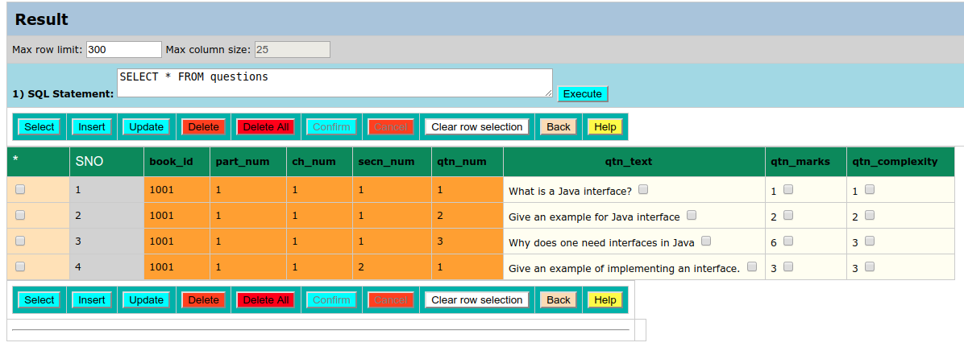

Test Status:
Platform | wjISQL | Date | Status | Remarks
Ubuntu 16.04 LTS  FireFox | 1.17.5(421) | 2017-10-11 | Success
Windows 7

Unsuccessful Test Cases
Test Case 1/18: Test updating of a row with character value for question complexity.
Test Prerequisites:
1 | Result window with data of the table questions is active.

Test Procedure
1 | Click check box of row 1.
2 | Click button update.
3 | Enter value A in cell of column qtn_complexity and row 1.
4 | Click button confirm.

Test Expected o/p:
1 | An error message window as shown below and control back to the table data after clicking button OK:

Test Status:
Platform | wjISQL | Date | Status | Remarks
Ubuntu 16.04 LTS  FireFox | 1.17.5(421) | 2017-10-11 | Success
Windows 7

Data Deletion Test Cases

Successful Test Cases
Test Case 1/19: Test deletion of a row from a table.
Test Prerequisites:
1 | Result window with data of the table questions is active.

Test Procedure
1 | Click check box of row 2.
2 | Click button delete.
3 | Click button confirm.
4 | Click OK button on an alert message window

Test Expected o/p:
1 | Result window with old row deleted:

Test Status:
Platform | wjISQL | Date | Status | Remarks
Ubuntu 16.04 LTS  FireFox | 1.17.5(421) | 2017-10-11 | Success
Windows 7

Unsuccessful Test Cases
Test Case 1/20: Test deletion of rows without selecting any row
Test Prerequisites:
1 | Result window with data of the table questions is active.

Test Procedure
1 | Do not select any row.
2 | Click button delete.

Test Expected o/p:
1 | An error message window as shown below and control back to the table data after clicking button OK:

Test Status:
Platform | wjISQL | Date | Status | Remarks
Ubuntu 16.04 LTS  FireFox | 1.17.5(421) | 2017-10-11 | Success
Windows 7

Test Case 2/21: Test cancelation of deletion of a row
Test Prerequisites:
1 | Result window with data of the table questions is active.

Test Procedure
1 | Select 2nd row
2 | Click button delete.
3 | Click button Cancel.

Test Expected o/p:
1 | A warning message window as shown below and control back to the table with original 2nd row data after clicking button OK:

Test Status:
Platform | wjISQL | Date | Status | Remarks
Ubuntu 16.04 LTS  FireFox | 1.17.5(421) | 2017-10-11 | Success
Windows 7

Row Selection Clearing Test Cases

Successful Test Cases
Test Case 1/22: Test clearing of selected rows
Test Prerequisites:
1 | Result window with data of the table questions is active.

Test Procedure
1 | Click check box of row 1 and 2.
2 | Click button Clear row selection.

Test Expected o/p:
1 | Result window with data with row selection cleared.

Test Status:
Platform | wjISQL | Date | Status | Remarks
Ubuntu 16.04 LTS  FireFox | 1.17.5(421) | 2017-10-11 | Success
Windows 7

Help Test Cases

Successful Test Cases
Test Case 1/23: Test display of help for the table data
Test Prerequisites:
1 | Result window with data of the table questions is active.

Test Procedure
1 | Click button Help.

Test Expected o/p:
1 | A new browser tab containing help:

Test Status:
Platform | wjISQL | Date | Status | Remarks
Ubuntu 16.04 LTS  FireFox | 1.17.5(421) | 2017-10-11 | Success
Windows 7

Button Select Test Cases

Successful Test Cases
Test Case 1/24: Test that button Select executes SELECT statement on the table and key column color is lost
Test Prerequisites:
1 | Result window with data of the table questions is active.

Test Procedure
1 | Click button Select.

Test Expected o/p:
1 | Table data as before but without data insert/update/delete related buttons and without orange color on table key columns:

Test Status:
Platform | wjISQL | Date | Status | Remarks
Ubuntu 16.04 LTS  FireFox | 1.17.5(421) | 2017-10-11 | Success
Windows 7

Button Delete All Test Cases

Successful Test Cases
Test Case 1/25: Test deletion of all rows from a table
Test Prerequisites:
1 | Result window with data of the table questions is active.

Test Procedure
1 | Click button Delete All.
2 | Click button confirm.
3 | Click OK button on an alert message window

Test Expected o/p:
1 | Result window with all rows deleted.

Unsuccessful Test Cases
Test Case 1/26: Test Cancellation of deletion of all rows from a table
Test Prerequisites:
1 | Result window with data of the table questions is active.

Test Procedure
1 | Click button Delete All.
2 | Click button confirm.
3 | Click button Cancel on an alert message window.

Test Expected o/p:
1 | Result window with all rows as they were before clicking the Delete All button

Button Cancel Test Case

Successful Test Cases
Test Case 1/27: Test Cancellation of Insert operation.
Test Prerequisites:
1 | Result window with data of the table emp is active.

Test Procedure
1 | Click button insert.
2 | Enter data in the displayed empty row of the table:  1007, Shiva, 1
3 | Click button Cancel.
4 | Click button OK on the displayed pop-up window.

Test Expected o/p:
1 | Original 6 rows in the table

Test Status:
Platform | wjISQL | Date | Status | Remarks

Test Case 2/28: Test Cancelling of Cancellation of Insert operation.
Test Prerequisites:
1 | Result window with data of the table emp is active.

Test Procedure
1 | Click button insert.
2 | Enter data in the displayed empty row of the table:  1007, Shiva, 1
3 | Click button Cancel.
4 | Click button Cancel on the displayed pop-up window.

Test Expected o/p:
1 | Original 6 rows in the table + 1 newly added row.

Test Status:
Platform | wjISQL | Date | Status | Remarks

Test Case 3/29: Test Cancellation of Update operation.
Test Prerequisites:
1 | Result window with data of the table emp is active.

Test Procedure
1 | Click 3 row check box.
2 | Change ename column value to Shiva.
3 | Click button Update.
4 | Click button Cancel.
5 | Click button OK on the displayed pop-up window.

Test Expected o/p:
1 | Original 6 rows in the table without any change to ename column

Test Status:
Platform | wjISQL | Date | Status | Remarks

Test Case 4/30: Test Cancelling of Cancellation of Update operation.
Test Prerequisites:
1 | Result window with data of the table emp is active.

Test Procedure

1 | Click 3 row check box.
2 | Change ename column value to Shiva.
3 | Click button Update.
4 | Click button Cancel.
5 | Click button Cancel on the displayed pop-up window.

Test Expected o/p:
1 | 3rd row fields are still in update mode for further changing values of fields and confirming/cancellation of the update operation

Test Status:
Platform | wjISQL | Date | Status | Remarks

Test Case 5/31: Test Cancellation of Delete operation.
Test Prerequisites:
1 | Result window with data of the table emp is active.

Test Procedure
1 | Click 3rd row check box.
2 | Click button Delete.
3 | Click button Cancel.
4 | Click button OK on the displayed pop-up window.

Test Expected o/p:
1 | Original 6 rows in the table without any change to ename column

Test Status:
Platform | wjISQL | Date | Status | Remarks

Test Case 6/32: Test Cancellation of Delete All operation.
Test Prerequisites:
1 | Result window with data of the table emp is active.

Test Procedure
1 | Click 3rd row check box.
2 | Click button Delete All.
3 | Click button Cancel.
4 | Click button OK on the displayed pop-up window.

Test Expected o/p:
1 | Original 6 rows in the table without any change to ename column

Test Status:
Platform | wjISQL | Date | Status | Remarks

Button Back Test Cases

Successful Test Cases
Test Case 1/33: Test that Back button takes control to Table properties screen
Test Prerequisites:
1 | Result window with data of the table emp is active.

Test Procedure
1 | Click button Back.

Test Expected o/p:
1 | Metadata contain coolumns of the table emp.

Test Status:
Platform | wjISQL | Date | Status | Remarks

Unsuccessful Test Cases
None

PostgreSQL Database Test Cases

Prerequisites

1 | PostgreSQL database pgsqldb is readily available for user pgsqlusr and password pgsql123. The user has DBA privileges.
2 | You have already logged into the database.
3 | Database setup was done as mentioned in wji.tpl.05.browse.docx
4 | SQL Statement(s) window is visibile.
5 | Tables emp and dept with data already exist. Otherwise, load script:  wjisql/wji_tsrc/wji_scripts/wji_16_sql_scripts/tst_16_002_sql_script_deptemp.sql

Test cases used for MariaDB are used for PostgreSQL as well.
Therefore, go to test source directory of MariaDB and run the tests.

Oracle Database Test Cases

Prerequisites

1 | Oracle database oradb is readily available for user orausr and password ora123. The user has DBA privileges.
2 | You have already logged into the database.
3 | Database setup was done as mentioned in wpl.tpl.05.browse.docx
4 | SQL Statement(s) window is visibile.
5 | Tables emp and dept with data already exist. Otherwise, load script:  wjisql/wji_tsrc/wji_scripts/wji_16_sql_scripts/tst_16_002_sql_script_deptemp.sql

Test cases used for MariaDB are used for Oracle Database as well.
Therefore, go to test source directory of MariaDB and run the tests.

MSSQL Database Test Cases

Prerequisites

1 | MS SQL database msqldb is readily available for user msqlusr and password msql123. The user has DBA privileges.
2 | You have already logged into the database.
3 | Database setup was done as mentioned in wpl.tpl.05.browse.docx
4 | SQL Statement(s) window is visibile.
5 | Tables emp and dept with data already exist. Otherwise, load script:  wjisql/wji_tsrc/wji_scripts/wji_16_sql_scripts/tst_16_002_sql_script_deptemp.sql

Test cases used for MariaDB are used for MS SQL Server as well.
Therefore, go to test source directory of MariaDB and run the tests.

SQLite Database Test Cases

Prerequisites

1 | SQLite database C:/TEMP/sqlitedb on windows or /tmp/sqlitedb on Linux machine is readily available (gets created if it does not exist!).
2 | You have already logged into the database.
3 | Database setup was done as mentioned in wpl.tpl.05.browse.docx
4 | SQL Statement(s) window is visibile.
5 | Tables emp and dept with data already exist. Otherwise, load script:  wjisql/wji_tsrc/wji_scripts/wji_16_sql_scripts/tst_16_002_sql_script_deptemp.sql

Test cases used for MariaDB are used for SQLiteas well.
Therefore, go to test source directory of MariaDB and run the tests.

Notes:-
- Some data type unsuccessful/error test cases fail because SQLite allows store text data even in non-numeric data. Added separate save file with extension ".sqlite" for these test cases.

