wjISQL

Data Transfer Test Plan

Change History
SNO | Version | Date | By | Description
1 | 1 | 2016-12-26 | Mvsagar | Created.

Table of Contents
1 Introduction 2
1.1 Prerequisites for all Tests 2
2 MySQL Database Test Cases 3
2.1 Prerequisites 3
2.2 MySQL To MySQL Database Transfer Test Cases 3
2.2.1 Successful Test Cases 3
2.2.2 Unsuccessful Test Cases 8
2.2.3 Post Test Test Cases 11
2.3 MySQL To PostgreSQL Database Transfer Test Cases 11
2.3.1 Successful Test Cases 11
2.3.2 Unsuccessful Test Cases 16
2.3.3 Post Test Test Cases 19
2.4 MySQL To SQLite Database Transfer Test Cases 19
2.4.1 Successful Test Cases 19
2.4.2 Unsuccessful Test Cases 24
2.4.3 Post Test Test Cases 27
2.5 MySQL To MariaDB Database Transfer Test Cases 28
2.5.1 Successful Test Cases 28
2.5.2 Unsuccessful Test Cases 32
2.5.3 Post Test Test Cases 36
3 MariaDB Database Test Cases 36
3.1 Prerequisites 36
3.2 MariaDB To MariaDB Database Transfer Test Cases 36
3.2.1 Successful Test Cases 36
3.2.2 Unsuccessful Test Cases 41
3.2.3 Post Test Test Cases 44
3.3 MariaDB To PostgreSQL Database Transfer Test Cases 44
3.3.1 Successful Test Cases 44
3.3.2 Unsuccessful Test Cases 49
3.3.3 Post Test Test Cases 52
3.4 MariaDB To SQLite Database Transfer Test Cases 52
3.4.1 Successful Test Cases 52
3.4.2 Unsuccessful Test Cases 57
3.4.3 Post Test Test Cases 60
3.5 MariaDB To MySQL Database Transfer Test Cases 61
3.5.1 Successful Test Cases 61
3.5.2 Unsuccessful Test Cases 65
3.5.3 Post Test Test Cases 69
4 PostgreSQL Database Test Cases 69
4.1 PostgreSQL To PostgreSQL Database Transfer Test Cases 69
4.2 PostgreSQL To MariaDB Database Transfer Test Cases 69
4.3 PostgreSQL To SQLite Database Transfer Test Cases 69
4.4 PostgreSQL To MySQL Database Transfer Test Cases 69
4.5 PostgreSQL To MySQL Database Transfer Test Cases 69
4.5.1 Pre Test Test Cases 69
4.5.2 Successful Test Cases 71
4.5.3 Unsuccessful Test Cases 76
4.5.4 Post Test Test Cases 79
5 Oracle Database Test Cases 80
5.1 Oracle To MSSQL Database Transfer Test Cases 80
5.1.1 Pre Test Test Cases 80
5.1.2 Successful Test Cases 82
5.1.3 Unsuccessful Test Cases 86
5.1.4 Post Test Test Cases 89
6 MS SQL Database Test Cases 90
6.1 MSSQL To Oracle Database Transfer Test Cases 90
6.1.1 Pre Test Test Cases 90
6.1.2 Successful Test Cases 92
6.1.3 Unsuccessful Test Cases 95
6.1.4 Post Test Test Cases 98
7 SQLite Database Test Cases 98
7.1 SQLite To SQLite Database Transfer Test Cases 98
7.2 SQLite To MariaDB Database Transfer Test Cases 98
7.3 SQLite To PostgreSQL Database Transfer Test Cases 98
7.4 SQLite To MSSQL Database Transfer Test Cases 98
7.4.1 Pre Test Test Cases 98
7.4.2 Successful Test Cases 100
7.4.3 Unsuccessful Test Cases 104
7.4.4 Post Test Test Cases 107
7.5 SQLite To Oracle Database Transfer Test Cases 108
7.5.1 Pre Test Test Cases 108
7.5.2 Successful Test Cases 110
7.5.3 Unsuccessful Test Cases 113
7.5.4 Post Test Test Cases 116
7.6 SQLite To MySQL Database Transfer Test Cases 117
7.6.1 Pre Test Test Cases 117
7.6.2 Successful Test Cases 119
7.6.3 Unsuccessful Test Cases 123
7.6.4 Post Test Test Cases 125

Introduction
Tests of this test plan test data transfer functionality of wjISQL. Data from one or more tables of a (source) database can be transferred to corresponding tables in another (destination) database managed by the same or another RDBMS.

Prerequisites for all Tests

1 | Installation test is successful.
2 | Main screen is of wjISQL is currently shown in the browser. Otherwise, enter "http://localhost:8080/wjisql" in the browser address field.

MySQL Database Test Cases

Prerequisites

1 | MySQL database mysqldb is readily available for user mysqlusr and password mysql123. The user has DBA privileges.
2 | Database setup was done as mentioned in wpl.tpl.05.browse.docx

MySQL To MySQL Database Transfer Test Cases

Successful Test Cases
Test Case 1/1: Create a destination database and user credentials.
Test Prerequisites:
1 | None

Test Procedure
1 | Connect to MySQL without any database using user root and related password.
2 | Click button SQL.
3 | Create database mysqltmpdb as following:  CREATE DATABASE mysqltmpdb CHARACTER SET=utf8;
4 | Create user and password as following:  CREATE USER 'mysqltmp'@'%' IDENTIFIED BY 'mysqltmp123';
5 | Grant permisions on the database to the user as following:  GRANT ALL ON mysqltmpdb.* TO 'mysqltmp'@'%';
6 | Disconnect
7 | Connect to mysqltmpdb with new user mysqltmp and related password.
8 | Click button SQL.
9 | Execute the following script to create tables without any data:  wjisql/wji_tsrc/wji_scripts/wji_01_basic_mysql_tables/tst_01_002_tables_create_uc.sql

Test Expected o/p:
1 | Successful create of tables in mysqltmpdb:  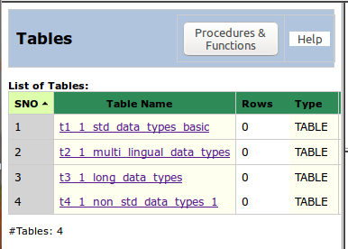

Test Status:
Platform | wjISQL | Date | Status | Remarks
Ubuntu 16.04 LTS  FireFox | 1.17.5(422) | 2017-10-11 | Success

Post Test Actions:
1 | Click button Disconnect to disconnect from mysqltmpdb.

Test Case 2/2: Test Transfer data of tables from database mysqldb to mysqltmpdb
Test Prerequisites:
1 | None.

Test Procedure
1 | Click button Transfer on the main menu.
2 | Connect to source database mysqldb with user mysqlusr and password mysql123.
3 | Connect to destination database mysqltmpdb with user mysqltmp and password mysqltmp123.
4 | Select four tables of source database as shown below:  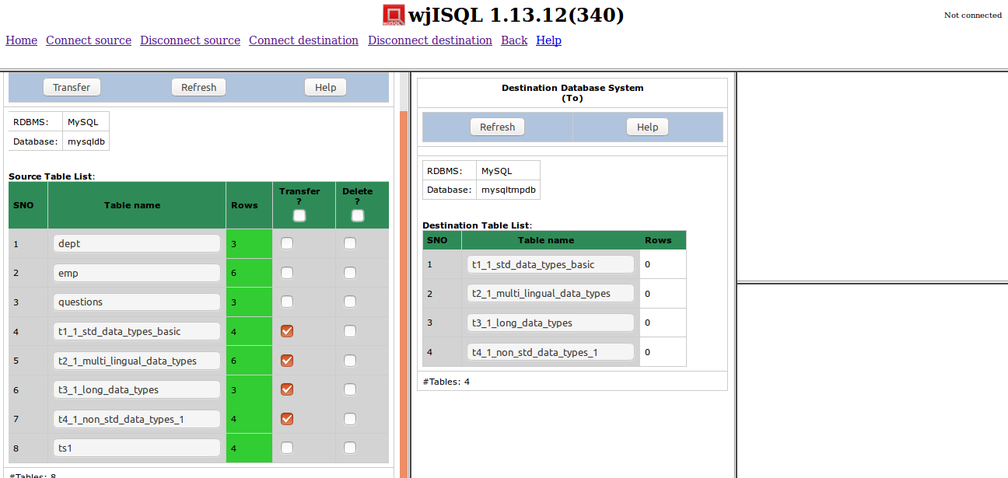
5 | Click button Transfer of source database window.
6 | Confirm OK on a transfer confirmation window.

Test Expected o/p:
1 | A new "Data Transfer and Status" tab of browser with successful data transfer as shown below:  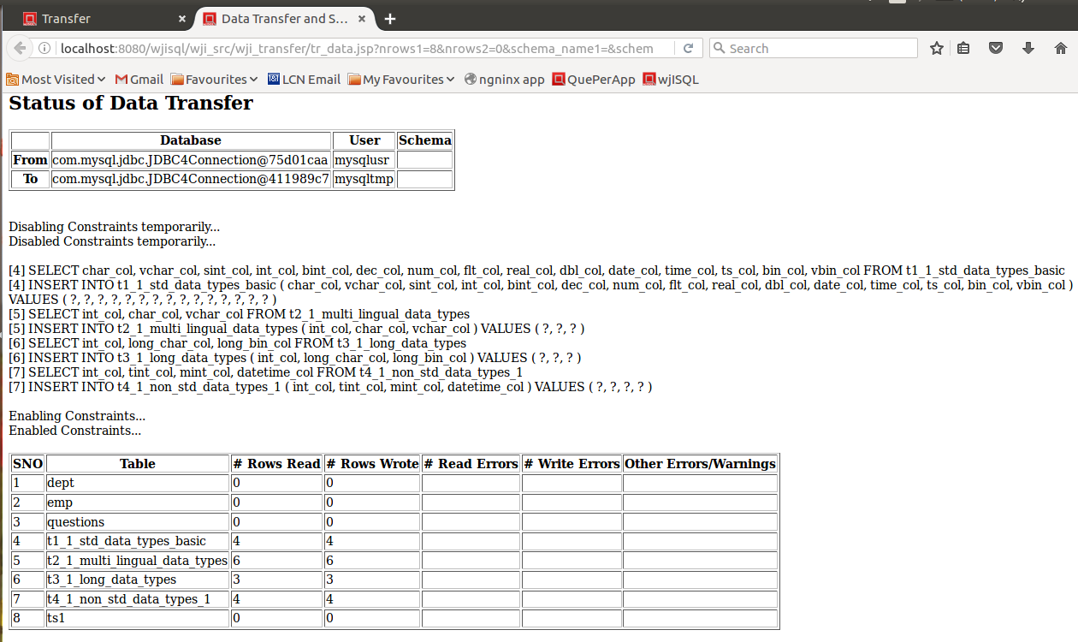

Post Test Actions
1 | Click on table "t1_1_..." in source and destination database table lists.
2 | Click on button Data on right side source and destination table properties windows.
3 | The resultant screen should indicate successfuly transfered number of rows and data as shown below (scroll windows if needed):  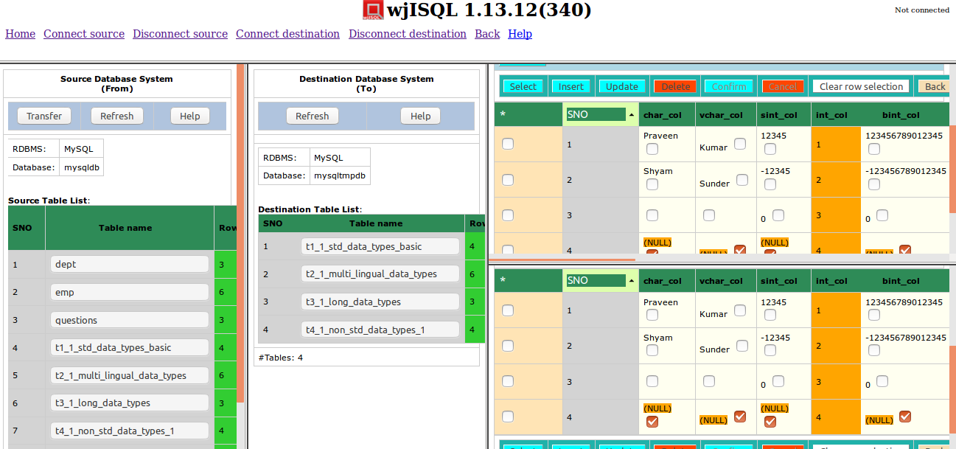

Test Status:
Platform | wjISQL | Date | Status | Remarks
Ubuntu 16.04 LTS  FireFox | 1.17.5(422) | 2017-10-11 | Success

Test Case 3/3: Test Transfer data of a table that does not have all columns of source table but has extra columns in the destination database
Test Prerequisites:
1 | Test Case 2.

Test Procedure
1 | Click on a table, say, t1_1..., in destination table list.
2 | Click button Data on the right bottom window to display the Result window that contains table data.
3 | Enter the following statement in SQL Statement window to create a new table that does not have column dno of source table but has extra columns edob and eexp:  CREATE TABLE emp(eno INT NOT NULL PRIMARY KEY , ename VARCHAR(20), edob DATE, eexp INT DEFAULT 0)
4 | Select table emp of source database for data transfer as shown below:  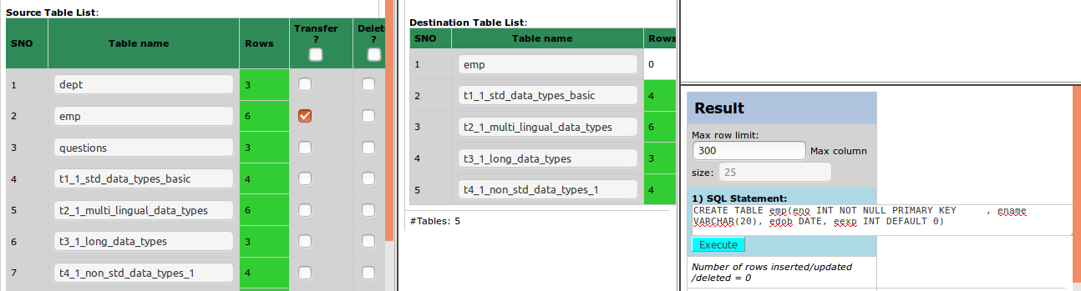
5 | Click button Transfer of source database window.
6 | Confirm OK on a transfer confirmation window.

Test Expected o/p:
1 | A new "Data Transfer and Status" tab of browser with successful data transfer with warnings on non-existing and extra columns in the destination table as shown below:  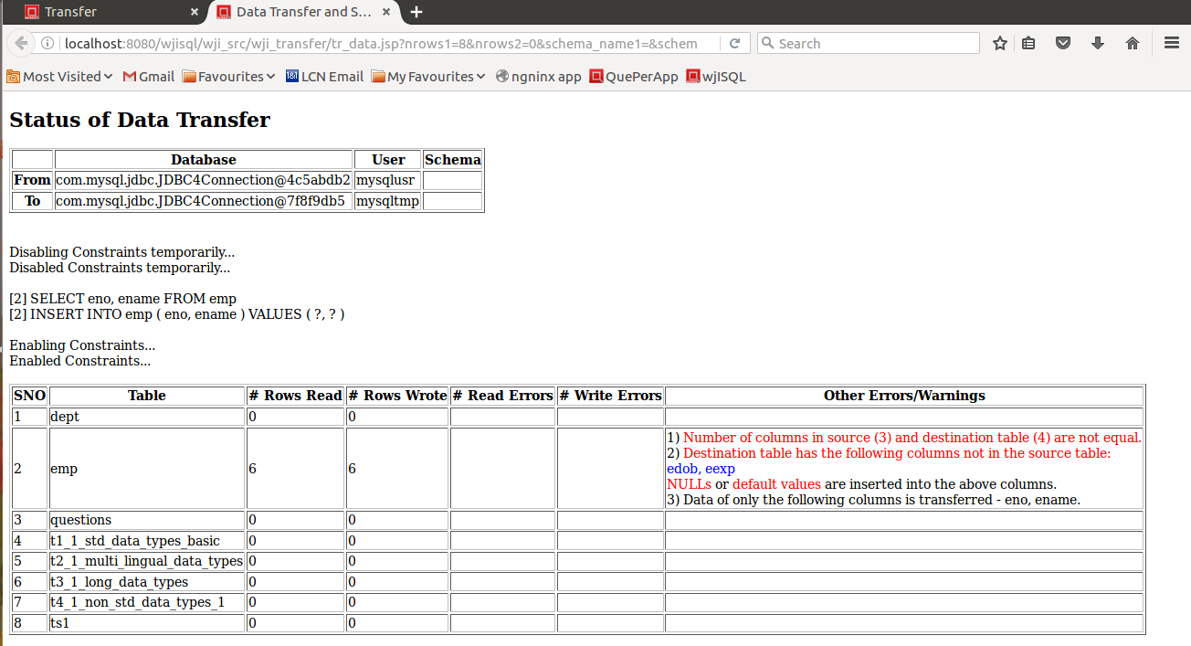

Post Test Actions
1 | Click on table "emp" in source and destination database table lists.
2 | Click on button Data on right side source and destination table properties windows.
3 | The resultant screen should indicate successful transfer of 6 rows of table emp and NULL values for column edob and default value of 0 for column eexp as shown below:  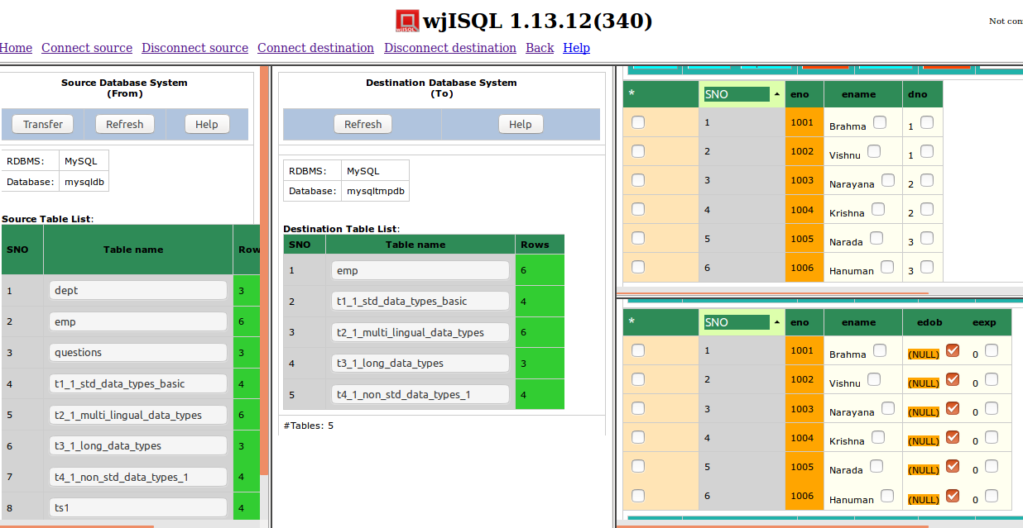

Test Status:
Platform | wjISQL | Date | Status | Remarks
Ubuntu 16.04 LTS  FireFox | 1.17.5(422) | 2017-10-11 | Success

Unsuccessful Test Cases
Test Case 1/4: Test failure of transfer of data of a table not defined in the destination database
Test Prerequisites:
1 | None

Test Procedure
1 | Click button Transfer on the main menu.
2 | Connect to source database mysqldb with user mysqlusr and password mysql123.
3 | Connect to destination database mysqltmpdb with user mysqltmp and password mysqltmp123.
4 | Select table dept of source database as shown below:  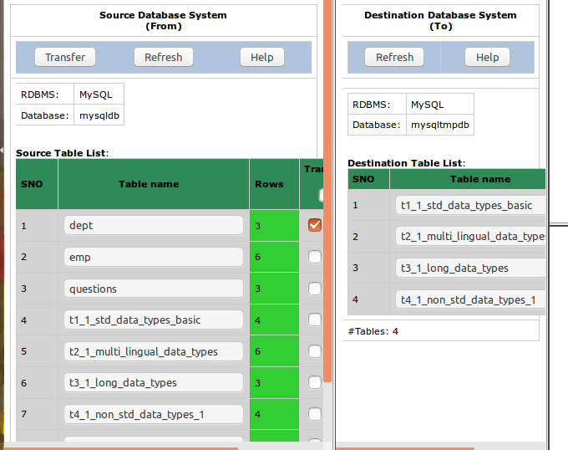
5 | Click button Transfer of source database window.
6 | Confirm OK on a transfer confirmation window.

Test Expected o/p:
1 | A new "Data Transfer and Status" tab of browser with with error message saying the table does not exist in the destination database.  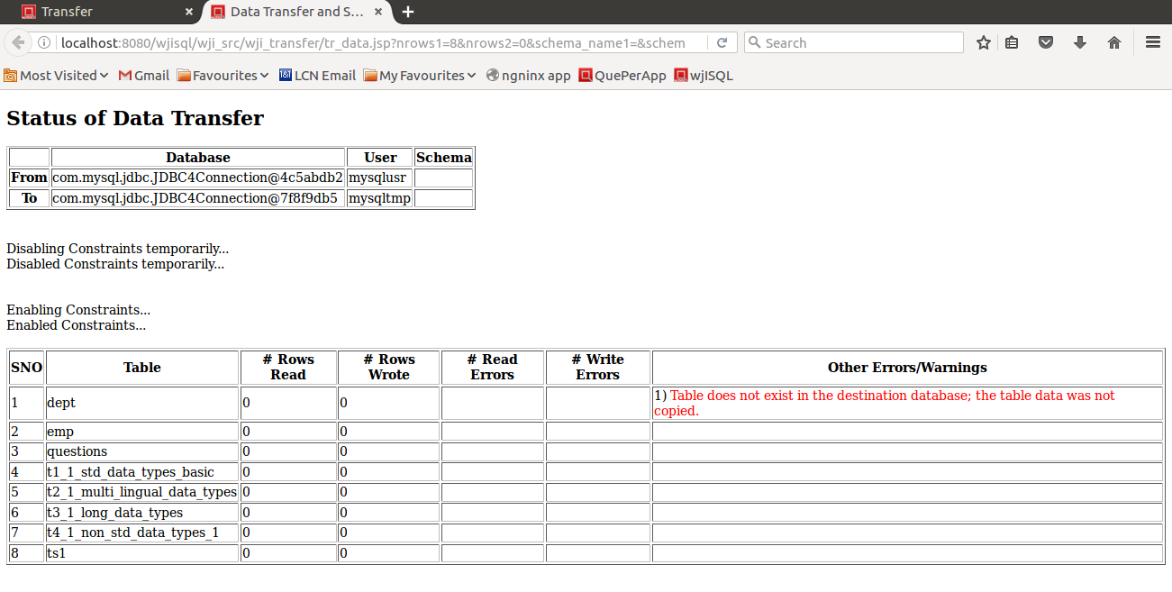

Post Test Actions
1 | Close browser tab "Data Transfer Status".

Test Status:
Platform | wjISQL | Date | Status | Remarks
Ubuntu 16.04 LTS  FireFox | 1.17.5(422) | 2017-10-11 | Success

Test Case 2/5: Test failure of transfer of data of a table due to constraints such as primary keys.
Test Prerequisites:
1 | Test Case 1

Test Procedure
1 | Select table t1_1_std_data_types_basic of source database for which data was already transferred as shown below:  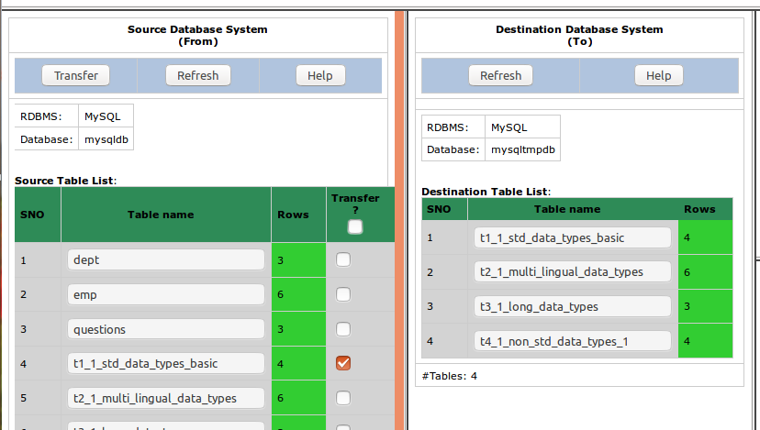
2 | Click button Transfer of source database window.
3 | Confirm OK on a transfer confirmation window.

Test Expected o/p:
1 | A new "Data Transfer and Status" tab of browser with with error messages saying duplicate entries and number of transfered rows (Rows Wrote) is 0 as shown below:  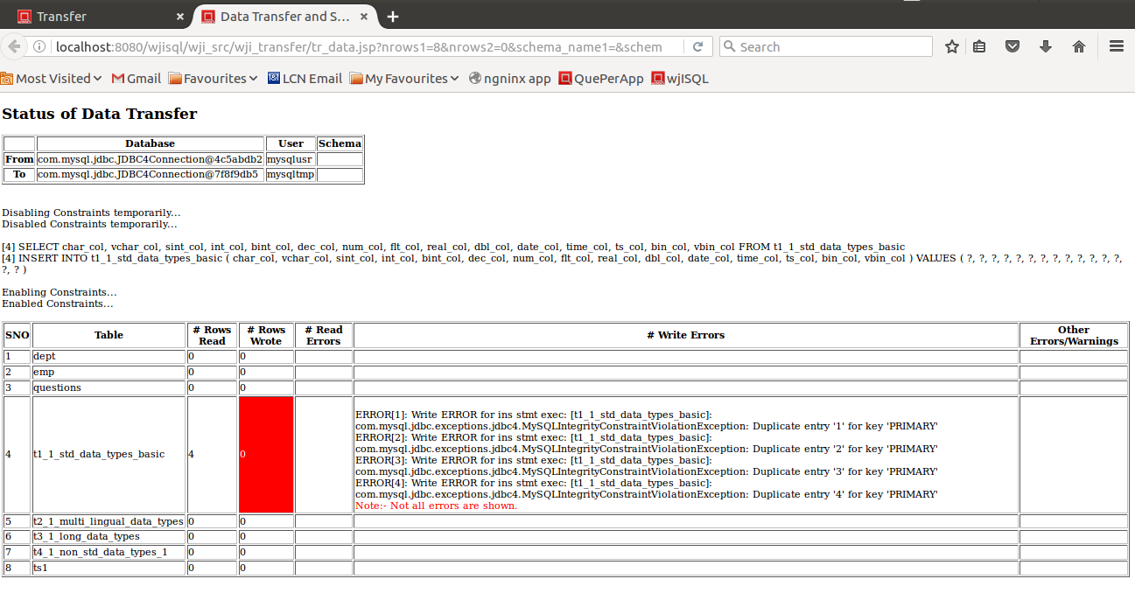

Post Test Actions
1 | Close browser tab "Data Transfer and Status".

Test Status:
Platform | wjISQL | Date | Status | Remarks
Ubuntu 16.04 LTS  FireFox | 1.17.5(422) | 2017-10-11 | Success

Post Test Test Cases
Test Case 1/6: Disconnect source and destination databases
Test Prerequisites:
1 | wjISQL is in Data Transfer screen.

Test Procedure
1 | Click menu item Disconnect source.
2 | Click menu item Disconnect destination.
3 | Click button Back.

Test Expected o/p:
1 | Main screen of wjISQL.

Test Status:
Platform | wjISQL | Date | Status | Remarks
Ubuntu 16.04 LTS  FireFox | 1.17.5(422) | 2017-10-11 | Success

MySQL To PostgreSQL Database Transfer Test Cases

Successful Test Cases
Test Case 1/7: Setup PostgreSQL Database for data transfer.
Test Prerequisites:
1 | None

Test Procedure
1 | Connect to PostgreSQL database pgsqldb with user if pgsqlusr and password pgsql123.
2 | Execute the following scripts from test source directory wjisql/wji_tsrc/wji_scripts/wji_04_basic_pgsql_tables to create tables without any data:  tst_04_001_tables_drop_uc.sql  tst_04_002_tables_create_uc.sql  and ignore table dropping errors that may showup while executing the first script.
3 | Disconnect

Test Expected o/p:
1 | Successful creatation of tables starting without any data in pgsqldb:  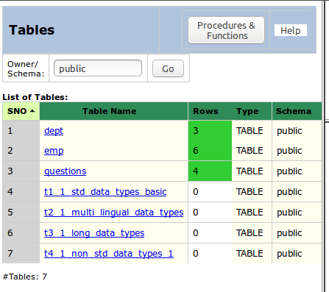

Test Status:
Platform | wjISQL | Date | Status | Remarks
Ubuntu 16.04 LTS  FireFox | 1.17.5(422) | 2017-10-11 | Success

Post Test Actions:
1 | Click button Disconnect to disconnect from pgsqldb.

Test Case 2/8: Test Transfer of data of tables from database mysqldb to pgsqldb
Test Prerequisites:
1 | Test case 1

Test Procedure
1 | Click button Transfer on the main menu.
2 | Connect to source database mysqldb with user mysqlusr and password mysql123.
3 | Connect to destination database pgsqldb with user pgsqlusr and password pgsql123.
4 | Select four tables of source database as shown below:  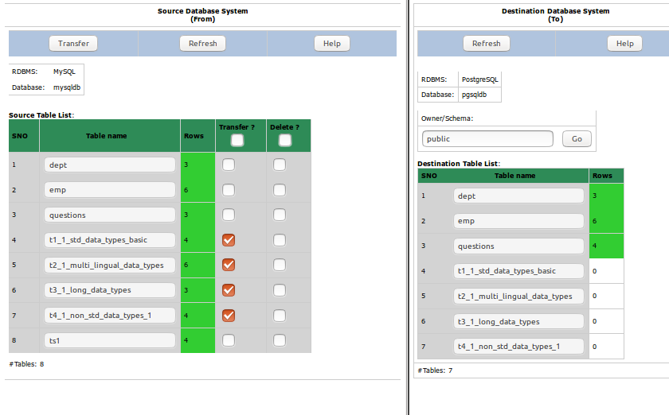
5 | Click button Transfer of source database window.
6 | Confirm OK on a transfer confirmation window.

Test Expected o/p:
1 | A new "Data Transfer Status" tab of browser with successful data transfer as shown below but with errors/warnings due non-matching of columns:  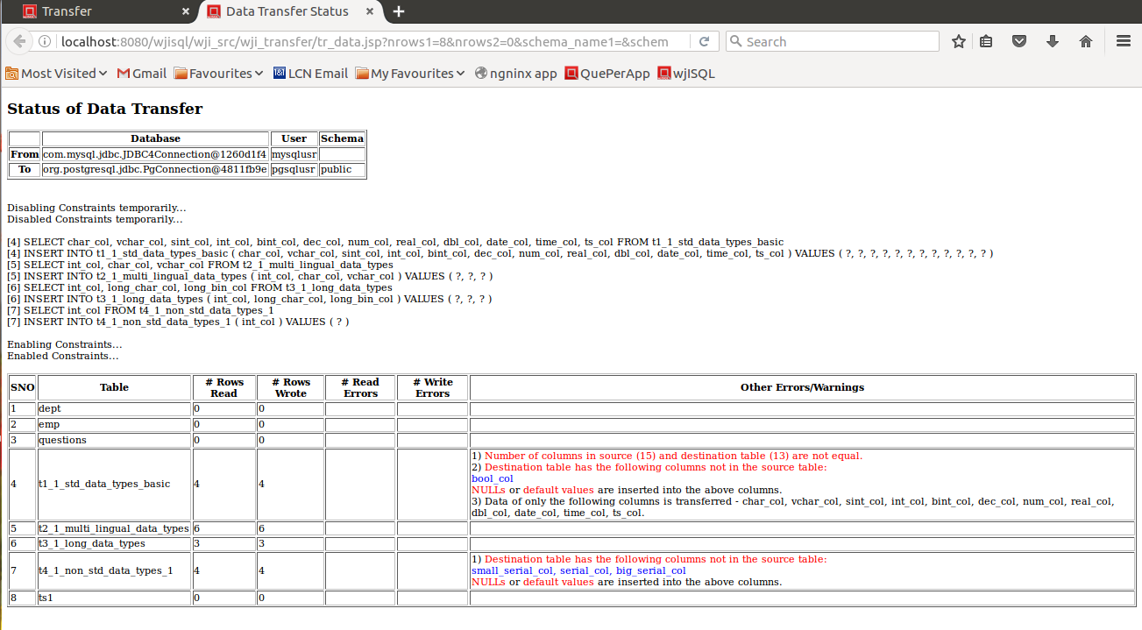

Post Test Actions
1 | Click on table "t1_1_..." in source and destination database table lists.
2 | Click on button Data on right side source and destination table properties windows.
3 | The resultant screen should indicate successfuly transfered number of rows and data as shown below (scroll windows if needed):  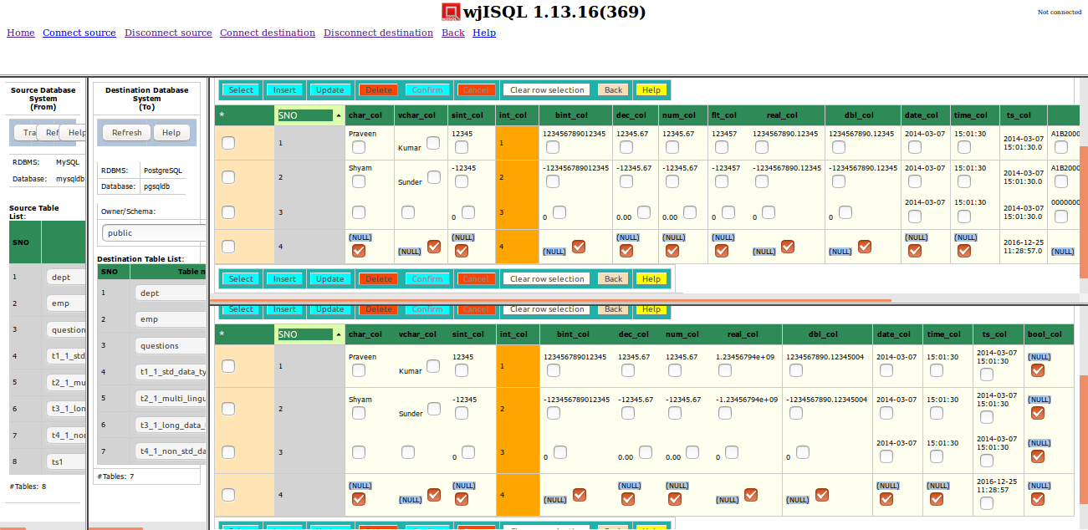

Test Status:
Platform | wjISQL | Date | Status | Remarks
Ubuntu 16.04 LTS  FireFox | 1.17.5(422) | 2017-10-11 | Success

Test Case 3/9: Test Transfer data of a table that does not have all columns of source table but has extra columns in the destination database
Test Prerequisites:
1 | Test Case 2.

Test Procedure
1 | Click on a table, say, t1_1..., in destination table list.
2 | Click button Data on the right bottom window to display the Result window that contains table data.
3 | Enter the following statements in SQL Statement window to create a new table that does not have column dno of source table but has extra columns edob and eexp:  DROP TABLE public.emp;  CREATE TABLE emp(eno INT NOT NULL PRIMARY KEY , ename VARCHAR(20), edob DATE, eexp INT DEFAULT 0);
4 | Select table emp of source database for data transfer as shown below:  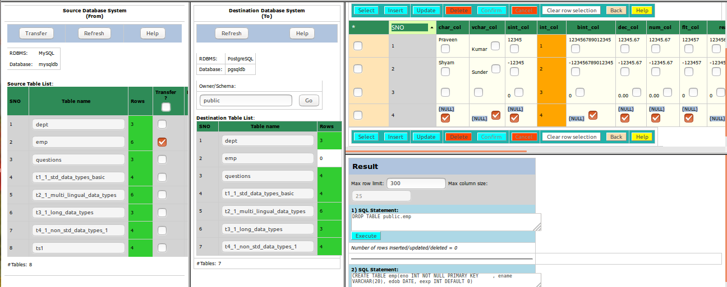
5 | Click button Transfer of source database window.
6 | Confirm OK on a transfer confirmation window.

Test Expected o/p:
1 | A new "Data Transfer and Status" tab of browser with successful data transfer with warnings on non-existing and extra columns in the destination table as shown below:  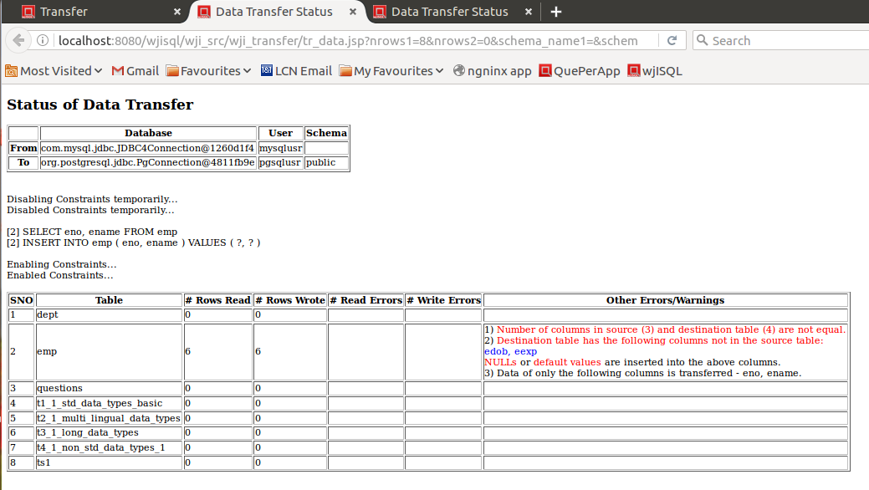

Post Test Actions
1 | Click on table "emp" in source and destination database table lists.
2 | Click on button Data on right side source and destination table properties windows.
3 | The resultant screen should indicate successful transfer of 6 rows of table emp and NULL values for column edob and default value of 0 for column eexp as shown below:  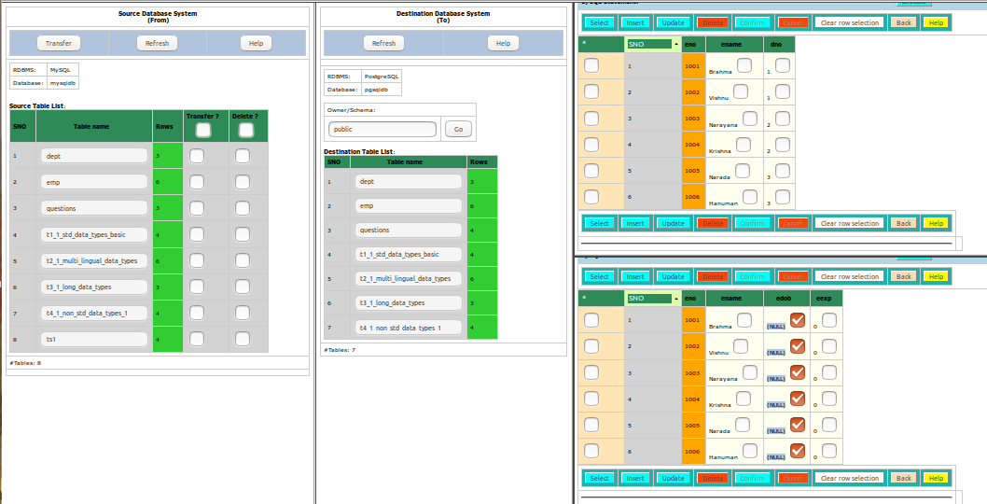

Test Status:
Platform | wjISQL | Date | Status | Remarks
Ubuntu 16.04 LTS  FireFox | 1.17.5(422) | 2017-10-11 | Success

Unsuccessful Test Cases
Test Case 1/10: Test failure of transfer of data of a table not defined in the destination database
Test Prerequisites:
1 | None

Test Procedure
1 | Select a table from the destination database and drop table dept if it exists.
2 | Select table dept of source database.
3 | Click button Transfer of source database window.
4 | Confirm OK on a transfer confirmation window.

Test Expected o/p:
1 | A new "Data Transfer and Status" tab of browser with with error message saying the table does not exist in the destination database.  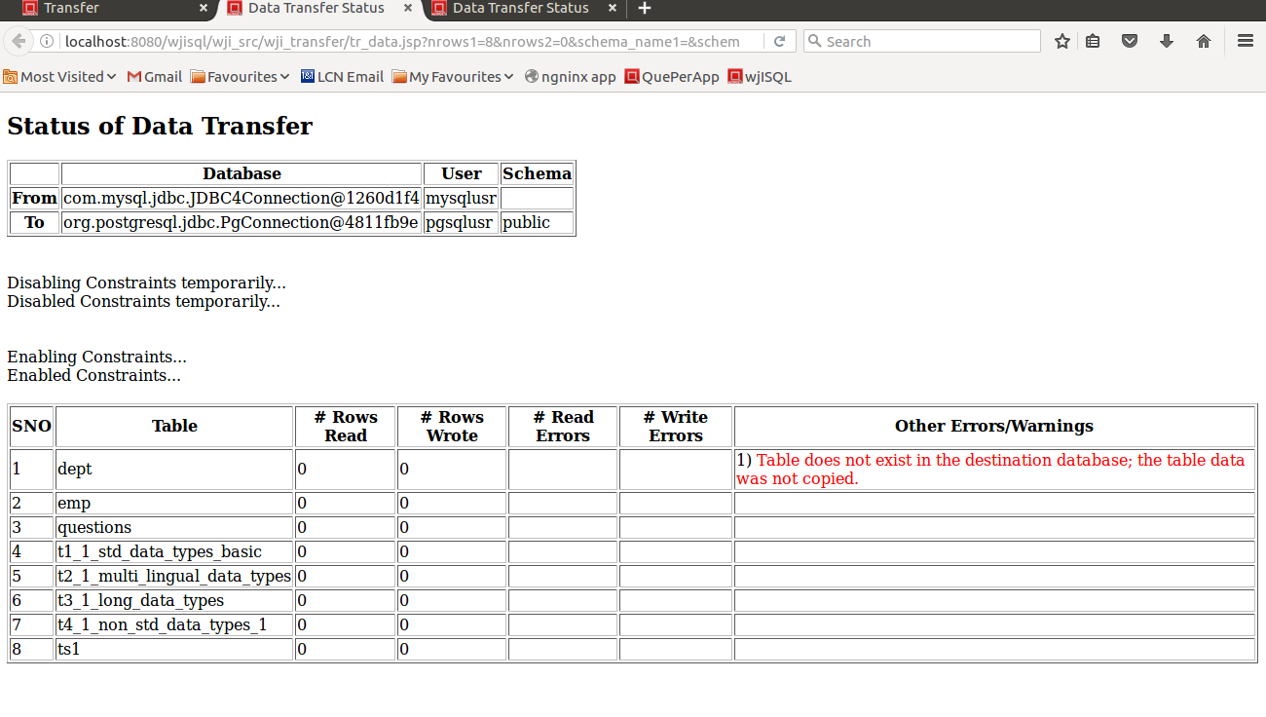

Post Test Actions
1 | Close browser tab "Data Transfer Status".

Test Status:
Platform | wjISQL | Date | Status | Remarks
Ubuntu 16.04 LTS  FireFox | 1.17.5(422) | 2017-10-11 | Success

Test Case 2/11: Test failure of transfer of data of a table due to constraints such as primary keys.
Test Prerequisites:
1 | Test Case 1

Test Procedure
1 | Select table t1_1_std_data_types_basic of source database for which data was already transferred as shown below:  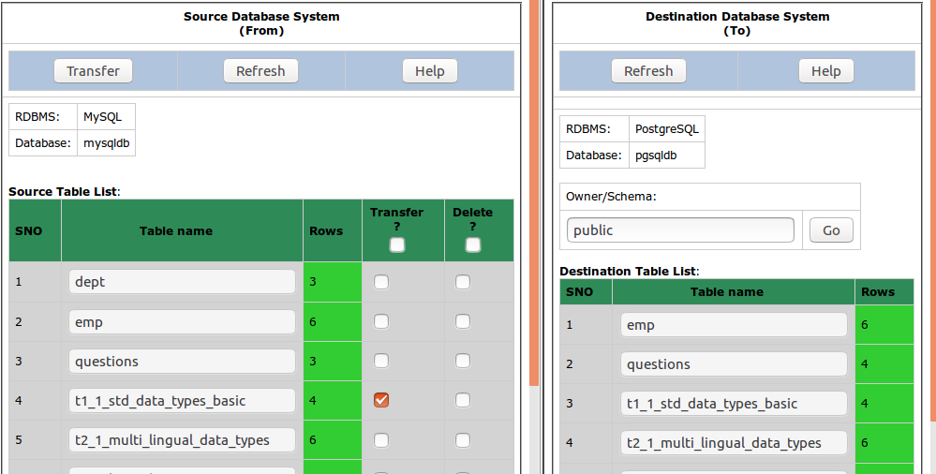
2 | Click button Transfer of source database window.
3 | Confirm OK on a transfer confirmation window.

Test Expected o/p:
1 | A new "Data Transfer and Status" tab of browser with with error messages saying duplicate entries and number of transfered rows (Rows Wrote) is 0 as shown below:  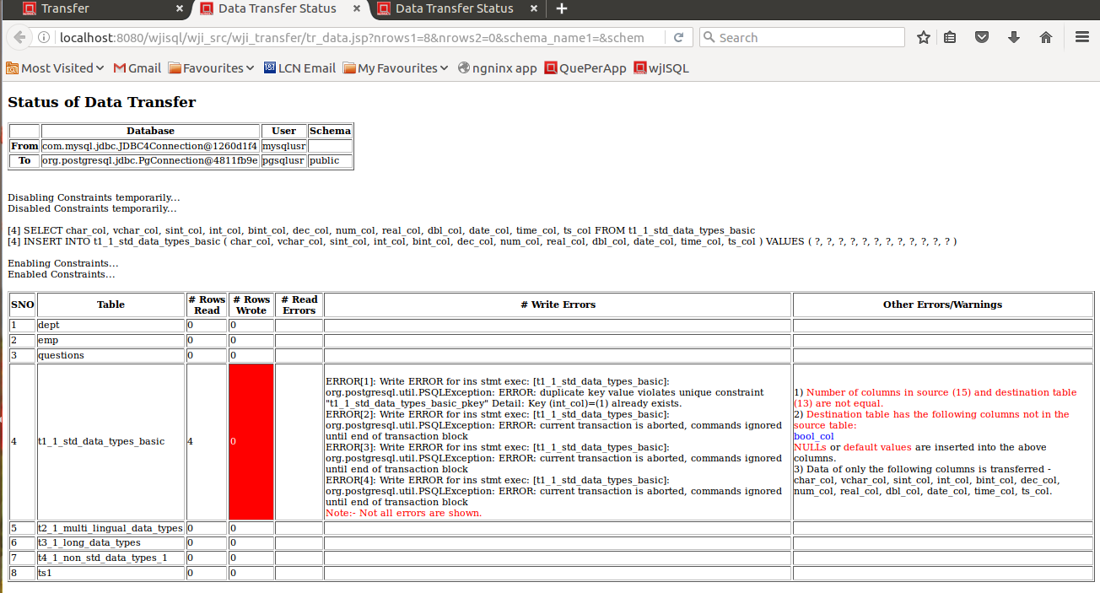

Post Test Actions
1 | Close browser tab "Data Transfer Status".

Test Status:
Platform | wjISQL | Date | Status | Remarks
Ubuntu 16.04 LTS  FireFox | 1.17.5(422) | 2017-10-11 | Success

Post Test Test Cases
Test Case 1/12: Disconnect source and destination databases
Test Prerequisites:
1 | wjISQL is in Data Transfer screen.

Test Procedure
1 | Click menu item Disconnect source.
2 | Click menu item Disconnect destination.
3 | Click button Back.

Test Expected o/p:
1 | Main screen of wjISQL.

Test Status:
Platform | wjISQL | Date | Status | Remarks
Ubuntu 16.04 LTS  FireFox | 1.17.5(422) | 2017-10-11 | Success

MySQL To SQLite Database Transfer Test Cases

Successful Test Cases
Test Case 1/13: Setup SQLite Database for data transfer.
Test Prerequisites:
1 | None

Test Procedure
1 | Connect to SQLite database /tmp/sqlitedb.
2 | Drop all tables that exist already.
3 | Execute the following scripts from test source directory wjisql/wji_tsrc/wji_scripts/wji_13_basic_sqlite_tables to create tables without any data:  tst_13_001_tables_drop_uc.sql  tst_13_002_tables_create_uc.sql  and ignore table dropping errors that may showup while executing the first script.
4 | Disconnect

Test Expected o/p:
1 | Successful creatation of tables starting with t without any data in sqlitedb:  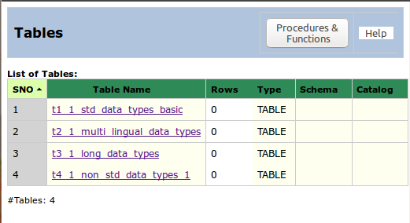

Test Status:
Platform | wjISQL | Date | Status | Remarks
Ubuntu 16.04 LTS  FireFox | 1.17.5(422) | 2017-10-12 | Success

Post Test Actions:
1 | Click button Disconnect to disconnect from sqlitedb.

Test Case 2/14: Test Transfer of data of tables from database mysqldb to sqlitedb.
Test Prerequisites:
1 | Test case 1

Test Procedure
1 | Click button Transfer on the main menu.
2 | Connect to source database mysqldb with user mysqlusr and password mysql123.
3 | Connect to destination database /tmp/sqlitedb.
4 | Select four tables of source database as shown below:  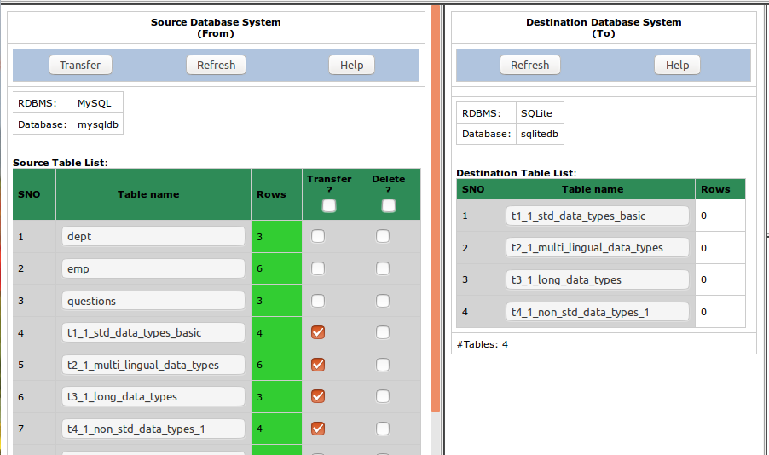
5 | Click button Transfer of source database window.
6 | Confirm OK on a transfer confirmation window.

Test Expected o/p:
1 | A new "Data Transfer Status" tab of browser with successful data transfer as shown below but with errors/warnings due to non-matching of columns:  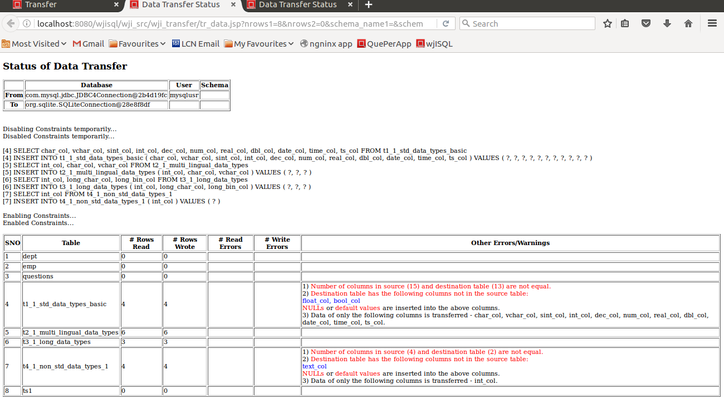

Post Test Actions
1 | Click on table "t2_1_..." in source and destination database table lists.
2 | Click on button Data on right side source and destination table properties windows.
3 | The resultant screen should indicate successfuly transfered number of rows and data as shown below (scroll windows if needed):  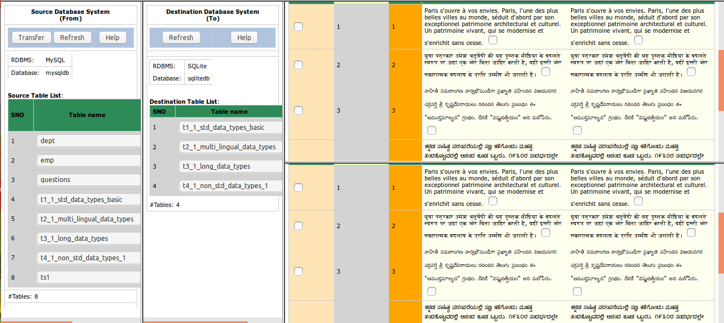

Test Status:
Platform | wjISQL | Date | Status | Remarks
Ubuntu 16.04 LTS  FireFox | 1.17.5(422) | 2017-10-13 | Success

Test Case 3/15: Test Transfer data of a table that does not have all columns of source table but has extra columns in the destination database
Test Prerequisites:
1 | Test Case 2.

Test Procedure
1 | Click on a table, say, t1_1..., in destination table list.
2 | Click button Data on the right bottom window to display the Result window that contains table data.
3 | Enter the following statement in SQL Statement window to create a new table that does not have column dno of source table but has extra columns edob and eexp:  CREATE TABLE emp(eno INT NOT NULL PRIMARY KEY , ename VARCHAR(20), edob DATE, eexp INT DEFAULT 0);
4 | Select table emp of source database for data transfer as shown below:  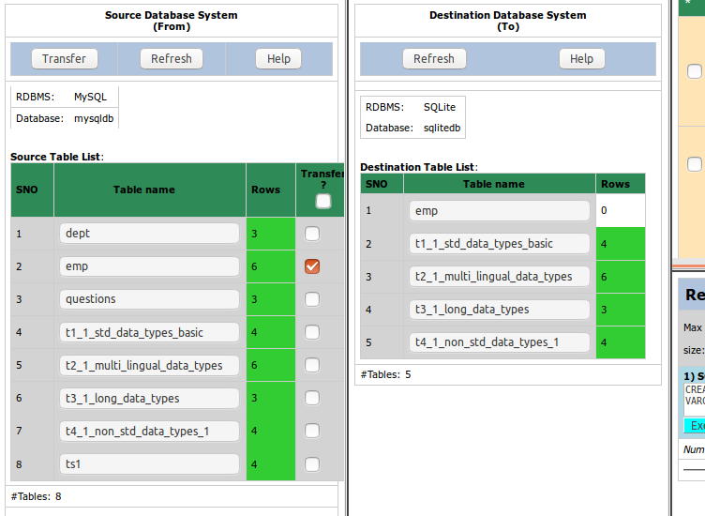
5 | Click button Transfer of source database window.
6 | Confirm OK on a transfer confirmation window.

Test Expected o/p:
1 | A new "Data Transfer Status" tab of browser with successful data transfer with warnings on non-existing and extra columns in the destination table as shown below:  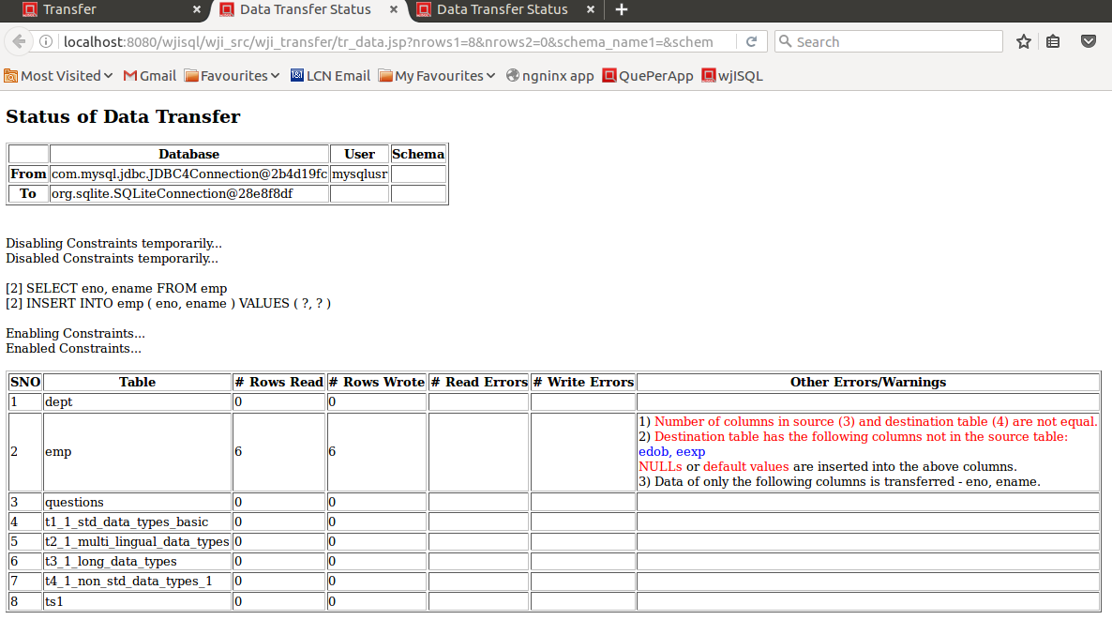

Post Test Actions
1 | Click on table "emp" in source and destination database table lists.
2 | Click on button Data on right side source and destination table properties windows.
3 | The resultant screen should indicate successful transfer of 6 rows of table emp and NULL values for column edob and default value of 0 for column eexp as shown below:  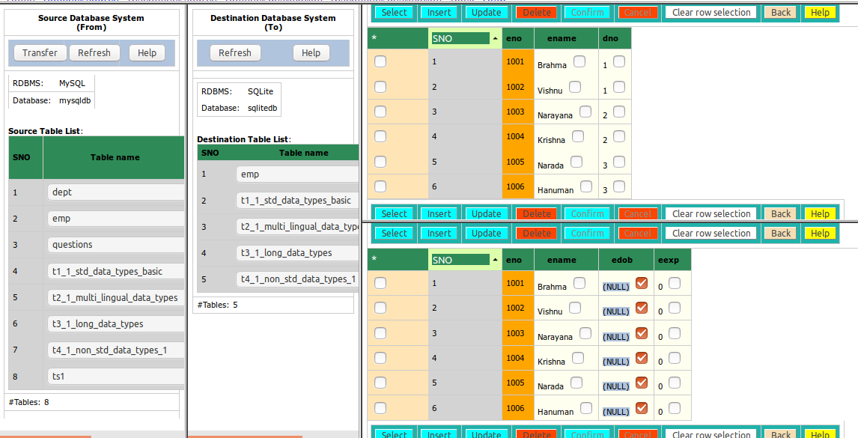

Test Status:
Platform | wjISQL | Date | Status | Remarks
Ubuntu 16.04 LTS  FireFox | 1.17.5(422) | 2017-10-13 | Success

Unsuccessful Test Cases
Test Case 1/16: Test failure of transfer of data of a table not defined in the destination database
Test Prerequisites:
1 | None

Test Procedure
1 | Select table dept of source database as shown below:  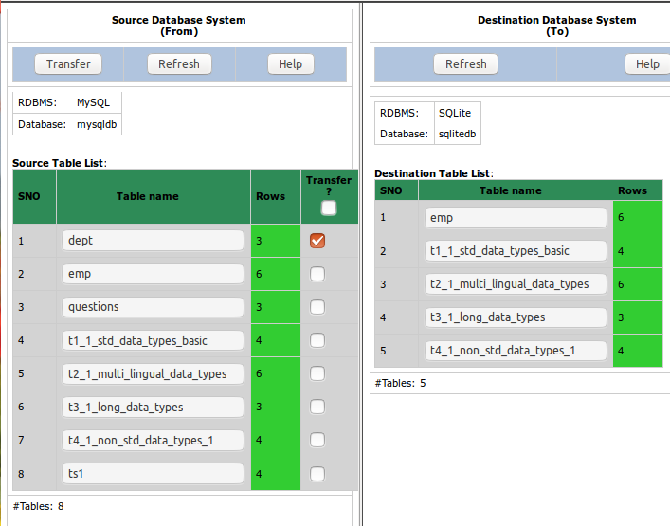
2 | Click button Transfer of source database window.
3 | Confirm OK on a transfer confirmation window.

Test Expected o/p:
1 | A new "Data Transfer Status" tab of browser with with error message saying the table does not exist in the destination database.  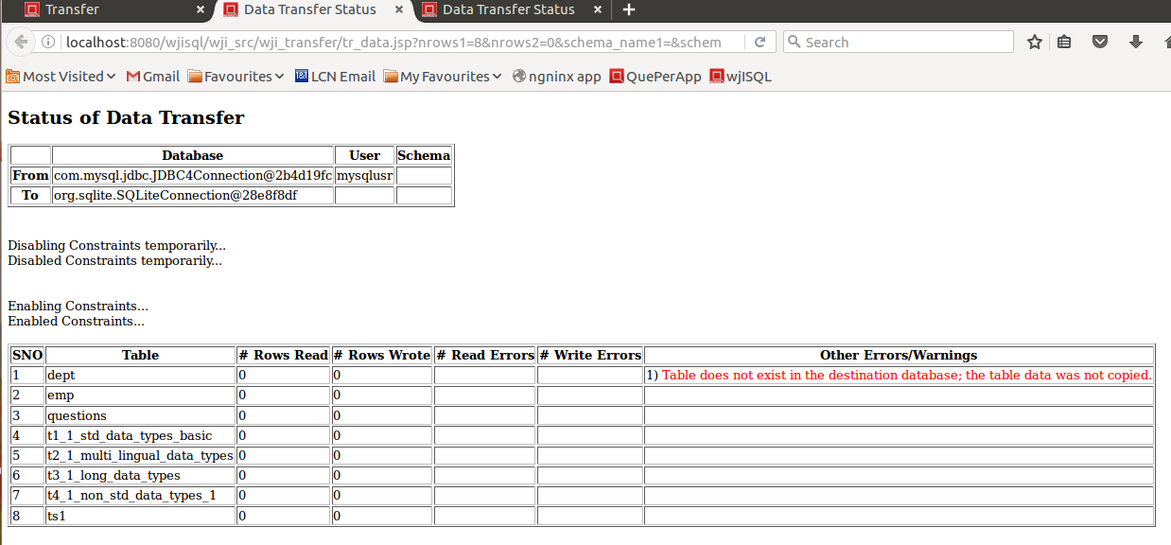

Post Test Actions
1 | Close browser tab "Data Transfer Status".

Test Status:
Platform | wjISQL | Date | Status | Remarks
Ubuntu 16.04 LTS  FireFox | 1.17.5(422) | 2017-10-13 | Success

Test Case 2/17: Test failure of transfer of data of a table due to constraints such as primary keys.
Test Prerequisites:
1 | Test Case 1

Test Procedure
1 | Select table t1_1_std_data_types_basic of source database for which data was already transferred as shown below:  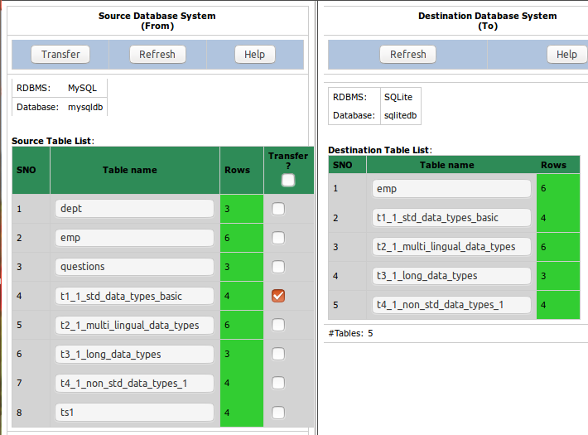
2 | Click button Transfer of source database window.
3 | Confirm OK on a transfer confirmation window.

Test Expected o/p:
1 | A new "Data Transfer and Status" tab of browser with with error messages saying unique constraint violation and number of transfered rows (Rows Wrote) is 0 as shown below:  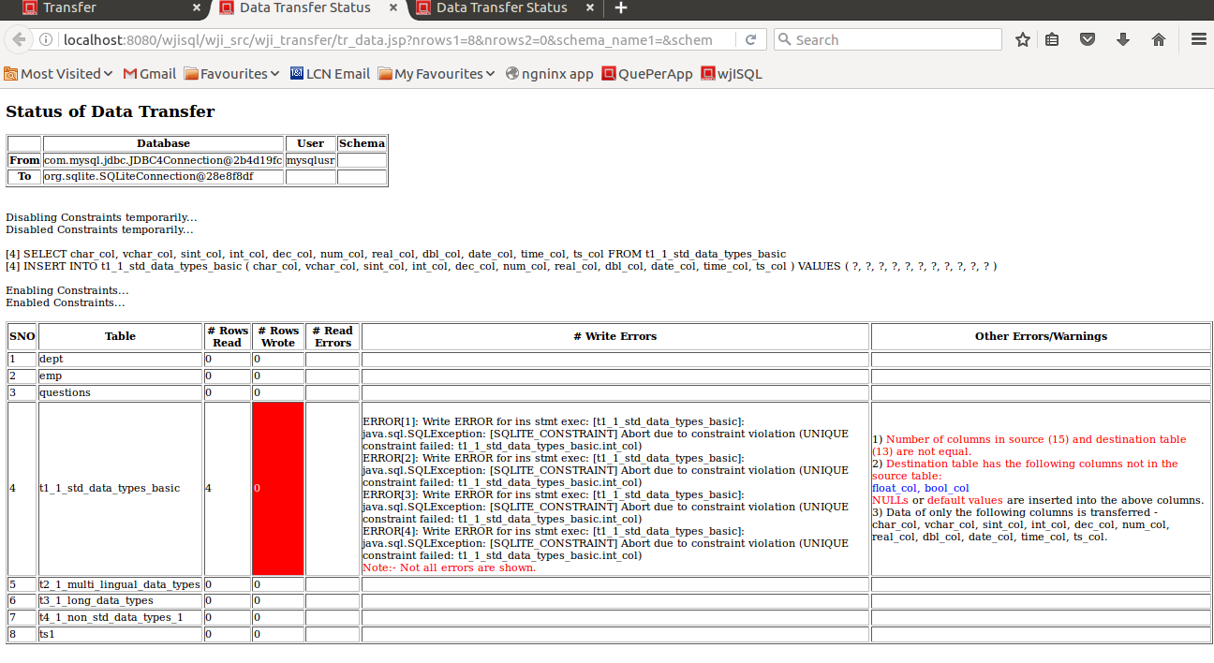

Post Test Actions
1 | Close browser tab "Data Transfer and Status".

Test Status:
Platform | wjISQL | Date | Status | Remarks
Ubuntu 16.04 LTS  FireFox | 1.17.5(422) | 2017-10-13 | Success

Post Test Test Cases
Test Case 1/18: Disconnect source and destination databases
Test Prerequisites:
1 | wjISQL is in Data Transfer screen.

Test Procedure
1 | Click menu item Disconnect source.
2 | Click menu item Disconnect destination.
3 | Click button Back.

Test Expected o/p:
1 | Main screen of wjISQL.

Test Status:
Platform | wjISQL | Date | Status | Remarks
Ubuntu 16.04 LTS  FireFox | 1.17.5(422) | 2017-10-13 | Success

MySQL To MariaDB Database Transfer Test Cases

Successful Test Cases
Test Case 1/19: Setup MariaDB Database for data transfer.
Test Prerequisites:
1 | None

Test Procedure
1 | Connect to MariaDB database mariadb.
2 | Drop all tables that exist already.
3 | Execute the following scripts from test source directory wjisql/wji_tsrc/wji_scripts/wji_18_basic_mariadb_tables to create tables without any data:  tst_19_001_tables_drop_uc.sql  tst_19_002_tables_create_uc.sql  and ignore table dropping errors that may showup while executing the first script.
4 | Disconnect

Test Expected o/p:
1 | Successful creatation of tables starting with t without any data in sqlitedb:

Test Status:
Platform | wjISQL | Date | Status | Remarks
Ubuntu 16.04 LTS  FireFox | 1.17.5(422) | 2017-10-13 | Success

Post Test Actions:
1 | Click button Disconnect to disconnect from sqlitedb.

Test Case 2/20: Test Transfer of data of tables from database mysqldb to sqlitedb.
Test Prerequisites:
1 | Test case 1

Test Procedure
1 | Click button Transfer on the main menu.
2 | Connect to source database mysqldb with user mysqlusr and password mysql123.
3 | Connect to destination database /tmp/sqlitedb.
4 | Select four tables of source database as shown below:
5 | Click button Transfer of source database window.
6 | Confirm OK on a transfer confirmation window.

Test Expected o/p:
1 | A new "Data Transfer Status" tab of browser with successful data transfer as shown below but with errors/warnings due to non-matching of columns:  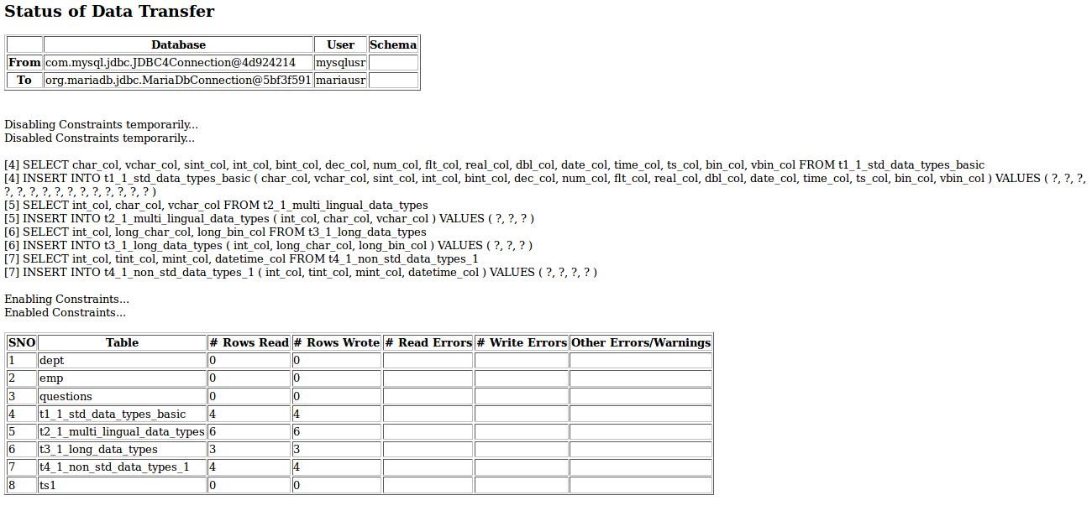

Post Test Actions
1 | Click on table "t2_1_..." in source and destination database table lists.
2 | Click on button Data on right side source and destination table properties windows.
3 | The resultant screen should indicate successfuly transfered number of rows and data as shown below (scroll windows if needed):

Test Status:
Platform | wjISQL | Date | Status | Remarks
Ubuntu 16.04 LTS  FireFox | 1.17.5(422) | 2017-10-13 | Success

Test Case 3/21: Test Transfer data of a table that does not have all columns of source table but has extra columns in the destination database
Test Prerequisites:
1 | Test Case 2.

Test Procedure
1 | Click on a table, say, t1_1..., in destination table list.
2 | Click button Data on the right bottom window to display the Result window that contains table data.
3 | Drop table emp if already exists.  Enter the following statement in SQL Statement window to create a new table that does not have column dno of source table but has extra columns edob and eexp:  CREATE TABLE emp(eno INT NOT NULL PRIMARY KEY , ename VARCHAR(20), edob DATE, eexp INT DEFAULT 0);
4 | Select table emp of source database for data transfer as shown below:
5 | Click button Transfer of source database window.
6 | Confirm OK on a transfer confirmation window.

Test Expected o/p:
1 | A new "Data Transfer Status" tab of browser with successful data transfer with warnings on non-existing and extra columns in the destination table as shown below:  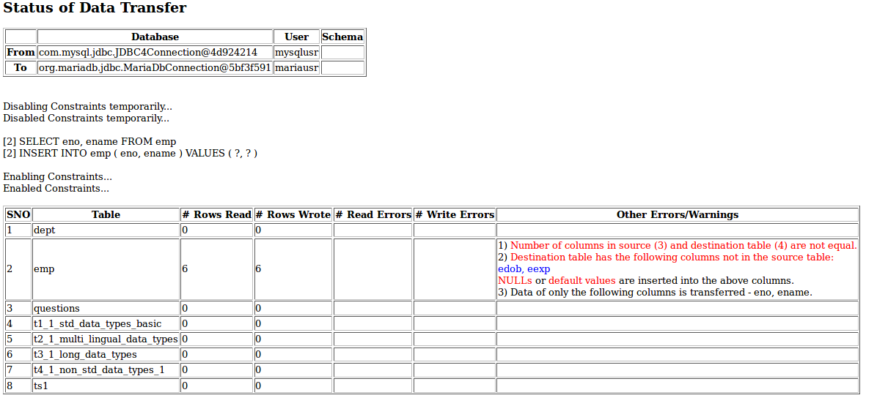

Post Test Actions
1 | Click on table "emp" in source and destination database table lists.
2 | Click on button Data on right side source and destination table properties windows.
3 | The resultant screen should indicate successful transfer of 6 rows of table emp and NULL values for column edob and default value of 0 for column eexp as shown below:

Test Status:
Platform | wjISQL | Date | Status | Remarks
Ubuntu 16.04 LTS  FireFox | 1.17.5(422) | 2017-10-13 | Success

Unsuccessful Test Cases
Test Case 1/22: Test failure of transfer of data of a table not defined in the destination database
Test Prerequisites:
1 | Table dept does not exist in the destination database.

Test Procedure
1 | Select table dept of source database as shown below:
2 | Click button Transfer of source database window.
3 | Confirm OK on a transfer confirmation window.

Test Expected o/p:
1 | A new "Data Transfer Status" tab of browser with with error message saying the table does not exist in the destination database.  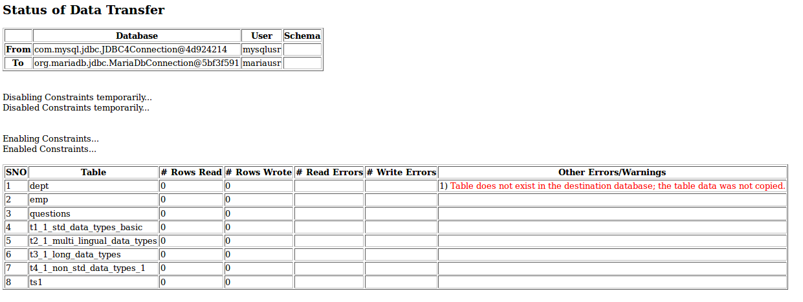

Post Test Actions
1 | Close browser tab "Data Transfer Status".

Test Status:
Platform | wjISQL | Date | Status | Remarks
Ubuntu 16.04 LTS  FireFox | 1.17.5(422) | 2017-10-13 | Success

Test Case 2/23: Test failure of transfer of data of a table due to constraints such as primary keys.
Test Prerequisites:
1 | Test Case 1

Test Procedure
1 | Select table t1_1_std_data_types_basic of source database for which data was already transferred as shown below:
2 | Click button Transfer of source database window.
3 | Confirm OK on a transfer confirmation window.

Test Expected o/p:
1 | A new "Data Transfer and Status" tab of browser with with error messages saying unique constraint violation and number of transfered rows (Rows Wrote) is 0 as shown below:  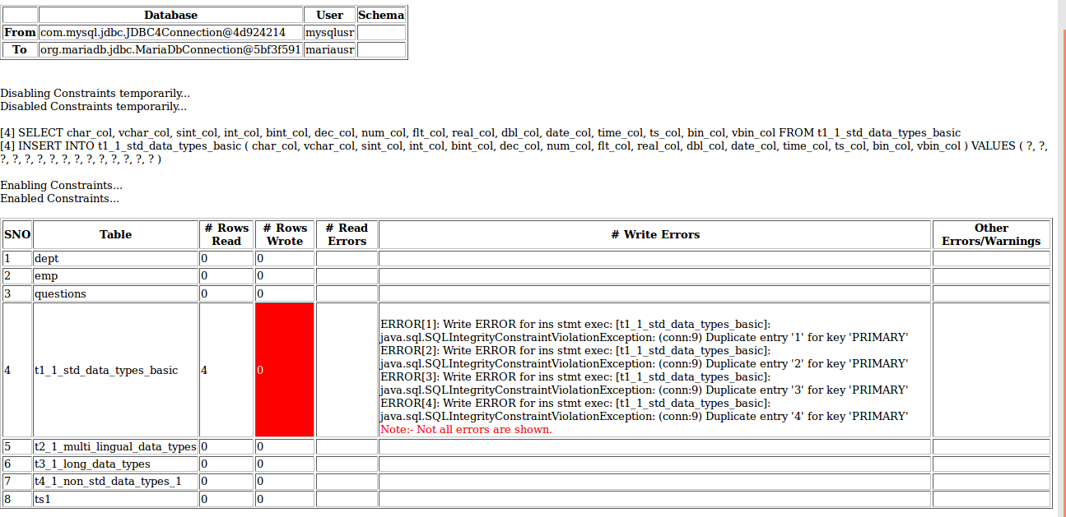

Post Test Actions
1 | Close browser tab "Data Transfer and Status".

Test Status:
Platform | wjISQL | Date | Status | Remarks
Ubuntu 16.04 LTS  FireFox | 1.17.5(422) | 2017-10-13 | Success

Post Test Test Cases
Test Case 1/24: Disconnect source and destination databases
Test Prerequisites:
1 | wjISQL is in Data Transfer screen.

Test Procedure
1 | Click menu item Disconnect source.
2 | Click menu item Disconnect destination.
3 | Click button Back.

Test Expected o/p:
1 | Main screen of wjISQL.

Test Status:
Platform | wjISQL | Date | Status | Remarks
Ubuntu 16.04 LTS  FireFox | 1.17.5(422) | 2017-10-13 | Success

MariaDB Database Test Cases

Prerequisites

1 | MariaDB database mariadb is readily available for user mariausr and password maria123. The user has DBA privileges.
2 | Database setup was done as mentioned in wpl.tpl.05.browse.docx

MariaDB To MariaDB Database Transfer Test Cases

Successful Test Cases
Test Case 1/25: Create a destination database and user credentials.
Test Prerequisites:
1 | None

Test Procedure
1 | Connect to MariaDB without any database using user root and related password.
2 | Click button SQL.
3 | Create database mysqltmpdb as following:  CREATE DATABASE destdb CHARACTER SET=utf8;
4 | Create user and password as following:  CREATE USER 'mariatmp'@'%' IDENTIFIED BY 'dest123';
5 | Grant permisions on the database to the user as following:  GRANT ALL ON destdb.* TO 'mariatmp'@'%';
6 | Disconnect
7 | Connect to destdb with new user mariatmp and related password.
8 | Click button SQL.
9 | Execute the following script to create tables without any data:  wjisql/wji_tsrc/wji_scripts/wji_18_basic_mariadb_tables/  tst_18_002_tables_create_uc.sql

Test Expected o/p:
1 | Successful create of tables in mysqltmpdb:

Test Status:
Platform | wjISQL | Date | Status | Remarks

Post Test Actions:
1 | Click button Disconnect to disconnect from mysqltmpdb.

Test Case 2/26: Test Transfer data of tables from database mariadb to mysqltmpdb
Test Prerequisites:
1 | None.

Test Procedure
1 | Click button Transfer on the main menu.
2 | Connect to source database mariadb with user mariausr and password maria123.
3 | Connect to destination database destdb with user destusr and password dest123.
4 | Select all tables of source database by clicking check box in column Transfer?.
5 | Click button Transfer of source database window.
6 | Confirm OK on a transfer confirmation window.

Test Expected o/p:
1 | A new "Data Transfer and Status" tab of browser with successful data transfer as shown below:

Post Test Actions
1 | Click on table "t2_1_..." in source and destination database table lists.
2 | Click on button Data on right side source and destination table properties windows.
3 | The resultant screen should indicate successfuly transfered number of rows and data.

Test Status:
Platform | wjISQL | Date | Status | Remarks

Test Case 3/27: Test Transfer data of a table that does not have all columns of source table but has extra columns in the destination database
Test Prerequisites:
1 | Test Case 2.

Test Procedure
1 | Click on a table, say, t1_1..., in destination table list.
2 | Click button Data on the right bottom window to display the Result window that contains table data.
3 | Enter the following statement in SQL Statement window to create a new table that does not have column dno of source table but has extra columns edob and eexp:  CREATE TABLE emp(eno INT NOT NULL PRIMARY KEY , ename VARCHAR(20), edob DATE, eexp INT DEFAULT 0)
4 | Select table emp of source database for data transfer as shown below:
5 | Click button Transfer of source database window.
6 | Confirm OK on a transfer confirmation window.

Test Expected o/p:
1 | A new "Data Transfer and Status" tab of browser with successful data transfer with warnings on non-existing and extra columns in the destination table as shown below:

Post Test Actions
1 | Click on table "emp" in source and destination database table lists.
2 | Click on button Data on right side source and destination table properties windows.
3 | The resultant screen should indicate successful transfer of 6 rows of table emp and NULL values for column edob and default value of 0 for column eexp as shown below:

Test Status:
Platform | wjISQL | Date | Status | Remarks

Unsuccessful Test Cases
Test Case 1/28: Test failure of transfer of data of a table not defined in the destination database
Test Prerequisites:
1 | None

Test Procedure
1 | Click button Transfer on the main menu.
2 | Connect to source database mariadb with user mariausr and password maria123.
3 | Connect to destination database destdb with user destusr and password dest123.
4 | Select table dept of source database as shown below:
5 | Click button Transfer of source database window.
6 | Confirm OK on a transfer confirmation window.

Test Expected o/p:
1 | A new "Data Transfer and Status" tab of browser with with error message saying the table does not exist in the destination database.

Post Test Actions
1 | Close browser tab "Data Transfer Status".

Test Status:
Platform | wjISQL | Date | Status | Remarks
Ubuntu 16.04 LTS  FireFox | 1.17.5(422) | 2017-10-11 | Success

Test Case 2/29: Test failure of transfer of data of a table due to constraints such as primary keys.
Test Prerequisites:
1 | Test Case 1

Test Procedure
1 | Select table t1_1_std_data_types_basic of source database for which data was already transferred as shown below:
2 | Click button Transfer of source database window.
3 | Confirm OK on a transfer confirmation window.

Test Expected o/p:
1 | A new "Data Transfer and Status" tab of browser with with error messages saying duplicate entries and number of transfered rows (Rows Wrote) is 0 as shown below:

Post Test Actions
1 | Close browser tab "Data Transfer and Status".

Test Status:
Platform | wjISQL | Date | Status | Remarks

Post Test Test Cases
Test Case 1/30: Disconnect source and destination databases
Test Prerequisites:
1 | wjISQL is in Data Transfer screen.

Test Procedure
1 | Click menu item Disconnect source.
2 | Click menu item Disconnect destination.
3 | Click button Back.

Test Expected o/p:
1 | Main screen of wjISQL.

Test Status:
Platform | wjISQL | Date | Status | Remarks
Ubuntu 16.04 LTS  FireFox | 1.17.5(422) | 2017-10-11 | Success

MariaDB To PostgreSQL Database Transfer Test Cases

Successful Test Cases
Test Case 1/31: Setup PostgreSQL Database for data transfer.
Test Prerequisites:
1 | None

Test Procedure
1 | Connect to PostgreSQL database pgsqldb with user if pgsqlusr and password pgsql123.
2 | Execute the following scripts from test source directory wjisql/wji_tsrc/wji_scripts/wji_04_basic_pgsql_tables to create tables without any data:  tst_04_001_tables_drop_uc.sql  tst_04_002_tables_create_uc.sql  and ignore table dropping errors that may showup while executing the first script.
3 | Disconnect

Test Expected o/p:
1 | Successful creatation of tables starting without any data in pgsqldb:

Test Status:
Platform | wjISQL | Date | Status | Remarks
Ubuntu 16.04 LTS  FireFox | 1.17.5(422) | 2017-10-11 | Success

Post Test Actions:
1 | Click button Disconnect to disconnect from pgsqldb.

Test Case 2/32: Test Transfer of data of tables from database mariadb to pgsqldb
Test Prerequisites:
1 | Test case 1

Test Procedure
1 | Click button Transfer on the main menu.
2 | Connect to source database mariadb with user mariausr and password maria123.
3 | Connect to destination database pgsqldb with user pgsqlusr and password pgsql123.
4 | Select four tables of source database as shown below:
5 | Click button Transfer of source database window.
6 | Confirm OK on a transfer confirmation window.

Test Expected o/p:
1 | A new "Data Transfer Status" tab of browser with successful data transfer as shown below but with errors/warnings due non-matching of columns:

Post Test Actions
1 | Click on table "t1_1_..." in source and destination database table lists.
2 | Click on button Data on right side source and destination table properties windows.
3 | The resultant screen should indicate successfuly transfered number of rows and data as shown below (scroll windows if needed):

Test Status:
Platform | wjISQL | Date | Status | Remarks
Ubuntu 16.04 LTS  FireFox | 1.17.5(422) | 2017-10-11 | Success

Test Case 3/33: Test Transfer data of a table that does not have all columns of source table but has extra columns in the destination database
Test Prerequisites:
1 | Test Case 2.

Test Procedure
1 | Click on a table, say, t1_1..., in destination table list.
2 | Click button Data on the right bottom window to display the Result window that contains table data.
3 | Enter the following statements in SQL Statement window to create a new table that does not have column dno of source table but has extra columns edob and eexp:  DROP TABLE public.emp;  CREATE TABLE emp(eno INT NOT NULL PRIMARY KEY , ename VARCHAR(20), edob DATE, eexp INT DEFAULT 0);
4 | Select table emp of source database for data transfer as shown below:
5 | Click button Transfer of source database window.
6 | Confirm OK on a transfer confirmation window.

Test Expected o/p:
1 | A new "Data Transfer and Status" tab of browser with successful data transfer with warnings on non-existing and extra columns in the destination table as shown below:

Post Test Actions
1 | Click on table "emp" in source and destination database table lists.
2 | Click on button Data on right side source and destination table properties windows.
3 | The resultant screen should indicate successful transfer of 6 rows of table emp and NULL values for column edob and default value of 0 for column eexp as shown below:

Test Status:
Platform | wjISQL | Date | Status | Remarks
Ubuntu 16.04 LTS  FireFox | 1.17.5(422) | 2017-10-11 | Success

Unsuccessful Test Cases
Test Case 1/34: Test failure of transfer of data of a table not defined in the destination database
Test Prerequisites:
1 | None

Test Procedure
1 | Select a table from the destination database and drop table dept if it exists.
2 | Select table dept of source database.
3 | Click button Transfer of source database window.
4 | Confirm OK on a transfer confirmation window.

Test Expected o/p:
1 | A new "Data Transfer and Status" tab of browser with with error message saying the table does not exist in the destination database.

Post Test Actions
1 | Close browser tab "Data Transfer Status".

Test Status:
Platform | wjISQL | Date | Status | Remarks
Ubuntu 16.04 LTS  FireFox | 1.17.5(422) | 2017-10-11 | Success

Test Case 2/35: Test failure of transfer of data of a table due to constraints such as primary keys.
Test Prerequisites:
1 | Test Case 1

Test Procedure
1 | Select table t1_1_std_data_types_basic of source database for which data was already transferred as shown below:
2 | Click button Transfer of source database window.
3 | Confirm OK on a transfer confirmation window.

Test Expected o/p:
1 | A new "Data Transfer and Status" tab of browser with with error messages saying duplicate entries and number of transfered rows (Rows Wrote) is 0 as shown below:

Post Test Actions
1 | Close browser tab "Data Transfer Status".

Test Status:
Platform | wjISQL | Date | Status | Remarks
Ubuntu 16.04 LTS  FireFox | 1.17.5(422) | 2017-10-11 | Success

Post Test Test Cases
Test Case 1/36: Disconnect source and destination databases
Test Prerequisites:
1 | wjISQL is in Data Transfer screen.

Test Procedure
1 | Click menu item Disconnect source.
2 | Click menu item Disconnect destination.
3 | Click button Back.

Test Expected o/p:
1 | Main screen of wjISQL.

Test Status:
Platform | wjISQL | Date | Status | Remarks
Ubuntu 16.04 LTS  FireFox | 1.17.5(422) | 2017-10-11 | Success

MariaDB To SQLite Database Transfer Test Cases

Successful Test Cases
Test Case 1/37: Setup SQLite Database for data transfer.
Test Prerequisites:
1 | None

Test Procedure
1 | Connect to SQLite database /tmp/sqlitedb.
2 | Drop all tables that exist already.
3 | Execute the following scripts from test source directory wjisql/wji_tsrc/wji_scripts/wji_13_basic_sqlite_tables to create tables without any data:  tst_13_001_tables_drop_uc.sql  tst_13_002_tables_create_uc.sql  and ignore table dropping errors that may showup while executing the first script.
4 | Disconnect

Test Expected o/p:
1 | Successful creatation of tables starting with t without any data in sqlitedb:

Test Status:
Platform | wjISQL | Date | Status | Remarks

Post Test Actions:
1 | Click button Disconnect to disconnect from sqlitedb.

Test Case 2/38: Test Transfer of data of tables from database mariadb to sqlitedb.
Test Prerequisites:
1 | Test case 1

Test Procedure
1 | Click button Transfer on the main menu.
2 | Connect to source database mariadb with user mariausr and password maria123.
3 | Connect to destination database /tmp/sqlitedb.
4 | Select all tables of source database as shown below:  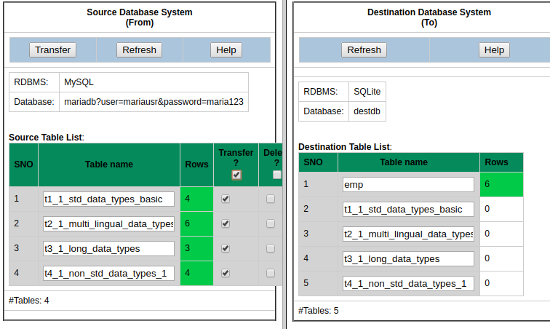
5 | Click button Transfer of source database window.
6 | Confirm OK on a transfer confirmation window.

Test Expected o/p:
1 | A new "Data Transfer Status" tab of browser with successful data transfer as shown below but with errors/warnings due to non-matching of columns:

Post Test Actions
1 | Click on table "t2_1_..." in source and destination database table lists.
2 | Click on button Data on right side source and destination table properties windows.
3 | The resultant screen should indicate successfuly transfered number of rows and data as shown below (scroll windows if needed):

Test Status:
Platform | wjISQL | Date | Status | Remarks
 |  |  |  | m

Test Case 3/39: Test Transfer data of a table that does not have all columns of source table but has extra columns in the destination database
Test Prerequisites:
1 | Test Case 2.

Test Procedure
1 | Click on a table, say, t1_1..., in destination table list.
2 | Click button Data on the right bottom window to display the Result window that contains table data.
3 | Enter the following statement in SQL Statement window to create a new table that does not have column dno of source table but has extra columns edob and eexp:  CREATE TABLE emp(eno INT NOT NULL PRIMARY KEY , ename VARCHAR(20), edob DATE, eexp INT DEFAULT 0);
4 | Select table emp of source database for data transfer as shown below:
5 | Click button Transfer of source database window.
6 | Confirm OK on a transfer confirmation window.

Test Expected o/p:
1 | A new "Data Transfer Status" tab of browser with successful data transfer with warnings on non-existing and extra columns in the destination table as shown below:

Post Test Actions
1 | Click on table "emp" in source and destination database table lists.
2 | Click on button Data on right side source and destination table properties windows.
3 | The resultant screen should indicate successful transfer of 6 rows of table emp and NULL values for column edob and default value of 0 for column eexp as shown below:

Test Status:
Platform | wjISQL | Date | Status | Remarks

Unsuccessful Test Cases
Test Case 1/40: Test failure of transfer of data of a table not defined in the destination database
Test Prerequisites:
1 | None

Test Procedure
1 | Select table dept of source database as shown below:
2 | Click button Transfer of source database window.
3 | Confirm OK on a transfer confirmation window.

Test Expected o/p:
1 | A new "Data Transfer Status" tab of browser with with error message saying the table does not exist in the destination database.

Post Test Actions
1 | Close browser tab "Data Transfer Status".

Test Status:
Platform | wjISQL | Date | Status | Remarks

Test Case 2/41: Test failure of transfer of data of a table due to constraints such as primary keys.
Test Prerequisites:
1 | Test Case 1

Test Procedure
1 | Select table t1_1_std_data_types_basic of source database for which data was already transferred as shown below:
2 | Click button Transfer of source database window.
3 | Confirm OK on a transfer confirmation window.

Test Expected o/p:
1 | A new "Data Transfer and Status" tab of browser with with error messages saying unique constraint violation and number of transfered rows (Rows Wrote) is 0 as shown below:

Post Test Actions
1 | Close browser tab "Data Transfer and Status".

Test Status:
Platform | wjISQL | Date | Status | Remarks

Post Test Test Cases
Test Case 1/42: Disconnect source and destination databases
Test Prerequisites:
1 | wjISQL is in Data Transfer screen.

Test Procedure
1 | Click menu item Disconnect source.
2 | Click menu item Disconnect destination.
3 | Click button Back.

Test Expected o/p:
1 | Main screen of wjISQL.

Test Status:
Platform | wjISQL | Date | Status | Remarks

MariaDB To MySQL Database Transfer Test Cases

Successful Test Cases
Test Case 1/43: Setup MariaDB Database for data transfer.
Test Prerequisites:
1 | None

Test Procedure
1 | Connect to MySQL database mysqldb.
2 | Drop all tables that exist already.
3 | Execute the following scripts from test source directory wjisql/wji_tsrc/wji_scripts/wji_01_basic_mysql_tables to create tables without any data.
4 | Disconnect

Test Expected o/p:
1 | Successful creatation of tables starting with t without any data in mysqldb:

Test Status:
Platform | wjISQL | Date | Status | Remarks
Ubuntu 16.04 LTS  FireFox | 1.17.5(422) | 2017-10-13 | Success

Post Test Actions:
1 | Click button Disconnect to disconnect from sqlitedb.

Test Case 2/44: Test Transfer of data of tables from database mariadb to mysqldb.
Test Prerequisites:
1 | Test case 1

Test Procedure
1 | Click button Transfer on the main menu.
2 | Connect to source database mariadb with user mariausr and password maria123.
3 | Connect to destination database mysqldb with user mysqlusr and password mysql123.
4 | Select four tables of source database as shown below:
5 | Click button Transfer of source database window.
6 | Confirm OK on a transfer confirmation window.

Test Expected o/p:
1 | A new "Data Transfer Status" tab of browser with successful data transfer as shown below but with errors/warnings due to non-matching of columns:

Post Test Actions
1 | Click on table "t2_1_..." in source and destination database table lists.
2 | Click on button Data on right side source and destination table properties windows.
3 | The resultant screen should indicate successfuly transfered number of rows and data as shown below (scroll windows if needed):

Test Status:
Platform | wjISQL | Date | Status | Remarks
Ubuntu 16.04 LTS  FireFox | 1.17.5(422) | 2017-10-13 | Success

Test Case 3/45: Test Transfer data of a table that does not have all columns of source table but has extra columns in the destination database
Test Prerequisites:
1 | Test Case 2.

Test Procedure
1 | Click on a table, say, t1_1..., in destination table list.
2 | Click button Data on the right bottom window to display the Result window that contains table data.
3 | Drop table emp if already exists.  Enter the following statement in SQL Statement window to create a new table that does not have column dno of source table but has extra columns edob and eexp:  CREATE TABLE emp(eno INT NOT NULL PRIMARY KEY , ename VARCHAR(20), edob DATE, eexp INT DEFAULT 0);
4 | Select table emp of source database for data transfer as shown below:
5 | Click button Transfer of source database window.
6 | Confirm OK on a transfer confirmation window.

Test Expected o/p:
1 | A new "Data Transfer Status" tab of browser with successful data transfer with warnings on non-existing and extra columns in the destination table as shown below:

Post Test Actions
1 | Click on table "emp" in source and destination database table lists.
2 | Click on button Data on right side source and destination table properties windows.
3 | The resultant screen should indicate successful transfer of 6 rows of table emp and NULL values for column edob and default value of 0 for column eexp as shown below:

Test Status:
Platform | wjISQL | Date | Status | Remarks
Ubuntu 16.04 LTS  FireFox | 1.17.5(422) | 2017-10-13 | Success

Unsuccessful Test Cases
Test Case 1/46: Test failure of transfer of data of a table not defined in the destination database
Test Prerequisites:
1 | Table dept does not exist in the destination database.

Test Procedure
1 | Select table dept of source database as shown below:
2 | Click button Transfer of source database window.
3 | Confirm OK on a transfer confirmation window.

Test Expected o/p:
1 | A new "Data Transfer Status" tab of browser with with error message saying the table does not exist in the destination database.

Post Test Actions
1 | Close browser tab "Data Transfer Status".

Test Status:
Platform | wjISQL | Date | Status | Remarks
Ubuntu 16.04 LTS  FireFox | 1.17.5(422) | 2017-10-13 | Success

Test Case 2/47: Test failure of transfer of data of a table due to constraints such as primary keys.
Test Prerequisites:
1 | Test Case 1

Test Procedure
1 | Select table t1_1_std_data_types_basic of source database for which data was already transferred as shown below:
2 | Click button Transfer of source database window.
3 | Confirm OK on a transfer confirmation window.

Test Expected o/p:
1 | A new "Data Transfer and Status" tab of browser with with error messages saying unique constraint violation and number of transfered rows (Rows Wrote) is 0 as shown below:

Post Test Actions
1 | Close browser tab "Data Transfer and Status".

Test Status:
Platform | wjISQL | Date | Status | Remarks
Ubuntu 16.04 LTS  FireFox | 1.17.5(422) | 2017-10-13 | Success

Post Test Test Cases
Test Case 1/48: Disconnect source and destination databases
Test Prerequisites:
1 | wjISQL is in Data Transfer screen.

Test Procedure
1 | Click menu item Disconnect source.
2 | Click menu item Disconnect destination.
3 | Click button Back.

Test Expected o/p:
1 | Main screen of wjISQL.

Test Status:
Platform | wjISQL | Date | Status | Remarks
Ubuntu 16.04 LTS  FireFox | 1.17.5(422) | 2017-10-13 | Success

PostgreSQL Database Test Cases

PostgreSQL To PostgreSQL Database Transfer Test Cases

PostgreSQL To MariaDB Database Transfer Test Cases

PostgreSQL To SQLite Database Transfer Test Cases

PostgreSQL To MySQL Database Transfer Test Cases

PostgreSQL To MySQL Database Transfer Test Cases

Pre Test Test Cases
Test Case 1/49: Setup PostgreSQL source database for data transfer.
Test Prerequisites:
1 | None

Test Procedure
1 | Connect to PostgreSQL database pgsqldb.
2 | Drop all tables that exist already.
3 | Execute the following scripts from test source directory wjisql/wji_tsrc/wji_scripts/wji_04_basic_pgsql_tables to create tables with data:  tst_04_001_tables_drop_uc.sql  tst_04_002_tables_create_uc.sql  tst_04_003_tables_insert_uc.sql
4 | Execute the following script from test source directory wjisql/wji_tsrc/wji_scripts/wji_16_sql_scripts to create tables without any data:  tst_16_002_sql_script_deptemp.sql  and ignore table dropping errors that may showup while executing the script.
5 | Disconnect

Test Expected o/p:
1 | Successful creation of tables t1* to t4* with data in pgsqldb:  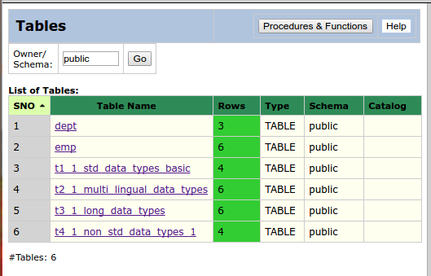

Test Status:
Platform | wjISQL | Date | Status | Remarks
Ubuntu 16.04 LTS  Chrome | 1.19.5(433) | 2017-10-22 | Success

Post Test Actions:
1 | Click button Disconnect to disconnect from pgsqldb.

Test Case 2/50: Setup MySQL destination database with empty tables to received data.
Test Prerequisites:
1 | None

Test Procedure
1 | Connect to MySQL database mysqldb using user id mysqlusr and password mysql123.
2 | Execute the following scripts from test source directory wjisql/wji_tsrc/wji_scripts/wji_01_basic_mysql_tables to create tables without any data:  tst_01_001_tables_drop_uc.sql  tst_01_002_tables_create_uc.sql
3 | Disconnect

Test Expected o/p:
1 | Successful creation of tables t1* to t4* without data in mysqldb:  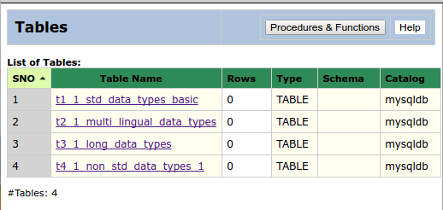

Test Status:
Platform | wjISQL | Date | Status | Remarks
Ubuntu 16.04 LTS  Chrome | 1.19.5(433) | 2017-10-22 | Success

Post Test Actions:
1 | Click button Disconnect to disconnect from mysqldb.

Successful Test Cases
Test Case 1/51: Test Transfer of data of tables from database pgsqldb to mysqldb.
Test Prerequisites:
1 | 3.1.1 Test Cases.

Test Procedure
1 | Click button Transfer on the main menu.
2 | Connect to source database pgsqldb with user pgsqlusr and password pgsql123.
3 | Connect to destination database mysqldb with user mysqlusr and password mysql123.
4 | Select four tables of source database as shown below:  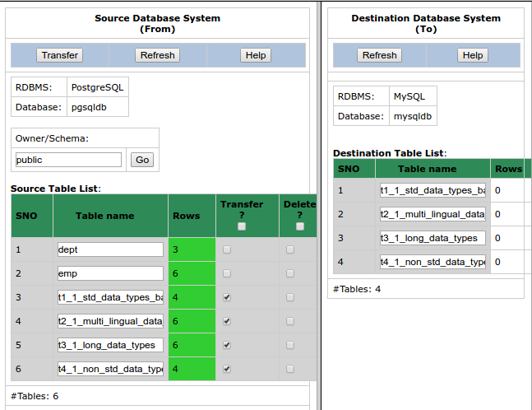
5 | Click button Transfer of source database window.
6 | Confirm OK on a transfer confirmation window.

Test Expected o/p:
1 | A new "Data Transfer Status" tab of browser with successful data transfer (see number of rows transferred) as shown below but with errors/warnings due to non-matching of columns:  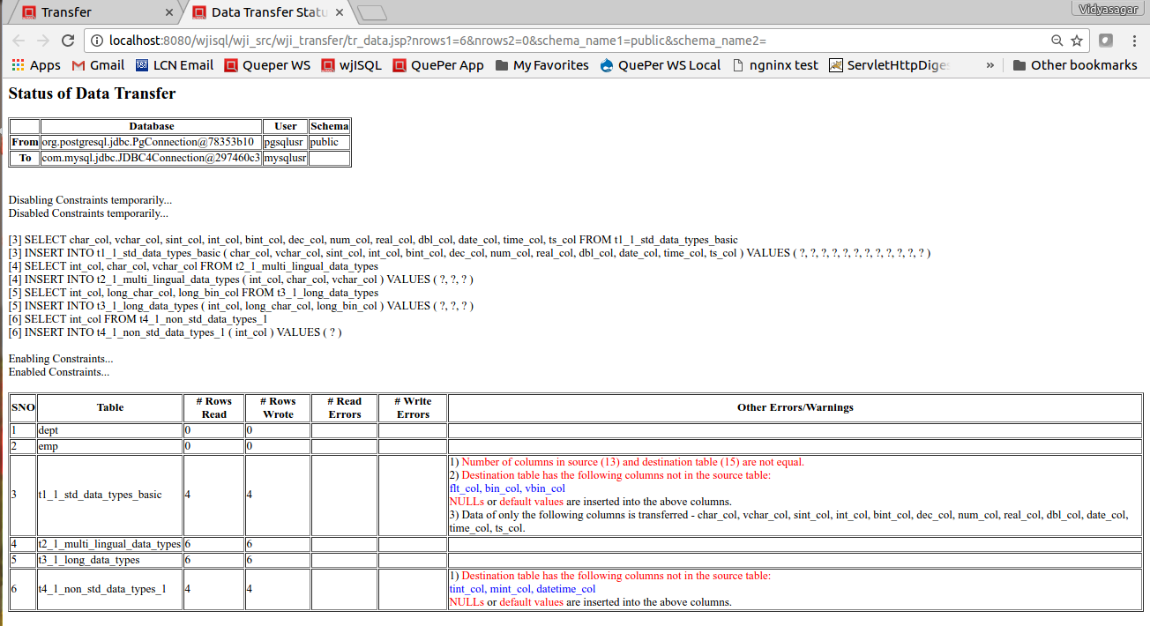

Post Test Actions
1 | Click on table "t2_1_..." in source and destination database table lists.
2 | Click on button Data on right side source and destination table properties windows.
3 | The resultant screen should indicate successfully transfered number of rows and data as shown below (scroll windows if needed):  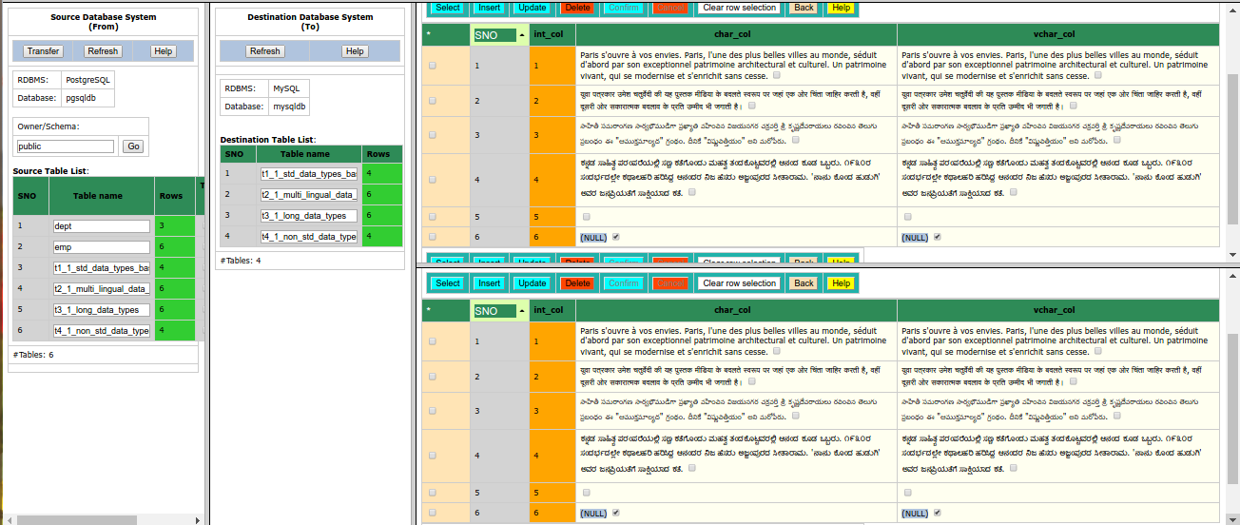

Test Status:
Platform | wjISQL | Date | Status | Remarks
Ubuntu 16.04 LTS  Chrome | 1.19.5(433) | 2017-10-22 | Success

Test Case 2/52: Test Transfer data of a table that does not have all columns of source table but has extra columns in the destination database
Test Prerequisites:
1 | Test Case 1.

Test Procedure
1 | Click on a table, say, t1_1..., in destination table list.
2 | Click button Data on the right bottom window to display the Result window that contains table data.
3 | Execute each of the following statements in SQL Statement window to create a new table that does not have column dno of source table but has extra columns edob and eexp:  DROP TABLE emp;  CREATE TABLE emp(eno INT NOT NULL PRIMARY KEY , ename VARCHAR(20), edob DATE, eexp INT DEFAULT 0);
4 | Select table emp of source database for data transfer as shown below:  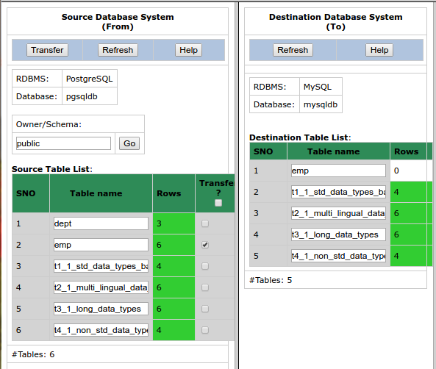
5 | Click button Transfer of source database window.
6 | Confirm OK on a transfer confirmation window.

Test Expected o/p:
1 | A new "Data Transfer Status" tab of browser with successful data transfer with warnings on non-existing and extra columns in the destination table as shown below:  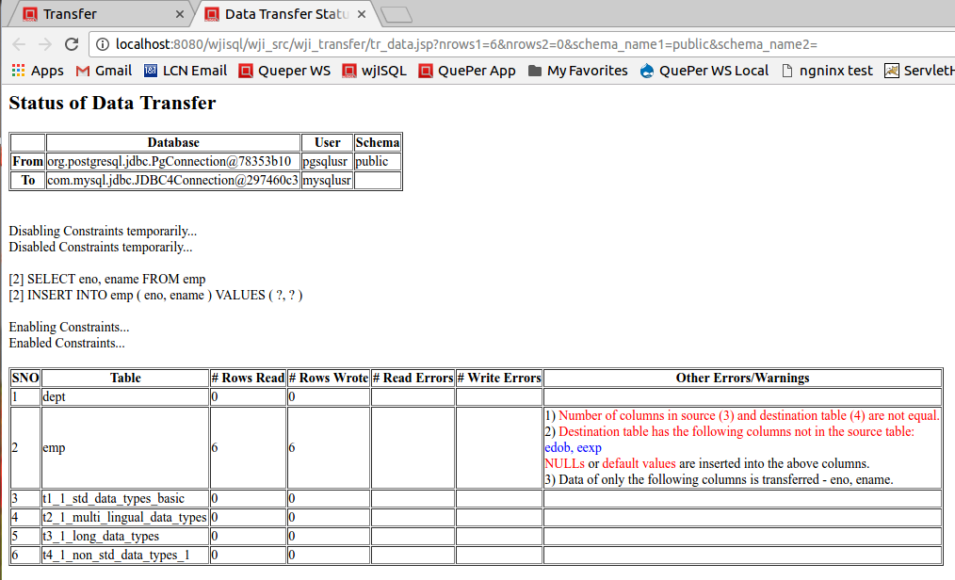

Post Test Actions
1 | Click on table "emp" in source and destination database table lists.
2 | Click on button Data on right side source and destination table properties windows.
3 | The resultant screen should indicate successful transfer of 6 rows of table emp and NULL values for column edob and default value of 0 for column eexp as shown below:  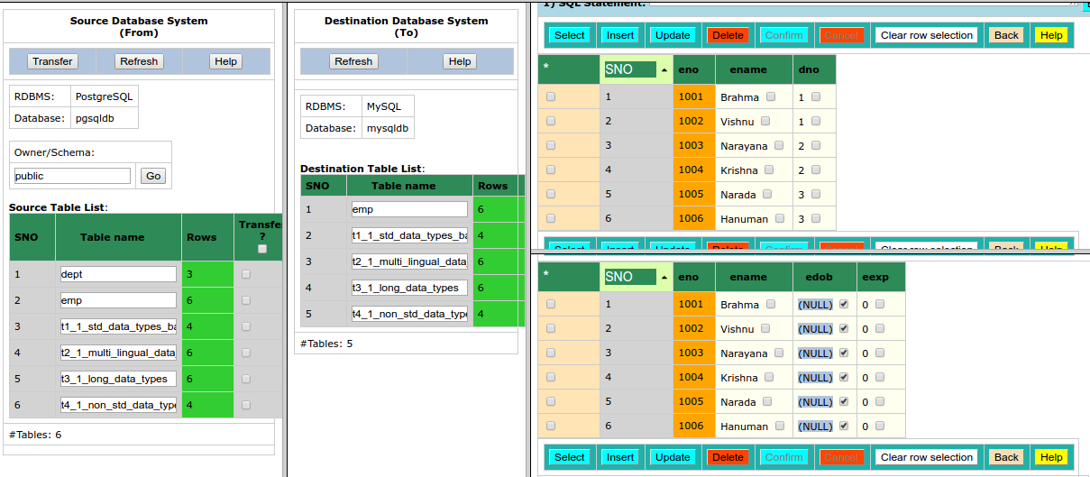

Test Status:
Platform | wjISQL | Date | Status | Remarks
Ubuntu 16.04 LTS  Chrome | 1.19.5(433) | 2017-10-22 | Success

Unsuccessful Test Cases
Test Case 1/53: Test failure of transfer of data of a table not defined in the destination database
Test Prerequisites:
1 | None

Test Procedure
1 | Select table dept of source database as shown below:  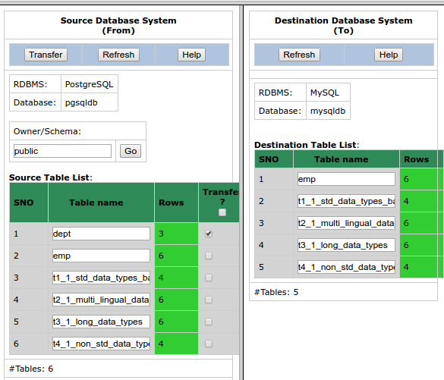
2 | Click button Transfer of source database window.
3 | Confirm OK on a transfer confirmation window.

Test Expected o/p:
1 | A new "Data Transfer Status" tab of browser with with error message saying the table does not exist in the destination database.  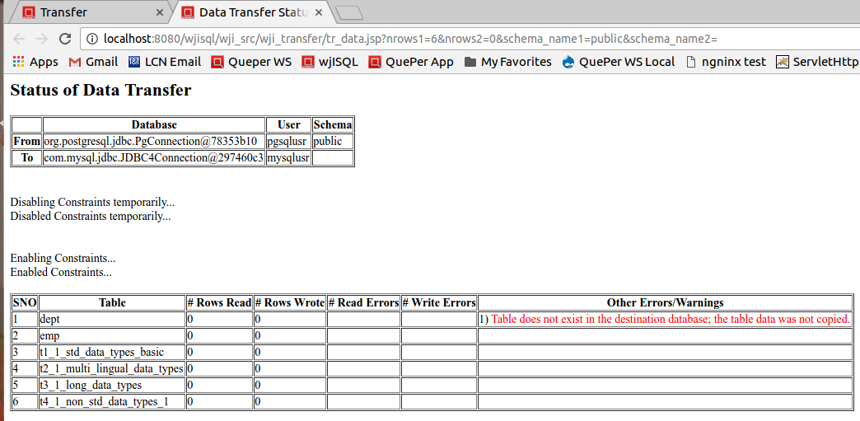

Post Test Actions
1 | Close browser tab "Data Transfer Status".

Test Status:
Platform | wjISQL | Date | Status | Remarks
Ubuntu 16.04 LTS  Chrome | 1.19.5(433) | 2017-10-22 | Success

Test Case 2/54: Test failure of transfer of data of a table due to constraints such as primary keys.
Test Prerequisites:
1 | None.

Test Procedure
1 | Select table t1_1_std_data_types_basic of source database for which data was already transferred as shown below:  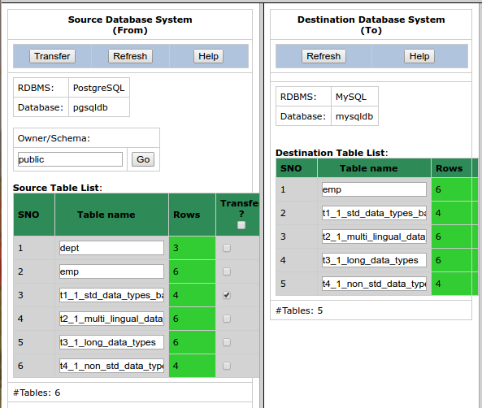
2 | Click button Transfer of source database window.
3 | Confirm OK on a transfer confirmation window.

Test Expected o/p:
1 | A new "Data Transfer Status" tab of browser with with error messages saying there is a constraint violation error and number of transfered rows (Rows Wrote) is 0 as shown below:  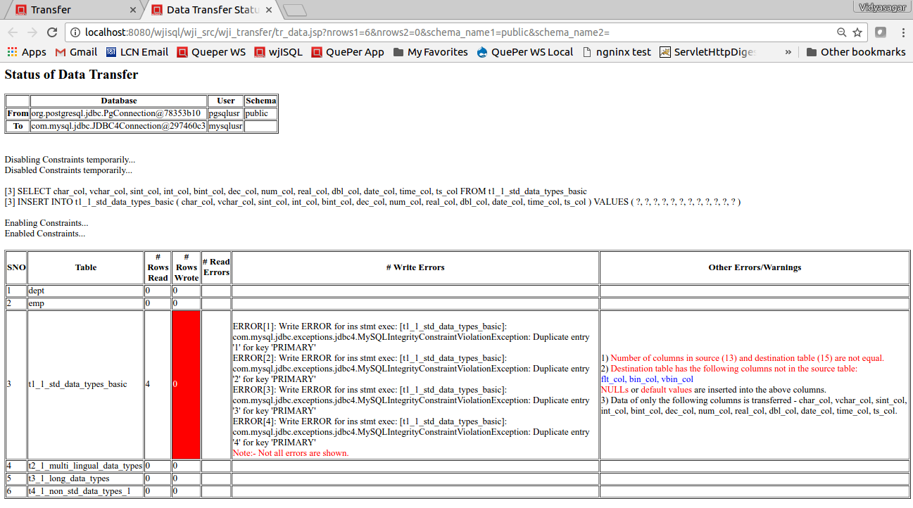

Post Test Actions
1 | Close browser tab "Data Transfer and Status".

Test Status:
Platform | wjISQL | Date | Status | Remarks
Ubuntu 16.04 LTS  Chrome | 1.19.5(433) | 2017-10-22 | Success

Post Test Test Cases
Test Case 1/55: Disconnect source and destination databases
Test Prerequisites:
1 | wjISQL is in Data Transfer screen.

Test Procedure
1 | Click menu item Disconnect source.
2 | Click menu item Disconnect destination.
3 | Click button Back.

Test Expected o/p:
1 | Main screen of wjISQL.

Test Status:
Platform | wjISQL | Date | Status | Remarks
Ubuntu 16.04 LTS  Chrome | 1.19.5(433) | 2017-10-22 | Success

Oracle Database Test Cases

Oracle To MSSQL Database Transfer Test Cases

Pre Test Test Cases
Test Case 1/56: Setup Oracle source database for data transfer.
Test Prerequisites:
1 | None

Test Procedure
1 | Connect to Oracle database oradb.
2 | Drop all tables that exist already.
3 | Execute the following scripts from test source directory wjisql/wji_tsrc/wji_scripts/wji_07_basic_oracle_tables to create tables with data:  tst_07_001_tables_drop_uc.sql  tst_07_002_tables_create_uc.sql  tst_07_003_tables_insert_uc.sql
4 | Execute the following script from test source directory wjisql/wji_tsrc/wji_scripts/wji_16_sql_scripts to create tables with data:  tst_16_002_sql_script_deptemp.sql  and ignore table dropping errors that may showup while executing the script.
5 | Disconnect

Test Expected o/p:
1 | Successful creation of tables with data in oradb:  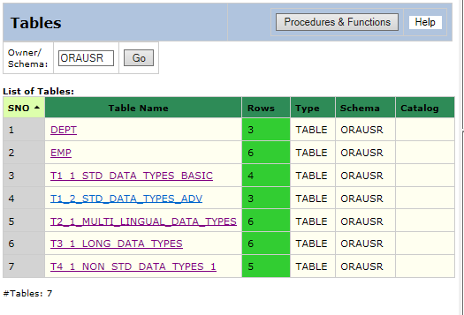

Test Status:
Platform | wjISQL | Date | Status | Remarks
Windows 7  IE 11.0 | 1.19.5(439) | 2017-10-27 | Success

Post Test Actions:
1 | Click button Disconnect to disconnect from oracledb.

Test Case 2/57: Setup MS SQL destination database with empty tables to received data.
Test Prerequisites:
1 | None

Test Procedure
1 | Connect to MS SQL database mssqldb using user id mssqlusr and password mssql123.
2 | Execute the following scripts from test source directory wjisql/wji_tsrc/wji_scripts/wji_10_basic_mssql_tables to create tables without any data:  tst_10_002_tables_drop_uc.sql  tst_10_002_tables_create_uc.sql
3 | Disconnect

Test Expected o/p:
1 | Successful creation of tables without data in mssqldb:  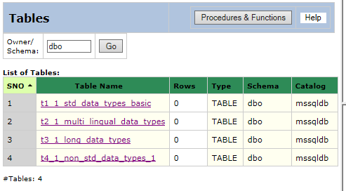

Test Status:
Platform | wjISQL | Date | Status | Remarks
Windows 7  IE 11.0 | 1.19.5(439) | 2017-10-27 | Success

Post Test Actions:
1 | Click button Disconnect to disconnect from mssqldb.

Successful Test Cases
Test Case 1/58: Test Transfer of data of tables from database oradb to mssqldb.
Test Prerequisites:
1 | 4.1.1 Test Cases.

Test Procedure
1 | Click button Transfer on the main menu.
2 | Connect to source database oradb with user orausr and password ora123.
3 | Connect to destination database mssqldb with user mssqlusr and password mssql123.
4 | Select four tables of source database as shown below:  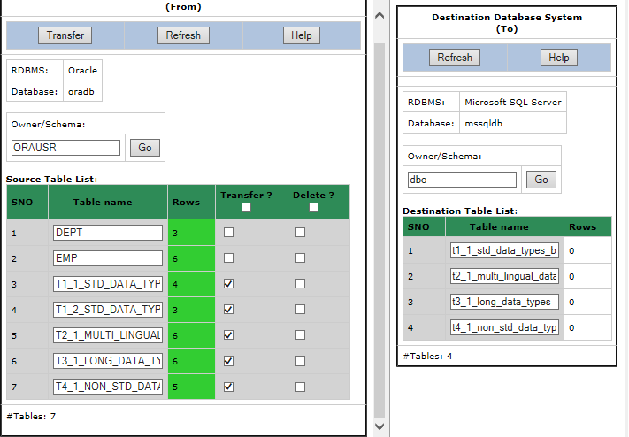
5 | Click button Transfer of source database window.
6 | Confirm OK on a transfer confirmation window.

Test Expected o/p:
1 | A new "Data Transfer Status" tab of browser with successful data transfer (see number of rows transferred) as shown below but with errors/warnings due to non-matching of columns:  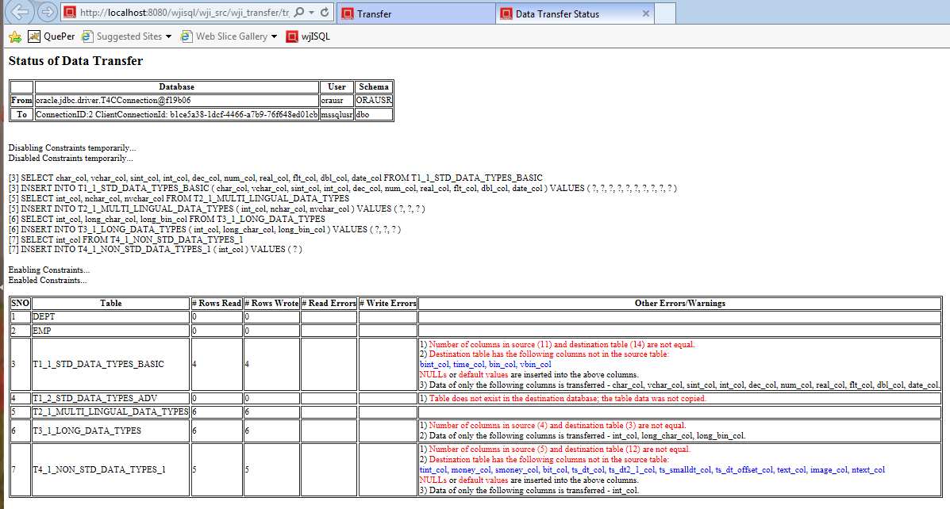

Post Test Actions
1 | Click on table "t2_1_..." in source and destination database table lists.
2 | Click on button Data on right side source and destination table properties windows.
3 | The resultant screen should indicate successfully transfered number of rows and data as shown below (scroll windows if needed):  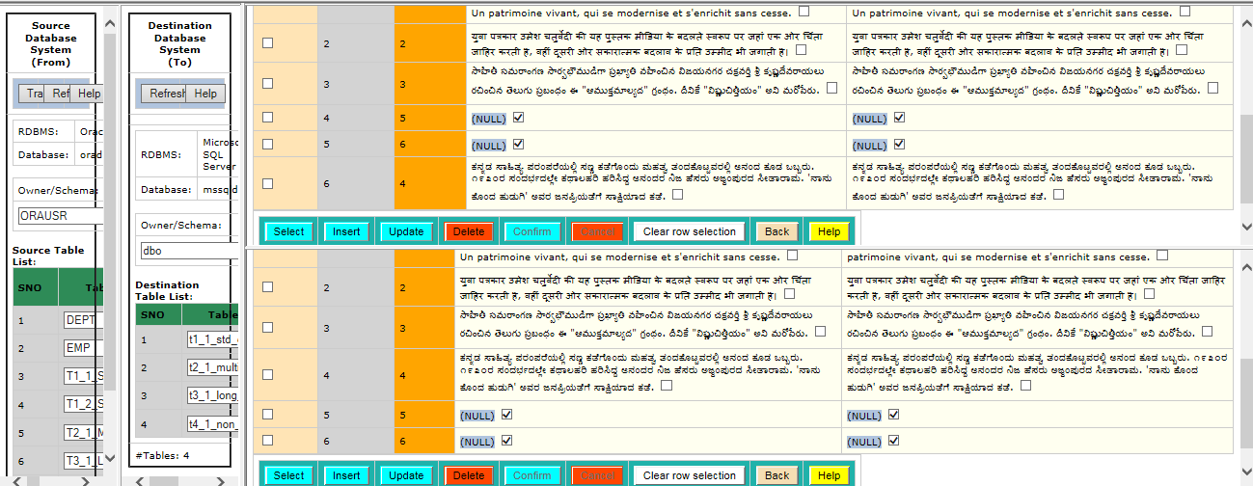

Test Status:
Platform | wjISQL | Date | Status | Remarks
Windows 7  IE 11.0 | 1.19.5(439) | 2017-10-27 | Success

Test Case 2/59: Test Transfer data of a table that does not have all columns of source table but has extra columns in the destination database
Test Prerequisites:
1 | Test Case 1.

Test Procedure
1 | Click on a table, say, t1_1..., in destination table list.
2 | Click button Data on the right bottom window to display the Result window that contains table data.
3 | Enter the following statement in SQL Statement window to create a new table that does not have column dno of source table but has extra columns edob and eexp:  CREATE TABLE emp(eno INT NOT NULL PRIMARY KEY , ename VARCHAR(20), edob DATE, eexp INT DEFAULT 0);  Drop the table if it already exists.
4 | Select table emp of source database for data transfer as shown below:  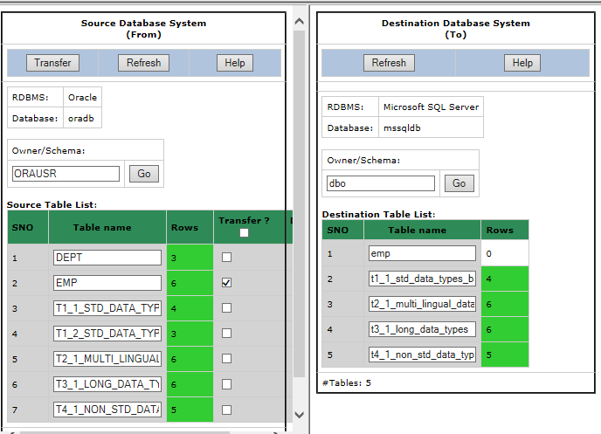
5 | Click button Transfer of source database window.
6 | Confirm OK on a transfer confirmation window.

Test Expected o/p:
1 | A new "Data Transfer Status" tab of browser with successful data transfer with warnings on non-existing and extra columns in the destination table as shown below:  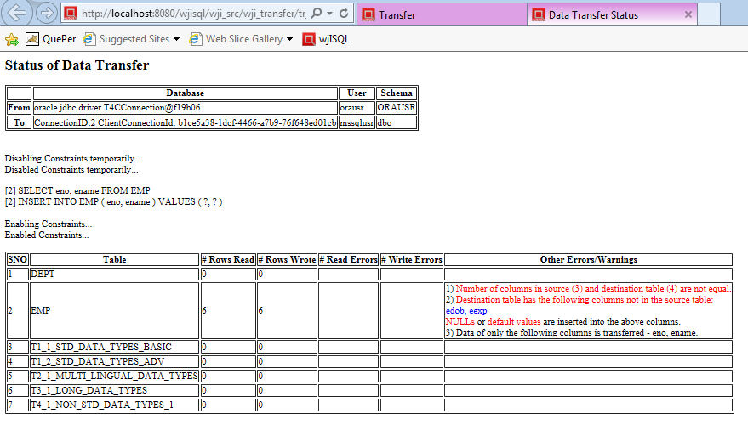

Post Test Actions
1 | Click on table "emp" in source and destination database table lists.
2 | Click on button Data on right side source and destination table properties windows.
3 | The resultant screen should indicate successful transfer of 6 rows of table emp and NULL values for column edob and default value of 0 for column eexp as shown below:  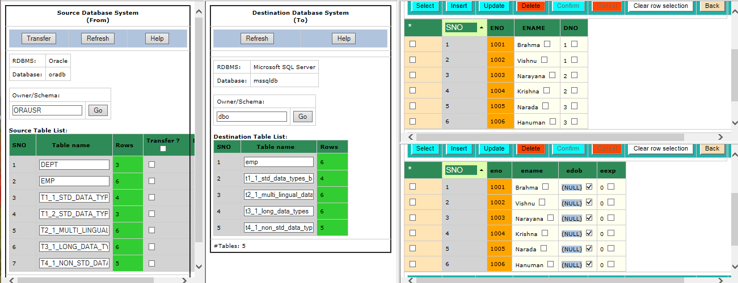

Test Status:
Platform | wjISQL | Date | Status | Remarks
Windows 7  IE 11.0 | 1.19.5(439) | 2017-10-27 | Success

Unsuccessful Test Cases
Test Case 1/60: Test failure of transfer of data of a table not defined in the destination database
Test Prerequisites:
1 | None

Test Procedure
1 | Select table dept of source database as shown below:  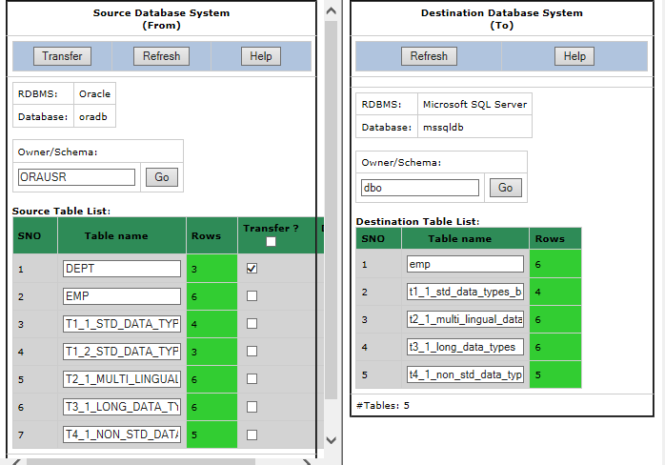
2 | Click button Transfer of source database window.
3 | Confirm OK on a transfer confirmation window.

Test Expected o/p:
1 | A new "Data Transfer Status" tab of browser with with error message saying the table does not exist in the destination database.  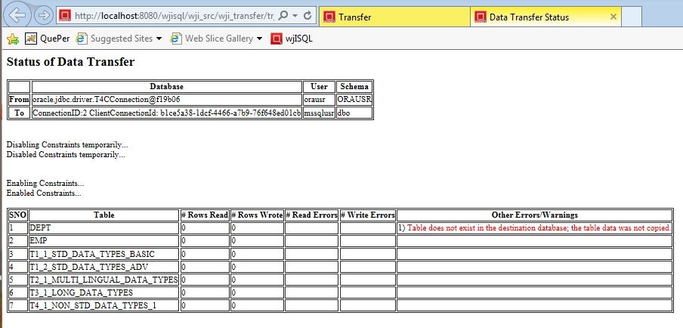

Post Test Actions
1 | Close browser tab "Data Transfer Status".

Test Status:
Platform | wjISQL | Date | Status | Remarks
Windows 7  IE 11.0 | 1.19.5(439) | 2017-10-27 | Success

Test Case 2/61: Test failure of transfer of data of a table due to constraints such as primary keys.
Test Prerequisites:
1 | None.

Test Procedure
1 | Select table t1_1_std_data_types_basic of source database for which data was already transferred as shown below:  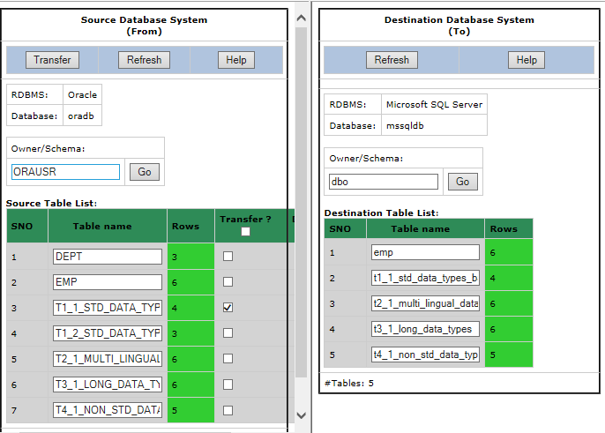
2 | Click button Transfer of source database window.
3 | Confirm OK on a transfer confirmation window.

Test Expected o/p:
1 | A new "Data Transfer Status" tab of browser with with error messages saying there is a constraint violation error and number of transfered rows (Rows Wrote) is 0 as shown below:  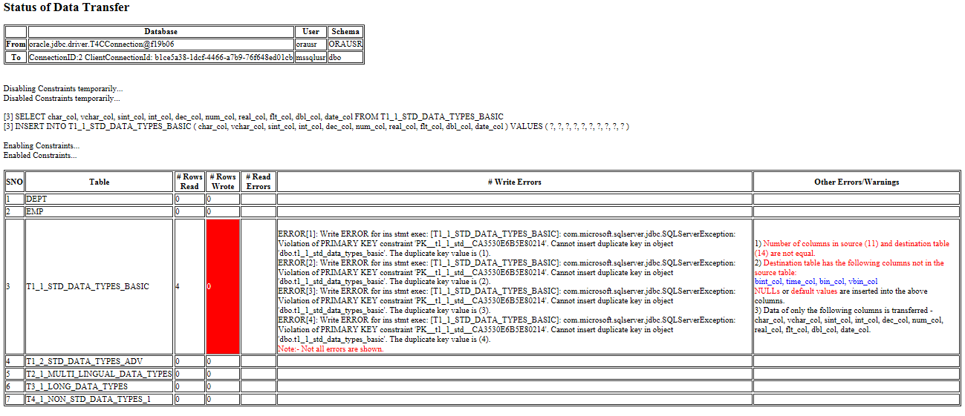

Post Test Actions
1 | Close browser tab "Data Transfer Status".

Test Status:
Platform | wjISQL | Date | Status | Remarks
Windows 7  IE 11.0 | 1.19.5(439) | 2017-10-27 | Success

Post Test Test Cases
Test Case 1/62: Disconnect source and destination databases
Test Prerequisites:
1 | wjISQL is in Data Transfer screen.

Test Procedure
1 | Click menu item Disconnect source.
2 | Click menu item Disconnect destination.
3 | Click button Back.

Test Expected o/p:
1 | Main screen of wjISQL.

Test Status:
Platform | wjISQL | Date | Status | Remarks
Windows 7  IE 11.0 | 1.19.5(439) | 2017-10-27 | Success

MS SQL Database Test Cases

MSSQL To Oracle Database Transfer Test Cases

Pre Test Test Cases
Test Case 1/63: Setup MS SQL source database with tables and data to transfer.
Test Prerequisites:
1 | None

Test Procedure
1 | Connect to MS SQL database mssqldb using user id mssqlusr and password mssql123.
2 | Execute the following scripts from test source directory wjisql/wji_tsrc/wji_scripts/wji_10_basic_mssql_tables to create tables with data:  tst_10_002_tables_drop_uc.sql  tst_10_002_tables_create_uc.sql  tst_10_002_tables_insert_uc.sql
3 | Execute the following script from test source directory wjisql/wji_tsrc/wji_scripts/wji_16_sql_scripts to create tables with data:  tst_16_002_sql_script_deptemp.sql
4 | Disconnect

Test Expected o/p:
1 | Successful creation of tables with data in mssqldb:  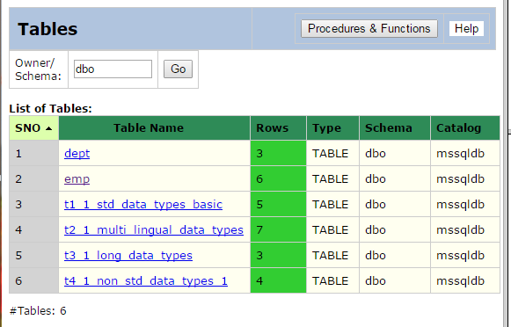

Test Status:
Platform | wjISQL | Date | Status | Remarks
Windows 7  Chrome 61.0 | 1.19.5(439) | 2017-10-27 | Success

Post Test Actions:
1 | Click button Disconnect to disconnect from mssqldb.

Test Case 2/64: Setup Oracle destination database for tables without data.
Test Prerequisites:
1 | None

Test Procedure
1 | Connect to Oracle database oradb.
2 | Drop all tables that exist already.
3 | Execute the following scripts from test source directory wjisql/wji_tsrc/wji_scripts/wji_07_basic_oracle_tables to create tables with data:  tst_07_002_tables_create_uc.sql  tst_07_003_tables_insert_uc.sql
4 | Disconnect

Test Expected o/p:
1 | Successful creation of tables without data in oradb:  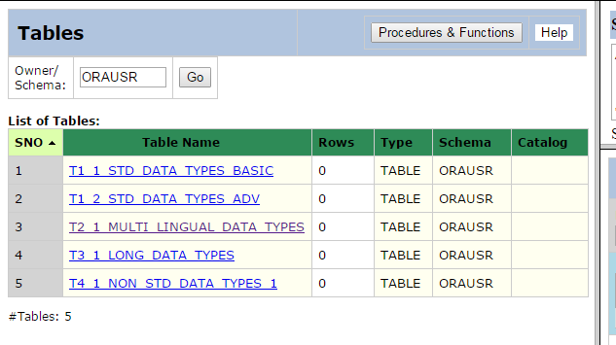

Test Status:
Platform | wjISQL | Date | Status | Remarks
Windows 7  Chrome 61.0 | 1.19.5(439) | 2017-10-27 | Success

Post Test Actions:
1 | Click button Disconnect to disconnect from oradb.

Successful Test Cases
Test Case 1/65: Test Transfer of data of tables from database mssqldb to oradb.
Test Prerequisites:
1 | 5.1.1 Test Cases.

Test Procedure
1 | Click button Transfer on the main menu.
2 | Connect to source database mssqldb with user mssqlusr and password mssql123.
3 | Connect to destination database oradb with user orausr and password ora123.
4 | Select four tables of source database as shown below:  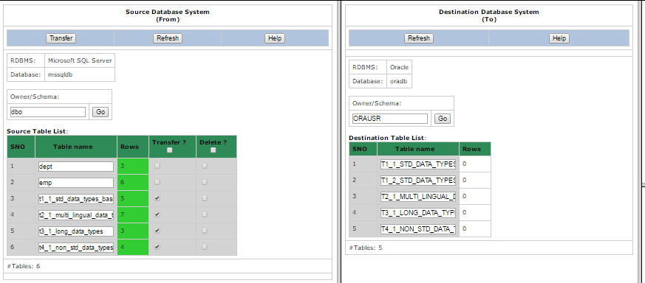
5 | Click button Transfer of source database window.
6 | Confirm OK on a transfer confirmation window.

Test Expected o/p:
1 | A new "Data Transfer Status" tab of browser with successful data transfer (see number of rows transferred) as shown below but with errors/warnings due to non-matching of columns:  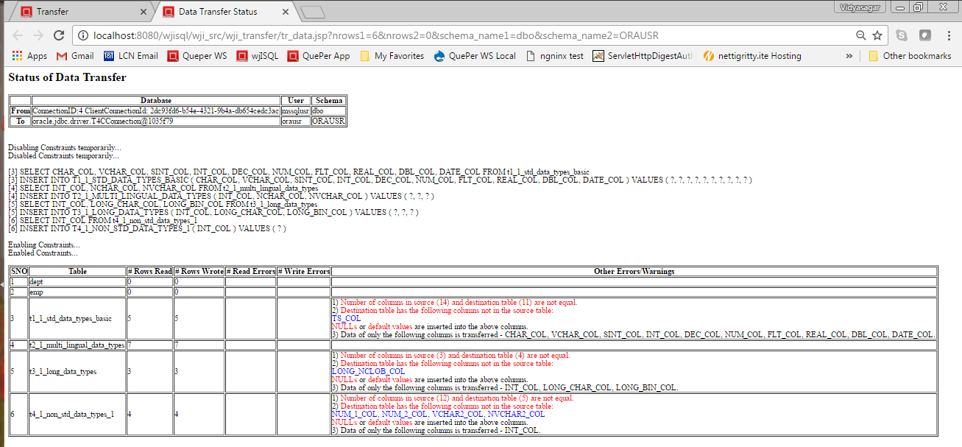

Post Test Actions
1 | Click on table "t2_1_..." in source and destination database table lists.
2 | Click on button Data on right side source and destination table properties windows.
3 | The resultant screen should indicate successfully transfered number of rows and data as shown below (scroll windows if needed):  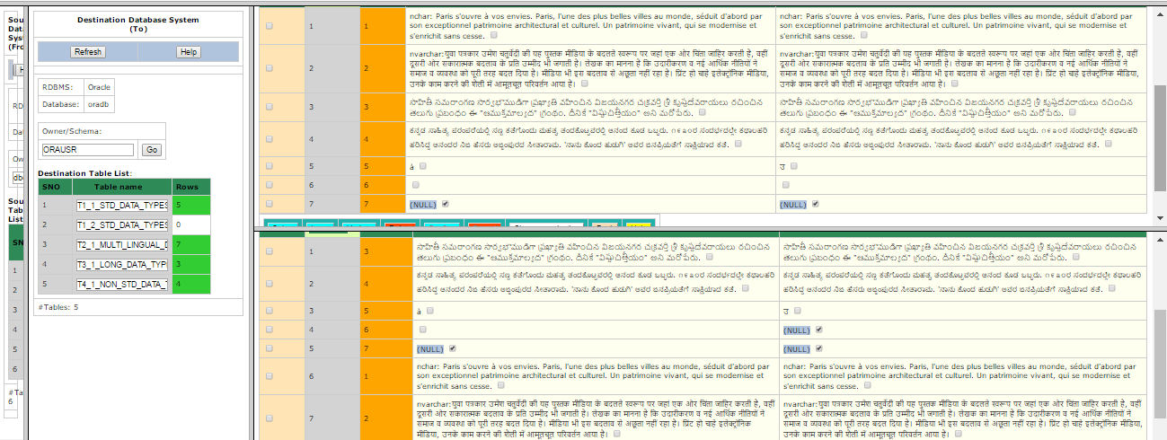  Note:- NULL was inserted instead of empty string in oracle's multi-lingual table. Oracle treats empty strings as NULLs.

Test Status:
Platform | wjISQL | Date | Status | Remarks
Windows 7  Chrome 61.0 | 1.19.5(439) | 2017-10-27 | Success

Test Case 2/66: Test Transfer data of a table that does not have all columns of source table but has extra columns in the destination database
Test Prerequisites:
1 | Test Case 1.

Test Procedure
1 | Click on a table, say, t1_1..., in destination table list.
2 | Click button Data on the right bottom window to display the Result window that contains table data.
3 | Enter the following statement in SQL Statement window to create a new table that does not have column dno of source table but has extra columns edob and eexp:  CREATE TABLE emp(eno INT NOT NULL PRIMARY KEY , ename VARCHAR(20), edob DATE, eexp INT DEFAULT 0);
4 | Select table emp of source database for data transfer as shown below:  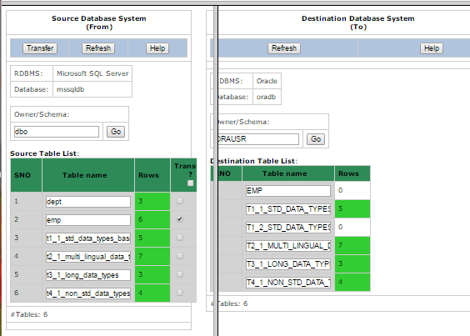
5 | Click button Transfer of source database window.
6 | Confirm OK on a transfer confirmation window.

Test Expected o/p:
1 | A new "Data Transfer Status" tab of browser with successful data transfer with warnings on non-existing and extra columns in the destination table as shown below:  <Test failed, no output.>

Post Test Actions
1 | Click on table "emp" in source and destination database table lists.
2 | Click on button Data on right side source and destination table properties windows.
3 | The resultant screen should indicate successful transfer of 6 rows of table emp and NULL values for column edob and default value of 0 for column eexp as shown below:  <Test failed, no output.>

Test Status:
Platform | wjISQL | Date | Status | Remarks
Windows 7  Chrome 61.0 | 1.19.5(439) | 2017-10-27 | FAILED | Bug filed:  W_B_20161231_64

Unsuccessful Test Cases
Test Case 1/67: Test failure of transfer of data of a table not defined in the destination database
Test Prerequisites:
1 | None

Test Procedure
1 | Select table dept of source database as shown below:  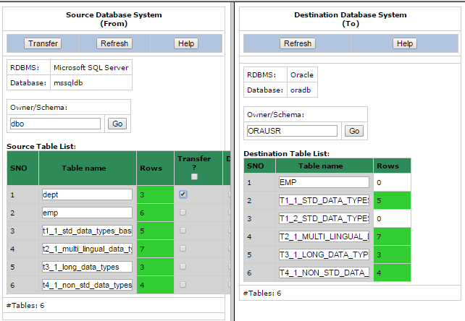
2 | Click button Transfer of source database window.
3 | Confirm OK on a transfer confirmation window.

Test Expected o/p:
1 | A new "Data Transfer Status" tab of browser with with error message saying the table does not exist in the destination database.  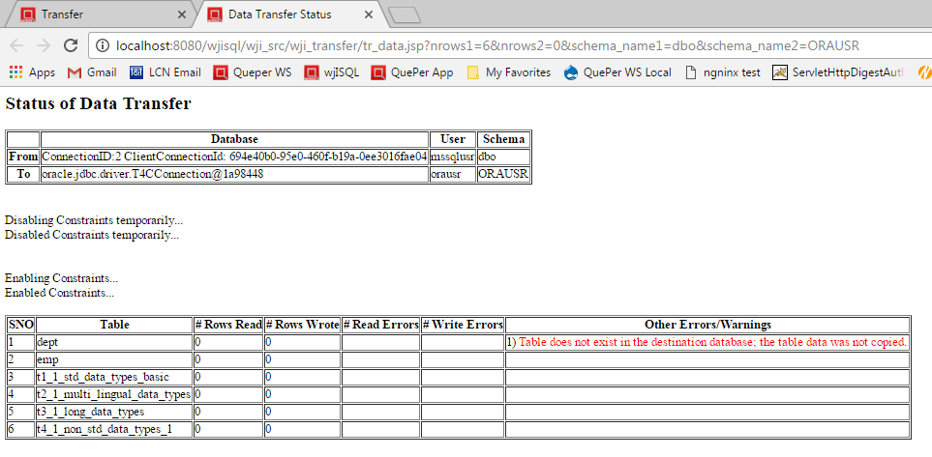

Post Test Actions
1 | Close browser tab "Data Transfer Status".

Test Status:
Platform | wjISQL | Date | Status | Remarks
Windows 7  Chrome 61.0 | 1.19.5(439) | 2017-10-27 | Success

Test Case 2/68: Test failure of transfer of data of a table due to constraints such as primary keys.
Test Prerequisites:
1 | None.

Test Procedure
1 | Select table t1_1_std_data_types_basic of source database for which data was already transferred as shown below:  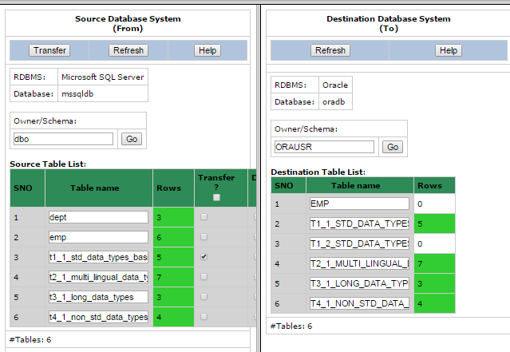
2 | Click button Transfer of source database window.
3 | Confirm OK on a transfer confirmation window.

Test Expected o/p:
1 | A new "Data Transfer Status" tab of browser with with error messages saying there is a constraint violation error and number of transfered rows (Rows Wrote) is 0 as shown below:  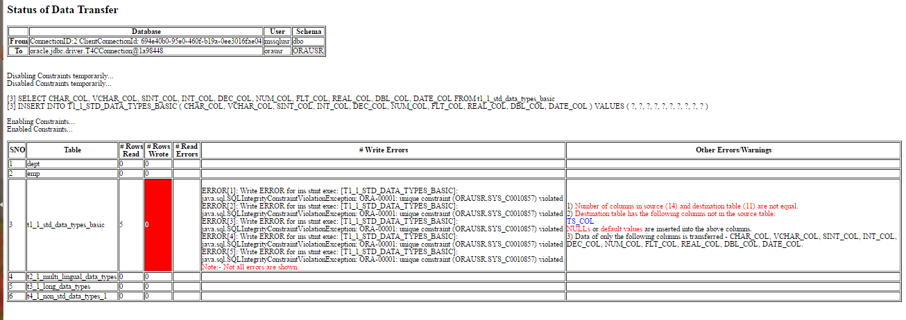

Post Test Actions
1 | Close browser tab "Data Transfer Status".

Test Status:
Platform | wjISQL | Date | Status | Remarks
Windows 7  Chrome 61.0 | 1.19.5(439) | 2017-10-27 | Success

Post Test Test Cases
Test Case 1/69: Disconnect source and destination databases
Test Prerequisites:
1 | wjISQL is in Data Transfer screen.

Test Procedure
1 | Click menu item Disconnect source.
2 | Click menu item Disconnect destination.
3 | Click button Back.

Test Expected o/p:
1 | Main screen of wjISQL.

Test Status:
Platform | wjISQL | Date | Status | Remarks
Windows 7  Chrome 61.0 | 1.19.5(439) | 2017-10-27 | Success

SQLite Database Test Cases

SQLite To SQLite Database Transfer Test Cases

SQLite To MariaDB Database Transfer Test Cases

SQLite To PostgreSQL Database Transfer Test Cases

SQLite To MSSQL Database Transfer Test Cases

Pre Test Test Cases

Test Case 1/70: Setup SQLite source database for data transfer.
Test Prerequisites:
1 | None

Test Procedure
1 | Connect to Oracle database C:/TEMP/sqlitedb.
2 | Drop all tables that exist already.
3 | Execute the following scripts from test source directory wjisql/wji_tsrc/wji_scripts/wji_13_basic_sqlite_tables to create tables with data:  tst_13_002_tables_drop_uc.sql  tst_13_002_tables_create_uc.sql  tst_13_003_tables_insert_uc.sql
4 | Execute the following script from test source directory wjisql/wji_tsrc/wji_scripts/wji_16_sql_scripts to create tables with data:  tst_16_002_sql_script_deptemp.sql
5 | Disconnect

Test Expected o/p:
1 | Successful creation of tables with data in sqlitedb:  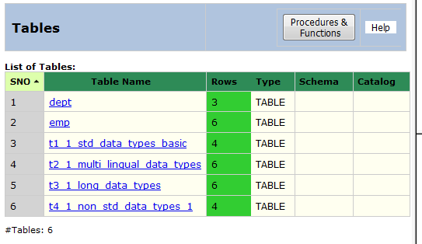

Test Status:
Platform | wjISQL | Date | Status | Remarks
Windows 7  FireFox 56.0 | 1.19.5(439) | 2017-10-26 | Success

Post Test Actions:
1 | Click button Disconnect to disconnect from sqlitedb.

Test Case 2/71: Setup MS SQL destination database with empty tables to received data.
Test Prerequisites:
1 | None

Test Procedure
1 | Connect to MS SQL database mssqldb using user id mssqlusr and password mssql123.
2 | Execute the following scripts from test source directory wjisql/wji_tsrc/wji_scripts/wji_10_basic_mssql_tables to create tables without any data:  tst_10_002_tables_drop_uc.sql  tst_10_002_tables_create_uc.sql
3 | Disconnect

Test Expected o/p:
1 | Successful creation of tables without data in mysqldb:  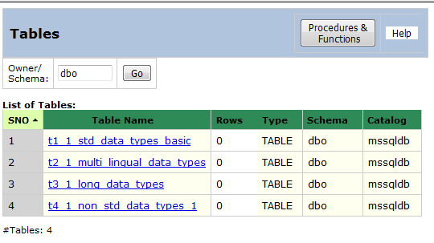

Test Status:
Platform | wjISQL | Date | Status | Remarks
Windows 7  FireFox 56.0 | 1.19.5(439) | 2017-10-26 | Success

Post Test Actions:
1 | Click button Disconnect to disconnect from mssqldb.

Successful Test Cases
Test Case 1/72: Test Transfer of data of tables from database sqlitedb to mssqldb.
Test Prerequisites:
1 | 6.1.1 Test Cases.

Test Procedure
1 | Click button Transfer on the main menu.
2 | Connect to source database C:/TEMP/sqlitedb.
3 | Connect to destination database mssqldb with user mssqlusr and password mssql123.
4 | Select four tables of source database as shown below:  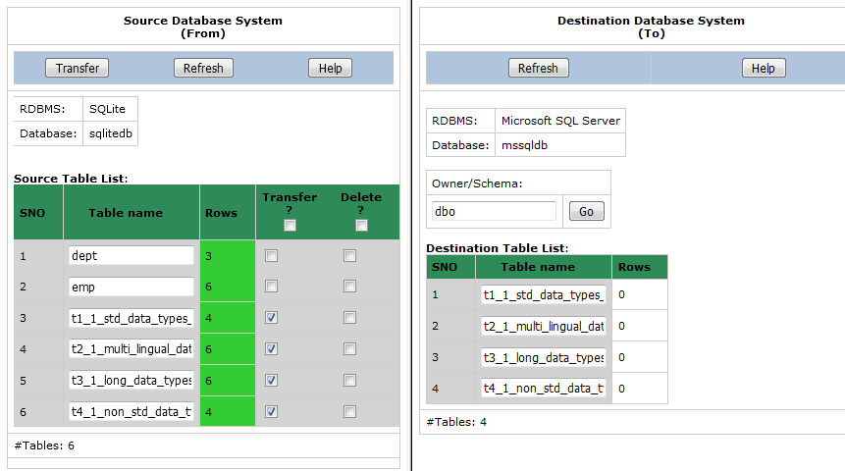
5 | Click button Transfer of source database window.
6 | Confirm OK on a transfer confirmation window.

Test Expected o/p:
1 | A new "Data Transfer Status" tab of browser with successful data transfer (see number of rows transferred) as shown below but with errors/warnings due to non-matching of columns:  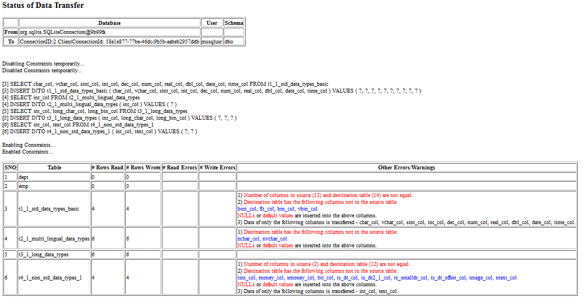

Post Test Actions
1 | Click on table "t2_1_..." in source and destination database table lists.
2 | Click on button Data on right side source and destination table properties windows.
3 | The resultant screen should indicate successful transfer of number of rows and data as shown below (scroll windows if needed):  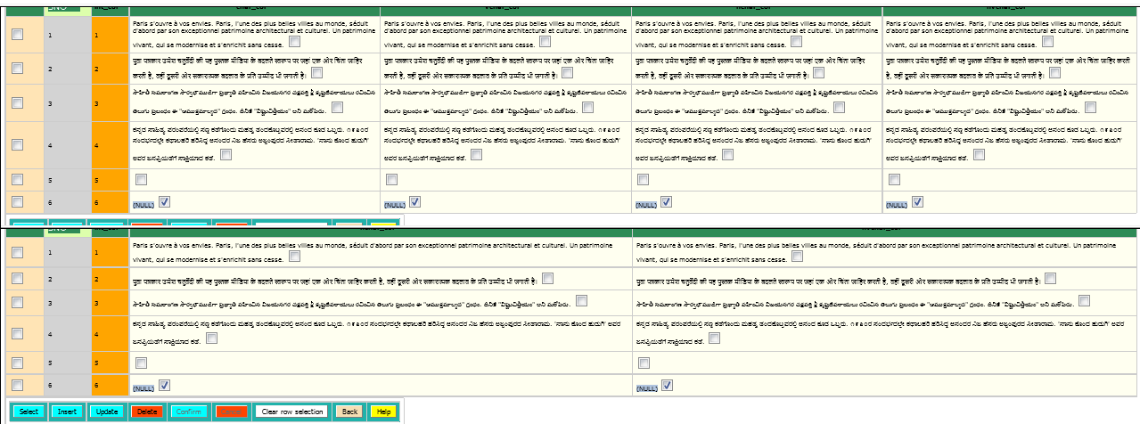

Test Status:
Platform | wjISQL | Date | Status | Remarks
Windows 7  FireFox 56.0 | 1.19.5(439) | 2017-10-26 | Success

Test Case 2/73: Test Transfer data of a table that does not have all columns of source table but has extra columns in the destination database
Test Prerequisites:
1 | Test Case 1.

Test Procedure
1 | Click on a table, say, t1_1..., in destination table list.
2 | Click button Data on the right bottom window to display the Result window that contains table data.
3 | Enter the following statement in SQL Statement window to create a new table that does not have column dno of source table but has extra columns edob and eexp:  CREATE TABLE emp(eno INT NOT NULL PRIMARY KEY , ename VARCHAR(20), edob DATE, eexp INT DEFAULT 0);
4 | Select table emp of source database for data transfer as shown below:  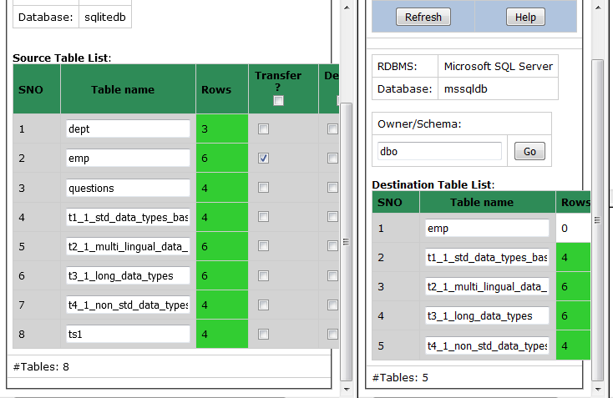
5 | Click button Transfer of source database window.
6 | Confirm OK on a transfer confirmation window.

Test Expected o/p:
1 | A new "Data Transfer Status" tab of browser with successful data transfer with warnings on non-existing and extra columns in the destination table as shown below:  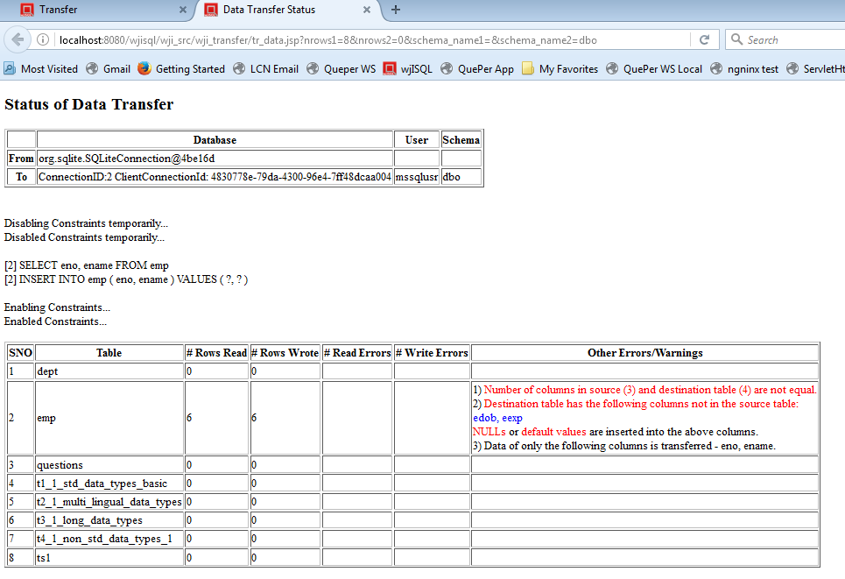

Post Test Actions
1 | Click on table "emp" in source and destination database table lists.
2 | Click on button Data on right side source and destination table properties windows.
3 | The resultant screen should indicate successful transfer of 6 rows of table emp and NULL values for column edob and default value of 0 for column eexp as shown below:  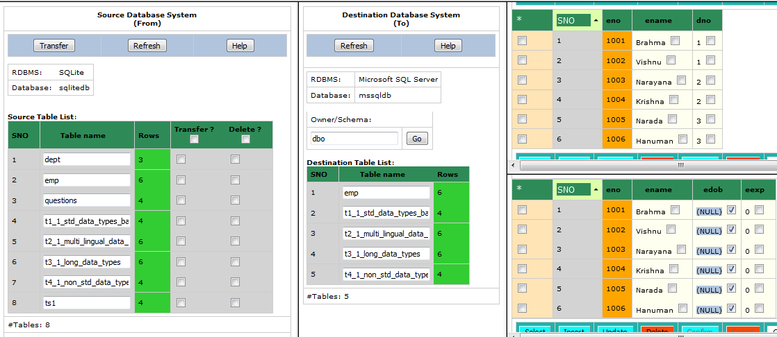

Test Status:
Platform | wjISQL | Date | Status | Remarks
Windows 7  FireFox 56.0 | 1.19.5(439) | 2017-10-26 | Success

Unsuccessful Test Cases
Test Case 1/74: Test failure of transfer of data of a table not defined in the destination database
Test Prerequisites:
1 | None

Test Procedure
1 | Select table dept of source database as shown below:  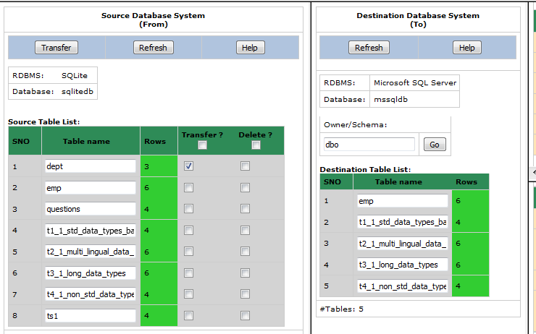
2 | Click button Transfer of source database window.
3 | Confirm OK on a transfer confirmation window.

Test Expected o/p:
1 | A new "Data Transfer Status" tab of browser with with error message saying the table does not exist in the destination database.  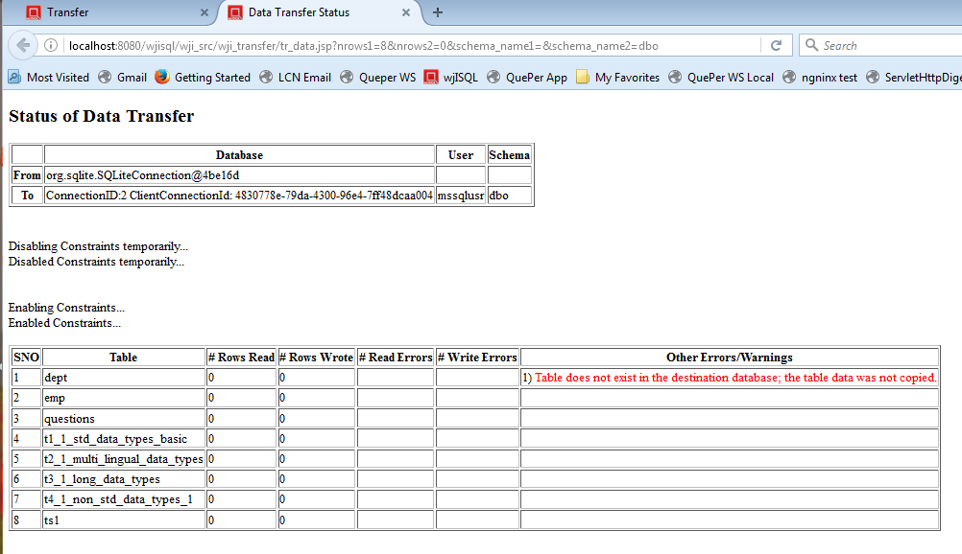

Post Test Actions
1 | Close browser tab "Data Transfer Status".

Test Status:
Platform | wjISQL | Date | Status | Remarks
Windows 7  FireFox 56.0 | 1.19.5(439) | 2017-10-26 | Success

Test Case 2/75: Test failure of transfer of data of a table due to constraints such as primary keys.
Test Prerequisites:
1 | None.

Test Procedure
1 | Select table t1_1_std_data_types_basic of source database for which data was already transferred as shown below:  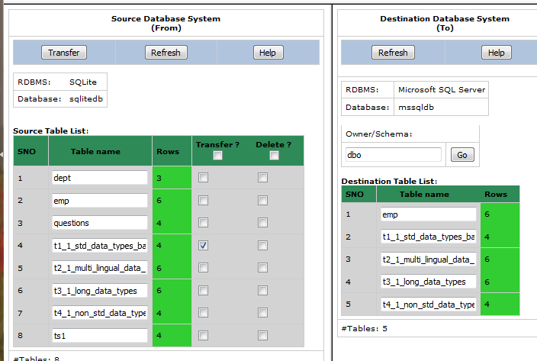
2 | Click button Transfer of source database window.
3 | Confirm OK on a transfer confirmation window.

Test Expected o/p:
1 | A new "Data Transfer Status" tab of browser with with error messages saying there is a constraint violation error and number of transfered rows (Rows Wrote) is 0 as shown below:  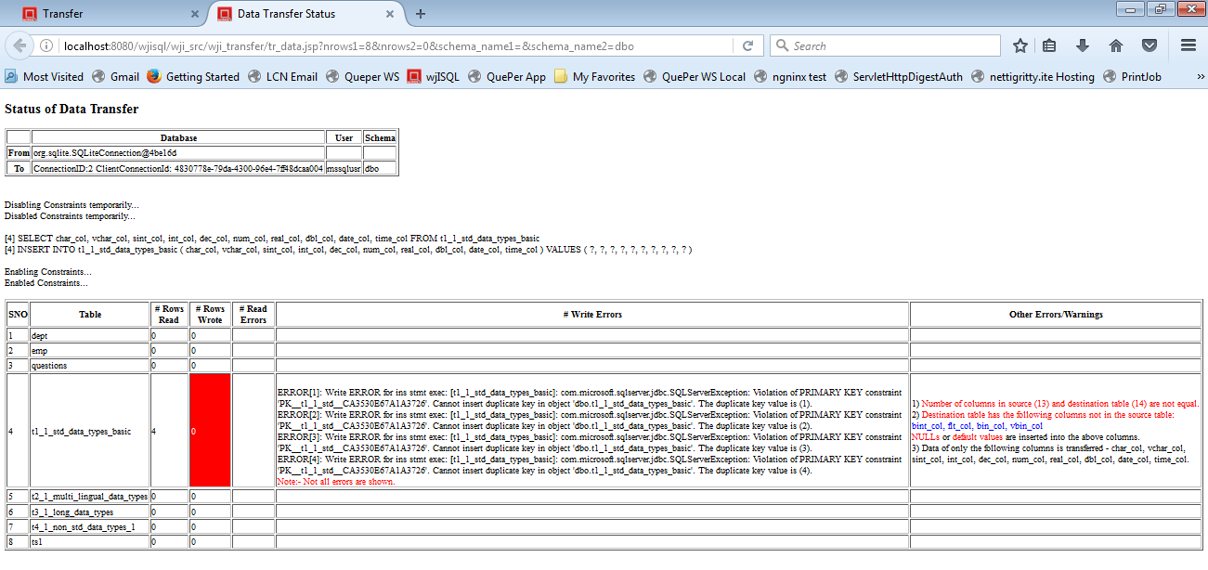

Post Test Actions
1 | Close browser tab "Data Transfer Status".

Test Status:
Platform | wjISQL | Date | Status | Remarks
Windows 7  FireFox 56.0 | 1.19.5(439) | 2017-10-26 | Success

Post Test Test Cases
Test Case 1/76: Disconnect source and destination databases
Test Prerequisites:
1 | wjISQL is in Data Transfer screen.

Test Procedure
1 | Click menu item Disconnect source.
2 | Click menu item Disconnect destination.
3 | Click button Back.

Test Expected o/p:
1 | Main screen of wjISQL.

Test Status:
Platform | wjISQL | Date | Status | Remarks
Windows 7  FireFox 56.0 | 1.19.5(439) | 2017-10-26 | Success

SQLite To Oracle Database Transfer Test Cases

Pre Test Test Cases

Test Case 1/77: Setup SQLite source database for data transfer.
Test Prerequisites:
1 | None

Test Procedure
1 | Connect to Oracle database C:/TEMP/sqlitedb.
2 | Drop all tables that exist already.
3 | Execute the following scripts from test source directory wjisql/wji_tsrc/wji_scripts/wji_13_basic_sqlite_tables to create tables with data:  tst_13_002_tables_create_uc.sql  tst_13_003_tables_insert_uc.sql
4 | Execute the following script from test source directory wjisql/wji_tsrc/wji_scripts/wji_16_sql_scripts to create tables with any data:  tst_16_002_sql_script_deptemp.sql
5 | Disconnect

Test Expected o/p:
1 | Successful creation of tables with data in sqlitedb:

Test Status:
Platform | wjISQL | Date | Status | Remarks
Windows 7  FireFox | 1.13.17(376) | 2017-01-01 | Success

Post Test Actions:
1 | Click button Disconnect to disconnect from sqlitedb.

Test Case 2/78: Setup Oracle destination database with empty tables to received data.
Test Prerequisites:
1 | None

Test Procedure
1 | Connect to MS SQL database oradb using user id orausr and password ora123.
2 | Drop all tables that exist already.
3 | Execute the following scripts from test source directory wjisql/wji_tsrc/wji_scripts/wji_07_basic_oracle_tables to create tables without any data:  tst_07_002_tables_create_uc.sql
4 | Disconnect

Test Expected o/p:
1 | Successful creation of tables without data in oradb:  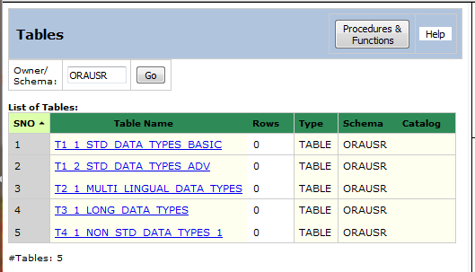

Test Status:
Platform | wjISQL | Date | Status | Remarks
Windows 7  FireFox | 1.13.17(376) | 2017-01-01 | Success

Post Test Actions:
1 | Click button Disconnect to disconnect from oradb.

Successful Test Cases
Test Case 1/79: Test Transfer of data of tables from database sqlitedb to oradb.
Test Prerequisites:
1 | 6.1.1 Test Cases.

Test Procedure
1 | Click button Transfer on the main menu.
2 | Connect to source database C:/TEMP/sqlitedb.
3 | Connect to destination database oradb with user orausr and password ora123.
4 | Select four tables of source database as shown below:  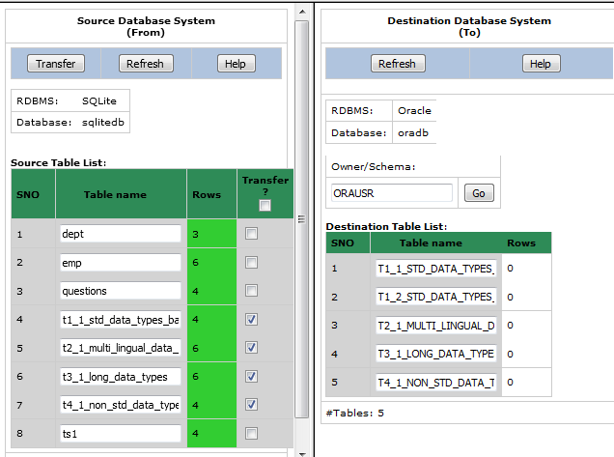
5 | Click button Transfer of source database window.
6 | Confirm OK on a transfer confirmation window.

Test Expected o/p:
1 | A new "Data Transfer Status" tab of browser with successful data transfer (see number of rows transferred) as shown below but with errors/warnings due to non-matching of columns:  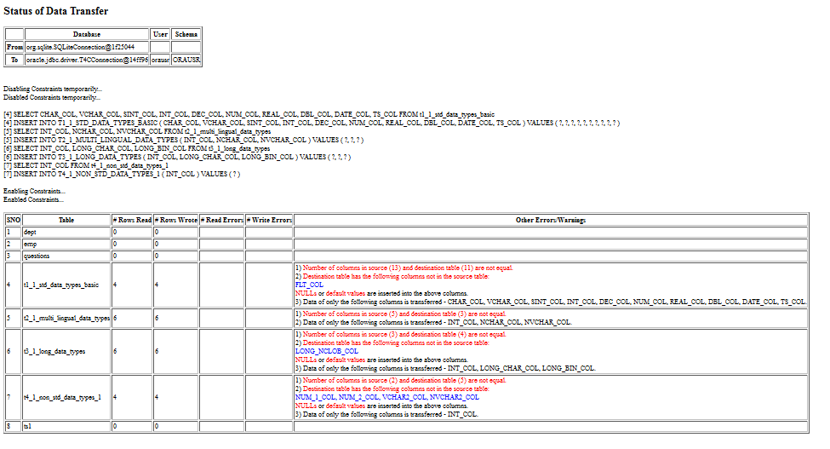

Post Test Actions
1 | Click on table "t2_1_..." in source and destination database table lists.
2 | Click on button Data on right side source and destination table properties windows.
3 | The resultant screen should indicate successful transfer of number of rows and data as shown below (scroll windows if needed):  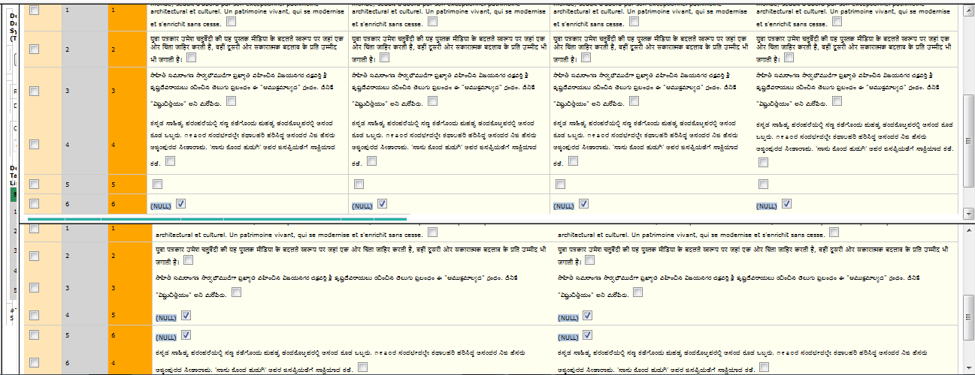  Note that NULLs were instead of empty strings in a row as expected for Oracle tables.

Test Status:
Platform | wjISQL | Date | Status | Remarks
Windows 7  FireFox | 1.13.17(376) | 2017-01-01 | Success

Test Case 2/80: Test Transfer data of a table that does not have all columns of source table but has extra columns in the destination database
Test Prerequisites:
1 | Test Case 1.

Test Procedure
1 | Click on a table, say, t1_1..., in destination table list.
2 | Click button Data on the right bottom window to display the Result window that contains table data.
3 | Enter the following statement in SQL Statement window to create a new table that does not have column dno of source table but has extra columns edob and eexp:  CREATE TABLE emp(eno INT NOT NULL PRIMARY KEY , ename VARCHAR(20), edob DATE, eexp INT DEFAULT 0);
4 | Select table emp of source database for data transfer as shown below:  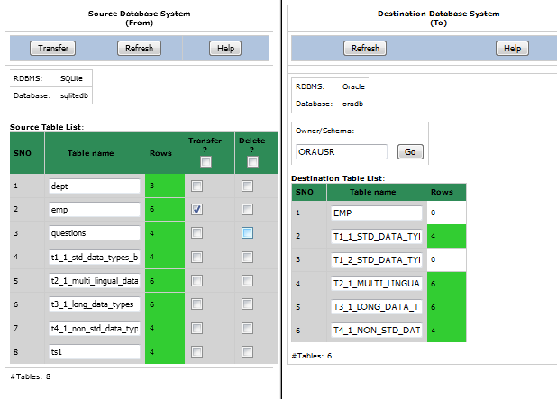
5 | Click button Transfer of source database window.
6 | Confirm OK on a transfer confirmation window.

Test Expected o/p:
1 | A new "Data Transfer Status" tab of browser with successful data transfer with warnings on non-existing and extra columns in the destination table as shown below:  <test failed> with following o/p:  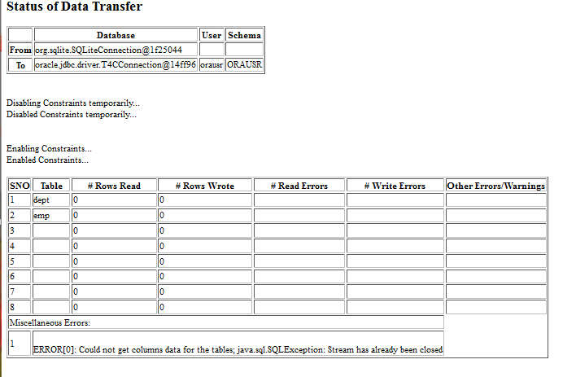

Post Test Actions
1 | Click on table "emp" in source and destination database table lists.
2 | Click on button Data on right side source and destination table properties windows.
3 | The resultant screen should indicate successful transfer of 6 rows of table emp and NULL values for column edob and default value of 0 for column eexp as shown below:  <test failed>

Test Status:
Platform | wjISQL | Date | Status | Remarks
Windows 7  FireFox | 1.13.17(376) | 2017-01-01 | FAILED | Bug filed:  W_B_20161231_64

Unsuccessful Test Cases
Test Case 1/81: Test failure of transfer of data of a table not defined in the destination database
Test Prerequisites:
1 | None

Test Procedure
1 | Select table dept of source database as shown below:  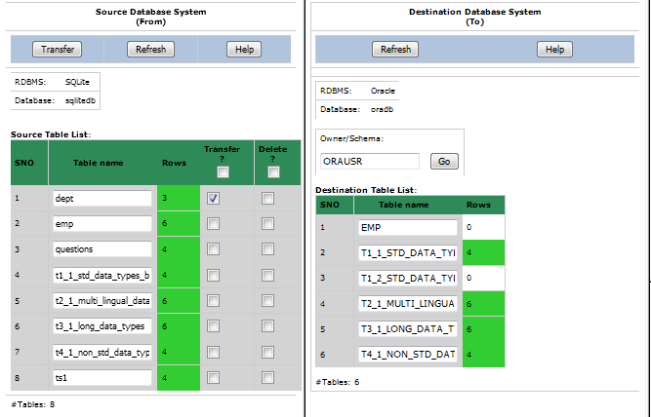
2 | Click button Transfer of source database window.
3 | Confirm OK on a transfer confirmation window.

Test Expected o/p:
1 | A new "Data Transfer Status" tab of browser with with error message saying the table does not exist in the destination database.  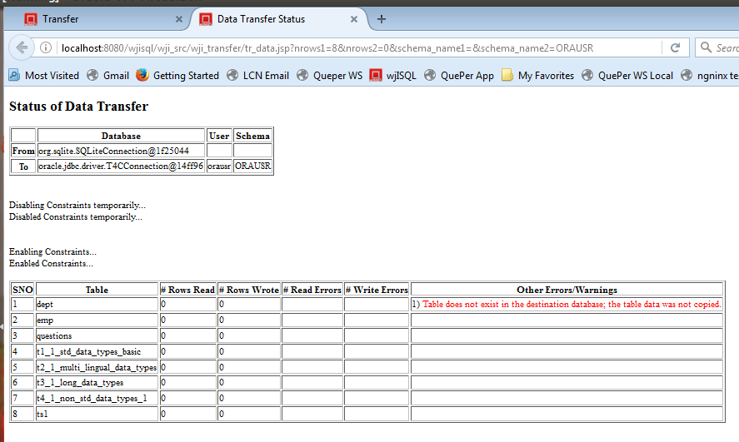

Post Test Actions
1 | Close browser tab "Data Transfer Status".

Test Status:
Platform | wjISQL | Date | Status | Remarks
Windows 7  FireFox | 1.13.17(376) | 2017-01-01 | Success

Test Case 2/82: Test failure of transfer of data of a table due to constraints such as primary keys.
Test Prerequisites:
1 | None.

Test Procedure
1 | Select table t1_1_std_data_types_basic of source database for which data was already transferred as shown below:  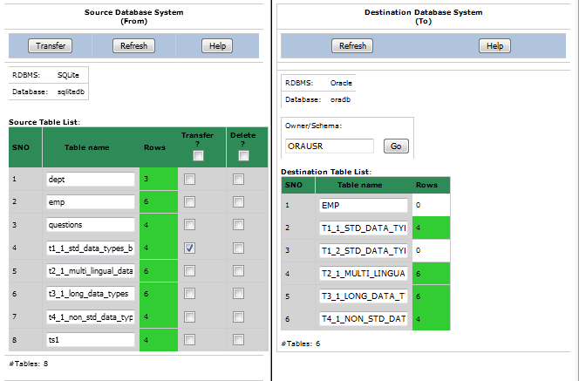
2 | Click button Transfer of source database window.
3 | Confirm OK on a transfer confirmation window.

Test Expected o/p:
1 | A new "Data Transfer Status" tab of browser with with error messages saying there is a constraint violation error and number of transfered rows (Rows Wrote) is 0 as shown below:  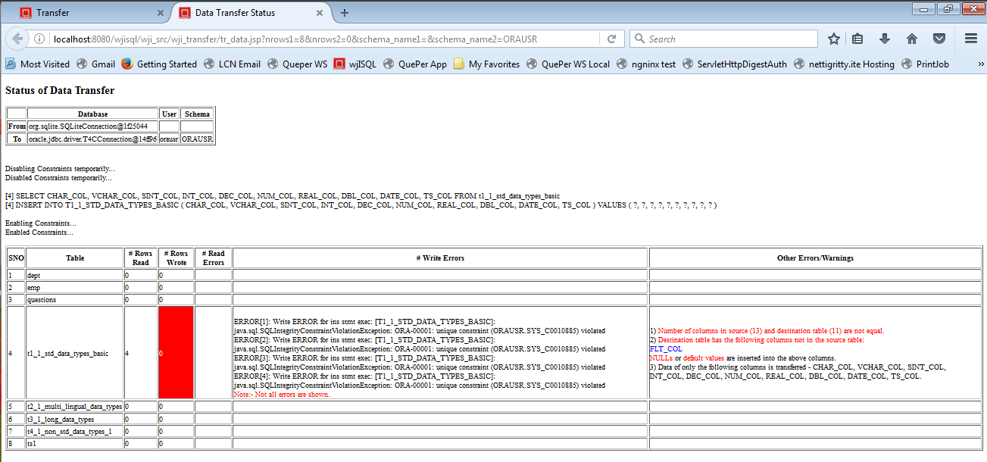

Post Test Actions
1 | Close browser tab "Data Transfer Status".

Test Status:
Platform | wjISQL | Date | Status | Remarks
Windows 7  FireFox | 1.13.17(376) | 2017-01-01 | Success

Post Test Test Cases
Test Case 1/83: Disconnect source and destination databases
Test Prerequisites:
1 | wjISQL is in Data Transfer screen.

Test Procedure
1 | Click menu item Disconnect source.
2 | Click menu item Disconnect destination.
3 | Click button Back.

Test Expected o/p:
1 | Main screen of wjISQL.

Test Status:
Platform | wjISQL | Date | Status | Remarks
Windows 7  FireFox | 1.13.17(376) | 2017-01-01 | Success

SQLite To MySQL Database Transfer Test Cases

Pre Test Test Cases

Test Case 1/84: Setup SQLite source database for data transfer.
Test Prerequisites:
1 | None

Test Procedure
1 | Connect to Oracle database /tmp/sqlitedb.
2 | Drop all tables that exist already.
3 | Execute the following scripts from test source directory wjisql/wji_tsrc/wji_scripts/wji_13_basic_sqlite_tables to create tables with data:  tst_13_001_tables_drop_uc.sql  tst_13_002_tables_create_uc.sql  tst_13_003_tables_insert_uc.sql
4 | Execute the following script from test source directory wjisql/wji_tsrc/wji_scripts/wji_16_sql_scripts to create tables with any data:  tst_16_002_sql_script_deptemp.sql
5 | Disconnect

Test Expected o/p:
1 | Successful creation of tables with data in sqlitedb:  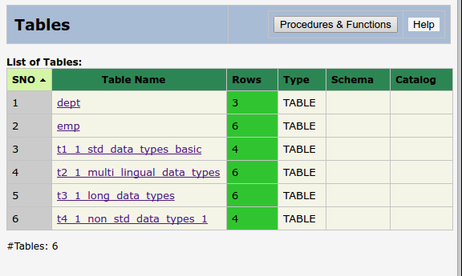

Test Status:
Platform | wjISQL | Date | Status | Remarks
Ubunitu 16.04 LTS  Chrome | 1.19.5(433) | 2017-10-22 | Success

Post Test Actions:
1 | Click button Disconnect to disconnect from sqlitedb.

Test Case 2/85: Setup MYSQL destination database with empty tables to receive data.
Test Prerequisites:
1 | None

Test Procedure
1 | Connect to MySQL database mysqldb using user id mysqlusr and password mysql123.
2 | Execute the following scripts from test source directory wjisql/wji_tsrc/wji_scripts/wji_01_basic_mysql_tables to create tables without any data:  tst_01_001_tables_drop_uc.sql  tst_01_002_tables_create_uc.sql
3 | Disconnect

Test Expected o/p:
1 | Successful creation of tables without data in mysqldb:  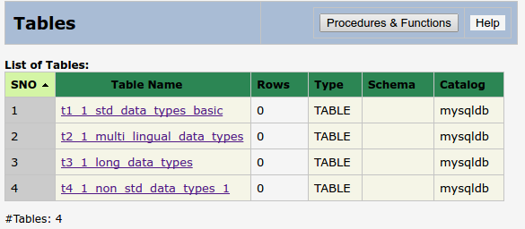

Test Status:
Platform | wjISQL | Date | Status | Remarks
Ubunitu 16.04 LTS  Chrome | 1.19.5(433) | 2017-10-22 | Success

Post Test Actions:
1 | Click button Disconnect to disconnect from mysqldb.

Successful Test Cases
Test Case 1/86: Test Transfer of data of tables from database sqlite to mysqldb.
Test Prerequisites:
1 | 6.3.1 Test Cases.

Test Procedure
1 | Click button Transfer on the main menu.
2 | Connect to source database /tmp/sqlitedb.
3 | Connect to destination database mysqldb with user mysqlusr and password mysql123.
4 | Select four tables of source database as shown below:  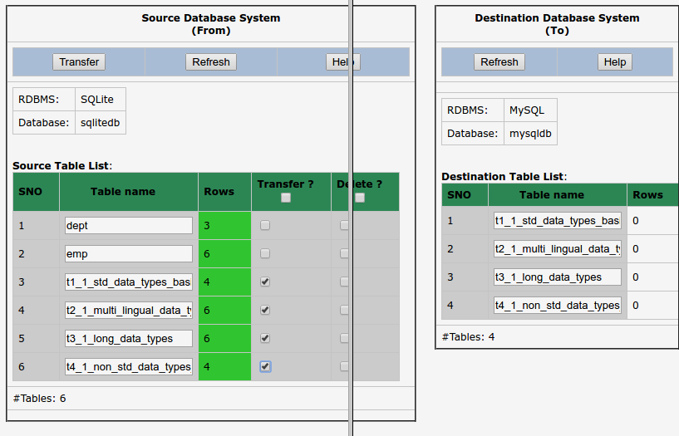
5 | Click button Transfer of source database window.
6 | Confirm OK on a transfer confirmation window.

Test Expected o/p:
1 | A new "Data Transfer Status" tab of browser with successful data transfer (see number of rows transferred) as shown below but with errors/warnings due to non-matching of columns:  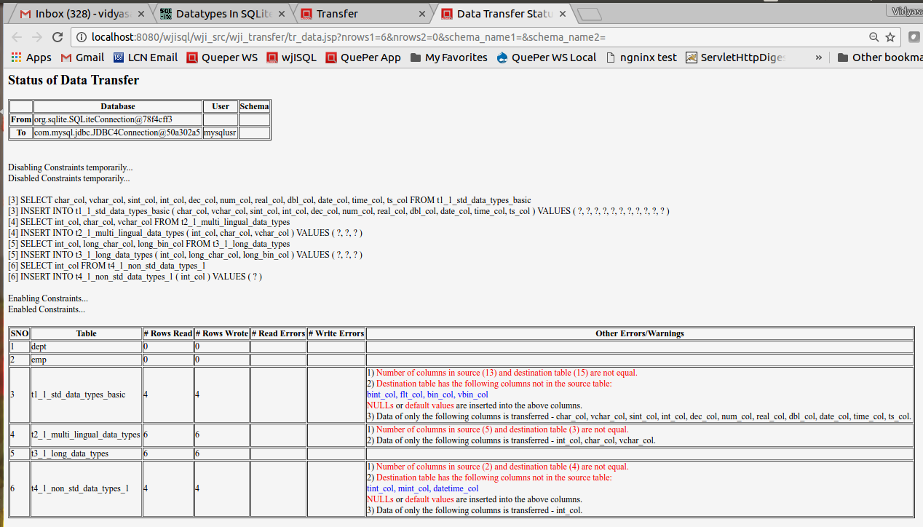

Post Test Actions
1 | Click on table "t2_1_..." in source and destination database table lists.
2 | Click on button Data on right side source and destination table properties windows.
3 | The resultant screen should indicate successful transfer of number of rows and data as shown below (scroll windows if needed):  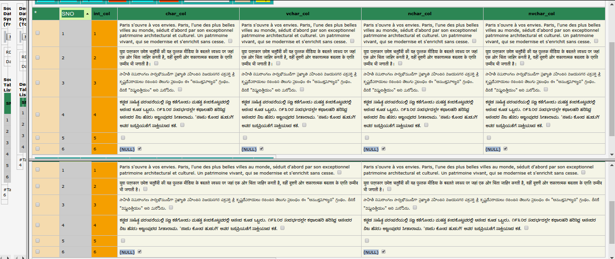

Test Status:
Platform | wjISQL | Date | Status | Remarks
Ubunitu 16.04 LTS  Chrome | 1.19.5(433) | 2017-10-22 | Success

Test Case 2/87: Test Transfer data of a table that does not have all columns of source table but has extra columns in the destination database
Test Prerequisites:
1 | Test Case 1.

Test Procedure
1 | Click on a table, say, t1_1..., in destination table list.
2 | Click button Data on the right bottom window to display the Result window that contains table data.
3 | Enter the following statement in SQL Statement window to create a new table that does not have column dno of source table but has extra columns edob and eexp:  CREATE TABLE emp(eno INT NOT NULL PRIMARY KEY , ename VARCHAR(20), edob DATE, eexp INT DEFAULT 0);
4 | Select table emp of source database for data transfer as shown below:  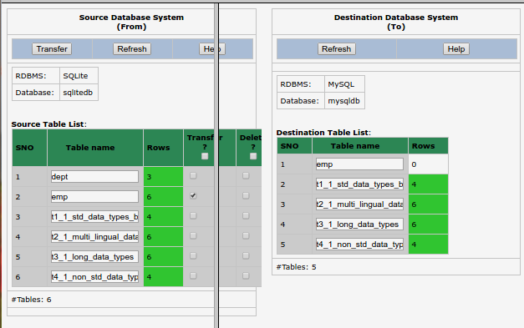
5 | Click button Transfer of source database window.
6 | Confirm OK on a transfer confirmation window.

Test Expected o/p:
1 | A new "Data Transfer Status" tab of browser with successful data transfer with warnings on non-existing and extra columns in the destination table as shown below:  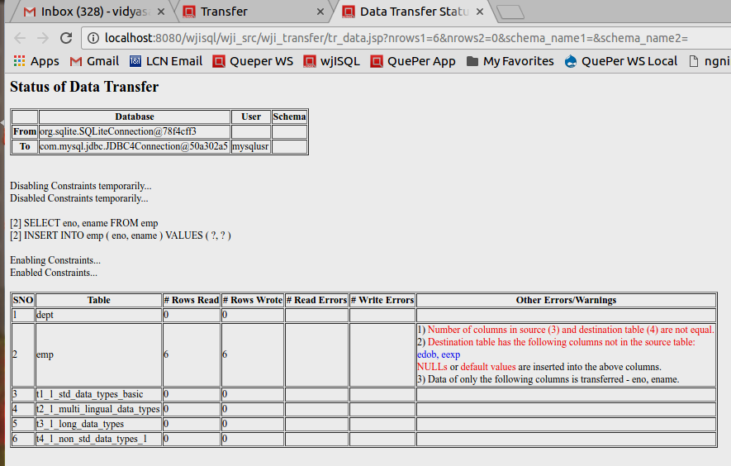

Post Test Actions
1 | Click on table "emp" in source and destination database table lists.
2 | Click on button Data on right side source and destination table properties windows.
3 | The resultant screen should indicate successful transfer of 6 rows of table emp and NULL values for column edob and default value of 0 for column eexp as shown below:  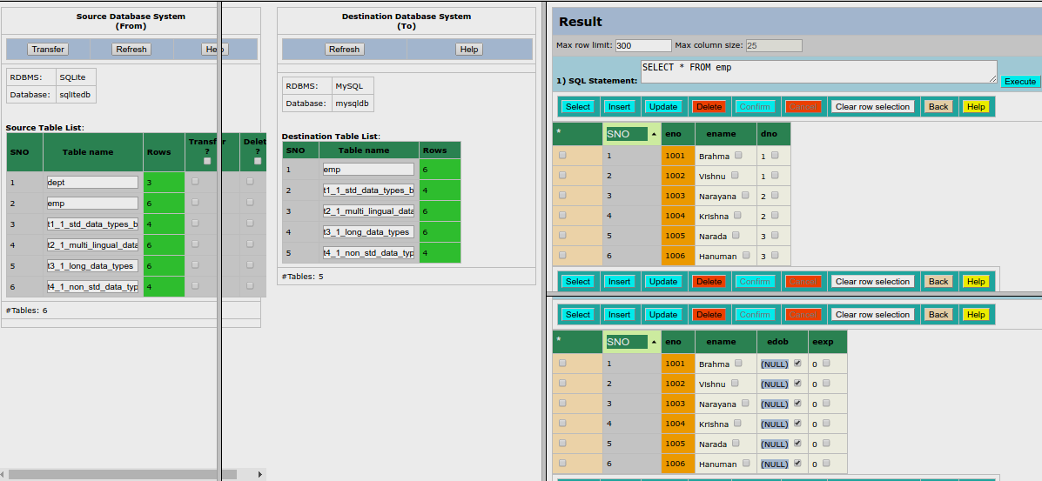

Test Status:
Platform | wjISQL | Date | Status | Remarks
Ubunitu 16.04 LTS  Chrome | 1.19.5(433) | 2017-10-22 | Success

Unsuccessful Test Cases
Test Case 1/88: Test failure of transfer of data of a table not defined in the destination database
Test Prerequisites:
1 | None

Test Procedure
1 | Select table dept of source database as shown below:  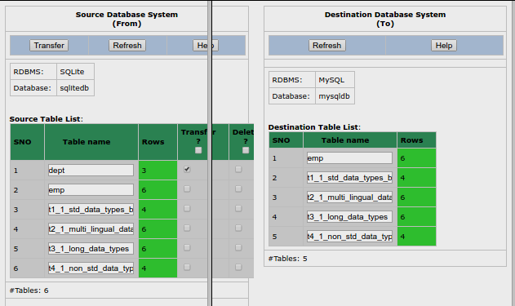
2 | Click button Transfer of source database window.
3 | Confirm OK on a transfer confirmation window.

Test Expected o/p:
1 | A new "Data Transfer Status" tab of browser with with error message saying the table does not exist in the destination database.  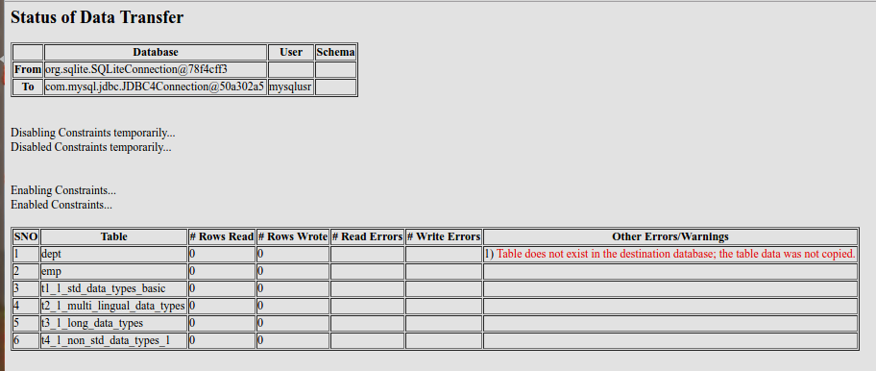

Post Test Actions
1 | Close browser tab "Data Transfer Status".

Test Status:
Platform | wjISQL | Date | Status | Remarks
Ubunitu 16.04 LTS  Chrome | 1.19.5(433) | 2017-10-22 | Success

Test Case 2/89: Test failure of transfer of data of a table due to constraints such as primary keys.
Test Prerequisites:
1 | None.

Test Procedure
1 | Select table t1_1_std_data_types_basic of source database for which data was already transferred as shown below:  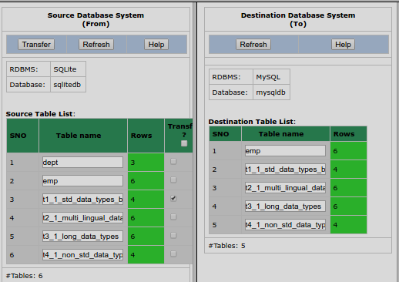
2 | Click button Transfer of source database window.
3 | Confirm OK on a transfer confirmation window.

Test Expected o/p:
1 | A new "Data Transfer Status" tab of browser with with error messages saying there is a constraint violation error and number of transfered rows (Rows Wrote) is 0 as shown below:  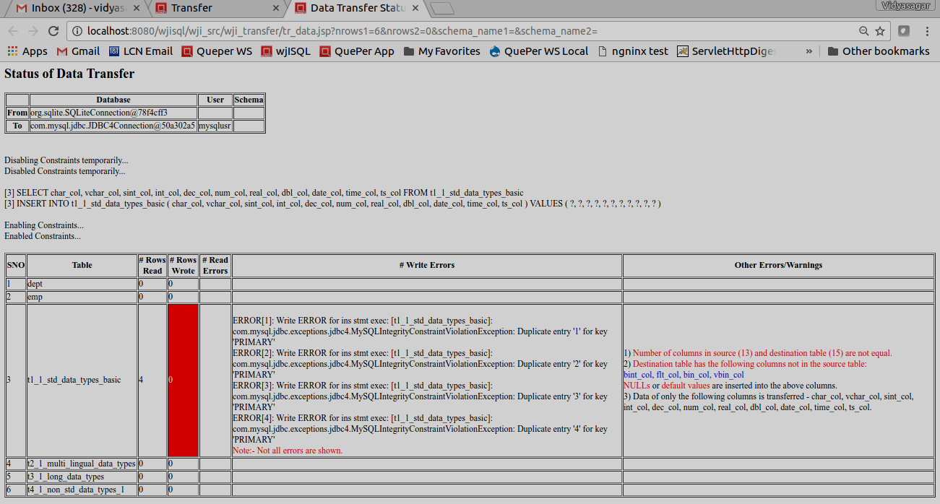

Post Test Actions
1 | Close browser tab "Data Transfer Status".

Test Status:
Platform | wjISQL | Date | Status | Remarks
Ubunitu 16.04 LTS  Chrome | 1.19.5(433) | 2017-10-22 | Success

Post Test Test Cases
Test Case 1/90: Disconnect source and destination databases
Test Prerequisites:
1 | wjISQL is in Data Transfer screen.

Test Procedure
1 | Click menu item Disconnect source.
2 | Click menu item Disconnect destination.
3 | Click button Back.

Test Expected o/p:
1 | Main screen of wjISQL.

Test Status:
Platform | wjISQL | Date | Status | Remarks
Ubunitu 16.04 LTS  Chrome | 1.19.5(433) | 2017-10-22 | Success

