WjISQL

DBMS Info Test Plan

Change History
SNO | Version | Date | By | Description
1 | 1 | 2016-12-26 | Mvsagar | Created.
2 | 2 | 2019-08-14 | Mvsagar | Done some trivial changes.

Table of Contents
1 Introduction 1
1.1 Prerequisites for all Tests 2
2 MySQL Database Test Cases 2
2.1 Prerequisites 2
2.2 DBMS Info Test Cases 2
2.2.1 Successful Test Cases 2
2.2.2 Unsuccessful Test Cases 4
3 MariaDB Database Test Cases 4
3.1 Prerequisites 4
3.2 DBMS Info Test Cases 5
3.2.1 Successful Test Cases 5
3.2.2 Unsuccessful Test Cases 6
4 PostgreSQL Database Connection and Disconnection Test Cases 7
4.1 Prerequisites 7
4.2 DBMS Info Test Cases 7
4.2.1 Successful Test Cases 7
4.2.2 Unsuccessful Test Cases 9
5 Oracle Database Test Cases 9
5.1 Prerequisites 9
5.2 DBMS Info Test Cases 10
5.2.1 Successful Test Cases 10
5.2.2 Unsuccessful Test Cases 11
6 MS SQL Database Test Cases 12
6.1 Prerequisites 12
6.2 DBMS Info Test Cases 12
6.2.1 Successful Test Cases 12
6.2.2 Unsuccessful Test Cases 14
7 SQLite Database Test Cases 14
7.1 Prerequisites 14
7.2 DBMS Info Test Cases 15
7.2.1 Successful Test Cases 15
7.2.2 Unsuccessful Test Cases 16

Introduction
Tests of this test plan test DBMS information menu item of wjISQL. This menu item gives various information such as product name, version number and capabilities of JDBC driver in use and RDBMS behind it.

Prerequisites for all Tests

1 | Installation test is successful.
2 | Main screen is of wjISQL is currently shown in the browser. Otherwise, enter "http://localhost:8080/wjisql" in the browser address field.

MySQL Database Test Cases

Prerequisites

1 | MySQL database mysqldb is readily available for user mysqlusr and password mysql123. The user has DBA privileges.

DBMS Info Test Cases

Successful Test Cases
Test Case 1/1: Test that menu item DBMS Info displays information about the JDBC driver and RDBMS behind it.
Test Prerequisites:
1 | None

Test Procedure
1 | Click menu item Connect.
2 | Connect to MySQL database mysqldb using user mysqlusr and password mysql123.
3 | Click menu item DBMS Info.

Test Expected o/p:
1 | MySQL DBMS info as shown below (not complete):  Initial part:  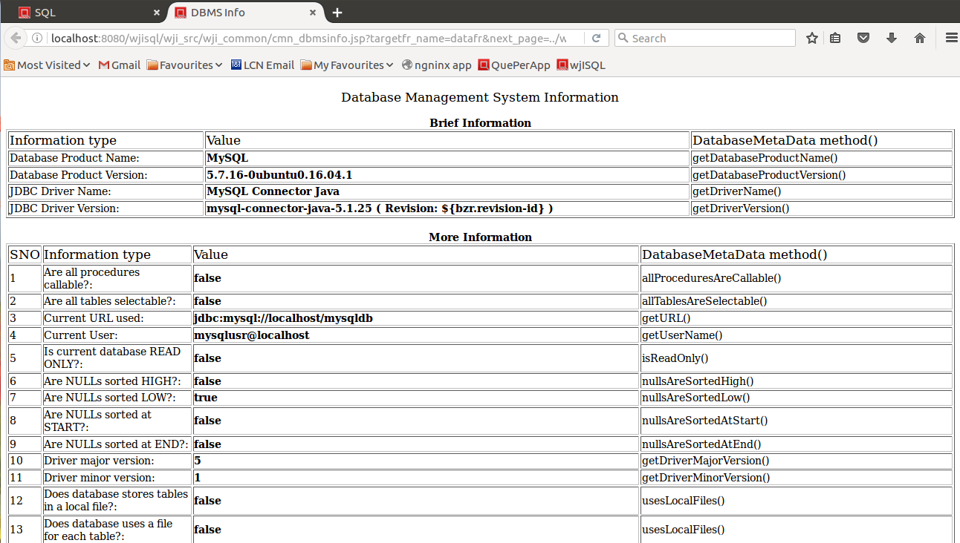  End part:  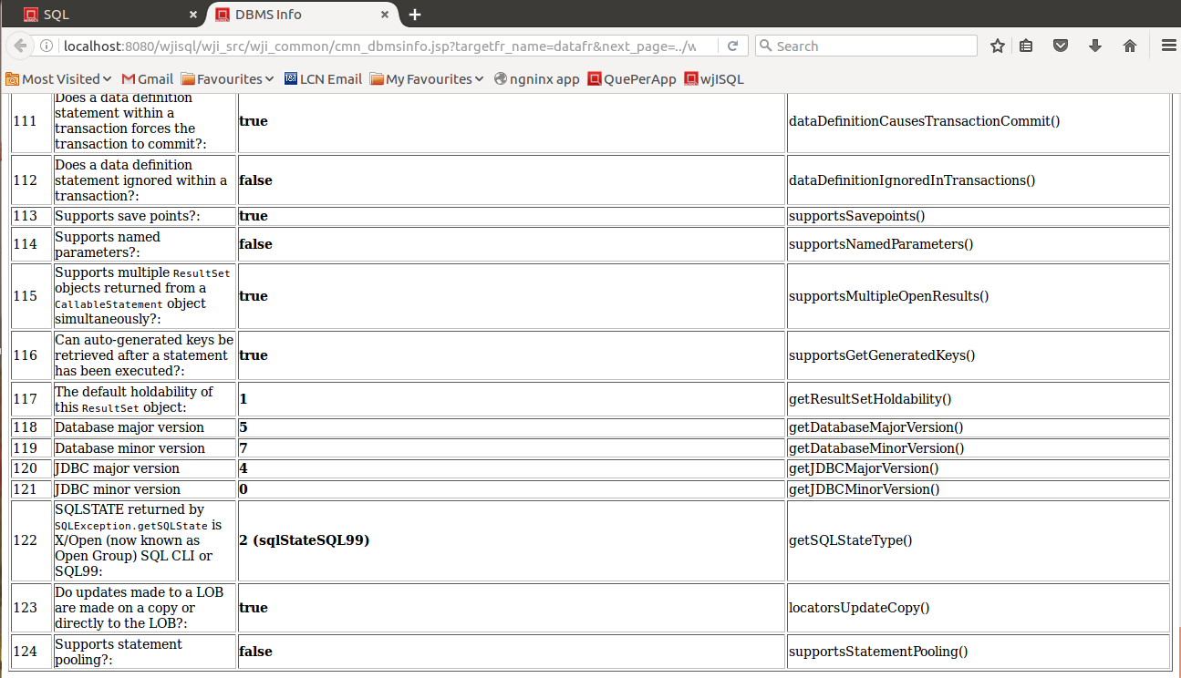

Test Status:
Platform | wjISQL | Date | Status | Remarks
Ubuntu 16.04 LTS  FireFox | 1.19.5(433) | 2017-10-22 | Success

Post Test Actions:
1 | Close the browser tab "DBMS Info".

Unsuccessful Test Cases
Test Case 1/2: Test failure of display of DBMS information when database is not connected.
Test Prerequisites:
1 | None

Test Procedure
1 | Click button Disconnect to logout from the database
2 | Click button DBMS Info.

Test Expected o/p:
1 | An alert message asking user to connect to the database first:  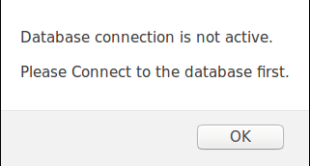

Post Test Actions
1 | Click button OK on the alert message box.

Test Status:
Platform | wjISQL | Date | Status | Remarks
Ubuntu 16.04 LTS  FireFox | 1.19.5(433) | 2017-10-22 | Success

MariaDB Database Test Cases

Prerequisites

1 | MariaDB database mariadb is readily available for user mariausr and password maria123. The user has DBA privileges.

DBMS Info Test Cases

Successful Test Cases
Test Case 1/3: Test that menu item DBMS Info displays information about the JDBC driver and RDBMS behind it.
Test Prerequisites:
1 | None

Test Procedure
1 | Click menu item Connect.
2 | Connect to MariaDB database mariadb using user mariausr and password maria123.
3 | Click menu item DBMS Info.

Test Expected o/p: On the next tab of browser.
1 | MariaDB DBMS info as shown below (not complete):  Initial part:  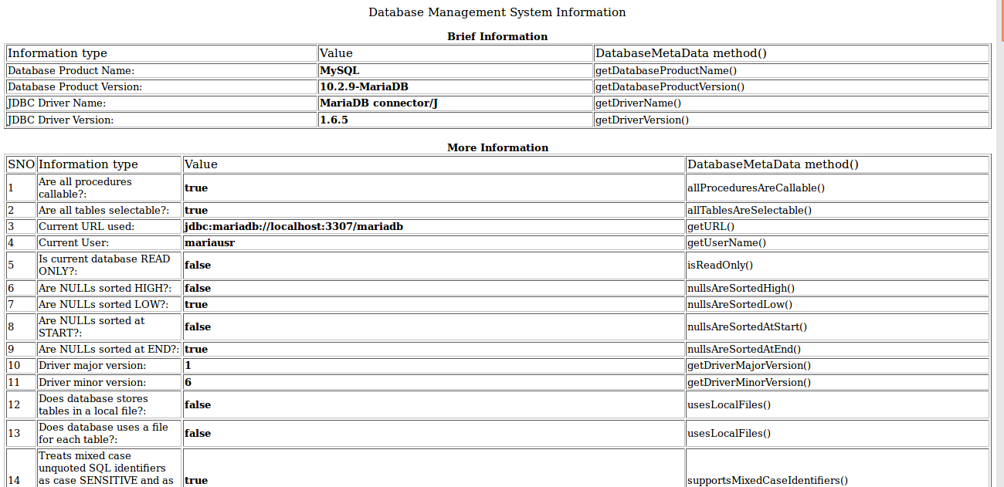  End part:  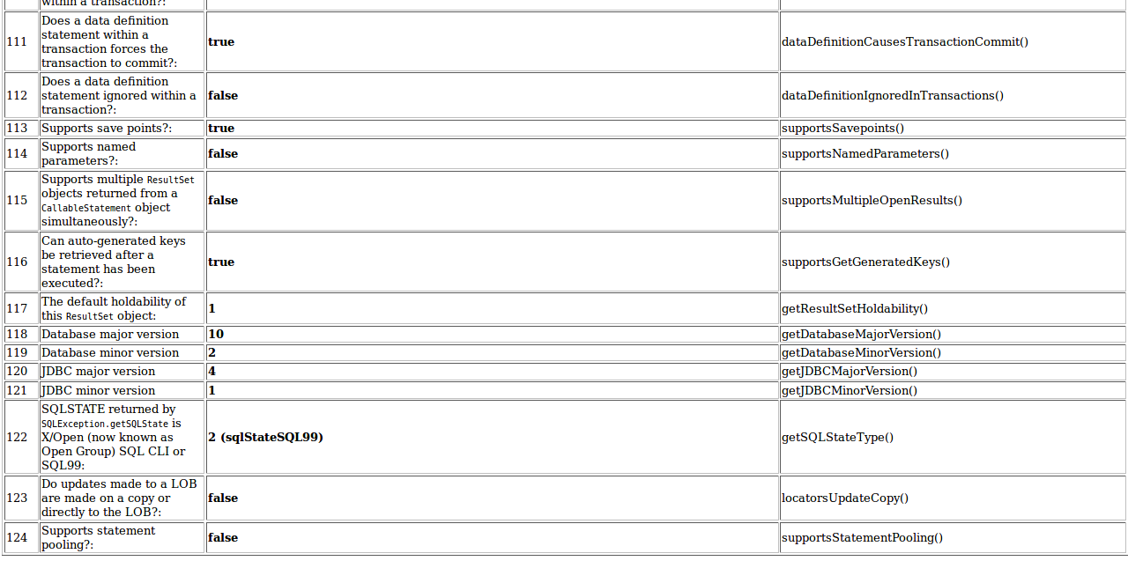

Test Status:
Platform | wjISQL | Date | Status | Remarks
Ubuntu 16.04 LTS  FireFox | 1.19.5(433) | 2017-10-22 | Success

Post Test Actions:
1 | Close the browser tab "DBMS Info".
2 | Click button Disconnect to logout from the database

Unsuccessful Test Cases
Test Case 1/4: Test failure of display of DBMS information when database is not connected.
Test Prerequisites:
1 | None

Test Procedure
1 | Click button DBMS Info.

Test Expected o/p:
1 | An alert message asking user to connect to the database first:

Post Test Actions
1 | Click button OK on the alert message box.

Test Status:
Platform | wjISQL | Date | Status | Remarks

PostgreSQL Database Connection and Disconnection Test Cases

Prerequisites

1 | PostgreSQL database pgsqldb is readily available for user pgsqlusr and password pgsql123. The user has DBA privileges.

DBMS Info Test Cases

Successful Test Cases
Test Case 1/5: Test that menu item DBMS Info displays information about the JDBC driver and RDBMS behind it.
Test Prerequisites:
1 | None

Test Procedure
1 | Click menu item Connect.
2 | Connect to PostgreSQL database pgsqldb using user pgsqlusr and password pgsql123.
3 | Click menu item DBMS Info.

Test Expected o/p:
1 | PostgreSQL DBMS info as shown below (not complete):  Initial part:  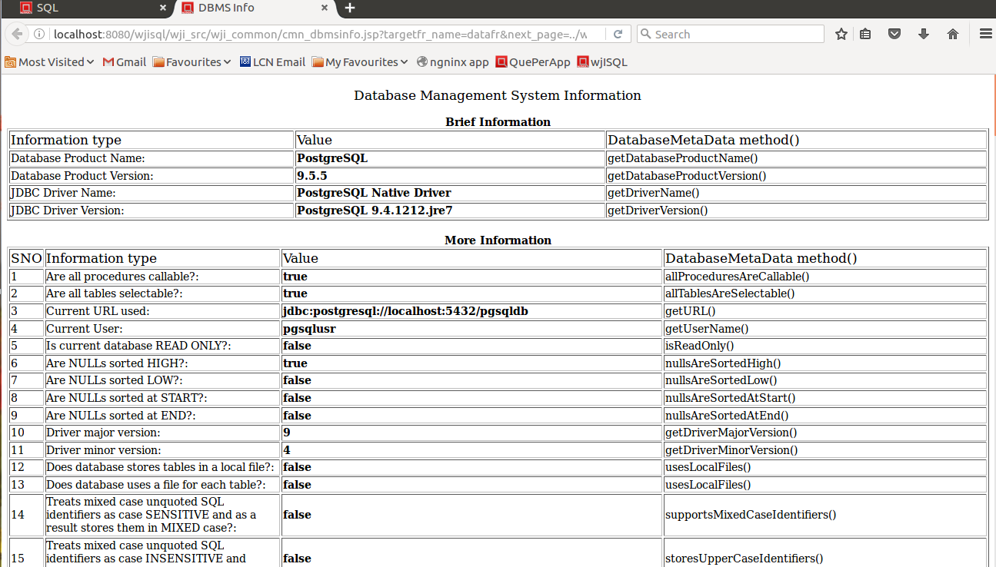  End part:  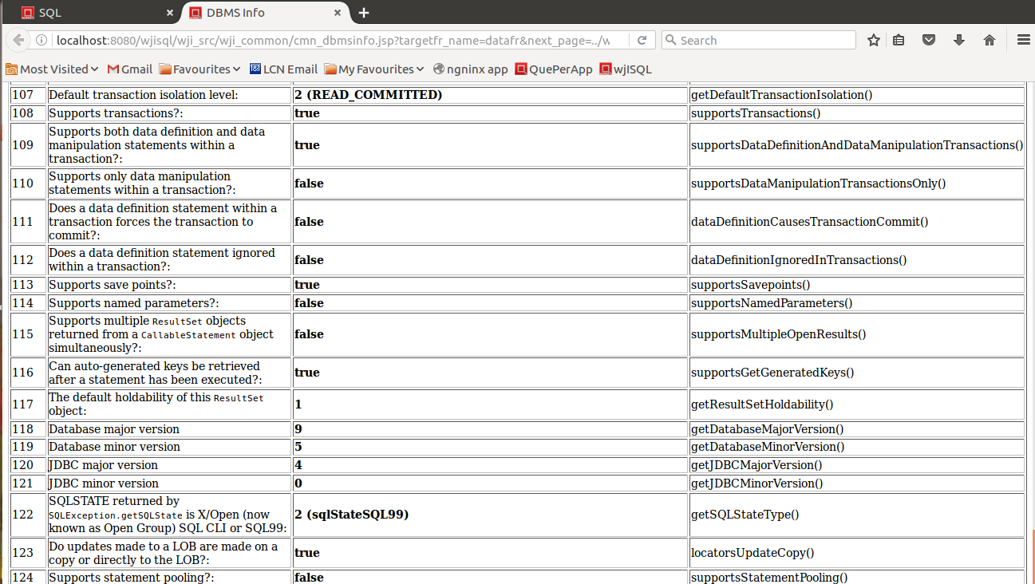

Test Status:
Platform | wjISQL | Date | Status | Remarks
Ubuntu 16.04 LTS  FireFox | 1.19.5(433) | 2017-10-22 | Success
Windows 7

Post Test Actions:
1 | Close the browser tab "DBMS Info".
2 | Click button Disconnect to logout from the database

Unsuccessful Test Cases
Test Case 1/6: Test failure of display of DBMS information when database is not connected.
Test Prerequisites:
1 | None

Test Procedure
1 | Click button DBMS Info.

Test Expected o/p:
1 | An alert message asking user to connect to the database first:

Post Test Actions
1 | Click button OK on the alert message box.

Test Status:
Platform | wjISQL | Date | Status | Remarks

Oracle Database Test Cases

Prerequisites

1 | Oracle database oradb is readily available for user orausr and password ora123. The user has DBA privileges.

DBMS Info Test Cases

Successful Test Cases
Test Case 1/7: Test that menu item DBMS Info displays information about the JDBC driver and RDBMS behind it.
Test Prerequisites:
1 | None

Test Procedure
1 | Click menu item Connect.
2 | Connect to Oracle database oradb using user orausr and password ora123.
3 | Click menu item DBMS Info.

Test Expected o/p:
1 | Oracle DBMS info as shown below (not complete):  Initial part:  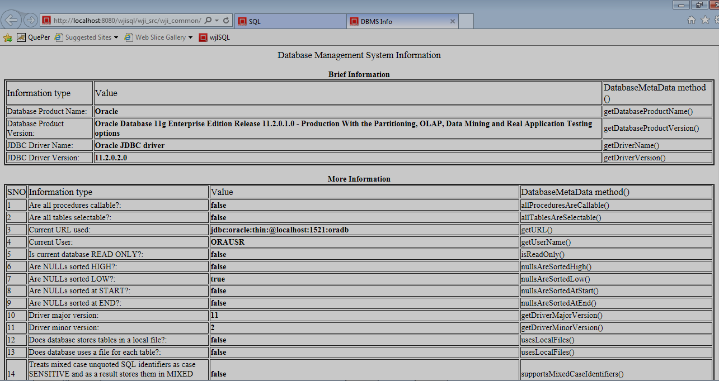  End part:  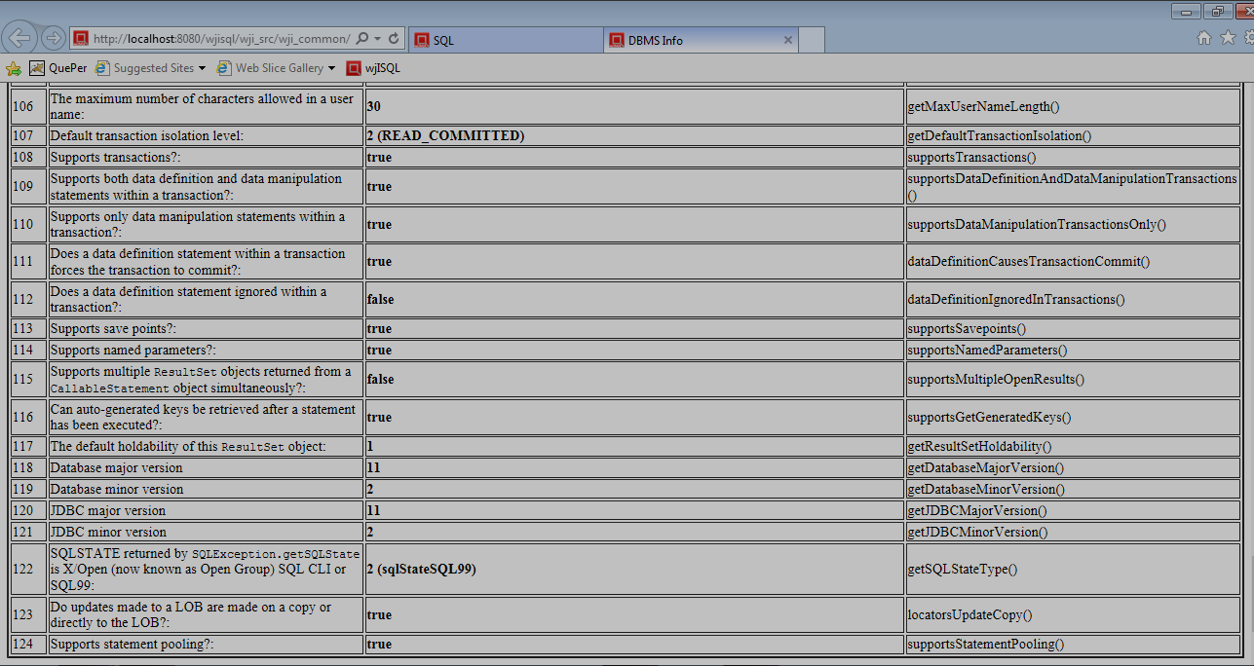

Test Status:
Platform | wjISQL | Date | Status | Remarks
Windows 7  IE 11.0 | 1.19.5(439) | 2017-10-27 | Success

Post Test Actions:
1 | Close the browser tab "DBMS Info".

Unsuccessful Test Cases
Test Case 1/8: Test failure of display of DBMS information when database is not connected.
Test Prerequisites:
1 | None

Test Procedure
1 | Click button Disconnect to logout from the database
2 | Click button DBMS Info.

Test Expected o/p:
1 | An alert message asking user to connect to the database first:  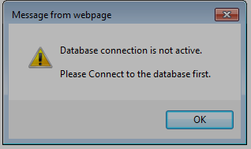

Post Test Actions
1 | Click button OK on the alert message box.

Test Status:
Platform | wjISQL | Date | Status | Remarks
Windows 7  IE 11.0 | 1.19.5(439) | 2017-10-27 | Success

MS SQL Database Test Cases

Prerequisites

1 | MS SQL database mssqldb is readily available for user mssqlusr and password mssql123. The user has DBA privileges.

DBMS Info Test Cases

Successful Test Cases
Test Case 1/9: Test that menu item DBMS Info displays information about the JDBC driver and RDBMS behind it.
Test Prerequisites:
1 | None

Test Procedure
1 | Click menu item Connect.
2 | Connect to Oracle database mssqldb using user mssqlusr and password mssql123.
3 | Click menu item DBMS Info.

Test Expected o/p:
1 | MS SQL DBMS info as shown below (not complete):  Initial part:  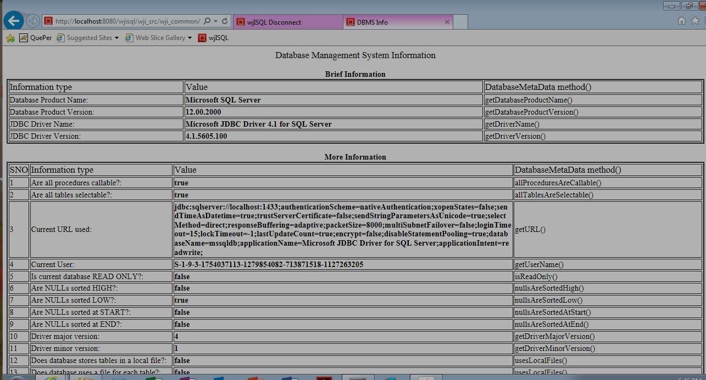  End part:  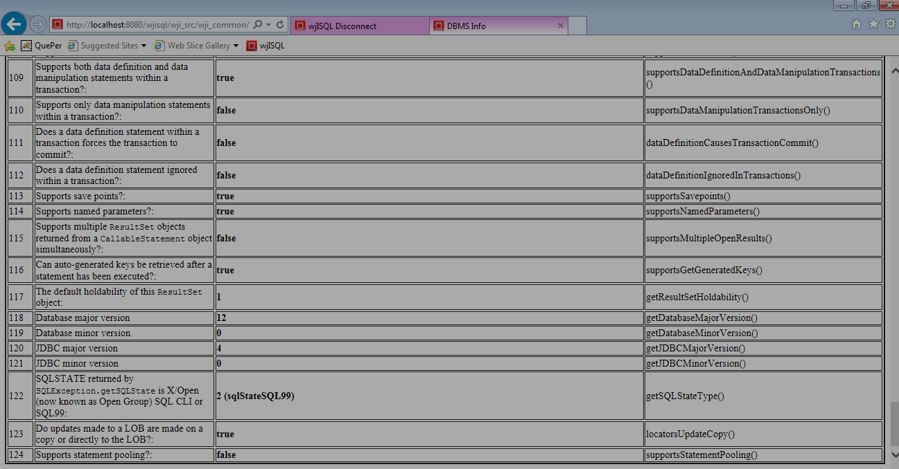

Test Status:
Platform | wjISQL | Date | Status | Remarks
Windows 7  IE 11.0 | 1.19.5(439) | 2017-10-27 | Success

Post Test Actions:
1 | Close the browser tab "DBMS Info".

Unsuccessful Test Cases
Test Case 1/10: Test failure of display of DBMS information when database is not connected.
Test Prerequisites:
1 | None

Test Procedure
1 | Click button Disconnect to logout from the database
2 | Click button DBMS Info.

Test Expected o/p:
1 | An alert message asking user to connect to the database first:

Post Test Actions
1 | Click button OK on the alert message box.

Test Status:
Platform | wjISQL | Date | Status | Remarks
Windows 7  IE 11.0 | 1.19.5(439) | 2017-10-27 | Success

SQLite Database Test Cases

Prerequisites

1 | None

DBMS Info Test Cases

Successful Test Cases
Test Case 1/11: Test that menu item DBMS Info displays information about the JDBC driver and RDBMS behind it.
Test Prerequisites:
1 | None

Test Procedure
1 | Click menu item Connect.
2 | Connect to database /tmp/sqlitedb.
3 | Click menu item DBMS Info.

Test Expected o/p:
1 | SQLite DBMS info as shown below (not complete):  Initial part:  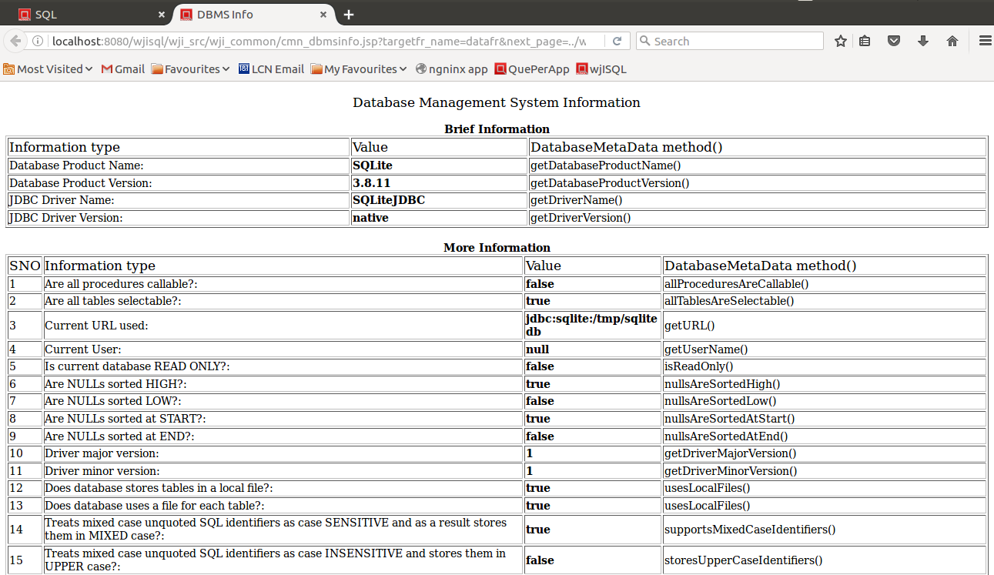  End part:  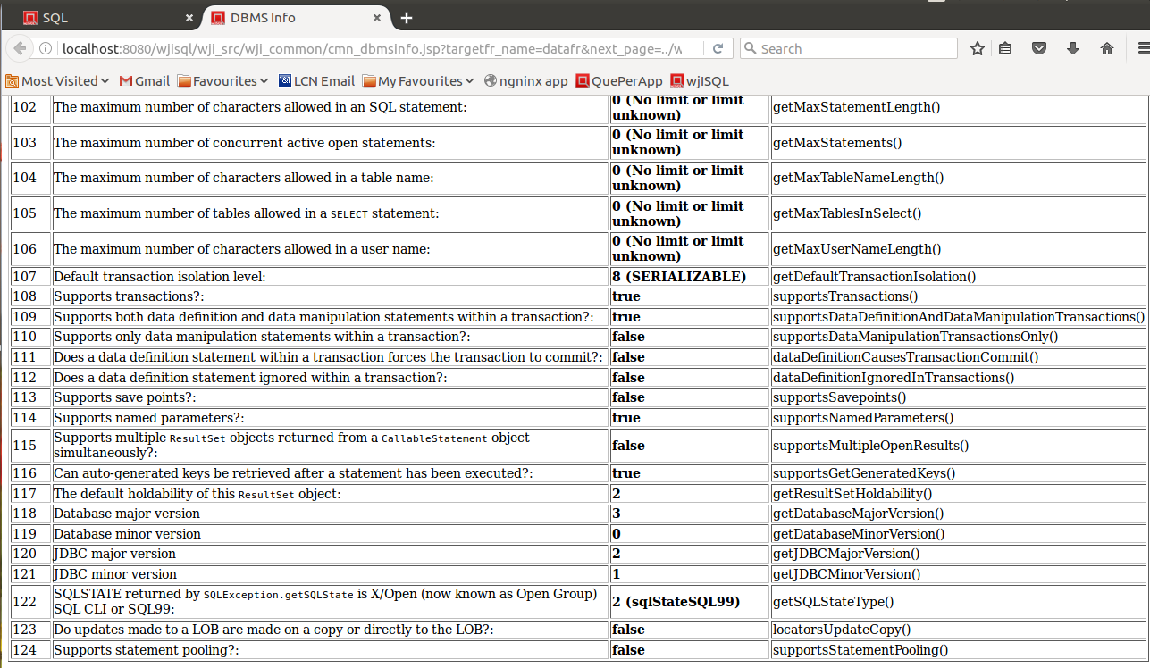

Test Status:
Platform | wjISQL | Date | Status | Remarks
Ubuntu 16.04 LTS  FireFox 56.0 | 1.19.5(439) | 2017-10-27 | Success

Post Test Actions:
1 | Close the browser tab "DBMS Info".
2 | Click button Disconnect to logout from the database

Unsuccessful Test Cases
Test Case 1/12: Test failure of display of DBMS information when database is not connected.
Test Prerequisites:
1 | None

Test Procedure
1 | Click button DBMS Info.

Test Expected o/p:
1 | An alert message asking user to connect to the database first:

Post Test Actions
1 | Click button OK on the alert message box.

Test Status:
Platform | wjISQL | Date | Status | Remarks

