WjISQL

Bug Fixes Test Plan

Change History
SNO | Version | Date | By | Description
1 | 1 | 2017-07-01 | Mvsagar | Created.

Table of Contents
1 Introduction 1
1.1 Prerequisites for all Tests 1
2 V1.16.5 Bug Fix Test Cases 1
2.1 Bug W_B_20161226_58: Destination database table list is not updated after data transfer 1
2.2 Bug W_B_20161226_60: Table lists do not disappear after closing connections 3
2.3 Bug W_B_20170617_74: PostgreSQL gives permission for each table 4
2.4 Bug W_B_20170711_75: SQL Script loading second time fails 5
2.5 Bug W_B_20170728_76: Order of rows of a result set is not as per ORDER BY clause. 7

Introduction
This test plan has test cases for testing bug fixes done in the current release and previous releases.

Prerequisites for all Tests

1 | Installation test is successful.
2 | Main screen is of wjISQL is currently shown in the browser. Otherwise, enter "http://localhost:8080/wjisql" in the browser address field.

V1.16.5 Bug Fix Test Cases

Bug W_B_20161226_58: Destination database table list is not updated after data transfer
Test Case 1/1: Test that destination database table is automatically updated after data transfer without clicking its Refresh button.
Test Prerequisites:
1 | Database setup
2 | Connect to mariadb database mariadb with user ID mariausr and password maria123.
3 | Execute the following script file to drop tables of mariadb; ignore errors if any. wji_tsrc/wji_scripts/wji_18_basic_mariadb_tables/tst_18_001_tables_drop_uc.sql
4 | Execute the following script file to create tables in mariadb: wji_tsrc/wji_scripts/wji_18_basic_mariadb_tables/tst_18_002_tables_create_uc.sql
5 | Execute the following script file to load data into the tables in mariadb: wji_tsrc/wji_scripts/wji_18_basic_mariadb_tables/tst_18_003_tables_insert_uc.sql
6 | Make sure that number of rows in tables t1*, t2*, t3* and t4* are 4, 6, 3 and 4 respectively.
7 | Disconnect from mariadb.
8 | Connect to PostgreSQL database pgsqldb with user ID pgsqlusr and password pgsql123.
9 | Execute the following script file to drop tables of pgsqldb; ignore errors if any. wji_tsrc/wji_scripts/wji_04_basic_pgsql_tables/tst_04_001_tables_drop_uc.sql
10 | Execute the following script file to create tables in pgsqldb: wji_tsrc/wji_scripts/wji_04_basic_pgsql_tables/tst_04_002_tables_create_uc.sql
11 | Make sure tables t1*, t2*, t3* and t4* have zero rows in them.
12 | Disconnect from pgsqldb.

Test Procedure

1 | Click menu item "Transfer".
2 | Connect to mariadb as source database and pgsqldb as destination database.
3 | Select all 4 tables t1* to t4* in source database table list.
4 | Click button Transfer.
5 | Examine data transfer page displayed.
6 | Go back to wjISQL Transfer page and exmine Rows column of destination table list.

Test Expected o/p:
1 | Data transfer page that shows successful transfer of data.
2 | Destination table list with automatically updates Rows column for each table.

Test Post actions:
1 | Disconnect source database connection.
2 | Disconnect destination database connection.
3 | Go back to Home page.

Test Status:
Platform | wjISQL | Date | Status | Remarks

Bug W_B_20161226_60: Table lists do not disappear after closing connections
Test Case 1/2: Test that table lists disappear after disconnecting source and destination databases
Test Prerequisites:
1 | Database setup
2 | Connect to mariadb database mariadb with user ID mariadbuser and password maria123.
3 | Execute the following script file to drop tables of mariadb; ignore errors if any. wji_tsrc/wji_scripts/wji_18_basic_mariadb_tables/tst_18_001_tables_drop_uc.sql
4 | Execute the following script file to create tables in mariadb: wji_tsrc/wji_scripts/wji_18_basic_mariadb_tables/tst_18_002_tables_create_uc.sql
5 | Execute the following script file to load data into the tables in mariadb: wji_tsrc/wji_scripts/wji_18_basic_mariadb_tables/tst_18_003_tables_insert_uc.sql
6 | Make sure that number of rows in tables t1*, t2*, t3* and t4* are 4, 6, 3 and 4 respectively.
7 | Disconnect from mariadb.
8 | Connect to PostgreSQL database pgsqldb with user ID pgsqluser and password pgsql123.
9 | Execute the following script file to drop tables of pgsqldb; ignore errors if any. wji_tsrc/wji_scripts/wji_04_basic_pgsql_tables/tst_04_001_tables_drop_uc.sql
10 | Execute the following script file to create tables in pgsqldb: wji_tsrc/wji_scripts/wji_04_basic_pgsql_tables/tst_04_002_tables_create_uc.sql
11 | Make sure tables t1*, t2*, t3* and t4* have zero rows in them.
12 | Disconnect from pgsqldb.

Test Procedure

1 | Disconnect from source database.
2 | Disconnect from destination database.

Test Expected o/p:
1 | Table lists of both source and destination databases disappear as shown below:  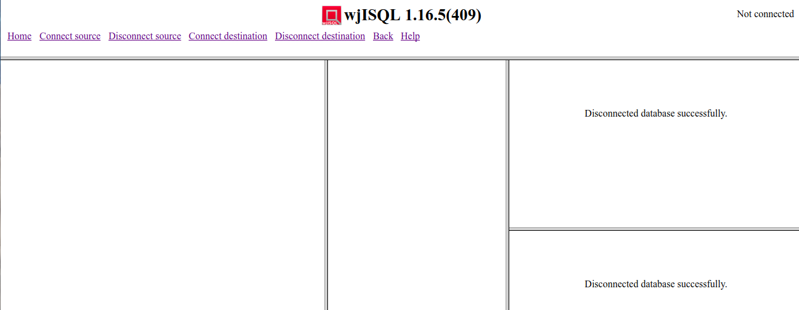

Test Post actions:
3 | Go back to Home page.

Test Status:
Platform | wjISQL | Date | Status | Remarks

Bug W_B_20170617_74: PostgreSQL gives permission error for each table

Test Case 1/3: Test that PostgreSQL gives permission error only once irrespective of number of tables user does not have access to
Test Prerequisites:
1 | Database setup

Test Procedure

1 | Login into pgsqldb with credentials pgsqlusr/pgsql123.
2 | Create user pgsqlusr1 and password pgsqlusr1 and do not give any privilges to the user.
3 | Logout.
4 | Login into pgsqldb with user id pgsqlusr1/pgsqlusr1.

Test Expected o/p:
1 | The following error message is displayed only once for all tables not accessible to the user:  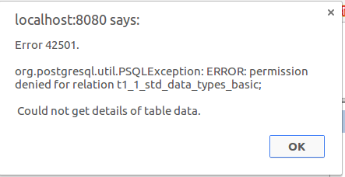
2 | Table list is displayed as following with red color for non-accessible tables with ? as row count:  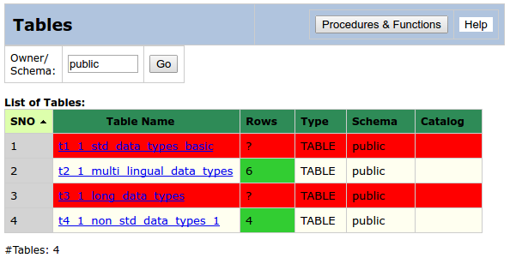

Test Status:
Platform | wjISQL | Date | Status | Remarks

Bug W_B_20170711_75: SQL Script loading second time fails
Test Case 1/4: Test that the same SQL script loads successfully second time.
Test Prerequisites:
1 | Setup mariadb with standard test tables.
2 | Connect to mariadb database mariadb with user ID mariausr and password maria123.

Test Procedure

1 | Execute the following script file to display data from the tables of mariadb:  wji_tsrc/wji_scripts/wji_18_basic_mariadb_tables/tst_18_004_select_star_uc.sql
2 | Load the same script again.
3 | Execute the script.

Test Expected o/p:
1 | Loading of the same script second time is successful.
2 | Successfull execution of the script/

Test Status:
Platform | wjISQL | Date | Status | Remarks

Test Case 2/5: Test that the same SQL script loads successfully second time after clearing SQL Statement window using button Clear.
Test Prerequisites:
1 | Setup mariadb with standard test tables.
2 | Connect to mariadb database mariadb with user ID mariausr and password maria123.

Test Procedure

1 | Load and execute the following script file to display data from the tables of mariadb:  wji_tsrc/wji_scripts/wji_18_basic_mariadb_tables/tst_18_004_select_star_uc.sql
2 | Click button Clear to clear contents of SQL Statement windows.
3 | Load and execute the same script again.

Test Expected o/p:
1 | Loading of the same script second time successfully after Clear.
2 | Successfull execution of the script/

Test Status:
Platform | wjISQL | Date | Status | Remarks

Bug W_B_20170728_76: Order of rows of a result set is not as per ORDER BY clause.
Test Case 1/6: Test that ORDER BY clause on integer column works as expected.
Test Prerequisites:
1 | Database setup
2 | Connect to mariadb database mariadb with user ID mariadbuser and password maria123.
3 | Execute the following script file to drop table tord1, create it, load it and select data from it; ignore errors if any.  wji_scripts/wji_17_bug_fix_scripts/tst_17_001_W_B_20170728_76_order.sql

Test Procedure

1 | Execute the following SQL statement:  SELECT c1, c2 FROM tord1 ORDER BY c1;

Test Expected o/p:
1 | Data in the order of values of column c1 as shown below:  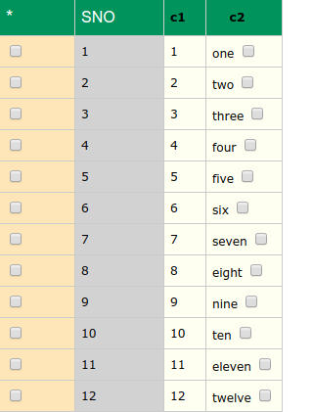

Test Status:
Platform | wjISQL | Date | Status | Remarks

Test Case 2/7: Test that ORDER BY clause with DESC option on integer column works as expected.
Test Prerequisites:
1 | Execution of Test Case 1.

Test Procedure

1 | Execute the following SQL statement:  SELECT c1, c2 FROM tord1 ORDER BY c1 DESC;

Test Expected o/p:
1 | Data in the descending order of values of column c1 as shown below:  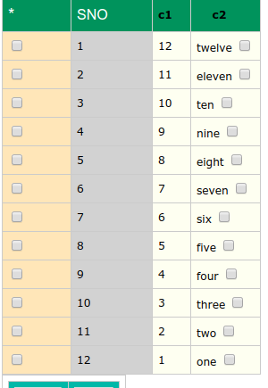

Test Status:
Platform | wjISQL | Date | Status | Remarks

Test Case 3/8: Test that ORDER BY clause on character column works as expected.
Test Prerequisites:
1 | Test Case 1

Test Procedure

1 | Execute the following SQL statement:  SELECT c1, c2 FROM tord1 ORDER BY c2;

Test Expected o/p:
1 | Data in the order of values of column c2 as shown below:  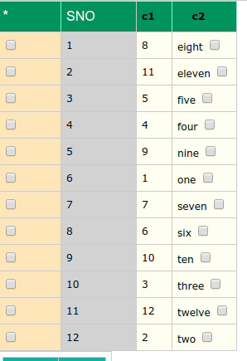

Test Status:
Platform | wjISQL | Date | Status | Remarks

Test Case 4/2: Test that ORDER BY clause with DESC option on character column works as expected.
Test Prerequisites:
1 | Execution of Test Case 1.

Test Procedure

1 | Execute the following SQL statement:  SELECT c1, c2 FROM tord1 ORDER BY c2 DESC;

Test Expected o/p:
1 | Data in the descending order of values of column c2 as shown below:  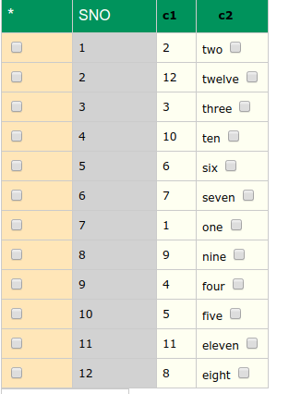

Test Status:
Platform | wjISQL | Date | Status | Remarks

