# **Flask Blog Post API**

## **Overview**

This is a RESTful API built using Python Flask for managing blog posts. It includes features for creating, retrieving, updating, and deleting blog posts. The API also implements JWT-based authentication to secure these operations. SQLAlchemy is used for in-memory database management.

## **Features**

* **JWT Authentication**: Users can sign up, sign in, and authenticate their requests.
* **CRUD Operations for Blog Posts**:
  + Create a new blog post
  + Retrieve a list of all blog posts
  + Retrieve a single blog post by its ID
  + Update an existing blog post
  + Delete a blog post

## **Technologies Used**

* **Python Flask**: Web framework for building the API.
* **SQLAlchemy**: ORM for database management.
* **JWT**: Authentication mechanism.

## 

## 

## 

## 

## 

## **Project Structure**

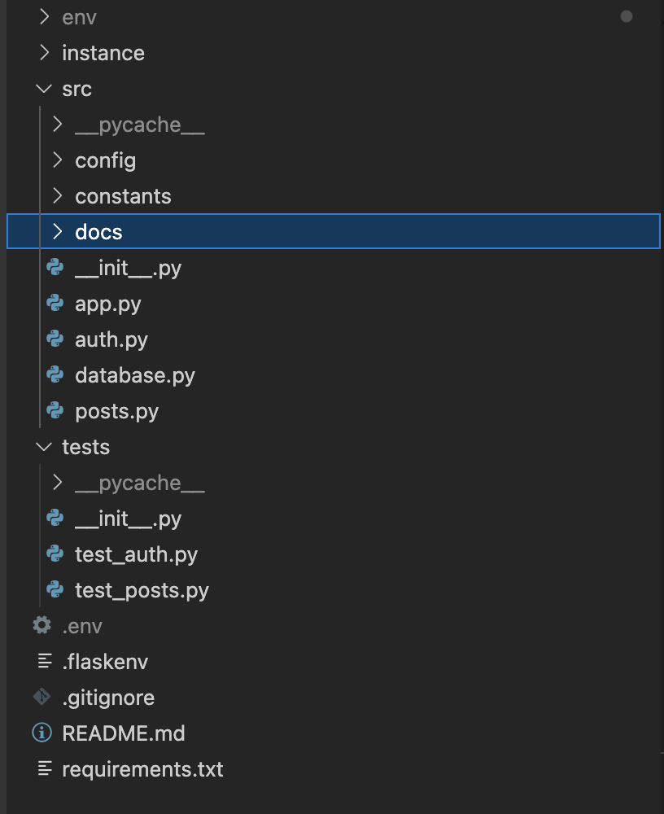

## **Setup and Installation**

* **Clone the repository**:
  + git clone <repository-url>
  + cd <repository-directory>
* **Create and activate a virtual environment**:
  + python -m venv env
  + source env/bin/activate (On Windows use `env\Scripts\activate`)
* **Install the dependencies**:
  + pip install -r requirements.txt
* **Set up environment variables for Mac**:

Create a .flaskenv file and add the following variables:

* + export FLASK_APP=src
  + export FLASK_RUN_PORT=8000
  + export FLASK_ENV=development
  + export FLASK_DEBUG=1
  + export SQLALCHEMY_DB_URI=sqlite:///posts.db
  + export JWT_SECRET_KEY=your_secret_key

Create a .env file and add the following variables:

* + export SECRET_KEY=your_secret_key

## **Running the Application**

To run the application, use the following command:

flask run

## **Testing the Application**

python -m unittest discover -s tests

## **Design Decisions and Trade-offs**

### **Design Decisions**

1. **Framework Choice**:
   * **Flask** was chosen for its simplicity and flexibility, which is suitable for building lightweight APIs quickly.
2. **Database Management**:
   * **SQLAlchemy** was selected as the ORM for its ease of integration with Flask and its capability to handle in-memory databases efficiently during development and testing.
3. **Authentication**:
   * **JWT (JSON Web Tokens)** was implemented for secure authentication, ensuring that each request is properly authenticated without maintaining session states on the server.
4. **Documentation:**
   * **Swagger** Add detailed API documentation using Swagger to make it easier for developers to understand and use the API.
5. **Testing**
   * **Unit test library** Used Unittest a built-in testing framework to write unit test cases.

### **Trade-offs**

1. **In-memory Database**:
   * Using an in-memory database with SQLAlchemy is efficient for development and testing but not suitable for production due to the lack of persistence. For production, a more robust database like PostgreSQL or MySQL should be used.
2. **Simplicity vs. Scalability**:
   * Flask is excellent for simple applications but may require additional configuration and extensions for handling larger, more complex applications.

### **Potential Improvements with More Time**

1. **Database Integration**:
   * Integrate a robust database such as PostgreSQL or MongoDB to handle data persistence more effectively.
2. **Enhanced Error Handling**:
   * Implement more comprehensive error handling and validation throughout the application to improve reliability and user experience.
3. **Automated Testing**:
   * Expand the test suite to include more test cases, ensuring greater coverage and reliability of the API.
4. **Deployment**:
   * Set up a deployment pipeline using Docker and a CI/CD tool to automate testing and deployment processes.
5. **Rate Limiting**:
   * Implement rate limiting to prevent abuse and ensure fair usage of the API.
6. **Testing**
   * Used inbuilt testing library, can shift to more robust and reliable testing tools like pytest.
7. **Frontend**
   * We can create a website to show blog posts by integrating with the APIs created.