**CSE 544**

**Assignment 3**

Raja Narsimha Reddy Palley (112685254)

Venkata Subba Narasa Bharath Meadam (112672986)

Shourie Amireddy (112684529)

Gowtham Kumar Karanam (112951546)

Srinivas Kotla (112688145)

Plots

Question: 2

2a) S = [1,3,3,6]

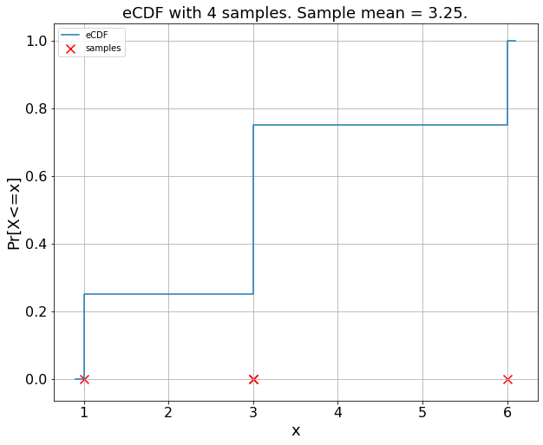

2b)

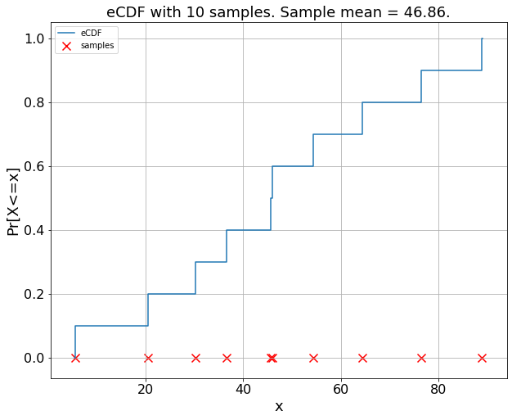 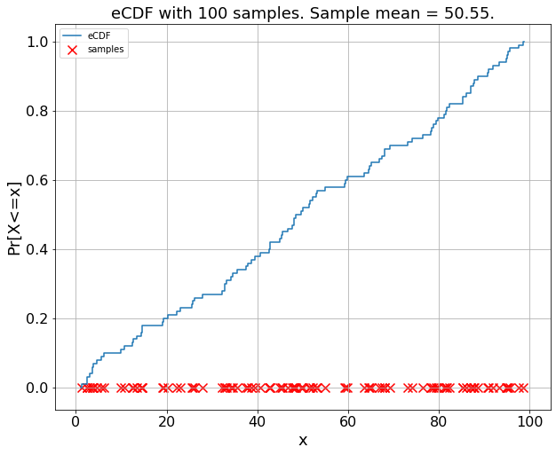

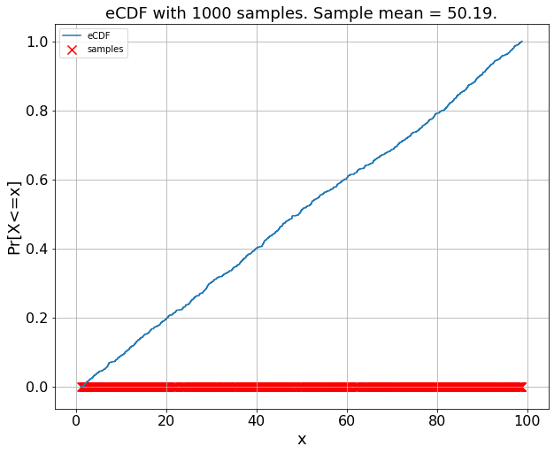

Observation:

As the number of samples increases, the eCDF is closer to a straight line.

(We know that our random samples are uniformly distributed and eCDF of a uniform distribution is a straight line)

As n increases the steps become small and small and converge into a straight line.

2c) [[0.1,3.2,2.3,1.4]),([1.7,3.3,0.8,2.1]), ([1.5,2.6,0.8,3.9])]

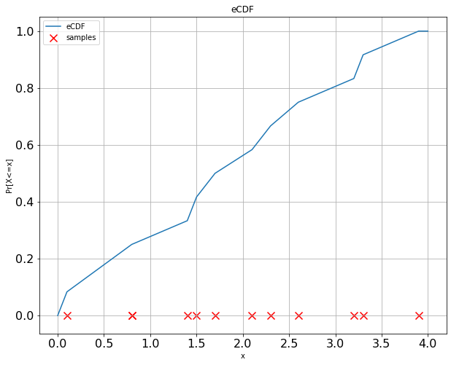

2d)

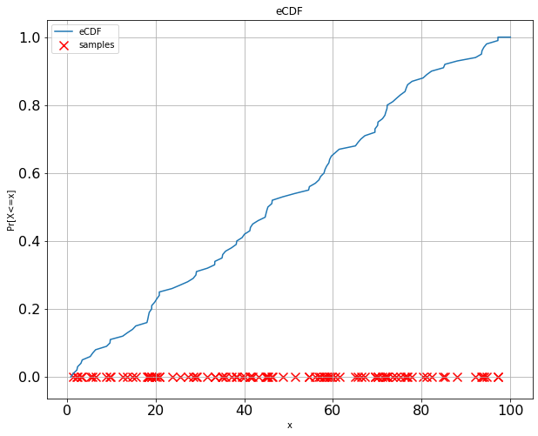 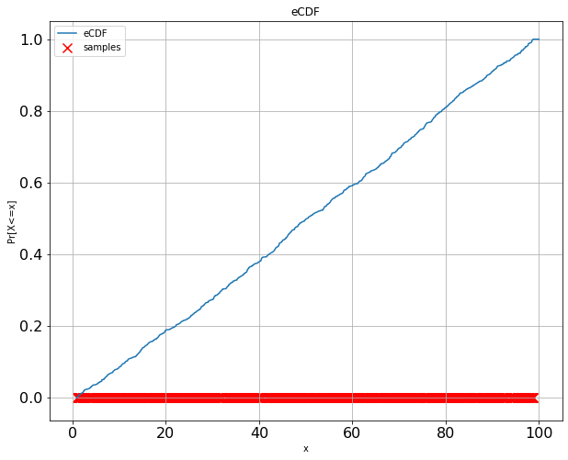

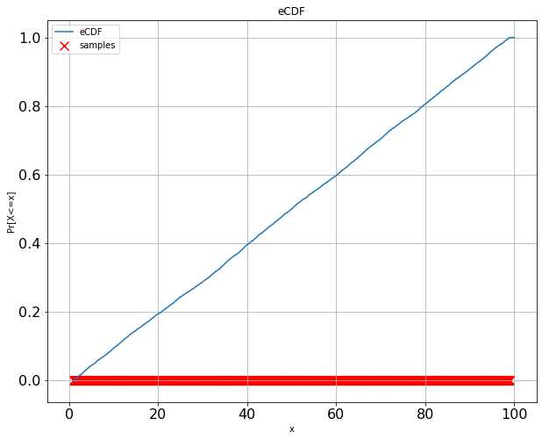

Observation:

This problem is similar to the one discussed in the class where there are n sample points and m students.

And your eCDF will only depend only n-samples and our remaining observations would be similar to 2(b).

We get perfect straight line as n increases.

As the number of samples increases, the eCDF is closer to a straight line.

(We know that our random samples are uniformly distributed and eCDF of a uniform distribution is a straight line)

As n increases the steps become small and small and converge into a straight line.

2e)

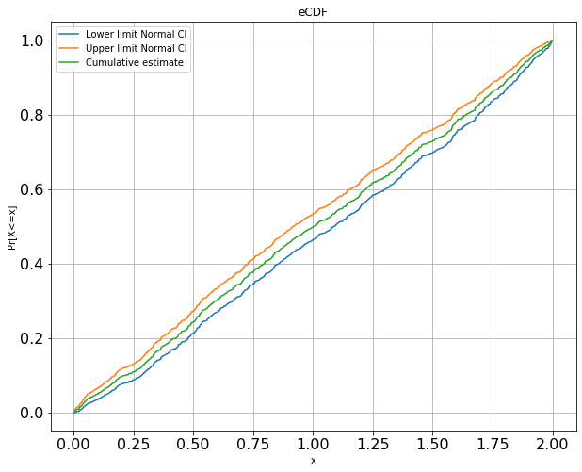

2f)

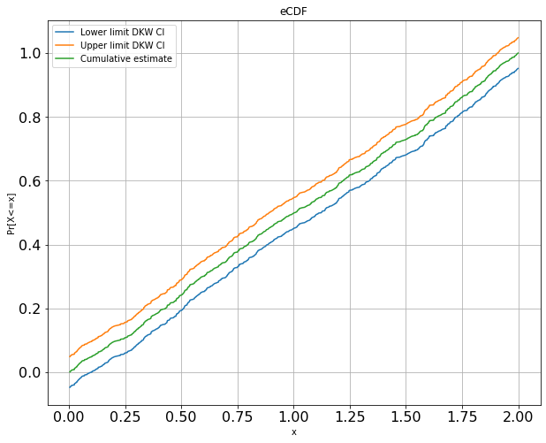

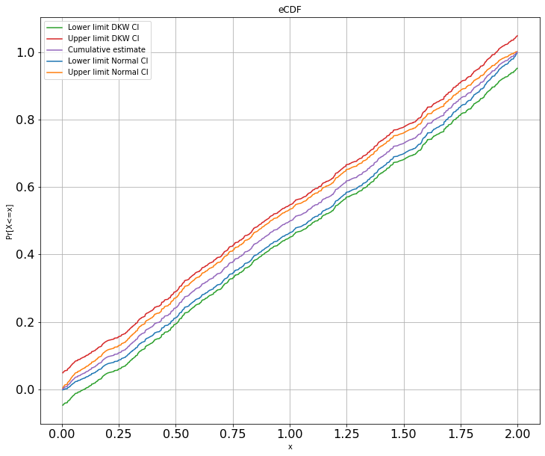

Observation:

From the graph, normal CI is a tighter bound that DKW CI.

5c)

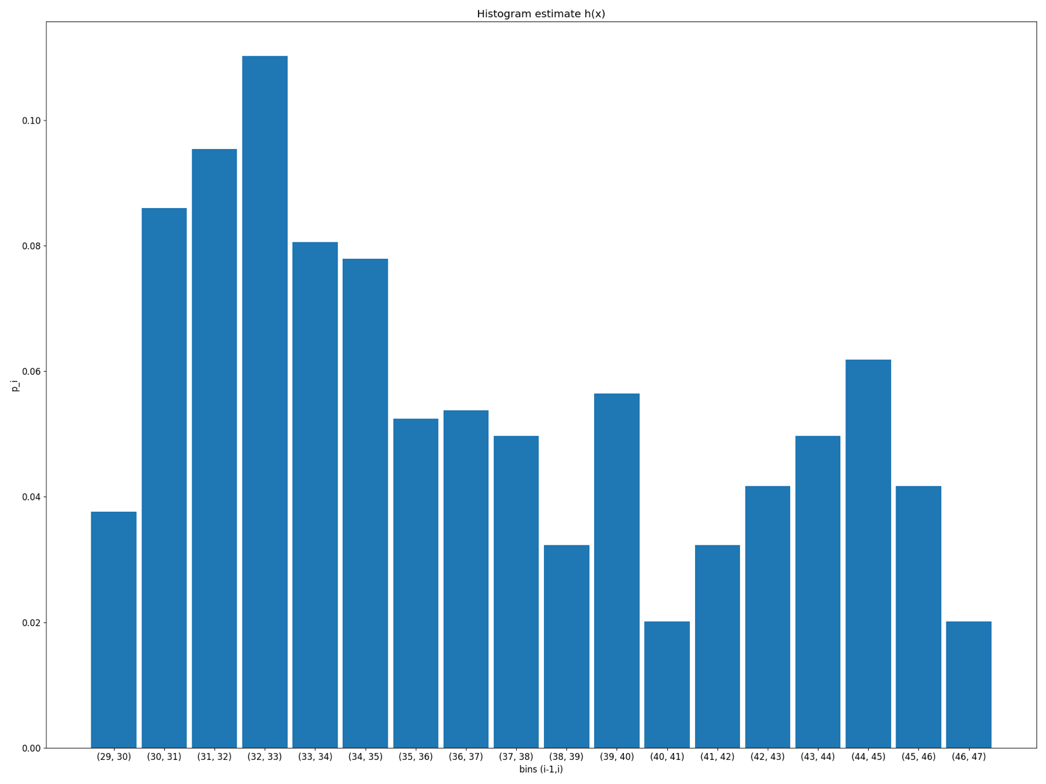

5d)

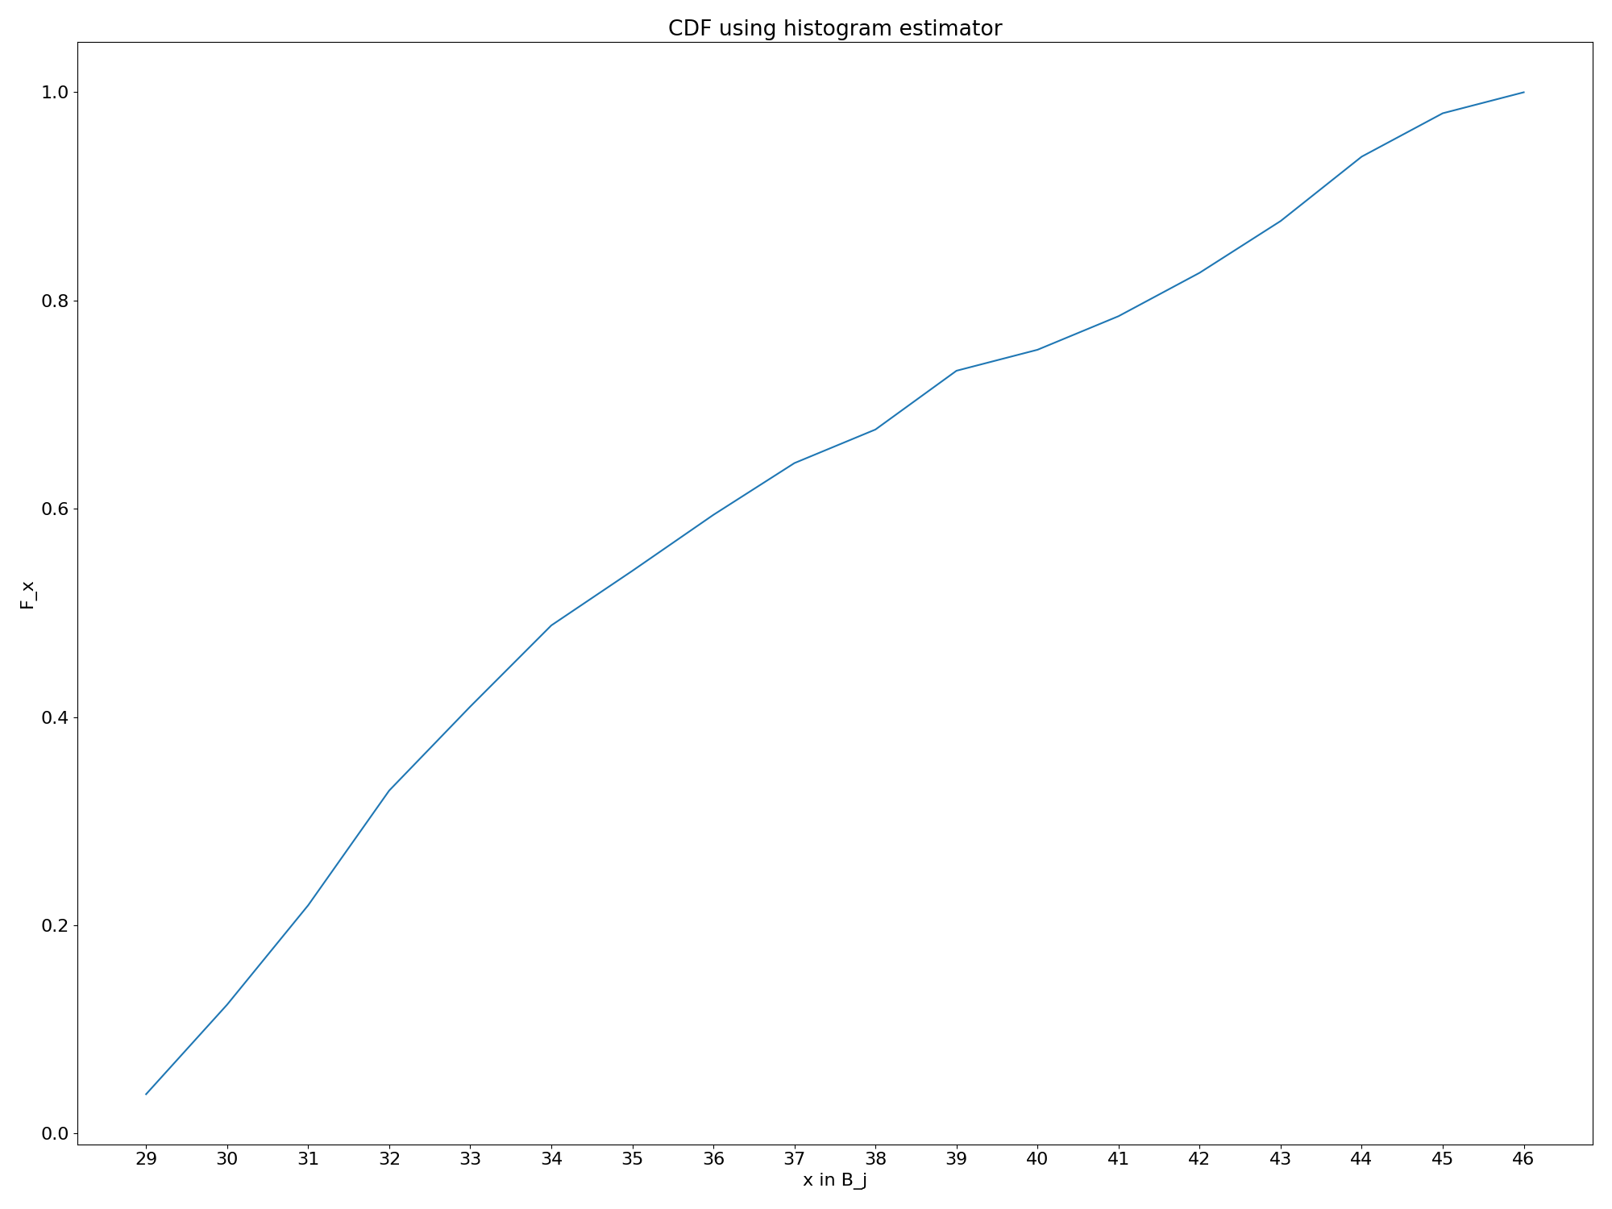

7a)

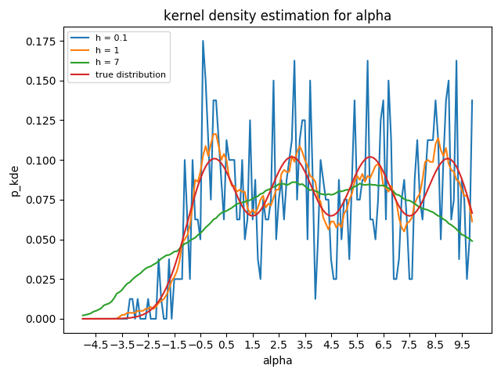

7b)

