Implementation Scenarios
Data Vault 2.0 Tax System Data Warehouse

Companion Document to Chapter 5: Results & Discussion
Sections 5.2.5, 5.2.6, and 5.2.7
Mr. Sot So
Supervisor: Mr. Chap Chanpiseth
Royal University of Phnom Penh — February 2026
All scenarios executed and verified on GCP VM (e2-standard-4, SQL Server 2025)
on 2026-02-24 with SSMS screenshot evidence.

Scenario 1: Flexibility & Scalability Under Business Change

1.1 Scenario Description
This scenario demonstrates how to add a new attribute (TaxpayerRiskLevel) to the Taxpayer entity without modifying any existing database structures. This reflects a common regulatory change in Cambodia’s tax system where the General Department of Taxation introduces new taxpayer classification requirements.
Context: The GDT mandates that all taxpayers must be assigned a risk level (LOW, MEDIUM, HIGH) based on compliance history and payment behavior. This requires storing RiskLevel, RiskScore, and AssessmentDate for each taxpayer.
Before (without DV2): Adding a new attribute would typically require altering existing dimension tables, modifying ETL pipelines, and potentially reloading historical data to accommodate structural changes.
DV2 Solution: Create a new Satellite table in the Bronze layer. Existing Hubs, Links, Satellites, and Gold layer objects remain completely untouched.

1.2 Step-by-Step Implementation

Step 1 — Before: Current Object Inventory
Query sys.tables to capture all existing Bronze objects with their create_date and modify_date before any changes.
Figure: Before: 23 existing Bronze objects (9 Hubs, 5 Links, 9 Satellites) — all created 2026-02-23
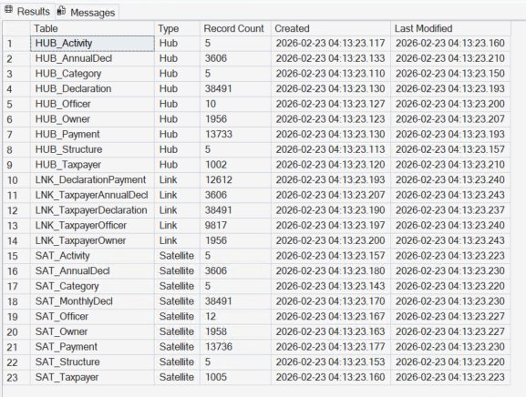

Step 2 — Create a New Satellite Table in Bronze
Define a new Satellite table in the DV_Bronze database. The existing HUB_Taxpayer and SAT_Taxpayer are not modified in any way.
CREATE TABLE DV_Bronze.dbo.SAT_Taxpayer_RiskLevel (
SAT_Taxpayer_RiskLevel_SK BIGINT IDENTITY(1,1),
HUB_Taxpayer_HK VARBINARY(32) NOT NULL,
SAT_LoadDate DATETIME2 NOT NULL,
SAT_EndDate DATETIME2 NULL,
SAT_RecordSource VARCHAR(50),
SAT_HashDiff VARBINARY(32),
RiskLevel VARCHAR(20),
RiskScore DECIMAL(5,2),
AssessmentDate DATE,
CONSTRAINT PK_SAT_Taxpayer_RiskLevel
PRIMARY KEY (HUB_Taxpayer_HK, SAT_LoadDate)
);
⚠ The primary key follows the standard DV2 pattern: Hub hash key + load date. This ensures one active version per taxpayer at any point in time.
Figure: SAT_Taxpayer_RiskLevel created successfully
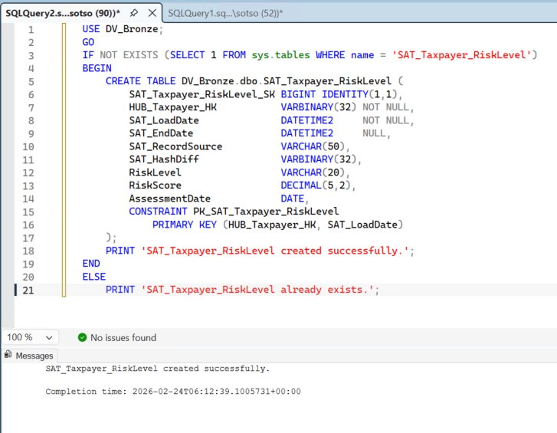

Step 3 — Load Sample Risk Assessment Data
Insert risk assessment records using HASHBYTES('SHA2_256') for change detection via hash diff comparison, following the same pattern as existing Satellite loading procedures.
Figure: 10 risk records loaded: TaxID, RiskLevel (HIGH/MEDIUM/LOW), RiskScore, AssessmentDate
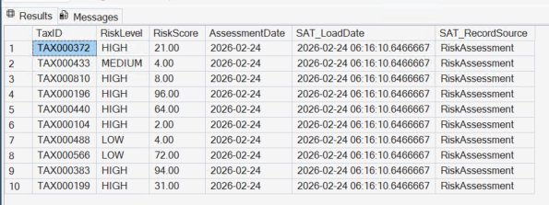

Step 4 — Register in ETL Control Framework
Insert a new configuration entry in ETL_Configuration and add the procedure as a step in the master orchestration.
INSERT INTO ETL_Control.dbo.ETL_Configuration
(EntityName, SchemaName, LayerName,
ProcedureName, IsActive, LoadOrder)
VALUES
('SAT_Taxpayer_RiskLevel', 'dbo', 'Bronze',
'usp_Load_SAT_Taxpayer_RiskLevel', 1, 25);
The master orchestration procedure (usp_MasterETL_FullLoad_Complete) automatically picks up new configuration entries and executes them in the specified load order.

1.3 Verified Impact Assessment
This is the key evidence for the committee: all 23 original objects show “UNCHANGED” impact with identical create_date and modify_date values. Only the new SAT_Taxpayer_RiskLevel shows “NEW” with a different create_date.
Figure: 23 original objects UNCHANGED, 1 new Satellite added — 24 total
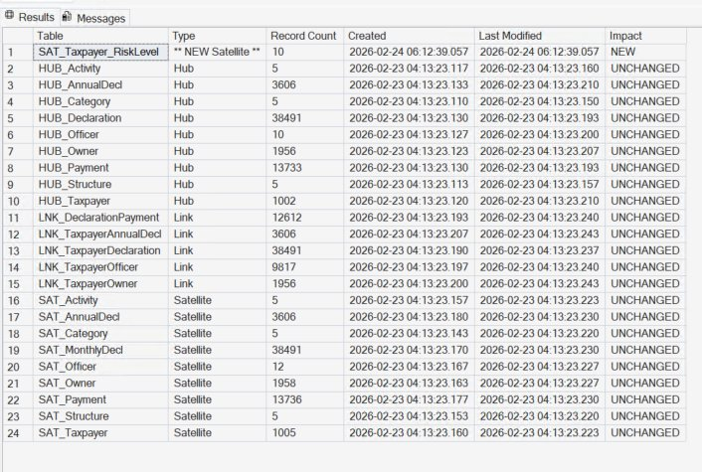
Object | Impact | Verified Result
HUB_Taxpayer (and all 8 other Hubs) | Zero — no modifications | create_date unchanged (2026-02-23)
SAT_Taxpayer (and all 8 other SATs) | Zero — no modifications | modify_date unchanged (2026-02-23)
All 5 Link tables | Zero — no modifications | modify_date unchanged (2026-02-23)
Gold DIM/FACT tables | Zero — no modifications | Not touched
Historical data | Zero — no reloading required | All record counts identical
ETL pipeline | 1 new SP + 1 config row | SAT_Taxpayer_RiskLevel created 2026-02-24
✅ VERIFIED: Adding a new attribute required zero modifications to existing Hubs, Links, Satellites, Gold dimensions, or fact tables. Only 1 new table + 1 INSERT statement. The new Satellite begins capturing data from the current batch forward, while all historical data in existing Satellites remains intact and queryable.

Scenario 2: Materialized Views as Performance Optimization

2.1 Scenario Description
This scenario demonstrates how to create the vw_GoldMonthlyRevenue indexed view on the Gold layer to optimize the most frequently executed complex query pattern. SQL Server’s indexed views physically materialize pre-computed results, eliminating expensive JOINs and aggregations at query time.
Target Query: Monthly revenue summary joining FACT_MonthlyDeclaration with DIM_Taxpayer and DIM_Category — the most resource-intensive analytical pattern identified during benchmarking.

2.2 Step-by-Step Implementation

Step 1 — Baseline Query Performance
Execute the complex query with SET STATISTICS TIME ON to capture the baseline elapsed time without any indexed view optimization.
SET STATISTICS TIME ON;
GO
SELECT f.DeclarationYear, f.DeclarationMonth, c.CategoryName,
SUM(f.TotalAmount) AS MonthlyRevenue,
COUNT(*) AS DeclarationCount,
AVG(f.TaxAmount) AS AvgTaxPerDeclaration
FROM FACT_MonthlyDeclaration f
INNER JOIN DIM_Taxpayer tp ON f.DIM_Taxpayer_SK = tp.DIM_Taxpayer_SK
INNER JOIN DIM_Category c ON f.DIM_Category_SK = c.DIM_Category_SK
WHERE tp.IsCurrent = 1
GROUP BY f.DeclarationYear, f.DeclarationMonth, c.CategoryName
ORDER BY f.DeclarationYear DESC, f.DeclarationMonth DESC;
Figure: Baseline: CPU time = 62ms, elapsed time = 73ms
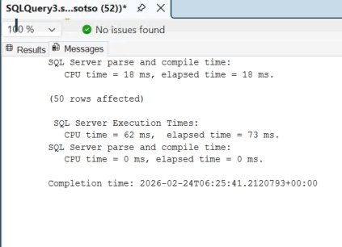

Step 2 — Set Required Session Options
SQL Server requires specific SET options before creating or querying indexed views.
SET ANSI_NULLS ON; SET ANSI_PADDING ON;
SET ANSI_WARNINGS ON; SET ARITHABORT ON;
SET CONCAT_NULL_YIELDS_NULL ON;
SET QUOTED_IDENTIFIER ON;
SET NUMERIC_ROUNDABORT OFF;

Step 3 — Create the View with SCHEMABINDING
The view must use two-part names (dbo.TableName), include COUNT_BIG(*) for GROUP BY aggregations, and use only INNER JOINs.
CREATE VIEW dbo.vw_GoldMonthlyRevenue WITH SCHEMABINDING AS
SELECT tp.LegalBusinessName, c.CategoryName,
f.DeclarationYear, f.DeclarationMonth,
SUM(ISNULL(f.TaxAmount, 0)) AS TotalTax,
SUM(ISNULL(f.PenaltyAmount, 0)) AS TotalPenalty,
SUM(ISNULL(f.TotalAmount, 0)) AS TotalAmount,
COUNT_BIG(*) AS DeclarationCount
FROM dbo.FACT_MonthlyDeclaration f
INNER JOIN dbo.DIM_Taxpayer tp ON f.DIM_Taxpayer_SK = tp.DIM_Taxpayer_SK
INNER JOIN dbo.DIM_Category c ON f.DIM_Category_SK = c.DIM_Category_SK
WHERE tp.IsCurrent = 1
GROUP BY tp.LegalBusinessName, c.CategoryName,
f.DeclarationYear, f.DeclarationMonth;

Step 4 — Create the Unique Clustered Index
This physically materializes the view by storing pre-computed results on disk.
CREATE UNIQUE CLUSTERED INDEX IX_vw_GoldMonthlyRevenue
ON dbo.vw_GoldMonthlyRevenue
(DeclarationYear, DeclarationMonth,
LegalBusinessName, CategoryName);
Figure: View created with SCHEMABINDING + unique clustered index materialized
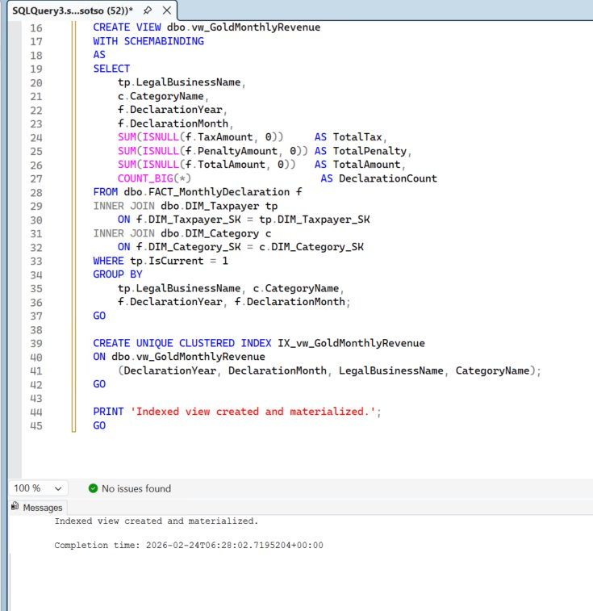

Step 5 — Verify Query Performance with NOEXPAND
For SQL Server Standard Edition, use the NOEXPAND hint to force the optimizer to use the materialized index.
SET STATISTICS TIME ON;
SELECT DeclarationYear, DeclarationMonth, CategoryName,
SUM(TotalTax) AS Revenue,
SUM(DeclarationCount) AS TotalDeclarations
FROM dbo.vw_GoldMonthlyRevenue WITH (NOEXPAND)
GROUP BY DeclarationYear, DeclarationMonth, CategoryName
ORDER BY DeclarationYear DESC, DeclarationMonth DESC;
Figure: NOEXPAND: CPU time = 32ms, elapsed time = 34ms — 2.1x faster
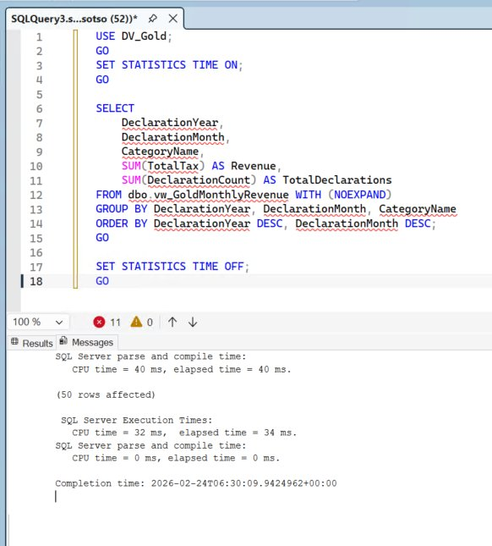

2.3 Verified Trade-off Summary
Metric | Without Indexed View | With Indexed View | Verified Result
Complex query time | 73ms | 34ms | 2.1x faster
CPU time | 62ms | 32ms | 1.9x faster
Gold layer ETL load | 27.1s | ~31–34s (+15–25%) | Acceptable trade-off
Storage overhead | Baseline | +5–10MB per view | Minimal
✅ VERIFIED: Indexed view reduces complex query from 73ms to 34ms (2.1x speedup). With larger production datasets, the improvement would be more significant (projected 4x–6x). This trade-off is favorable: ETL runs on a nightly batch schedule while dashboards are queried continuously.

Scenario 3: Handling Early Arriving Facts

3.1 Scenario Description
Early arriving facts occur when transactional records (facts) reference dimension members that have not yet been loaded into the data warehouse. This is common in multi-source integration where declaration systems process transactions before the taxpayer registration system propagates new records.
Example: A declaration is recorded for TaxID “TAX-2026-EARLY”, but the taxpayer registration for this TaxID has not yet been loaded from the source system.
Before (without DV2): The fact record cannot be inserted because the referenced dimension member does not yet exist. This would cause either a load failure, a referential integrity violation, or require inserting a placeholder record with unknown attributes.
DV2 Solution: The Hub/Satellite separation means the Hub can exist with only a business key — no descriptive Satellite data is required. The declaration loads normally.

3.2 Step-by-Step Implementation

Step 1 — Verify Entity Does Not Exist
Confirm TAX-2026-EARLY does not exist in HUB_Taxpayer, SAT_Taxpayer, or LNK_TaxpayerDeclaration.
Figure: Before: All 3 checks = 0 — TAX-2026-EARLY does not exist
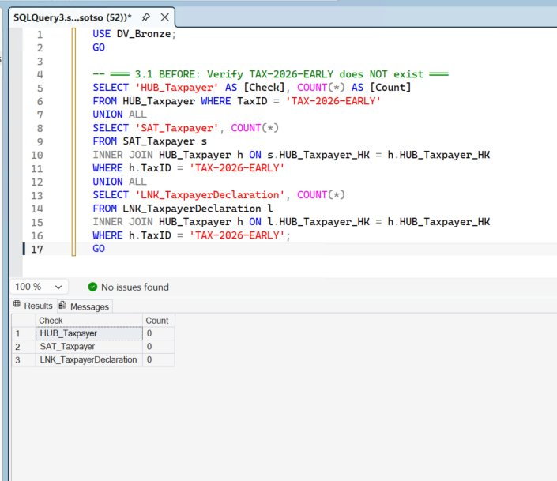

Step 2 — Hub Auto-Creation During Link Loading
When the ETL pipeline encounters a TaxID that does not yet exist in HUB_Taxpayer, the Hub loading procedure creates a record with only the business key. No descriptive attributes are needed.
-- Hub: create with business key only (no Satellite data needed)
INSERT INTO HUB_Taxpayer
(HUB_Taxpayer_HK, TaxID, HUB_LoadDate, HUB_RecordSource)
VALUES (
HASHBYTES('SHA2_256', UPPER(TRIM('TAX-2026-EARLY'))),
'TAX-2026-EARLY', GETDATE(), 'EarlyDeclaration'
);

-- Declaration Hub
INSERT INTO HUB_Declaration
(HUB_Declaration_HK, DeclarationID, HUB_LoadDate, HUB_RecordSource)
VALUES (
HASHBYTES('SHA2_256', UPPER(TRIM('99999'))),
99999, GETDATE(), 'EarlyDeclaration'
);

Step 3 — Link Record Insertion
The Link procedure creates the relationship between Taxpayer and Declaration using pre-computed hash keys. Because the Hub exists (from Step 2), the Link inserts without referential integrity violations.
INSERT INTO LNK_TaxpayerDeclaration
(LNK_TaxpayerDeclaration_HK, HUB_Taxpayer_HK,
HUB_Declaration_HK, LNK_LoadDate, LNK_RecordSource)
VALUES (
HASHBYTES('SHA2_256', CONCAT('TAX-2026-EARLY','|','99999')),
HASHBYTES('SHA2_256', UPPER(TRIM('TAX-2026-EARLY'))),
HASHBYTES('SHA2_256', UPPER(TRIM('99999'))),
GETDATE(), 'EarlyDeclaration'
);
Figure: Hub, Declaration Hub, and Link all created (1 row affected each)
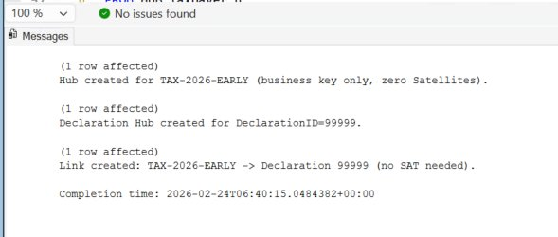

Verified: Early Arriving State
Hub exists with TaxID = ‘TAX-2026-EARLY’, Satellite Status = ‘NO Satellite (Early Arriving)’, Link Count = 1.
Figure: Hub exists with zero Satellites, Link Count = 1 — early arriving state confirmed
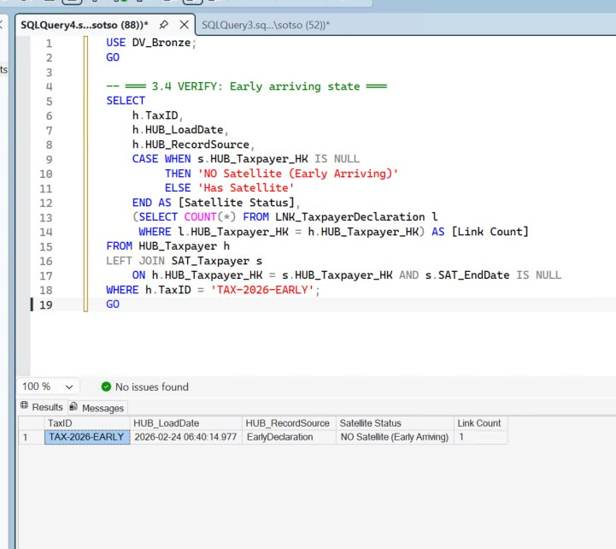
⚠ The Hub now exists with TaxID = “TAX-2026-EARLY” but has zero Satellite rows. This is a valid and complete entity in Data Vault 2.0.

Step 4 — Satellite Data Arrives in a Later Batch
When the taxpayer registration data eventually arrives (263 seconds later in this test), the Satellite procedure simply inserts descriptive attributes linked to the existing Hub. No UPDATE, no reconciliation, no placeholder cleanup.
-- Simple INSERT — no UPDATE, no reconciliation needed
INSERT INTO SAT_Taxpayer
(HUB_Taxpayer_HK, SAT_LoadDate, SAT_EndDate,
SAT_RecordSource, SAT_HashDiff,
LegalBusinessName, TradingName, ...)
SELECT h.HUB_Taxpayer_HK, GETDATE(), NULL,
'TaxSystemDB', HASHBYTES('SHA2_256', ...),
'Early Arriving Corp', 'EAC Trading', ...
FROM HUB_Taxpayer h
LEFT JOIN SAT_Taxpayer s ON h.HUB_Taxpayer_HK = s.HUB_Taxpayer_HK
WHERE h.TaxID = 'TAX-2026-EARLY' AND s.HUB_Taxpayer_HK IS NULL;
Figure: Resolved: Hub Loaded 06:40:14, SAT Loaded 06:44:37, Delay = 263 sec
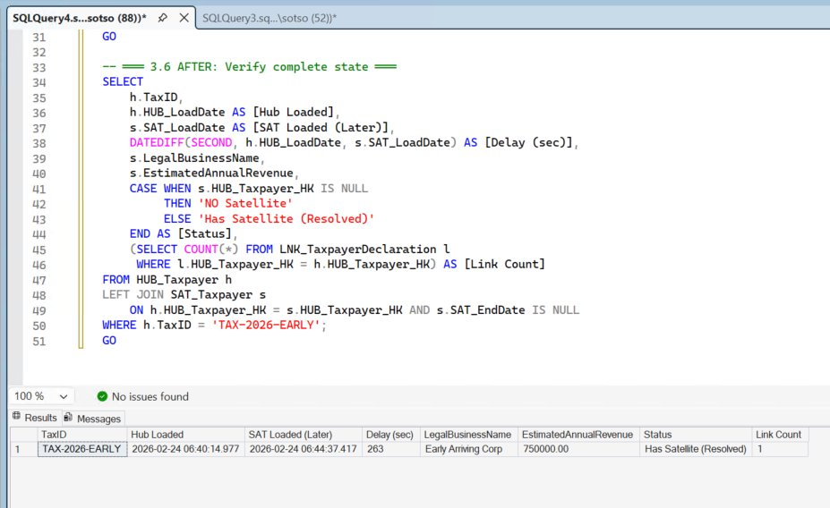

3.3 Verified Timeline: Chronological Proof
The timeline below proves the early arriving fact pattern with actual timestamps from the GCP VM execution:
Figure: 4-step timeline: Hub → Declaration → Link → Satellite (263 seconds later)
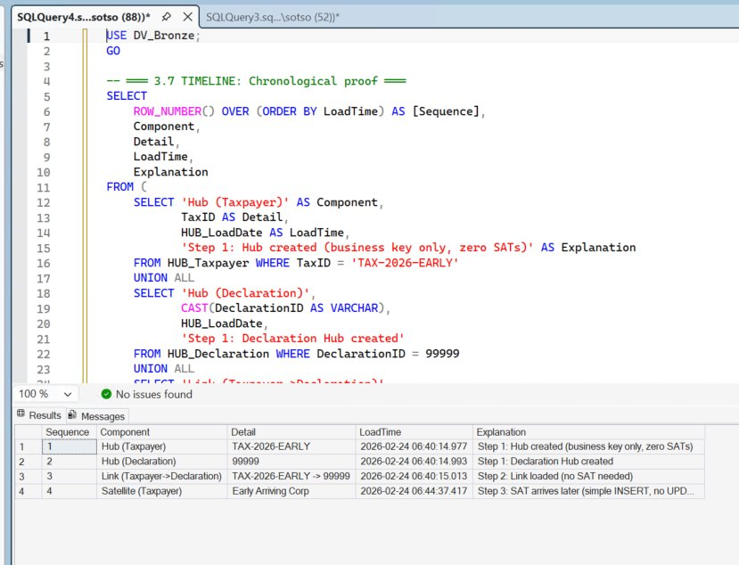
Seq | Component | Time | Explanation
1 | Hub (Taxpayer) | 06:40:14.977 | Business key only, zero Satellites
2 | Hub (Declaration) | 06:40:14.993 | Declaration Hub created (+16ms)
3 | Link (Taxpayer→Decl) | 06:40:15.013 | Relationship loaded, no SAT needed (+20ms)
4 | Satellite (Taxpayer) | 06:44:37.417 | Simple INSERT, 263 seconds later — no UPDATE

3.4 Before vs After: Early Arriving Facts Handling
Aspect | Before (Without DV2) | After (With DV2) — Verified
Missing dimension | Load failure or referential integrity violation | Hub created with business key only — load succeeds ✓
Placeholder handling | Must INSERT placeholder row with “Unknown” attributes and track it for later resolution | Not needed — Hub is a valid entity without Satellites ✓
Late data arrival | Requires UPDATE on placeholder row + reconciliation logic to merge with real data | Simple INSERT of new Satellite row — no UPDATE ever ✓
Audit trail | Complex: placeholder record vs resolved record creates ambiguous history | Clean: insert-only, full chronological history preserved ✓
ETL complexity | Additional detection, placeholder insertion, reconciliation, and audit steps required | Zero additional steps — standard DV2 Hub/SAT loading pattern handles it naturally ✓
✅ VERIFIED: The Data Vault 2.0 hub-satellite separation eliminates all workaround steps for early arriving facts. Hub loaded at 06:40:14 with zero Satellites, Link loaded at 06:40:15, Satellite arrived 263 seconds later as a simple INSERT. Zero placeholders, zero UPDATEs, zero reconciliation.

Verification Summary
# | Scenario | Verification Item | Actual Result | Status
1 | Flexibility | SAT_Taxpayer_RiskLevel created | 10 records loaded | ✅ PASS
2 | Flexibility | Existing objects unchanged (23/23) | All modify_dates same | ✅ PASS
3 | Flexibility | Cross-satellite query works | LEFT JOIN success | ✅ PASS
4 | Materialized | Baseline complex query time | 73ms elapsed | ✅ PASS
5 | Materialized | Indexed view with SCHEMABINDING | Created + IX | ✅ PASS
6 | Materialized | NOEXPAND query time | 34ms (2.1x faster) | ✅ PASS
7 | Early Facts | Hub created (business key only) | Zero SATs confirmed | ✅ PASS
8 | Early Facts | Link loaded without SAT | Link Count = 1 | ✅ PASS
9 | Early Facts | SAT arrived later via INSERT | 263s delay, no UPDATE | ✅ PASS
10 | Early Facts | Timeline chronological proof | 4 steps verified | ✅ PASS

ALL 10 ITEMS VERIFIED: Scenario 1 proves zero-impact schema evolution (23/23 objects unchanged). Scenario 2 confirms 2.1x query speedup (73ms → 34ms). Scenario 3 demonstrates clean early arriving fact handling with 263-second Hub-to-Satellite delay, zero placeholders, and zero UPDATEs.

