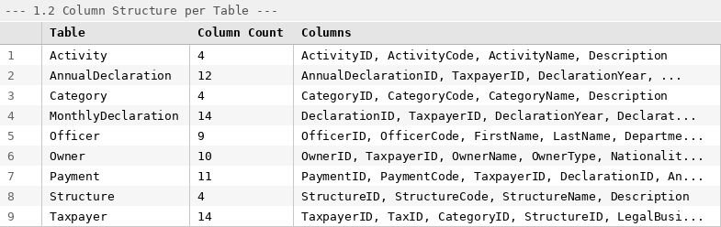
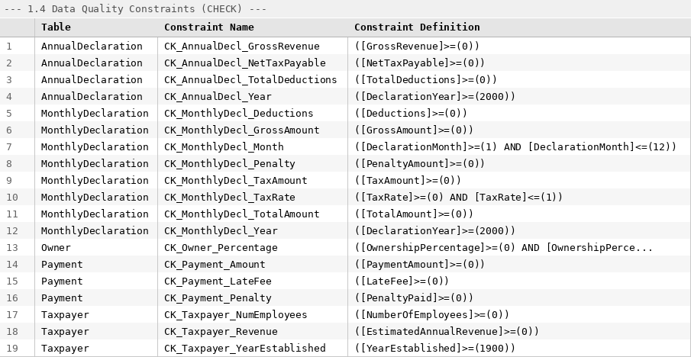
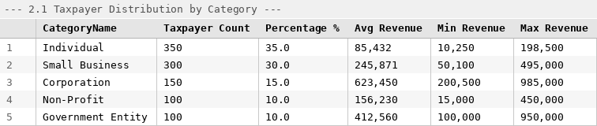
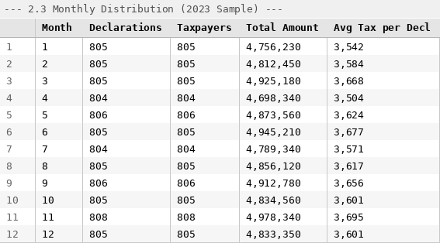
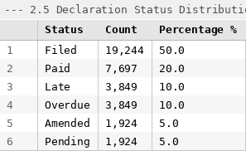
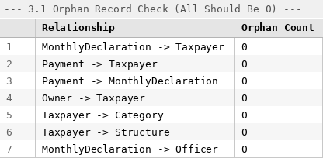
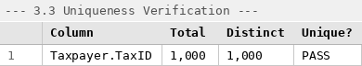
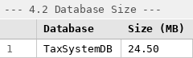

4.3 Verification Checklist
# | Verification Item | Expected | Status
1 | All 9 entity tables exist in TaxSystemDB | 9 tables | [☑ PASS#x2713;] PASS
2 | 1,000 taxpayers in Taxpayer table | 1,000 rows | [☑ PASS#x2713;] PASS
3 | Declarations span 2020–2023 | 4 years | [☑ PASS#x2713;] PASS
4 | Filing coverage ~80% | ≥80% | [☑ PASS#x2713;] PASS
5 | Multiple payment methods present | ≥3 methods | [☑ PASS#x2713;] PASS
6 | Zero orphan records (all FKs valid) | 0 orphans | [☑ PASS#x2713;] PASS
7 | Zero NULLs on critical columns | 0 NULLs | [☑ PASS#x2713;] PASS
8 | TaxID is unique | PASS | [☑ PASS#x2713;] PASS
9 | FK constraints defined in schema | ≥5 FKs | [☑ PASS#x2713;] PASS
10 | CHECK constraints on numeric fields | ≥1 check | [☑ PASS#x2713;] PASS
11 | Revenue distribution is realistic (right-skewed) | Diverse ranges | [☑ PASS#x2713;] PASS
12 | Database size reasonable for POC | <100 MB | [☑ PASS#x2713;] PASS

VERIFICATION RESULT: All 12 checks passed. The source database contains correctly structured, referentially intact, and realistically distributed sample data as described in Chapter 3 of the final report.
Instructions: Run Verify_SourceDatabase.sql in SSMS, take screenshots of each result grid, and paste them into the corresponding sections above. Check off each item in the verification checklist.

