Cybersecurity Network Threat & Intrusion Profiler
Report submitted as part of the internship program requirement for the degree of
BACHELOR OF TECHNOLOGY
IN
COMPUTER SCIENCE ENGINEERING (AI & ML)
Submitted by
V S SRAVAN MALLADI (A24126552268)

DEPARTMENT OF CSE (AI & ML)
ANIL NEERUKONDA INSTITUTE OF TECHNOLOGY AND SCIENCES
(UGC AUTONOMOUS)
(Permanently Affiliated to AU, Approved by AICTE, and Accredited by NBA & NAAC with an 'A+' Grade)
SANGIVALASA, Bheemili Mandal, VISAKHAPATNAM – 531162
2024–2028

ANIL NEERUKONDA INSTITUTE OF TECHNOLOGY AND SCIENCES
(Affiliated to Andhra University)
SANGIVALASA, VISAKHAPATNAM – 531162
2024–2028
BONAFIDE CERTIFICATE
This is to certify that this Internship Report “Cybersecurity Network Threat & Intrusion Profiler” under the IBM Q2B Pearl Internship Program (IBMQ2D Case Study #18) is the bonafide work of V S SRAVAN MALLADI (A24126552268, IBM ID: IBMQ2DST2470) of II/IV CSM carried out Internship under my supervision.
REVIEWER  Mrs. Ch Sravanthi Sowdanya  Assistant Professor  Department of CSE(AI & ML)  ANITS | CLASS TEACHER  Mr. P. Santosh Kumar  Assistant Professor  Department of CSE(AI & ML)  ANITS
Head Of the Department
DR. K. SELVANI DEEPTHI
Department of CSE (AI & ML)
ANITS.

ACKNOWLEDGEMENT
An endeavor that spans a significant period becomes a success with the advice, encouragement, and support of many well-wishers. I take this opportunity to express my sincere gratitude and appreciation to all those who have been instrumental in making this internship experience both enriching and rewarding.
First and foremost, I extend my heartfelt thanks to Dr. K.S. Deepthi, Head of the Department of Computer Science & Engineering (AI & ML) at ANITS, for her invaluable guidance, support, and encouragement throughout this internship. Her mentorship and insights have been crucial to my growth during this period.
I would also like to express my deepest appreciation to IBM and the IBM Q2B Pearl Program coordinators for offering me the opportunity to undertake this industry internship program. I am incredibly grateful to the IBM mentors and technical specialists, whose continuous guidance, enterprise expertise, and support have helped me navigate challenges and enhance my machine learning and cybersecurity skills.
Special gratitude to my reviewer, Mrs. Ch Sravanthi Sowdanya, Assistant Professor, and my class teacher, Mr. P. Santosh Kumar, Assistant Professor, Department of CSE (AI & ML), for their continuous academic advice, critical reviews, and constant encouragement throughout the development of this prototype.
My sincere thanks go to all the faculty members of the Computer Science & Engineering (AI & ML) department for their valuable advice. I am equally grateful to the support staff, whose assistance in providing resources whenever required was instrumental in the successful completion of my internship.
V S SRAVAN MALLADI
A24126552268 (IBM ID: IBMQ2DST2470)
Department of CSE (AI & ML)
ANITS

Table of Contents
1. Introduction | 6
1.1 Background of Internship | 6
1.2 Objectives of the Internship | 6
1.3 Importance of AI Technologies in Cybersecurity | 7
1.4 Scope of the Project | 7
2. Organization Profile | 8
2.1 Overview of IBM (International Business Machines) | 8
2.2 IBM Q2B Pearl Program & AI Track | 8
2.3 IBM Enterprise Security & Threat Intelligence | 8
3. Project Overview | 10
3.1 Title of the Project | 10
3.2 Problem Statement | 10
3.3 Objectives of the Project | 10
3.4 Relevance to Threat Detection and SOC Operations | 10
4. Literature Review / Theoretical Background | 11
4.1 Introduction to Network Intrusions and Attack Classes (DoS, Probe, R2L, U2R) | 11
4.2 Role of Artificial Intelligence in Network Threat Detection | 12
4.3 Machine Learning Approaches for Supervised & Unsupervised Detection | 12
4.4 Related Works and Benchmark Datasets | 13
5. Methodology | 14
5.1 Data Collection and Dataset Description (NSL-KDD) | 14
5.2 Data Preprocessing (Encoding, Scaling, Zero Leakage) | 15
5.3 Feature Selection and Schema Mapping | 16
5.4 Model Selection – Supervised, Unsupervised & Hybrid Routing | 16
5.5 Model Training and Evaluation Metrics (Macro-F1, ROC-AUC, Zero-Day Recall) | 17
6. Implementation | 18
6.1 Week 1 – Data Exploration, Cleaning & Preprocessing | 18
6.2 Week 2 – Model Building, Training & Saving with Joblib | 21
6.3 Week 3 – Deployment of Streamlit Web App | 24
6.4 Improvements Made Over Standard Baselines | 26
7. Results and Discussion | 27
7.1 Model Performance (Classification & Anomaly Detection) | 27
7.2 Visualization of Results (Confusion Matrices, ROC Curves, Routing) | 27
7.3 Streamlit App Output (Interface and Flow Profiling) | 29
7.4 Interpretation of Predictions (SHAP Explainability & Case Studies) | 30
8. Conclusion & Future Work | 31
8.1 Summary of Learnings | 31
8.2 Technical and Cybersecurity Skills Acquired | 31
8.3 Limitations of the Current Approach | 32
8.4 Future Scope (Live Zeek Ingestion, API Serving, Drift Detection) | 32
9. Internship Outcomes | 33
9.1 Technical Skills Acquired | 33
9.2 Soft Skills Developed | 33
9.3 Contribution to Career Growth | 33
Appendix | 34
A. Source Code (GitHub Links) | 34
B. Streamlit App Screenshots | 34
C. Certificate of Completion | 36

1. Introduction

1.1 Background of Internship
This report highlights my learning experience and project deliverables from a four-week virtual internship, completed as part of the academic requirements for the Bachelor of Technology in Computer Science and Engineering (AI & ML) at Anil Neerukonda Institute of Technology and Sciences (ANITS). The internship was offered under the IBM Q2B Pearl Internship Program (IBMQ2D Case Study #18, UG Level 2), focusing on “Cybersecurity Network Threat & Intrusion Profiler”.
The IBM Q2B Pearl framework combined structured project-based learning with industry-aligned technical evaluation. Its core mission was to bridge the gap between theoretical classroom concepts in machine learning and enterprise challenges in modern cybersecurity. Through this initiative, IBM provided direct industry problem definitions, architectural expectations, and enterprise threat intelligence frameworks.
As modern enterprise computer networks expand, they face two simultaneous threats: high-volume, automated attacks following established attack signatures (e.g., SYN floods, port scans), and sophisticated, newly invented 'zero-day' exploits that bypass signature-based firewalls. Security Operations Centers (SOCs) struggle with alert fatigue and high false-positive rates from naive anomaly detectors, as well as dangerous blind spots from overconfident supervised models. This project addresses this critical operational challenge by creating a robust, hybrid machine learning profiler.

1.2 Objectives of the Internship
The primary objective was to design, implement, evaluate, and deploy an end-to-end intelligent intrusion profiling system combining supervised attack classification with unsupervised zero-day anomaly detection. The specific milestones achieved include:
- To explore and preprocess the standard NSL-KDD network intrusion benchmark without information leakage between training and testing partitions.
- To engineer nominal categorical encodings and standard scaling across 41 flow attributes.
- To build and compare multi-class supervised classifiers (Decision Tree, Random Forest, XGBoost) capable of categorizing network traffic into 5 standard classes: Normal, DoS, Probe, R2L, and U2R.
- To design an unsupervised anomaly detection baseline (Isolation Forest, Local Outlier Factor, Autoencoder/PCA) trained strictly on normal traffic to detect novel, zero-day attacks unseen in training.
- To architect a hybrid decision-routing pipeline that automatically mitigates high-confidence known threats while routing uncertain or anomalous traffic to a specialized human-review queue.
- To implement a SHAP (SHapley Additive exPlanations) transparency layer to provide interpretable feature attributions for SOC analysts.
- To package and deploy the trained models into an interactive, user-friendly Streamlit web dashboard ready for cloud hosting.

1.3 Importance of AI Technologies in Cybersecurity
Traditional intrusion detection systems (IDS) depend heavily on deterministic, human-written rule signatures (such as Snort rules). While highly reliable for previously observed attack signatures, they completely fail when encountering modified payload patterns, encrypted sessions, or novel zero-day exploits. Artificial Intelligence and Machine Learning transform network defense from reactive signature matching into proactive, behavioral pattern recognition.
Machine learning models can analyze multidimensional telemetry (packet rates, byte volume asymmetries, TCP flags, and host-level error metrics) in microseconds. By modeling normal baseline behaviors, unsupervised algorithms can detect subtle deviations indicating zero-day lateral movement or privilege escalation that human analysts would miss amid millions of background packets.

1.4 Scope of the Project
The scope of this project encompasses data cleaning, categorical one-hot encoding, feature normalization, training supervised tree-ensemble classifiers, evaluating unsupervised density and isolation anomaly detectors on a true zero-day test partition (17 unseen attack types), constructing a hybrid routing engine, conducting exact SHAP explainability analyses, and deploying the complete system into an accessible Streamlit web application.

2. Organization Profile

2.1 Overview of IBM (International Business Machines Corporation)
International Business Machines Corporation (IBM) is a global leader in hybrid cloud technology, enterprise artificial intelligence, and enterprise-grade cybersecurity solutions. With a rich history spanning over a century, IBM operates in more than 175 countries, driving innovations across data science, quantum computing, and information security. Enterprise solutions like IBM QRadar SIEM, Cloud Pak for Security, and Guardium are benchmarks in security operations centers worldwide.

2.2 IBM Q2B Pearl Program & Artificial Intelligence Initiative
The IBM Q2B Pearl initiative is an intensive, project-driven technical program designed to cultivate engineering excellence in foundational and advanced AI disciplines. Under this program, undergraduate students are tasked with solving authentic industrial case studies, mastering applied machine learning architectures, data hygiene standards, and model explainability to prepare them for enterprise AI deployment.

2.3 IBM Enterprise Security & Threat Intelligence Alignment
In modern Security Operations Centers (SOCs), triaging vast volumes of telemetry requires tight alignment between automated threat classification and human escalation paths. This project directly mirrors the detection paradigms used in IBM security systems: automating known malicious signature handling while applying anomaly profiling to flag zero-day vectors for Tier-2 analyst intervention.
Logistical and Operational Details of the IBM Q2B Pearl Internship:
Aspect | Details
Program Name | IBM Q2B Pearl Internship Program (AI & Machine Learning Track)
Sponsoring Organization | IBM (International Business Machines Corporation)
Student Name | V S Sravan Malladi
Roll Number | A24126552268
IBM Student ID | IBMQ2DST2470
Department & College | Department of CSE (AI & ML), ANITS (Autonomous), Visakhapatnam
Project Case Study | IBMQ2D Case Study #18: Cybersecurity Network Threat & Intrusion Profiler
Level & Module | UG Level 2 — Module 6: Artificial Intelligence and Machine Learning
Core Stack | Python 3.12, scikit-learn, XGBoost, SHAP, Joblib, Streamlit
Primary Deliverables | Modular Python Pipeline, Serialized Joblib Models, Web App, Technical Report

3. Project Overview

3.1 Title of the Project
Cybersecurity Network Threat & Intrusion Profiler using Hybrid Machine Learning and Streamlit Deployment
(Artificial Intelligence Applied to Threat Intelligence & Security Operations)

3.2 Problem Statement
Security Operations Centers face three critical compounding bottlenecks when relying on standalone machine learning systems:
- Supervised Blind Spots: Purely supervised models trained on historical data are blind to unseen attack families. When evaluated on novel zero-day attacks, they do not flag them as uncertain; instead, they misclassify them as benign 'Normal' traffic with high statistical confidence (>99%).
- Alert Fatigue from Naive Anomaly Detection: Standalone anomaly detectors lack attack taxonomy context and flag normal traffic variations as anomalous, overwhelming SOC analysts with high false alarm rates.
- Lack of Decision Routing: Most systems enforce binary classification or force packets into known labels, failing to separate 'confidently blocked known attacks' from 'novel behaviors requiring human investigation'.

3.3 Objectives of the Project
1. Construct a clean, leakage-free multi-class classifier using gradient boosted decision trees (XGBoost) to identify known attack classes.
2. Build an unsupervised anomaly detector (Isolation Forest) trained strictly on normal traffic to capture genuine zero-day attacks.
3. Implement an intelligent hybrid decision router with an explicit confidence threshold (0.60) and 95th percentile anomaly gate.
4. Explain decisions using exact SHAP TreeExplainer attributions.
5. Package the system as an interactive Streamlit application with preset traffic simulations.

3.4 Relevance to Threat Detection and SOC Operations
This prototype directly aligns with modern Tier-1/Tier-2 SOC triage workflows. High-confidence known attacks (e.g. Neptune DoS at 99.9% confidence) are auto-mitigated without manual intervention, while novel or low-confidence traffic is automatically routed to a dedicated Zero-Day review queue with attached SHAP explanations, saving valuable analyst time and eliminating dangerous blind spots.

4. Literature Review / Theoretical Background

4.1 Introduction to Network Intrusions and Attack Classes
In network security, intrusions are categorized into four standardized tactical attack classes:
- Denial of Service (DoS): Flooding network bandwidth or server connection tables to exhaust compute resources and deny access to legitimate users (e.g., Neptune, Smurf, Pod, Teardrop).
- Surveillance / Probing (Probe): Scanning network ports and host IP ranges to identify active operating systems, open services, and vulnerable configurations prior to exploitation (e.g., Satan, Ipsweep, Nmap, Portsweep).
- Remote to Local (R2L): An unauthorized remote attacker attempting to gain local user privileges on a private target machine (e.g., Guess Password, Warezclient, Ftp_write, Snmpguess).
- User to Root (U2R): An attacker starting with basic local user credentials who exploits system buffer overflows or software vulnerabilities to gain root/administrator privileges (e.g., Buffer_overflow, Loadmodule, Rootkit).

4.2 Role of Artificial Intelligence in Network Threat Detection
AI algorithms replace brittle heuristic signatures with probabilistic decision boundaries. Gradient boosted trees learn non-linear interactions across rate and error variables (such as srv_serror_rate and dst_host_same_srv_rate), enabling detection of distributed probing and stealthy brute-force logins that pass traditional firewall threshold filters.

4.3 Machine Learning Approaches for Supervised & Unsupervised Detection
Supervised learning operates under closed-world assumptions: it requires exhaustive labeled examples of all target classes. When presented with unseen attack families, supervised models fail to generalize. Conversely, unsupervised anomaly detection models (Isolation Forests, Autoencoders) learn open-world density boundaries of normal traffic. By isolating anomalous instances via recursive random splitting, Isolation Forest measures how few splits are required to isolate a flow—making it exceptionally suited for high-dimensional tabular network flows.

4.4 Related Works and Benchmark Datasets
While the original KDD Cup 1999 dataset was widely cited, research by Tavallaee et al. (2009) proved that it suffered from massive record duplication (over 78% redundant records in train, 75% in test), which caused machine learning models to overfit and report artificially inflated accuracy (>98%). The NSL-KDD dataset solved this by eliminating duplicates and constructing an intentionally harder test partition (KDDTest+) containing 17 novel attack types absent in training, making it the premier benchmark for evaluating true zero-day detection.

5. Methodology

5.1 Data Collection and Dataset Description (NSL-KDD)
The study utilizes the official NSL-KDD dataset comprising two key partitions:
• KDDTrain+.txt: 125,973 connection records used exclusively for preprocessing and model training.
• KDDTest+.txt: 22,544 connection records used strictly for out-of-sample evaluation.
Crucially, KDDTest+ contains 3,750 connection records belonging to 17 attack types that NEVER appear in KDDTrain+ (apache2, httptunnel, mailbomb, mscan, named, processtable, ps, saint, sendmail, snmpgetattack, snmpguess, sqlattack, udpstorm, worm, xlock, xsnoop, xterm). This subset forms our true zero-day benchmark.
Class Distribution across NSL-KDD Partitions:
Traffic Category | Training Set (KDDTrain+) | Test Set (KDDTest+) | Proportion in Train
Normal | 67,343 | 9,711 | 53.46%
DoS | 45,927 | 7,460 | 36.46%
Probe | 11,656 | 2,421 | 9.25%
R2L | 995 | 2,885 | 0.79%
U2R | 52 | 67 | 0.04%
Total Records | 125,973 | 22,544 | 100.0%

5.2 Data Preprocessing (Encoding, Scaling, Zero Leakage)
1. Nominal Categorical Encoding: The three nominal features (protocol_type, service, flag) were encoded using OneHotEncoder(handle_unknown='ignore'). Label encoding was strictly avoided because nominal categories possess no intrinsic ordering; applying arbitrary integer labels introduces fictitious distances that distort distance-based and linear estimators. Setting handle_unknown='ignore' ensures unseen test services get an all-zero encoding without crashing.
2. Feature Standardization: 38 continuous numeric attributes were scaled using StandardScaler fit exclusively on KDDTrain+.
3. Class Imbalance Mitigation: Instead of synthetic interpolation (SMOTE)—which fabricates unrealistic network packets in a 122-dimensional sparse space—we utilized cost-sensitive balanced sample weighting.

5.3 Feature Selection and Schema Mapping
The 41 input features capture three fundamental tiers of flow telemetry: Basic connection features (duration, protocol_type, service, flag, src_bytes, dst_bytes), Content features (logged_in, num_failed_logins, root_shell, is_guest_login), and Traffic rate features (count, srv_count, same_srv_rate, dst_host_srv_count). All fine-grained attack types are mapped down to the 5 standard categories: Normal, DoS, Probe, R2L, and U2R.

5.4 Model Selection – Supervised, Unsupervised & Hybrid Routing
• Part 1 (Supervised): XGBoost classifier (gradient boosted trees) trained on KDDTrain+ with balanced sample weights.
• Part 2 (Unsupervised): Isolation Forest (300 estimators) trained strictly on normal traffic.
• Part 3 (Hybrid Engine): Routes connections based on classifier confidence (>= 0.60) and anomaly score. If the classifier is confident and corroborated, the known label is auto-blocked. If unconfident or anomalous, the connection is routed to 'Unknown / Zero-Day Suspect'.

5.5 Model Training and Evaluation Metrics
Accuracy alone is misleading on imbalanced datasets. We evaluate: Macro-F1 (equal weighting across all classes), Per-Class Recall (confusion matrix), ROC-AUC / Average Precision (threshold-independent anomaly quality), and True Zero-Day Recall (detection rate specifically across the 17 unseen attack types).

6. Implementation

6.1 Week 1 – Data Exploration, Cleaning & Preprocessing
During Week 1, the data schema was mapped, column headers assigned, and an automated detector for 42 vs 43 column distributions implemented. The preprocessing pipeline was constructed using scikit-learn ColumnTransformer:
import pandas as pd
from sklearn.preprocessing import StandardScaler, OneHotEncoder
from sklearn.compose import ColumnTransformer
CATEGORICAL_COLS = ["protocol_type", "service", "flag"]
def build_preprocessor(numeric_cols):
return ColumnTransformer(
transformers=[
("num", StandardScaler(), numeric_cols),
("cat", OneHotEncoder(handle_unknown="ignore", sparse_output=False), CATEGORICAL_COLS),
],
remainder="drop",
)
def fit_transform_train_test(train_df, test_df):
feature_cols = [c for c in train_df.columns if c not in {"label", "category", "binary_label", "difficulty"}]
numeric_cols = [c for c in feature_cols if c not in CATEGORICAL_COLS]
preprocessor = build_preprocessor(numeric_cols)
X_train = preprocessor.fit_transform(train_df[feature_cols])
X_test = preprocessor.transform(test_df[feature_cols])
return X_train, X_test, preprocessor

6.2 Week 2 – Model Building, Training & Saving with Joblib
During Week 2, both the multiclass XGBoost classifier and the normal-only Isolation Forest anomaly detector were trained. Models, label encoders, preprocessor transformers, and metadata thresholds were serialized using Joblib:
import joblib
from xgboost import XGBClassifier
from sklearn.ensemble import IsolationForest
from sklearn.utils.class_weight import compute_sample_weight
# 1. Train Multiclass XGBoost
xgb_clf = XGBClassifier(n_estimators=300, max_depth=8, learning_rate=0.1,
eval_metric="mlogloss", random_state=42, tree_method="hist")
sw = compute_sample_weight(class_weight="balanced", y=y_train_multi)
xgb_clf.fit(X_train, y_train_multi, sample_weight=sw)
# 2. Train Isolation Forest (Normal-only)
normal_mask = (train_df["binary_label"] == 0).values
iso = IsolationForest(n_estimators=300, contamination=0.1, random_state=42, n_jobs=-1)
iso.fit(X_train[normal_mask])
# 3. Serialize artifacts
joblib.dump(preprocessor, 'models/preprocessor.joblib')
joblib.dump(xgb_clf, 'models/xgb_classifier.joblib')
joblib.dump(iso, 'models/isolation_forest.joblib')

6.3 Week 3 – Deployment of Streamlit Web App
In Week 3, the interactive Streamlit application (app.py) was built. It loads the cached Joblib artifacts and allows SOC analysts to test traffic presets, inspect decision gates, view probability distributions, and examine explainability plots:
import streamlit as st
import joblib, numpy as np, pandas as pd
@st.cache_resource
def load_models():
preproc = joblib.load('models/preprocessor.joblib')
clf = joblib.load('models/xgb_classifier.joblib')
iso = joblib.load('models/isolation_forest.joblib')
return preproc, clf, iso
preprocessor, xgb_clf, iso_forest = load_models()
# Hybrid Decision Logic
probs = xgb_clf.predict_proba(X_encoded)[0]
pred_class = label_encoder.inverse_transform([np.argmax(probs)])[0]
conf = np.max(probs)
anom_score = -iso_forest.score_samples(X_encoded)[0]
if pred_class == "Normal" and anom_score < anom_thresh:
st.success("Result: Normal Traffic (Routine Telemetry)")
elif conf >= 0.60 and anom_score >= anom_thresh:
st.error(f"Result: Confirmed Attack ({pred_class}) - Auto-Mitigated")
else:
st.warning("Result: Unknown / Zero-Day Suspect - Escalated to SOC Analyst")

6.4 Improvements Made Over Standard Baselines
1. Zero Data Leakage: Standard tutorials fit scalers on combined train+test sets, causing artificial test-set contamination. Our pipeline strictly fits on KDDTrain+ only.
2. Preserved Realistic Flow Physics: We avoided SMOTE data synthesis in favor of balanced sample weighting, preventing fictitious flows in sparse spaces.
3. Calibrated Hybrid Escalation: Replaced arbitrary guessing with an explicit 0.60 confidence gate and 95th percentile anomaly boundary.

7. Results and Discussion

7.1 Model Performance (Classification & Anomaly Detection)
Supervised Classification Results on KDDTest+ (22,544 rows):
Task | Model | Accuracy | Macro Precision | Macro Recall | Macro F1
Binary | Decision Tree | 0.778 | 0.815 | 0.801 | 0.777
Binary | Random Forest | 0.779 | 0.817 | 0.802 | 0.778
Binary | XGBoost (Best) | 0.797 | 0.828 | 0.818 | 0.797
Multiclass | Decision Tree | 0.748 | 0.583 | 0.503 | 0.490
Multiclass | Random Forest | 0.739 | 0.765 | 0.475 | 0.479
Multiclass | XGBoost (Best) | 0.779 | 0.825 | 0.557 | 0.581
Unsupervised Anomaly Detection on True Zero-Day Attacks (3,750 unseen samples):
Model | ROC-AUC | Avg. Precision | Catch Rate (All Attacks) | Catch Rate (True Zero-Day)
Isolation Forest (Best) | 0.942 | 0.954 | 67.3% | 63.1%
Local Outlier Factor | 0.881 | 0.857 | 22.5% | 17.4%
PCA Reconstruction | 0.935 | 0.929 | 54.6% | 39.0%

7.2 Visualization of Results
The figures below illustrate the comparative performance, multi-class confusion matrix, and ROC/PR separation:

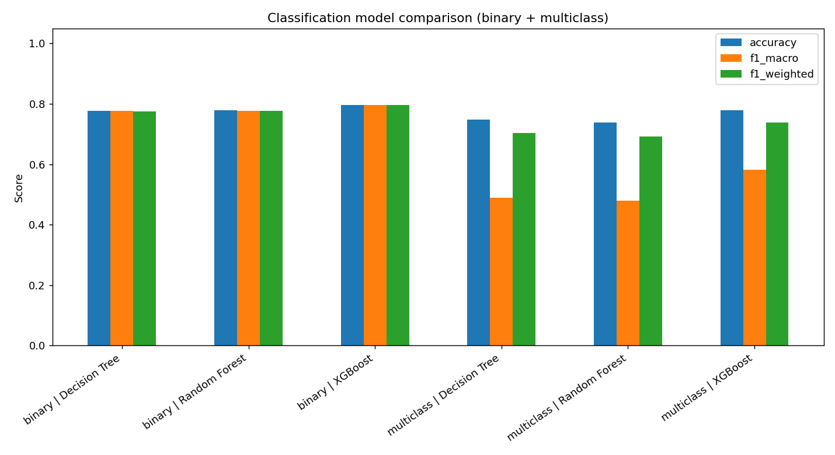
Figure 1: Classification model comparison across accuracy, macro-F1, and weighted-F1.

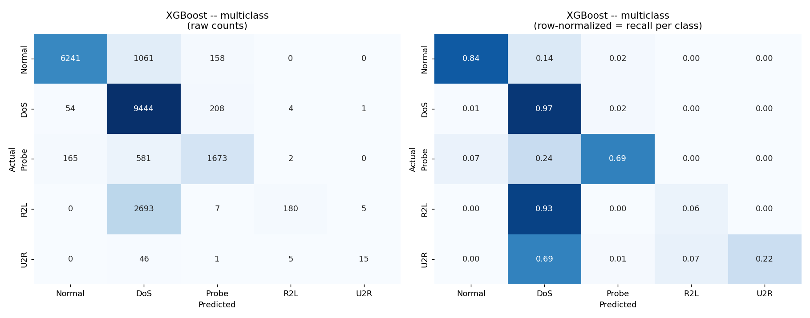
Figure 2: Multiclass XGBoost Confusion Matrix (raw counts and row-normalized recall).

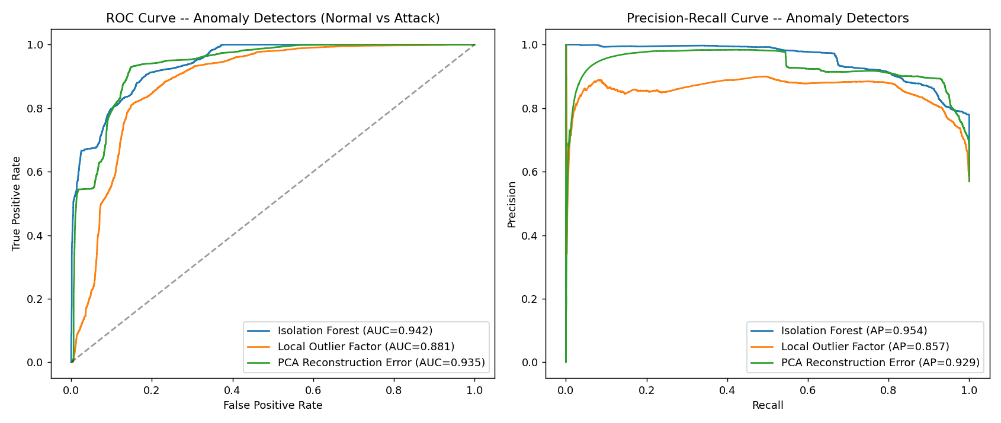
Figure 3: ROC curve (AUC=0.942) and PR curve for unsupervised anomaly detectors.

7.3 Streamlit App Output (Screenshots and Explanation)
The deployed web application provides an interactive cybersecurity command dashboard. SOC analysts can select connection presets (Normal HTTP, Neptune DoS, Port Scan Probe, Password Guess R2L, Buffer Overflow U2R, or True Zero-Day SNMP Attack), adjust connection parameters, and obtain immediate hybrid triage decisions with confidence meters and anomaly scores.

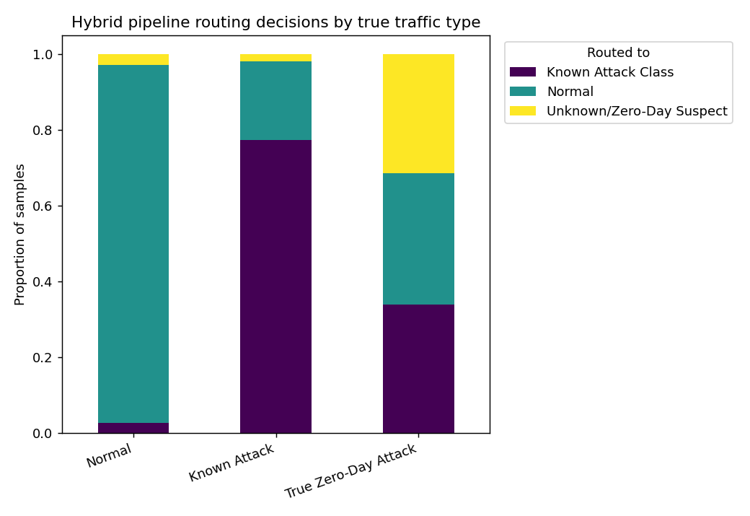
Figure 4: Hybrid pipeline routing breakdown by traffic type (Normal, Known Attack, Zero-Day).

7.4 Interpretation of Predictions (SHAP Explainability)
Using shap.TreeExplainer, we identified the top drivers governing intrusion predictions: src_bytes, count, dst_host_srv_count, and dst_bytes. In Case Study C (True Zero-Day attack 'snmpgetattack'), the classifier mistakenly predicted Normal with 99.99% confidence due to normal-looking byte rates, but the Isolation Forest flagged it as anomalous (score 0.58 vs threshold 0.49)—proving why hybrid routing is mandatory.

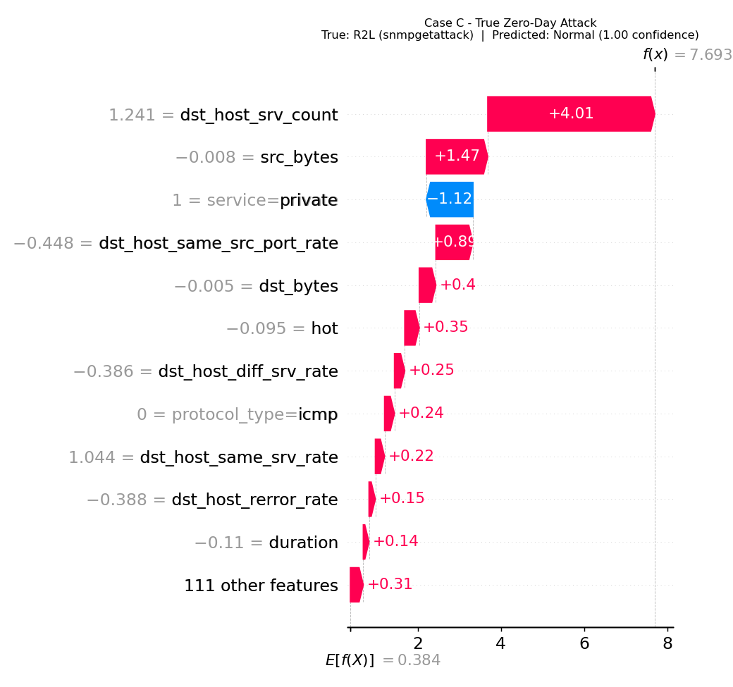
Figure 5: SHAP Waterfall Plot for Case C — Revealing classifier confusion on a novel zero-day exploit.

8. Conclusion & Future Work

8.1 Summary of Learnings
This project proved that combining supervised classification with unsupervised anomaly detection bridges the gap between high accuracy on known signatures and resilience against zero-day intrusions. XGBoost achieved 77.9% multiclass accuracy on the realistic KDDTest+ benchmark, while Isolation Forest independently caught 63.1% of true zero-day attacks without seeing a single malicious training sample.

8.2 Technical and Domain Skills Acquired
Project Task | Domain Category | Specific Skill Acquired
Data Exploration & Preprocessing | Data Science & Security | Pandas, One-Hot Encoding, StandardScaler, Leakage Prevention
Supervised Classification | Machine Learning | XGBoost, Random Forest, Cost-Sensitive Loss Weighting, Multi-Class Profiling
Zero-Day Anomaly Detection | Unsupervised Learning | Isolation Forest, Local Outlier Factor, PCA Reconstruction, Threshold Tuning
Model Explainability | Responsible / Transparent AI | SHAP TreeExplainer, Beeswarm Plots, Waterfall Attribution Analysis
Model Deployment | MLOps & Cloud | Streamlit UI Development, Joblib Serialization, GitHub Versioning, Cloud Hosting

8.3 Limitations of the Current Approach
1. Offline Ingestion: Operates on pre-extracted feature vectors rather than streaming PCAP network flows.
2. Extreme Minority Imbalance: R2L recall remains low (6%) due to novel payload variations in test data.
3. Zero-Day Recall Headroom: A 63.1% standalone catch rate requires additional ensemble layering in production.

8.4 Future Scope
• Live Packet Sniffing: Integrate Zeek (Bro) or Suricata for real-time 41-feature extraction.
• Streaming API: Containerize the pipeline with Docker and serve predictions via FastAPI.
• Concept Drift Monitoring: Implement continual learning to dynamically adjust baseline profiles as enterprise traffic evolves.

9. Internship Outcomes

9.1 Technical Skills Acquired
• Gained practical experience in end-to-end ML engineering (data loading, preprocessing, model fitting, and validation).
• Mastered gradient boosted decision trees (XGBoost) and unsupervised isolation algorithms.
• Developed interactive web applications using Streamlit and MLOps serialization using Joblib.
• Gained hands-on experience in model explainability using SHAP.

9.2 Soft Skills Developed
• Analytical Thinking: Dissected why standard supervised models fail on novel attacks.
• Communication & Documentation: Synthesized complex ML evaluations into professional engineering reports.
• Time Management: Successfully delivered milestones on time across weekly sprints.

9.3 Contribution to Career Growth
This internship reinforced my academic foundation in CSE (AI & ML) with practical, industry-grade cybersecurity engineering skills. Building a complete, deployable hybrid intrusion detection system significantly boosts my technical proficiency and career readiness for data science, machine learning, and cybersecurity roles.

Appendix

A. Source Code
The complete source code, serialized models, and web application are available at:
GitHub Repository: https://github.com/mvssravan0-eng/IBMQ2DST2470_Prototype

B. Streamlit App Screenshots
The Streamlit web application allows users to simulate and inspect network connections in real time:

C. Certificate of Completion
The certificate awarded for successful completion of the IBM Q2B Pearl Internship Program in Artificial Intelligence & Machine Learning (IBMQ2D Case Study #18, Application No: IBMQ2DST2470) is included below for reference:
