Rice Variety Classification Using Lightweight Machine Learning
A Project Report submitted in fulfillment of the requirements for the Machine Learning Project
BACHELOR OF TECHNOLOGY
IN
DEPARTMENT OF COMPUTER SCIENCE AND ENGINEERING(AI&ML)
Submitted by
MALLADI VENKATA SUBRAHMANYA SRAVAN (A24126552268)
DWARAPUDI SUSWETHA (A24126552079)
ROHITH GURUGUBELLI (A24126552112)
KOYYA APPALA REDDY (A24126552089)
Under the guidance of :
Dr. Appala Srinuvasu Muttipati
Associate Professor

DEPARTMENT OF COMPUTER SCIENCE AND ENGINEERING(AI&ML)
ANIL NEERUKONDA INSTITUTE OF TECHNOLOGY AND SCIENCES
(UGC AUTONOMOUS)
(Permanently Affiliated to AU, Approved by AICTE and Accredited by NBA & NAAC with 'A+' Grade)
Sangivalasa, bheemili mandal, visakhapatnam dist.(A.P)
2026-2027

ANITS CERTIFICATE
This is to certify that the project report entitled “RICE VARIETY CLASSIFICATION USING LIGHTWEIGHT MACHINE LEARNING” submitted by 1. MALLADI VENKATA SUBRAHMANYA SRAVAN (Regd No. A24126552268), 2. DWARAPUDI SUSWETHA (Regd No. A24126552079), 3. ROHITH GURUGUBELLI (Regd No. A24126552112), 4. KOYYA APPALA REDDY (Regd No. A24126552089), in fulfillment of the requirements for the Machine Learning Project in the Department of Computer Science and Engineering (AI&ML) during the year 2026-2027 of Anil Neerukonda Institute of Technology and Sciences (A+), Visakhapatnam, is a record of bonafide work to be carried out under the guidance and supervision named below, pending review and signature.

PROJECT GUIDE:  Dr. Appala Srinuvasu Muttipati  ASSOCIATE PROFESSOR  DEPARTMENT OF CSE (AI&ML)  ANITS | HEAD OF THE DEPARTMENT:  Dr K. Selvani Deepthi  DEPARTMENT OF CSE (AI&ML)  ANITS

DECLARATION
We hereby declare that the project report entitled “RICE VARIETY CLASSIFICATION USING LIGHTWEIGHT MACHINE LEARNING”, submitted for the Machine Learning Project, is a record of original work carried out by us under the guidance of Dr. Appala Srinuvasu Muttipati, Associate Professor, Department of Computer Science and Engineering (AI&ML). The implementation, experiments, and results reported were produced and verified by us; all external ideas, definitions and results drawn from published sources have been acknowledged in the References section.
We further declare that this report has not been submitted, in full or in part, for the award of any other degree, diploma, or similar title to this or any other institution.
Place: Visakhapatnam
Date: 05-10-2026
MALLADI VENKATA SUBRAHMANYA SRAVAN (A24126552268)
DWARAPUDI SUSWETHA (A24126552079)
ROHITH GURUGUBELLI (A24126552112)
KOYYA APPALA REDDY (A24126552089)

ACKNOWLEDGEMENT
We express our sincere gratitude to our project guide, Dr. Appala Srinuvasu Muttipati, Associate Professor, Department of CSE (AI&ML), for his valuable guidance, continuous encouragement, and constructive feedback throughout this project. His insistence on precise reasoning at every step shaped the way we approached this work from the outset.
We thank Dr. K. Selvani Deepthi, Head of the Department, for providing the departmental resources, laboratory access, and environment necessary to carry out this work, and for fostering a culture in the department where this kind of applied, project-driven learning is encouraged. We are equally grateful to all the faculty members of the Department of Computer Science and Engineering (AI&ML) for their valuable advice and encouragement.
Finally, we thank our classmates for the many useful discussions during the course of this project, and our families for their patience and support throughout the duration of this work.
TEAM MEMBERS:
MALLADI VENKATA SUBRAHMANYA SRAVAN (A24126552268)
DWARAPUDI SUSWETHA (A24126552079)
ROHITH GURUGUBELLI (A24126552112)
KOYYA APPALA REDDY (A24126552089)

TABLE OF CONTENTS

1. Problem statement 6
2. Dataset 6
3. Exploratory data analysis 6
4. Baseline model comparison 7
5. Feature selection 7
6. Lightweight model comparison 8
7. Final model 8
8. Error analysis and limitations 9
9. OUTPUTS AND EXPERIMENTAL RESULTS 10
10. APPENDIX: SOURCE CODE IMPLEMENTATION 11
11. Conclusion 12

Rice Variety Classification Using Lightweight Machine Learning

1. Problem statement
This project classifies individual rice grains as **Cammeo** or **Osmancik** from physical and morphological measurements. The main goal is to identify a small group of highly useful measurements and build a model that remains accurate while needing fewer inputs.

2. Dataset
The supplied Rice Cammeo and Osmancik dataset was used directly from `Rice_Cammeo_Osmancik.arff`.
Item | Result
Total records | 3,810
Input features | 7
Target classes | Cammeo, Osmancik
Cammeo records | 1,630
Osmancik records | 2,180
Missing values | 0
Duplicate rows | 0
The input measurements are Area, Perimeter, Major Axis Length, Minor Axis Length, Eccentricity, Convex Area, and Extent. An 80:20 stratified train-test split was used, giving 3,048 training samples and 762 unseen test samples.

3. Exploratory data analysis
The class distribution is moderately uneven, with more Osmancik observations, so stratified splitting was used. No values were missing and no duplicate records were found. The correlation plot shows that area-related measurements have strong relationships with each other, which supports the aim of removing redundant input features.
Generated visuals:
- `outputs/figures/01_class_distribution.png`
- `outputs/figures/02_key_feature_boxplots.png`
- `outputs/figures/03_feature_correlation.png`

4. Baseline model comparison
All seven features were standardized where needed. Five classifiers were trained and evaluated on the same unseen test set.
Model | Accuracy | Precision (Cammeo) | Recall (Cammeo) | F1 score | ROC-AUC
XGBoost | 91.99% | 92.60% | 88.34% | 90.42% | 97.39%
Random Forest | 91.86% | 92.58% | 88.04% | 90.25% | 97.18%
Logistic Regression | 91.60% | 91.72% | 88.34% | 90.00% | 97.50%
Support Vector Machine | 91.08% | 91.35% | 87.42% | 89.34% | 95.62%
K-Nearest Neighbors | 90.94% | 90.54% | 88.04% | 89.27% | 94.90%
Decision Tree | 89.76% | 88.51% | 87.42% | 87.96% | 89.47%
XGBoost produced the highest baseline test accuracy at 91.99%. Logistic Regression had the strongest ROC-AUC, indicating strong separation between the two varieties.

5. Feature selection
Three methods were used: Random Forest importance, mutual information, and Recursive Feature Elimination (RFE). Random Forest ranked the features in this order:
1. Major Axis Length
2. Perimeter
3. Area
4. Convex Area
5. Eccentricity
6. Minor Axis Length
7. Extent
The first three features were selected for the final lightweight model because they delivered the strongest reduced-feature baseline result while reducing the inputs from seven to three. This is a 57% reduction in the number of required measurements.
The complete feature-selection results are in `outputs/feature_selection_results.csv`, and the plot is `outputs/figures/04_feature_importance.png`.

6. Lightweight model comparison
Support Vector Machine models were tested with the top 3, top 5, and all 7 features.
Number of features | Feature subset | Accuracy | F1 score (Cammeo)
3 | Major Axis Length, Perimeter, Area | 91.47% | 89.80%
5 | Top 3 + Convex Area, Eccentricity | 91.21% | 89.51%
7 | All features | 91.08% | 89.34%
The three-feature version achieved the highest baseline accuracy among the SVM variants. Adding more inputs did not improve this result on the test set. The comparison chart is saved as `outputs/figures/05_lightweight_tradeoff.png`.

7. Final model
The final model is a Support Vector Machine using only Major Axis Length, Perimeter, and Area. A grid search with five-fold cross-validation tuned its parameters.
Metric | Final result
Selected features | 3
Best hyperparameters | C = 50, gamma = 0.1
Five-fold CV weighted F1 | 93.31%
Test accuracy | 91.21%
Test precision, Cammeo | 92.54%
Test recall, Cammeo | 85.89%
Test F1, Cammeo | 89.09%
Test ROC-AUC | 95.96%
Incorrect test predictions | 67 of 762
The full Random Forest has a marginally higher accuracy of 91.86%, but it requires every input feature and is more complex. The final SVM uses only three measurements and gives 91.21% accuracy, a difference of 0.66 percentage points. It is therefore the preferred lightweight solution.
The saved final model is `outputs/models/lightweight_rice_svm.joblib`. Its confusion matrix, ROC curve, metrics, and incorrect test rows are available in the output folder.

8. Error analysis and limitations
The final model misclassified 67 of 762 unseen grains. The lower Cammeo recall means some Cammeo grains have shape and size values that overlap with Osmancik grains. The dataset contains image-derived measurements, so model performance may differ if measurement quality changes in a new imaging setup. The model distinguishes only the two varieties represented in this dataset and should not be used to identify other rice varieties.

OUTPUTS AND EXPERIMENTAL RESULTS

01_class_distribution.png
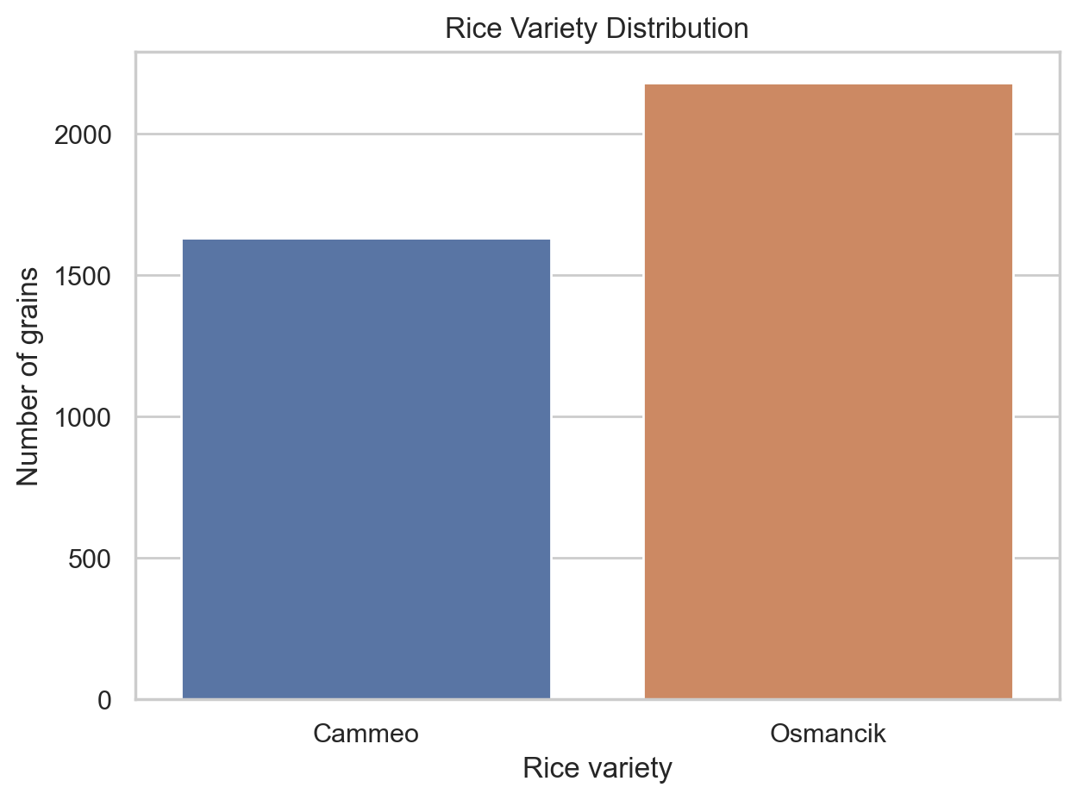

02_key_feature_boxplots.png
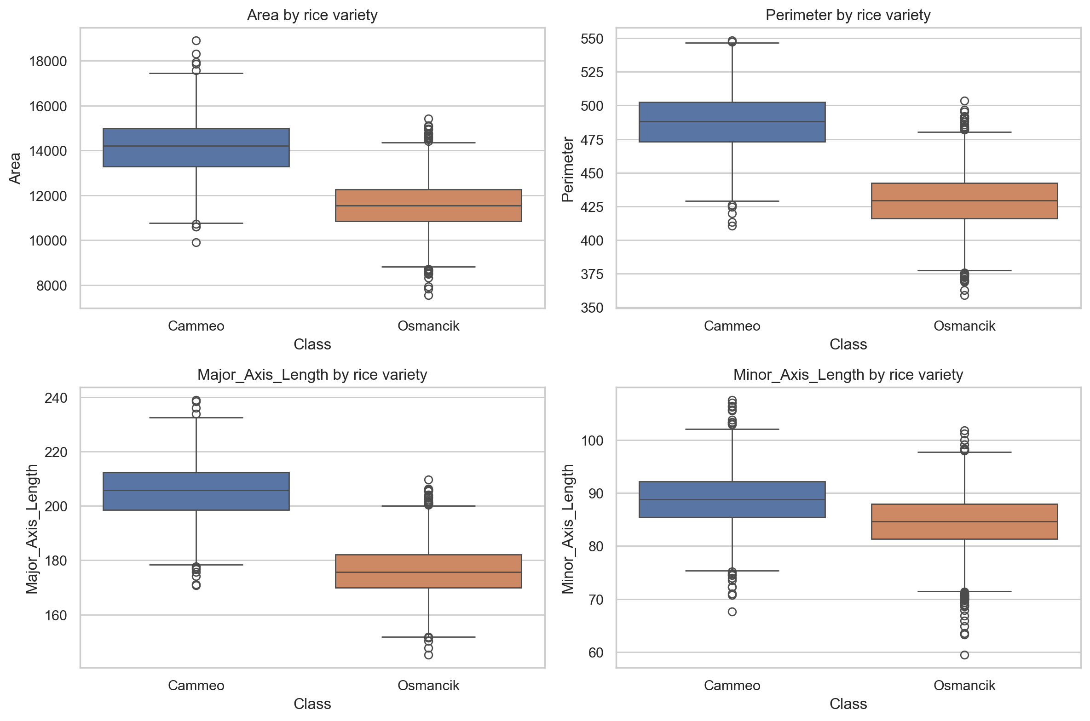

03_feature_correlation.png
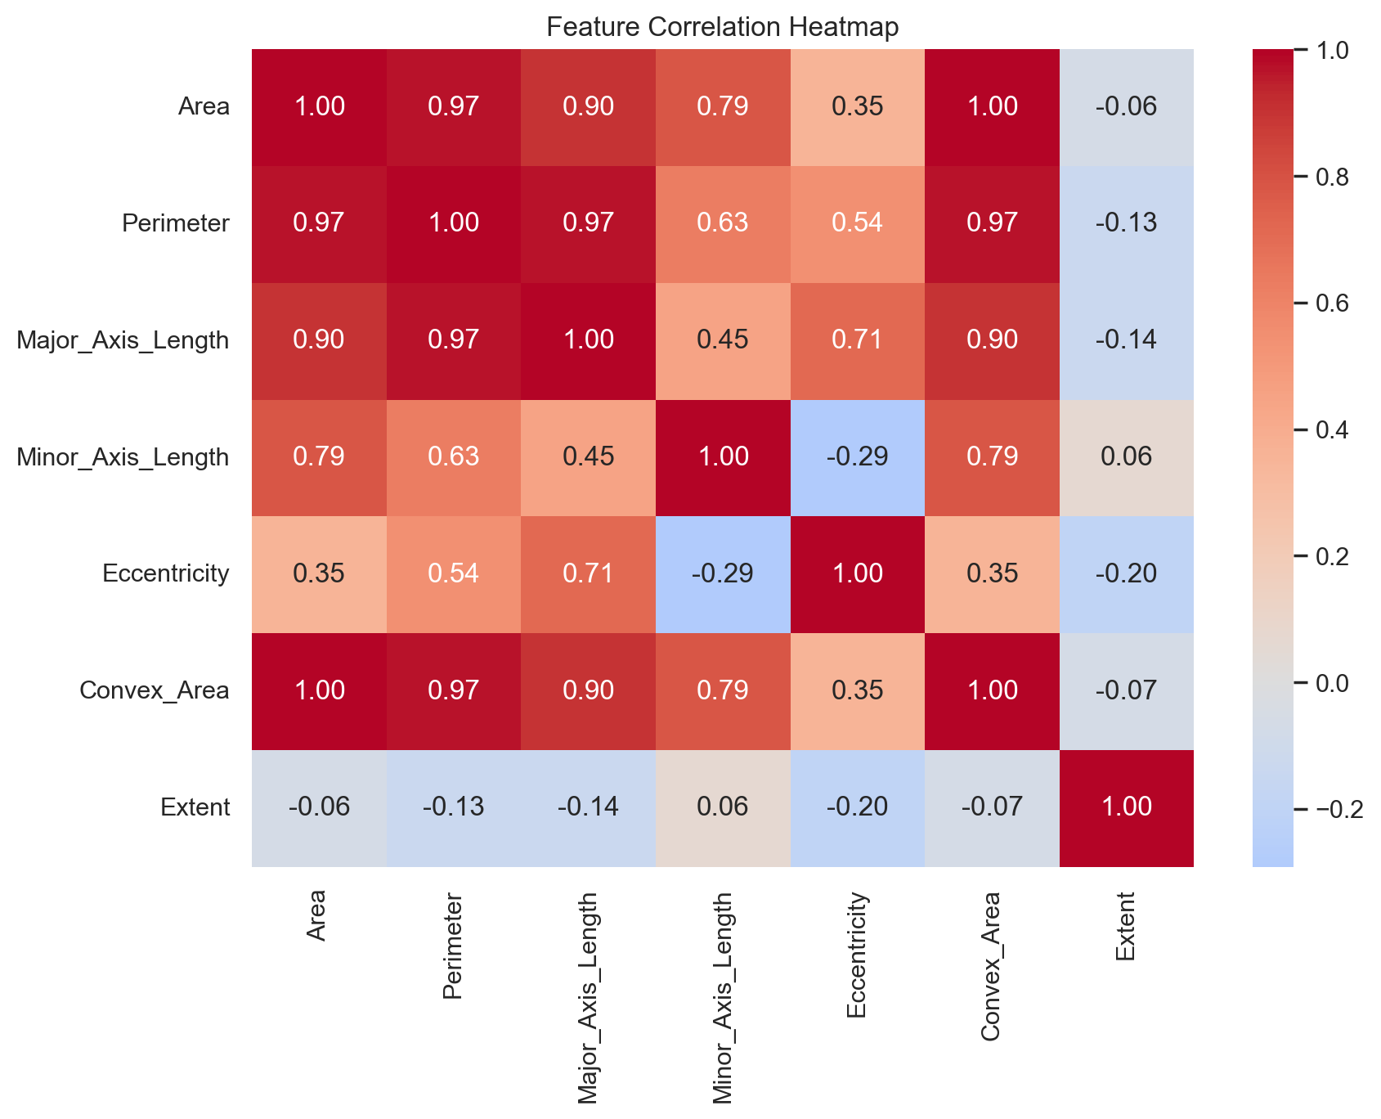

04_feature_importance.png
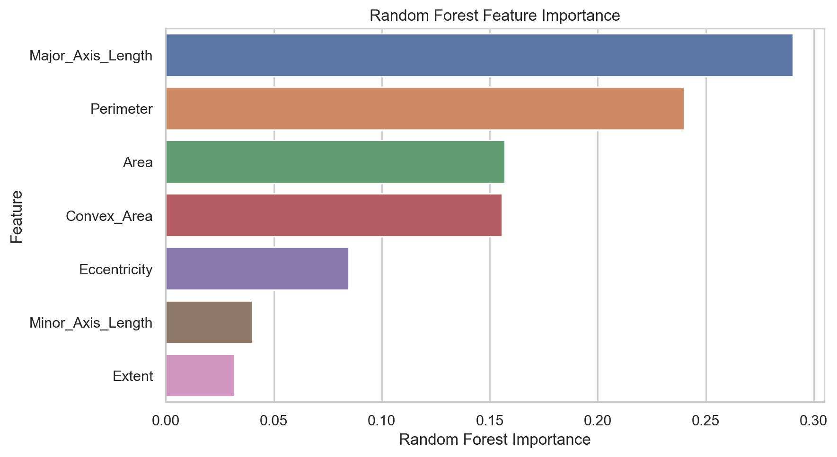

05_lightweight_tradeoff.png
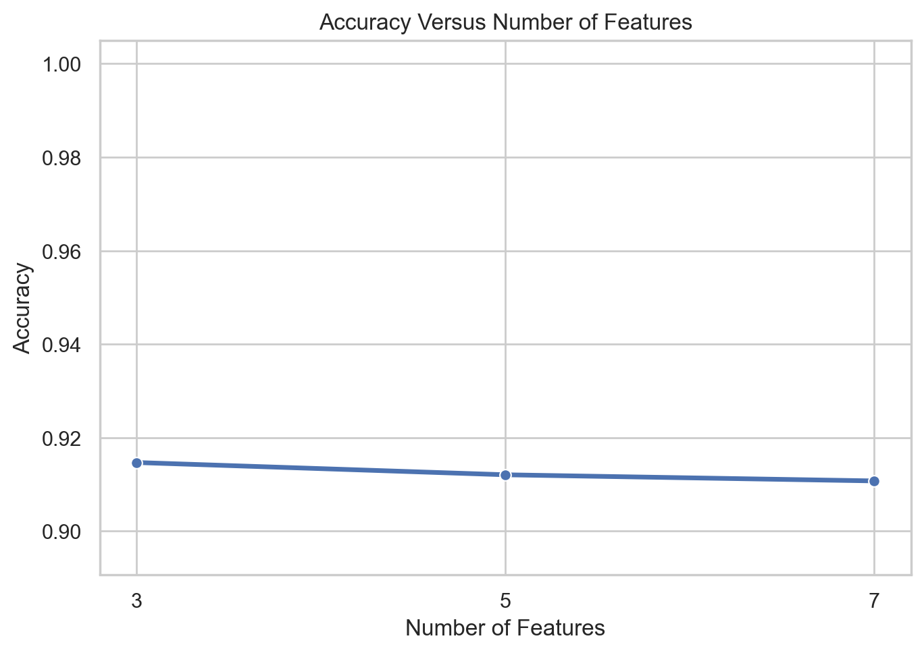

06_final_confusion_matrix.png
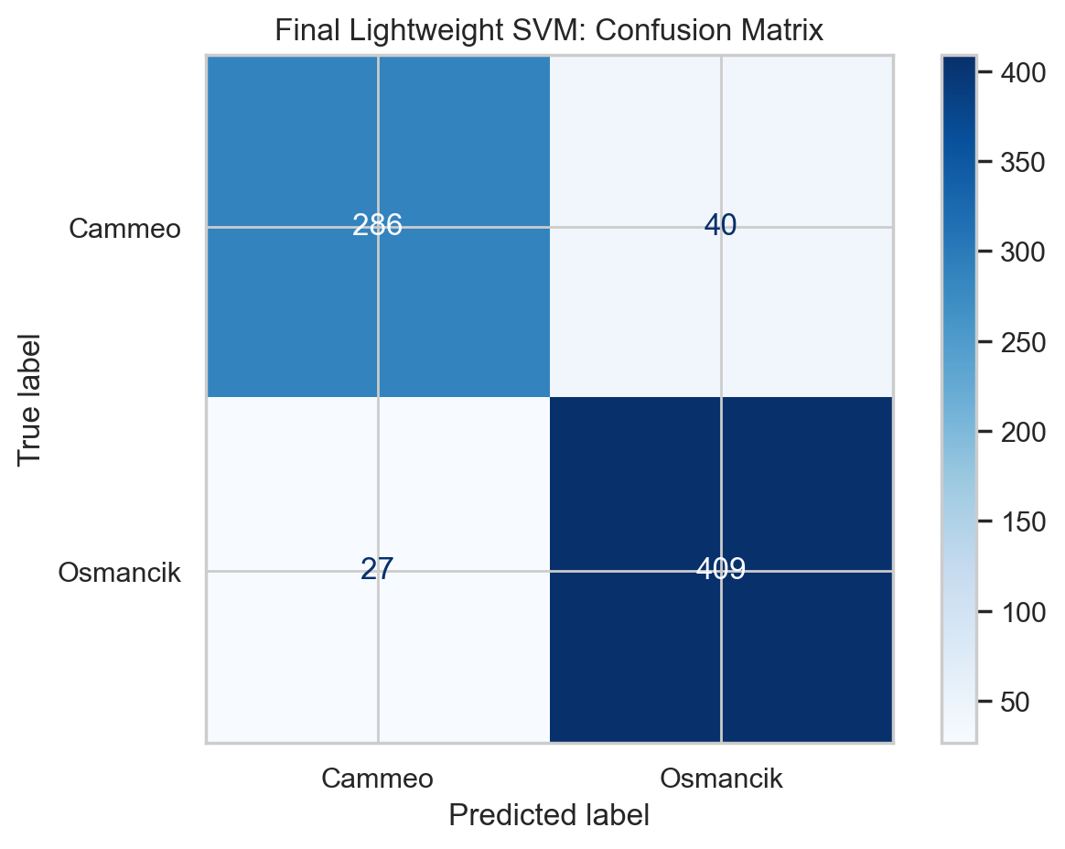

07_final_roc_curve.png
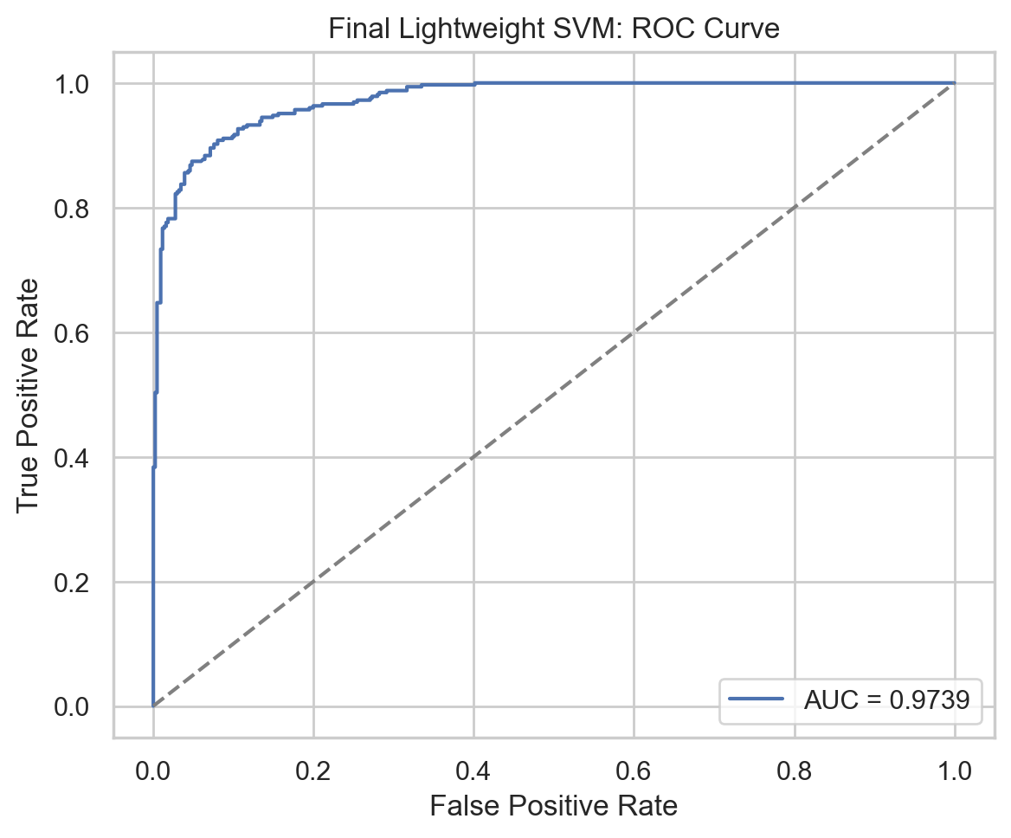

APPENDIX: SOURCE CODE IMPLEMENTATION

run_project.py
"""End-to-end lightweight rice variety classification project.
Run from the project directory:
python rice_classification_project/run_project.py
The script reads the supplied ARFF file, creates figures and CSV result files,
compares baseline models, selects useful features, tunes the final classifier,
and saves a deployment-ready model.
"""
from pathlib import Path
import json
import sys
import types
import warnings
import joblib
import matplotlib
matplotlib.use("Agg")
import matplotlib.pyplot as plt
import numpy as np
import pandas as pd
import seaborn as sns
from scipy.io import arff
# The local Anaconda pyarrow installation cannot load its native DLL. Scikit-learn
# only checks pyarrow's version at import time and this project does not use it.
try:
import pyarrow # noqa: F401
except ImportError:
pyarrow = types.ModuleType("pyarrow")
pyarrow.__version__ = "17.0.0"
sys.modules["pyarrow"] = pyarrow
from sklearn.ensemble import RandomForestClassifier
from sklearn.feature_selection import RFE, mutual_info_classif
from sklearn.linear_model import LogisticRegression
from sklearn.metrics import (
ConfusionMatrixDisplay,
accuracy_score,
classification_report,
f1_score,
precision_score,
recall_score,
roc_auc_score,
roc_curve,
)
from sklearn.model_selection import GridSearchCV, train_test_split
from sklearn.neighbors import KNeighborsClassifier
from sklearn.pipeline import Pipeline
from sklearn.preprocessing import StandardScaler
from sklearn.svm import SVC
from sklearn.tree import DecisionTreeClassifier
from xgboost import XGBClassifier
warnings.filterwarnings("ignore", category=FutureWarning)
ROOT = Path(__file__).resolve().parent
DATASET = ROOT.parent / "rice+cammeo+and+osmancik" / "Rice_Cammeo_Osmancik.arff"
OUTPUT = ROOT / "outputs"
FIGURES = OUTPUT / "figures"
MODELS = OUTPUT / "models"
RANDOM_STATE = 42
def save_figure(name: str) -> None:
"""Save the active plot consistently and release its memory."""
plt.tight_layout()
plt.savefig(FIGURES / name, dpi=200, bbox_inches="tight")
plt.close()
def load_data() -> pd.DataFrame:
"""Load the supplied ARFF dataset and make the class values readable."""
data, _ = arff.loadarff(DATASET)
frame = pd.DataFrame(data)
frame["Class"] = frame["Class"].str.decode("utf-8")
return frame
def make_eda(df: pd.DataFrame, features: list[str]) -> dict:
"""Create dataset inspection outputs and exploratory plots."""
class_counts = df["Class"].value_counts().rename_axis("Class").reset_index(name="Count")
class_counts.to_csv(OUTPUT / "class_distribution.csv", index=False)
df.describe().T.to_csv(OUTPUT / "feature_summary.csv")
sns.set_theme(style="whitegrid", palette="deep")
ax = sns.countplot(data=df, x="Class", hue="Class", legend=False)
ax.set(title="Rice Variety Distribution", xlabel="Rice variety", ylabel="Number of grains")
save_figure("01_class_distribution.png")
fig, axes = plt.subplots(2, 2, figsize=(12, 8))
for ax, feature in zip(axes.ravel(), ["Area", "Perimeter", "Major_Axis_Length", "Minor_Axis_Length"]):
sns.boxplot(data=df, x="Class", y=feature, hue="Class", legend=False, ax=ax)
ax.set_title(f"{feature} by rice variety")
save_figure("02_key_feature_boxplots.png")
plt.figure(figsize=(9, 7))
sns.heatmap(df[features].corr(), annot=True, fmt=".2f", cmap="coolwarm", center=0)
plt.title("Feature Correlation Heatmap")
save_figure("03_feature_correlation.png")
return {
"records": int(len(df)),
"input_features": int(len(features)),
"missing_values": int(df.isna().sum().sum()),
"duplicate_rows": int(df.duplicated().sum()),
"class_counts": {str(k): int(v) for k, v in df["Class"].value_counts().items()},
}
def evaluate_models(X_train, X_test, y_train, y_test) -> tuple[pd.DataFrame, dict]:
"""Fit baseline classifiers and return comparable test metrics."""
classifiers = {
"Logistic Regression": LogisticRegression(max_iter=2000, random_state=RANDOM_STATE),
"K-Nearest Neighbors": KNeighborsClassifier(n_neighbors=5),
"Support Vector Machine": SVC(kernel="rbf", C=1.0, probability=True, random_state=RANDOM_STATE),
"Decision Tree": DecisionTreeClassifier(random_state=RANDOM_STATE),
"Random Forest": RandomForestClassifier(n_estimators=300, random_state=RANDOM_STATE, n_jobs=-1),
"XGBoost": XGBClassifier(
n_estimators=300,
max_depth=4,
learning_rate=0.05,
subsample=0.9,
colsample_bytree=0.9,
objective="binary:logistic",
eval_metric="logloss",
random_state=RANDOM_STATE,
n_jobs=-1,
),
}
results, fitted = [], {}
for name, classifier in classifiers.items():
model = Pipeline([("scaler", StandardScaler()), ("classifier", classifier)])
if name == "XGBoost":
# XGBoost expects numeric class labels; encode Cammeo as the positive class.
encoded_train = (y_train == "Cammeo").astype(int)
model.fit(X_train, encoded_train)
prediction = np.where(model.predict(X_test) == 1, "Cammeo", "Osmancik")
probability = model.predict_proba(X_test)[:, 1]
else:
model.fit(X_train, y_train)
prediction = model.predict(X_test)
probability = model.predict_proba(X_test)[:, list(model.classes_).index("Cammeo")]
results.append({
"Model": name,
"Accuracy": accuracy_score(y_test, prediction),
"Precision": precision_score(y_test, prediction, pos_label="Cammeo"),
"Recall": recall_score(y_test, prediction, pos_label="Cammeo"),
"F1 Score": f1_score(y_test, prediction, pos_label="Cammeo"),
"ROC-AUC": roc_auc_score((y_test == "Cammeo").astype(int), probability),
})
fitted[name] = model
table = pd.DataFrame(results).sort_values("Accuracy", ascending=False).reset_index(drop=True)
table.to_csv(OUTPUT / "baseline_model_comparison.csv", index=False)
return table, fitted
def select_features(X_train, y_train) -> pd.DataFrame:
"""Rank features using three complementary feature-selection methods."""
forest = RandomForestClassifier(n_estimators=500, random_state=RANDOM_STATE, n_jobs=-1)
forest.fit(X_train, y_train)
rfe = RFE(LogisticRegression(max_iter=2000, random_state=RANDOM_STATE), n_features_to_select=1)
rfe.fit(StandardScaler().fit_transform(X_train), y_train)
mutual_information = mutual_info_classif(X_train, y_train, random_state=RANDOM_STATE)
feature_table = pd.DataFrame({
"Feature": X_train.columns,
"Random Forest Importance": forest.feature_importances_,
"Mutual Information": mutual_information,
"RFE Rank (1 is best)": rfe.ranking_,
}).sort_values("Random Forest Importance", ascending=False).reset_index(drop=True)
feature_table.to_csv(OUTPUT / "feature_selection_results.csv", index=False)
plt.figure(figsize=(9, 5))
sns.barplot(data=feature_table, x="Random Forest Importance", y="Feature", hue="Feature", legend=False)
plt.title("Random Forest Feature Importance")
save_figure("04_feature_importance.png")
return feature_table
def compare_lightweight_models(X_train, X_test, y_train, y_test, ranking: list[str]) -> tuple[pd.DataFrame, dict]:
"""Compare 3, 5 and 7 feature SVM versions to quantify simplification."""
results, fitted = [], {}
for number in [3, 5, len(ranking)]:
selected = ranking[:number]
model = Pipeline([
("scaler", StandardScaler()),
("classifier", SVC(kernel="rbf", C=1.0, probability=True, random_state=RANDOM_STATE)),
])
model.fit(X_train[selected], y_train)
prediction = model.predict(X_test[selected])
results.append({
"Number of Features": number,
"Features": ", ".join(selected),
"Accuracy": accuracy_score(y_test, prediction),
"F1 Score": f1_score(y_test, prediction, pos_label="Cammeo"),
})
fitted[number] = model
table = pd.DataFrame(results)
table.to_csv(OUTPUT / "lightweight_feature_comparison.csv", index=False)
plt.figure(figsize=(7, 5))
sns.lineplot(data=table, x="Number of Features", y="Accuracy", marker="o", linewidth=2.5)
plt.ylim(max(0.8, table["Accuracy"].min() - 0.02), 1.005)
plt.title("Accuracy Versus Number of Features")
plt.xticks(table["Number of Features"])
save_figure("05_lightweight_tradeoff.png")
return table, fitted
def tune_and_save_final_model(X_train, X_test, y_train, y_test, selected: list[str]) -> dict:
"""Tune the final lightweight SVM, report errors, and persist the pipeline."""
pipeline = Pipeline([
("scaler", StandardScaler()),
("classifier", SVC(probability=True, random_state=RANDOM_STATE)),
])
search = GridSearchCV(
pipeline,
{"classifier__C": [0.1, 1, 10, 50], "classifier__gamma": ["scale", 0.01, 0.1, 1]},
scoring="f1_weighted",
cv=5,
# Keep tuning in this interpreter: the installed pyarrow DLL prevents
# spawned worker processes from importing scikit-learn.
n_jobs=1,
)
search.fit(X_train[selected], y_train)
final_model = search.best_estimator_
prediction = final_model.predict(X_test[selected])
probability = final_model.predict_proba(X_test[selected])[:, list(final_model.classes_).index("Cammeo")]
ConfusionMatrixDisplay.from_predictions(y_test, prediction, cmap="Blues")
plt.title("Final Lightweight SVM: Confusion Matrix")
save_figure("06_final_confusion_matrix.png")
actual_binary = (y_test == "Cammeo").astype(int)
fpr, tpr, _ = roc_curve(actual_binary, probability)
plt.figure(figsize=(6, 5))
plt.plot(fpr, tpr, label=f"AUC = {roc_auc_score(actual_binary, probability):.4f}")
plt.plot([0, 1], [0, 1], "--", color="gray")
plt.xlabel("False Positive Rate")
plt.ylabel("True Positive Rate")
plt.title("Final Lightweight SVM: ROC Curve")
plt.legend(loc="lower right")
save_figure("07_final_roc_curve.png")
errors = X_test[selected].copy()
errors["Actual"] = y_test
errors["Predicted"] = prediction
errors["Correct"] = errors["Actual"] == errors["Predicted"]
errors.loc[~errors["Correct"]].to_csv(OUTPUT / "misclassified_test_samples.csv", index=False)
report = classification_report(y_test, prediction, output_dict=True)
metrics = {
"selected_features": selected,
"best_parameters": search.best_params_,
"cross_validation_f1_weighted": float(search.best_score_),
"test_accuracy": float(accuracy_score(y_test, prediction)),
"test_precision_cammeo": float(precision_score(y_test, prediction, pos_label="Cammeo")),
"test_recall_cammeo": float(recall_score(y_test, prediction, pos_label="Cammeo")),
"test_f1_cammeo": float(f1_score(y_test, prediction, pos_label="Cammeo")),
"test_roc_auc": float(roc_auc_score(actual_binary, probability)),
"test_errors": int((prediction != y_test).sum()),
"test_samples": int(len(y_test)),
"classification_report": report,
}
with open(OUTPUT / "final_model_metrics.json", "w", encoding="utf-8") as file:
json.dump(metrics, file, indent=2)
joblib.dump({"model": final_model, "features": selected}, MODELS / "lightweight_rice_svm.joblib")
return metrics
def main() -> None:
OUTPUT.mkdir(exist_ok=True)
FIGURES.mkdir(exist_ok=True)
MODELS.mkdir(exist_ok=True)
df = load_data()
features = df.drop(columns="Class").columns.tolist()
overview = make_eda(df, features)
X, y = df[features], df["Class"]
X_train, X_test, y_train, y_test = train_test_split(
X, y, test_size=0.20, random_state=RANDOM_STATE, stratify=y
)
baseline, _ = evaluate_models(X_train, X_test, y_train, y_test)
feature_table = select_features(X_train, y_train)
ranking = feature_table["Feature"].tolist()
lightweight, _ = compare_lightweight_models(X_train, X_test, y_train, y_test, ranking)
# The top three inputs match the strongest reduced-set baseline while using
# less than half of the original measurements.
final_features = ranking[:3]
final_metrics = tune_and_save_final_model(X_train, X_test, y_train, y_test, final_features)
overview["baseline_best_model"] = baseline.iloc[0]["Model"]
overview["baseline_best_accuracy"] = float(baseline.iloc[0]["Accuracy"])
overview["lightweight_results"] = lightweight.to_dict(orient="records")
overview["final_model"] = final_metrics
with open(OUTPUT / "project_summary.json", "w", encoding="utf-8") as file:
json.dump(overview, file, indent=2)
print("Project completed successfully.")
print(f"Final selected features: {', '.join(final_features)}")
print(f"Final test accuracy: {final_metrics['test_accuracy']:.4f}")
print(f"Outputs saved to: {OUTPUT}")
if __name__ == "__main__":
main()

predict_rice.py
"""Interactive predictor for the final lightweight rice-variety model."""
from pathlib import Path
import sys
import types
import joblib
import pandas as pd
# See run_project.py: this avoids a broken optional pyarrow DLL during the
# scikit-learn import triggered while loading the saved model.
try:
import pyarrow # noqa: F401
except ImportError:
pyarrow = types.ModuleType("pyarrow")
pyarrow.__version__ = "17.0.0"
sys.modules["pyarrow"] = pyarrow
MODEL_PATH = Path(__file__).resolve().parent / "outputs" / "models" / "lightweight_rice_svm.joblib"
def main() -> None:
artifact = joblib.load(MODEL_PATH)
model, features = artifact["model"], artifact["features"]
print("Rice Variety Predictor")
print("Enter physical measurements for one grain.\n")
values = {}
for feature in features:
values[feature] = float(input(f"{feature}: "))
sample = pd.DataFrame([values])
predicted_class = model.predict(sample)[0]
probabilities = model.predict_proba(sample)[0]
confidence = probabilities[list(model.classes_).index(predicted_class)]
print(f"\nPredicted rice variety: {predicted_class}")
print(f"Confidence: {confidence:.2%}")
if __name__ == "__main__":
main()

11. Conclusion
The project successfully developed a rice-variety classifier and reduced the required features from seven to three. Major Axis Length, Perimeter, and Area carry enough information to achieve 91.21% test accuracy after tuning. The final lightweight SVM provides a practical balance between accuracy, simplicity, and deployment cost.

