HELMET DETECTION

RAVVA VENKATA SAI LIKITH

School of Computing Amrita School of Engineering Coimbatore,India

likith1118@gmail.com@gmail.com

K.RUPESH SAI SATHWIK

School of Computing Amrita School of Engineering Coimbatore,India

kancharlasathwik.2003@gmail.com

PA.GURUDEV

School of Computing Amrita School of Engineering Coimbatore,India

gurudevpasupuleti055@gmail.com P.SAI SAMHITHA

School of Computing Amrita School of Engineering Coimbatore,India

saisamhitha2109@gmail.com

P.SAI KIRAN

School of Computing Amrita School of Engineering Coimbatore,India

[puvvadasaikiran87@gmail.com](mailto:puvvadasaikiran87@gmail.com)

M.V.S.VINEETH

School of Computing Amrita School of Engineering Coimbatore,India

vineethmannevaram@gmail.com

*Abstract*—Worker safety at construction sites is a growing concern for many construction industries. Wearing safety helmets can reduce injuries to workers at construction sites, but due to various reasons, safety helmets are not always worn properly. Hence, a computer vision-based automatic safety helmet detection system is extremely important. The goal of the project is to use machine learning to build a model that can accurately detect the safety helmets at construction sites. This project includes a python notebook that explain the steps involved in building the machine learning model including data preprocessing, creating a model, training the model. This notebook also includes data visualization and analysis that helps us to understand the performance of the model.

Keywords—Computer vision, Machine learning model, Preprocessing, Training, Data Visualization, Data Analysis.

# INTRODUCTION

Machine learning (ML) is the field of Artificial Intelligence in which a trained model works on its own using the inputs given during training period. Machine learning algorithms build a mathematical model of sample data, known as "training data", in order to make predictions or decisions and are also used in the applications of object detection. Therefore, by training with a specific dataset, a Helmet detection model can be implemented. Using this helmet detection model helmet-less workers can be easily detected.

We created a machine learning model using Data pre-processing, KNN (K-Nearest Neighbours), SVM (Support Vector Machine), Decision trees, Random-forest, perceptron and tested on a sample of 300 images after being trained. including data pre-processing, creating a model, training the model. This notebook also includes data visualization and analysis that helps us to understand the performance of the model.

The objective of this paper is to develop a system to enforce helmet wearing with the help of cameras. The developed system aims in changing unsafe behaviors and consequently reducing the number of accidents and its severity.

#### II. RELATED WORK

Over the past years, multiple approaches have been proposed to solve the problem of helmet detection. The authors used Support Vector Machines (SVM) to classify helmets and human heads without helmets. Proposed a hybrid descriptor model based on geometric shape and texture features to detect safety workers without helmet automatically. They used Hough transform with SVM to detect the head of the safety workers. Additionally, they extend their work in by multi-layer perception model for classification of various objects.

Machine learning-based technologies use hand-crafted features for safety helmet detection that could lead to poor generalization in complex environments like bad weather or at big construction sites. With the recent developments in the area of deep learning-based object detection, many researchers have used deep learning strategies for safety helmet detection. Wang et al. used different YOLO architectures to detect four different color safety helmets, persons, and vests. Among all the architectures, YOLOv5x gives the best precision and YOLOv5s has the fastest speed.

Similarly, Geng et al. and Nath et al. also used YOLO-based architecture for safety helmet detection. Geng et al. used YOLOv3 architecture to detect safety helmets for the unbalanced dataset. They have improved the accuracy of YOLOv3 by using the Gaussian blurring method to deal with the associated data imbalance problems. Wu et al. proposed a single shot-based CNN model to automatically detect hard hats and identify the corresponding color. They used SSD to detect safety helmets and achieved a MAP of 83.89%. Similarly, Li et al. and Han et al. used SSD for helmet detection. Li et al. proposed a deep learning based method for real-time detection of safety helmets. An SSD-Mobile-Net algorithm was used in this study and presented good precision and recall. However, the model was not performing well for smaller images and complex backgrounds, resulting in very low MAP. Shen et al. used bounding-box regression and transfer learning to detect safety helmets. They have used Dense Net-based strategies to improve the efficiency of the model and achieved an excellent accuracy of 94.47%. One of the major limitations of their work is the use of a face detection-based approach, as the model fails when the worker is not facing the camera, which is very common on construction sites.

This related work shows that many studies have been conducted on safety helmet detection on construction sites based on sensor, machine learning, and deep learning techniques. Most of them fail in detecting safety helmets in complex scenarios, such as sites with multiple workers. Furthermore, helmet detection in low-light conditions and with small object sizes needs significant improvements for real-time systems deployment.

##### III. METHODOLOGY

This work proposes a deep learning-based framework architecture to detect workers’ helmets at construction sites using a publicly available benchmark dataset. The figure 1 shows the general steps in safety helmet detection for the workers.

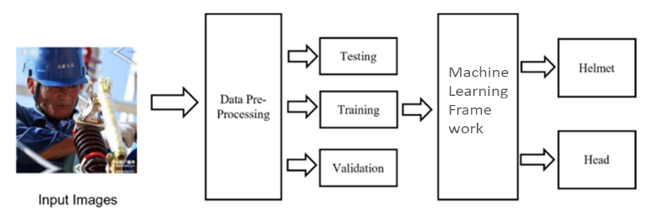

1. General Architecture for Helmet Detection using Machine Learning Framework.

## Dataset

The Hard Hat worker image dataset published by Make machine learning was used in this paper for the detection of hard helmets used in the construction industry. It contains 5000 images. Initially, it has three classes: Helmet, Person, and Head, but this research focuses on only two classes, Helmet and Head, which makes this a binary classification problem. Figure 2 shows some examples of Helmet and Head images.

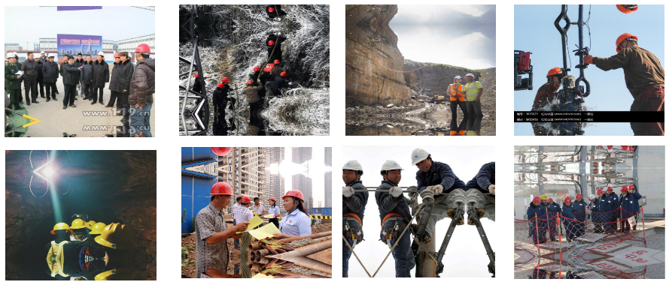

1. Example of Construction Site images of People wearing helmets.

The data is further divided into three sets (training and testing) with the split of 80% for the training, 20% for the testing. The training dataset was used to train the machine learning model and testing was used to test the model.

## Pre-Processing

## B -1. Exploring the data

Since our dataset is based on images, we read and explored those images by help of importing cv2.

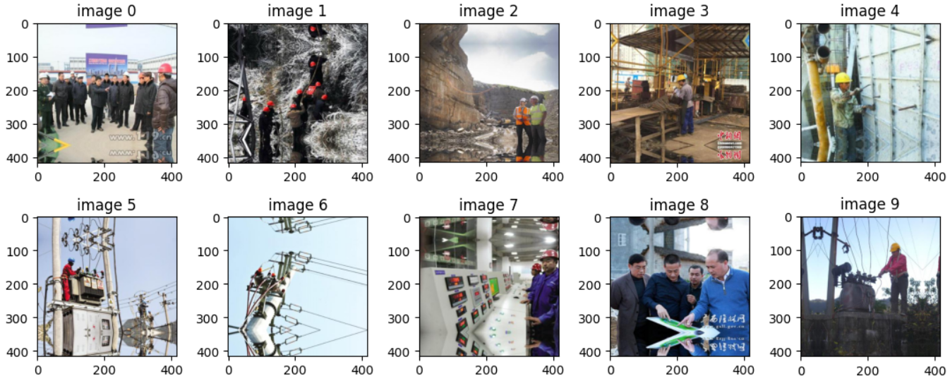

1. Example Exploring the images using cv2.

## B -2. Edge Detection

We have applied grayscale on sample of 10 images, so that we can differentiate in between the persons and objects.

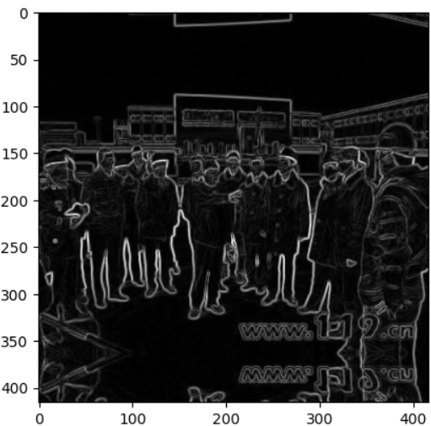

1. After applying the grayscale to the image.

## B -3. Plotting the RGB colours.

We have plotted a histogram of RGB values of an image.

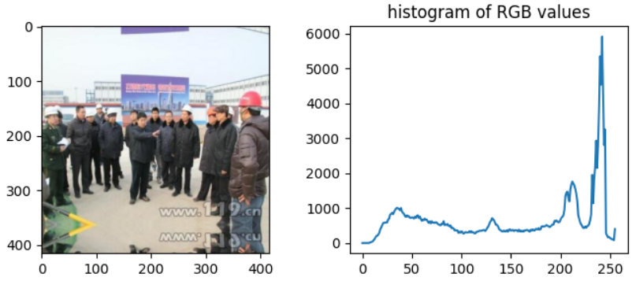

1. Plotting the histogram of RGB values of an image.

## Models

Safety Helmet detection has made a comparison of accuracy in Pointing the outcome of Testing set between different models. That includes Logistic Regression, Linear Regression, K – Nearest Neighbor (KNN), Support Vector Machine (SVM), Decision Tree, Naïve Bayes, Random Forest, Perceptron, Principal Component Analysis (PCA), K Means Clustering.

## DATA VISUALIZATION :

We have detected the helmet and head and plotted and plotted the bar graph of head and helmet.

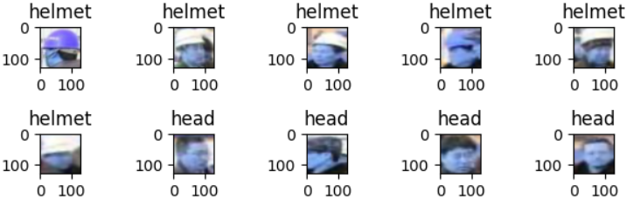

1. Detecting the Helmet and Head

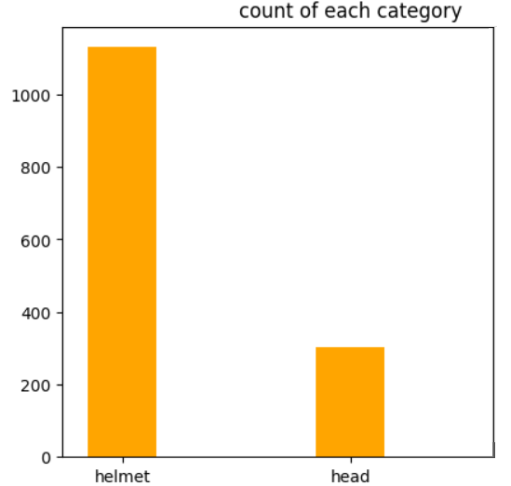

1. Bar graph of Head and Helmet.

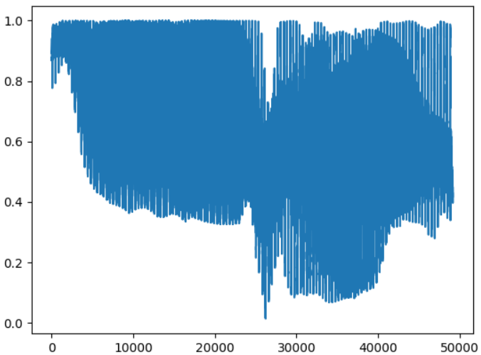

1. Plotting of an image.

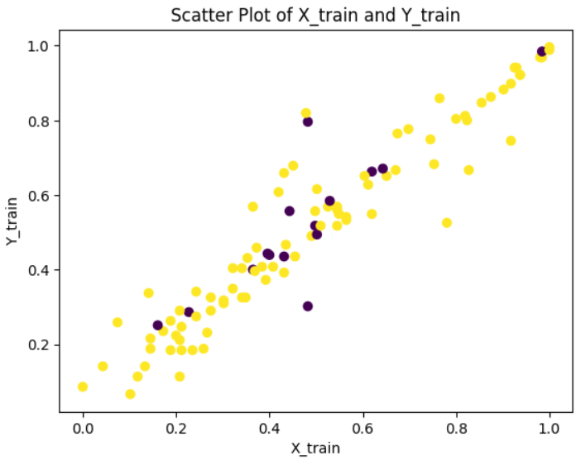

1. Scatter plot of the training dataset.

## MODEL VISUALIZATION :

With the help of data visualization, we can see how the data looks like and what kind of correlation is held by the attributes of data.

1. *Logistic Regression*

Logistic regression is a data analysis technique that uses mathematics to find the relationships between two data factors. It then uses this relationship to predict the value of one of those factors based on the other. The prediction usually has a finite number of outcomes, like yes or no.

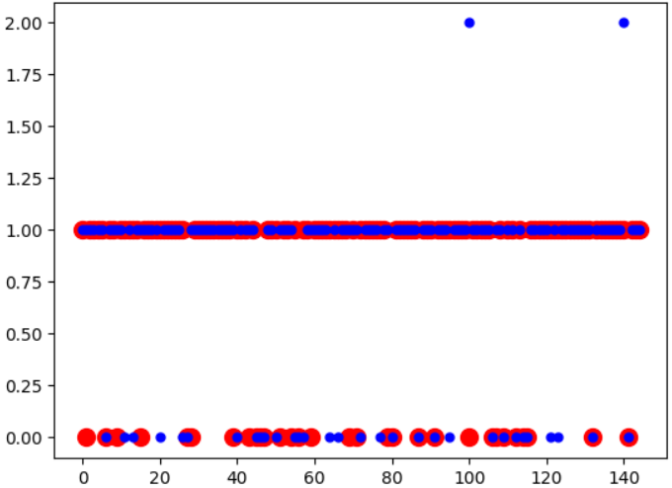

1. Plotting of predicted values of validation dataset.

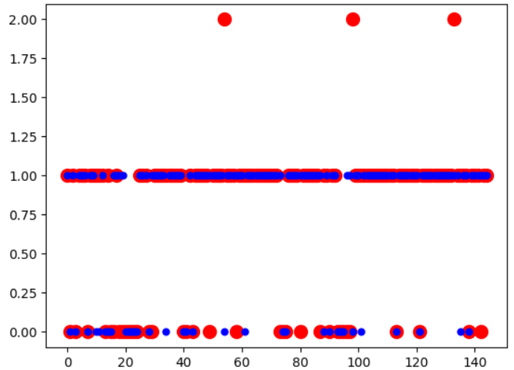

1. Plotting of predicted values of x test dataset.

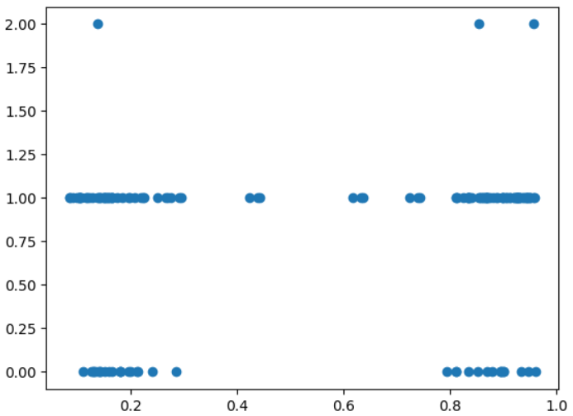

1. Plotting of predicted values of y test dataset.

Accuracy : 0.8413793103448276

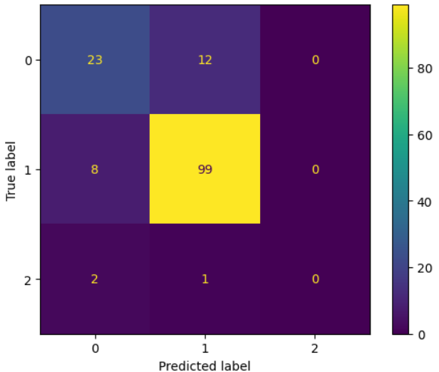

1. Confusion matrix between Actual vs Predicted values.
2. *Decision Tree*

A decision tree is a type of supervised machine learning used to categorize or make predictions based on how a previous set of questions were answered. The model is a form of supervised learning, meaning that the model is trained and tested on a set of data that contains the desired categorization.

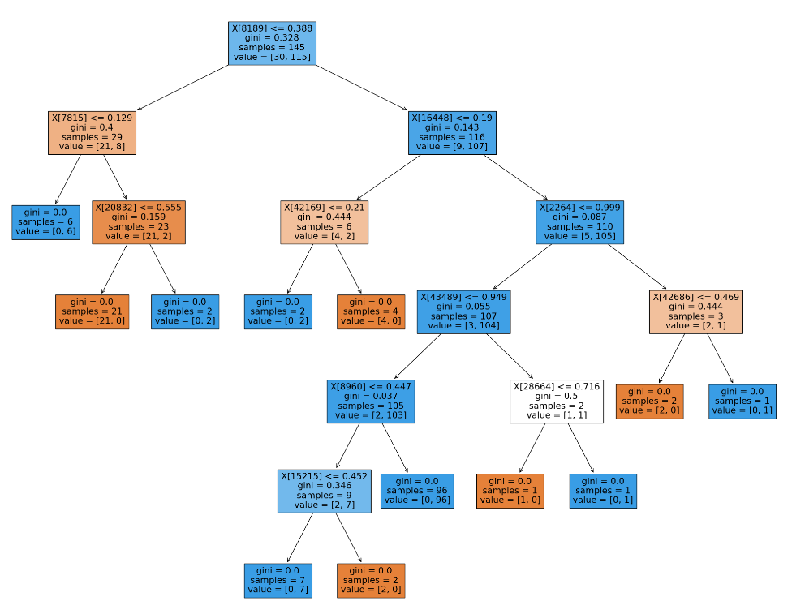

1. Decision Tree.

Accuracy: 0.7379310344827587

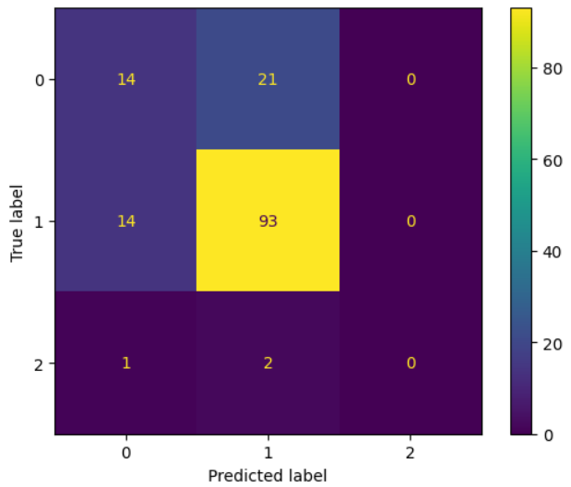

1. Confusion Matrix of Actual and Predicted values.
2. *Naïve bayes(NB)*

Naïve Bayes algorithm is a supervised learning algorithm, which is based on Bayes theorem and used for solving classification problems. It is mainly used in text classification that includes a high-dimensional training dataset.

Accuracy: 0.6827586206896552

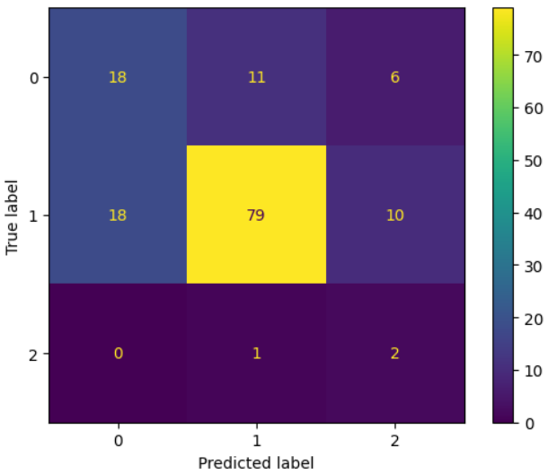

1. Confusion matrix of Navie Bayes.
2. *Random Forest*

Random Forest is a powerful and versatile supervised machine learning algorithm that grows and combines multiple decision trees to create a “forest.” It can be used for both classification and regression problems in R and Python.

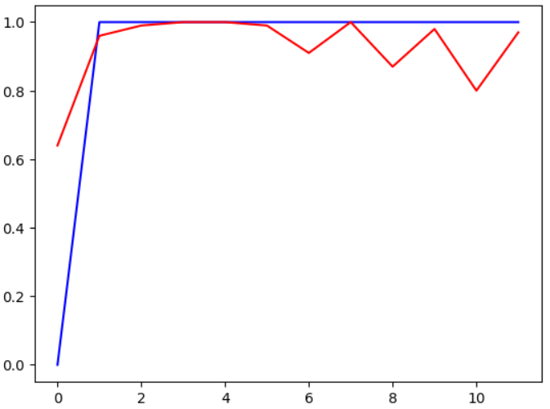

1. Plotting of predicted values in Random Forest.
2. *KNN(K-Nearest Neighbour)*

The k-nearest neighbors’ algorithm, also known as KNN or k-NN, is a non-parametric, supervised learning classifier, which uses proximity to make classifications or predictions about the grouping of an individual data point.

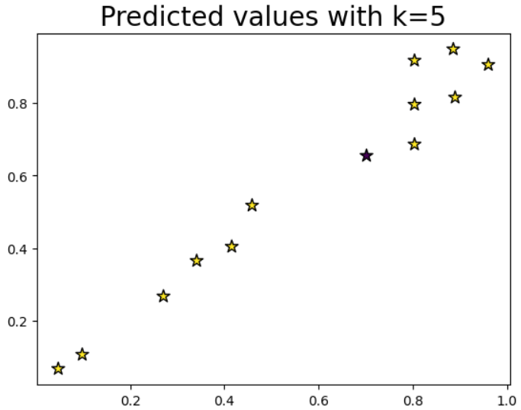

1. Plotting of Predicted values of KNN(K-Nearest Neighbours).

Accuracy: 0.84

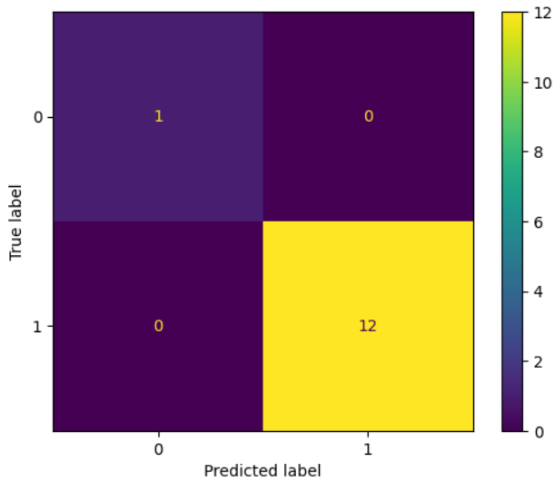

1. Confusion matrix of KNN(K-Nearest Neighbours).
2. *SVM(Support Vector Machnine)*

SVMs are used in applications like handwriting recognition, intrusion detection, face detection, email classification, gene classification, and in web pages. This is one of the reasons we use SVMs in machine learning. It can handle both classification and regression on linear and nonlinear data.

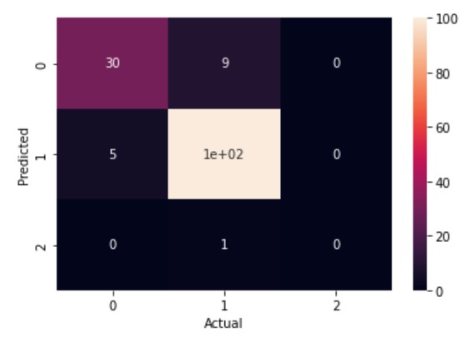

Accuracy: 0.8965517241379311

1. *PCA(Principle Component Analysis)*

Principal component analysis, or PCA, is a dimensionality-reduction method that is used to reduce the dimensionality of large data sets, by transforming a large set of variables into a smaller one.

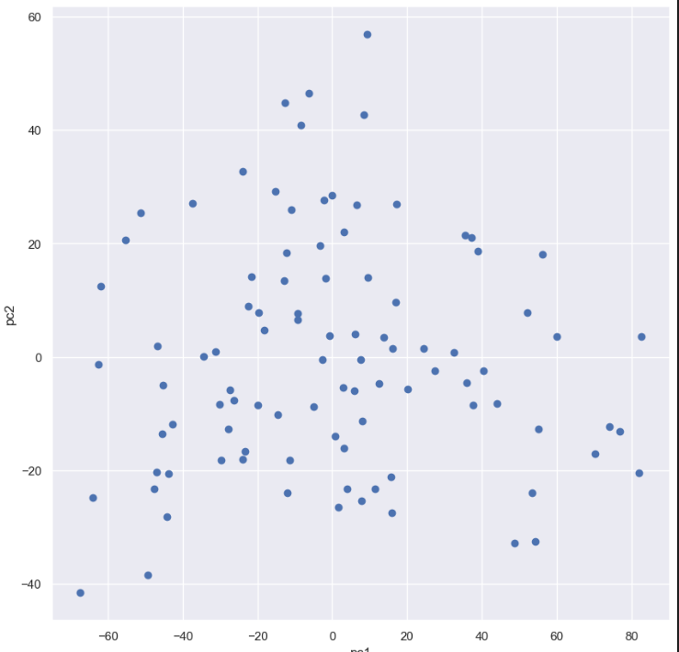

1. Plotting the values of PCA.

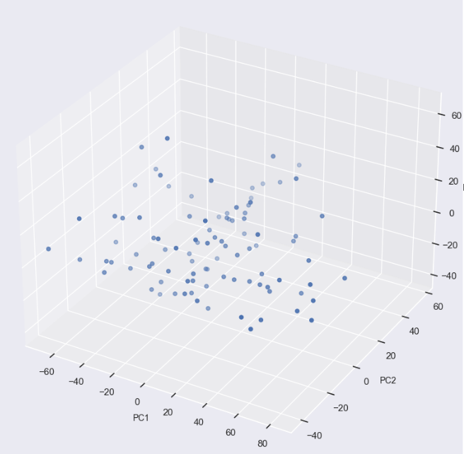

1. Plotting the values oof PCA in 3D.
2. *K_Means Clustering*

K-Means Clustering is an Unsupervised Learning algorithm, which groups the unlabeled dataset into different clusters. Here K defines the number of pre-defined clusters that need to be created in the process, as if K=2, there will be two clusters, and for K=3, there will be three clusters, and so on.

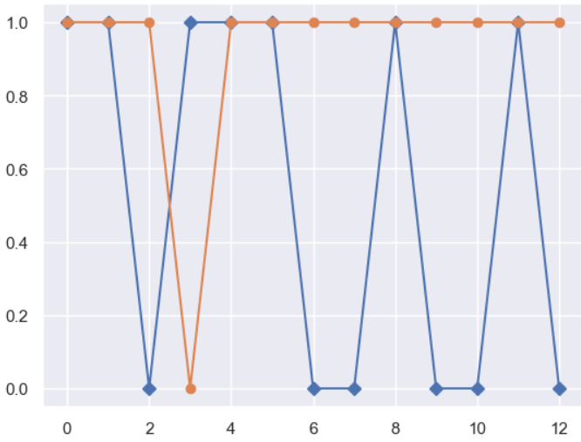

1. Plotting the values K_Means Clustering.

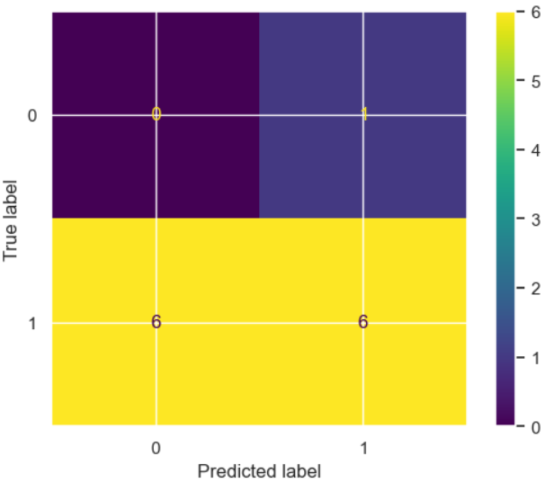

1. Confusion matrix of K-Means Clusreting.

Accuracy: 0.46153846153846156

1. *Agglomerative Clustering*

Agglomerative Clustering is a type of hierarchical clustering algorithm. It is an unsupervised machine learning technique that divides the population into several clusters such that data points in the same cluster are more similar and data points in different clusters are dissimilar.

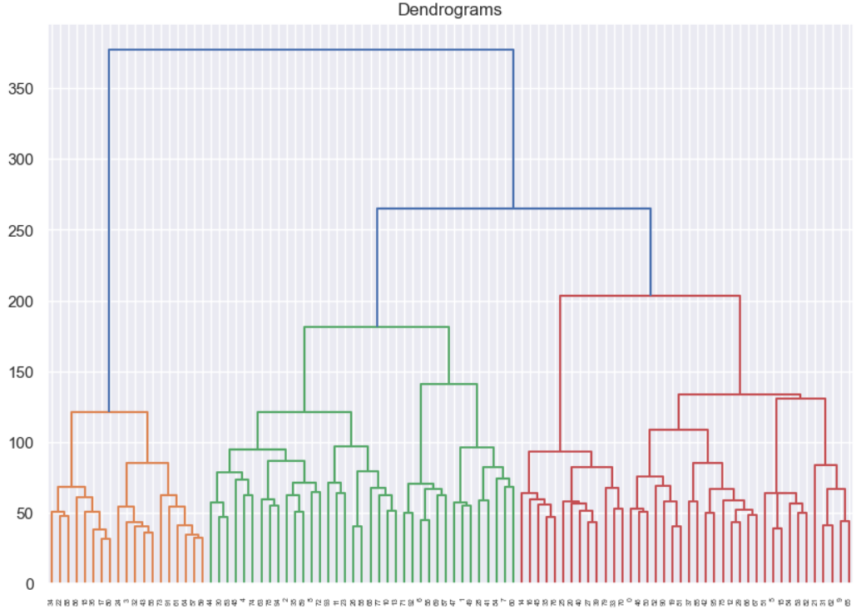

1. Plotting the values Agglomerative Clustering.

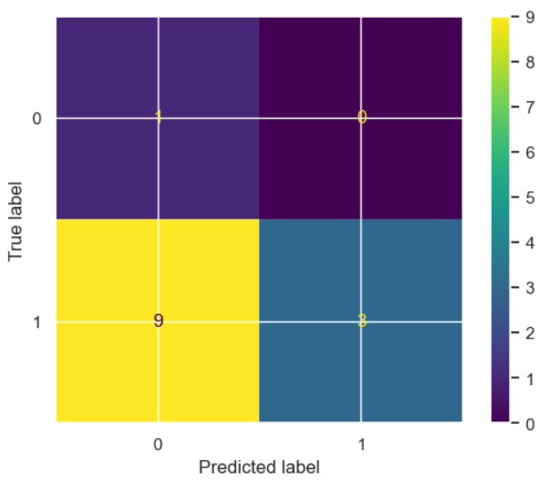

1. Confusion Matrix of Agglomerative Clustering.

Accuracy: 0.3076923076923077

1. *Perceptron*

A neural network link that contains computations to track features and uses Artificial Intelligence in the input data is known as Perceptron. This neural links to the artificial neurons using simple logic gates with binary outputs.

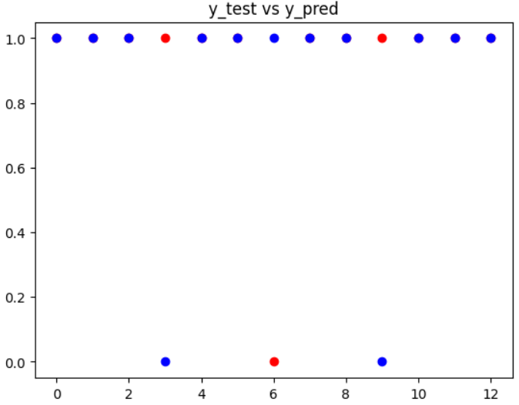

1. Plotting the values of Perceptron

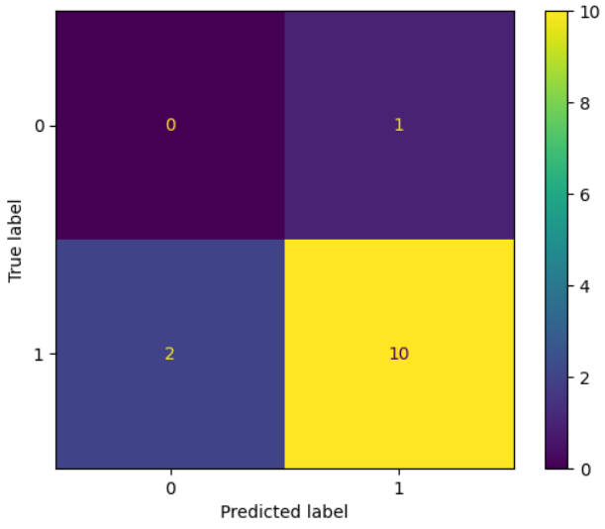

1. Confusion Matrix of Perceptron.

Accuracy: 0.692

Comparisions:

|  |  |
| --- | --- |
| **Models** | **Accuracy** |
| Logistic Regression | 0.84 |
| Decision Tree | 0.37 |
| Navie Bayes | 0.68 |
| Random Forest | 0.78 |
| KNN | 0.84 |
| SVM | 0.89 |
| K-Means | 0.46 |
| Agglomerative | 0.30 |
| Perceptron | 0.69 |

Acknwoledgement:

We would like to express our gratitude to our

Dr.S Padmavathi for her invaluable assistance in the development of our Helmet Detection.

References:

<https://www.kaggle.com/datasets/whenamancodes/helmet-detection-at-work-for-safety>

-Referred for dataset.

Conclusion:

As worker safety is a major concern on construction sites, this study considered helmet detection as a computer vision problem, and proposed a machine learning-based solution. The main aim is to include all aspects that detect the helmets and to detect the helmets more accurately. This helps many people who work in the construction sites to save their lives when accident happens. This project includes the detection of helmet using machine learning model that uses Logistic Regression, KNN, SVM, Perceptron, PCA, Clustering, Navie Bayes, Random Forest and Decision Trees.