**Overview**

The objective of this analysis was to help a client learn more about the effectiveness of various kickstarted campaigns to help her better understand the market and learn tricks of how to manage her kickstarter campaign. We looked at two primary focuses in kickstarter campaigns; the launch times and progressions and the goals which were most successful.

**Analysis and Challenges**

For the first deliverable we found the date of start and length of the campaign. To do this we first needed to convert the unix timestamp into a readable date using =(((J2/60)/60)/24)+DATE(1970,1,1) where the J column stood for the unix date stamps. To create a chart for the deliverable we also need to separate a column into parent and subcategory using text to columns. To make the chart we then created a pivot table using years and parent category as filters, outcomes as columns, date created as rows and count of outcomes as values. We did have to go in and remove years and quarters from the rows so that only the months would show. Then we made a chart with the table we created giving us the following result. For this deliverable I faced little challenges except for realising how to filter the table so that only months would be shown.

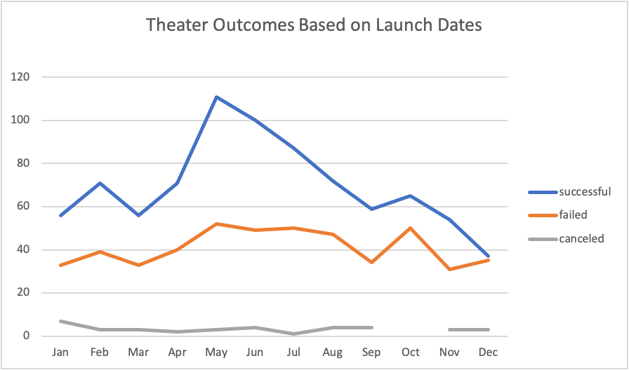

Graph 1

For the second deliverable we were asked to look at the success of campaigns based on their goal for the kickstarter campaign. In order to do this we used countif statements to filter through the main sheet to find the count of successful, failed, and canceled campaigns based on ranges of values increasing by 5000$. We had to filter the countif using the goal amount, subcategory as plays and stays by successful, failed and canceled. This gave me some difficulty as I originally did not use the countif function to do all the filtering but used manual filtering of the applicable columns. When you use a countif function on a filtered column it’ll count all original values and not just the ones visible. After realising this I filtered using the countif to create lines similar to this: =COUNTIFS(Sheet1!$D:$D, “<=1000”,Sheet1!F:F,"Successful",Sheet1!O:O,"plays"). The goal number would change based on the row and successful would be changed to failed or cancelled in the applicable columns. After this we found the total number of projects based on goal category using the sum function : =SUM(B2,C2,D2), the row would change based on the goal range row. With these value we were then able to calculate the percent successful, failed and cancelled per range of goals where the cell holding the number of successful, failed or canceled is divided by the cell containing the total projects. Now with this information we could create a second table using copy past for just the percentages and goal ranges using paste value. This table could then be turned into a line chart displaying the percentages of successful, failed and canceled campaigns. The graph created is pasted below.

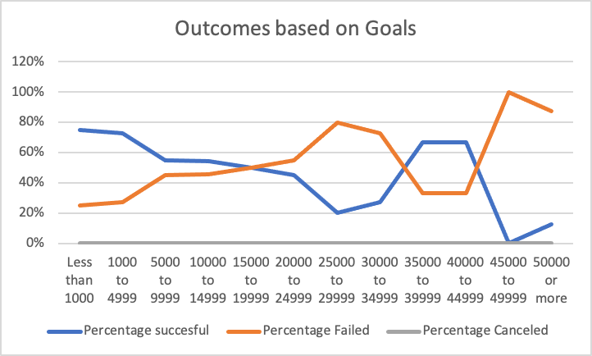

Graph 2

**Results**

Using graph 1 we can see that most successful campaigns are started in May while the least successful are started in December. These findings could be useful to the client in determining when to start her campaign.

Using graph 2 we can see that the line graph shows the values as inverses of each other. Success was more likely than failure at less than 1000 and 35000-40000. At 15000-20000,35000-39999 and 45000-49999 the chance of failure or success was split 50/50.

Some limitations of this set is the size of the data. Our client wanted to start a campaign for a play but the kick-starting campaign data was spread across many sections and made the data solely for plays rather limited. I think it could have been helpful to see success after reaching the goals as well so that measuring if a goal was enough or not could be possible.

I think an interesting graph would have been the length of campaigns campaigns compared to their success. We did based on the starting month but not of the entirety of the campaign and I think that could provide useful insights for the client.