Uncertainty-Aware Triage for Rule-Based ICAO Face-Image Compliance:
Label-Conditional Conformal Guarantees under Class Imbalance
Mustafa Vedat Yıldırım · Inna Skarga-Bandurova
Oxford Brookes University — School of Engineering, Computing and Mathematics
Draft — methodology & results (introduction / related work to be expanded)

Abstract
Automated verification of ICAO/ISO compliance for face images in machine-readable travel documents is typically performed by rule-based analyzers that return hard pass/fail decisions per requirement. Such decisions carry no statistical guarantee, and their false rejections translate into unnecessary photo retakes; conversely, a missed violation is far more costly than a retake, so the decision problem is one of triage under class imbalance and asymmetric error cost. We wrap an existing rule-based analyzer (BioGaze) with a lightweight per-criterion calibration layer and study split conformal prediction as the source of a distribution-free guarantee, evaluated under a strictly subject-disjoint protocol on the TONO synthetic dataset (4,561 valid images; 275 identities, 247 of which appear across multiple violation types). We find that marginal coverage holds (mean 0.903 ± 0.015 over five subject-disjoint splits at a 0.90 target), but that marginal conformal silently under-covers the minority violation class (mean violation-class coverage 0.819, as low as 0.32 for one criterion) — precisely the quantity that matters when a missed violation is costly. Label-conditional (Mondrian) conformal restores the guarantee on the violation class (0.909 ± 0.022). We further compare five triage strategies — raw rules, logistic recalibration, threshold-with-abstention, marginal LAC and Mondrian conformal — and characterise their false-flag / detection trade-off honestly: most of the reduction in false flags (roughly 69–75%) comes from recalibration itself, while conformal's contribution is a coverage guarantee rather than raw accuracy, and marginal LAC in particular buys a low false-positive rate at the cost of violation recall. At the image level, no true-violation image (0 of 925) is wrongly accepted; violations are routed to REJECT or RETAKE. We report the multiple-comparison (joint-coverage) limitation and the fact that TONO's single-violation design precludes evaluating the ACCEPT class, motivating a follow-up study on real, multi-attribute data (DFIC).

1. Introduction
This paper asks whether the outputs of an existing rule-based ICAO compliance analyzer can be endowed with a statistical guarantee and turned into an uncertainty-aware accept/reject/retake decision, without modifying or retraining the analyzer. The task is not simply to maximise accuracy: in a document-issuance pipeline the cost of accepting a non-compliant photo (a downstream rejection, re-issuance, or a security risk) greatly exceeds the cost of asking for a retake, and true violations are the minority class. The right framing is therefore uncertainty-aware triage under class imbalance and asymmetric cost, and the right guarantee is one that holds on the violation class, not merely on average.
We use conformal prediction, a distribution-free framework that converts any predictor's scores into prediction sets with a user-chosen coverage level, and we contrast the standard marginal formulation with its label-conditional (Mondrian) variant. Because the same synthetic identities recur across violation types in our data, we adopt a strictly subject-disjoint evaluation to avoid identity leakage between calibration and test.
Contributions.
- A model-agnostic per-criterion calibration layer that wraps a rule-based ICAO analyzer (BioGaze) and endows each of 14 decisions with a distribution-free coverage guarantee, evaluated under a subject-disjoint protocol.
- Evidence that marginal conformal under-covers the minority violation class, and that label-conditional (Mondrian) conformal restores a ~0.90 guarantee on that class — the cost-relevant quantity.
- An honest comparison of five triage strategies (raw rules, logistic recalibration, threshold-with-abstention, marginal LAC, Mondrian) characterising the false-flag / detection trade-off, with the finding that most false-flag reduction stems from recalibration and conformal's value is the guarantee.
- An image-level ACCEPT/REJECT/RETAKE analysis showing zero wrongly-accepted violations, together with an explicit TONO→ICAO→BioGaze scope mapping and a joint-coverage (multiple-comparison) analysis.
Note. The Introduction and Related Work are intentionally left as a sketch pending agreement on the final experimental protocol; this draft focuses on method and results.

2. Method
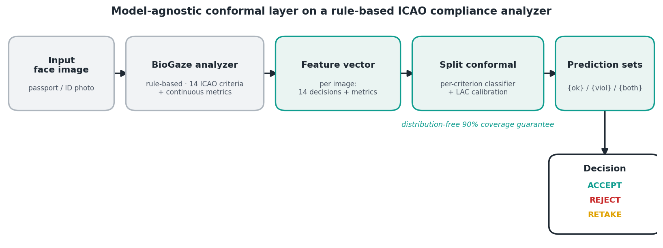
Figure 1. Model-agnostic conformal layer on a rule-based ICAO analyzer: BioGaze features → per-criterion classifier → split-conformal prediction sets → ACCEPT/REJECT/RETAKE.

2.1 Features from the rule-based analyzer
For each image, BioGaze produces 14 binary ICAO decisions together with continuous metrics (inter-eye distance, head-pose angles, eye- and mouth-openness, and a glasses indicator). For each criterion c we form a feature vector from these outputs and fit a probabilistic classifier (regularised logistic regression, class-balanced) to predict the ground-truth label — violation vs. compliant — for c. The analyzer itself is never retrained; the layer only calibrates its outputs.

2.2 Subject-disjoint evaluation
The TONO subject identifier is parsed from each filename. Of 275 identities, 247 appear in more than one violation folder (one in up to 17), so a split stratified by violation type would place the same identity in both calibration and test and inflate coverage. We therefore partition identities — not images — into train/calibration/test at 60/20/20, guaranteeing that no identity is shared across the three sets (verified: zero overlap). Split manifests are saved, and every headline number is reported as mean ± standard deviation over five independent subject-disjoint splits.

2.3 Split conformal prediction: marginal and label-conditional
We apply split (inductive) conformal prediction with the LAC (least-ambiguous-set) non-conformity score s = 1 − p̂(y): the classifier is fit on the training split, a conformity threshold q̂ is estimated on the calibration split as the finite-sample ⌈(n+1)(1−α)⌉/n empirical quantile, and a class k is included in an image's prediction set iff 1 − p̂(k) ≤ q̂. For a target α = 0.10 this yields, per image and per criterion, a set over {compliant, violation} whose marginal coverage is at least 0.90 independently of the analyzer's internal behaviour. The marginal formulation uses a single q̂; the label-conditional (Mondrian) formulation estimates a separate q̂ per true class on the calibration split, which enforces the coverage level within each class and thus on the minority violation class. The conformal layer is implemented from scratch for full control over per-class calibration and cross-checked against the MAPIE library for the marginal case (agreement within 0.003 coverage).

2.4 Triage strategies compared
On one common subject-disjoint test set we compare five strategies: (a) the raw BioGaze rule decision; (b) the logistic classifier alone (argmax, no conformal); (c) a probability threshold with a symmetric abstention band; (d) marginal LAC conformal; and (e) Mondrian conformal. For the set-valued methods, a confident singleton {violation} maps to REJECT, a confident {compliant} to ACCEPT, and an ambiguous or empty set to RETAKE; the threshold method abstains (RETAKE) inside its band.

3. Dataset and evaluation scope
TONO is a synthetic, single-violation dataset in which each image carries exactly one degradation and the folder name gives the violated attribute. We map every folder to the corresponding ICAO/ISO requirement and to the BioGaze criterion that checks it. Sixteen folders map to an in-scope criterion (across 14 distinct criteria; closed-eyes-with-glasses and the two looking-away variants collapse onto Eyes_open and Gaze_in_camera). Two mappings were verified against the recorded metrics rather than the folder name: tq denotes a head-pose (yaw) deviation — median |yaw| 13.0° versus 1.2° dataset-wide, flagged non-frontal on 99% of images — and correctly maps to Frontal_pose. The zoom folder, by contrast, is out of scope: its median inter-eye distance is 138 px versus 96 px dataset-wide, i.e. a head-size / framing violation of a requirement BioGaze does not check. We therefore do not treat zoom images as ‘genuinely compliant’; they are reported separately. A consequence of the single-violation design is that the test set contains essentially no fully-compliant images, which limits image-level ACCEPT evaluation (Section 4.4).

4. Results

4.1 Marginal coverage holds under the honest split
Across five subject-disjoint splits, mean per-criterion marginal coverage is 0.903 ± 0.015 at the 0.90 target (Figure 2, left), confirming that the distribution-free guarantee transfers to the rule-based analyzer's decisions even without identity leakage.
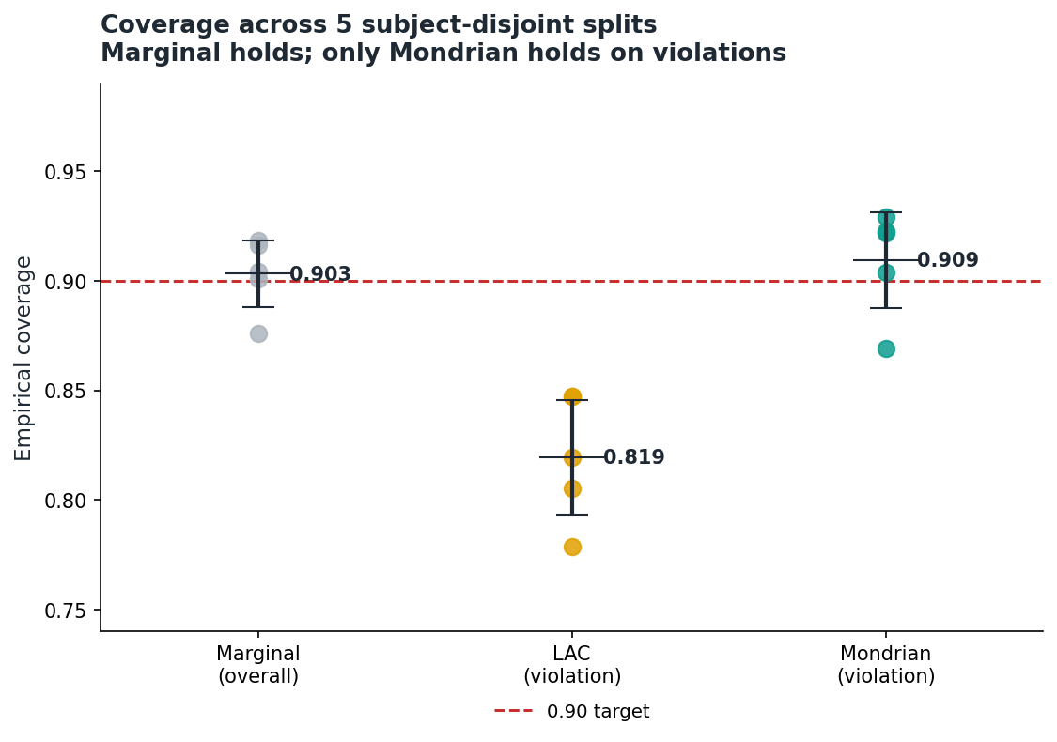
Figure 2. Empirical coverage over five subject-disjoint splits. Marginal coverage (overall) tracks 0.90; marginal LAC under-covers the violation class (0.819); only Mondrian holds on violations (0.909).

4.2 Marginal conformal under-covers violations; Mondrian restores the guarantee
The marginal average hides the cost-relevant quantity. Conditioning on true violations, marginal LAC coverage averages only 0.819 and falls to 0.32 for No_posterization, with seven of fourteen criteria below 0.90 (Table 1, Figure 3). Label-conditional (Mondrian) conformal raises mean violation-class coverage to 0.909 and brings every weak criterion close to or above target, at the cost of slightly larger prediction sets. This is the paper's central methodological result: under class imbalance, the guarantee that matters is class-conditional, and marginal conformal does not provide it.
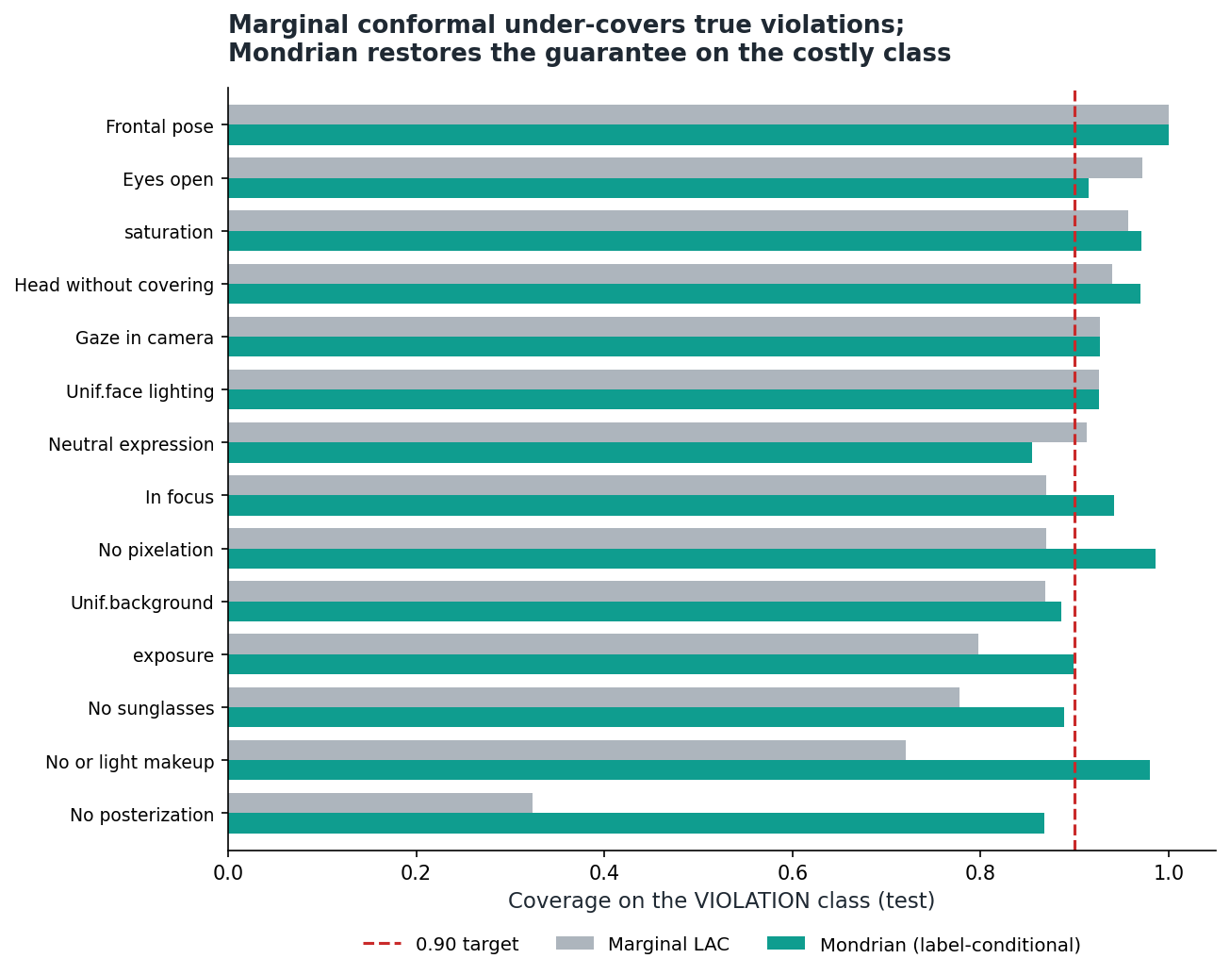
Figure 3. Per-criterion coverage on the violation class: marginal LAC (grey) vs. Mondrian (teal). Marginal conformal drops well below the 0.90 target on several criteria; Mondrian restores it.
Table 1. Per-criterion coverage (subject-disjoint test, seed 0, target 0.90): marginal overall, marginal violation-class, Mondrian violation-class, and mean prediction-set size.
ICAO criterion | Marg. cov. | Marg. viol. cov. | Mondrian viol. cov. | Set size
Head without covering | 0.914 | 0.939 | 0.970 | 0.92
Eyes open | 0.927 | 0.971 | 0.914 | 0.93
No sunglasses | 0.939 | 0.778 | 0.889 | 0.94
No posterization | 0.904 | 0.324 | 0.868 | 0.90
Gaze in camera | 0.934 | 0.927 | 0.927 | 0.97
Neutral expression | 0.938 | 0.913 | 0.855 | 0.99
In focus | 0.936 | 0.870 | 0.942 | 0.94
Correct exposure | 0.889 | 0.797 | 0.899 | 1.00
No or light makeup | 0.890 | 0.720 | 0.980 | 0.89
No pixelation | 0.910 | 0.870 | 0.986 | 0.92
Frontal pose | 0.890 | 1.000 | 1.000 | 0.99
Correct saturation | 0.932 | 0.957 | 0.971 | 0.95
Uniform background | 0.930 | 0.869 | 0.885 | 1.11
Uniform face lighting | 0.924 | 0.926 | 0.926 | 1.12

4.3 The false-flag / detection trade-off across five strategies
Table 2 and Figure 4 compare the five strategies. Two observations are important for honesty. First, most of the reduction in per-criterion false flags comes from recalibration, not from conformal: a plain logistic layer already removes 69% of BioGaze's false flags (false-positive rate 0.147 → 0.050) while keeping violation recall at 0.947. Second, marginal LAC attains the lowest false-positive rate (0.033, ≈75% false-flag reduction) but only by sacrificing violation recall (0.808) and by under-covering the violation class. Mondrian is the balanced operating point: it preserves the violation-class guarantee, recovers recall to 0.882, and still removes ~72% of false flags. The contribution is thus not ‘conformal reduces retakes’ but ‘label-conditional conformal supplies a violation-class guarantee, and we characterise the trade-off of the alternatives.’
Table 2. Triage strategies on the common subject-disjoint test set: false-positive rate, recall on true violations, per-criterion false-flag reduction vs. raw rules, and output type.
Method | FPR | Recall (viol.) | False-flag reduction | Output
Raw BioGaze (rules) | 0.147 | 0.950 | — | point
Logistic only (no conformal) | 0.050 | 0.947 | 69% | point
Threshold + abstention | 0.034 | 0.932 | 77% | abstain
LAC conformal (marginal) | 0.033 | 0.808 | 75% | set
Mondrian conformal (label-cond.) | 0.045 | 0.882 | 72% | set

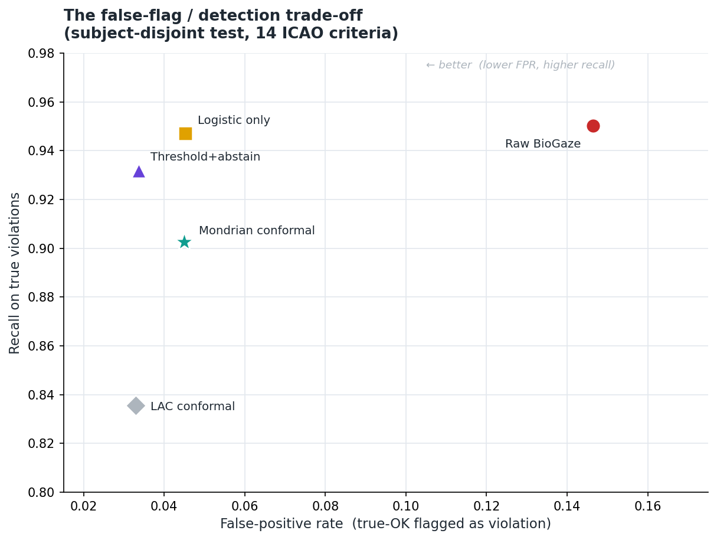
Figure 4. False-positive rate vs. violation recall for the five strategies (subject-disjoint test). Raw rules sit at high FPR; recalibrated methods cluster at low FPR with differing recall.

4.4 Image-level triage and safety
Aggregating the marginal-LAC per-criterion sets into an image decision yields 6 ACCEPT, 878 REJECT and 110 RETAKE on the 994-image test set. Critically, none of the 925 true-violation images is wrongly accepted: every violation is routed to REJECT (862) or RETAKE (63) (Figure 5). The ACCEPT class is tiny and consists only of out-of-scope zoom images — a property of TONO's single-violation design, not of the method, and the reason a real, multi-attribute dataset is required to evaluate ACCEPT.
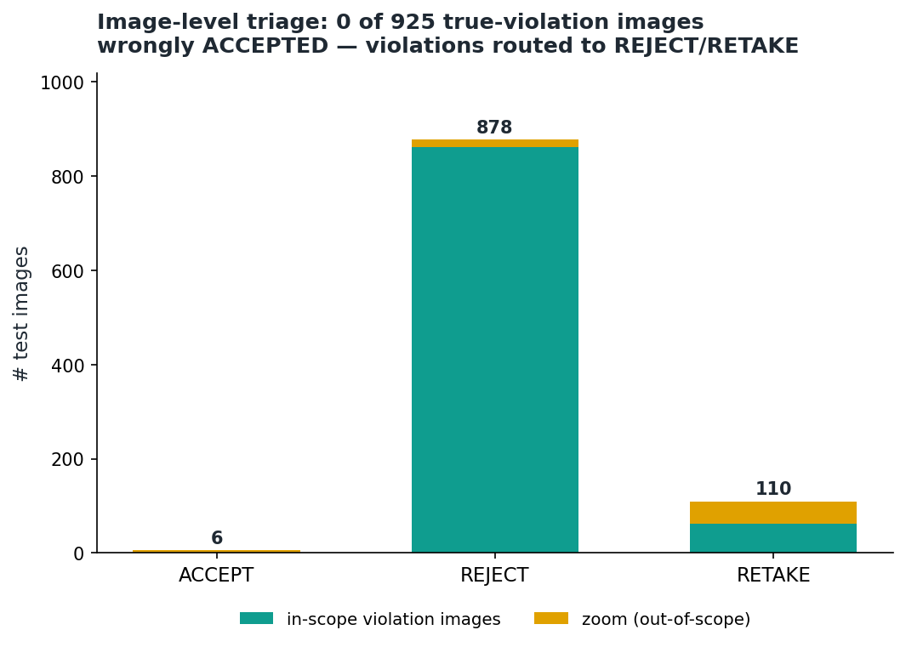
Figure 5. Image-level ACCEPT/REJECT/RETAKE decisions, split into in-scope violation images (teal) and out-of-scope zoom images (amber). Zero true-violation images are accepted.

4.5 Joint (multi-criterion) coverage
The per-criterion guarantees are marginal in the criteria: requiring all 14 prediction sets to simultaneously contain the truth gives only ≈0.31 empirical joint coverage, the expected multiple-comparison effect. Attaining a joint 0.90 guarantee would require a per-criterion target near 0.993 (Bonferroni). We report this openly; a corrected joint guarantee is left to future work.

5. Explainability
Because the underlying decisions are rule-based, we can attach faithful region-level explanations — face-parsing segmentation and 68-point landmarks localising the evidence for each criterion (e.g. the lens region for sunglasses, the eyelid geometry for closed eyes). These are exact by construction rather than post-hoc saliency, and align with pixel-level face-image-quality interpretability.
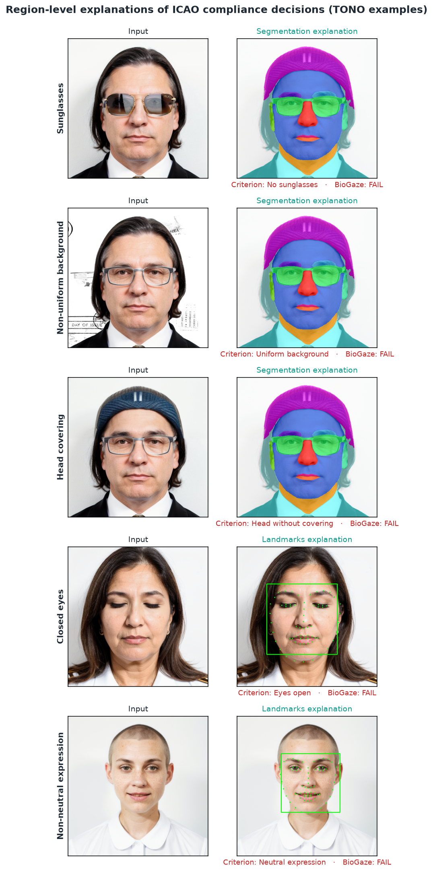
Figure 6. Region-level explanations of ICAO compliance decisions on TONO examples (segmentation and landmark overlays), faithful to the rule-based evidence.

6. Limitations and discussion
- Recalibration vs. conformal. Much of the false-flag reduction is achieved by logistic recalibration alone; conformal's added value is the distribution-free guarantee (and, via Mondrian, the class-conditional guarantee), not a further accuracy gain.
- Marginal vs. class-conditional coverage. Marginal LAC under-covers the violation class and reduces recall; Mondrian is preferred when missed violations are costly.
- Joint coverage. Per-criterion guarantees do not compose into an image-level joint guarantee without a multiple-comparison correction.
- Synthetic, single-violation data. TONO provides clean per-criterion ground truth but no co-occurring violations and essentially no fully-compliant images, so the ACCEPT class and multi-attribute interactions cannot be evaluated here.
- Cost calibration. The RETAKE region is not yet tuned to an explicit asymmetric miss/retake cost; doing so is natural future work.
These limitations motivate a follow-up study on DFIC — real passport-style images with multi-attribute labels and genuinely compliant examples — re-running the identical pipeline under a subject-disjoint split to evaluate the full ACCEPT/REJECT/RETAKE confusion and a cost-calibrated RETAKE region.

7. Conclusion
We showed that a rule-based ICAO compliance analyzer can be wrapped with a per-criterion conformal layer that, under a strictly subject-disjoint protocol, supplies a distribution-free coverage guarantee (marginal 0.903 ± 0.015 at a 0.90 target). The key finding is that marginal conformal silently under-covers the minority violation class (0.819), which label-conditional (Mondrian) conformal restores (0.909); and that, across five triage strategies, the honest picture is a false-flag / detection trade-off in which recalibration removes most false flags and conformal supplies the guarantee. No true-violation image was wrongly accepted. Future work will (i) adopt a corrected joint guarantee and an explicit asymmetric cost, and (ii) validate on real, multi-violation data (DFIC).

References
[1] International Civil Aviation Organization. Doc 9303, Machine Readable Travel Documents, 8th ed. ICAO, 2021.
[2] ISO/IEC 39794-5:2019, Information technology — Extensible biometric data interchange formats — Part 5: Face image data. ISO, 2019.
[3] M. Ferrara, A. Franco, D. Maio and D. Maltoni. Face image conformance to ISO/ICAO standards in machine readable travel documents. IEEE Trans. Information Forensics and Security, 7(4):1204–1213, 2012.
[4] G. Borghi et al. TONO: A synthetic dataset for ICAO compliance of face images. ECCV 2024 Workshops. doi:10.1007/978-3-031-91907-7_1.
[5] BioGaze: an open-source ICAO/ISO face-image compliance analyzer. FG 2025 (demo).
[6] T. Schlett, C. Rathgeb, O. Henniger, J. Galbally, J. Fierrez and C. Busch. Face image quality assessment: a literature survey. ACM Computing Surveys, 54(10s):1–49, 2022.
[7] P. Terhörst et al. Pixel-level face image quality assessment for explainable face recognition. arXiv:2110.11001, 2021.
[8] V. Vovk, A. Gammerman and G. Shafer. Algorithmic Learning in a Random World. Springer, 2005.
[9] A. N. Angelopoulos and S. Bates. A gentle introduction to conformal prediction and distribution-free uncertainty quantification. arXiv:2107.07511, 2021.
[10] V. Taquet, V. Blot, T. Morzadec, L. Lacombe and N. Brunel. MAPIE: an open-source library for distribution-free uncertainty quantification. arXiv:2207.12274, 2022.

