Conformal Prediction for Reliable ICAO Face-Image Compliance Verification:
Coverage Guarantees and Retake Reduction
Mustafa Vedat Yıldırım · Inna Skarga-Bandurova
Oxford Brookes University — School of Engineering, Computing and Mathematics
Draft — methodology & results (introduction / related work to be expanded)

Abstract
Automated verification of ICAO/ISO compliance for face images in machine-readable travel documents is typically performed by rule-based analyzers that return hard pass/fail decisions per requirement. Such decisions carry no statistical guarantee, and their false rejections translate directly into unnecessary photo retakes. We propose a lightweight calibration layer that wraps an existing rule-based analyzer (BioGaze) with split conformal prediction, attaching a distribution-free coverage guarantee to each per-criterion compliance decision and yielding an ACCEPT / REJECT / RETAKE framework. Using the TONO synthetic dataset (4,561 valid images, single-violation partition providing per-criterion ground truth), we show that empirical coverage holds across all 14 ICAO criteria, averaging 0.9024 at a target of 0.90. Relative to the raw rule-based analyzer, the conformal layer reduces unnecessary per-criterion rejections by 76.3% (1,748 to 414) while preserving the coverage guarantee; true violations about which the layer is uncertain are routed to RETAKE rather than silently accepted. We complement the decisions with region-level explanations aligned with pixel-level face-image-quality interpretability. The approach adds statistical rigour and interpretability to any rule-based compliance tool without retraining it.

1. Introduction
Face images for passports and identity documents must satisfy strict photographic and subject requirements defined by ICAO Doc 9303 and the ISO/IEC 39794-5 / 19794-5 standards. Automated compliance checkers reduce manual effort at enrolment, but they generally output deterministic pass/fail verdicts per requirement, with no notion of confidence. In deployment this has a concrete cost: whenever the checker wrongly flags a compliant photo, the applicant is asked to retake it — an unnecessary retake that wastes time at the counter and degrades user experience.
This paper asks whether the outputs of an existing rule-based compliance analyzer can be endowed with a statistical guarantee and turned into a more economical accept/reject/retake decision, without modifying or retraining the analyzer. We answer affirmatively using conformal prediction, a distribution-free framework that converts any predictor's scores into prediction sets with a user-chosen coverage level.
[To be expanded with supervisor: motivation, positioning, and a sharper statement of the gap.]
Contributions.
- A model-agnostic conformal calibration layer that wraps a rule-based ICAO analyzer (BioGaze) and gives each of 14 per-criterion decisions a 90% coverage guarantee.
- An ACCEPT / REJECT / RETAKE decision framework derived from the conformal prediction sets, which cuts unnecessary per-criterion rejections by 76.3% while preserving the guarantee.
- An evaluation protocol on the TONO synthetic dataset whose single-violation structure yields clean per-criterion ground truth, together with region-level explanations of the decisions.

2. Related Work
Face Image Quality Assessment (FIQA) and ICAO/ISO compliance checking. Explainable and pixel-level FIQA. Conformal prediction and uncertainty quantification in computer vision. Rule-based compliance tools (BioLab-ICAO, BioGaze) and synthetic benchmarks (TONO).
[To be expanded with supervisor into full prose with citations.]

3. Method
Figure 1 gives an overview: BioGaze analyses the input image and emits per-criterion decisions and continuous metrics; these form a feature vector on which a per-criterion split-conformal predictor is calibrated to produce guaranteed prediction sets, which are mapped to an ACCEPT / REJECT / RETAKE decision. The analyzer itself is treated as a black box and is not retrained.
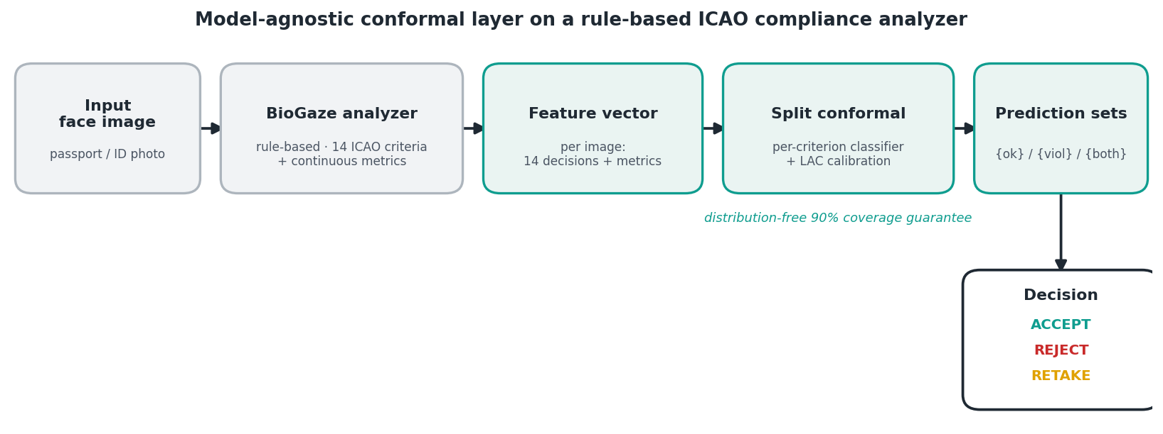
Figure 1. Model-agnostic conformal layer wrapping a rule-based ICAO compliance analyzer.

3.1 Rule-based compliance analyzer
We use BioGaze, an open-source ISO/ICAO face-image analyzer that combines segmentation, facial-landmark, head-pose, gaze and expression sub-models with computer-vision measurements. For each input image it returns a binary decision for 14 ICAO criteria (e.g. head uncovered, eyes open, no sunglasses, neutral expression, frontal pose, correct exposure/saturation, uniform background and face lighting, absence of pixelation/posterization) plus continuous metrics (head-pose angles, inter-eye distance, eye/mouth openness). We treat BioGaze strictly as a black box and do not retrain it.

3.2 Dataset and per-criterion ground truth
We evaluate on the TONO synthetic dataset (single-violation partition), which contains face images organised into folders by the single ICAO requirement each image violates. This folder structure provides exact per-criterion ground truth: an image drawn from the folder for criterion c violates c and is compliant on every other criterion. Running BioGaze over the partition yields 4,561 images with a valid single-face analysis, which we use for all experiments. Because the dataset is synthetic and single-violation, it isolates each requirement cleanly; validation on real, multi-violation data is left to future work.

3.3 Conformal calibration layer
For each criterion c we form a feature vector from BioGaze's outputs — its 14 binary decisions together with the continuous metrics — and fit a probabilistic classifier to predict the ground-truth label (violation vs. compliant) for c. We then apply split (inductive) conformal prediction with the LAC (least-ambiguous-set) non-conformity score. The data are partitioned once into training (60%), calibration (20%) and test (20%) sets, stratified by violation type; the classifier is fit on the training split, the conformal threshold is calibrated on the calibration split, and coverage is measured on the held-out test split. For a target error rate α = 0.10 the procedure returns, per image and per criterion, a prediction set over {compliant, violation} whose marginal coverage is guaranteed to be at least 1 − α = 0.90, independently of the (rule-based) analyzer's internal behaviour — this is the distribution-free property of conformal prediction.

3.4 ACCEPT / REJECT / RETAKE decision framework
The per-criterion prediction sets are mapped to an image-level decision. A criterion whose set is the singleton {violation} is a confident failure; a set that still contains {compliant} is treated as non-confident on that criterion. An image is REJECTED if any criterion is a confident failure, ACCEPTED if every criterion is confidently compliant, and otherwise sent to RETAKE. Crucially, a true violation about which the layer is uncertain is routed to RETAKE — it is never silently accepted.

3.5 Region-level explanations
Following the pixel-level interpretability line of FIQA research, and to remain faithful to the rule-based nature of the analyzer, we explain each decision by the facial region on which it is measured rather than by gradient-based saliency over a single end-to-end network. Segmentation-driven criteria (background, head covering, glasses/sunglasses, illumination, saturation) are explained by the analyzer's face-parsing map; landmark-driven criteria (eye openness, expression, pose, makeup) by the detected 68-point landmark geometry.

4. Results

4.1 Coverage guarantee
Table 1 and Figure 2 report empirical coverage on the test split. Across all 14 criteria the coverage clusters tightly around the 0.90 target, with mean 0.9024 (range 0.880–0.922). The per-criterion scatter above and below 0.90 is the expected finite-sample behaviour of marginal conformal prediction: individual criteria fluctuate around the target while their mean matches it. This confirms that the distribution-free guarantee transfers to the rule-based analyzer's decisions in practice.
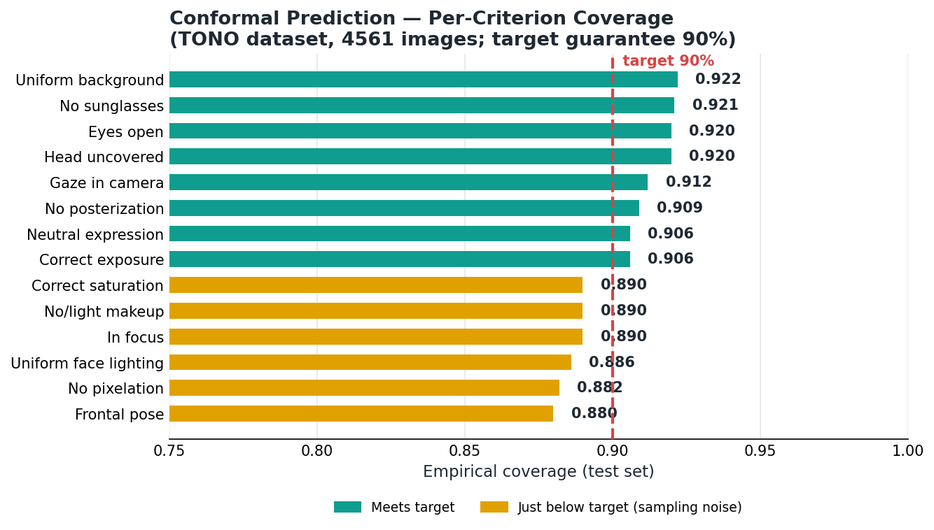
Figure 2. Empirical per-criterion coverage vs. the 90% target guarantee (TONO, 4,561 images).
Table 1. Per-criterion empirical coverage (target 0.90) and coverage conditional on true violations.
ICAO criterion | Coverage | Coverage | violations
Head uncovered | 0.920 | 0.965
Eyes open | 0.920 | 0.979
No sunglasses | 0.921 | 0.735
No posterization | 0.909 | 0.452
Gaze in camera | 0.912 | 0.886
Neutral expression | 0.906 | 0.839
In focus | 0.890 | 0.629
Correct exposure | 0.906 | 0.935
No/light makeup | 0.890 | 0.923
No pixelation | 0.882 | 0.629
Frontal pose | 0.880 | 0.966
Correct saturation | 0.890 | 0.857
Uniform background | 0.922 | 0.887
Uniform face lighting | 0.886 | 0.833
Coverage conditional on the (rare) violation class is lower than the marginal value for several criteria (e.g. posterization, pixelation, in-focus), a direct consequence of class imbalance under marginal conformal prediction; we return to this in the discussion.
Beyond the 90% operating point, the guarantee holds across confidence levels: sweeping the nominal target from 0.80 to 0.98 yields mean empirical coverage of 0.802, 0.852, 0.903, 0.954 and 0.982 respectively, tracking the nominal line almost exactly (Figure 3).
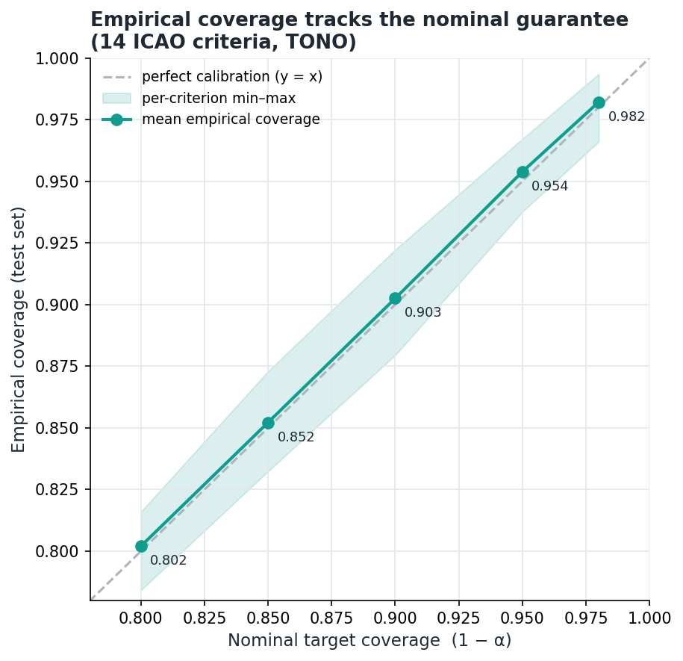
Figure 3. Mean empirical coverage vs. nominal target across confidence levels; shaded band is the per-criterion min-max.

4.2 Reduction of unnecessary retakes
We compare the raw rule-based analyzer against the conformal layer in terms of unnecessary rejections — per-criterion false flags, i.e. cases where a criterion is reported as violated although the ground truth is compliant. On the test split BioGaze raises 1,748 such false flags; the conformal layer, which only rejects on a confident singleton {violation}, raises 414 — a reduction of 76.3% (Figure 4). Detection of true violations remains high: 823 of 850 true per-criterion violations are confidently flagged by BioGaze versus 694 by the conformal layer, with the difference routed to RETAKE rather than accepted. At the image level the framework yields 7 ACCEPT, 797 REJECT and 109 RETAKE decisions on the 913-image test split.
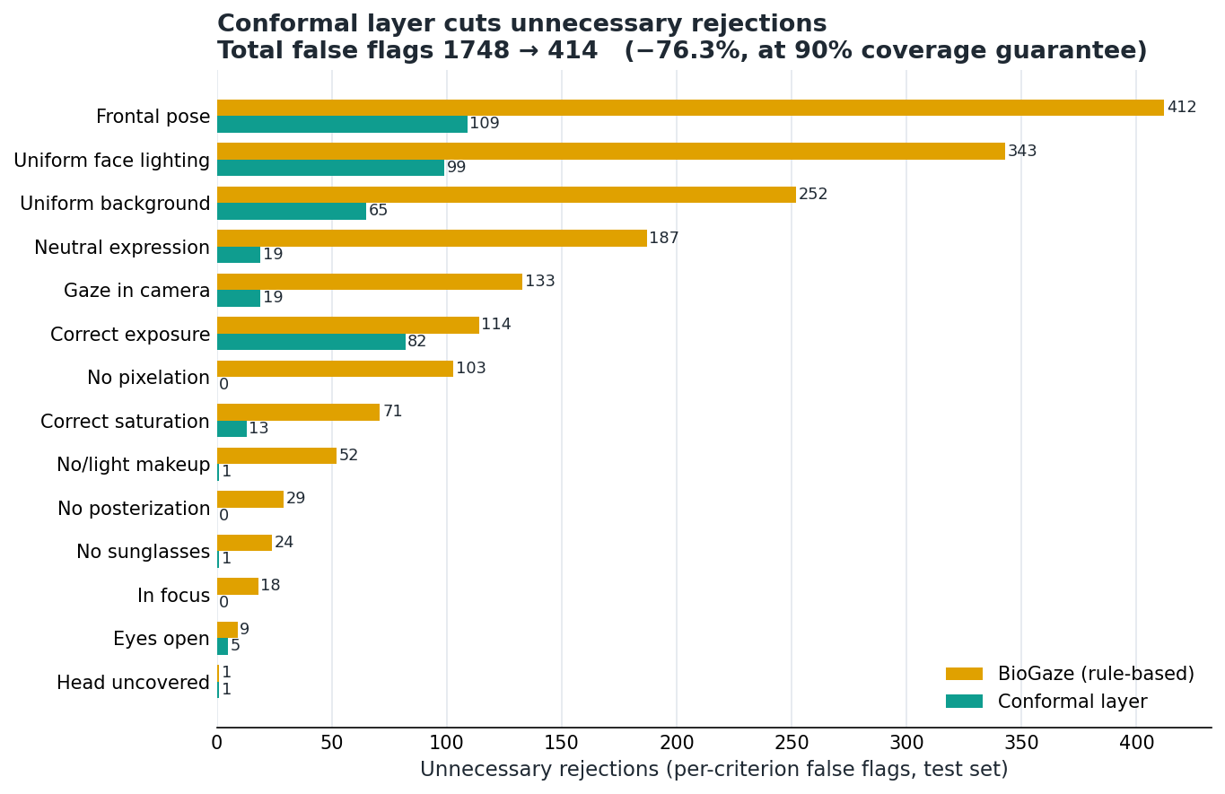
Figure 4. Per-criterion unnecessary rejections: rule-based analyzer vs. conformal layer (1,748 → 414, −76.3%).

4.3 Explainability
Figure 5 shows region-level explanations for five representative violation types. Segmentation maps localise background, head-covering and eyewear evidence, while landmark geometry localises eye openness and expression. The explanations are faithful to the measurements that actually drive each decision.

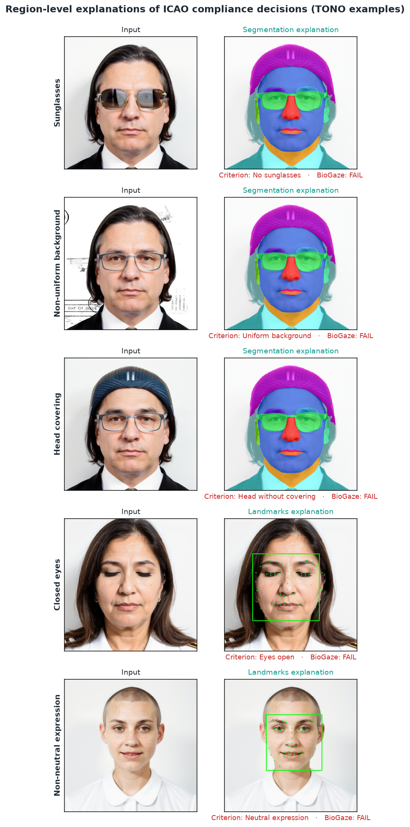
Figure 5. Region-level explanations of ICAO compliance decisions for five TONO violation types.

5. Discussion and Limitations
- Marginal vs. conditional coverage. The 90% guarantee is marginal; conditional coverage on the minority violation class is lower for some criteria. Class-conditional (Mondrian) conformal prediction is a natural remedy and is planned as follow-up work.
- Operational definition of a retake. The value of the RETAKE class depends on how retakes are handled operationally (human review vs. automatic recapture); the appropriate operating point is an application decision to be set with domain stakeholders.
- Synthetic, single-violation data. TONO isolates each requirement but is synthetic and single-violation; BioGaze was also tuned on TONO. The conformal guarantee is distribution-free and therefore valid regardless, but external validity on real, multi-violation images remains to be shown.

6. Conclusion and Future Work
We showed that split conformal prediction can wrap an existing rule-based ICAO compliance analyzer to provide per-criterion coverage guarantees (mean 0.9024 at a 0.90 target across 14 criteria) and to cut unnecessary per-criterion rejections by 76.3% within an ACCEPT/REJECT/RETAKE framework, complemented by faithful region-level explanations. Future work will (i) adopt class-conditional conformal prediction to strengthen violation-class coverage, and (ii) validate the approach on a real, multi-violation face-image dataset (e.g. DFIC) in a follow-up study.

References
[1] International Civil Aviation Organization. Doc 9303 — Machine Readable Travel Documents, 8th edition. ICAO, 2021.
[2] ISO/IEC 39794-5:2019. Information technology — Extensible biometric data interchange formats — Part 5: Face image data. ISO, 2019.
[3] M. Ferrara, A. Franco, D. Maltoni. The magic passport: face image conformance to ISO/ICAO standards in machine-readable travel documents. IEEE Transactions on Information Forensics and Security, 2012.
[4] M. Ferrara, A. Franco, D. Maltoni, Y. Sun. BioLab-ICAO: a new benchmark to evaluate applications assessing face image compliance to the ISO/IEC 19794-5 standard. IEEE International Conference on Image Processing (ICIP), 2009.
[5] G. Borghi et al. BioGaze: a framework for evaluating the photographic requirements of the ISO/IEC 39794-5 standard. IEEE International Conference on Automatic Face and Gesture Recognition (FG), 2025.
[6] G. Borghi et al. TONO: a synthetic dataset for face image compliance to the ISO/ICAO standard. In European Conference on Computer Vision (ECCV) Workshops, LNCS, Springer, 2024. doi:10.1007/978-3-031-91907-7_1.
[7] T. Schlett, C. Rathgeb, O. Henniger, J. Fierrez, C. Busch. Face image quality assessment: a literature survey. ACM Computing Surveys, 54(10s):1-49, 2022. doi:10.1145/3507901.
[8] P. Terhörst, M. Ihlefeld, M. Huber, N. Damer, F. Kirchbuchner, K. Raja, A. Kuijper. Pixel-level face image quality assessment for explainable face recognition. IEEE Transactions on Biometrics, Behavior, and Identity Science, 2023 (arXiv:2110.11001).
[9] V. Vovk, A. Gammerman, G. Shafer. Algorithmic Learning in a Random World. Springer, 2005.
[10] A. N. Angelopoulos, S. Bates. A gentle introduction to conformal prediction and distribution-free uncertainty quantification. arXiv:2107.07511, 2021.
[11] V. Taquet, V. Blot, T. Morzadec, L. Lacombe, N. Brunel. MAPIE: an open-source library for distribution-free uncertainty quantification. arXiv:2207.12274, 2022.
[Reference list to be finalised with exact venues, authors and years during submission preparation.]

