- mkdir mm-rag-full-stack-genai-bootcamp-1.0
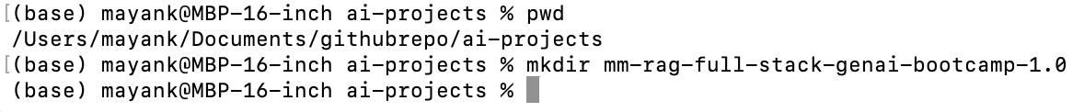
- To invoke visual code, use following command from above folder
code .
- Now, create a virtual environment
  - Terminal -> New Terminal
  - uv python list
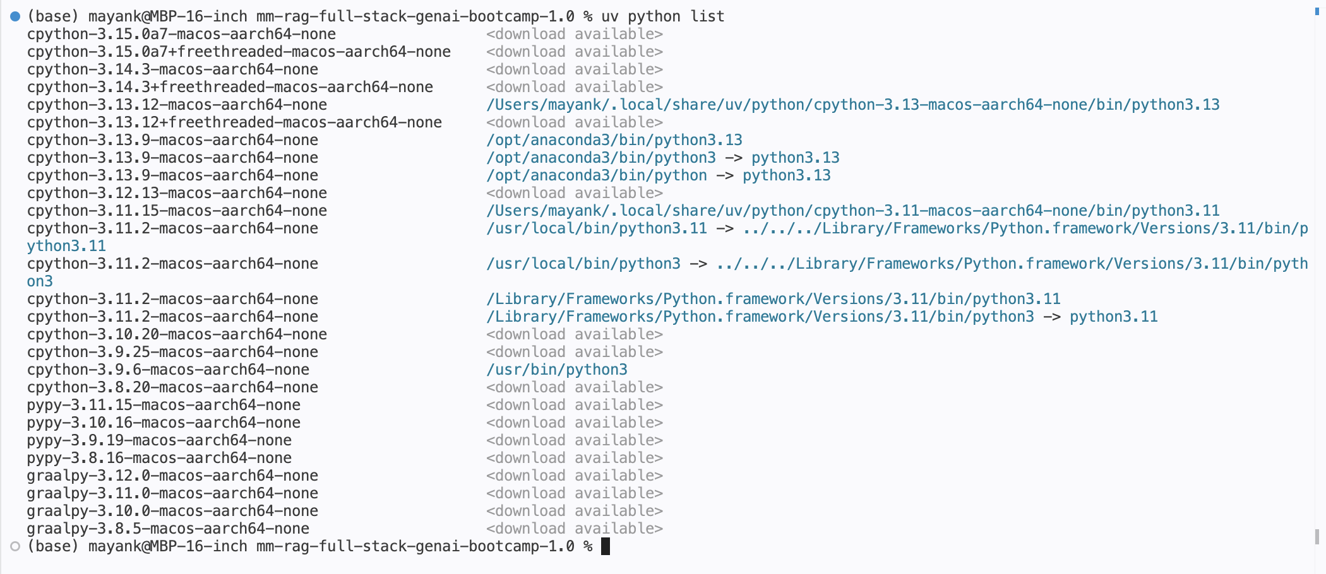
  - Now start Python 3.12.11 env
  - Check if Python 3.12.11 is available
uv python list 3.12.11 --all-versions
base) mayank@MBP-16-inch mm-rag-full-stack-genai-bootcamp-1.0 % uv python list 3.12.11 --all-versions
cpython-3.12.11-macos-aarch64-none <download available>
  - Now install it:
uv python install 3.12.11
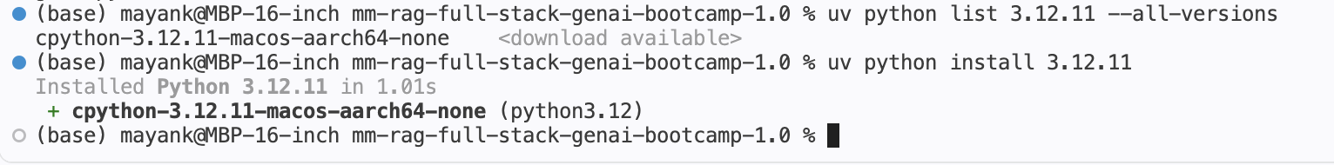
  - uv python list
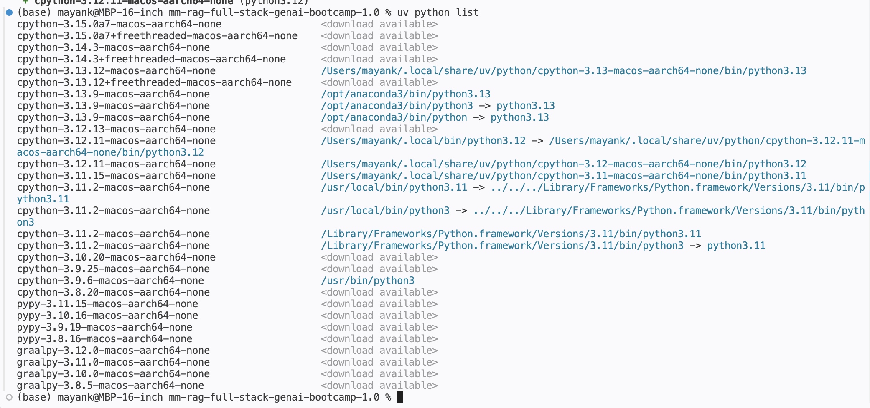
  - uv venv --python cpython-3.12.11-macos-aarch64-none
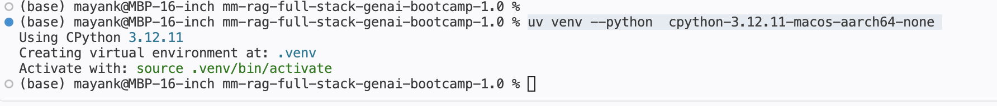
  - source .venv/bin/activate
  - To initialize github repo:
git init
  - Now to share this repo on github, click on ‘Source Control’ icon on top left area, and commit the changes:
  - Gave code following instruction to populate README.md
Can you write the project detail inside the readme.md and I am using uv python list for listing the python version and uv venv env --python <python version> for creating a virtual env for this project. I am using python 3.12 so just mention all the details inside readme.md file
  - After reviewing Readme.md file, gave following command:
Instead of powershell, mention terminal or command prompt
  - To install requirements.txt:
uv pip install requirements.txt
  - Gave codex following instruction:
analyze parsing.py file and fill requirements.txt file
  - Gave codex following instruction:
Check below section of parsing.py and update it to the correct path according to the data folder:
if __name__ == "__main__":
DATA_DIR = PROJECT_ROOT / "data"
PDF_PATH = DATA_DIR / "Client_Contracts_Policies_and_Incident_Records.pdf"
OUTPUT_DIR = DATA_DIR / "parsed_pdf_output"
TESSERACT_PATH = (
r"C:\Program Files\Tesseract-OCR\tesseract.exe"
)
parser = ComplexPDFParser(
pdf_path=PDF_PATH,
output_dir=OUTPUT_DIR,
tesseract_path=TESSERACT_PATH,
)
result = parser.parse()
documents = result["documents"]
  - To run parsing.py
python ./src/parsing.py
  - Once successful run below command to lock version in requirements.txt:
python /Users/mayank/Documents/githubrepo/ai-projects/mm-rag-full-stack-genai-bootcamp-1.0/get_library_version.py

