HeavyWater Machine Learning Solution

Mark Wilber

What we are dealing with

62,204 documents, 14 categories

Unbalanced classes, spanning nearly 2 orders of magnitude
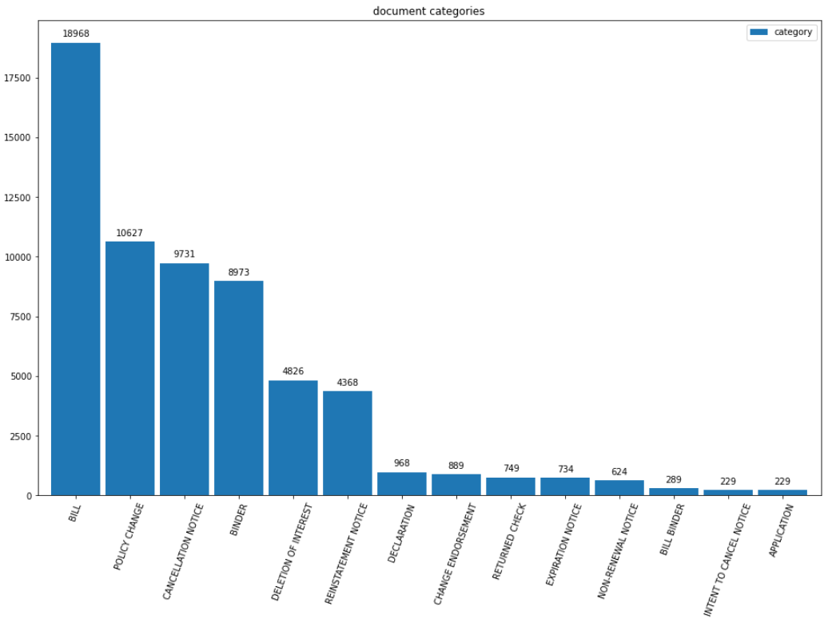

What we are dealing with

Document lengths spanning 0–9076 tokens in length (mode: 100, median: 252, mean: 334.1)

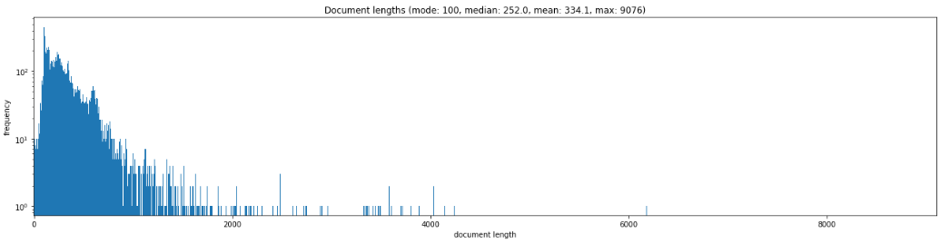
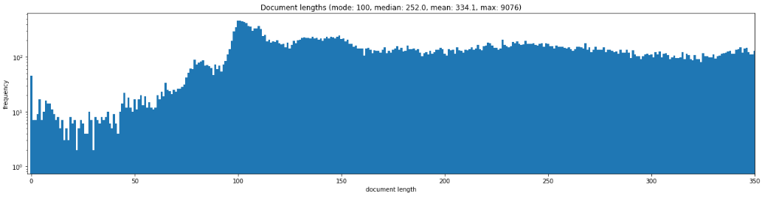

What we are dealing with

Document lengths vary widely by category, but few are shorter than 10 tokens

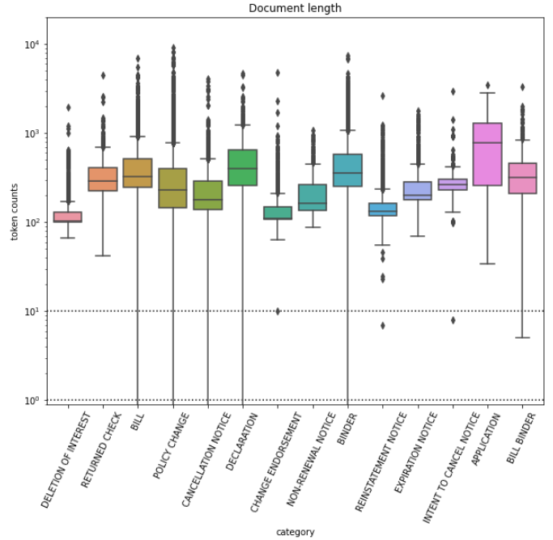

What we are dealing with

1,037,933 unique tokens, which contrasts with: Entire English language.

Problem vocabulary exceeds that of OED:

Oxford Dictionary has 273,000 headwords; 171,476 of them being in current use, 47,156 being obsolete words and around 9,500 derivative words included as subentries. The dictionary contains 157,000 combinations and derivatives in bold type, and 169,000 phrases and combinations in bold italic type, making a total of over 600,000 word-forms. There is one count that puts the English vocabulary at about 1 million words — but that count presumably includes words such as Latin species names, prefixed and suffixed words, scientific terminology, jargon, foreign words of extremely limited English use and technical acronyms.

It seems exceedingly unlikely that there is so much variation in the lexicon of mortgages and loans.
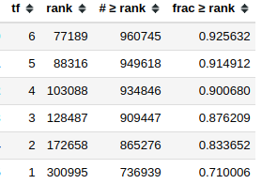

Explanation: most of the tokens are “uninformative” (garbage).

71% of tokens only appear once, 92.6% occur 6 × or fewer.
- A small fraction are names (of humans, businesses), special codes
- Speculation: bogus terms due to scan / OCR noise 🢣 smudges create nonsense terms

What we are dealing with

Frequent terms don’t follow Zipf’s law
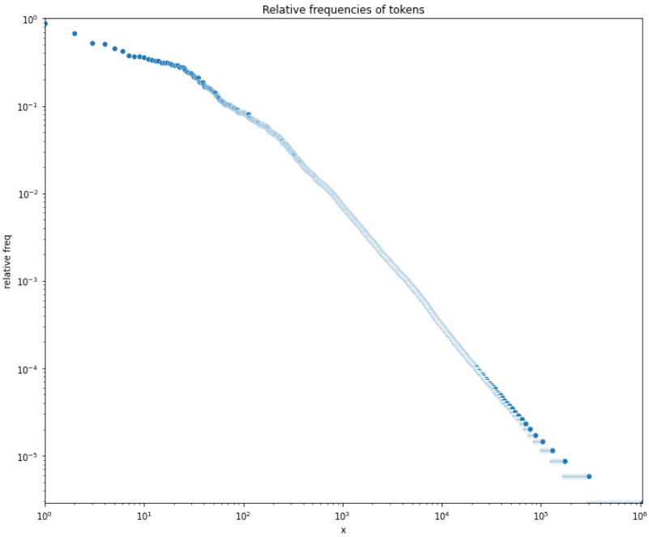
- First ~25 tokens frequency declines weakly vs Zipf
- After 750th ranked token, looks OK

Is this corpus actually this unusual?

Handling Data

Problem with stop words:

- Can’t use curated lists for stop words, as we only have word hashes
- Test with sklearn.feature_extraction.text.TfidfVectorizer shows: max_df=0.80 eliminates 9 tokens, but it’s anybody’s guess what they are. Probably stop words?
- Given time and justification, could use statistical bases for identifying stop words, e.g.:

Gerlach, M., Shi, H. & Amaral, L.A.N. A universal information theoretic approach to the identification of stopwords. Nat Mach Intell 1, 606–612 (2019). https://doi.org/10.1038/s42256-019-0112-6

Handling Data

Trouble with small classes:

- With smallest class sizes O(200), even train-test split yields ~10% uncertainty in test stats
🢣 Can’t be sure cross-validation picks best model

Many documents seem too short.

Test-train split

- 1st removed documents of length < 10 (still retaining very short examples)
- 50-50 test-train split to retain plausible stats on results, at some cost …
- stratified sampling
- after model selection, can train on full data set (but won’t know how much better results may be)

Handling Data

tf-idf features

- min_df=5: 🢣 Eliminates most vocabulary
- ngram_range=(1, 2): 🢣 283 k vocabulary
- sublinear_tf=True

Modeling

f1_scorer: 🢣 when doing grid search, optimize for f₁

Complement Naive Bayes
- Default settings for baseline
- Followed by grid search

Model Results

Model | Macro Averaged |  |  | Weighted Average
Model | precision | recall | f₁ | precision | recall | f₁
Naive Bayes default (baseline) | 0.75 | 0.50 | 0.53 | 0.79 | 0.78 | 0.76
Naive Bayes best | 0.80 | 0.58 | 0.62 | 0.81 | 0.81 | 0.80
Random Forest default | 0.80 | 0.65 | 0.70 | 0.84 | 0.85 | 0.84
Random Forest best | 0.80 | 0.75 | 0.77 | 0.87 | 0.87 | 0.87
Gradient Boosting default | 0.81 | 0.64 | 0.69 | 0.81 | 0.81 | 0.80
XGBoost default | 0.79 | 0.65 | 0.70 | 0.82 | 0.82 | 0.82
XGBoost best
CNN
Bidirectional LSTM

