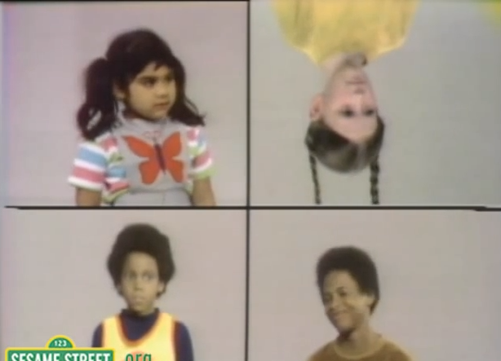
Which of These Does Not Belong?

Anomaly Detection in Images Using a Deep Neural Network and Isolation Forest
Mark Wilber, Galvanize Hiring Day
“... as we know, there are known knowns; ... things we know we know. We also know there are known unknowns; ... we know there are some things we do not know. But there are also unknown unknowns ~ the ones we don't know we don't know.”

Donald Rumsfeld, 2002

Much of anomaly detection is done using classifiers, supervised learning

- Use existing data sets, label anomalies (fraud, network intrusions, etc.)
- Train on anomalies we know about: known knowns

Motivation
Motivation
Alternatives exist

- Suppose that data can be fit by multi-variate Gaussian
- flag as anomalies those points sufficiently far into tail
Will not work if “ordinary” data are in widely-spaced
clusters

- Distance-based methods, which become impractical in high-dimensional space, or which require knowledge of how many clusters of normal points there are.
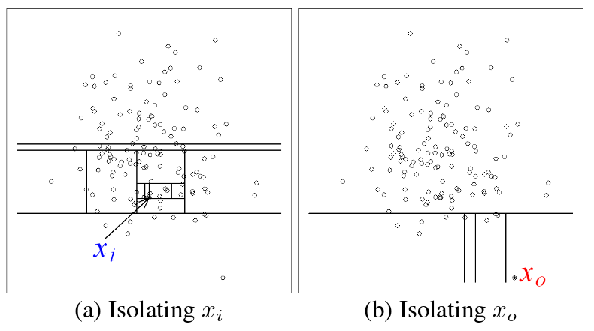
Isolation Forest¹

- Un-supervised method of statistically isolating points that have no close neighbors in feature space
- Advantage: no need to compute large numbers of distances to find which points are distant from others.
Solution
¹Liu, F.T. et al, ICDM `08b, 2008.
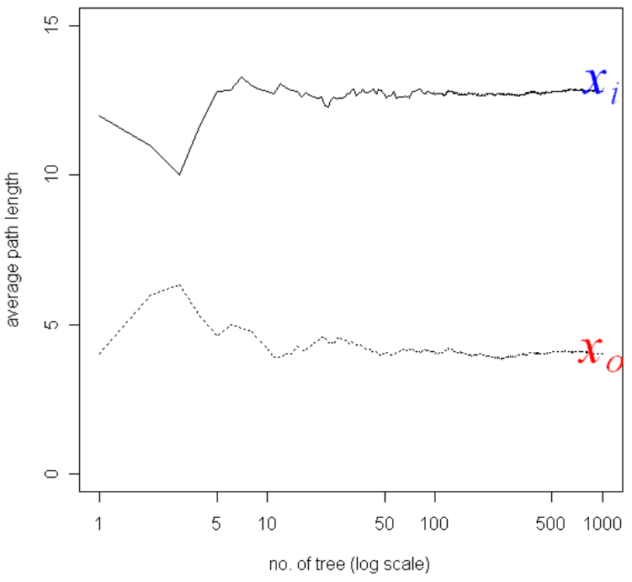
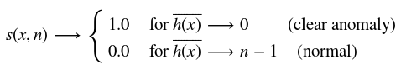
Solution
Isolation Forest¹

Anomaly score, makes use of ensemble averages for trees to isolate each point, with:
¹Liu, F.T. et al, ICDM `08b, 2008.
Appropriate Features
When data are in the form of images, could work with raw pixels, but ...

- Identical images translated by a few pixels can be located far apart in p-dimensional feature space

- Should take advantage of excellent work done in image feature representation ― deep neural nets (DNN)
“Featurizing” Images
Introduce available pre-trained deep neural network²

- Re-size images, subtract training average, insert into DNN
- Extract (4096) high-level feature weights for each image
- Apply Isolation Forest to these features
- Determine anomaly score threshold:
  - That which matches some significance criterion
  - That which yields true positive rate that can afford to investigate in detail.

²Krizhevsky, A, et al, Imagenet classification with deep convolutional neural networks, 2012.
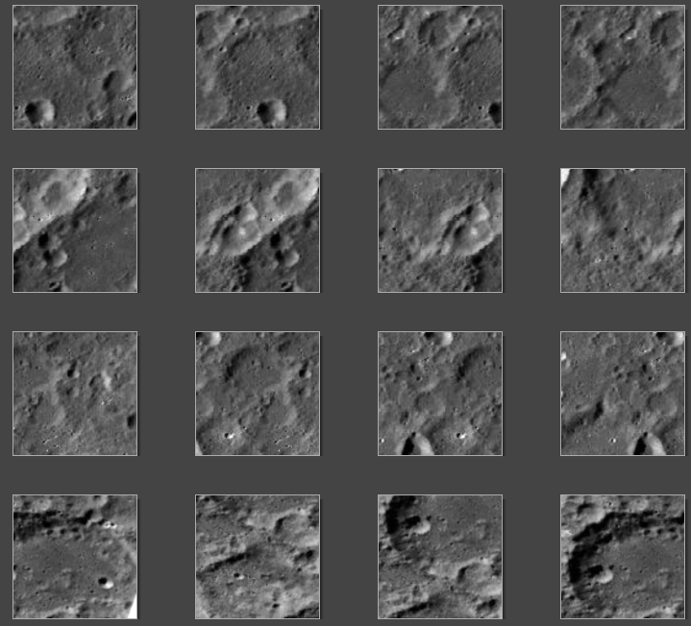
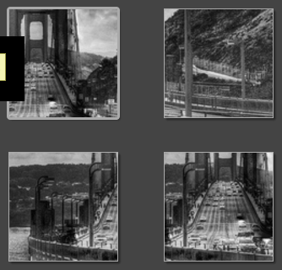
Results

Starting with 2000+ photos of lunar landscapes, with a few sections from a photo of the Golden Gate Bridge.
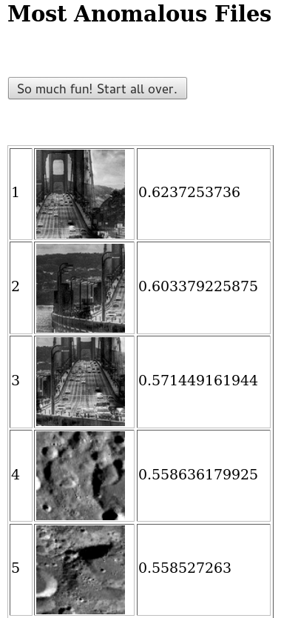
Results
Out of 2000+ images, the anomaly scores for the Golden Gate Bridge are at the top, separated by all others by 10% or more.

