Chi-An Wang

Citi Bike in October

Word Count: 947

As the cold front passed through, temperatures in New York City started to drop from the mid-70s in late September, to the high-40s on October 3. The cold front not only brought intermittent rain and high wind, but also brought blue days to Citi Bike.

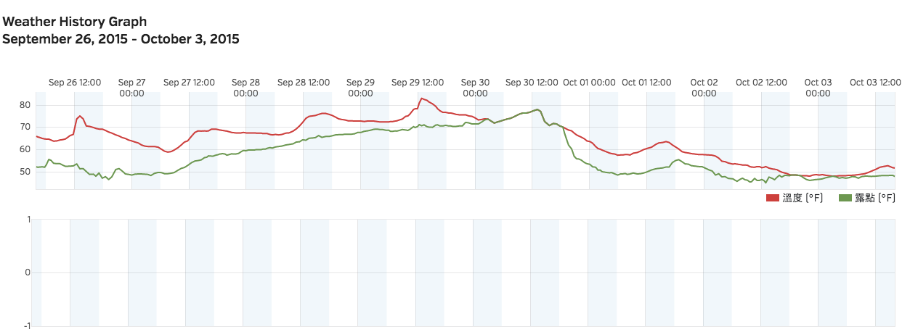

Temperature Chart in New York City

The temperature has dropped since September 30

According to past data, October is the month that Citi Bike sees its summer ridership numbers start to decline. In 2013, the first year of operation, the total riding time reached approximately 260,032 hours in September. The next month, the total riding time went down to 237,986 hours.

In 2014, the total riding time hit a high 238,052 hours in September. Again, in October, it fell to 203,424 hours.

October is the first month that New Yorkers start to feel the weather change.

"Averages don't really tell the story as to feel. You can get a cool last two weeks of August followed by some hot spells in September, but generally in October is when the weather starts balancing out," said Jonathan Jaffe, who has been living in New York City for 40 years.

There was an 8.47 percent riding time drop in October 2013, and a 14.54 percent in October 2014. Riding time this year is also expected to decline in October. What is different this year, is that the company is offering a discount for annual membership, celebrating their expansion in an attempt to keep Citi Bikes out of theit docks. They have installed 91 new stations in Long Island City, Greenpoint, Williamsburg and Bed-Stuy. They also expanded their territory in Manhattan up to 86th Street with 48 new stations on the Upper East and Upper West Sides. By signing up before October 5th, new members can save $25 and get a full year membership for $124.

According to most recent membership data online, annual membership had reached 150,811 people at the end of September 2015. Membership tracking data from 2014 indicates that many fewer people pay for annual membership in the winter.

Daily Annual Membership addition Chart

As temperature fell, subscribers for membership fell along

There was only one exception during last winter’s membership subscription decline. On October 28, a sudden uptick of annual membership subscriptions occurred due to an email forecasting a rate hike. Both new members and members renewing hurried to pay before the price rose from $95 to $149. This year, without the hike motivating renewal and subscriptions, Citi Bike is hoping that the $25 discount can attract some bikers to signup.

Also afftected by the rain and cold brought by the cold front was the success of a challenge of a charity event held by Citi Bike on that first weekend of October. #CitiBikeForGood running from September 16 until October 16, encourages people to sign up to become members and ride more bike over this period. Depending on the ridership during the event, Citi Bike will donate to three New York charities up to $50,000 each. Besides the main event of reaching 1,000,000 rides during the campaign, there are several parallel sub-events.

One of the challenges called Weekend Warrior Challenge, challenges its members to ride bikes on this soggy weekend, and reach 30,000 rides. They have a humorous letter of challenge that says: “If you’re going to get wet walking anyways, you might as well go by bike and get there faster…”

Citi Bike seems to be a community-minded company that does not set the bar to their charitable works too high. Last year, they only had 125,109 annual members as their base, and this year they have over 150,811 members, there is a fair chances that they hit the goal today. Data reveals that riderships during an October rainy weekend in 2014 reached 36,810. On October 4, 2014 the temperature was 61°F along with 29.97 mm rainfall, and 54°F without rain the next day, which was pretty similar to what we have this weekend.

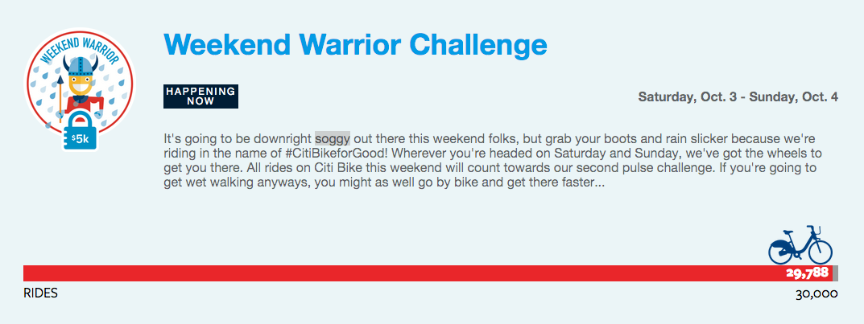

Website of Citi Bike For Good event

Convenience is the main reason that keeps people riding in cold and rainy days. Mike Waring, whose business is at the west most of Tribeca, has to commute from his home to his office in Chelsea. Neither his office or home is right next to subway station, but they are both close to Citi Bike stops. "I can go all the way straight down," said Waring. He will always take ride the Citi Bike unless it is pouring rain or strong wind. "Strong wind isn't fun," he said.

"You can start paddling away," said another Citi Bike fan, Andrew Battista, who was undocking his bike at the intersection of Columbus Avenue and 84th Street in the rain. Battista said he would still be riding the bike in the winter unless there is a large pack of snow. "Everyone should be a member of Citi Bike," he said with a smile on his face.

Here's some Twitter post about their experience for who still rode Citi Bike in the cold rain.

“Today I rode a Citi Bike in the rain to get to a meeting when my train was running late. That made me feel like a pretty legit New Yorker,” said Kate O’Neill.

“Back to back 1st try citi bike kings in the rain!!!! This rain got me bored,” said Blake Ular.





Thanks for the turn off hurricane Joaquin explained by the NHC, next week New York City is going to start with a partly cloudy Monday, and a following sunny weekdays, but showers on the weekend. So riders, who still decide to ride a Citi Bike in the rain, might find [this](http://gothamist.com/2013/05/29/citi_bike_day_2_rain_doesnt_have_to.php) article helpful.