Chi-An Wang
Citi Bike Expansion
Word count: 1182

After Citi Bike expanded its stations into the Brooklyn and Queens neighborhoods of Long Island City, Greenpoint, Williamsburg and Bedford-Stuyvesant, their rides reached 1.2 million in September 2015, a new record, ,. Among the 1.2 million, male rides still had an overwhelming majority with 0.8 million rides, and female accounted for 0.26 million trips. The good news is, the fraction of female ridership has reached a new high, 25 percent.

One of the main goals of expansion into Queens and Brooklyn was to attract more women and less wealthy people to ride Citi Bikes. According to the data Citi Bike released recently, they seem to have made progress in attracting more females into their system, but failed to reach their goals of usage in these neighborhoods.

According to a research conducted by the Rudin Center of New York University, women tend to ride their bikes from a safe stop with lower bike incident rates and less traffic. Women also have a higher percentage of starting a trip from stations adjacent to a bike lane. The neighborhoods of Long Island City, Bedford-Stuyvesant, Williamsburg and Greenpoint are expected to provide safer and friendlier biking environments for women.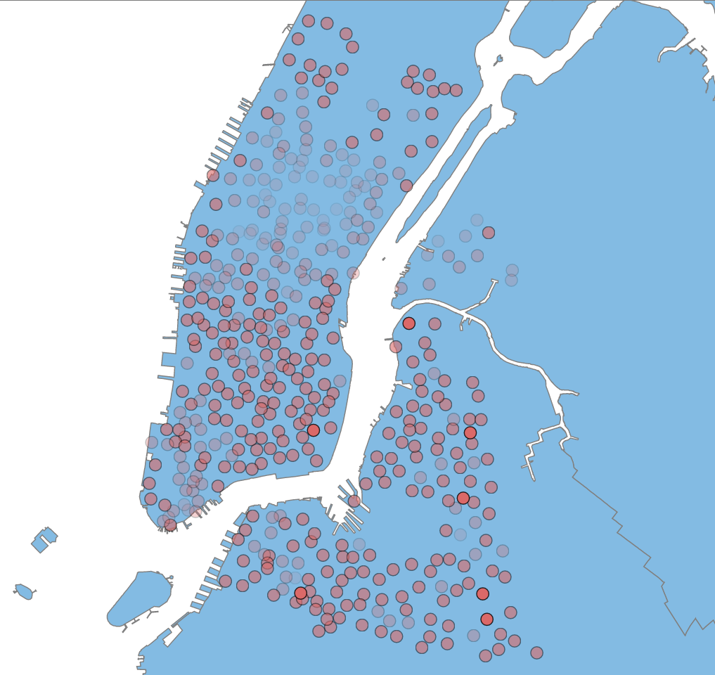

In this visualized data of Citi bike September ride, each red dot indicates a Citi Bike station. The opacity of red dot represents the fraction of female ridership. With a threshold of 0.4, as long as the station has more than 40 percent of rides started by a woman, than it has the opacity of one, giving it a solid color. There is only one solid dot on Manhattan Island, and six solid dots in Brooklyn.

The only Citi Bike station that had more female rides in the New York City in September was the one located on Putnam Avenue and Throop Avenue, with 147 female rides and 123 male rides (118 unknown gender data). Being in a residential district, the traffic here is always light. Another station that ranked second with 46.7 percent of female rides was on Greene Avenue and Throop Avenue. Both of them sit on the intersection of two one way roads, they are both in a residential area and most important of all, they both are right next to a wide single-lane road with a bike lane.

According to a report conducted in Bedford-Stuyvesant by the Brooklyn District Public Health Office, 89 percent of the observed 2,461 cyclists were riding in the bike lane, and 95 percent of them preferred the road with a bike lane.

The popularity among female riders is also related to the demographics in Bedford-Stuyvesant. According to the census data released by nyc.gov, 54 percent of the population, 82,000 people, in this neigborhood are female. The ratio is much higher than Greenpoint and Williamburg's 50.5 percent and Long Island City's 51 percent.

Other stations with a female fraction larger than 40 percent include stations at Franklin Street and Dupont Street; Graham Avenue and Withers Street; Leonard Street and Boerum Street; and Bond Street and Fulton Street.

What's interesting in the data, is that the station at Bond Street and Fulton Street had low ridership in September, only seven trips. Only three women and four men started a ride from that station, as a consequence of it not opening until September 29. Nevertheless, it still had a 42.8 percent of female ridership. With all these indicators, Brooklyn is arguably a great choice to fulfill the goal of increasing female ridership.

"Safety, I mean bike lanes for sure. I think Brooklyn, in general is pretty good for bike riding, way better than Manhattan," said Nora Quinn, a female bike owner who has been living in the Bedford-Stuyvesant neighborhood for eight years.

In order to encourage more women try the blue bike, Citi Bike is holding an activity with WE BIKE NYC, an organization trying to break down barriers to biking, on Saturday 1p.m at Union Square Park. The activity is only open to women, female-identifying and gender nonconforming people. During the event, members of WE BIKE NYC will teach newbies how to ride a bike, and also provide tips about how to have fun and which Citi Bike application to use.

The most popular station for female riders on Manhattan Island stands at the intersection of Lafayette Street and Jersey Street in Soho. According to the same data released by Citi Bike, bikes has been undocked from this station 2,700 times by female riders in September.
Spending one hour in front of the bike station on a Tuesday afternoon, there were six women who undocked bikes from this station and four stopped their bikes here. At the same time, only three men left from the station and four men came to the station, providing a relatively high portion of female riders.

One of the reasons is the popularity of bike lanes in this region that provide a safer biking condition. Fashion boutiques stores and delicate coffee shops, which are ubiquitous in Soho, tend to hire female clerks who commute on a daily basis, with Citi Bike.

Anne Luneae, who works in Soho and commutes from Westchester, takes Metro North to Grand Central and rides a Citi Bike to the station in front of the Broadway-Lafayetter Street subway station almost every day. "It's a lot cheaper, it's exercise, it's mental hygiene, and in summer time the subway smells and it's more controll, " Luneae said.

Another employee of a startup based in Soho, also rides a bike to this station on a daily basis. Ashley Anderson, who works in marketing, rides a bike at least twice a day. When she has to go out for dinner, she will ride Citi Bike up to four times. "I just love it," said Anderson.

Despite the success in raising female riders' rate, the brand new docks installed in Queens and Brooklyn contributed little to ridership citywide. In September, 513 stations contributed 1.28 million rides, but only 62 thousand trips started from the new 90 stations installed in August and September. The other stations contributed 2900 trips on average, which is four times more than these new stations. Population density might be a contributing factor to this problem, while Manhattan is two times denser than Brooklyn and 3.5 times denser than Queens. Higher car ownership in Brooklyn and Queens might also reduce the need short-term bike rentals.

After the expansion in Brooklyn, people there seem to have different opinions about the new service.

"I've been waiting for the Citi Bike to come here for two years," said Mathieu Wache, a man with a blue helmet who just got off Citi Bike and took his groceries out of the bike's rack. "Citi Bike saves me 10 minutes every day," he added.

A Greenpointer, Heather Fink, posted on her Instagram, "The entire fucking weekend @citibike no bikes only broken ones! Displeasure!" on October 12.

// Embed a nInstagram post here
https://instagram.com/p/8vvy9HpkqZ/

"Lost in Brooklyn on a CitiBike is my new workout routine," said Carla.
// Embed a twitter link here

"I hate Citi Bike, the station is really ugly, they take away a lot of parking spaces, they are super ugly," said Ted Shred, a Brooklyn resident who owns a bike store in Greenpoint. His bike shop's business has been affected pretty much by the "over saturated market," Shred said. "They should give up, it's way too much," he added.

With an ambitious vision of having 12,000 bikes at over 700 stations by the end of 2017, Citi Bike and DOT has already started to their next phase of expansion. After they launched the new stops in Brooklyn, community board No. 10 of Manhattan, located in Harlem, held their transportation committee meeting on October 14, talking about the agenda of Citi Bike expansion plans in this region. According to Maria Garcia, chair of the transportation committee, the DOT is going to hold a briefing on November 10 at their next transportation meeting. The DOT will also host a workshop that demonstrates how other parts of the city have adopted Citi Bike and also collect feedback from individuals about where to install bike stations from 86th Street up to 130th Street. In order to make the workshop helpful, there will be several translators to help residents communicate their concerns. "We are the only community board that will have two meetings," said Garcia with a confident look on her face.

