## **Project “Valiant Heart” 1.5-Page GDD**

*Brief Summary or Hook*

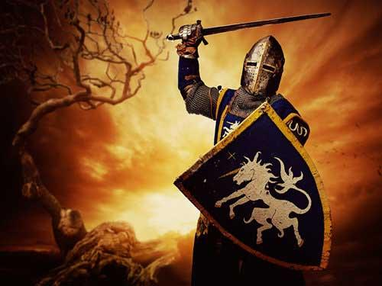

**Genre:** 3rd-Person, RPG, Single Player.  
**Target Audience:** 13+, those who like old RPG style (Rate T for Teen).

**Controls:** Mouse & Keyboard.

**Thematic Setting:** Medieval, Fantasy.

**Tech Stack:** Unity 2019.3.0a4.

**Platform(s):** Steam.

**MVP Game Moment:** Co-op upto 4 Players at the same time.

**Game Summary:** The game take place in a small village in a fantasy world. You are an adventure who was hired by the villager to defend their land from monsters and bandits.

As a trainee adventure, you have to start with weakest opponent to gain experiments and equipments to make you stronger. As one can’t fight again a big army, you can co-op with 3 other adventures become an powerful team and protect the village.

**Core Player Experience:** Funny, Relax with little Tension.

**Central Story Theme:** Trainee adventure.

**Design Pillar:** Combat system.

**Remarkability:** Ridiculous death style and combat system.

**Anticipated Steam Early Access Launch date:** 1/9/2019

**Feature Development Priorities:**

* Combat system;
* Skills set;
* Stats and attributes;
* Items, equipments and buffs;
* Dialogs;
* Quests;

**Reference Games:** Diablos series, Touch Light 2, Mighty Loot,...