JFM Rapids Justification (one or two sentences)
Building on the self-similar analysis of Rayleigh–Taylor mixing by Ristorcelli & Clark (J. Fluid Mech. 507, 2004), this work shows that surface tension can change the growth parameter of immiscible Rayleigh–Taylor mixing only through a correction in the capillary length relative to the layer width, and that the observed increase of the growth parameter with surface tension, approximately as We₀^{−1/2}, is a correction linear in this ratio produced by an indirect effect of surface tension on the flow structure. The result is short and directly testable against the simulations and experiments of immiscible mixing that are now being reported, including in this journal.

Graphical abstract: late-time isovolume rendering of the simulation at We₀ = 50 (graphical_abstract.jpg, 1224 × 1020 px, 1.2:1, no text)
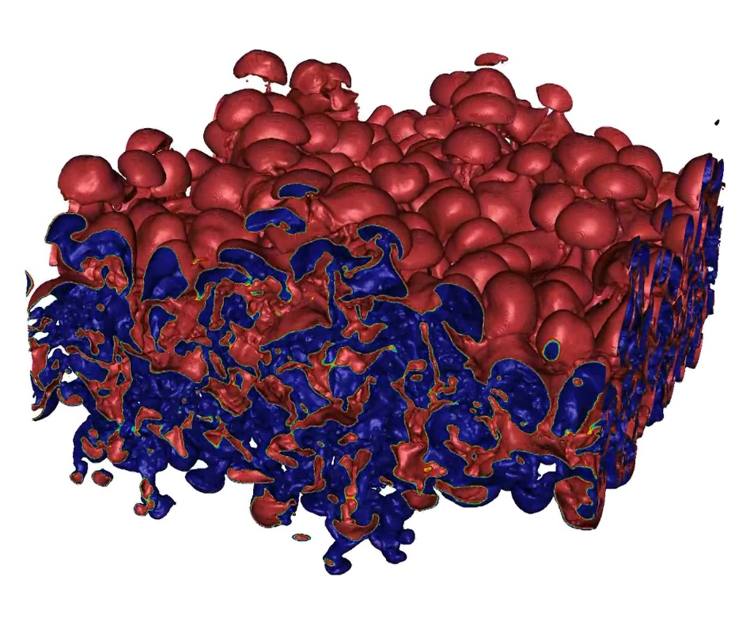

Statement of Significance (separate file, 50–100 words)
Two immiscible fluids mixed by the Rayleigh–Taylor instability form a turbulent layer that grows faster than one of miscible fluids, and recent simulations show that it grows faster still as surface tension increases, although surface tension slows the instability in linear theory. We show from the self-similar moment equations that surface tension can change the growth only through a correction that fades as the layer widens, that its direct force slows the growth, and that the acceleration comes from its effect on the flow structure. Simulations compared at equal layer width follow the predicted form.

Cover letter (maximum 32768 characters)
Associate Editor selection: Professor D. Lohse, University of Twente (https://www.cambridge.org/core/journals/journal-of-fluid-mechanics/information/about-this-journal/editorial-board#rapids)

Dear Professor Lohse and other Editors,

Please find enclosed our manuscript, ‘Capillary effects on the self-similar growth of immiscible Rayleigh–Taylor mixing’, which we submit for consideration as a JFM Rapids article.

In Rayleigh–Taylor mixing of immiscible fluids, experiments find a late-time growth parameter α larger than for miscible fluids (Roberts & Jacobs, J. Fluid Mech. 787, 2016), and recent simulations, including our own and those of Zhao, Huang & Li (J. Fluid Mech. 1040, A56, 2026), find that it increases further as the surface tension increases. Our simulations show an approximately We₀^{−1/2} dependence on the initial Weber number. Linear theory predicts the opposite tendency, because surface tension stabilises short wavelengths, and no theory has explained the observed increase.

This paper explains the form of this dependence by extending the self-similar moment analysis of Ristorcelli & Clark (J. Fluid Mech. 507, 2004) to immiscible fluids with surface tension. We show that complete self-similarity leaves no dimensionless group containing the surface tension, so We₀ can enter only through corrections in the ratio of the capillary length ℓ_{σ} to the layer width h. The direct capillary term in the mid-plane scalar-flux budget is the inverse instantaneous Weber number; it reduces α in proportion to We₀⁻¹. Because, with fixed profile constants, the moment balance relaxes from any departure approximately as h⁻⁴⁰, the observed increase must come from an indirect effect of surface tension on the flow structure, and a correction linear in ℓ_{σ}/h is the form that gives the We₀^{−1/2} dependence. Our simulations follow this form when compared at equal mixing width, α − α_{We₀=∞} ≈ 8.9 ℓ_{σ}/h, whereas exponents extracted at fixed time drift with the time of comparison. A decomposition of the mid-plane mass flux and the measured Hinze scale, given in full in the supplementary material, are consistent with this dependence.

The work builds directly on analyses published in this journal, the self-similar moment analysis of Ristorcelli & Clark (2004) and the mid-plane mass-flux analysis of Cook, Cabot & Miller (J. Fluid Mech. 511, 2004), and it addresses the trends reported here by Roberts & Jacobs (2016) and Zhao et al. (2026). We believe it suits the Rapids format: it is a single, self-contained theoretical argument with a direct comparison to simulations, it explains the form of the surface-tension dependence of the growth parameter now being reported in simulations of immiscible Rayleigh–Taylor turbulence, and it shows how such dependences should be compared, at equal mixing width rather than at fixed time.

Given your expertise in multiphase and buoyancy-driven turbulence, including the role of surface tension in bubbly and droplet-laden flows, we believe you would be well suited to evaluate this work.

This research builds on work presented at the 2025 and 2026 APS Division of Fluid Dynamics annual meetings, ‘Effects of Surface Tension and Viscosity on Immiscible Rayleigh–Taylor Mixing’ (2025, Session U30) and ‘Quantifying Mixing and Turbulent Transition in Immiscible Rayleigh–Taylor Instability’ (2026, Session M40), and on two companion articles submitted to Physical Review Fluids, ‘Immiscible Rayleigh–Taylor turbulence I: Macroscopic behavior and growth dynamics’ and ‘Immiscible Rayleigh–Taylor turbulence II: Mesoscale mixing and spectral characteristics’. Those articles present the simulation database and report the We₀^{−1/2} trend as an observation, with a short interpretation based on dimensional analysis. The theoretical analysis in this paper does not appear in them; the paper uses the simulations only for comparison.

The work has not been published and is not under consideration elsewhere. All authors have contributed significantly to the work and approve of its submission to the Journal of Fluid Mechanics.

Thank you for your time and consideration.

Very Respectfully,
Michael D. Walker, on behalf of all authors
P.E., PhD Candidate, Mechanical and Aerospace Engineering, Computational Turbulent Reacting Flow Laboratory (CTRFL), Princeton University

Abstract (250 words, in unicode)
In immiscible Rayleigh–Taylor turbulence, the growth parameter α increases as the initial Weber number We₀ decreases, approximately as We₀^{−1/2} in recent simulations. This paper derives the form that such a dependence can take in a self-similar mixing layer. Complete self-similarity leaves no dimensionless group containing the surface tension, so We₀ can enter only through corrections in the ratio of the capillary length ℓ_{σ} to the layer width h. When the self-similar moment analysis of Ristorcelli & Clark (J. Fluid Mech., vol. 507, 2004, p. 213) is extended to immiscible fluids, the direct capillary term in the mid-plane scalar-flux budget is the inverse instantaneous Weber number, (ℓ_{σ}/h)²/2α; it reduces α in proportion to We₀⁻¹. With fixed profile constants, the same budget relaxes from any departure approximately as h⁻⁴⁰, so an increase that decays slowly with h requires an indirect effect of surface tension on the flow structure. A correction linear in ℓ_{σ}/h gives α − α∞ ∝ We₀^{−1/2} at fixed h/λ₀, and a spectral closure in which surface tension sets the inner cut-off of a smooth interface produces this form. High-resolution simulations compared at equal mixing width support the form α − α_{We₀=∞} ≈ 8.9 ℓ_{σ}/h, whereas exponents extracted at fixed time drift with the time of comparison.

