JFM Rapids Justification (one or two sentences)
A single spectral sum over all scales of turbulence gives the turbulent burning velocity in closed form, as a function of u′/sL and the Reynolds number alone, and the result has the same form as the power-law flame-wrinkling factor of Charlette et al. (2002) with exponent 1/2, so that Damköhler’s area and diffusivity mechanisms need not be treated separately. With spectral constants from non-reacting turbulence, it follows measurements across four decades of scale separation, accounts for the excess of burning velocity over flame-surface area in recent experiments in intense turbulence, and gives large-eddy simulation a sub-filter wrinkling factor derived from the spectrum rather than fitted to combustion data.

Graphical abstract: contour plot?
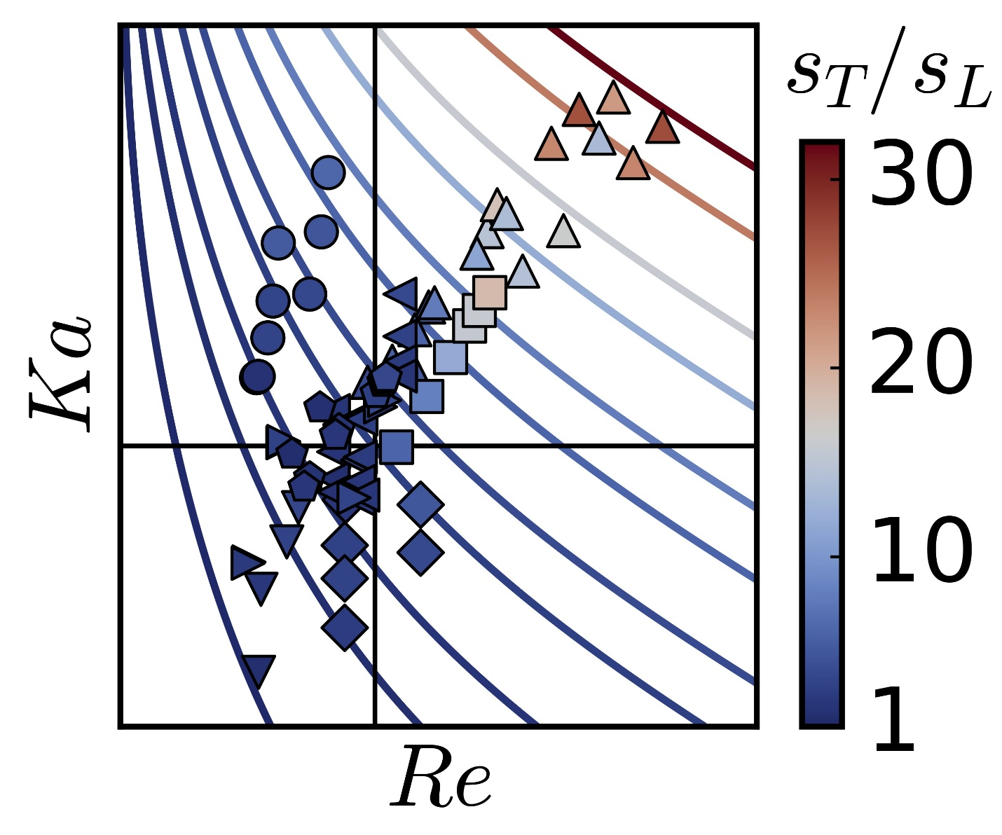

Statement of Significance (separate file, 50–100 words)
Turbulent premixed flames burn faster than laminar ones through two mechanisms identified by Damköhler: wrinkling by large eddies and enhanced transport by smaller ones. These are typically modelled separately. We show that integrating a spectral eddy diffusivity across the turbulence spectrum yields a closed-form solution for burning velocity, providing deep insight into multiscale turbulence-flame interactions. Our continuous spectral framework shares its form with an established power-law wrinkling model and agrees with measurements across four decades of scale separation. Furthermore, it resolves the consumption speed and flame surface area discrepancy in recent intense turbulence experiments, delivering a parameterisation directly testable against simulations and experiments.

Cover letter (maximum 32768 characters)
Associate Editor selection: Zaki
https://www.cambridge.org/core/journals/journal-of-fluid-mechanics/information/about-this-journal/editorial-board#rapids

Dear Professor Zaki and other Editors,

Please find enclosed our manuscript, ‘A spectral theory for turbulent burning velocity across scales,’ which we submit for consideration as a JFM Rapids article.

The manuscript shows that the turbulent burning velocity of a premixed flame follows from a single spectral sum over all scales of turbulence. Taking the diffusivity at each wavenumber from the spectral eddy diffusivity of two-point closures, the sum reduces to a closed-form relation in which the burning velocity depends only on u′/sL and the turbulent Reynolds number. This relation has the same form as the power-law flame-wrinkling factor of Charlette et al. (2002) with exponent 1/2. Area enhancement by large eddies and diffusive enhancement by small eddies, the two mechanisms proposed by Damköhler, therefore need not be treated separately when predicting the burning velocity.

The relation recovers Damköhler’s linear scaling in weak turbulence and the bending of the burning velocity in strong turbulence without a quenching model. With spectral constants taken from non-reacting turbulence, the prediction agrees within a factor of 1.5 with most of 80 measurements from eight datasets spanning four decades of Karlovitz and Reynolds numbers. It further resolves the discrepancy between consumption speed and flame surface area in recent experiments on intensely turbulent premixed jet flames. Such a unification across scales is unmatched in the literature.

The starting point is an estimate by three of us (‘Reconciling turbulent burning velocity with flame surface area in small-scale turbulence,’ Nivarti, Cant & Hochgreb, J. Fluid Mech. 858, R1, 2019), which attributed that discrepancy to an enhanced diffusivity due to eddies smaller than the flame. That estimate used a dimensionally inconsistent integrand and covered only sub-flame scales. The present formulation replaces the integrand with the closure’s eddy diffusivity, carries the sum over the whole spectrum and recovers the earlier Ka^(1/3) scaling as its small-scale limit. The closed-form result, its equivalence with power-law flame wrinkling and the comparison with experiments are new.

Given your expertise in high-fidelity computational fluid dynamics and scale interactions in turbulent flows, we believe you would be well suited to evaluate this work. This result suits the Rapids format: it is short, closed-form and directly testable, and it impacts how sub-filter flame wrinkling is modelled in large-eddy simulation. We believe the immediate utility of this model for the computational combustion community justifies the rapid dissemination provided by the Rapids format.

Parts of this analysis were first developed in the first author’s MPhil thesis (University of Cambridge, 2019), which is cited in the manuscript. The work has not otherwise been published and is not under consideration elsewhere. All authors have contributed significantly to the work and approve of its submission to the Journal of Fluid Mechanics.

Thank you for your time and consideration.

Very Respectfully,
Michael D. Walker, on behalf of all authors
P.E., PhD Candidate, Mechanical and Aerospace Engineering, Computational Turbulent Reacting Flow Laboratory (CTRFL), Princeton University
Abstract (250 words)

Damköhler's two hypotheses attribute the enhancement of the turbulent burning velocity sT over the laminar value sL to an increase in flame-surface area by eddies larger than the flame thickness δL, and to an increase in effective diffusivity by smaller eddies. In intense turbulence, the measured sT/sL exceeds the measured area ratio several-fold, an excess that Nivarti et al. (J. Fluid Mech., vol.858, 2019, R1) attributed to a sub-δL diffusivity integrated over a model energy spectrum. Here that integral is extended to the whole spectrum and made dimensionally consistent by taking the diffusivity at each wavenumber from the spectral eddy diffusivity of two-point closures. For a model spectrum, the total enhancement reduces to Cℱ(Re)u'/sL, where u' is the turbulence intensity, C is a constant and ℱ is a weak, saturating function of the turbulence Reynolds number Re. The resulting relation sT/sL = [1+Cℱ(Re)u'/sL]¹/² recovers Damköhler's linear growth of sT with u' in weak turbulence and the sublinear 'bending' in strong turbulence, and its sub-δL part recovers the Ka¹/³ scaling of Nivarti et al., where Ka is the Karlovitz number. The relation has the same form as the power-law flame-wrinkling factor of Charlette et al. (Combust. Flame, vol.131, 2002, p.159) with exponent 1/2, which supports the square-root dependence at large scales. With spectral constants from non-reacting turbulence, the prediction follows 80 measurements from eight datasets spanning four decades of Ka and Re, 71% of them within a factor of 1.5.

