

**TIMETABLE SCHEDULER**

**PERSONAL DETAILS**

**NAME: FRANCIS MWANGI MURAYA**

**ADM.NO: KUC/COM/249/12**

**SCHOOL: PURE AND APPLIED SCIENCE**

**DEPARTMENT: COMPUTER SCIENCE**

Table of Contents

**Chapter one3**

1.1 INTRODUCTION 3

1.2 PROBLEM STATEMENT 3

1.3 LITERATURE REVIEW 3

1.4 OLD SYSTEM PROCEDURE4

1.5 FAILURE OF THE SYSTEM 4

1.6 OBJECTIVES OF THE AUTOMATED SYSTEM4

1.7 LIMITATION OF THE AUTOMATED 4

1.8 THE PROBLEM STATEMENT SCOPE4

**Chapter two**5

2.1 TABLE DESIGN AND THEIR RELATIONS 5

2.2 SYSTEM CODE 6

**Chapter three** 6

3.0 User manual 7

**Acknowledgment**

Thanks to the founders of all staff involved in offering courses at edx

* 1. **INTRODUCTION**

Time table scheduler software takes groups the unit their take, the lecturer teaching those units and the lecture halls as inputs and gives the time table as the schedule

Karatina University is a growing university with about 30 courses, 25 lecture rooms and about 20 lectures as the numbers stands and as the university grows it becomes hard to schedule for classes

Increased computation power that has led to advancement of artificial intelligence which had diminished in late 90’s. Algorithms in artificial intelligence do tasks that require human intelligence such as scheduling timetable

Time is of essence in any university institution, each semester has four months wasting time in making the timetable and correcting the errors causes delays to commencing of lectures

* 1. **PROBLEM STATEMENT**

The manual timetable scheduling is tedious and often result too many errors which often take time to correct

Manual timetable is time consuming taking up to one month of preparation in large institutions

Expensive to schedule timetable since it requires a group of people and most universities tend to outsource the task

* 1. **LITERATURE REVIEW**

Most timetable uses AI concepts specifically the constrain satisfaction problem concept

The algorithm was introduced in the late 18’s due to low computation power it didn’t become famous and its use was minimal

Since 2003 the computation power increased which led to the emergence of constrain satisfaction problem.

The first scheduling software was scheduling software at IBM. It required large computer with a lot of power.

The algorithm has been advanced since then to schedule much faster such that a pc can schedule a timetable

**1.4 OLD SYSTEM PROCEDURE**

Timetable was scheduled manually by a group of staff.

1.5 **FAILURE OF THE SYSTEM**

The system was taking a lot of time to construct and often results to errors this led to delay in commencing of classes

It was also expensive since it requires a group of staff members

1.6 **THE NEED OF COMPUTEREISED SYSTEM**

Time is of much essence in any academic institution and delays to starting of lectures to delays in making of timetable and errors resulting to the timetable and yet is quite expensive suggest and automated system is required

1.7 **OBJECTIVES OF THE AUTOMATED SYSTEM**

To produce an accurate timetable

To take at most 30 minutest of schedule

To be easy to use such that one staff literate to computer can schedule the timetable

1.8 **LIMITATIONS OF THE AUTOMATED**

Assumes that each group and attends its class alone without being combined with other groups. This hiders those courses that are common not to be combined to one class

1.9 **THE PROBLEM STATEMENT SCOPE**

This is a timetable scheduler used for academic institutions

**CHAPERT TWO**

**2. SOFTWARE DESIGN DOCUMENT**

2.1 **Table Design and their relations**

There are five tables:

1. Group -> contains information of all groups

b. GroupUnit -> contains groups and the units they take

To be scheduled

Id

lectureId

lectureName

Group

Unit

Lecturer

Id

groupId

groupCapacity

groupName

Id

Group

Unit

lectureRoom

Time

c. Lecturer -> contains lectures information

d. TimeTable -> contains the timetable that has been made

Unit -> contains all information about the unit taught

LectureRoom -> contains all information about the lecture rooms

Id

Unitcode

unitName

Id

lectureRoom

lectureCapacity

2.2 **SYSTEM CODE**

Cod can be found on http://www.github/timetable

**CHAPTER THREE**

3. **SYSTEM USER MANUAL**

3.1 Entering Unit information

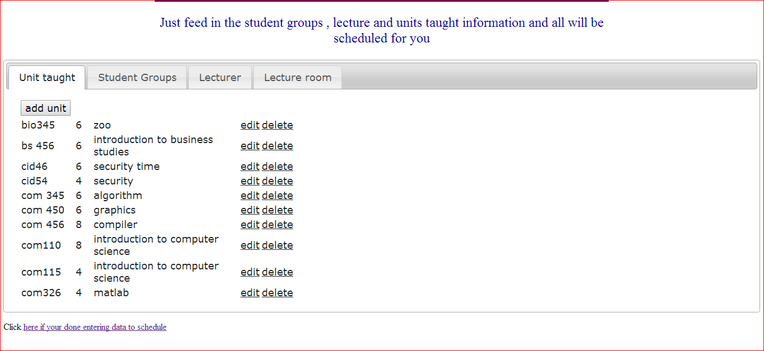

To enter unit you click the add unit button and the form below will be displayed enter the data and then click . unitcode and unitHours are required.

The form that is going to be displayed

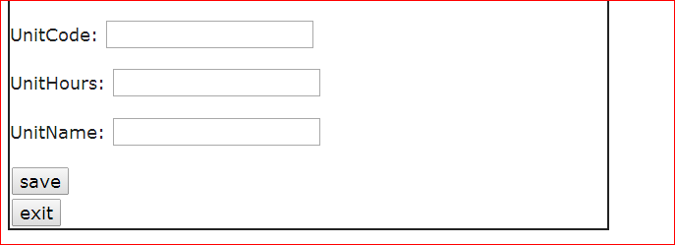

**3.2 Adding Student groups**

To add student groups first click the student tab

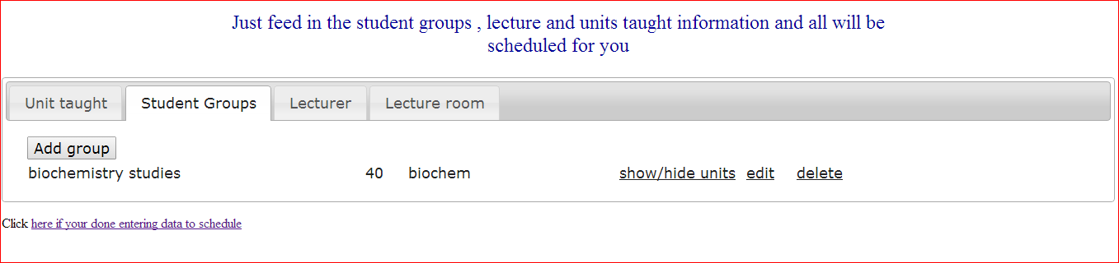

Then click the button group which displays the following form to fill

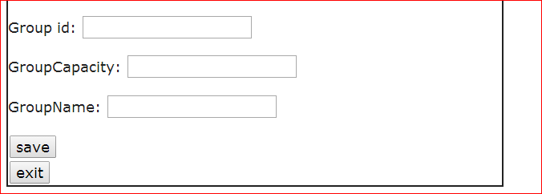

In the form fill in the student group id group capacity and groupName. Group id and GroupCapacity are required . Group capacity must be numbers

Click save when you’re done

**3.3 Adding units taken by a specific group**

Click on tab student tab. Once you have clicked click show/hide units on one of the group you are interested with

Click the button add unit shown below

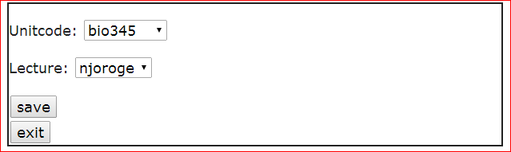

The unit to be added should already be added at the unit tab and the lecture to be added should be already added to lecture tab .when you are done click save

**3.4 Add lecture**

Click lecture tab and then click on the button add lecture the following form appears

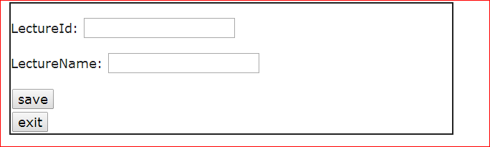

Lecture id must be filled in

After finishing click save

**3.4 Add lecture room**

Click on tab lecture room

Then click on the button lecture room

This form will display

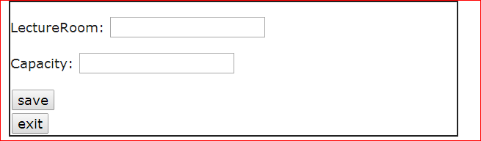

Lecture Room and capacity must be filled in.

After you are done click save

When you are done entering all the information click on the link below to schedule the timetable