Practical ASIC Development Course

UART Register file HDD

Name: Mohammad Wael Monir

- Block Description
The aim of the UART register file is to provide interface between Host (ex. CPU) and the UART system in order for the Host to configure some UART parameters such Enable, Baud Rate, Mode and observe UART errors such as parity.
- Block Diagrams
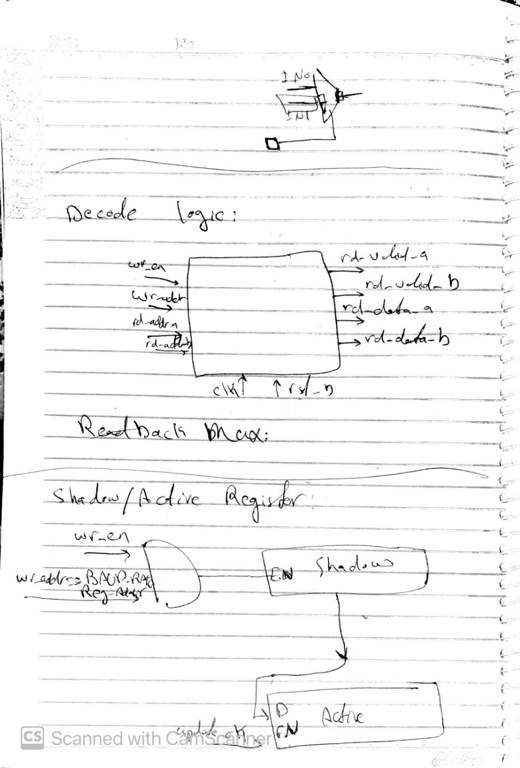
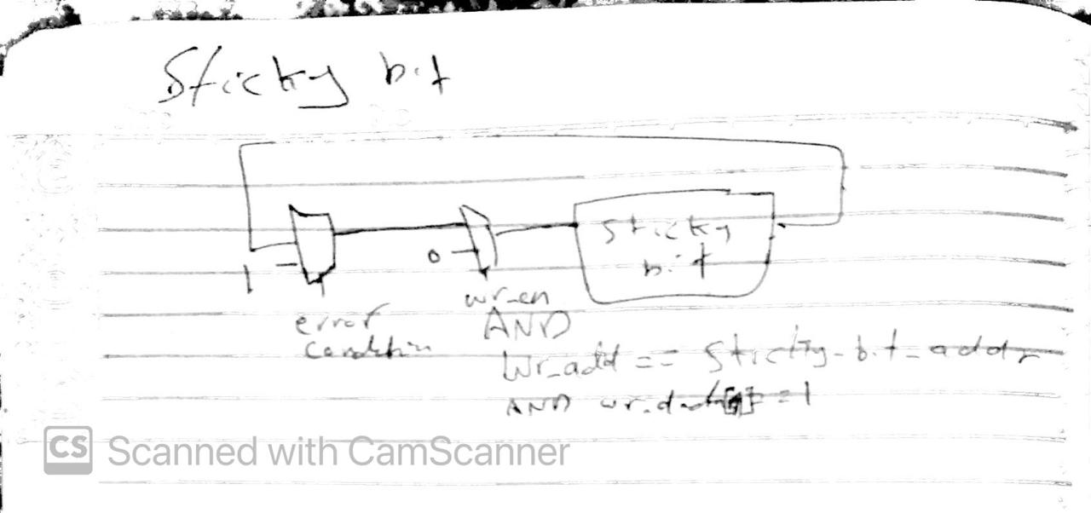
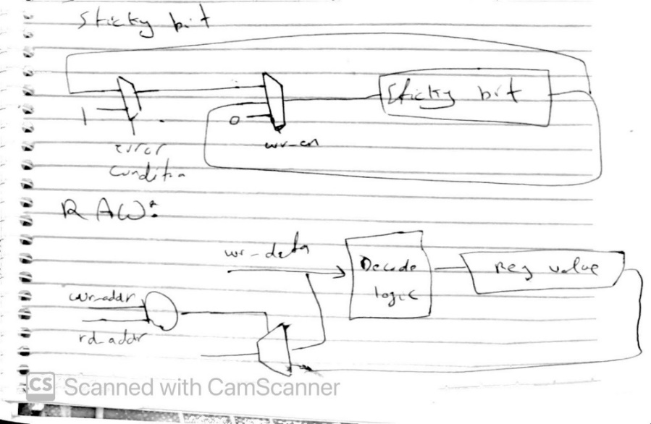
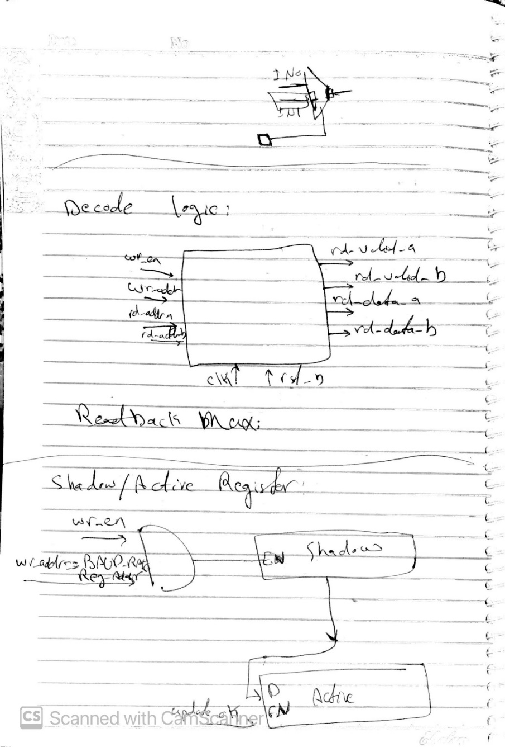
- Inputs/Outputs and parameter description
- Inputs/Outputs
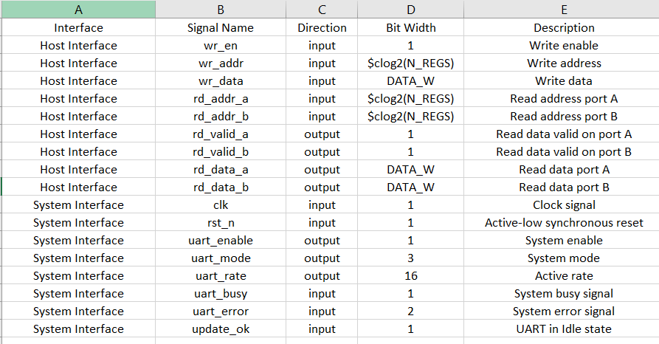
- Parameter Description
DATA_W: Data width of Words in register file.
N_REGS: Number of registers I the register file.
READ_LATENCY: Specifies if read_data_* and read_valid_* are registered or not.
- Register file description
Note: All Reserved bits are RO
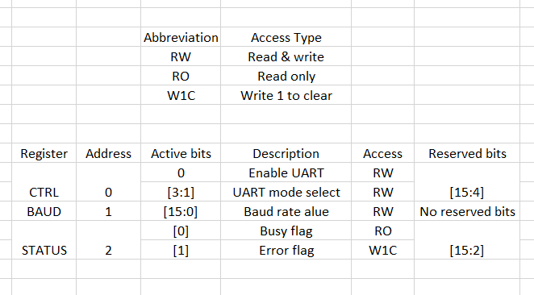
- Behavioural polices
OOB (Out of bounds) read/write: This ensures that during read if the read/write address is decoded to register doesn’t exist (has address greater than last register), in case of write nothing will happen and in case of read read_valid_* is asserted to 0.
RAW policy (write-first): This ensures that when the Host eants to write and read at the same cycle, the new written data is asserted on the read port.
Sticky ERROR W1C semantics: When UART sends error to register file, the error is written in the register and becomes sticky until the Host writes one, then it’s cleared.
Shadow/commit policy using update_ok: If the Host wants to change the baud rate, then the new value will be written in register called shadow register and will not be changed until update_ok is high, which indicated that UART is in IDLE state.
Read latency behaviour (0 vs 1): If the parameter is 0, If the Host asserted rd_add_* then it must read rd_valid_* and rd_data_* the next clock cycle, while if it’s 1 then it must read them after 2 cycles.
- Timing Behaviour
- READ_LATENCY = 0
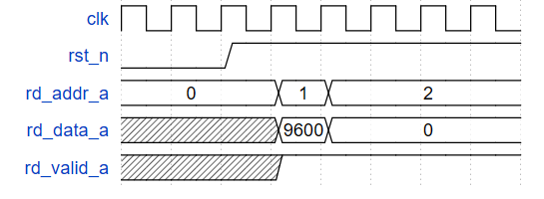
- READ_LATENCY = 1
