**SUPPLEMENTARY DATA**

**Title:** Variation of tolerance to isothiazolinones among Daphnia pulex clones

*Study clones: populations of origin*

**Table S1.** Locations of the D. pulex study populations of origin of the study’s clonal lineages

|  |  |  |  |  |  |
| --- | --- | --- | --- | --- | --- |
| Clonal line | | Population origin | | | Isolation date |
| Name | Code | Type | Location | |
| Séné 2 | SE2 | Natural population | Séné | 47.616636, -2.713638 | 10/2019 |
| Séné 5 | SE5 | Natural population | Séné | 47.616636, -2.713638 | 10/2019 |
| Pearl 7 | PE7 | Aquaculture tanks | Rennes | 48.112800, -1.709124 | 10/2019 |
| Pearl 16 | P16 | Aquaculture tanks | Rennes | 48.112800, -1.709124 | 10/2019 |
| Rennes | RE0 | Aquaculture tanks | Rennes | 48.112800, -1.709124 | 12/2016 |
| Goven 6 | GO6 | Natural population | Goven | 47.994867, -1.859119 | 10/2019 |
| Lassalle | LA0 | Natural population | Saint-Judoce | 48.359723, -1.951767 | 11/2019 |
| Alsace | AL0 | Commercial strain (Aqualiment©) | - | - | bought in 2016 |

*Quantification by UPLC-MS/MS*

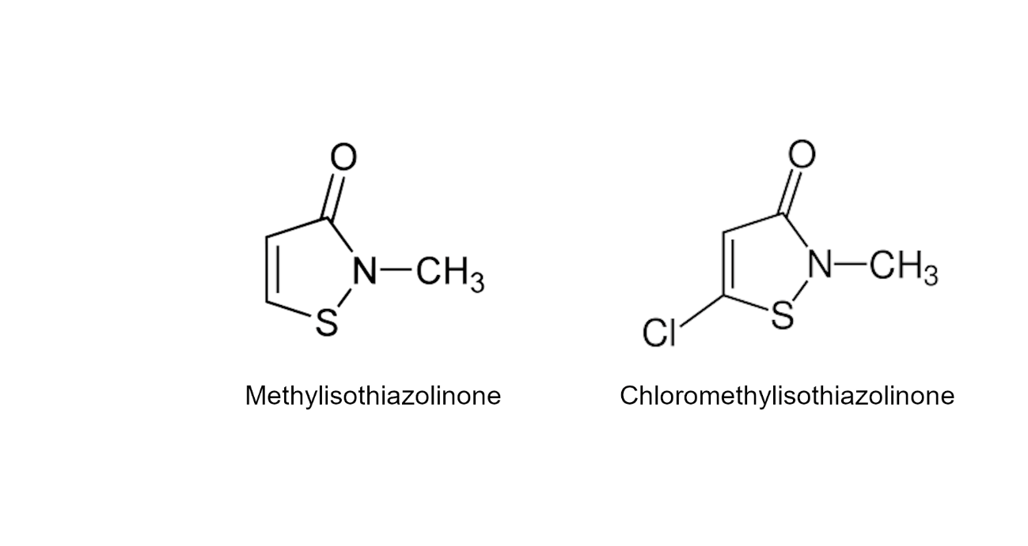

**Figure S1.** Formulas of 2-méthylisothiazol-3(2H)-one (CAS n°2682-20-4) and 5-Chloro-2-methyl-1,2-thiazol-3(2H)-one (CAS n°26172-55-4)

Calibration curves were obtained from standards at the following concentrations: (1) 0.02, 0.04, 0.2, 0.6 and 0.8 mg/L and 0.2 mg/L of the internal standard solution for the mixture of CMIT and MIT and at (2) 0.1, 0.2, 1.5, 5.5 and 6.5 mg/L and 1.5 mg/L of the internal standard solution for the MIT alone. The concentrations reported for the mixture are the cumulated concentrations of both CMIT and MIT (3:1 ratio). Each solution and blanks were injected ten times.

Using quantification transitions, CMIT and MIT areas were normalized by the I.S. area for each injection (calibration and bioassay samples). Calibration curves (Figure 1) were generated with R (version 4.0.0) as linear regression with generalized least squares to correct for heteroscedasticity of residuals.

**Table S2.** Mass transitions and retention times for the target compounds in UPLC-MS/MS. I.S., internal standard.

|  |  |  |  |  |
| --- | --- | --- | --- | --- |
| Compound | Precursor ion (*m/z*) | Product ion (*m/z*) | Collision energy (eV) | Retention time (min) |
| MIT | 116.0170 | 100.9935 | 28 | 0.3 – 0.4 |
| CMIT | 149.9790 | 134.9546 | 28 | 1.1 – 1.2 |
| MIT-D3 (I.S.) | 119.0360 | 100.9935 | 28 | 0.3 – 0.4 |

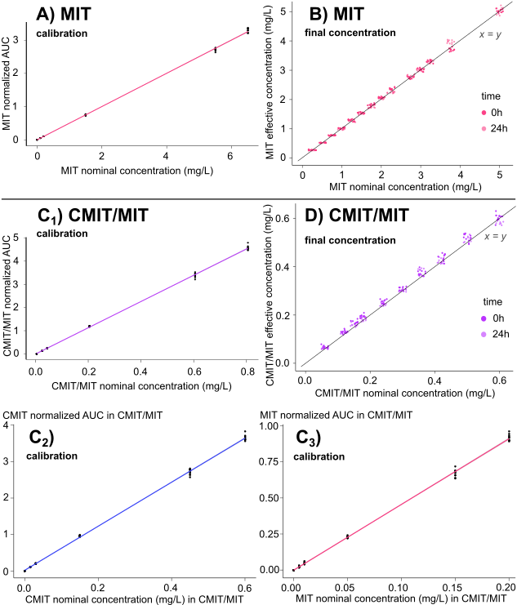

**Figure S2.** Measures of isothiazolinones concentration in water contaminated with MIT (A and B) or CMIT/MIT (C1-2-3 and D), with 10 technical replicates. In calibration curves (A and C), the areas under the curve (AUC) are normalized by the internal standard area. For CMIT/MIT samples, calibration curves show CMIT (C2, adjusted R² = 0.999, p-value < 0.001) and MIT (C3, adjusted R² = 0.998, p-value < 0.001) AUC separately, and the mixture CMIT/MIT (C1, adjusted R² = 0.999, p-value < 0.001) as derived from the single molecules’ AUC. Based on calibration curves, the bioassay samples’ effective concentrations are plotted against nominal concentrations for MIT samples (B) and CMIT/MIT samples (D), showing strong linear relationship in both cases (MIT: R² = 0.998, p-value < 0.001; CMIT/MIT: R² = 0.995, p-value < 0.001). Effective concentrations in samples are displayed at 0 and 24h after contamination and are reported in supplemental material (table S3).

**Table S3.** CMIT and MIT concentrations measured with analysis by UPLC-MS/MS (mg/L) and degradation over 24h. CMIT+MIT concentration was computed by adding CMIT and MIT measures in mixture.

|  |  |  |  |  |  |
| --- | --- | --- | --- | --- | --- |
|  | Nominal concentration (mg/L) | Effective median concentration in mg/L (SD) | Effective median concentration in mg/L (SD)  at 0h | Effective median concentration in mg/L (SD)  at 24h | Percentage decrease in concentration over 24h |
| CMIT+MIT in mixture | 0.06 | 0.064 (0.005) | 0.067 (0.005) | 0.062 (0.002) | 7.5 % |
| 0.12 | 0.129 (0.006) | 0.131 (0.006) | 0.126 (0.004) | 3.8 % |
| 0.15 | 0.166 (0.009) | 0.170 (0.006) | 0.158 (0.006) | 7.1 % |
| 0.18 | 0.191 (0.009) | 0.195 (0.006) | 0.182 (0.007) | 6.7 % |
| 0.24 | 0.248 (0.009) | 0.253 (0.008) | 0.244 (0.007) | 3.6 % |
| 0.30 | 0.305 (0.007) | 0.311 (0.007) | 0.303 (0.007) | 2.6 % |
| 0.36 | 0.370 (0.012) | 0.376 (0.011) | 0.366 (0.014) | 2.7 % |
| 0.42 | 0.431 (0.015) | 0.437 (0.016) | 0.423 (0.014) | 3.2 % |
| 0.50 | 0.519 (0.014) | 0.52 (0.016) | 0.519 (0.012) | 0.2 % |
| 0.60 | 0.595 (0.016) | 0.608 (0.015) | 0.585 (0.012) | 3.8 % |
| CMIT in mixture | 0.045 | 0.047 (0.004) | 0.049 (0.005) | 0.045 (0.002) | 8.2 % |
| 0.090 | 0.093 (0.004) | 0.094 (0.005) | 0.091 (0.004) | 3.2 % |
| 0.112 | 0.118 (0.006) | 0.122 (0.005) | 0.114 (0.005) | 6.6 % |
| 0.135 | 0.137 (0.007) | 0.139 (0.005) | 0.130 (0.005) | 6.5 % |
| 0.180 | 0.177 (0.007) | 0.180 (0.007) | 0.175 (0.006) | 2.8 % |
| 0.225 | 0.219 (0.007) | 0.222 (0.006) | 0.217 (0.007) | 2.3 % |
| 0.270 | 0.265 (0.007) | 0.269 (0.01) | 0.261 (0.012) | 3.0 % |
| 0.315 | 0.305 (0.012) | 0.308 (0.012) | 0.302 (0.012) | 1.9 % |
| 0.375 | 0.370 (0.011) | 0.369 (0.012) | 0.371 (0.009) | -0.5 % |
| 0.450 | 0.424 (0.013) | 0.430 (0.013) | 0.416 (0.009) | 3.3 % |
| MIT in mixture | 0.015 | 0.019 (0.001) | 0.019 (0.001) | 0.018 (0.001) | 5.3 % |
| 0.030 | 0.037 (0.002) | 0.039 (0.002) | 0.036 (0.001) | 7.7 % |
| 0.038 | 0.048 (0.003) | 0.051 (0.002) | 0.047 (0.002) | 7.8 % |
| 0.045 | 0.055 (0.003) | 0.058 (0.002) | 0.054 (0.003) | 6.9 % |
| 0.060 | 0.075 (0.003) | 0.076 (0.002) | 0.072 (0.002) | 5.3 % |
| 0.075 | 0.092 (0.002) | 0.092 (0.002) | 0.090 (0.002) | 2.2 % |
| 0.090 | 0.112 (0.003) | 0.112 (0.003) | 0.112 (0.003) | 0.0 % |
| 0.105 | 0.129 (0.004) | 0.132 (0.004) | 0.127 (0.002) | 3.8 % |
| 0.125 | 0.155 (0.004) | 0.156 (0.004) | 0.154 (0.004) | 1.3 % |
| 0.150 | 0.179 (0.006) | 0.181 (0.006) | 0.176 (0.004) | 2.8 % |
| MIT | 0.25 | 0.258 (0.110) | 0.260 (0.011) | 0.255 (0.011) | 1.9 % |
| 0.5 | 0.507 (0.009) | 0.505 (0.009) | 0.511 (0.007) | -1.2 % |
| 0.75 | 0.764 (0.100) | 0.767 (0.011) | 0.759 (0.009) | 1.0 % |
| 1.0 | 0.993 (0.027) | 1.012 (0.012) | 0.969 (0.015) | 4.2 % |
| 1.25 | 1.255 (0.034) | 1.291 (0.018) | 1.233 (0.012) | 4.5 % |
| 1.5 | 1.520 (0.026) | 1.531 (0.016) | 1.495 (0.025) | 2.4 % |
| 1.75 | 1.762 (0.055) | 1.801 (0.026) | 1.707 (0.021) | 5.2 % |
| 2.0 | 2.038 (0.026) | 2.054 (0.022) | 2.030 (0.024) | 1.2 % |
| 2.25 | 2.305 (0.069) | 2.341 (0.030) | 2.226 (0.031) | 4.9 % |
| 2.75 | 2.759 (0.048) | 2.715 (0.034) | 2.780 (0.044) | -2.4 % |
| 3.0 | 3.016 (0.041) | 2.996 (0.048) | 3.021 (0.033) | -0.8 % |
| 3.25 | 3.283 (0.040) | 3.296 (0.048) | 3.278 (0.033) | 0.5 % |
| 3.75 | 3.827 (0.146) | 3.685 (0.050) | 3.955 (0.051) | -7.3 % |
| 5.0 | 4.996 (0.085) | 4.996 (0.049) | 4.996 (0.113) | 0 % |

*Survival data*

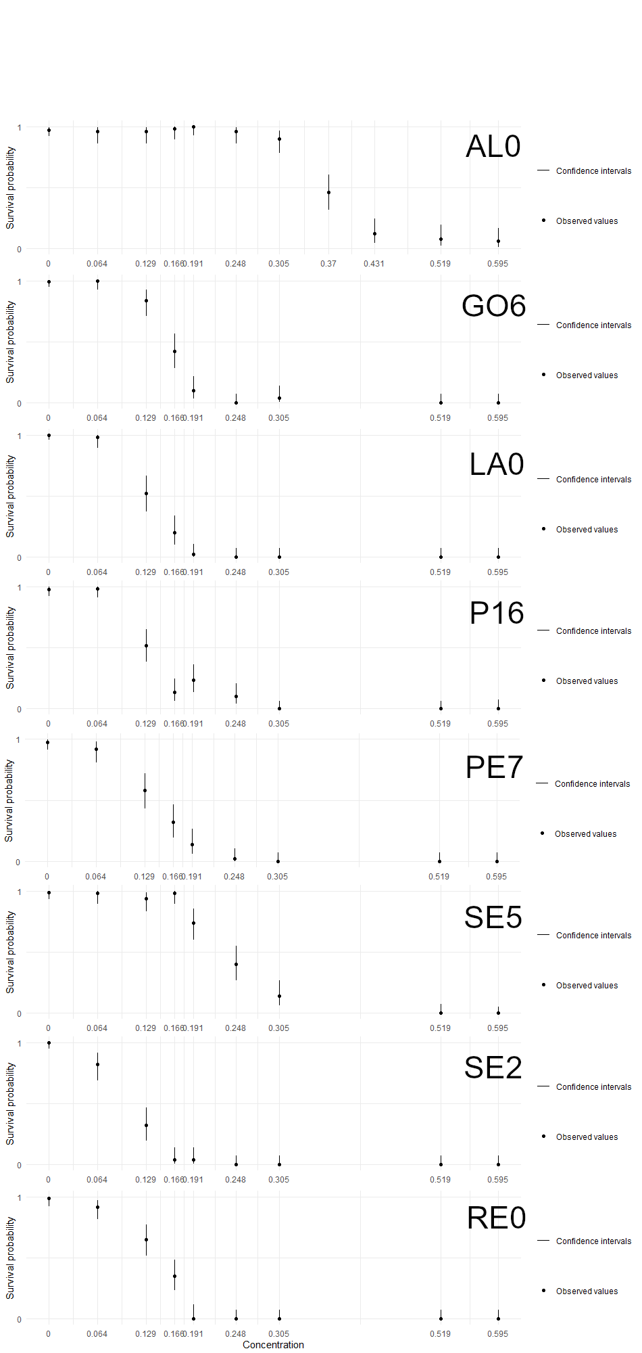

**Figure S3.** Survival rate of each clonal line for the CMIT/MIT assay at 48h as a function of concentration, with binomial confidence intervals around the data (n=50).

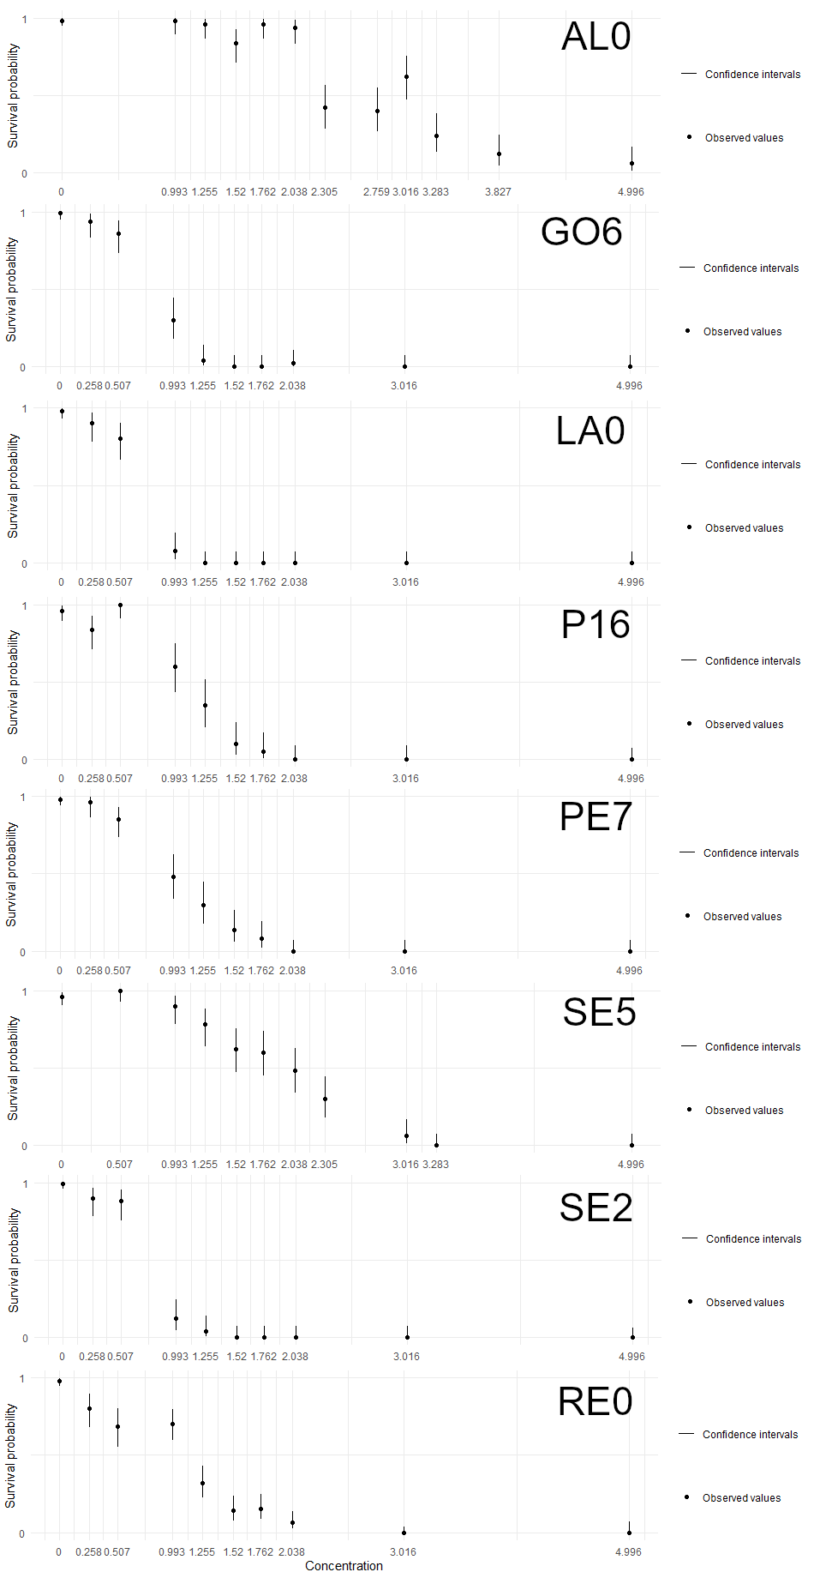

**Figure S4.** Survival rate of each clonal line for the MIT assay at 48h as a function of concentration, with binomial confidence intervals around the data (n=50).

*Modeling*

**Table S4.** GUTS models parameters estimates for the 8 clonal lineages, median and 95% credible interval. With general GUTS parameters: hb as the background mortality, and kD as the dominant rate constant, that is to the slowest compensating process dominating the overall dynamics of toxicity. Parameters specific of IT models are related to the individual threshold concentration which is described as a log-logistic probability distribution with mw the median and β the shape of the distribution

|  |  |  |  |  |  |  |  |  |
| --- | --- | --- | --- | --- | --- | --- | --- | --- |
| Clone | CMIT + MIT | | | | MIT | | | |
| kD | hb (e-02) | mw | β | kD | hb (e-02) | mw | β |
| Alsace | 1.25  [1.01-1.51] | 1.09  [0.49-2.06] | 0.34  [0.31-0.37] | 6.62  [5.52-7.85] | 0.98  [0.72-1.25] | 0.81  [0.23-1.92] | 2.44  [2.10-2.71] | 3.32  [2.77-3.92] |
| Goven6 | 0.93  [0.68-1.18] | 0.37  [0.05-1.29] | 0.13  [0.11-0.15] | 5.82  [4.85-6.95] | 1.53  [1.12-2.02] | 1.22  [0.28-2.97] | 0.74  [0.63-0.86] | 5.38  [4.24-7.07] |
| Lassalle | 1.31  [0.98-1.67] | 0.25  [0.02-1.31] | 0.12  [0.10-0.13] | 5.17  [4.18-6.36] | 0.75  [0.46-1.10] | 2.64  [1.00-5.03] | 0.52  [0.37-0.66] | 5.62  [4.39-7.13] |
| Rennes | 1.82  [1.41-2.28] | 1.32  [0.19-3.74] | 0.14  [0.12-0.15] | 4.89  [3.82-6.33] | 0.94  [0.60-1.29] | 2.52  [0.81-5.24] | 0.81  [0.58-1.02] | 2.58  [2.03-3.47] |
| Sene2 | 1.23  [0.87-1.63] | 0.35  [0.02-2.17] | 0.09  [0.07-0.10] | 4.22  [3.46-5.19] | 0.97  [0.65-1.36] | 1.70  [0.67-3.36] | 0.63  [0.49-0.76] | 6.66  [5.32-8.46] |
| Sene5 | 1.69  [1.35-2.07] | 0.74  [0.15-2.04] | 0.23  [0.21-0.25] | 5.71  [4.69-6.92] | 1.51  [1.22-1.82] | 1.62  [0.60-3.38] | 1.75  [1.60-1.89] | 4.66  [3.92-5.54] |
| Pearl16 | 1.28  [0.97-1.62] | 0.76  [0.17-2.21] | 0.12  [0.10-0.13] | 3.64  [3.05-4.31] | 0.66  [0.39-0.94] | 3.35  [1.72-5.71] | 0.79  [0.54-0.98] | 4.86  [3.90-6.00] |
| Pearl7 | 1.46  [1.08-1.85] | 1.31  [0.28-3.46] | 0.13  [0.11-0.14] | 4.27  [3.43-5.36] | 0.62  [0.36-0.91] | 1.15  [0.35-2.64] | 0.66  [0.44-0.84] | 3.59  [3.01-4.31] |

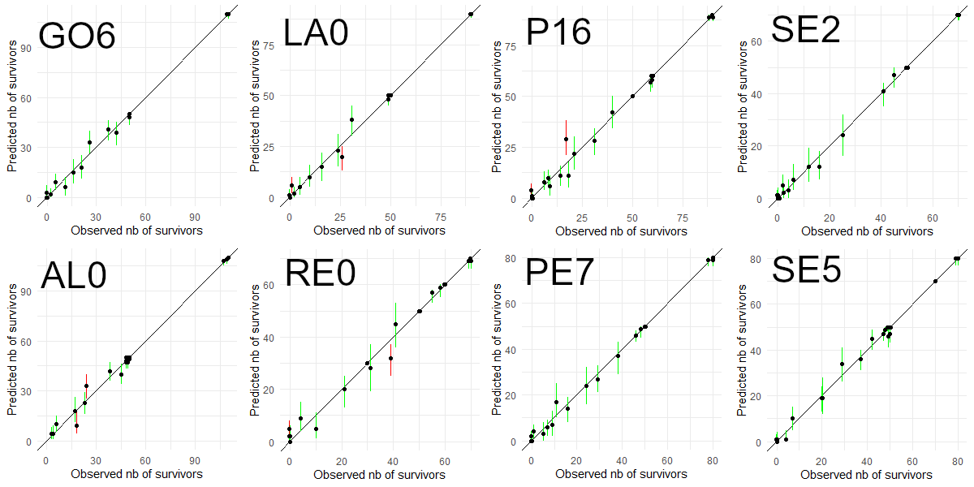

**Figure S5.** Posterior predictive checks of GUTS-RED-IT models for the eight clonal lineages for CMIT/MIT assay. The dots represent the median values of the predicted number of survivors and segments are the 95% credible intervals, and the x-axis correspond to the observed values. The segments are green when the observed value falls in the 95% credible interval and red otherwise.

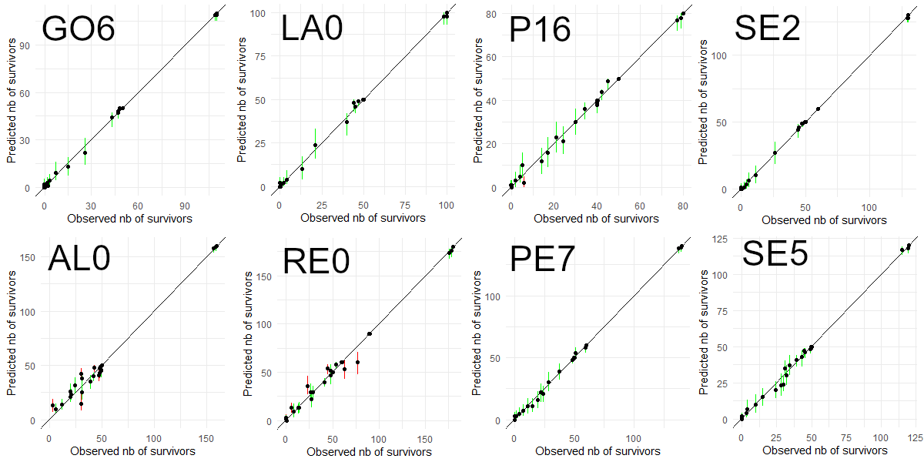

**Figure S6.** Posterior predictive checks of GUTS-RED-IT models for the eight clonal lineages for MIT assay. The dots represent the median values of the predicted number of survivors and segments are the 95% credible intervals, and the x-axis correspond to the observed values. The segments are green when the observed value falls in the 95% credible interval and red otherwise.

*Time-target model*

Source: morse modelling vignette (https://CRAN.R-project.org/package=morse)

The number *Ni* of surviving organisms at time *t* follows a binomial distribution:

$$N_{i} \sim B(n_{i}^{init}, f(c_{i}))$$

With $n_{i}^{init}$ as the initial number of organisms and *c* the contaminant level, and *f* the three parameters log-logistic function:

$$f(c) = \frac{d}{1+ {(\frac{c}{e})}^{b}}$$

Where *b* relates to the effect intensity of the contaminant and so to the steepness of the slope in the dose-response curve, *d* is the survival rate in absence of contaminant, and *e* is the LC50

**Table S5.** Log-logistic models parameters estimates at 48h for the 8 clonal lineages, median and 95% credible interval. The parameters describe as follow: b relates to the effect intensity of the contaminant and so to the steepness of the slope in the dose-response curve, d is the survival rate in absence of contaminant, and e is the LC50.

|  |  |  |  |  |  |  |
| --- | --- | --- | --- | --- | --- | --- |
| Clone | CMIT + MIT | | | MIT | | |
| b | d | e | b | d | e |
| Alsace | 8.69  [6.92-10.83] | 0.97  [0.95-0.99] | 0.37  [0.36-0.39] | 4.71  [3.87-5.74] | 0.98  [0.95-0.99] | 2.73  [2.59-2.88] |
| Goven6 | 8.16  [6.23-10.54] | 0.99  [0.97-1.00] | 0.157  [0.148-0.164] | 5.48  [4.10-8.61] | 0.97  [0.93-0.99] | 0.79  [0.70-0.92] |
| Lassalle | 7.09  [5.34-9.34] | - | 0.13  [0.12-0.14] | 6.84  [5.02-16.54] | 0.95  [0.90-0.98] | 0.66  [0.59-0.86] |
| Rennes | 8.11  [5.72-10.98] | 0.95  [0.90-0.98] | 0.146  [0.137-0.154] | 4.33  [2.79-5.81] | 0.90  [0.86-0.95] | 1.14  [0.96-1.24] |
| Sene2 | 4.45  [3.54-5.51] | - | 0.10  [0.09-0.11] | 6.63  [4.85-10.93] | 0.96  [0.93-0.99] | 0.74  [0.65-0.86] |
| Sene5 | 7.36  [5.71-9.51] | 0.98  [0.95-0.99] | 0.24  [0.22-0.25] | 4.81  [3.91-6.01] | 0.96  [0.92-0.98] | 1.86  [1.74-1.98] |
| Pearl16 | 4.68  [3.72-5.87] | 0.98  [0.94-0.99] | 0.13  [0.12-0.14] | 6.76  [5.01-8.99] | 0.93  [0.88-0.96] | 1.12  [1.03-1.20] |
| Pearl7 | 5.86  [4.22-7.93] | 0.95  [0.91-0.99] | 0.14  [0.13-0.15] | 4.01  [3.12-5.38] | 0.97  [0.93-0.99] | 0.96  [0.85-1.07] |

**Table S6.** Fixed-effects coefficients and variance estimates of random-effects for survival modelled as a function of line-specific response to dosage.

|  |  |  |  |  |
| --- | --- | --- | --- | --- |
| **CMIT/MIT** |  |  |  |  |
| **Model Coeff.** | **Est.** | **PDI0.025** | **PDI0.975** | **pMCMC** |
| 0 ALS | 6.33 | 5.58 | 7.17 | 0.001 |
| 0 GOV | 8.37 | 6.60 | 10.11 | 0.001 |
| 0 LAS | 8.60 | 6.74 | 10.53 | 0.001 |
| 0 PEA | 4.92 | 2.91 | 6.98 | 0.032 |
| 0 REN | 5.82 | 3.91 | 7.73 | 0.386 |
| 0 SEN2 | 5.93 | 3.99 | 7.88 | 0.522 |
| 0 SEN5 | 6.83 | 5.03 | 8.99 | 0.426 |
| 0 U3E7 | 6.62 | 4.60 | 8.63 | 0.674 |
| 1 ALS | -16.35 | -19.35 | -13.90 | 0.001 |
| 1 GOV | -55.73 | -62.00 | -49.75 | 0.001 |
| 1 LAS | -70.78 | -78.60 | -62.43 | 0.001 |
| 1 PEA | -37.72 | -45.93 | -30.14 | 0.001 |
| 1 REN | -46.30 | -53.42 | -40.15 | 0.001 |
| 1 SEN2 | -58.99 | -65.60 | -52.79 | 0.001 |
| 1 SEN5 | -29.70 | -36.95 | -22.72 | 0.001 |
| 1 U3E7 | -53.48 | -60.35 | -46.78 | 0.001 |
| **Var. Comp.** | **Var** | **Var0.025** | **Var0.975** |  |
| Var{0 Rep|Line} | 1.7370 | 1.3870 | 2.1330 |  |
| Var{residual} | 0.0592 | 0.0003 | 0.2070 |  |
| **MIT** |  |  |  |  |
| **Model Coeff.** | **Est.** | **PDI0.025** | **PDI0.975** | **pMCMC** |
| 0 ALS | 5.41 | 4.33 | 6.34 | 0.001 |
| 0 GOV | 5.07 | 2.56 | 7.39 | 0.612 |
| 0 LAS | 4.13 | 1.92 | 6.26 | 0.046 |
| 0 PEA | 4.41 | 1.91 | 6.58 | 0.122 |
| 0 REN | 4.02 | 1.78 | 6.03 | 0.016 |
| 0 SEN2 | 4.20 | 1.62 | 6.63 | 0.150 |
| 0 SEN5 | 5.05 | 2.77 | 7.19 | 0.560 |
| 0 U3E7 | 4.72 | 2.48 | 7.13 | 0.356 |
| 1 ALS | -1.90 | -2.33 | -1.55 | 0.001 |
| 1 GOV | -6.51 | -8.22 | -5.44 | 0.001 |
| 1 LAS | -6.50 | -8.35 | -5.41 | 0.001 |
| 1 PEA | -4.58 | -5.77 | -3.53 | 0.001 |
| 1 REN | -3.95 | -4.83 | -3.09 | 0.001 |
| 1 SEN2 | -5.88 | -8.05 | -4.28 | 0.001 |
| 1 SEN5 | -2.86 | -3.86 | -2.00 | 0.004 |
| 1 U3E7 | -4.73 | -6.19 | -3.80 | 0.001 |
| **Var. Comp.** | **Var** | **Var0.025** | **Var0.975** |  |
| Var{0 Rep|Line} | 2.0370 | 1.4790 | 2.7080 |  |
| Var{residual} | 0.0509 | 0.0013 | 0.3011 |  |