KeywordDriven Overview

Overview of KeywordDriven Test Automation tool

mwahab25

Table of Contents

1. Approaches for Test Automating 1

2. TAA (Test Automation Architecture) 2

3. TAS (Test Automation Solution) 5

4. TAF (Test Automation Framework) 5

# Approaches for Test Automating

Figure 1: Approaches for Test Automation

1. Implements test cases directly into automated test scripts, Include:

* **Linear scripting:** starts with some manual test cases and convert them directly to test scripts each test script contains its sequence of actions and data.

1. Designs test procedures and transforms them into automated test scripts, include:

* **Structured scripting:** build on the linear scripting but there’s introduction of a script library that contains reusable scripts that perform sequences of instructions that are commonly required across a number of tests.
* **Data-driven testing:** builds on the structured scripting but test data puts in separate files called data files and extracted from test scripts.
* **Keyword-driven testing:** builds on the data-driven but there’s only one control script extracted data from separated test definition file contains a description of the tests and high level instructions (keywords) and also contain test data.

Figure 2: Keyword-driven technique- general

1. Generates test procedures and translates into automated test scripts directly from models, include:

* **Model-based testing:** refers to the automated generation of test cases as opposed to the automated execution of test cases by use of linear scripting, structured scripting, data-driven scripting or keyword -driven scripting. Model-based testing derive tests from models that allows to concentrate on the essence of testing.

# TAA (Test Automation Architecture)

To define the architecture of Test Automation Solution (TAS).

Figure 3: Generic Test Automation Architecture (gTAA)

Figure 4: Test Automation Architecture that define Test Automation Solution

# TAS (Test Automation Solution)

Implementation of a TAA and development of Test Automation Framework (TAF).

Figure 5: Development of Test Automation Framework based on Keyword-driven

# TAF (Test Automation Framework)

The environment and the tool required for test automation.

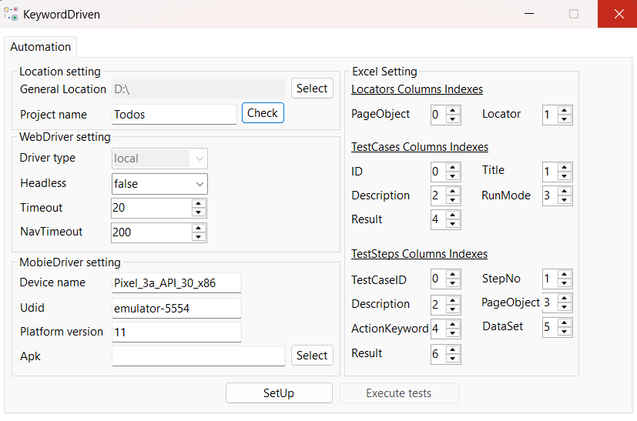

Figure 6: KeywordDriven Desktop Application

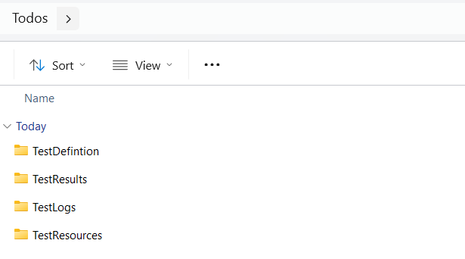

Figure 7: Test Folders Location for specific Project

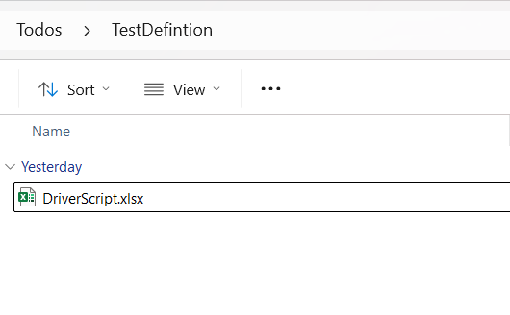

Figure 8: Test Definition-DriverScript

Figure 9: DriverScript Excel – Locators sheet

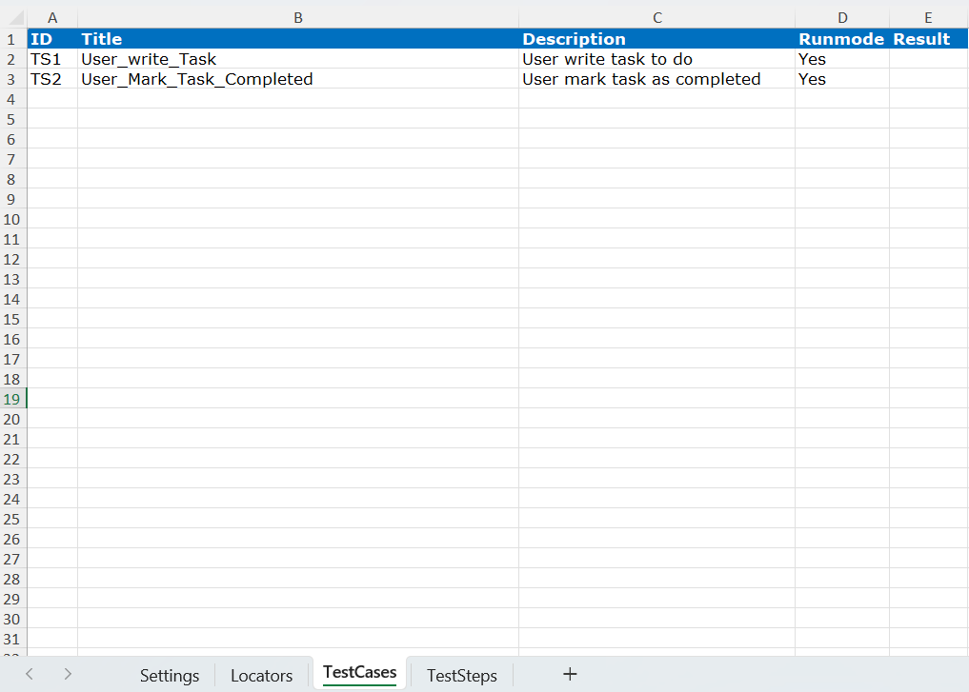

Figure 10: DriverScript Excel – TestCases sheet

Figure 11: DriverScript Excel – TestSteps sheet

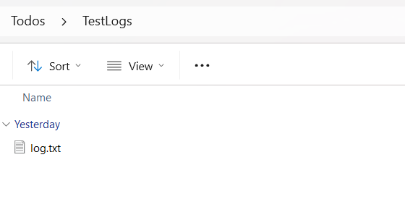

Figure 12: TestLogs – Log file

Figure 12: TestResults – index report