Bug Report - Login Page

# Title:

[BUG] Form login tidak menampilkan pesan error ketika field password kosong

**Environment:**

OS: macOS 11  
Browser: Chrome 138.0.7204.184

**Steps to Reproduce:**

1. Buka halaman Login  
2. Masukkan email valid user@test.com  
3. Biarkan field password kosong  
4. Klik tombol Login

**Expected Result:**

Sistem menolak login dan menampilkan pesan error 'Password required'.

**Actual Result:**

Hanya muncul pesan Email is required!' meskipun email sudah valid, error password tidak ditampilkan.

**Severity:** Medium

**Attachment:  
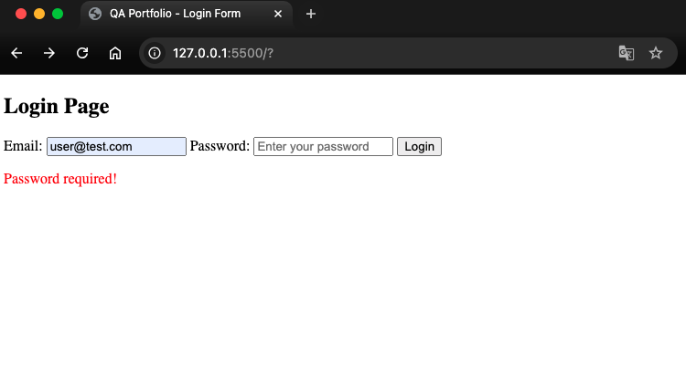**

Screenshot diatas form login saat field password kosong.