
WORKING SPECIFICATION
Portfolio Holder Portal
Data Sources, Statuses and Formula Booklet
Draft v0.1 - 24 July 2026
Prepared for ReferredBy portfolio-holder validation and future operating-guide development

DOCUMENT STATUS
Working draft. This booklet records the implementation as it exists today and highlights business rules that still require confirmation before the portal is treated as an auditable reporting source.

How to use this booklet
Use this document to validate each visible number before launch. Every screen section identifies the database source, the calculation performed in the web application, and unresolved policy questions.
Interpretation key
Label | Meaning
Direct field | Displayed from a Supabase table without a financial calculation.
Calculated | Derived in src/lib/portfolioApi.js or src/App.jsx from one or more database fields.
UI-only | Navigation, read-only state, masking, or a client-side export.
Decision required | The database or supplied calculation guide does not fully define the business rule.

SECURITY SCOPE
The browser uses the authenticated Supabase session and row-level security. No service-role key is present in the portal. Portfolio access is resolved through portfolio_holder_users and auth.users app metadata.

Authentication and portfolio scope
Step | Source | Rule
1. Sign in | auth.users | Email/password authentication is handled by Supabase Auth.
2. Identify user type | auth.users.raw_app_meta_data | user_type must equal portfolio_holder.
3. Resolve holder | portfolio_holder_users.portfolio_holder_id | The mapping for auth.uid() determines the permitted portfolio holder.
4. Load portfolio | portfolio_holders.id | Only the mapped holder record is requested.
5. Load societies | lending_societies.portfolio_holder_id | Only linked societies are requested.
6. Load loans/payments | RLS helper functions | Rows are restricted to the mapped holder's linked societies or holder ID.

Core source inventory
Table | Current use | Key fields
portfolio_holders | Portfolio identity and opening allocation | id, name, total_allocation, status, contact_person, region
lending_societies | Linked society list and allocation | id, name, partner_type, portfolio_allocation, portfolio_holder_id
nano_loans | Nano loan book and pipeline | loan_id, user_id, loan_amount, outstanding_balance, status, approved_at, disbursed_at, due_date
term_loans | Term loan book and pipeline | Same selected fields as nano_loans
loan_payments | Collections, due amounts and arrears | loan_id, amount_due, amount_paid, payment_date, payment_ref, days_late, status
partner_ratings | Society rating display/export | lending_society_id, default_rate, rating_tier, score
portfolio_holder_users | Authenticated holder mapping | user_id, portfolio_holder_id, user_type
activity_history | Not connected yet | Future audit feed after portfolio-holder RLS and mapping are approved

SCREEN 1

Overview
Portfolio-wide capital, performance, monthly movement, composition and the six-component calculated score.
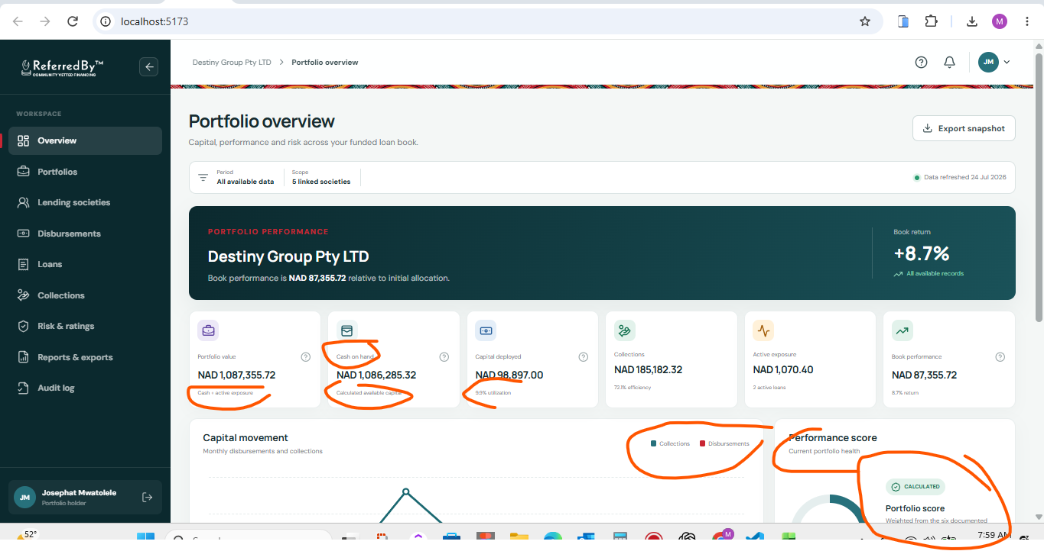
UI review capture - Overview. Orange annotations were supplied during review and identify fields requiring clarification.
Overview data lineage
UI item | Source fields | Current implementation
Portfolio holder name | portfolio_holders.name | Direct field.
Initial allocation | portfolio_holders.total_allocation; fallback lending_societies.portfolio_allocation | Use holder total when non-zero; otherwise sum linked society allocations.
Capital deployed | nano_loans.loan_amount; term_loans.loan_amount; status | Sum loan_amount where status is DU, OT, BL or PU.
Collections | loan_payments.amount_paid | Sum amount_paid across scoped payment rows.
Active exposure | loan outstanding_balance; status | Sum outstanding_balance where status is DU, OT or BL.
Monthly movement | loan disbursed_at; loan_amount; payment_date; amount_paid | Group qualifying disbursements and collections by UTC month; show latest six months with data.
Performance score | Calculated portfolio metrics | Weighted six-component score; no qualitative band is assumed.

Overview formulas
Metric | Formula | Review note
Cash on hand | Initial allocation - capital deployed + collections | No separate authorised cash-adjustment ledger is included.
Portfolio value | Cash on hand + active exposure | Confirmed against supplied calculation guide.
Book performance | Portfolio value - initial allocation | Absolute gain/loss.
Book return % | Book performance / initial allocation x 100 | Null when allocation is zero.
Utilization % | Capital deployed / initial allocation x 100 | Cumulative deployment, not current exposure.
Collection efficiency % | Sum amount_paid / sum amount_due x 100 | Payment-status inclusion rules still require confirmation.
Cash share % | Cash on hand / portfolio value x 100 | Used for composition and risk component.

DECISION REQUIRED
Confirm whether capital deployed should come from a successful disbursement transaction ledger rather than loan status, and which loan_payments.status values must be excluded as failed, reversed, duplicate or test records.

SCREEN 2

Portfolios
Single authenticated portfolio summary, capital position, ratios and links to detailed modules.
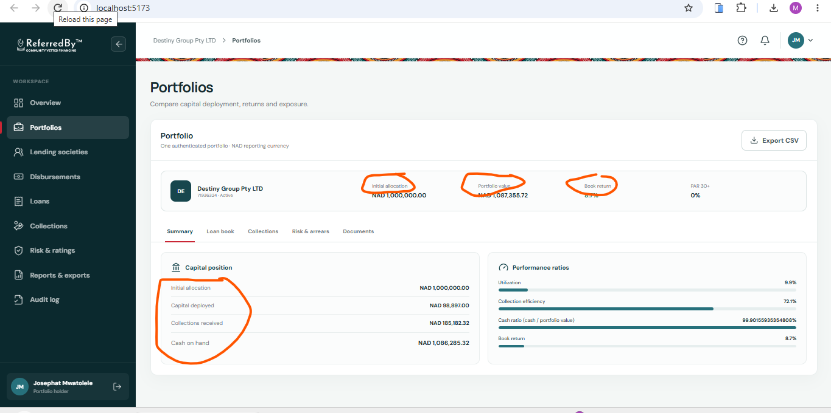
UI review capture - Portfolios. Orange annotations were supplied during review and identify fields requiring clarification.
Element | Source / formula | Behavior
Portfolio identity | portfolio_holders.name, id, status | Direct fields; ID is shortened for display.
Allocation and value | Same formulas as Overview | Values must reconcile exactly with Overview.
PAR 30+ | 30+ arrears / active exposure x 100 | See Risk section for arrears derivation.
Summary tab | Calculated portfolio metrics | Current page.
Loan book | Navigation | Opens Loans.
Collections | Navigation | Opens Collections.
Risk & arrears | Navigation | Opens Risk & ratings.
Documents | Navigation | Opens Reports & exports.
Export CSV | Client-side export | Downloads the calculated portfolio summary; does not write to Supabase.

REVIEW NOTE
The portal currently supports one authenticated portfolio per holder mapping. Compare functionality was removed because there is no second portfolio dataset in scope.

SCREEN 3

Lending societies
Breakdown of linked societies, their allocated capital, loan exposure, collections and rating information.
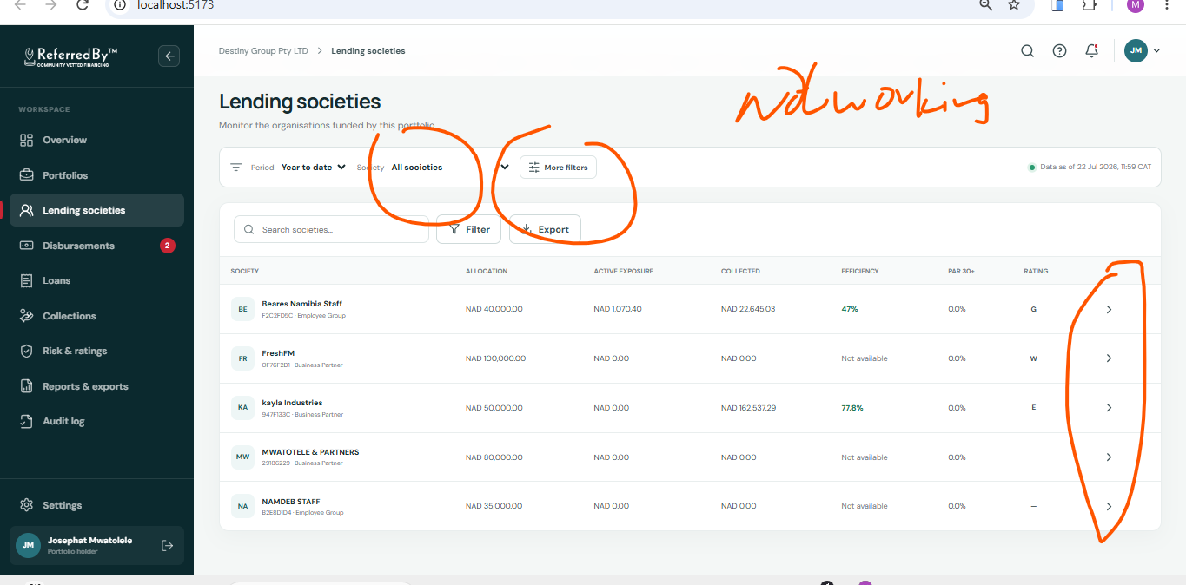
UI review capture - Lending societies. Orange annotations were supplied during review and identify fields requiring clarification.
Column | Source | Formula / rule
Society | lending_societies.name, id, partner_type | Direct fields; code is first eight characters of UUID.
Allocation | lending_societies.portfolio_allocation | Direct numeric field.
Active exposure | nano_loans + term_loans | Sum outstanding_balance for that society where status is DU, OT or BL.
Collected | loan_payments.amount_paid | Sum amount_paid for that society.
Efficiency | loan_payments.amount_paid, amount_due | Collected / due x 100; N/A when due is zero.
PAR 30+ | partner_ratings.default_rate | Direct rating-service field on this screen.
Rating | partner_ratings.rating_tier | Full tier text; no first-letter abbreviation.
Expanded row | Same row calculations | Chevron expands a read-only detail line.

DECISION REQUIRED
The society PAR field comes from partner_ratings.default_rate, while portfolio PAR is calculated from loan_payments.days_late. Confirm whether these are intentionally different measures.

SCREEN 4

Disbursements
Read-only approval and disbursement pipeline derived from canonical loan status codes.
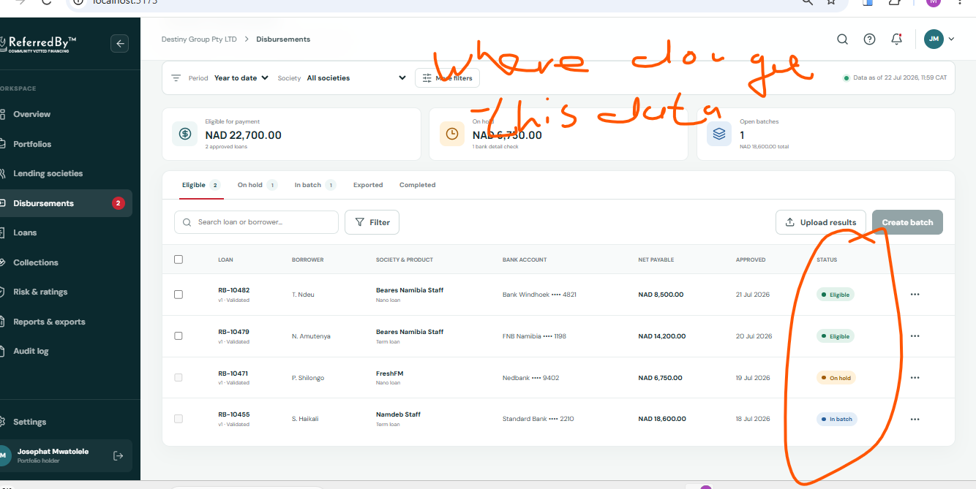
UI review capture - Disbursements. Orange annotations were supplied during review and identify fields requiring clarification.
UI item | Source | Rule
Awaiting approval | nano_loans.status; term_loans.status | AA rows; amount is sum loan_amount.
Awaiting disbursement | nano_loans.status; term_loans.status | AD rows; amount is sum loan_amount.
Borrower reference | loan.user_id | Masked to last four UUID characters; no borrower name is queried.
Product | Source table | Nano loan or Term loan label added when rows are combined.
Approved date | loan.approved_at | Direct timestamp formatted for display.
Export | Current filtered rows | Client-side CSV only.

READ-ONLY BOUNDARY
Payment-batch creation, bank-account display, upload-results actions and invented Eligible/On hold/In batch statuses were removed. No supporting holder-scoped batch table was identified.

SCREEN 5

Loans
Combined nano and term loan book with canonical status labels and masked borrower references.
SCREENSHOT PENDING
A verified current-state screenshot for Loans has not yet been embedded. Add it during the next documentation pass.

Column | Source | Display rule
Loan ID | nano_loans.loan_id / term_loans.loan_id | Direct field.
Borrower reference | user_id | Masked; users table is not queried by this portal.
Lending society | lending_societies.id -> name | Client-side ID-to-name lookup.
Product | Originating table | Nano loan or Term loan.
Original principal | loan_amount | Direct numeric field.
Active balance | outstanding_balance | Direct numeric field; zero is shown as NAD 0.00.
Due date | due_date; fallback final_deduction_date | First available date is formatted.
Status | status | Mapped using the canonical status dictionary in this booklet.

SCREENSHOT PENDING
Add a verified Loans capture after the next visual review. The booklet already records the exact live fields and mappings.

SCREEN 6

Collections
Monthly due-versus-collected chart, collection efficiency and recent payment ledger.
SCREENSHOT PENDING
A verified current-state screenshot for Collections has not yet been embedded. Add it during the next documentation pass.

Element | Source | Formula / rule
Monthly due | loan_payments.amount_due; payment_date or created_at | Group by UTC month.
Monthly collected | loan_payments.amount_paid; payment_date or created_at | Group by UTC month.
Collection efficiency | amount_paid; amount_due | Sum paid / sum due x 100.
Recent collections | payment_ref, loan_id, amount_paid, payment_date | Positive amount_paid rows sorted newest first; show five.
Society name | payment.lending_society_id -> lending_societies.name | Client-side lookup.
Download ledger | All scoped loan_payments rows | Client-side CSV.

DECISION REQUIRED
Confirm the allowed loan_payments.status values for financial reporting and how reversals, refunds, prepayments, late receipts and duplicate references affect efficiency.

SCREEN 7

Risk & ratings
Portfolio-level weighted score and arrears ageing derived from calculated portfolio metrics.
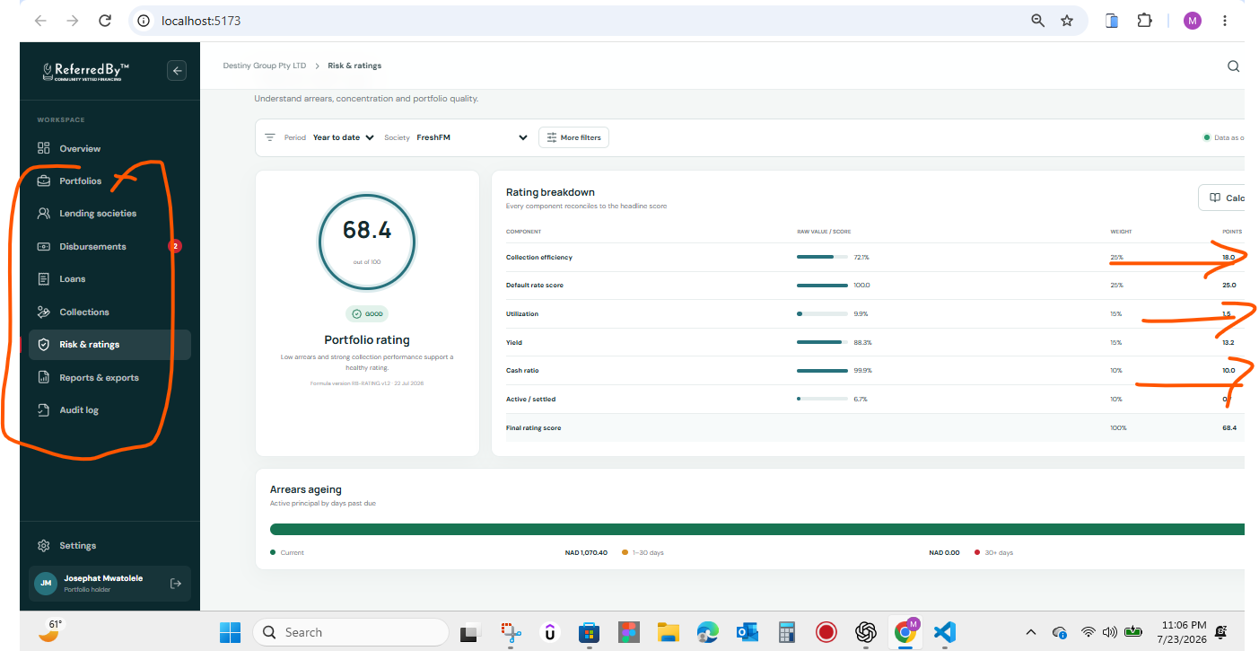
UI review capture - Risk & ratings. Orange annotations were supplied during review and identify fields requiring clarification.
Current weighted-score implementation
Component | Component score | Weight
Collection efficiency | Clamp(collection efficiency, 0, 100) | 25%
Default rate score | Clamp(100 - portfolio PAR 30+, 0, 100) | 25%
Utilization | Clamp(capital deployed / allocation x 100, 0, 100) | 15%
Yield | Clamp(book performance / capital deployed x 100, 0, 100) | 15%
Cash ratio | Clamp(cash on hand / portfolio value x 100, 0, 100) | 10%
Active / settled | Clamp(active loan count / settled loan count x 100, 0, 100) | 10%
Final score | Sum(component score x decimal weight) | 100%

Arrears implementation
Ageing bucket | Source / formula
30+ days | For each payment with days_late >= 30: max(amount_due - amount_paid, 0).
1-30 days | For each payment with 0 < days_late < 30: max(amount_due - amount_paid, 0).
Current | max(active exposure - 1-30 arrears - 30+ arrears, 0).
Portfolio PAR 30+ | 30+ arrears / active exposure x 100.

DECISION REQUIRED
The supplied calculation guide states that rating-band thresholds and transformations are not confirmed. The portal therefore shows a numerical calculated score but no Good/Strong qualitative band. Confirm the cash-ratio denominator, active/settled transformation and default definition.

SCREEN 8

Reports & exports
Client-side CSV downloads created from data already authorised and loaded into the signed-in browser.
SCREENSHOT PENDING
A verified current-state screenshot for Reports & exports has not yet been embedded. Add it during the next documentation pass.

Download | Rows included | Database write
Portfolio performance | Calculated portfolio object, excluding nested objects | None
Loan book | Scoped nano_loans and term_loans | None
Collections ledger | Scoped loan_payments | None
Society risk | Calculated society rows plus partner_ratings fields | None

CURRENT LIMITATION
Exports are CSV rather than PDF/XLSX and are not written to an audit table. If controlled report generation is required, define a server-side report service and audit event contract.

SCREEN 9

Audit log
Placeholder screen that deliberately shows no invented historical activity.
SCREENSHOT PENDING
A verified current-state screenshot for Audit log has not yet been embedded. Add it during the next documentation pass.

Current state | Reason | Proposed source
No historical events displayed | activity_history is not yet exposed through an approved portfolio-holder policy. | public.activity_history
Signed-in email may be shown | Available from the authenticated session. | auth.users session
Export actions not logged | Current CSV generation is entirely client-side. | Future server-side audit event

IMPLEMENTATION PREREQUISITE
Define which activity_history.entity_type values belong to a portfolio holder, add a safe RLS policy or scoped RPC/view, then map event names and actor identities without exposing unrelated staff or borrower data.

Canonical loan status dictionary
These definitions come from the supplied database schema for nano_loans and term_loans. They replace the earlier presentation-only labels.
Code | Display label | Exposure / pipeline treatment
NR | Not requested | Neither active exposure nor disbursement pipeline.
AA | Awaiting approval | Approval pipeline; not active exposure.
AD | Awaiting disbursement | Disbursement pipeline; not yet counted as capital deployed.
DU | Due | Active exposure; counted as capital deployed.
OT | Outstanding | Active exposure; counted as capital deployed.
BL | Blocked | Active exposure; counted as capital deployed.
PU | Paid up | Settled; counted in cumulative capital deployed.
DE | Declined | Excluded from active exposure and capital deployed.

Calculation control checklist
Control question | Current answer | Owner decision
Single reporting cut-off across all cards? | No. dataAsOf is browser load time; source maxima are not returned. | Define snapshot timestamp or reporting view.
Successful disbursements sourced from ledger? | No. Inferred from loan status. | Confirm transaction table/source of truth.
Failed/reversed payments excluded? | Not explicitly. All scoped amount_paid values are summed. | Define eligible payment statuses.
Cash adjustments included? | No separate adjustment source queried. | Identify allocation adjustments/transfers/reserves.
PAR denominator approved? | Current portfolio PAR uses active exposure. | Confirm eligible exposure denominator.
Rating band thresholds approved? | No. Numerical score only. | Provide policy thresholds and hard stops.
Audit events persisted? | No. Client CSV only. | Define server-side event service and RLS.

Revision log
Version | Date | Change
0.1 | 24 Jul 2026 | Initial working specification based on current React/Supabase implementation, supplied schema and calculation guide.
0.2 | Pending | Business-owner corrections to tables, formulas, statuses and reporting rules.

