Megan Walker

Bellevue University

**WEB 335 Introduction to NoSQL**

Professor Krasso

March 28, 2023

Discussion 2.1 – Normalization

**What is Database Normalization?**

Database normalization is a process used to organize data in a database efficiently. It is a technique of minimizing data redundancy and dependencies to improve data integrity and overall database performance. Normalization involves dividing a database into two or more tables and defining relationships between them to ensure data consistency.

**Why is Normalization Important?**

Normalization is important because it helps to eliminate data redundancy. This reduces the chances of data inconsistencies, improves data quality, and saves disk space. Normalized data is also easier to maintain, update, and query.

**Describe Each Normal Form**

There are different normal forms, each with its own set of rules. The first normal form (1NF) requires that every data element in a table be indivisible or atomic. This means that each field in a table should only contain one value.

The second normal form (2NF) requires that every non-key attribute or field in a table should depend on the entire primary key of that table. This means that each non-key field should be related to the entire primary key and not just part of it.

The third normal form (3NF) requires that every non-key attribute in a table should be independent of each other. This means that no non-key field should be dependent on another non-key field.

The fourth normal form (4NF) requires that a table should not have any multi-valued dependencies. This means that there should be no fields in a table that contain more than one value.

**How are 1-to-many relationships represented in MongoDB**

MongoDB is a popular NoSQL database that uses a document-based model to store data. In MongoDB, 1-to-many relationships can be represented using the embedded approach. In this approach, the data for the many-side of the relationship is embedded within the document of the one-side of the relationship. For example, a document representing a blog post can embed the comments made on that post.

**Provide an explanation of why this is the preferred approach and include at least one visual example.**

The embedded approach is preferred in MongoDB because it reduces the number of database queries required to retrieve related data. This approach also provides better performance for read-heavy workloads. However, it can lead to data duplication and increased storage requirements, especially when dealing with large amounts of data.

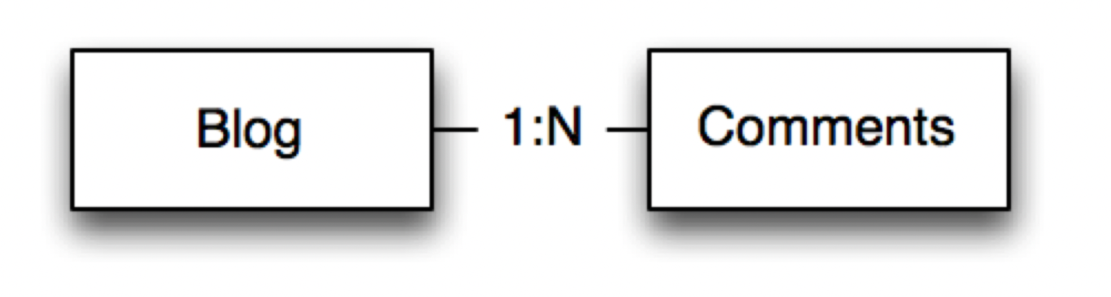

References

Gathoni, M. (2022, February 7). *Working With Data Relationships in MongoDB*. MUO; MUO. https://www.makeuseof.com/working-with-data-relationships-in-mongodb/

*Schema Basics*. (2014). Learnmongodbthehardway.com. https://learnmongodbthehardway.com/schema/schemabasics/

*What is Normalization in DBMS (SQL)? 1NF, 2NF, 3NF Example*. (2020, January 25). Guru99. https://www.guru99.com/database-normalization.html