Megan Walker

Bellevue University

**WEB 335 Introduction to NoSQL**

Professor Krasso

April 01, 2023

Assignment 3.2

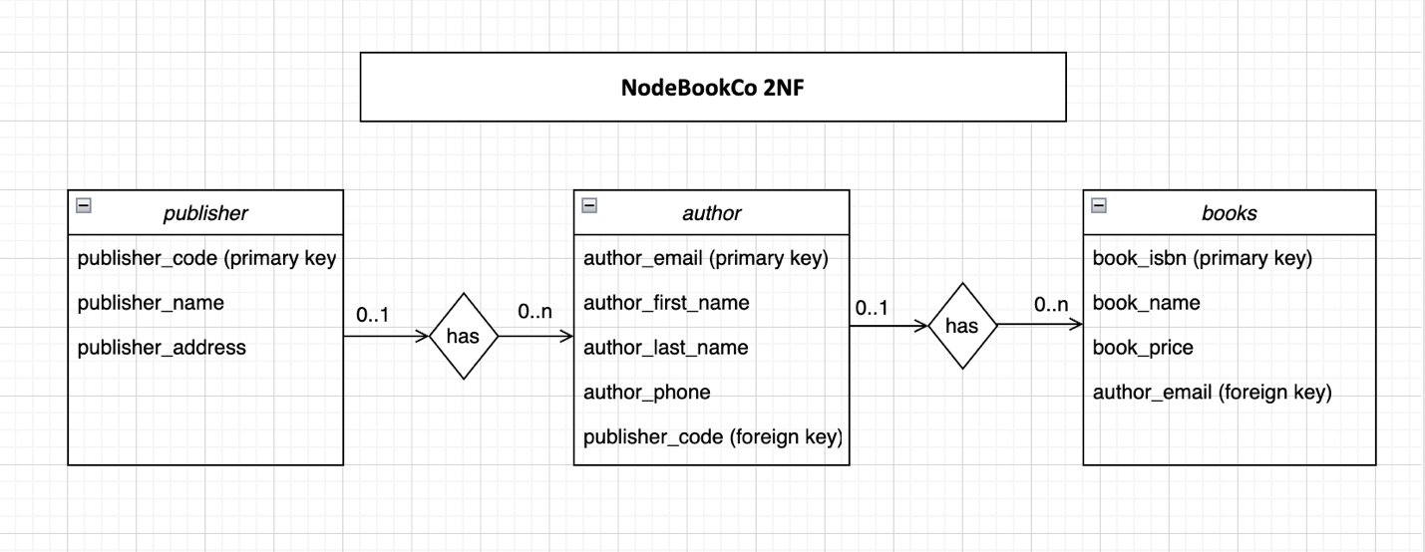

[

{

"publisher_code": "123456789",

"publisher_name": "ABC Publisher",

"publisher_address": "123 Main Street",

"authors": [

{

"author_email": "jdoe@ABCpublishing.com",

"author_first_name": "John",

"author_last_name": "Doe",

"author_phone": "555-555-5555",

"books": [

{

"book_isbn": "1234567890123",

"book_name": "Book 1",

"book_price": 9.99

},

{

"book_isbn": "1234567890124",

"book_name": "Book 2",

"book_price": 9.99

}

]

},

{

"author_email": "bboberson@ABCpublishing.com",

"author_first_name": "Bob",

"author_last_name": "Boberson",

"author_phone": "111-111-1111",

"books": [

{

"book_isbn": "1234567890125",

"book_name": "Book 3",

"book_price": 9.99

},

{

"book_isbn": "1234567890126",

"book_name": "Book 4",

"book_price": 9.99

}

]

}

]

}

]