CprE 381 – Computer Organization and

Assembly-Level Programming

Lab-01 Report

Student Name ______________________________________________

Section / Lab Time _________________________

Submit a typeset pdf version of this on Canvas by the due date (i.e., the start of your next lab section). Refer to the highlighted language in the Lab-01 instructions for the context of the following questions.

- [Part 1 (b)] Reference the circuit diagram at the end of this document (some parts simplified). There are 33 labeled areas in the diagram. For 15 of these labels, specify where (VHDL file and line number) these values are located – some will be found in more than one place. Also attempt to explain the functionality of each label as it occurs in the code.
iCLK: Line 24 of Quadratic. Used as the circuits clock signal
iX: Line 25 of Quadratic. Used as an input integer
oY: Line 26 of Quadratic. Used as an output integer
iA: Line 36 of Quadratic. Used as an integer input for multiply and add
iB: Line 37 of Quadratic. Used as an integer input for multiply and add
oC: Line 38 of Quadratic. Used as an integer output for multiply and add
cA: Line 49 of Quadratic. Used as an integer constant for the constants of the quadratic equation
cB: Line 50 of Quadratic. Used as an integer constant for the constants of the quadratic equation
cC: Line 51 of Quadratic. Used as an integer constant for the constants of the quadratic equation
sVALUE_Ax: Line 54 of Quadratic. The name of the wire connecting mult1 and mult3, carries an integer
sVALUE_Bx: Line 54 of Quadratic. The name of the wire connecting mult2 and add1, carries an integer
sVALUE_Axx: Line 56 of Quadratic. The name of the wire connecting mult3 and add2, carries an integer
sVALUE_BxpC: Line 58 of Quadratic. The name of the wire connecting add1 and add2, carries an integer
q_Mult1: Line 66 of Quadratic. The name of one of the block diagrams of Multiplier.vhdl. Multiplies two numbers with rising edge of a clock

- [Part 1 (h)] In your report, provide a brief explanation of how the timing waveform corresponds to your understanding of the adder design.
The adder design performs an addition when the rising edge of a clock is given. The waveform shows that the two numbers were added together when the rising edge was met.
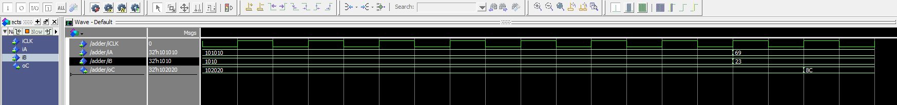
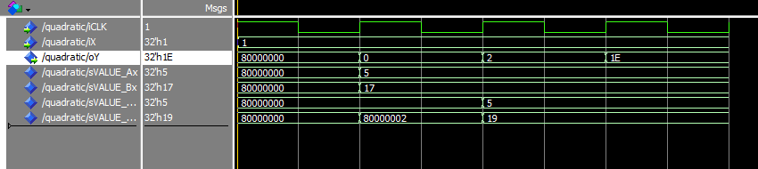
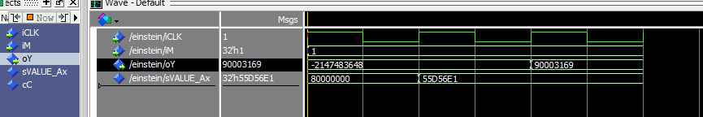
- [Feedback] You must complete this section for your lab to be graded. Write down the first response you think of; I expect it to take roughly 5 minutes (do not take more than 10 minutes).

  - How many hours did you spend on this lab?

Task | During lab time | Outside of lab time
Reading lab | .5 | 0
Pencil/paper design | .2 | 0
VHDL design | .5 | 0
Assembly coding | 0 | 0
Simulation | .2 | 0
Debugging | .1 | 0
Report writing | .2 | 0
Other: | 0 | 0
Total | 1.5 | 0

  - If you could change one thing about the lab experience, what would it be? Why?
Reassure me that the waveform file im about to submit is actually the right thing.
  - What was the most interesting part of the lab?

Being able to see the rising and falling edge clock signals and how they update the circuit

