TANZANIA COMMERCIAL BANK

TECHNICAL ARCHITECTURE
Government Securities Digital Platform (GovSec Platform)
Onboarding • Bidding • Allocation • Settlement for T-Bills and T-Bonds

Document type | Technical Architecture Document (TAD)
System | GovSec Platform
Version | 1.0 – Draft for architecture review
Date | 23 September 2026
Classification | Confidential – TCB internal

Document Control
Version | Date | Author | Description
0.1 | [dd/mm/yyyy] | [Solution Architect] | Initial draft
1.0 | 23/09/2026 | [Solution Architect] | Draft for architecture review board

Approver | Role | Signature / Date
[Name] | Head of ICT, TCB
[Name] | Chief Information Security Officer, TCB
[Name] | Head of Treasury Operations, TCB
[Name] | Enterprise / Solution Architect

Contents
Right-click and choose Update Field to build the table of contents.

1. Introduction

1.1 Purpose
This document describes the technical architecture of the GovSec Platform. The platform digitises how investors buy and manage Government securities (Treasury Bills and Treasury Bonds) through Tanzania Commercial Bank (TCB), from onboarding and CDS account opening through bidding, allocation, settlement, holdings, coupons and maturities. It integrates with TCB's Core Banking System (CBS) and with the Bank of Tanzania (BoT) Central Depository System (CDS) and Auction platforms.
It is the reference for design, build, integration, security review, infrastructure provisioning and operations.

1.2 Audience
Audience | Use of this document
Architecture review board | Approve the target architecture and key decisions
Development and integration teams | Service boundaries, APIs, integration patterns, data ownership
Information security | Security controls, trust boundaries, compliance mapping
Infrastructure and operations | Deployment topology, sizing, HA/DR, monitoring
BoT technical counterparts | Interfaces, security of connectivity, reconciliation

1.3 Scope
- Investor onboarding (individual, joint, minor via guardian, corporate, institutional), KYC and initiation of the CDS account.
- Auction catalogue (T-Bills 35/91/182/364-day and T-Bonds of all tenors), competitive and non-competitive bidding, funds holds, and consolidated submission to BoT.
- Results, allocation, instant notification, payment and settlement, holdings, coupons, redemptions and rollovers.
- Investor channels: USSD, Chatbot, Web Portal and Mobile App. Staff back-office and BoT oversight portals.
- Reporting and analytics for TCB and BoT.

Not covered: secondary-market trading, and onboarding other banks as participants. The architecture supports both as extensions (Section 4.4).

1.4 Key Architectural Decisions (summary)
- One core, many channels: every channel uses the same versioned APIs. Business rules are defined once.
- Anti-corruption adapters for CBS, BoT CDS, BoT Auction, payment rails, NIDA, SMS and USSD.
- Funds held before a bid is accepted, so settlement cannot fail for lack of funds.
- Event-driven core (Kafka) feeding the audit trail, notifications, analytics and three-way reconciliation.
- On-premise Kubernetes in TCB's primary and DR data centres, for in-country data residency.

Section 17 records the full decisions and their rationale.

1.5 References
Ref | Document
R1 | BoT Government Securities auction rules and procedures (current edition)
R2 | BoT Government Securities Bidding Process & Authentication API, BOT-SPEC-GSS-2026-v1.0 (Sept 2026)
R2a | BoT CDS account-opening, holdings and settlement interface specifications (to be obtained)
R3 | BoT cybersecurity and ICT risk management guidelines for banks
R4 | Personal data protection legislation of Tanzania
R5 | TCB ICT Policy, Information Security Policy, and Change Management standards
R6 | TCB CBS integration / API gateway specifications

2. System Context
Figure 1 shows the GovSec Platform as a single system, with the people and external systems it interacts with.
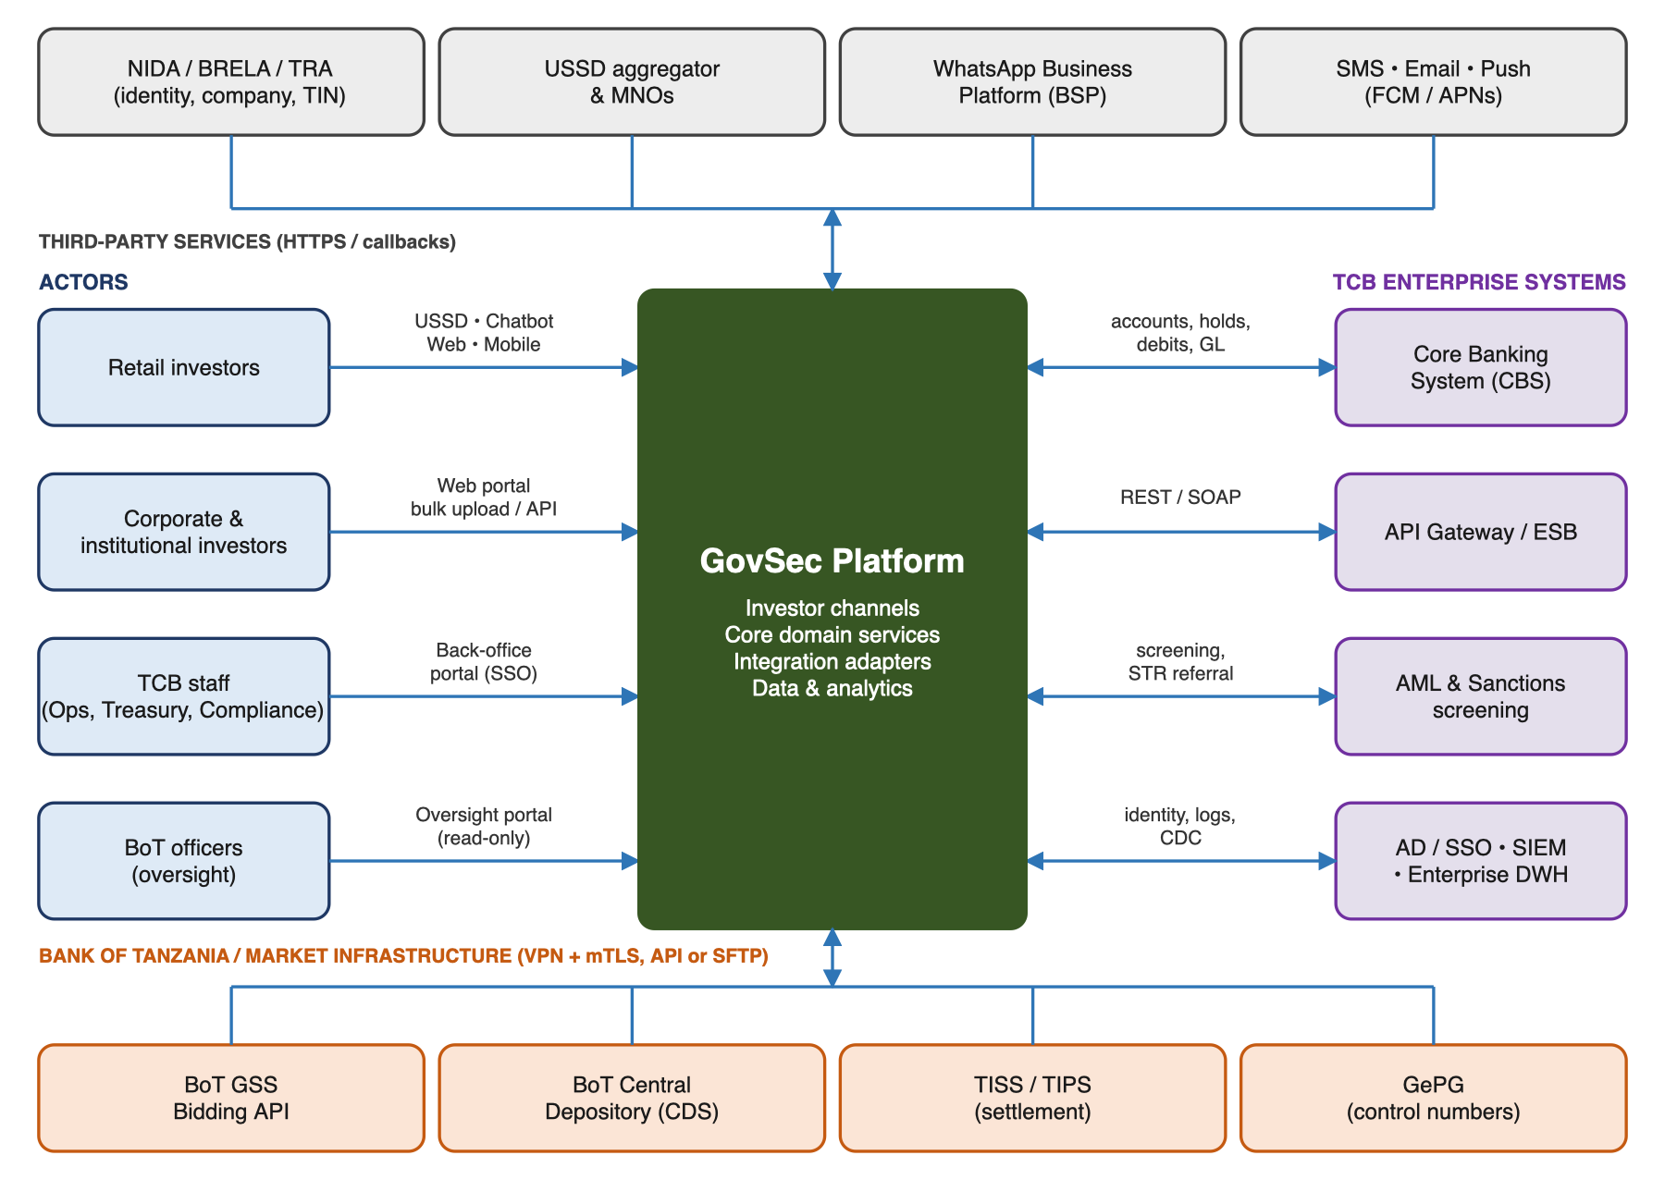
Figure 1 – System context
Actor / system | Role | Interaction
Investors (retail, corporate, institutional) | End-users and holders of securities | USSD, chatbot, web portal, mobile app
TCB staff | Operate the platform | Back-office portal: KYC exceptions, auction control, settlement, reconciliation
Bank of Tanzania | Regulator, auction authority, fiscal agent | Auction and CDS interfaces; oversight portal; regulatory reports
Central Depository (CDS/CSD) | Custodian and record-keeper of securities | Account opening, holdings, statements, coupon/redemption data
TCB Core Banking | System of record for accounts and money | Customer lookup, account opening, holds, debits, credits, GL postings
Other banks / primary dealers (future) | Participants and access points | Partner APIs; interbank settlement counterparties

3. Architecture Principles
Principle | Rationale | Implication
API-first, channel-agnostic | Four investor channels plus staff and BoT portals must behave identically | All logic lives in core services behind versioned REST APIs. Channels are thin presentation layers.
Regulatory fidelity | BoT is the auction authority and CDS is the golden source of holdings | BoT auction rules are configuration, not code. Holdings are always reconciled to CDS.
Money-safe by design | Settlement failures erode trust and create operational risk | Funds are held before a bid is accepted, operations are idempotent, the outbox pattern is used, and reconciliation runs daily and per auction.
Secure and private by default | Investor PII and financial data are regulated | Zero-trust network zones, encryption everywhere, least privilege, and data minimisation per the DPPA.
Loose coupling | BoT and CBS interfaces may evolve | Anti-corruption adapters per external system, with contract tests.
Observable and auditable | Oversight and dispute resolution | Correlation IDs end to end, structured logs, metrics, traces, and an immutable audit log.
Elastic for auction peaks | Load concentrates in the hours before cut-off | Stateless, horizontally scalable services on Kubernetes with queue-based buffering.
Prefer TCB standards | Lower total cost and easier support | Reuse TCB's API gateway, IAM, SIEM, HSM and database platforms where available.

4. Logical Architecture

4.1 Layered View
Figure 2 shows the platform's logical layers. Requests flow from the channel layer through the security edge to the core domain services. The core services use the integration layer to reach TCB and BoT systems, and all layers share the data and platform services.
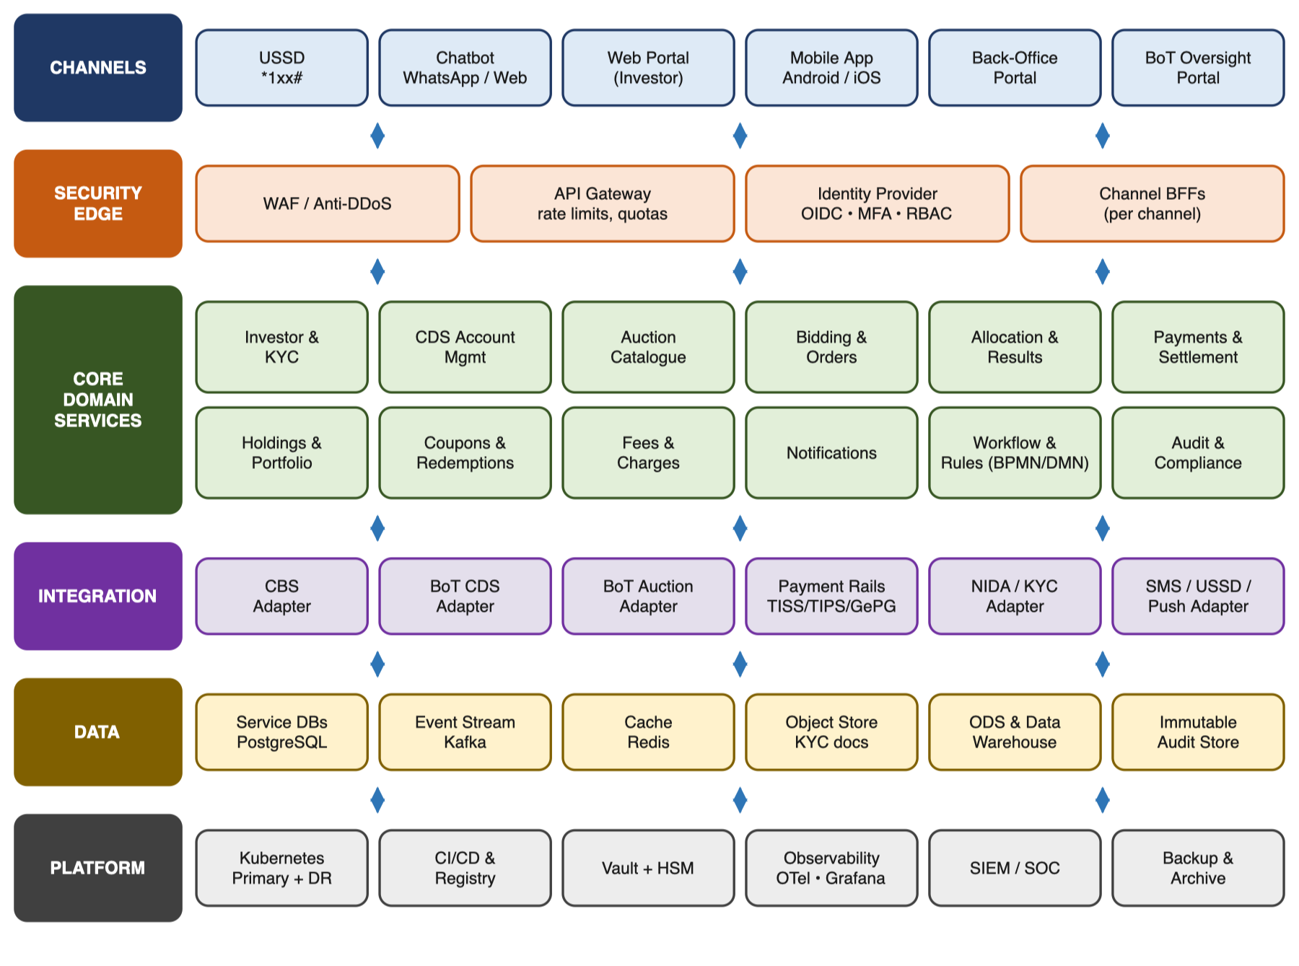
Figure 2 – Logical layered architecture

4.2 Core Domain Services
Service | Responsibilities | Key data owned
Investor & KYC | Registration, NIDA/TIN/BRELA verification, risk rating, AML/PEP/sanctions screening, KYC refresh, consent capture | Investor profile, KYC documents, risk score, consents
CDS Account Management | Initiate CDS account opening with BoT, track status, link CDS number to TCB settlement account, handle amendments | CDS account number, status, linked accounts
Auction Catalogue | Import BoT auction calendar and notices; publish security details, cut-off times, minimum amounts and tenors | Auctions, securities (ISIN), calendars
Bidding & Order Management | Capture competitive/non-competitive bids, validate against rules, place funds hold, allow amend/cancel before cut-off, consolidate and submit | Bids, bid states, consolidated submissions
Allocation & Results | Ingest BoT results, apply allocation (full/partial/pro-rata), compute settlement amounts, trigger notifications | Results, allocations, weighted average prices/yields
Payments & Settlement | Convert holds to debits, release unallocated funds, post GLs, interbank settlement to BoT, confirm CDS credit | Payment instructions, settlement status, GL postings
Holdings & Portfolio | Mirror CDS holdings, valuations, statements, investment certificates | Positions, statements
Coupons & Redemptions | Coupon schedules, maturity proceeds, auto-credit to CBS accounts, optional rollover instructions | Cash-flow schedules, payouts
Fees & Charges | Configurable commission, CDS and channel fees; tax (WHT where applicable) | Fee schedules, charge records
Notifications | Omni-channel messages (SMS, email, push, WhatsApp) from templates in Kiswahili and English | Templates, delivery logs
Rules & Workflow Engine | BoT auction rules, limits, cut-offs, maker-checker approvals, long-running process orchestration | Rule sets, workflow instances
Audit & Compliance | Tamper-evident audit trail, regulatory reports, STR/CTR hooks to the AML system | Audit events (hash-chained)

4.3 Supporting Components
- Channel Backends-for-Frontends (BFFs): each channel has a lightweight BFF that adapts the core APIs to its own needs. Examples are compact payloads for USSD, conversational state for the chatbot, and aggregated screens for web and mobile.
- Workflow engine: the engine (e.g. Camunda 8 / Flowable) orchestrates long-running processes that span days, such as onboarding → CDS account approval and bid → results → settlement. It uses timers for cut-offs and escalations.
- Rules engine: decision tables (DMN) hold eligibility, minimum bid amounts, bid limits per investor category, cut-off times and fee rules. Authorised users can change them under maker-checker control, without a code release.

4.4 Multi-Participant Readiness
The data model is participant-aware: every investor, bid and settlement record carries a participant (bank) identifier. TCB runs it as the only participant at go-live. Other banks or primary dealers can later be onboarded through partner APIs without redesign.

5. End-to-End Process Architecture
This section describes the main business processes end to end. Each step shows the system that performs it. Message formats for BoT steps will be finalised once BoT's interface specifications (R2) are received.

5.1 Investor Onboarding and CDS Account Initiation
Step | Actor / System | Action
1 | Investor (any channel) | Starts registration. Enters NIDA number (individual) or TIN/BRELA number (corporate) and mobile number, then verifies by OTP.
2 | Investor & KYC service | Verifies identity with NIDA (biometric/demographic where available). Screens against sanctions/PEP lists and computes a risk rating.
3 | Investor & KYC service | Existing TCB customer: pulls CIF and accounts from CBS. New customer: triggers CBS account opening (e-KYC tier based on risk).
4 | Back-office (maker-checker) | Reviews exceptions only, such as high-risk, corporate or name mismatches. Low-risk retail cases are straight-through.
5 | CDS Account service → BoT CDS | Submits the CDS account opening request with KYC attributes and the linked settlement account, then tracks the acknowledgement.
6 | BoT CDS → Platform | Returns the CDS account number and status. The platform links it to the investor profile.
7 | Notifications | Tells the investor the account is ready to bid (SMS and channel message).

Table – Onboarding and CDS account initiation flow

5.2 Auction Publication and Bid Submission
Step | Actor / System | Action
1 | BoT Auction → Auction Catalogue | The platform imports the auction calendar and each auction notice (security, tenor, offer size, cut-off date and time) by API or scheduled file.
2 | Notifications | Sends auction alerts to opted-in investors on their preferred channel.
3 | Investor | Selects the auction and enters a bid: non-competitive (amount) or competitive (amount plus price per 100 face value, as BoT's API requires). Accepts terms and confirms with PIN or biometric.
4 | Bidding service + Rules engine | Validates eligibility, the CDS account, the minimum and multiple amounts, the cut-off time and the per-investor limits.
5 | Payments service → CBS | Places a funds hold (lien) on the settlement account for the bid amount plus fees. The bid is REJECTED if funds are insufficient.
6 | Bidding service | Records the bid as ACCEPTED-PENDING-SUBMISSION, issues a bid reference and sends a confirmation receipt.
7 | Investor | May amend or withdraw the bid before cut-off. Each change adjusts the hold.
8 | Bidding service → BoT Auction | At the configured pre-cut-off time, consolidates bids. After maker-checker approval by Treasury Operations, submits them by API or in the BoT file format and stores BoT's acknowledgement.

Table – Auction publication and bidding flow

5.3 Results, Allocation and Instant Notification
Step | Actor / System | Action
1 | BoT Auction → Allocation service | Receives results by BoT webhook (POST /bidding/callback) and confirms them with GET /winners/{ISIN}: allotted amount and price per bid.
2 | Allocation service | Matches results to individual bids and computes the allocated face value, settlement amount (discounted price for T-Bills, clean price plus accrued interest for T-Bonds) and fees.
3 | Notifications | Pushes the result to each investor within minutes of receipt: successful, partially successful or unsuccessful, with amounts.
4 | Payments service → CBS | Releases holds for unsuccessful or unallocated amounts immediately.

Table – Results and allocation flow

5.4 Payment and Settlement
Step | Actor / System | Action
1 | Payments service → CBS | On value date, converts holds into debits and credits the TCB GovSec settlement/suspense GL.
2 | Payments service → TISS/BoT | Settles the aggregate amount to BoT through TISS (or the BoT-prescribed mechanism, e.g. a GePG control number) and captures the settlement reference.
3 | BoT CDS → Holdings service | Receives confirmation that securities are credited to each investor's CDS account and updates the holdings mirror.
4 | Reconciliation job | Three-way match: platform allocations ↔ CBS postings ↔ CDS holdings. Breaks go to an exceptions queue with an SLA.
5 | Notifications / Documents | Issues the settlement advice and investment confirmation. The portfolio view is updated.

Table – Payment and settlement flow

5.5 Coupons, Maturities and Rollovers
Step | Actor / System | Action
1 | Coupons service | Keeps coupon and maturity schedules per holding, based on BoT security data.
2 | BoT / CDS → Coupons service | Receives the payment file or confirmation of coupon and redemption proceeds paid to TCB.
3 | Payments service → CBS | Credits each investor's account net of applicable taxes and fees, then notifies the investor.
4 | Investor (optional) | Pre-instructs a rollover into the next auction of the same tenor. The platform auto-creates the bid with the held funds.

Table – Coupon and maturity processing

5.6 Sequence View: Bid to Settlement
Figure 3 shows how the components interact across the four phases of an auction cycle. Solid arrows are requests or events; dashed arrows are responses or callbacks.
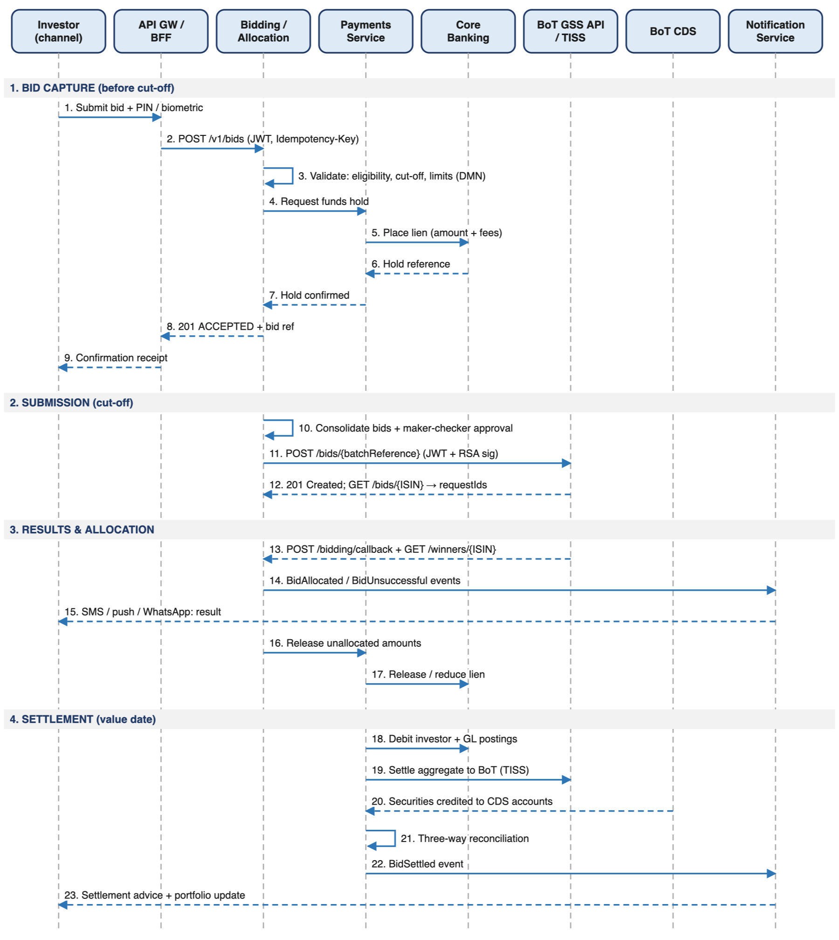
Figure 3 – Bid-to-settlement sequence

5.7 Bid Lifecycle States
The bid is the central aggregate of the platform. Figure 4 shows its state machine, which is enforced by the Bidding service; every transition publishes an event.
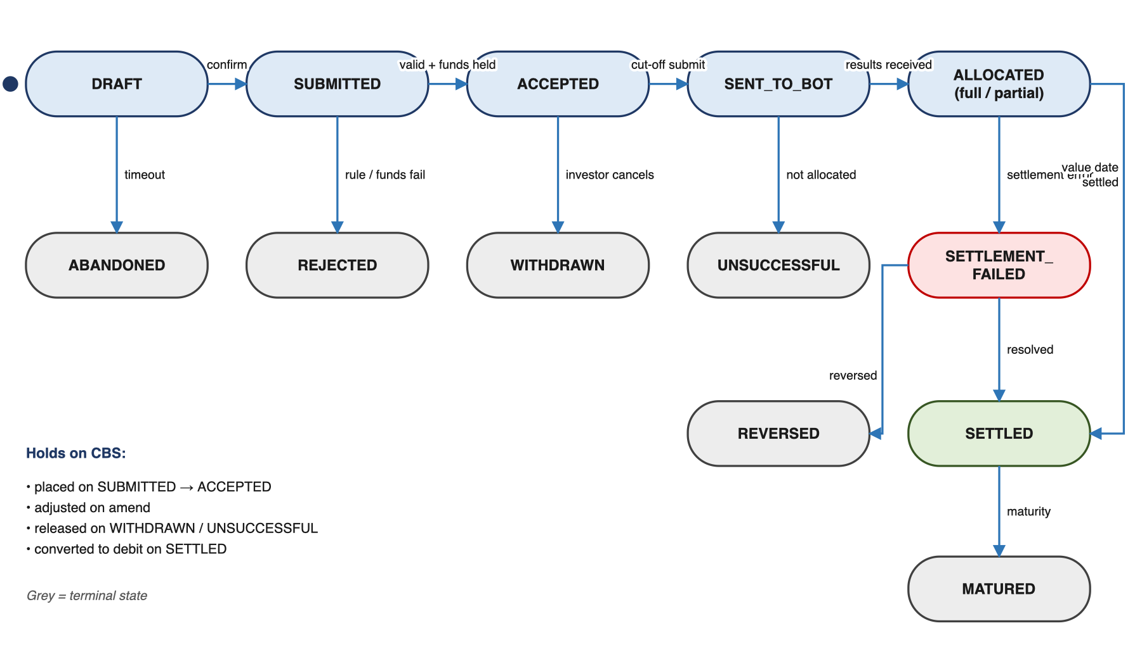
Figure 4 – Bid state machine
State | Meaning | Next states
DRAFT | Captured but not confirmed by the investor | SUBMITTED, ABANDONED
SUBMITTED | Confirmed by the investor; validation and funds hold in progress | ACCEPTED, REJECTED
ACCEPTED | Valid and funds held; can be amended or withdrawn until cut-off | WITHDRAWN, SENT_TO_BOT
SENT_TO_BOT | Included in the consolidated submission and acknowledged by BoT | ALLOCATED_FULL, ALLOCATED_PARTIAL, UNSUCCESSFUL
ALLOCATED_FULL / PARTIAL | Result received; settlement pending | SETTLED, SETTLEMENT_FAILED
UNSUCCESSFUL | Not allocated; hold released | (terminal)
SETTLED | Paid and credited in CDS | MATURED (via holding)
SETTLEMENT_FAILED | Exception; routed to operations for resolution | SETTLED, REVERSED

6. Investor Channel Architecture

6.1 USSD Channel
- A dedicated short code (e.g. *150*xx#) is connected through a licensed USSD aggregator to all major MNOs (Vodacom, Airtel, Tigo/Yas, Halotel, TTCL).
- The USSD BFF keeps session state in Redis and stays within MNO session timeouts (typically 120–180 seconds). Menus are short and have a "resume" option.
- Functions: register, check CDS status, view open auctions, place and withdraw a non-competitive bid, view results and holdings, change PIN, and request a mini statement.
- Competitive bids are limited to simple price entry (with the equivalent yield shown) with a confirmation screen showing the total amount and fees.
- Security: a 4–6 digit PIN (hashed with an HSM-backed key), SIM-swap check via the MNO API where available, a lockout policy, and transaction limits per session and per day.
- Kiswahili is the default, with English available.

6.2 Chatbot Channel
- Available on WhatsApp Business Platform (official Meta BSP) and as a web chat widget on the portal and mobile app.
- A conversational engine (e.g. Rasa or an equivalent NLU running on-premise) handles intents: learn about T-Bills/T-Bonds, auction dates, yield calculator, onboarding guidance, bid status, results and holdings.
- Transactions require step-up authentication (OTP or a deep-link to the app or web). Sensitive data is masked in chat transcripts.
- Unresolved queries are handed over to TCB contact-centre agents, with the conversation context passed along.
- Content is managed by TCB (FAQs, market education) through a CMS, so updates need no code release.

6.3 Web Portal
- A responsive single-page application (React/Angular) that meets WCAG 2.1 AA, is bilingual, and is served through a CDN/WAF at the DMZ.
- Covers the full investor journey: onboarding with document upload, the auction calendar, competitive and non-competitive bidding, a yield/price calculator, portfolio and statements, downloadable confirmations, and profile and notification preferences.
- A corporate and institutional mode adds multi-user mandates (initiator and approver), bulk bid upload (CSV/Excel) and API keys for integrated clients.
- Authentication is OIDC with MFA (OTP or authenticator app), protected by session timeouts and CSRF/CSP headers.

6.4 Mobile Application
- Native-performance cross-platform app (Flutter or React Native) for Android and iOS, published under TCB's store accounts.
- Device binding at first login, biometric authentication (fingerprint/Face ID), and secure storage in Keystore/Keychain.
- Protected by certificate pinning, root/jailbreak detection, code obfuscation and RASP, and tested against OWASP MASVS L2.
- Push notifications for auctions and results, in-app chatbot, portfolio dashboard, and an offline-tolerant read cache for holdings.
- Can also be embedded as a module in the existing TCB mobile banking app to reuse the customer base (open issue OI-05).

6.5 Staff and BoT Portals
Portal | Users | Key functions
Back-Office Portal | TCB Operations, Treasury, Compliance, Customer Service, ICT admins | KYC exception queues, CDS account tracking, auction setup and cut-off control, bid consolidation and maker-checker submission, results upload/validation, settlement and reconciliation workbench, fee/rule configuration, customer 360, complaint handling
BoT Oversight Portal | Authorised BoT officers (read-only) | Real-time participation dashboards, bid and allocation statistics by channel, region, investor type and gender, settlement status, compliance and exception reports, and data export

7. Integration Architecture
All external communication goes through dedicated adapters in the integration layer (Figure 5). Core services never call TCB, BoT or third-party systems directly.
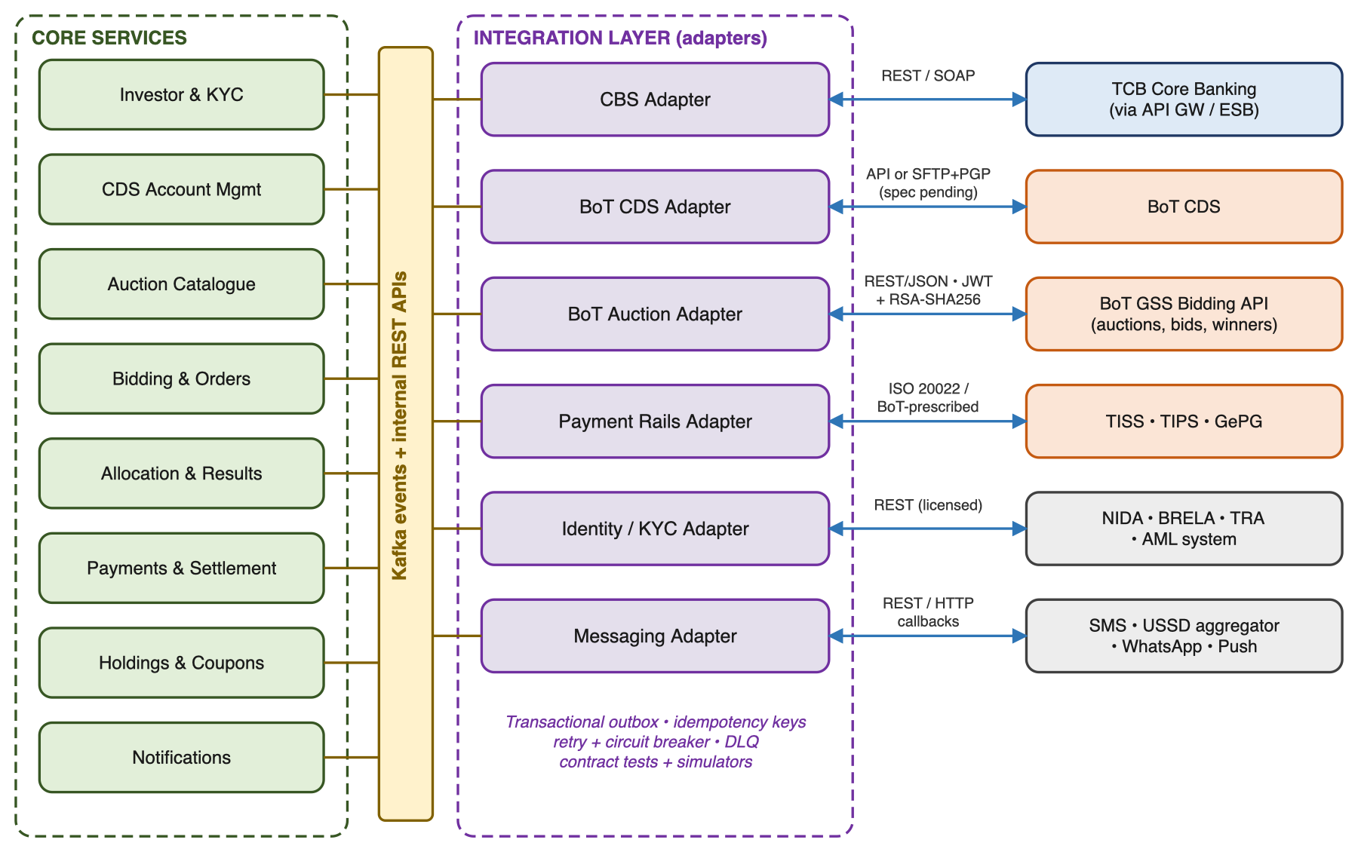
Figure 5 – Integration architecture

7.1 Integration Patterns
- Synchronous APIs (REST/JSON or ISO 20022 XML over HTTPS with mTLS) for real-time calls such as balance enquiry, funds hold, NIDA lookup and CDS enquiries.
- Asynchronous messaging (Kafka / message queue) for internal events and for buffering calls to external systems during peaks or outages.
- Secure file transfer (SFTP with PGP) as the fallback or primary channel wherever BoT or CDS interfaces are file-based, such as bid submission files and results files.
- Transactional outbox and idempotency keys on every financial instruction, so a retry never creates a duplicate hold, debit or bid.
- Circuit breakers, retries with back-off and dead-letter queues with alerts to operations.
- Contract tests and sandbox simulators for each external interface, so development continues before BoT/CBS sandbox access is granted.

7.2 Interface Catalogue
ID | External system | Purpose | Pattern / protocol | Frequency
INT-01 | TCB Core Banking | Customer/CIF lookup, account opening, balance enquiry | REST/SOAP via TCB API gateway / ESB | Real-time
INT-02 | TCB Core Banking | Funds hold/lien, release, debit, credit, GL posting | REST/SOAP, idempotent | Real-time + batch on value date
INT-03 | BoT CDS | CDS account opening and status | API (mTLS) or file | Real-time / intraday
INT-04 | BoT CDS | Holdings, statements, coupon/redemption data | API or file | Daily + on event
INT-05 | BoT GSS Bidding API | Auction discovery – GET /auctions | REST/JSON, JWT + RSA-SHA256 signature | Scheduled + on demand
INT-06 | BoT GSS Bidding API | Batch bid submission, query and update – POST /bids/{batchReference}, GET /bids/{ISIN}, PUT /bids/{ISIN}/{reference} | REST/JSON, JWT + RSA-SHA256 signature | Per auction before cut-off
INT-07 | BoT GSS Bidding API | Results – webhook POST /bidding/callback (inbound) and GET /winners/{ISIN} | REST/JSON; BoT-signed callback | Per auction
INT-07a | BoT GSS Bidding API | Authentication – POST /api/auth (12-hour JWT) | REST/JSON, API key + RSA-SHA256 | Before expiry
INT-08 | TISS / TIPS / GePG | Interbank settlement and payment references | ISO 20022 / BoT-prescribed | Value date
INT-09 | NIDA / BRELA / TRA | Identity, company and TIN verification | REST (licensed access) | Real-time
INT-10 | USSD aggregator / MNOs | USSD sessions and SIM-swap checks | HTTP callbacks | Real-time
INT-11 | SMS gateway, email, FCM/APNs, WhatsApp BSP | Notifications | REST | Real-time
INT-12 | TCB AML / Sanctions system | Screening and suspicious-activity referral | REST / batch | Real-time + daily
INT-13 | TCB AD / SSO, SIEM, DWH | Staff identity, security logs, enterprise reporting | LDAP/SAML/OIDC, syslog, CDC | Continuous

INT-05 to INT-07a follow BoT specification R2. The BoT API does not cover CDS account opening, holdings, coupons or settlement, so INT-03, INT-04 and INT-08 still depend on specifications not yet received (R2a). For those, the adapter keeps the API and SFTP-file options (ADR-04).

7.3 BoT GSS Bidding API Integration
The BoT Auction adapter implements BoT's Government Securities Bidding Process & Authentication API (R2). BoT exposes a sandbox gateway (https://proxy-sandbox.bot.go.tz) and a production gateway (https://proxy.bot.go.tz). The production gateway is reachable only over the BoT Secure Financial WAN, from static IP addresses registered at onboarding.
BoT endpoint | Platform use | Adapter behaviour
POST /api/auth | Obtain JWT access token (12-hour lifetime) and refresh token | Token cached in memory/Redis; renewed at 80% of lifetime and on any 401; one token per adapter cluster
GET /auctions | Populate the Auction Catalogue (ISIN, instrument type, auction date, maturity, tender sizes, status) | Polled on a schedule and before each cut-off; changes published as AuctionPublished / AuctionClosed events
POST /bids/{batchReference} | Submit the consolidated TCB batch for an auction | One batch per ISIN per submission window; approved via maker-checker; bids grouped by ISIN with CDS securityAccount, amount, competitive Y/N, price
GET /bids/{ISIN} | Confirm BoT's view of submitted bids and their status | Called after submission and before cut-off; maps each BoT requestId to the platform bid; drives reconciliation
PUT /bids/{ISIN}/{reference} | Amend a bid (amount, competitive flag, price) before cut-off | Asynchronous: 202 Accepted, final state confirmed via GET /bids or callback
GET /winners/{ISIN} | Retrieve allotment results after the auction | Authoritative pull; used to confirm or replace webhook results
POST /bidding/callback (hosted by TCB) | Receive bid status, auction closing and allotment events from BoT | Exposed in the DMZ; BoT signature verified; idempotent; acknowledged with 200 before asynchronous processing

Request signing and authentication
- TCB generates an RSA 2048-bit key pair and exchanges public keys with BoT. BoT assigns the interface code, sender code and x-api-key.
- Every request carries interface, sender, x-api-key, x-timestamp and x-signature, plus Authorization: Bearer <token> on all endpoints except /api/auth.
- x-signature = Base64(RSA-SHA256, PKCS#1 v1.5) over the canonical string METHOD \n PATH_AND_QUERY \n TIMESTAMP \n BODY. The adapter signs the exact body bytes it sends.
- The private key is held in the HSM (non-exportable) and signing is done through the HSM. The API key and tokens are held in Vault.
- BoT rejects requests older than 300 seconds, so all adapter nodes are NTP-synchronised to TCB time sources and alert if clock skew exceeds 5 seconds.
- Inbound callbacks are verified against BoT's public key and x-timestamp before processing, and are accepted only from BoT source IPs.

Bid submission rules applied before calling BoT
- Batch reference format: 8 alphanumeric characters (BoT-assigned participant code) + YYMMDD + 3-digit sequence, e.g. XXXXXXXX-260930-001. The sequence is allocated centrally, so a retried batch reuses its reference (BoT returns 409 for duplicates).
- Minimum bid amount of TZS 500,000 per bid, enforced in the rules engine so the investor is told at capture time and not after submission.
- Price is sent as a string with two decimals, per 100 face value. The channels show the equivalent yield for information only.
- Each bid's investor CDS security account must already exist. The BoT API does not open CDS accounts (see OI-01).
- BoT bid statuses map to platform states as follows: initiated/processing → SENT_TO_BOT; accepted → SENT_TO_BOT (confirmed); rejected → REJECTED (hold released); allotted → ALLOCATED.

Error handling
BoT response | Adapter action
400 Bad Request | No retry; bid(s) marked for operations review with BoT's code and message
401 Unauthorized | Re-authenticate once via POST /api/auth, then retry; alert if it repeats
403 Forbidden | No retry; security alert (signature, IP allow-list or instrument registration problem)
404 Not Found | Refresh auction catalogue; flag the bid or batch for review
409 Conflict | Cut-off passed: bids set to REJECTED and holds released. Duplicate reference: treat as already submitted and reconcile via GET /bids
500 / timeout | Retry with exponential back-off and the same batch reference until the cut-off guard time; then escalate to Treasury Operations

7.4 Reconciliation
Reconciliation | Sources compared | Frequency | Outcome
Bid vs hold | Accepted bids ↔ active CBS holds | Hourly on auction days; before cut-off | Orphan holds released; unfunded bids blocked
Submission | Platform batch ↔ BoT GET /bids/{ISIN} (by batchReference and requestId) | Per auction, before cut-off | Missing or rejected bids flagged before cut-off
Allocation vs settlement | BoT results ↔ CBS debits ↔ TISS settlement | Value date | Settlement breaks routed to exceptions queue
Holdings | Platform holdings ↔ BoT CDS statement | Daily | Position breaks investigated within the agreed SLA
Coupons/maturities | Expected cash flows ↔ BoT proceeds ↔ investor credits | On payment date | Unpaid or overpaid items corrected

7.5 Event-Driven Architecture
Each service writes its state change and an outbox record in the same database transaction. A relay publishes outbox records to Kafka, so an event is never lost and never published for a rolled-back change. Consumers are idempotent and track processed event IDs.
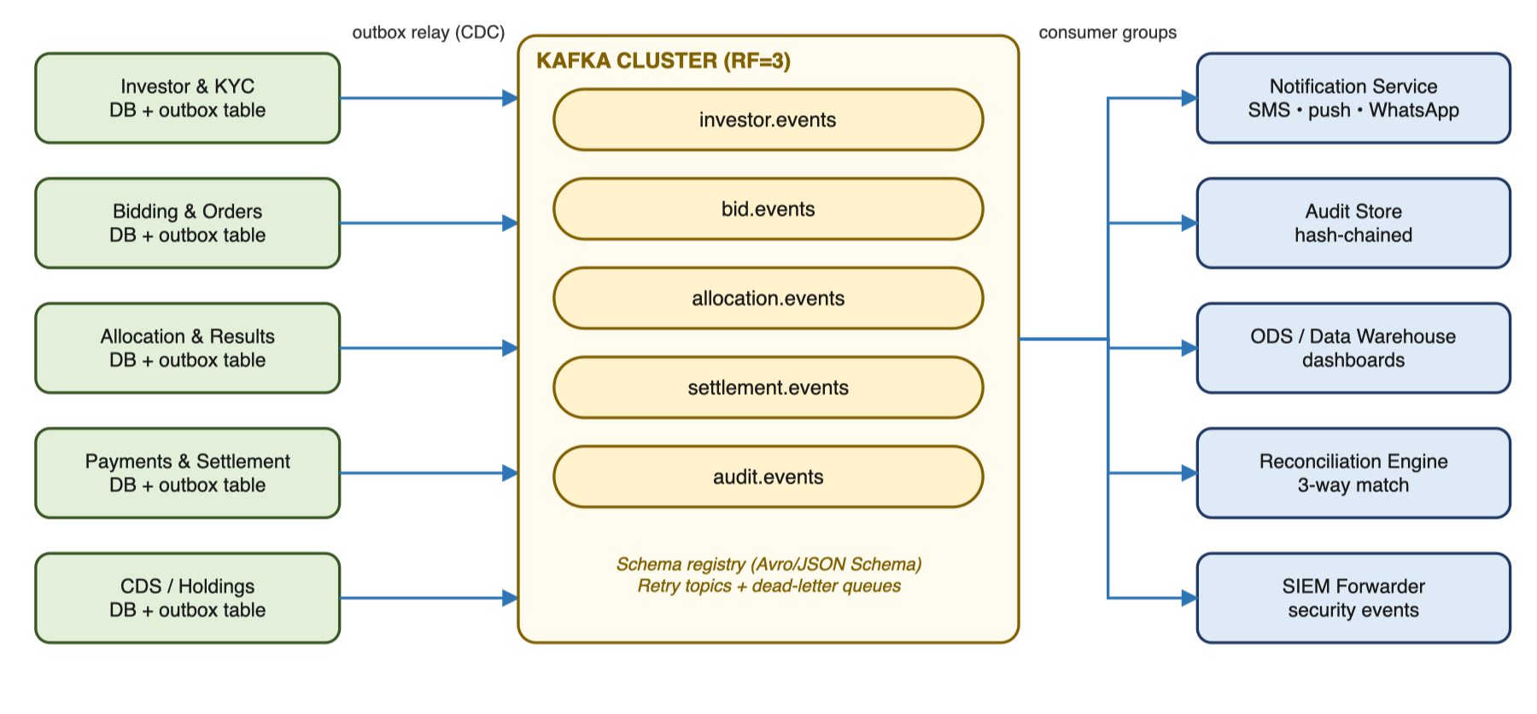
Figure 6 – Event-driven architecture
Event | Producer | Main consumers
InvestorRegistered / KycApproved | Investor & KYC | CDS Account, Notifications, Audit, ODS
CdsAccountOpened | CDS Account | Notifications, Audit, ODS
AuctionPublished / AuctionClosed | Auction Catalogue | Notifications, Bidding, ODS
BidAccepted / BidWithdrawn / BidRejected | Bidding | Payments, Notifications, Audit, ODS
BidsSubmitted | Bidding | Audit, ODS, Reconciliation
BidAllocated / BidUnsuccessful | Allocation | Payments, Notifications, Audit, ODS
BidSettled / SettlementFailed | Payments | Holdings, Notifications, Reconciliation, Audit
CouponPaid / SecurityMatured | Coupons & Redemptions | Payments, Notifications, ODS

8. API Architecture

8.1 API Standards
Aspect | Standard
Style and contract | REST over HTTPS with JSON; OpenAPI 3.1 contract per service, published in the API portal; contract-first development
Versioning | URI major version (/v1/…); backward-compatible changes only within a version; 6-month deprecation window
Security | OAuth 2.0 / OIDC access tokens (JWT) validated at the gateway; scopes per channel and role; mTLS between gateway and services
Idempotency | Idempotency-Key header required on all POST requests that create financial effects (bids, holds, payments)
Traceability | X-Correlation-ID propagated end to end and written to logs, traces and audit events
Errors | RFC 7807 problem+json with stable error codes (e.g. BID_CUTOFF_PASSED, INSUFFICIENT_FUNDS)
Data formats | ISO 8601 timestamps in UTC with EAT display; amounts as decimal strings with currency (TZS); ISIN for securities
Limits | Rate limits and quotas per channel and client at the gateway; cursor-based pagination on lists

8.2 Key Endpoints
Method | Endpoint | Purpose | Consumers
POST | /v1/investors | Register investor and start KYC | All channels
POST | /v1/investors/{id}/documents | Upload KYC documents | Web, Mobile, Back-office
POST | /v1/investors/{id}/cds-accounts | Initiate CDS account opening | All channels
GET | /v1/auctions?status=OPEN | List open auctions | All channels
POST | /v1/bids | Submit a bid (creates funds hold) | All channels
PATCH / DELETE | /v1/bids/{bidRef} | Amend or withdraw before cut-off | All channels
GET | /v1/bids?investorId=… | Bid history and status | All channels
GET | /v1/holdings, /v1/statements | Portfolio, statements, confirmations | All channels
POST | /v1/ops/auctions/{no}/submissions | Prepare consolidated submission (maker) | Back-office
POST | /v1/ops/submissions/{id}/approve | Approve and send to BoT (checker) | Back-office
GET | /v1/oversight/statistics | Participation and settlement statistics | BoT portal
POST | /internal/v1/auction-results | Ingest BoT results (from adapter) | BoT Auction adapter

8.3 Example: Bid Submission (channel → platform)
POST /v1/bids
Authorization: Bearer <access-token>
Idempotency-Key: 6f1c2a9e-3b7d-4c55-9a01-2f7e8d0c4b11
X-Correlation-ID: 9b2e7c1d-...

{
"auctionNo": "TB-2026-0912",
"isin": "TZ1996100000",
"bidType": "COMPETITIVE",
"faceValue": { "amount": "5000000.00", "currency": "TZS" },
"price": "99.50",
"settlementAccount": "0150XXXXXXXX",
"channel": "MOBILE"
}

201 Created
{ "bidRef": "B-7Q4K2M", "state": "ACCEPTED", "holdRef": "LN-88213",
"heldAmount": { "amount": "5012500.00", "currency": "TZS" },
"cutOff": "2026-09-30T11:00:00+03:00" }

Identifiers and values above are illustrative only.

8.4 Example: Batch Submission (platform → BoT)
POST https://proxy.bot.go.tz/bids/XXXXXXXX-260930-001
Authorization: Bearer <BoT access token>
interface: <BoT-assigned interface code>
sender: <BoT-assigned sender code>
x-api-key: <from Vault>
x-timestamp: 2026-09-30T08:15:00Z
x-signature: <Base64 RSA-SHA256 of canonical string, signed in HSM>
content-type: application/json

[
{ "ISIN": "TZ1996106013",
"bids": [
{ "securityAccount": "<investor CDS account>", "amount": 5000000,
"competitive": "Y", "price": "99.50" },
{ "securityAccount": "<investor CDS account>", "amount": 2000000,
"competitive": "N", "price": "<see OI-03>" } ] } ]

9. Data Architecture

9.1 Core Information Model
Figure 7 shows the core entities and their relationships. Each service owns its entities; other services refer to them only by identifier.
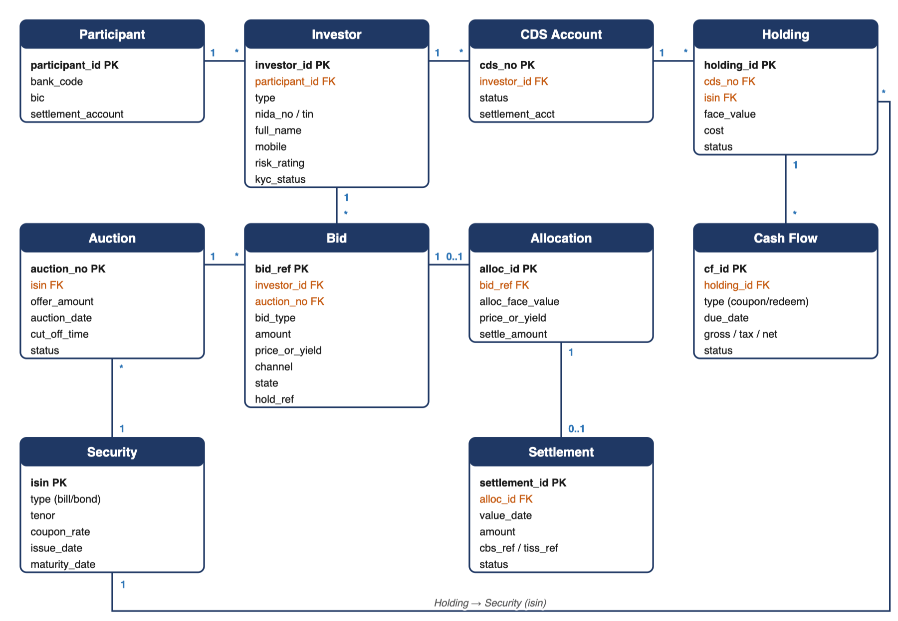
Figure 7 – Core information model
Entity | Key attributes | Source of truth
Participant | Bank code, name, BIC, settlement account | Platform (config)
Investor | Investor ID, type, NIDA/TIN, name, contacts, risk rating, KYC status, consent flags | Platform (KYC), CBS (CIF)
CDS Account | CDS number, investor ID, status, linked settlement account | BoT CDS
Security | ISIN, type (T-Bill/T-Bond), tenor, coupon, issue/maturity dates | BoT
Auction | Auction no., security, offer amount, dates, cut-off time, status | BoT
Bid | Bid ref, investor, auction, type, amount, price, channel, state, hold reference, BoT requestId, batchReference | Platform
Allocation | Bid ref, allotted amount, allotted price, settlement amount | BoT (results) / Platform (computed)
Settlement | Settlement ID, value date, amounts, CBS/TISS references, status | Platform + CBS
Holding | CDS number, ISIN, face value, acquisition cost, status | BoT CDS (mirrored)
Cash-flow | Holding, type (coupon/redemption), due date, gross, tax, net, status | Platform / BoT
Audit event | Timestamp, actor, channel, action, before/after, correlation ID, hash | Audit store

9.2 Data Stores
- Transactional: PostgreSQL (or TCB's standard Oracle), one schema per service, in synchronous streaming replication to the DR site.
- Events: Apache Kafka with a schema registry. Retention is configured for replay. Events feed the ODS, audit trail and notifications.
- Documents: S3-compatible object storage (e.g. MinIO) holds KYC images and confirmations. Files are encrypted and managed under retention policies.
- Analytics: an operational data store for near-real-time dashboards, plus a dimensional data warehouse (star schema) that can feed TCB's enterprise DWH.

9.3 Data Protection and Retention
- All personal data is stored and processed in Tanzania, in TCB's primary and DR data centres.
- Data is classified (Public, Internal, Confidential, Restricted). NIDA numbers, phone numbers and account numbers are Restricted and are encrypted at field level with tokenisation for analytics.
- Consent is captured and versioned per purpose (processing, marketing and data sharing with BoT/CDS), and data-subject requests are supported.
- Retention follows BoT and AML record-keeping requirements (at least 10 years for transaction records, or as set by TCB policy). Archival and secure purge are automated.
- Non-production environments use anonymised or masked data only, in line with TCB policy.

10. Security Architecture
Figure 8 shows the trust zones, the controls applied at each boundary, and the shared security services.
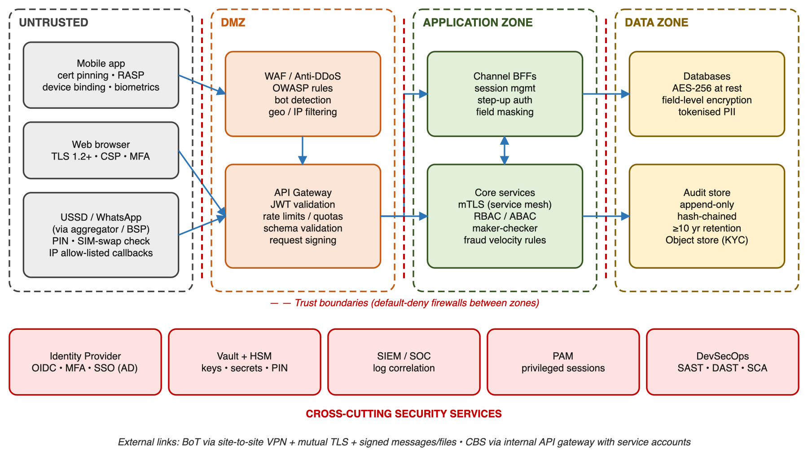
Figure 8 – Security architecture and trust boundaries

10.1 Security Controls by Layer
Layer | Controls
Identity & access | OIDC/OAuth 2.0 (Keycloak or TCB IAM); MFA for web, portal and staff; device binding plus biometrics for mobile; PIN plus SIM-swap check for USSD; RBAC/ABAC with least privilege; maker-checker for all financial and configuration actions; PAM for privileged access; staff SSO through TCB AD
Network | Segmented zones (Internet → DMZ → App → Data → Integration); WAF and anti-DDoS; default-deny firewalls; IP allow-lists and site-to-site VPN or private link to BoT; no direct database access from the DMZ
Application | Secure SDLC; OWASP ASVS L2 (web/API) and MASVS L2 (mobile); input validation; rate limiting; bot/fraud detection; SAST, DAST, SCA and container scanning in CI/CD; secrets never stored in code
Data | TLS 1.2+ everywhere and mTLS for service-to-service and BoT links; AES-256 at rest; field-level encryption for Restricted data; HSM-backed key management and rotation; masking in logs and non-production
Transaction integrity | Digitally signed messages and files to and from BoT (PKI); idempotency; hash-chained audit log; four-eyes approval of consolidated submissions
Monitoring & response | Centralised logging to TCB SIEM/SOC; use cases for account takeover, abnormal bidding and privilege misuse; incident response playbooks aligned to BoT incident-reporting timelines
Assurance | Independent penetration test before go-live and annually after; vulnerability management with SLAs; ISO 27001-aligned controls

10.2 Compliance Mapping
Requirement source | Key obligations | Architectural response
Bank of Tanzania Act, 2006 and BoT auction rules/guidelines | Fiscal-agent rules, participant obligations, auction procedures | Configurable rules engine, BoT-format submissions, oversight portal
BoT cybersecurity and ICT risk management guidelines | Governance, risk assessment, security controls, incident reporting, outsourcing | Controls in 10.1, SIEM integration, DR, third-party access through PAM
Personal data protection legislation (R4) | Lawful processing, consent, security, data-subject rights, cross-border limits | In-country hosting, consent service, encryption, retention and purge
AML/CFT legislation and regulations | CDD/EDD, screening, record keeping, STR reporting | KYC service, sanctions/PEP screening, AML system integration, 10-year audit
TCB ICT and Security Policies | Internal standards for access, change, hosting, logging | Adoption of TCB IAM, SIEM, change management and hosting standards

11. Reporting and Analytics
Audience | Dashboards and reports
TCB Management | Participation trends, bid volumes and values by channel, region, investor type and gender; revenue from fees; new investors; channel adoption
TCB Treasury & Operations | Live auction-day monitor (bids, holds, time to cut-off), submission status, results summary, settlement and reconciliation status, exceptions ageing
TCB Compliance | KYC status, high-risk investors, screening hits, maker-checker overrides, audit trail queries
BoT (oversight) | Real-time and per-auction statistics, retail vs institutional participation, geographic distribution, settlement performance, regulatory returns in BoT formats
Investors | Portfolio, statements, confirmations, coupon/maturity calendar, tax certificates

Reports can be exported to PDF, Excel and CSV and scheduled for email distribution. Dashboards refresh in near real time from the event stream (latency under 1 minute).

12. Non-Functional Requirements
Attribute | Target
Availability | 99.9% monthly for investor channels; 99.95% during auction windows
Performance | API p95 < 500 ms (excluding external calls); USSD step response < 2 s; results notification to all investors within 15 minutes of result receipt
Capacity | Sized for 500,000 registered investors, 50,000 bids per auction and 300 concurrent bids per second at the cut-off peak; horizontally scalable
Recovery | RPO ≤ 5 minutes; RTO ≤ 2 hours; tested DR failover twice a year
Security | Zero critical/high findings open at go-live; OWASP ASVS L2 and MASVS L2
Usability | Kiswahili and English; WCAG 2.1 AA for web; onboarding in under 10 minutes for existing TCB customers
Auditability | 100% of state changes audited with actor, timestamp and channel; immutable retention of at least 10 years
Maintainability | Automated test coverage ≥ 70% on core services; zero-downtime rolling deployments

13. Deployment Architecture

13.1 Network Zones and Hosting
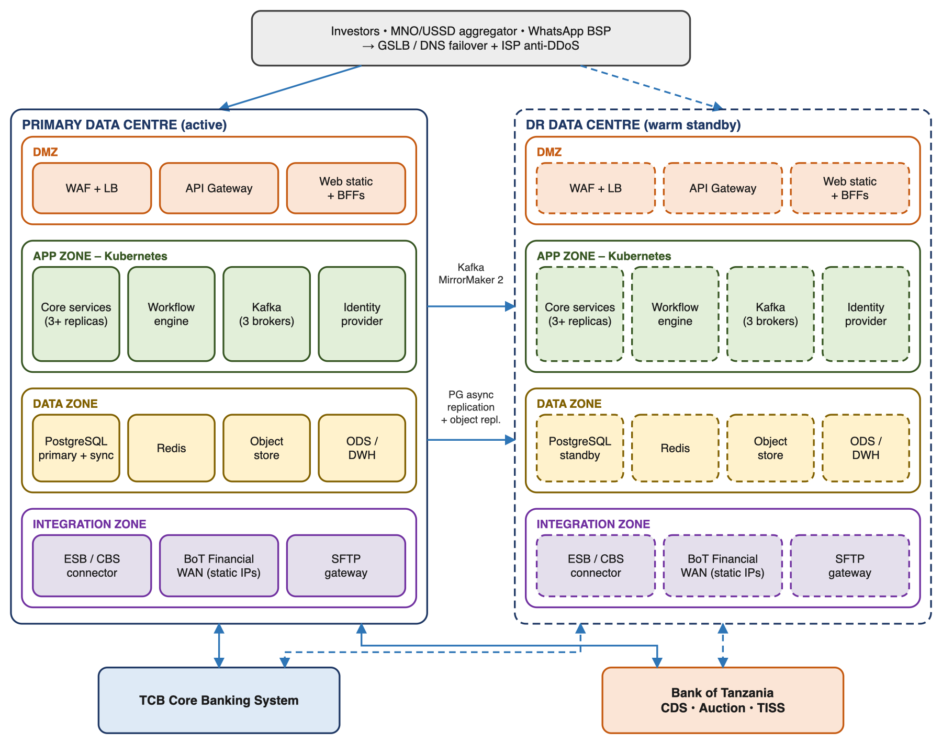
Figure 9 – Deployment topology across primary and DR data centres
- Active-passive deployment across TCB's primary data centre and DR site, with database replication and Kafka mirroring. The DMZ and stateless tiers can run active-active if TCB's network allows.
- Container platform: Kubernetes (e.g. Red Hat OpenShift or RKE2), or TCB's existing standard, with GitOps (Argo CD) for declarative deployments.
- Infrastructure as Code (Terraform/Ansible) produces environments that are consistent and auditable.

13.2 Environments
Environment | Purpose | Data
DEV | Development and unit testing, with BoT/CBS simulators | Synthetic
SIT | System integration testing with TCB and BoT sandboxes | Anonymised
UAT | Business acceptance by TCB and BoT users | Anonymised
PRE-PROD | Performance, security and DR rehearsals; production-like | Anonymised
PROD / DR | Live service | Production

13.3 Indicative Infrastructure Sizing (Production, per site)
Component | Nodes | vCPU / RAM per node | Storage
Kubernetes worker nodes | 4 | 16 vCPU / 64 GB | 200 GB
Kubernetes control plane | 3 | 4 vCPU / 16 GB | 100 GB
PostgreSQL (primary + replica) | 2 | 16 vCPU / 64 GB | 2 TB SSD
Kafka brokers | 3 | 8 vCPU / 32 GB | 1 TB SSD
Object storage | 3 | 4 vCPU / 16 GB | 4 TB
DWH / Reporting | 1 | 16 vCPU / 64 GB | 2 TB

Final sizing will be validated through performance testing in pre-production.

14. Technology Stack
Where TCB already has a standard product (for example an API gateway, IAM, database or SIEM), the platform uses it to reduce licensing and support overhead (open issue OI-06).
Layer | Proposed technology | Alternatives / TCB standard
Core services | Java 21 / Spring Boot (microservices) | .NET 8
Web portals | React + TypeScript | Angular
Mobile app | Flutter | React Native; native Kotlin/Swift
USSD | Custom USSD BFF (Spring) + Redis session store | Aggregator-hosted menu engine
Chatbot | Rasa (on-premise NLU) + WhatsApp Business Platform | Microsoft Bot Framework
Workflow / rules | Camunda 8 (BPMN/DMN) | Flowable, Drools
API gateway | Kong / WSO2 | TCB existing gateway
Identity | Keycloak (OIDC) | TCB IAM / Azure AD for staff
Messaging | Apache Kafka | RabbitMQ, IBM MQ
Databases | PostgreSQL 16, Redis | Oracle (TCB standard)
Analytics | PostgreSQL DWH + Apache Superset / Power BI | TCB DWH platform
Observability | OpenTelemetry, Prometheus, Grafana, ELK/OpenSearch | TCB monitoring tools
Security tooling | HashiCorp Vault + HSM, SonarQube, OWASP ZAP, Trivy | TCB security stack
Platform | Kubernetes (OpenShift/RKE2), Argo CD, GitLab CI | TCB standard

15. High Availability and Disaster Recovery
Component | High availability (within a site) | Disaster recovery (across sites)
DMZ / API gateway | ≥ 2 instances behind a load balancer | Pre-deployed at DR; DNS/GSLB failover
Stateless services and BFFs | ≥ 3 replicas across nodes; HPA autoscaling; pod disruption budgets | Deployed at DR through GitOps; scaled up on failover
Workflow engine | Clustered brokers; state persisted to the database | Replicated state; resumes in-flight processes
PostgreSQL | Primary plus synchronous standby (Patroni); automatic failover | Asynchronous streaming replica at DR; RPO ≤ 5 min
Kafka | 3 brokers; replication factor 3; min.insync.replicas = 2 | MirrorMaker 2 to the DR cluster; consumer offsets synced
Redis (sessions, cache) | Sentinel or cluster mode | Rebuilt at DR; USSD sessions restart
Object storage | Erasure-coded, 3+ nodes | Bucket replication to DR
BoT / CBS connectivity | Redundant links and VPN tunnels | Separate BoT link and certificates provisioned at DR

- Failover runbook: freeze bid intake, promote the DR database, switch GSLB, replay outbox and Kafka, run reconciliation, then reopen channels. Target RTO is 2 hours or less.
- Auction-day safeguard: if a failover happens near cut-off, submission can be triggered manually from DR after a reconciliation check. TCB will agree an escalation path with BoT in advance.
- Backups: daily full backups plus continuous WAL archiving. Backups are encrypted and kept offsite and immutable. Restores are tested every quarter.

16. Observability and Operations

16.1 Monitoring
- Business activity monitoring for auction days: bids per minute, hold failures, time to cut-off, submission and result status.
- Technical monitoring: service health, latency, error rates, queue depth and external interface availability (BoT, CBS, NIDA, MNOs), with alerts by SMS, email and on-call.
- Distributed tracing (OpenTelemetry) with one correlation ID from the channel request through to CBS and BoT calls.
- Structured JSON logs with PII masked, shipped to the log platform and forwarded to TCB SIEM.
- Synthetic transactions on each channel every 5 minutes.

16.2 Incident Severity Model
Severity | Definition | Response | Resolution / workaround
P1 – Critical | Platform or a channel is down, or bidding/settlement cannot be processed | 15 min (24x7) | 4 hours
P2 – High | Major function degraded; workaround exists | 1 hour | 8 hours
P3 – Medium | Minor function affected | 4 business hours | 3 business days
P4 – Low | Cosmetic issue or enquiry | 1 business day | Next release

16.3 Release and Change Management
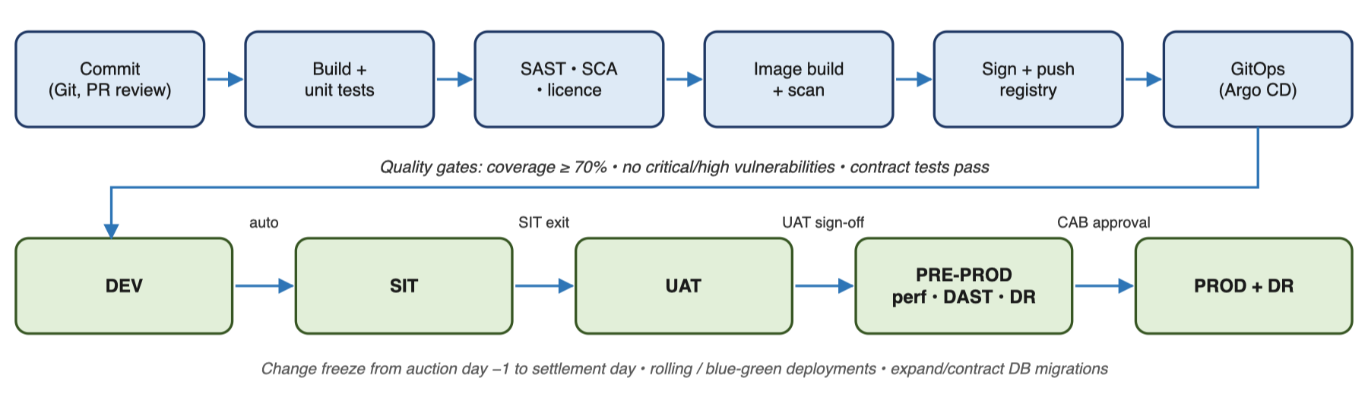
Figure 10 – CI/CD pipeline and environment promotion
- Trunk-based development. CI pipelines build, test, scan (SAST, SCA, containers) and sign each image.
- Promotion DEV → SIT → UAT → PRE-PROD → PROD goes through GitOps, with CAB approval before production.
- Rolling or blue-green deployments with zero downtime. Database migrations are backward-compatible (expand/contract).
- A change freeze applies in the window from auction day minus 1 to settlement day.

17. Architecture Decision Records
ID | Decision | Rationale | Alternatives considered
ADR-01 | Microservices by business domain behind channel BFFs | Independent scaling for auction peaks; channel isolation; clear data ownership | Modular monolith (simpler, but one scaling unit)
ADR-02 | Funds hold on CBS before a bid is accepted | Removes settlement failures from insufficient funds | Debit at submission (poor experience if unsuccessful); debit at settlement (settlement risk)
ADR-03 | Kafka event backbone with transactional outbox | Reliable events for audit, notifications, analytics and reconciliation | Direct synchronous calls only; RabbitMQ
ADR-04 | BoT GSS Bidding API (REST) for auctions, bids and results; API-or-file adapters kept for CDS and settlement | BoT has published R2 for bidding; CDS and settlement interfaces are still unspecified | File-only integration
ADR-05 | BPMN workflow engine for long-running processes | Visible, auditable state for multi-day flows; timers for cut-offs | Hand-coded state machines
ADR-06 | DMN rules for auction and eligibility parameters | BoT rule changes need no code release | Hard-coded configuration
ADR-07 | On-premise Kubernetes at TCB primary and DR sites | Data residency, BoT connectivity, TCB control | Public cloud (residency and connectivity constraints)
ADR-08 | Participant ID on all records (multi-participant ready) | Other banks can join without redesign | Single-tenant model
ADR-09 | Hash-chained, append-only audit store | Tamper evidence for regulators and disputes | Ordinary database audit tables

18. Technical Risks and Open Issues

18.1 Technical Risks
Risk | Impact | Mitigation
BoT winners/callback payloads lack per-account identifiers (see Appendix B) | High | Raise with BoT immediately; interim matching on batchReference + requestId + amount + price with manual review of ambiguous matches
CDS account-opening and settlement interfaces not yet specified | High | Simulators and contract tests; API-or-file adapters (ADR-04)
BoT 300-second timestamp tolerance and 12-hour token expiry | Medium | NTP synchronisation and skew alerts; proactive token renewal
CBS lacks API support for lien/hold operations | High | Fallback: a dedicated hold/suspense account model with GL-based controls
Auction-day load spike near cut-off | Medium | Queue-based buffering, autoscaling, load tests at 2× forecast peak
Fraud or account takeover on remote channels | Medium | MFA, device binding, SIM-swap checks, velocity limits, fraud monitoring
USSD session timeouts on long journeys | Medium | Short menus, resumable sessions, complex actions pushed to other channels
Dependence on third-party providers (MNO, WhatsApp BSP, NIDA) | Medium | Multi-provider SMS, graceful degradation, contractual SLAs

18.2 Open Issues to Resolve
# | Open issue | Owner
OI-01 | Obtain BoT interfaces for CDS account opening, holdings and coupon/redemption data (not in R2) | TCB ICT + BoT
OI-02 | Confirm the settlement mechanism to BoT (TISS aggregate vs GePG control number per investor); R2 has no settlement endpoint | TCB Treasury + BoT
OI-03 | Resolve the BoT API clarifications listed in Appendix B before building the Auction adapter | TCB ICT + BoT
OI-04 | Confirm CBS capabilities for lien, GL posting and account opening APIs | TCB ICT
OI-05 | Standalone app vs module in the existing TCB mobile banking app | TCB Digital
OI-06 | Reuse TCB enterprise IAM, API gateway, SIEM and HSM vs dedicated instances | TCB ICT / CISO
OI-07 | Fee and tax rules (commission, CDS fees, withholding tax) per investor category | TCB Finance / Compliance

Appendix B – BoT API Specification Review (R2)
The table below lists gaps and inconsistencies found in BOT-SPEC-GSS-2026-v1.0 that affect the platform. Items marked High block straight-through processing and should be raised with BoT before the Auction adapter is built.
# | Area | Observation in R2 | Impact on TCB | Priority
B1 | Winners / allotment | GET /winners/{ISIN} and WinnerResponse return only investor name, amount, price and competitive flag, with no securityAccount or requestId. | TCB submits many investors in one batch; allotments cannot be matched to individual investors reliably. | High
B2 | Bid identifiers | POST /bids returns only batch-level totals (the Model6 schema has a single requestId); PUT needs a per-bid {reference}. | Per-bid BoT identifiers must be obtained via GET /bids/{ISIN}; the response should return a requestId per bid. | High
B3 | Cancellation | The overview says bids can be cancelled, but no DELETE or cancel operation is defined; PUT only updates. | Investor withdrawals before cut-off cannot be sent to BoT. | High
B4 | Auction data | AuctionItem has no cut-off time, minimum bid, coupon rate, auction number or settlement date, although section 5 says these are provided. | Cut-off enforcement and T-Bond pricing need these fields; otherwise they must be keyed in manually. | High
B5 | Non-competitive bids | price is required on every bid (Model3), including non-competitive bids, which are allotted at the weighted average price. | Unclear what price to send for competitive = N. | Medium
B6 | Callback contract | The callback schema is generic (data: object); status 'allotted' and action 'approve' are not in the documented enums; event types, retry policy and ordering are not defined. The 401 text mentions HMAC while the header is RSA; the cURL sample shows the participant calling BoT's URL. | Webhook handling needs a defined event catalogue, retry/idempotency rules and a single signature scheme. | High
B7 | Result summary | Section 7 mentions cut-off yields and pro-rata percentages, but the schemas carry none of them. | Investor notices and BoT reporting need cut-off price, weighted average price/yield and pro-rata ratio. | Medium
B8 | Response shapes | The schemas define {status, data} envelopes, but the /auctions and /bids samples return bare arrays; the /winners sample is keyed by ISIN. | The adapter must handle both shapes until BoT confirms one. | Medium
B9 | Sample data | POST /bids sample totalAmount (35,000,000) does not equal the bids sent (15,000,000); ISIN TZ1996106013 is a 364-day bill in one sample and a 20-year bond in another. | Low on its own, but test fixtures should come from the sandbox, not the document. | Low
B10 | Timestamp and signing | x-timestamp may be ISO 8601 or epoch milliseconds; the Python sample signs path only, while the specification says PATH_AND_QUERY. | Signature mismatches on GET requests with query strings; TCB will use ISO 8601 and sign path + query, subject to sandbox confirmation. | Medium
B11 | Token refresh | A refreshToken is issued, but no refresh endpoint is documented. | The platform re-authenticates via POST /api/auth before expiry. | Low
B12 | Amounts | Amounts are JSON numbers with no stated unit (face value vs consideration) and prices are strings in requests but numbers in responses. | Risk of rounding and interpretation errors in settlement. | Medium
B13 | Limits | No rate limits, maximum bids per batch, or batch size limits are documented. | Needed to size batching for large retail auctions. | Medium
B14 | Out of scope of R2 | No endpoints for CDS account opening, holdings, statements, coupons/redemptions or settlement. | Covered by OI-01 and OI-02. | High

Appendix A – Glossary
Term | Meaning
BoT | Bank of Tanzania
CBS | Core Banking System
CDS / CSD | Central Depository System / Central Securities Depository
T-Bill / T-Bond | Treasury Bill (short-term, discounted) / Treasury Bond (long-term, coupon-bearing)
TISS | Tanzania Interbank Settlement System (RTGS)
TIPS | Tanzania Instant Payment System
GePG | Government Electronic Payment Gateway
NIDA | National Identification Authority
BFF | Backend-for-Frontend – channel-specific API layer
mTLS | Mutual Transport Layer Security
HSM | Hardware Security Module
SIEM | Security Information and Event Management
RPO / RTO | Recovery Point Objective / Recovery Time Objective
UAT / SIT | User Acceptance Testing / System Integration Testing
DPPA | Data Protection and Privacy Act
GSS | BoT Government Securities System
JWT | JSON Web Token
Maker-checker | Four-eyes control where one user initiates and another approves

