**Laastras Specification－defeat crime, poverty, unemployment, and inequalities**

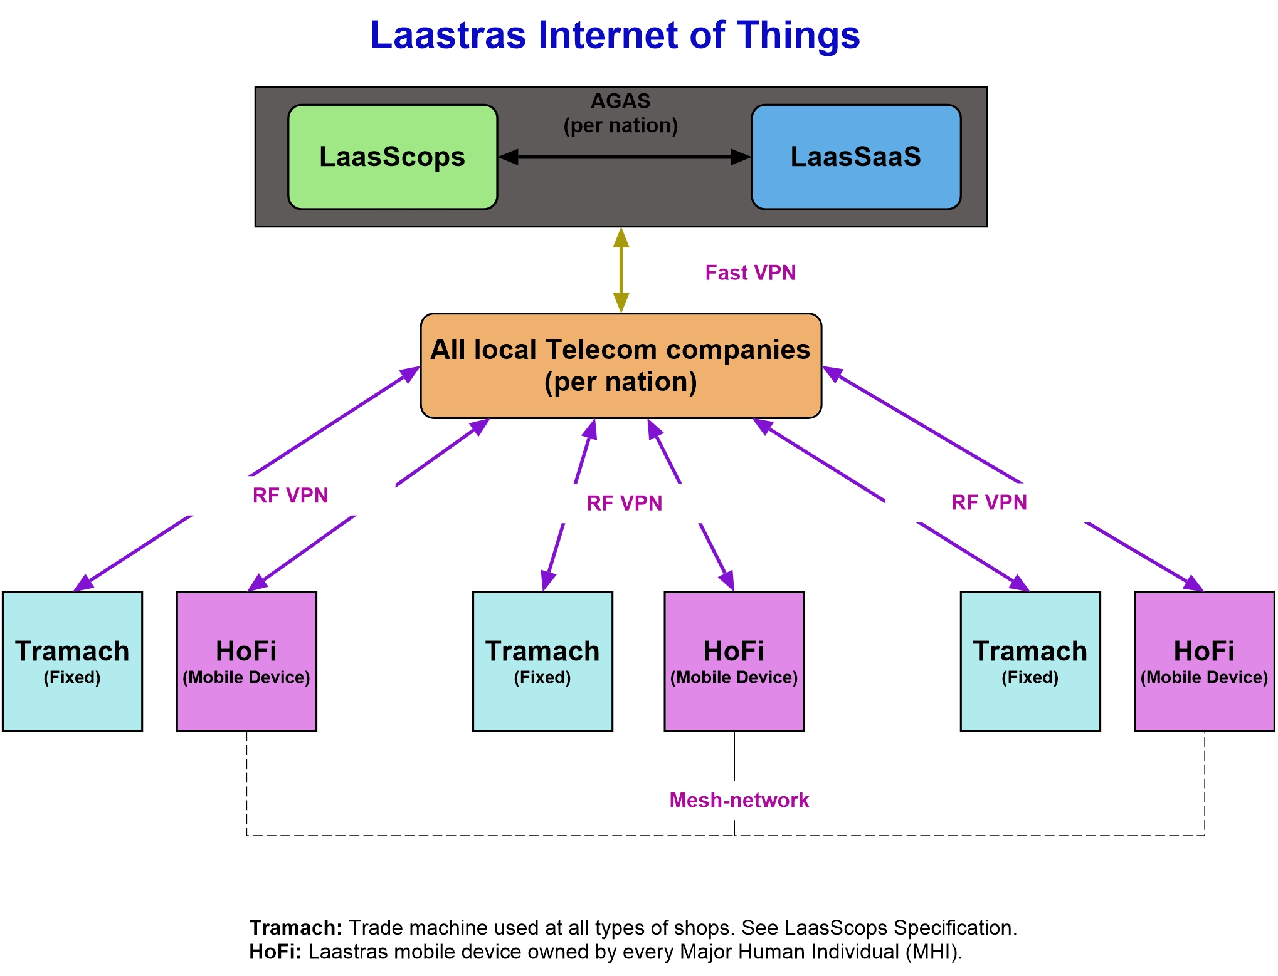

－Obed-Edom Nkezabahizi

# Table of contents

Introduction ……………………………………………………………………… 3

1. LaasScops …………………………………………………………………….. 3

Keywords ………………………………………………………………... 3

[Laastras Organizational Diagram](#_Laastras Organizational Diagram) ……………………………………….. [5](#_Laastras Organizational Diagram)

[Shopping Protocol](#_Shopping Protocol) ………………………………………………………. [5](#_Shopping Protocol)

[Crecon Establishment Protocol Through Laastras AORI](#_Crecon Establishment Protocol Through Laastras AORI) ………………. [6](#_Crecon Establishment Protocol Through Laastras AORI)

[LaasScops Deliverables for Starters](#_LaasScops Deliverables For Starters) ……………………………………. [7](#_LaasScops Deliverables For Starters)

[LaasScops Logic Diagram](#_LaasScops Logic Diagram) ……………………………………………… [8](#_LaasScops Logic Diagram)

[LaasScops Use Cases](#_LaasScops Use Cases) …………………………………………………... [8](#_LaasScops Use Cases)

1. LaasSaaS …………………………………………………………………….. 10

[LaasSaaS Deliverables](#_LaasSaaS Deliverables) …………………………………………………. [10](#_LaasSaaS Deliverables)

[LaasSaaS C14 Services Diagram](#_LaasSaaS C14 Services Diagram) ……………………………………….. [11](#_LaasSaaS C14 Services Diagram)

[LaasSaaS Use Cases](#_LaasSaaS Use Cases) …………………………………………………….. [11](#_LaasSaaS Use Cases)

1. Conclusion ……………………………………………………………………. 13

[Laastras Project Equipment](#_Laastras Project Equipment) …………………………………………….. [13](#_Laastras Project Equipment)

[Important Results to Achieve](#_Important Results to Achieve) …………………………………………… [13](#_Important Results to Achieve)

[Solved Problems](#_Solved Problems) ………………………………………………………… [13](#_Solved Problems)

[Marketing Strategies](#_Marketing Strategies) ……………………………………………………. [14](#_Marketing Strategies)

# Introduction

Free trade capability requires a unified system that allows human individuals to move freely and to perform transactions anywhere in the world. To avoid chaos, there’s a need to use one card that supports three functions: commercial transaction, local official identification (national id), and, ultimately, international identification (passport). LaasScops and LaasSaaS are two cloud services that make Laastras (<https://laastras.herokuapp.com>) possible. They will pave the way for common virtual currency world over and a world federal government. See

<https://leanpub.com/World-Federal-Government-Constitution--Leadership-as-a-Service>.



# LaasScops

Laastras is an organizational project devised to simplify our mission to establish lasting peace in our society. Wars and instabilities have ceased in many parts of the world thanks to national and international security measures taken by countries. Sadly, however, conflicts in the domain of trade are wreaking havoc and are often translated into organized crimes, trade wars, poverty, unemployment, and inequality amongst people and nations. Two major services, that is, IooT (Internet of our Things) and AORI (Acquire or Integrate), are designed to help Laastras solve those trade-related issues so as to establish stability in countries, at first, and then around the world. LaasScops refers to those two services and will put local and international trade straight so as to defeat crime, poverty, unemployment, and inequality. Our portfolio at <https://laastras.herokuapp.com> sheds more light on the project.



# Keywords

**Identification Card (Idec)**: A simplistic tag, like an NFC tag, that can hold an identification string that is or can be mapped to a phone number and therefore to a resident’s legal complete identification. This will replace current passports and will make trade and movement easy. Still, they must be kept simple and cheap.

**Identification seal (Ides):** An object used to identify a tradable item. E.g. QR code, bar-code.

**Identification seal reader (Ideser):** A device that recognizes an ides. E.g. QR code or bar-code reader.

**Identification card Reader (Idecar)**: A card reader, like an NFC tag reader, that reads data off an idec.

**Package:** A collection of good(s) sealed in such a way that they can be identified by an ideser.

**A package scanner (Pascan):** A device that can scan the presence of package(s) within a specified volume.

**Service name voice analyzer (Senavoan):** A device that can recognize a service name.

**RF internet modem (Rfintermod):** An internet peripheral that uses BTS to access internet.

**Trade machine (Tramach):** A machine that allows hubengs to do trade amongst themselves. It must support the following functions: ideser, idecar, pascan, senavoan, and rfintermod.

**Shop**: An entity to which one and only one tramach is associated.

**Market**: A collection of **Shops**. These do not have to be located within contiguous geographic locations. They can be scattered around to allow associations to be formed in a flexible way.

**House:** A shop that offers shelter.

**Hotel:** A collection of houses.

**Householder:** An MHI (Major Human Individual) living on his own or with others in a house.

**Regional Market Supervisor (Remsup)**: Given a region, one supervisor must be appointed to oversee trade therein.

**Consumer’s Shopping List (Coshol)**: An ordered list of items to buy from a **Shop** or **Market**. The list must bear at least four columns: a list number, an item’s name, the language, in which the list is written, a seal.

**Shop Order List (Shol):** A list of items needed by a **Shop**.

**Crecon:** Creator Economy enterprise. An enterprise made of all services that use the existing communication media. It is based off of networks, all types. It is also known as **CaaS** (Communication as a Service). It comprises Telecom Companies, Banks, Universities, TV channels and Radios, Internet and Web services, and all other services that leverage communication technologies.

**Resident:** An individual living on a country’s soil.

**Human being (Hubeng):** Reserved.

**Sign of human life (Sihul):** An indicator of a human being that can be detected by a sensor.

**Sihul reader (Sihulir):** A device that can talk to a sihul.

**A Minor Human Individual (Mihuin):** A human individual whose age is less than an MHI’s age.

**Point of Sale (Poisale):** A Shop or Market.

**Delivery:** A service that involves depositing a package to a poisale.

**Delivery duration time (Dedut):** Maximum time spent doing one package delivery. It must be fixed by the poisale ideser system.

**Visit:** A service rendered to a householder with no intention of doing any delivery or consuming any shelter service.

**Companionship:** A service rendered to human individual(s) by being within their two-arms-length proximity for longer than dedut.

**Sex:** Companionship with physical contact(s), sexual excitement, and sexual climaxing.

**Shelter:** A service that requires staying in a provisioned space with the possibility of sleeping, eating, sex, and companionship.

**Meeting:** Companionship with the purpose of settling issues through ideas exchange.

**Class:** Companionship with the purpose of increasing your knowledge from a teacher.

**Outing:** Companionship with the purpose of having fun.

**HoFi Mobile Device (Hofimobdev or HoFi):** A mobile device that supports the following functions: tramach, sihulir, companionship detector, sex detector, and tap input.

# Laastras Organizational Diagram

The following diagram depicts the national and international bigger picture. This specification describes the Crecon-to-Resident part of the diagram.

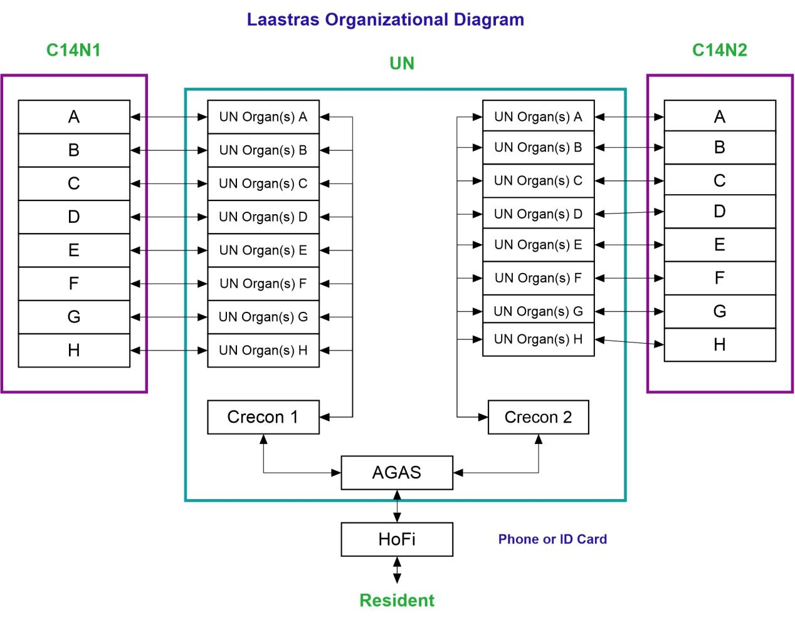

For maximum trade experience it is very important to define the shopping protocol that our LaasScops follows.

# Shopping Protocol

* Every last day of the week, the Remsup must issue time tables for every Idec holder in their jurisdiction. That time table must include the date and market or shop. Hence, it is advised to every Idec holder or householder to submit a weekly list of items to buy. These lists will be aggregated to form a persistent database of AGAS (Available Goods and Services). They will resubmit the list every time it needs modifying. If an Idec holder wants to do window shopping, they must issue a request to the Remsup so a date can be arranged according to date slot availability.
* To every Coshol must be associated a {item, shopkeeper location, item price, a confirmation ides} hash table.
* A consumer will use their Idec at the entrance of a Shop or Market so as to get a Coshol to use for their shopping experience. The insignia will be put near every item on the Coshol to symbolize successful exchange.
* Every Shopkeeper must submit a record to AGAS so as to properly be located. This record provides all the information needed to get to the Shop: available goods and services, quantities, and prices.
* Every Shopkeeper must own an Idecar, a simple computer, like a Raspberry Pi, access to internet through an RF internet dongle that uses a local Telecom network, a geo-location and fingerprint reader. The latter will be coupled with the Idec for security and authentication reasons. Once funds are available, these devices will be given to all Shops and Markets that are willing to pay them according to a monthly plan that will be established.
* Once nutritionists have started planning the daily/weekly shopping experience for the individuals in the region, then people will no longer have to submit a weekly list of items to buy.
* Every nation must have servers located within their borders that will host the local AGAS. They will, in the end, be aggregated to form a global AGAS under UN’s supervision. These servers must be well designed with this aggregation in mind. So care must be taken to use the highest level of professionalism in designing and installing these servers.
* Shops and Markets must issue Shols to Delivery (Logistics) so as to take care of these asap. For more details on this network, please, read our book on the matter published at <https://leanpub.com/World-Federal-Government-Constitution--Leadership-as-a-Service>. HDN, WTSC, and Traprosec must be seeded in the local AGAS so as to ultimately be included in the global AGAS under UN’s oversight. We have planned out the entire mission by way of milestones at <https://laastras.herokuapp.com>. Feel free to read through and ask any questions on the matter.



Once Laastras AORI is completed nationwide, we will have a fully functional C14 system all over the country. Our goal is to put together all local Telecom companies to establish a foundation for CaaS (Communication as a Service) group in the C14 system. Also, this will provision the Free Trade Capability group therein.

# Crecon Establishment Protocol Through Laastras AORI

* Telecom companies will provision mobile money infrastructure that maps Idec to every transaction method in the country.
* Banks must make sure their clients switch from specialized cards to mobile money hooks into their banking systems so as to use a single type of Idec, same as a national id. These ones may not cooperate due to the loss implied, so we may have to wait until the governmental legal system constrains them to do so. Note that many banks already have mobile money support infrastructure.
* LaasScops must include an application that takes care of this Idec-to-transaction-method map.

Once funds are available, we will start overseeing LaasScops in partnership with local Telecom Companies and Banks using the AORI contract as seen on the following diagram.

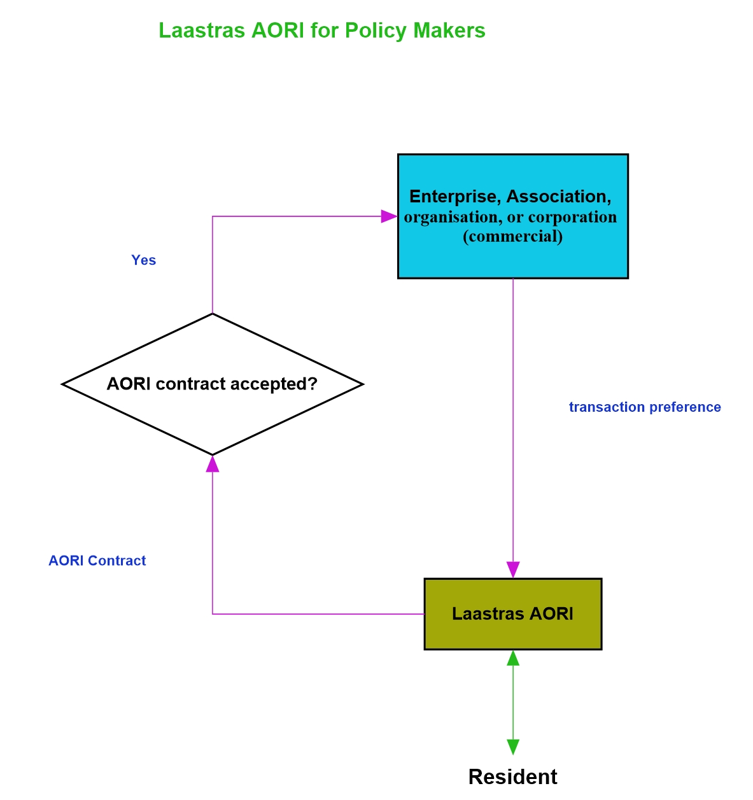

# LaasScops Deliverables For Starters

* Tramach system application.
* Transaction method multiplex (Tramem). This will be demultiplexed through banks all the way to the central bank to use the existing banking infrastructure without reinventing the wheel.
* Shopkeeper’s database that will manage (Shodaman) Shols and other Shopkeeper’s records.
* Consumer’s database that handles (Consdahan) consumer’s Coshols and any other consumer’s records.
* The Remsup relation to Delivery (Logistics)

# LaasScops Logic Diagram

LaasSaaS leverages other mobile application development technologies that already exist in the software industry. It includes Apps for Logistics, E-commerce, and IoT that pave the way for financial security for all in society.

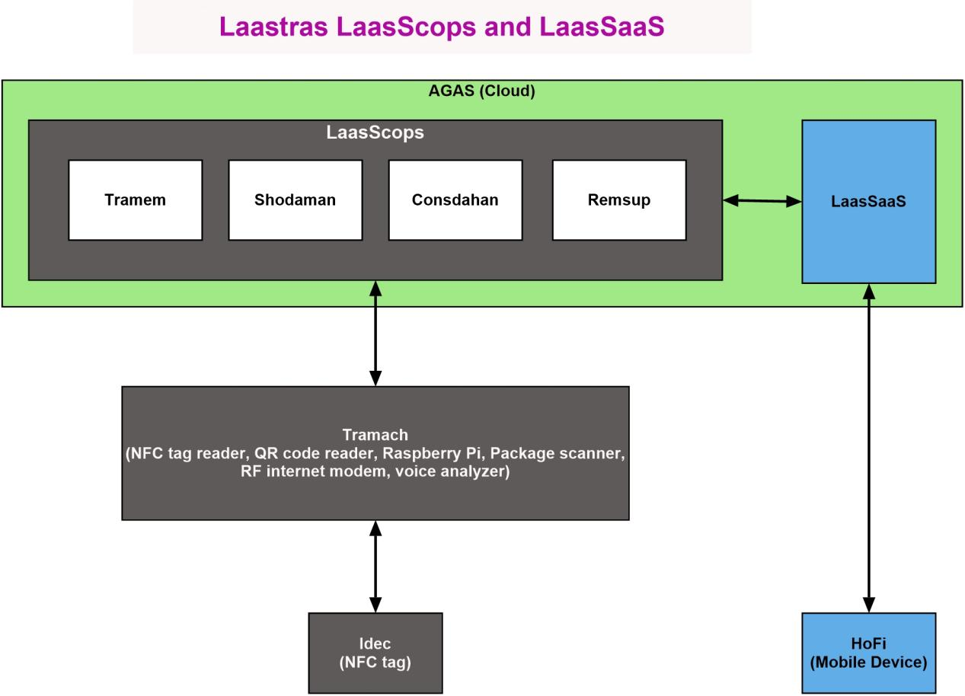

# LaasScops Use Cases

**Shopping at a Market or Shop**

1. Vocally list items to buy, at the entrance Tramach. It is much easier than copying them. Also, skip this if the above shopping protocol was followed since AGAS knows what you need on that day.
2. A coshol is issued by Tramach as printed document. Reason why shops with printers must be easily identifiable since these will be first-places-to-go as entries to shops associations. It could be at the entrance of a mall or marketplace.
3. If it’s a market, head to the shopkeeper(s) location(s). Once there give the coshol to the shopkeeper or just input your idec.
4. Tramach tells the shopkeeper the item(s) you need so this one can give them to you.
5. The shopkeeper gives you the item(s), each with a confirmation seal fixed on the coshol in its appropriate location.
6. You head back to the exit (entrance) (if it’s a mall or marketplace) where Tramach scans the confirmation ides and AGAS verifies payment.

**Visiting a House or a Hotel**

1. Vocally list the services to render or to expect: visit, delivery, etc.
2. Tramach sorts them by priority.
3. Tramach scans for all present packages.
4. If no delivery is involved, Tramach tells you the packages to leave outside the entrance. An area must be provisioned outside the entrance for packages that are not meant for delivery.
5. Tramach enters sleep waiting on your idec …
6. Once it detects your idec, it first scans you again to make sure you left all the non-delivery packages. Next, Tramach runs a check on all householders to make sure the packages or services were ordered or are expected by any. If so, it opens the door (or gate) for you.

**Delivery at a Market or Shop**

1. Vocally state “delivery” service followed by your idec input.
2. Tramach scans for all present packages and checks that all ordered packages are present through AGAS shol. She does so for all the shops in the market, if at all at the market.
3. If any packages are missing, it prints a list of missing packages for the deliverer, then it enters blocking state until the market’s supervisor or the shopkeeper applies his/her idec on her. A report is issued to AGAS signaling possible threat.
4. If there are any non-requested packages, Tramach prints a list of them so they can be discarded.
5. If all packages are accounted for, all is good.
6. Then it enters sleep, waiting on the deliverer’s idec …
7. From sleep, once the deliverer’s idec is detected, it prints a list of the requested packages to use for delivery. The list has the shopkeeper’s location column and another for a confirmation ides. Head to the shopkeeper(s), if at the market. The shopkeeper starts collecting the packages putting a confirmation ides in the appropriate cell on the printed list.

**Sufficient eat for a day**

1. Nutritionists, given a record of all available eats, fix daily eat portion for every household.
2. Then delivery and/or shopping.

**Satisfying all the desires of the heart**

1. Laastras EEOF consumes all AGAS products and services freely and likes them so much. Then, EEOF decides everybody should consume them freely. For more on EEOF, see our main publication at <https://leanpub.com/World-Federal-Government-Constitution--Leadership-as-a-Service>.
2. Then delivery and/or shopping.

The above use cases are sufficient since they can be used at all types of shops: market, shop, house, hotel, trans-shipment warehouse, class, meeting location, club, pub, restaurant, play grounds, bus, cab, aeroplane, etc. Hence, there must be a provisioned entrance at all shops.

# LaasSaaS

Comfort and security are very fundamental to peace, happiness, and tranquility. Those who cannot openly commit crime will resort to other subtle means such as poison, persecution, etc. They prey on trade vulnerabilities and financial insecurity. Logistics, E-commerce, and IoT can go a long way in putting an end to those sad situations. Packaging, monitoring and evaluation through AGAS, and encounters detection are LaasSaaS services that will carefully be implemented so as to achieve that noble goal.

#### LaasSaaS Deliverables

LaasSaaS will achieve the following objectives:

1. Laastras Cloud API (Application Programming Interface), called **LaasCla**, that will make needed reusable SaaS services available for AGAS. LaasCla must provision these services: Map-based geo-location, E-payment system that supports local E-payment vendors, centralized company database, role and authorization management, and Solidus-Spreecommerce API. LaasCla must have a dedicated internet domain named “laascla.com”.
2. Laastras Web App (**Laaswapp**) that serves as the main web portal for the company. It is currently hosted by a third-party at <https://laastras.herokuapp.com> but must have an internet domain called “laastras.com”.



1. Laastras cross-platform App services that will pave the way for the Morshux vision to eradicate unemployment, poverty, conflicts, and lack of financial security in businesses. Morshux is briefly explained at the above website, vision section. It must kick off with the following cross-platform software services: Laastras Real Estate (**Laasreale**), Laastras Talent Pool (**Laastalp**), Laastras E-commerce (**Laasec**), and **Laaslogistics** that puts those transportation and tourism services straight (ticketing, delivery, provisioned resorts for tourists, etc). We also give to families a simplified tool that uses AGAS called **HoFi**. It takes care of family budgeting and will be their unique tool for budgeting, shopping, and their main portal to AGAS.
2. Laastras interpersonal services (**Laasips**): visit, companionship, shelter, sex, meeting, class, outing, etc. They are mainly based on companionship and are very crucial since they add to our happiness. Technologies like mesh-network, human life detection, excitement detection, image recognition, voice pattern recognition, etc will be applied.
3. Laastras crecon mirrors (**Laascremir**): Locally mirroring all creator economy services that can be accessed through the internet so as to maximize internet speed, and preserve nation’s pride, a good strategy for marketing and for other things.

#### LaasSaaS C14 Services Diagram

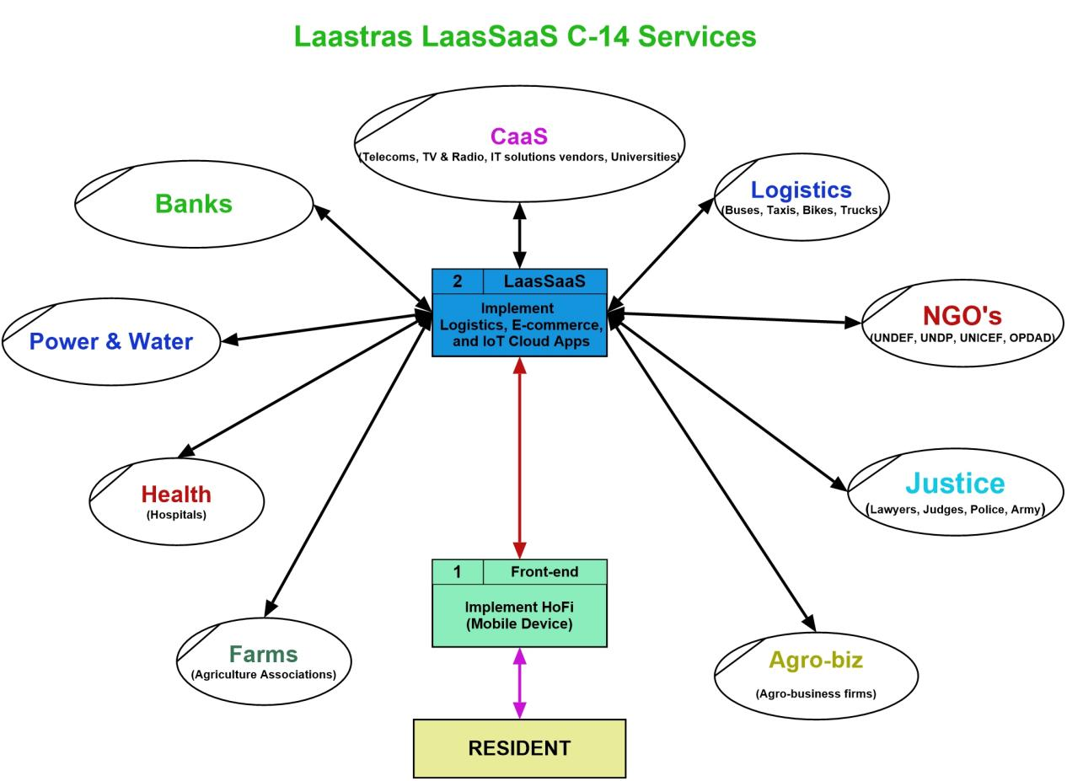

Our focus will be on constituting Communication as a Service (CaaS) and free trade capability (Logistics, E-commerce, and IoT) C14 groups. Progressively, the other groups will be constituted as legislators and other businesses consume Laastras services.

#### LaasSaaS Use Cases

Since peace is our main goal and because we won’t have to wait for the legislators to include Laastras project in the nation-level plans, we will strive to find a way to work with all local Telecom companies so as to use their services for marketing. Also, it will make things easy for our AORI service, which includes supporting mobile money transaction.



**Police arrest**

1. A police agent comes across a suspect so as to arrest the suspect.
2. HoFi, through mesh-network detects companionship, then, meeting, then due to the police agent identity, AGAS interpretes the situation as possible arrest.
3. AGAS waits for the police agent to read the suspect’s idec using his/her HoFi.

The use case above is enough to extrapolate it to other cases such as robbery, human trafficking, violence, rape, sexual harassment, etc.

**Online shopping (laasec)**

1. An individual runs search for an item. HoFi pulls out possible choices and images.
2. The individual picks the desired item.
3. HoFi takes care of payment and delivery heavy-lifting.
4. The individual gets delivery details.
5. Then delivery service. See LaasScops section.

**Groceries (laasEgrocery)**

After initially finding householders at their homes, hotels, and restaurants, collecting their weekly groceries lists, and delivering the provisions to them, we will build shopping carts for them and direct them to shops where to buy them. The services will include nutrition, revenue cycle management, and clients distribution. We will then build a section of the “Food source and water” cooperative, made of all traders dealing in that particular category. Afterwards, we will create a packaging and storage enterprise and a farm.

**Scheduled Tourism (Laaslogistics)**

1. Given a global work schedule record for all working class members, official holidays or weekends may be used to schedule visits to any places in the world.
2. Each nation must make arrangements so as to host and provide for the visitors through provisioned resorts. All needs must be taken care of.

Same situation applies to all other services like sex, online courses, etc.

For details on the reasons behind LaasSaaS services, see our main publication at

<https://leanpub.com/World-Federal-Government-Constitution--Leadership-as-a-Service>.

#### Conclusion

#### Laastras Project Equipment

1. **Idec**. Identification card that supports three functions: commercial transaction, national identification (national id), and international identification (passport).
2. **Ides**. Identification seal for all sorts of packages.
3. **Tramach**, fixed device for all types of shops.
4. **HoFi**, mobile device for every Major Human Individual (MHI).
5. **Tecoserc**, Telecom Company Service Controller that injects requests from users into the Telecom Company’s system and connects it to AGAS through a fast VPN. It must also be able to read the RF VPN data.
6. **Servers**. They must be inside a nation and our network, from the user to AGAS, and must not leave the nation’s space before it reaches these AGAS local servers.

#### Important Results to Achieve

* Only one card, Idec, must be used for transactions and identification.
* Every tradable asset must be packaged and idessed.
* All goods must transit through the packaging industry that will make the packaging decisions.
* Delivery and packaging services must be separate, for safety reasons.
* Every shop and market must use Tramach.
* Every Major Human Individual (MHI) must use HoFi mobile device.
* Government services, once Laastras project gets legalized, will comply with Laastras. E.g police, immigration, customs office, etc.
* All notes must be replaced by the idec-associated Virtual Currency.
* Education for all.
* A world federal government.

#### Solved Problems

* Conflicts, all types, including religious conflicts and persecution.
* Human rights violations.
* Inequality amongst human individuals and nations.
* Capitalism chaos and tyranny.
* Organized and isolated crimes, poverty, and unemployment.
* Financial insecurity that causes trade war, murder, and the deep gap between the haves and the have-nots.
* Relationships issues such as battered women, child abuse, love affair problems.

#### Marketing Strategies

* **Lightweight philanthropy:** Since Laastras relies on electronic transactions, transaction fees can be very discouraging. These will be covered for our clients and it will remain so until their “chiffre d’affaire” hits a specific threshold. The equipment will be given free of charge and a small affordable amount of fees will be credited from their account on a monthly basis. That amount can be tantamount to their “chiffre d’affaire”. We must use RF services given by Telecom companies to encourage them to be our business partners. Those fees must also be covered by Laastras capitals. Once the Telecom companies are fully aoried, we will be relieved from that financial burden. Then, we will charge our clients for those RF services in a reasonable way until they form associations big enough to be fully aoried to Laastras. Examples of RF services: RF internet, mobile money, SMS, etc.
* **Mobile money or online banking through HoFi:** Some banks use software that consumes their online services. We will offer them two choices: mobile money in the above fashion or support for their online services through HoFi, which is more convenient. Otherwise, they will entirely lose their online banking consumers due to our best QoS. Those banks that do not have online banking services will be given mobile money hooks.
* **Public marketing:** Teams of agents will storm the streets and business places advertising Laastras business benefits, its social convenience, and the many blessings to reap from its success.
* **Lobbying:** In the meantime, trained agents will be lobbying for Laastras so that legislators adopt the plan at the country level, which will ease things up for AORI acquire service.
* **Model City:** The other business and political competitors may have a diversity of means to deter people from consuming Laastras products and services. To remedy the situation, although very costly, we may have to build a model city built according to the provisions in this specification. Everyone who is involved must live there and the city must have:

1. **Crecon (CaaS):** Servers, Telecom Company, Bank, School, University, Media, etc.
2. **Protection (Army, police, and justice):** Private contractors or foreign troops, a judiciary system that consumes our servers data, etc.
3. **Power source:** Green energy or contracts.
4. **Health system:** Hospital(s) and doctors.
5. **Eat:** Farms, production and transformation industries, and the needed logistics infrastructures like a fleet of buses, trucks, airplanes, etc.
6. **Water:** Tanks and contracts.

Etc.