Laastras Organization Mission Book－A Post-COVID-19 Strategy to Contain Pandemics, Eradicate Poverty, Unemployment, Conflicts, and Establish Pure Democracy.

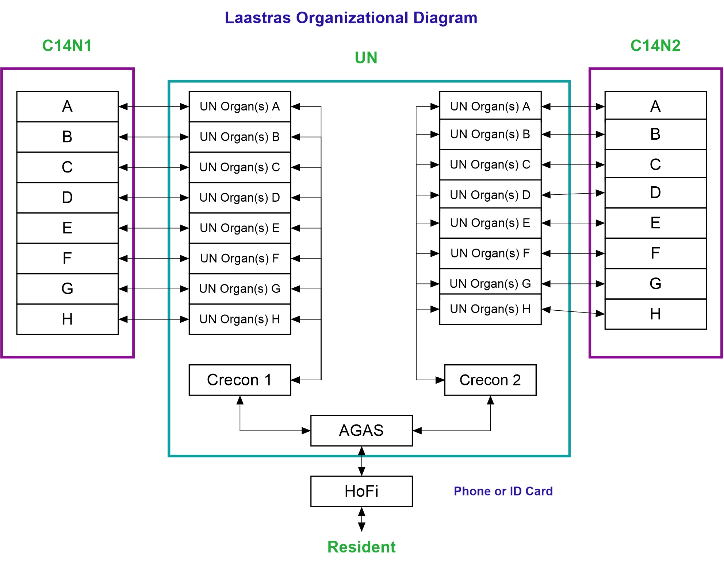

**－Obed-Edom Nkezabahizi**

**Table of Contents**

1. [AORI Policy](#_AORI Policy) ………………………………………………………………. [2](#_AORI Policy)
2. [Laastras AORI Policy Diagram](#_Laastras AORI Policy Diagram)……………………………………………. [3](#_AORI Policy)
3. [Nationwide Provisions](#_Nationwide Provisions) …………………………………………………….. [4](#_Nationwide Provisions)
4. [AORI Contract Terms Succinctly](#_AORI Contract Terms Succinctly) …………………………………………. [4](#_AORI Contract Terms Succinctly)
5. [Laastras AORI Department](#_Laastras AORI Department) ……………………………………………….. [4](#_Laastras AORI Department)
6. Constraints …………………………………………………………. 4
7. [Laastras AORI Service Logic Diagram](#_Laastras AORI Service Logic Diagram) ……………………………. [4](#_Laastras AORI Service Logic Diagram)
8. [Laastras Organizational Diagram](#_Laastras Organizational Diagram) ………………………………….. [5](#_Laastras Organizational Diagram)
9. [Action Plan](#_Action Plan) ………………………………………………………….[7](#_Action Plan)
10. [Bank Details](#_Bank Details) ……………………………………………………………….[7](#_Bank Details)

## AORI Policy

Our society has struggled to eradicate poverty, unemployment, hunger, and conflicts. Thorough study and analysis led us to conclude that we cannot win the battle without achieving unity and peace in every nation and globally. Laastras AORI (“Acquire or Integrate”) is a plan devised to meet the challenges and constraints to unity and peace in every nation and worldwide while at the same time defeating poverty, unemployment, hunger, and conflicts.

The entire Laastras plan can be found at <https://laastras.herokuapp.com>



We basically go through two steps:

* **Integrate:** In every nation, we bring all commercial transactions into one unique management portal (AGAS). This will make it possible to hit the “Services Exchange” impact. It will also pave the way for the creation of “Virtual Currency” since all currency will be grouped outside the internal transaction realm.
* **Acquire:** Every enterprise in Laastras AORI portal can decide to fully migrate to Laastras by signing the AORI contract with us. We will briefly mention the AORI contract terms. The goal is to achieve Morshux (“Management of resources that support human existence”) vision, which is the strategy to establish pure democracy. The details about pure democracy philosophy can be found in the book published at <https://leanpub.com/World-Federal-Government-Constitution--Leadership-as-a-Service>

## Laastras AORI Policy Diagram

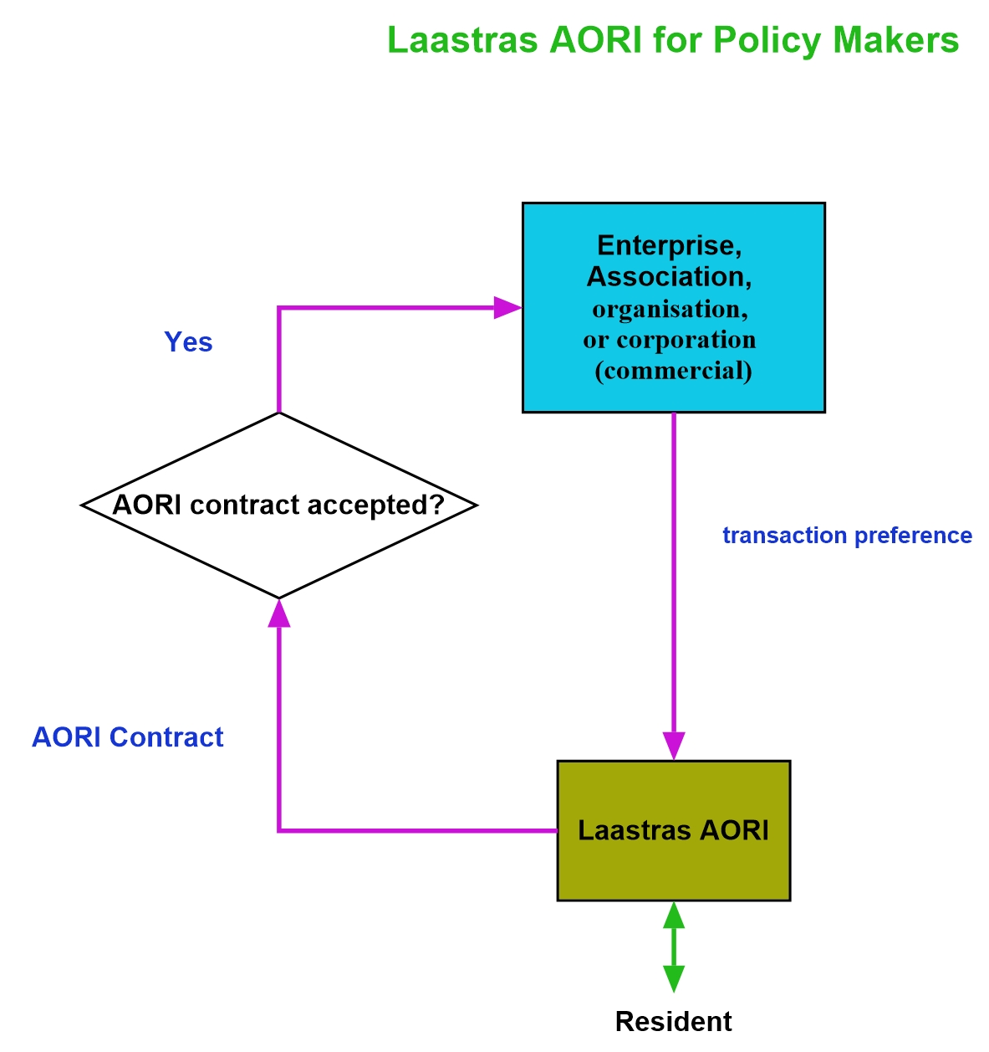

The details on Laastras AORI policy are compiled in our online portfolio at the following http address: <https://laastras.herokuapp.com>



## Nationwide Provisions

Every business in the country must be a part of commercial associations the size of which must be decided by local empowered authorities. The authorities will decide whether a business is to affiliate an association or whether it can stand alone in order to consume Laastras AORI management services. If no policy exists, then Laastras AORI will decide on the terms of association through AORI contract.

## AORI Contract Terms Succinctly

1. All commercial transactions of the enterprise signing the contract must go through Laastras AORI portal after the enterprise has communicated to Laastras AORI all the commercial transaction specifics supported by the enterprise. This is the Integrate part of AORI plan.
2. If interested or constrained by local governmental policy, the enterprise signing the contract must fully migrate to Laastras AORI organization or department by being its shareholder with all rights reserved to Laastras AORI organization or department, which include remunerating all employees with the right to all Laastras AORI services/goods and cash to cover the other expenses unmet by Laastras AORI.

## Laastras AORI Department

### Constraints

* One AGAS Cloud for the whole world. The cloud will eventually turn the global market into World Trade System. As stated above, we will then achieve our vision: Services Exchange and Virtual Currency. Morshux will be achieved by making all Morshux related services free, price value 0.
* One HoFi App Suite for every Major Human Individual (MHI) on earth. The other individual talents, existing and future, will use Virtual Currency through HoFi App suite.

Thus, Laastras Vision will be accomplished in its entirety. For details on the vision, please, head to our online portfolio at <https://laastras.herokuapp.com>



### Laastras AORI Service Logic Diagram

We devised AORI as a step by step protocol to get us to C14 policy given the status quo. Nations policy makers must start by grouping local businesses into legal containers (associations) that will make it easy for them to constitute C14 groups, that is, Self-Contained Personal Space (SCoPS). For details on the SCoPS philosophy, please read the book at <https://leanpub.com/World-Federal-Government-Constitution--Leadership-as-a-Service>

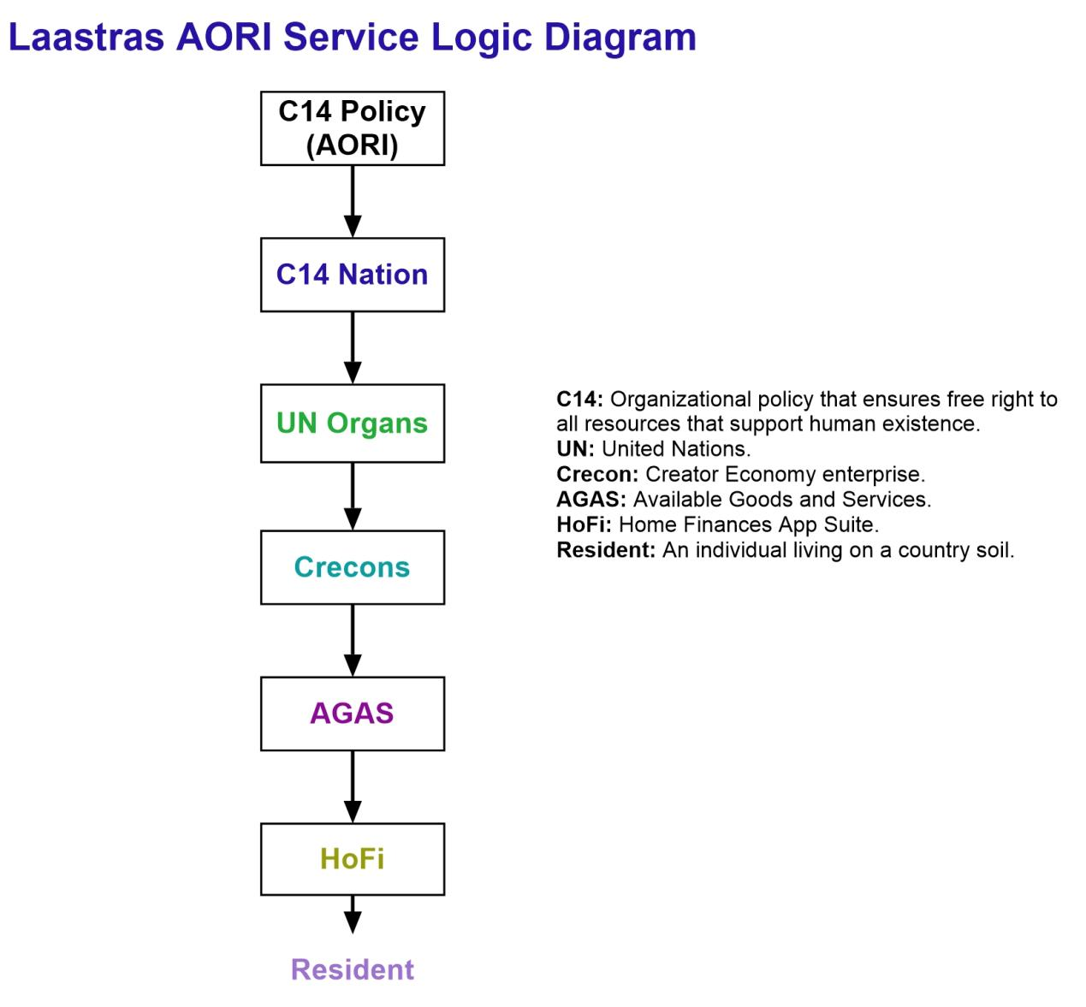

### Laastras Organizational Diagram

Laastras has another number of services such as E-commerce, Logistics, etc. AORI stands out as a facility that consumes the other services but with the ultimate goal of achieving the organization vision completely. Our portfolio lists Laastras services and milestones that will get us to the bigger picture, that is, world federal government constitution (WoFeGoC), say, Laaszen (Leadership as a Service World Citizenship Nation). The portfolio can be looked up at <https://laastras.herokuapp.com>



The following is Laastras Organization Diagram.

### laastras-organizational-diagram

The following results will ensue:

* UN will serve as a bond of union amongst nations, a noble goal that she has striven to achieve ever since her creation after World War 2.
* Poverty and unemployment will be eradicated and conflicts will be solved properly and peacefully. Also, Democracy will be purified, ironing out its deficiencies.
* Lasting peace, world unity, and world citizenship for mankind.

### Action Plan

As nations constitute C14 policy, that is, legalizing free right to all services/goods in Morshux, UN can be reorganizing their Organs in such a way that each Morshux group is headed by their equivalent UN Organ(s). UN must also see to it that Crecons, one per nation, are appointed. AGAS will then be a unified intermediary between Crecons and HoFi App Suite.

## Bank Details

**Bank account owner:**  Nkezabahizi Obed-Edom

**Bank account number:** 6690439461

**Bank swift:** KCBLBIBI

**Bank address:** Rohero 1,

Pierre Ngendandumwe Avenue,

Bujumbura Mairie, Burundi